Supplementary Figures and Tables
Infection Risks in Multiple Myeloma: A systematic review and meta-analysis of randomized trials from 2015-2019

Nicole Balmaceda, Muhammad Aziz, Viveksandeep Thoguluva Chandrasekar, Brian McClune, Suman Kambhampati, Leyla Shune, Al-Ola Abdallah, Faiz Anwer, Aneela Majeed, Muzaffar Qazilbash, Siddhartha Ganguly, Joseph McGuirk, Ghulam Rehman Mohyuddin

Supplementary Figure 1: Incidence of Grade III or higher pneumonia in frontline myeloma trials

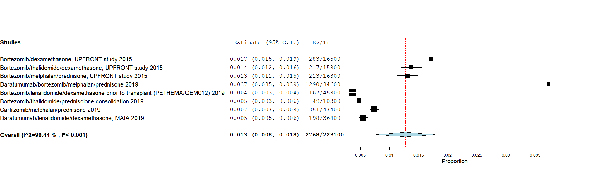

Supplementary Figure 2: Incidence of Grade III or higher neutropenia in frontline myeloma trials

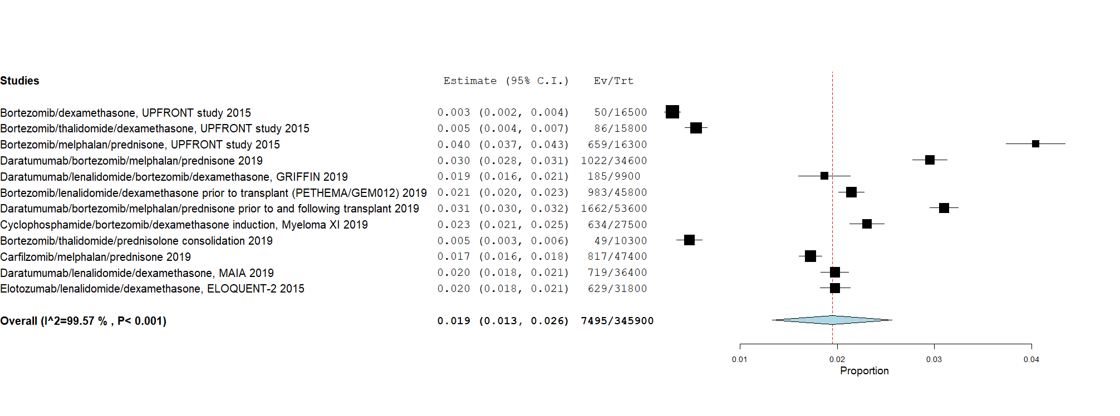

Supplementary Figure 3: Incidence of Grade III or higher pneumonia in relapsed/refractory myeloma trials
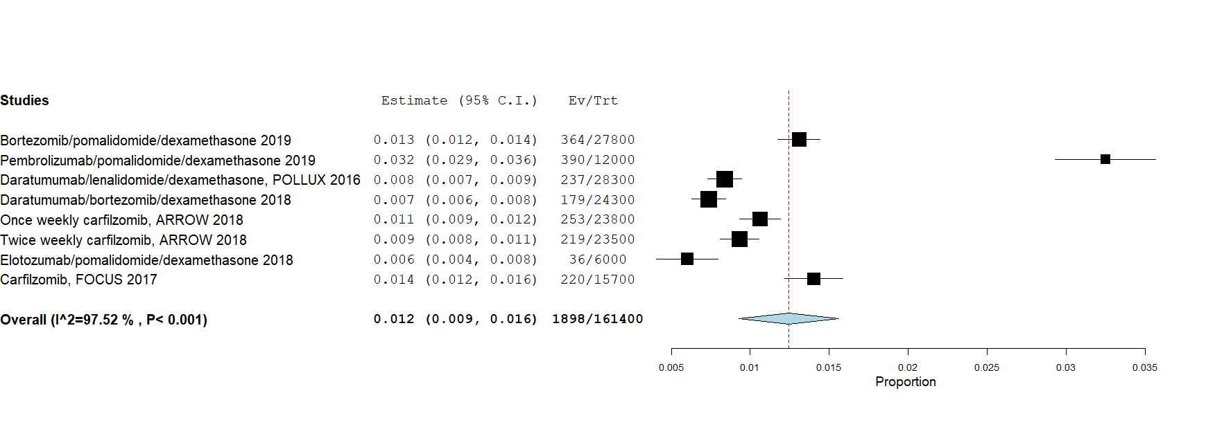

Supplementary Figure 4: Incidence of Grade III or higher neutropenia in relapsed/refractory myeloma trials

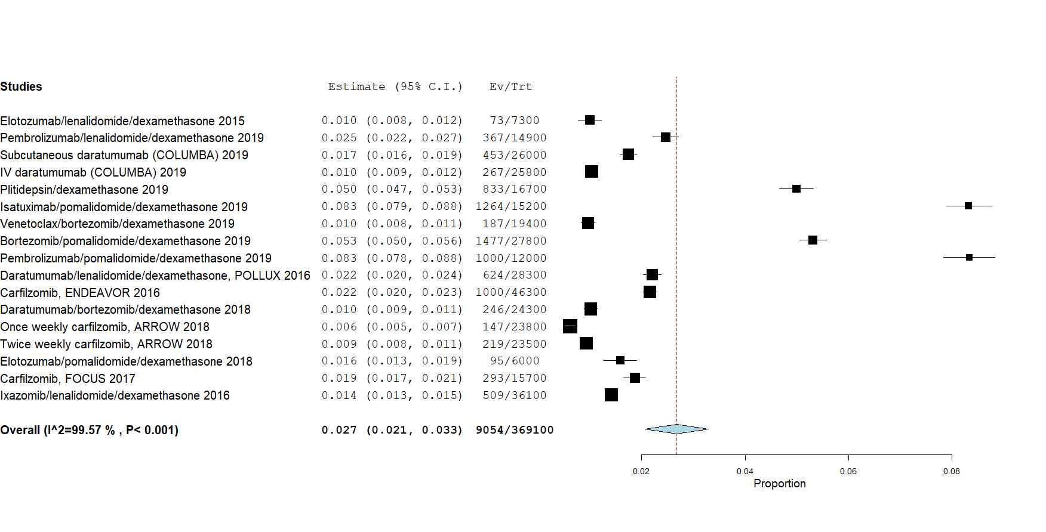

Supplementary Figure 5: Incidence of Grade III or higher neutropenia in myeloma maintenance trials
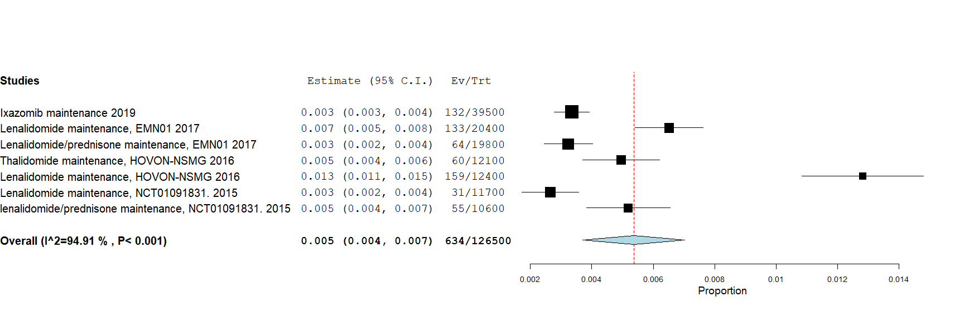

Supplementary Figure 6: Incidence of Grade III or higher infection in myeloma trials with 2-drug regimens
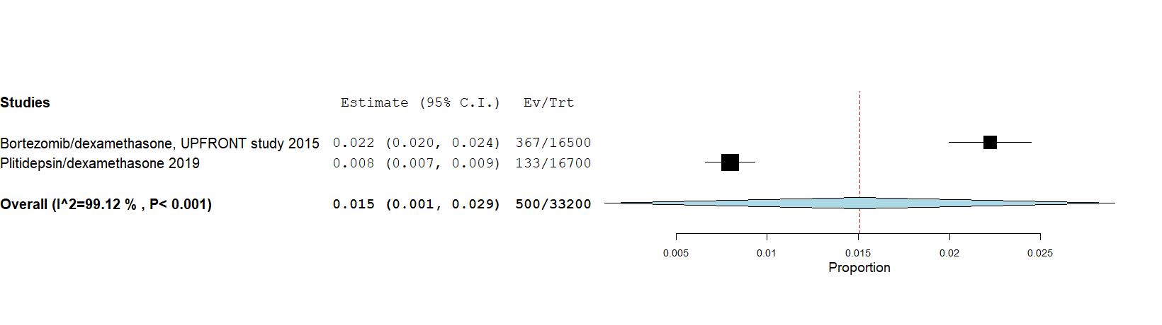

Supplementary Figure 7: Incidence of Grade III or higher infection in myeloma trials with 3-drug regimens

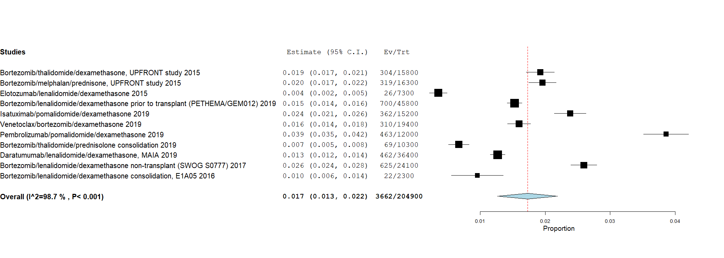

Supplementary Figure 8: Incidence of Grade III or higher pneumonia in myeloma trials with 2-drug regimens
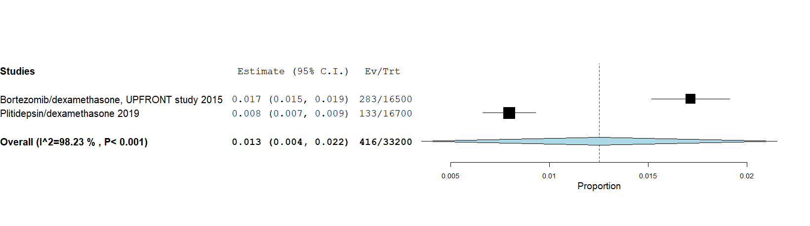

Supplementary Figure 9: Incidence of Grade III or higher pneumonia in myeloma trials with 3-drug regimens
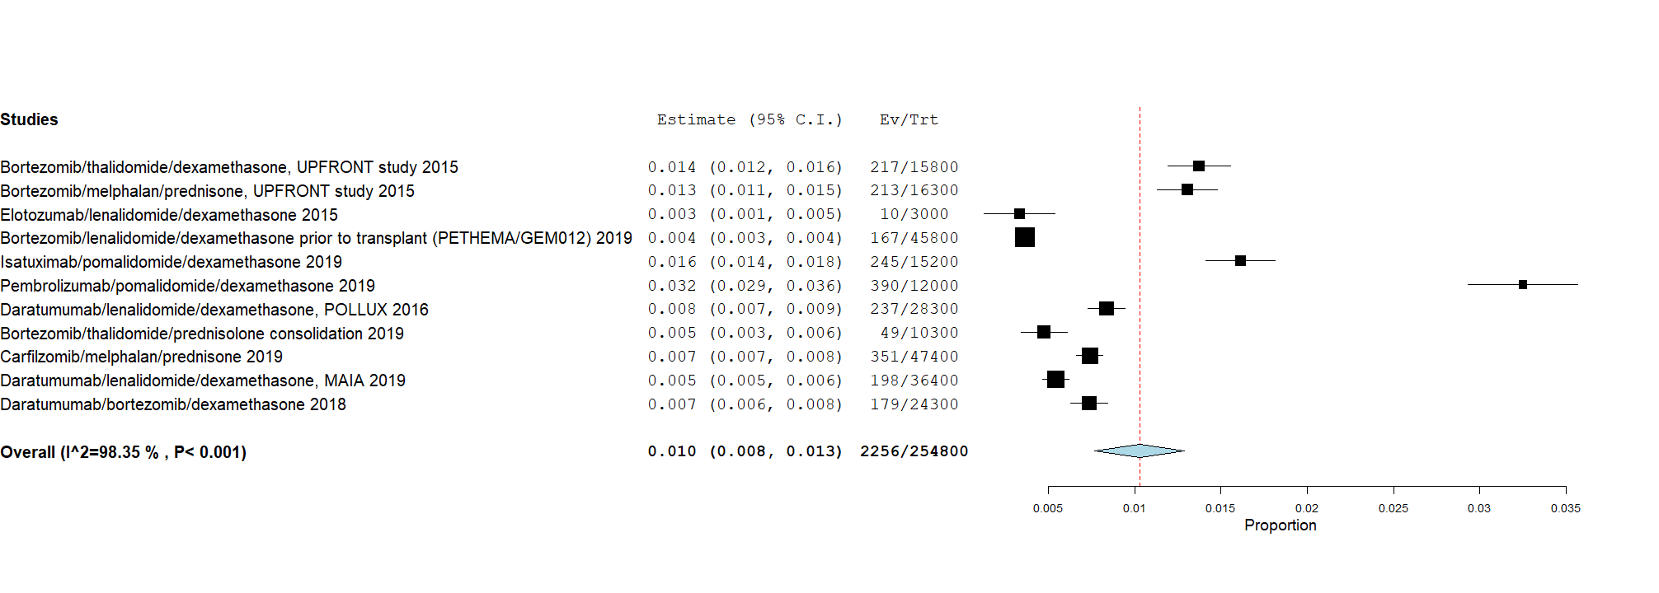
Supplementary Figure 10: Incidence of Grade III or higher neutropenia in myeloma trials with 2-drug regimens
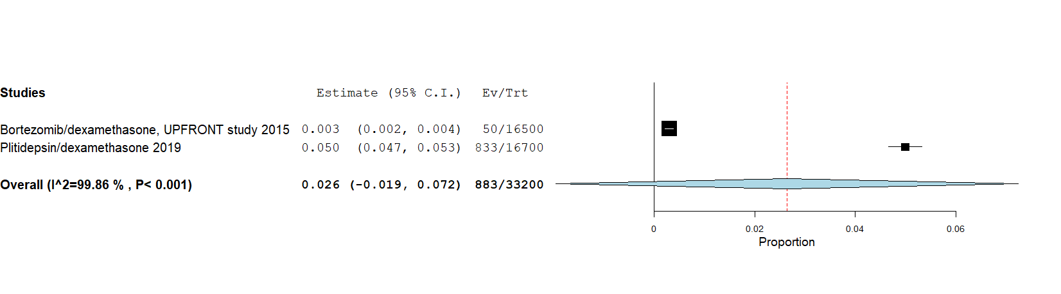

Supplementary Figure 11: Incidence of Grade III or higher neutropenia in myeloma trials with 3-drug regimens
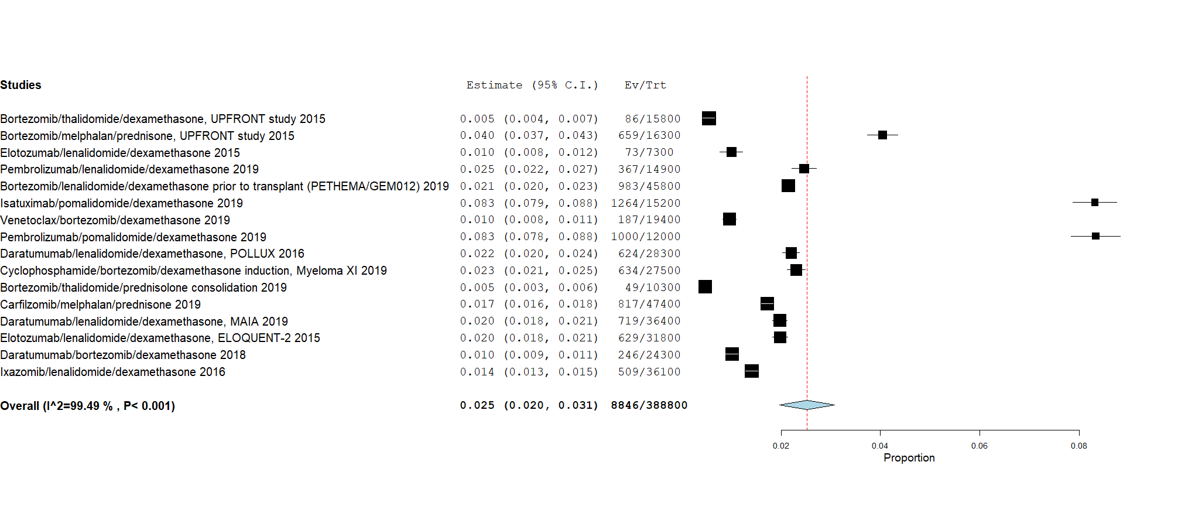

Supplementary Figure 12: Leave one out plot examining the influence of individual studies shows no significant change in pooled grade III or higher infection rate per months with exclusion of any one study

Supplementary Table 1: Example search strategy
S. No. | Query | Studies
1. | myeloma OR myelomas OR myelomatos* OR 'kahler disease' OR 'myeloma'/exp | 108931
2. | (myeloma OR myelomas OR myelomatos* OR 'kahler disease' OR 'myeloma'/exp) AND [2015-2020]/py | 74264
3. | #2 AND 'human'/de | 66345
4. | #2 AND 'human'/de NOT ('conference review'/it OR 'editorial'/it OR 'review'/it OR 'short survey'/it) | 55869
5. | 'phase 3 clinical trial'/exp | 44510
6. | 'crossover procedure':de OR 'double-blind procedure':de OR 'randomized controlled trial':de OR 'single-blind procedure':de OR random*:de,ab,ti OR factorial*:de,ab,ti OR crossover*:de,ab,ti OR ((cross NEXT/1 over*):de,ab,ti) OR placebo*:de,ab,ti OR ((doubl* NEAR/1 blind*):de,ab,ti) OR ((singl* NEAR/1 blind*):de,ab,ti) OR assign*:de,ab,ti OR allocat*:de,ab,ti OR volunteer*:de,ab,ti | 2527911
7. | #5 AND #6 | 32676
8. | #4 AND #7 | 743
9. | 'phase 3 clinical trial (topic)'/exp | 36043
10. | #6 AND #9 | 22280
11. | #4 AND #10 | 354
12. | 'kidney disease'/exp/mj OR 'kidney function'/exp/mj OR kidney*:ti OR renal:ti | 784026
13. | #11 AND #12 | 5
14. | #8 OR #13 | 748
Supplementary Table 2: Characteristics of included studies (R/R= relapsed/refractory, ND= newly diagnosed, M=maintenance)

Author (Year) | Trial Name | Study Phase | Phase Treatment | Regimen | No. Patients | Median Age (Years) | Median Duration of Treatment (Months)
Niesvizky  (2015) [14] | UPFRONT | 3 | ND | Bortezomib/dexamethasone | 165 | 74.5 | 6
 |  |  |  | Bortezomib/thalidomide/dexamethasone | 158 | 73 | 4.6
 |  |  |  | Bortezomib/melphalan/prednisone | 163 | 72 | 4.7
Richardson (2015)[26] |  | 2 | RR | Elotuzumab/lenalidomide/dexamethasone | 73 | 62 | 19.1
Mateos (2019) [15] | ALCYONE | 3 | ND | Daratumumab/bortezomib/melphalan/prednisone | 346 | 71 | 13.5
Voorhees (2019) [16] | GRIFFIN | 2 | ND | Daratumumab/lenalidomide/bortezomib/dexamethasone | 99 | 59 | 22.1
Usmani (2019)[38] | KEYNOTE-185 | 3 | RR | Pembrolizumab/lenalidomide/dexamethasone | 149 | 74 | 4.4
Mateos (2019)  [40] | COLUMBA | 3 | RR | Subcutaneous daratumumab | 260 | 65 | 7.5
 |  |  |  | IV daratumumab | 258 | 68 | 7.5
Spicka (2019)[27] | ADMYRE | 3 | RR | Plitidepsin/dexamethasone | 167 | 64 | 3
Rosinol (2019)[17] | PETHEMA/GEM2012 | 3 | ND | Bortezomib/lenalidomide/dexamethasone prior to transplant | 458 | 58 | 6
Attal (2019) [28] | ICARIA-MM | 3 | RR | Isatuximab/pomalidomide/dexamethasone | 152 | 68 | 10.2
Morgan (2019)[41] | TOURMALINE-MM3 study | 3 | M | Ixazomib maintenance | 395 | 58 | 15.2
Moreau (2019) [29] | BELLINI | 3 | RR | Venetoclax/bortezomib/dexamethasone | 194 | 66 | 18.7
Moreau (2019) [18] | CASSIOPEIA | 3 | ND | Daratumumab/bortezomib/melphalan/prednisone prior to and following transplant | 536 | 59 | 8.9
Richardson (2019)[30] | OPTISIMISMM | 3 | RR | Bortezomib/pomalidomide/dexamethasone | 278 | 67 | 8.8
Mateos (2019) [31] | KEYNOTE-183 | 3 | RR | Pembrolizumab/pomalidomide/dexamethasone | 120 | 65 | 4.1
Dimopoulos (2018)[35] | POLLUX | 3 | RR | Daratumumab/lenalidomide/dexamethasone | 283 | 65 | 24.5
Jackson (2019)[24] | Myeloma XI | 3 | ND | Cyclophosphamide/bortezomib/dexamethasone induction | 275 | 66 | 2.8
Horvath (2019)[19] | VCAT | 3 | ND | Bortezomib/thalidomide/prednisolone consolidation | 103 | 58 | 10.2
Facon (2019) [23] | CLARION | 3 | ND | Carfilzomib/melphalan/prednisone | 474 | 72 | 13.1
Facon (2019) [20] | MAIA | 3 | ND | Daratumumab/lenalidomide/dexamethasone | 364 | 73 | 25.3
Lonial (2015) [25] | ELOQUENT-2 | 3 | RR | Elotuzumab/lenalidomide/dexamethasone | 318 | 67 | 17
Dimopoulos (2016)[32] | ENDEAVOR | 3 | RR | Carfilzomib | 463 | 65 | 10
Spencer (2018) [36] | CASTOR | 3 | RR | Daratumumab/bortezomib/dexamethasone | 243 | 64 | 13.4
Moreau (2018)[33] | A.R.R.O.W. | 3 | RR | Once weekly carfilzomib | 238 | 66 | 9.5
 |  |  |  | Twice weekly carfilzomib | 235 | 66 | 7.3
Dimopoulos  (2018) [34] | ELOQUENT-3 | 2 | RR | Elotuzumab/pomalidomide/dexamethasone | 60 | 69 | 8.4
Hajek (2016) [37] | FOCUS | 3 | RR | Carfilzomib | 157 | 63 | 4.1
Durie (2017)[21] | SWOG S0777 | 3 | ND | Bortezomib/lenalidomide/dexamethasone non-transplant | 242 | 63 | 5.6
Bringhen (2019)[42] | EMN01 | 3 | M | Lenalidomide maintenance | 204 | 73 | 32.4
 |  |  |  | Lenalidomide/prednisone maintenance | 198 | 73 | 29.8
Zweegman (2016) [43] | HOVON-NSMG | 3 | M | Thalidomide maintenance | 121 | 72 | 5
 |  |  |  | Lenalidomide maintenance | 124 | 73 | 17
Moreau (2016)[39] |  | 3 | RR | Ixazomib/lenalidomide/dexamethasone | 361 | 66 | 15.9
Jacobus (2016)[22] | E1A05 | 3 | NF | Bortezomib/lenalidomide/dexamethasone consolidation, | 23 |  | 4.55
Gay (2015)[44] |  | 3 | M | Lenalidomide maintenance | 117 | 57 | 28.9
 |  |  |  | lenalidomide/prednisone maintenance | 106 | 56 | 25.3

Supplementary Table 3: Risk of bias for included studies
Author (Year) | Selection bias, as pertains to random sequence generation | Selection bias related to allocation concealment | Performance bias due to non-blinding of participants and investigators | Detection bias due to non-blinding of outcome assessment | Attrition bias due to incomplete outcome data | Reporting bias due to selective reporting
Niesvizky (2015) | NO | NO | YES | NO | NO | NO
Richardson (2015) | NO | NO | YES | NO | NO | NO
Mateos (2019) | NO | NO | YES | NO | NO | NO
Voorhees (2019) | NO | NO | YES | NO | NO | NO
Usmani (2019) | NO | NO | YES | NO | NO | NO
Mateos (2019) | NO | NO | YES | NO | NO | NO
Spicka (2019) | NO | NO | YES | NO | NO | NO
Rosinol (2019) | NO | NO | YES | NO | NO | NO
Attal (2019) | NO | NO | YES | NO | NO | NO
Morgan (2019) | NO | NO | NO | NO | NO | NO
Moreau (2019) | NO | NO | NO | NO | NO | NO
Moreau (2019) | NO | NO | YES | NO | NO | NO

Supplementary Table 4: Table S4: Antibiotics use of included studies

Author (Year) | Regimen | No. Patients | Antibiotic Prophlaxis Mandated | No. Patients Recived Antibiotics | Name Antibiotics Given | No. Patients Died from Infection
Niesvizky (2015) | Bortezomib/dexamethasone | 165 | NA | NA | NA
 | Bortezomib/thalidomide/dexamethasone | 158 | NA | NA | NA
 | Bortezomib/melphalan/prednisone | 163 | NA | NA | NA
Richardson (2015) | Elotuzumab/lenalidomide/dexamethasone | 73 | NA | NA | NA
Mateos (2019) | Daratumumab/bortezomib/melphalan/prednisone | 346 | NA | NA | NA
Voorhees (2019) | Daratumumab/lenalidomide/bortezomib/dexamethasone | 99 | NA | NA | NA
Usmani (2019) | Pembrolizumab/lenalidomide/dexamethasone | 149 | NA | NA | NA
Mateos (2019) | Subcutaneous daratumumab | 260 | NA | NA | NA
 | IV daratumumab | 258 | NA | NA | NA
Spicka (2019) | Plitidepsin/dexamethasone | 167 | NA | NA | NA
Rosinol (2019) | Bortezomib/lenalidomide/dexamethasone prior to transplant | 458 | NA | NA | NA | 4
Attal (2019) | Isatuximab/pomalidomide/dexamethasone | 152 | NA | NA | NA | 1
Morgan (2019) | Ixazomib maintenance | 395 | NA | NA | NA
Moreau (2019) | Venetoclax/bortezomib/dexamethasone | 194 | NA | NA | NA
Moreau (2019) | Daratumumab/bortezomib/melphalan/prednisone prior to and following transplant | 536 | NA | NA | NA
Richardson (2019) | Bortezomib/pomalidomide/dexamethasone | 278 | Permitted | NA | NA | 5
Mateos (2019) | Pembrolizumab/pomalidomide/dexamethasone | 120 | NA | NA | NA | 5
Dimopoulos (2018) | Daratumumab/lenalidomide/dexamethasone | 283 | NA | NA | NA
Jackson (2019) | Cyclophosphamide/bortezomib/dexamethasone induction | 275 | Permitted | NA | NA
Horvath (2019) | Bortezomib/thalidomide/prednisolone consolidation | 103 | NA | NA | NA
Facon (2019) | Carfilzomib/melphalan/prednisone | 474 | NA | NA | NA
Facon (2019) | Daratumumab/lenalidomide/dexamethasone | 364 | NA | NA | NA | 18
Lonial (2015) | Elotuzumab/lenalidomide/dexamethasone | 318 | NA | NA | NA | 2
Dimopoulos (2016) | Carfilzomib | 463 | NA | NA | NA | 6
Spencer (2018) | Daratumumab/bortezomib/dexamethasone | 243 | NA | NA | NA
Moreau (2018) | Once weekly carfilzomib | 238 | NA | NA | NA | 1
 | Twice weekly carfilzomib | 235 | NA | NA | NA
Dimopoulos (2018) | Elotuzumab/pomalidomide/dexamethasone | 60 | NA | NA | NA
Hajek (2016) | Carfilzomib | 157 | NA | NA | NA
Durie (2017) | Bortezomib/lenalidomide/dexamethasone non-transplant | 242 | NA | NA | NA | 1
Bringhen (2019) | Lenalidomide maintenance | 204 | NA | NA | NA
 | Lenalidomide/prednisone maintenance | 198 | NA | NA | NA
Zweegman (2016) | Thalidomide maintenance | 121 | Permitted | NA | NA | 6
 | Lenalidomide maintenance | 124 | Permitted | NA | NA | 8
Moreau (2016) | Ixazomib/lenalidomide/dexamethasone | 361 | NA | NA | NA
Jacobus (2016) | Bortezomib/lenalidomide/dexamethasone consolidation, | 23 | NA | NA | NA
Gay (2015) | Lenalidomide maintenance | 117 | NA | NA | NA
 | lenalidomide/prednisone maintenance | 106 | NA | NA | NA

