Supplementary file
Anabolic-androgenic steroid administration increases self-reported aggression in healthy males: A systematic review and meta-analysis of experimental studies

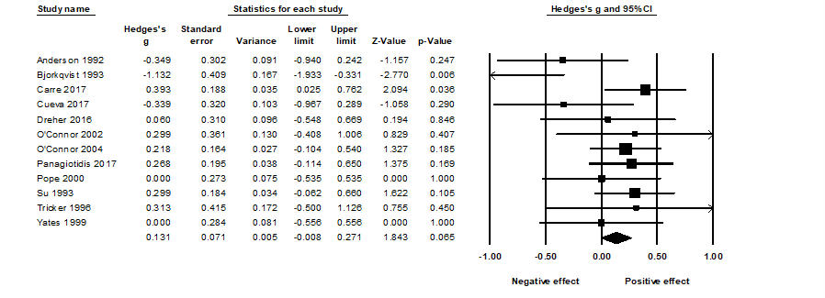
Supplementary Figure 1. The effect (random-effects model) of AAS administration on self-reported aggression with the inclusion of Björkqvist et al. (1994)

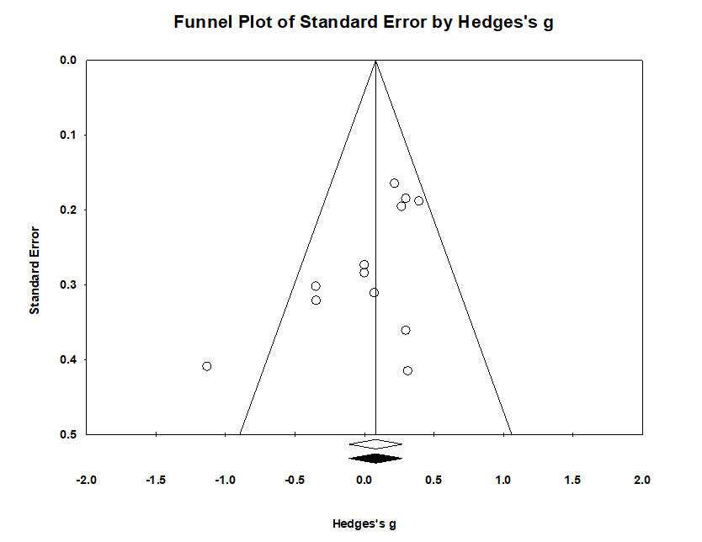
Supplementary Figure 2. Funnel plot of observed and imputed studies (random-effects model) of the effect of AAS administration on self-reported aggression

Appendix A
Corpora and search terms
Corpus
MEDLINE, PsycINFO, ISI Web of Science, ProQuest, Google Scholar, and Cochrane Library
Keywords/search terms for AAS
‘anabol*’, ‘androgen*’, ‘steroid’, ‘doping’, ‘testosterone’, ‘4-Hydroxytestosterone’, ‘11-Ketotestosterone’, ‘Boldenone’, ‘Clostebol’, ‘4-Androstenediol’, ‘4-Dehydroepiandrosterone’, ‘4-DHEA’, ‘5-Androstenedione’, ‘5-Dehydroandrosterone’, ‘5-DHA’, ‘11β-Hydroxyandrostenedione’, ‘11β-OHA4’, ‘Adrenosterone’, ‘11-ketoandrostenedione’, ‘11-KA4’, ‘Androstenediol’, ‘5-androstenediol’, ‘A5’, ‘Androstenedione’, ‘4-androstenedione’, ‘A4’, ‘Atamestane’, ‘Boldione’, ‘1,4-androstadienedione’, ‘Dehydroepiandrosterone’, ‘DHEA’, ‘5-DHEA;prasterone’, ‘androstenolone’, ‘Exemestane’, ‘Formestane’, ‘Cloxotestosterone’, ‘Quinbolone’, ‘Silandrone’, ‘Dihydrotestosterone’, ‘DHT’, ‘Androstanolone’, ‘stanolone’, ‘1-Testosterone’, ‘dihydro-1-testosterone’, ‘dihydroboldenone’, ‘11-Ketodihydrotestosterone’, ‘11-KDHT’, ‘Drostanolone’, ‘Epitiostanol’, ‘epithioandrostanol’, ‘Mesterolone’, ‘Metenolone’, ‘methenolone’, ‘Methylandrostenolone’, ‘Nisterime’, ‘1-Androsterone’, ‘1-Andro’, ‘1-DHEA’, ‘1-Androstenediol’, ‘dihydro-1-androstenediol’, ‘5α-Androst-2-en-17-one’, ‘Androsterone’, ‘Epiandrosterone’, ‘Mepitiostane’, ‘Mesabolone’, ‘Prostanozol’, ‘Bolazine’, ‘di(drostanolone)azine’, ‘2α-methyl-5α-androstan-17β-ol-3-one’, ‘Nandrolone’, ‘nortestosterone’, ‘11β-Methyl-19-nortestosterone’, ‘11β-MNT’, ‘Dienolone’, ‘Dimethandrolone’, ‘Norclostebol’, ‘Oxabolone’, ‘Trenbolone’, ‘Trienolone’, ‘Trestolone’, ‘MENT’, ‘7α-Methyl-19-nor-4-androstenedione’, ‘Mentdione’, ‘Trestione’, ‘19-Nor-5-androstenediol’, ‘Bolandiol’, ‘nor-4-androstenediol’, ‘Dienedione’, ‘nor-4,9-androstadienedione’, ‘Methoxydienone’, ‘methoxygonadiene’, ‘Bolmantalate’, ‘nandroloneadamantoate’, ‘Bolasterone’, ‘Calusterone’, ‘Chlorodehydromethyltestosterone’, ‘CDMT’, ‘Enestebol’, ‘Fluoxymesterone’, ‘Formebolone’, ‘Hydroxystenozole’, ‘Metandienone’, ‘Methandienone’, ‘methandrostenolone’, ‘Methylclostebol’, ‘chloromethyltestosterone’, ‘Oxymesterone’, ‘Tiomesterone’, ‘Thiomesterone’, ‘Chlorodehydromethylandrostenediol’, ‘CDMA’, ‘Chloromethylandrostenediol’, ‘CMA’, ‘Methandriol’, ‘methylandrostenediol’, ‘Methyltestosterone 3-hexyl ether’, ‘Penmesterol’, ‘Penmestrol’, ‘Androisoxazole’, ‘Desoxymethyltestosterone’, ‘Furazabol’, ‘Mestanolone’, ‘methyl-DHT’, ‘Methasterone’, ‘Methyldrostanolone’, ‘Methyl-1-testosterone’, ‘methyldihydro-1-testosterone’, ‘Methylepitiostanol’, ‘Methylstenbolone’, ‘Oxandrolone’, ‘Oxymetholone’, ‘Stanozolol’, ‘Mebolazine’, ‘Dimethazine’, ‘Di(methasterone)azine’, ‘Dimethyltrienolone’, ‘7α,17α-dimethyltrenbolone’, ‘Ethyldienolone’, ‘Ethylestrenol’, ‘ethylnandrol’, ‘Methyldienolone’, ‘Methylhydroxynandrolone’, ‘MOHN’, ‘MHN’, ‘Metribolone’, ‘methyltrienolone,R-1881’, ‘Mibolerone’, ‘Norboletone’, ‘Norethandrolone’, ‘ethylnandrolone’, ‘ethylestrenolone’, ‘Normethandrone’, ‘methylestrenolone’, ‘normethisterone’, ‘Tetrahydrogestrinone’, ‘THG’, ‘Bolenol’, ‘ethylnorandrostenol’, ‘Propetandrol’, ‘Vinyltestosterone’, ‘Norvinisterone’, ‘vinylnortestosterone’, ‘Etynodiol’, ‘Ethynodiol’, ‘3β-hydroxynorethisterone’, ‘Gestrinone’, ‘R-2323’, ‘ethylnorgestrienone’, ‘Levonorgestrel’, ‘(−)-norgestrel’, ‘Lynestrenol’, ‘3-deketonorethisterone’, ‘Norgestrel’, ‘18-methylnorethisterone’, ‘Norgestrienone’, ‘ethynyltrenbolone’, ‘Tibolone’, ‘7α-methylnoretynodrel’, ‘Quingestanol’, ‘Etynodioldiacetate’, ‘ethynodioldiacetate’, ‘Norethisteroneacetate’, ‘norethindroneacetate’, ‘Norethisteroneenanthate’, ‘norethindroneenanthate’, and ‘Quingestanolacetate’
Keywords/Search terms for Aggression
‘Aggress*’, ‘Hostil*’, ‘Anger*’, ‘Irritab*’, ‘Violen*’, ‘Impuls*’, ‘Angry’, and ‘Agres*’

Appendix B
PRISMA-E 2012 Checklist
Checklist of Items for Reporting Equity-Focused Systematic Reviews
Section | Item | Standard PRISMA Item | Extension for Equity-Focused Reviews | Pg #
Title
Title | 1 | Identify the report as a systematic review, meta-analysis, or both. | Identify equity as a focus of the review, if relevant, using the term equity | 1
Abstract
Structured summary | 2 | 2. Provide a structured summary including, as applicable: background; objectives; data sources; study eligibility criteria, participants, and interventions; study appraisal and synthesis methods; results; limitations; conclusions and implications of key findings; systematic review registration number. | State research question(s) related to health equity. | 2
 | 2A |  | Present results of health equity analyses (e.g. subgroup analyses or meta-regression).
 | 2B |  | Describe extent and limits of applicability to disadvantaged populations of interest.
Introduction
Rationale | 3 | Describe the rationale for the review in the context of what is already known. | Describe assumptions about mechanism(s) by which the intervention is assumed to have an impact on health equity. | 3
 | 3A |  | Provide the logic model/analytical framework, if done, to show the pathways through which the intervention is assumed to affect health equity and how it was developed. | 3
Objectives | 4 | Provide an explicit statement of questions being addressed with reference to participants, interventions, comparisons, outcomes, and study design (PICOS). | Describe how disadvantage was defined if used as criterion in the review (e.g. for selecting studies, conducting analyses or judging applicability). | 4
 | 4A |  | State the research questions being addressed with reference to health equity | 4
Methods
Protocol and registration | 5 | Indicate if a review protocol exists, if and where it can be accessed (e.g., Web address), and, if available, provide registration information including registration number. |  | 7
Eligibility criteria | 6 | 6. Specify study characteristics (e.g., PICOS, length of follow-up) and report characteristics (e.g., years considered, language, publication status) used as criteria for eligibility, giving rationale. | Describe the rationale for including particular study designs related to equity research questions. | 5
 | 6A |  | Describe the rationale for including the outcomes - e.g. how these are relevant to reducing inequity. | 7, 8
Information sources | 7 | Describe all information sources (e.g., databases with dates of coverage, contact with study authors to identify additional studies) in the search and date last searched. | Describe information sources (e.g. health, non-health, and grey literature sources) that were searched that are of specific relevance to address the equity questions of the review. | 7
Search | 8 | Present full electronic search strategy for at least one database, including any limits used, such that it could be repeated. | Describe the broad search strategy and terms used to address equity questions of the review. | Appendix A
Study selection | 9 | State the process for selecting studies (i.e., screening, eligibility, included in systematic review, and, if applicable, included in the meta-analysis). |  | 8
Data collection process | 10 | Describe method of data extraction from reports (e.g., piloted forms, independently, in duplicate) and any processes for obtaining and confirming data from investigators. |  | 8
Data items | 11 | List and define all variables for which data were sought (e.g., PICOS, funding sources) and any assumptions and simplifications made. | List and define data items related to equity, where such data were sought (e.g. using PROGRESS-Plus or other criteria, context). | 8
Risk of bias in individual studies | 12 | Describe methods used for assessing risk of bias of individual studies (including specification of whether this was done at the study or outcome level), and how this information is to be used in any data synthesis. |  | 7
Summary measures | 13 | State the principal summary measures (e.g., risk ratio, difference in means). |  | 7
Synthesis of results | 14 | Describe the methods of handling data and combining results of studies, if done, including measures of consistency (e.g., I²) for each meta-analysis. | Describe methods of synthesizing findings on health inequities (e.g. presenting both relative and absolute differences between groups). | 6
Risk of bias across studies | 15 | 15. Specify any assessment of risk of bias that may affect the cumulative evidence (e.g., publication bias, selective reporting within studies). |  | 7
Additional analyses | 16 | Describe methods of additional analyses (e.g., sensitivity or subgroup analyses, meta-regression), if done, indicating which were pre-specified. | Describe methods of additional synthesis approaches related to equity questions, if done, indicating which were pre-specified | 6
Results
Study selection | 17 | Give numbers of studies screened, assessed for eligibility, and included in the review, with reasons for exclusions at each stage, ideally with a flow diagram. |  | 7
Study characteristics | 18 | For each study, present characteristics for which data were extracted (e.g., study size, PICOS, follow-up period) and provide the citations. | Present the population characteristics that relate to the equity questions across the relevant PROGRESS-Plus or other factors of interest. | 8
Risk of bias within studies | 19 | Present data on risk of bias of each study and, if available, any outcome level assessment (see item 12). |  | 10
Results of individual studies | 20 | For all outcomes considered (benefits or harms), present, for each study: (a) simple summary data for each intervention group (b) effect estimates and confidence intervals, ideally with a forest plot. |  | 11
Synthesis of results | 21 | Present results of each meta-analysis done, including confidence intervals and measures of consistency. | Present the results of synthesizing findings on inequities (see 14). | 11,12
Risk of bias across studies | 22 | Present results of any assessment of risk of bias across studies (see Item 15). |  | 10
Additional analysis | 23 | Give results of additional analyses, if done (e.g., sensitivity or subgroup analyses, meta-regression [see Item 16]). | Give the results of additional synthesis approaches related to equity objectives, if done, (see 16). | 11
Discussion
Summary of evidence | 24 | Summarize the main findings including the strength of evidence for each main outcome; consider their relevance to key groups (e.g., healthcare providers, users, and policy makers). |  | 12
Limitations | 25 | Discuss limitations at study and outcome level (e.g., risk of bias), and at review-level (e.g., incomplete retrieval of identified research, reporting bias). |  | 13
Conclusions | 26 | Provide a general interpretation of the results in the context of other evidence, and implications for future research. | Present extent and limits of applicability to disadvantaged populations of interest and describe the evidence and logic underlying those judgments. | 14
 | 26A |  | Provide implications for research, practice or policy related to equity where relevant (e.g. types of research needed to address unanswered questions). | 14
Funding
Funding | 27 | Describe sources of funding for the systematic review and other support (e.g., supply of data); role of funders for the systematic review. |  | 1

