SUPPLEMENTARY MATERIAL

Does immune checkpoint inhibitor increase the risks of poor outcomes in COVID-19-infected cancer patients? A systematic review and meta-analysis

Gilbert Lazarus¹, Refael Alfa Budiman¹, Ikhwan Rinaldi²

¹Faculty of Medicine, Universitas Indonesia, Jakarta, Indonesia
²Division of Hematology and Medical Oncology, Department of Internal Medicine, Faculty of Medicine Universitas Indonesia - Cipto Mangunkusumo Hospital, Jakarta, Indonesia.

Table and Contents
Supplementary Material | Page
Methods | 2
Table S1. Search strategy | 2
Table S2. Signaling questions for Quality of Prognosis Studies tool | 5
Additional methods | 8
Results | 9
Figure S1. Summary of risk of bias assessment by using the Quality in Prognosis Studies tool | 9
Figure S2. Details on risk of bias assessment using the Quality in Prognosis Studies tool | 10
Table S3. Summary of quality of evidence as assessed with the modified GRADE framework | 11
Table S4. Study-specific estimates on the risks of poor COVID-19 outcomes between cancer patients with and without prior ICI exposure | 14
Table S5. Study-specific estimates on the risks of poor COVID-19 outcomes between cancer patients with prior ICI exposure vs other treatments | 18
Figure S3. Results of sensitivity analysis on the (A) unadjusted and (B) adjusted effects between prior ICI exposure and mortality and the unadjusted effects between prior ICI exposure with (C) severity and (D) hospitalization. | 21
Supplementary References | 22

METHODS

Table S1. Search strategy
Database (Hits) | Keywords
PubMed (203) | ((("programmed cell death 1 receptor"[MeSH Terms]) OR ("ctla-4 antigen"[MeSH Terms]) OR ("ipilimumab"[MeSH Terms]) OR ("nivolumab"[MeSH Terms]) OR ("B7-H1 antigen"[MeSH Terms]) OR "checkpoint inhibitor" OR "anti-PD-1" OR "anti-PD-L1" OR "anti-CTLA-4" OR "atezolizumab" OR "pembrolizumab" OR "avelumab" OR "durvalumab" OR "cemiplimab" OR "PD-L1 inhibitor" OR "CTLA-4 inhibitor" OR "PD-1 inhibitor" OR "immune checkpoint" OR "PD-1 ligand 1" OR "sintilimab" OR "camrelizumab" OR “ALPS5“ OR “CD152“ OR “CELIAC3“ OR “CTLA-4“ OR “GRD4“ OR “GSE“ OR “IDDM12“ OR “B7-H“ OR “B7H1“ OR “PDCD1L1“ OR “PDCD1LG1“ OR “PDL1“ OR “CD274“ OR “CD279” OR “PD-1” OR “PD1” OR “SLEB2” OR “hPD-1” OR “hPD-l” OR “hSLE1” OR “Programmed cell death 1” OR “PDCD1”) AND (("Coronavirus"[MeSH Terms]) OR ("Coronavirus Infections"[MeSH Terms]) OR “coron?virus” OR “coron?virinae” OR “coron?-virus” OR "2019-nCoV" OR “nCoV-2019” OR "COVID-19" OR "HCoV-19" OR “N-cov” OR "SARS-CoV-2" OR “SARS-Cov-19” OR “2019-new coronavirus” OR “2019-ncov” OR “2019?novel coronavirus” OR “Ncorona” OR “COVID19” OR “HCoV19” OR “Ncov” OR “SARSCoV2” OR “SARSCoV19” OR “2019novel-coronavirus” OR “2019ncov” OR “2019new-coronavirus”))
PubMed’s ‘similar articles’ algorithm (2183) | 32398243[PMID] OR 32581323[PMID] OR 32539942[PMID] OR 32345594[PMID] OR 32473682[PMID] OR 32540204[PMID] OR 32729142[PMID] OR 32737082[PMID] OR 32586724[PMID]
CENTRAL (13) | #1 MeSH descriptor: [Programmed Cell Death 1 Receptor] explode all trees  #2 MeSH descriptor: [B7-H1 Antigen] explode all trees  #3 MeSH descriptor: [CTLA-4 Antigen] explode all trees  #4 MeSH descriptor: [Ipilimumab] explode all trees  #5 MeSH descriptor: [Nivolumab] explode all trees  #6 MeSH descriptor: [Coronavirus] explode all trees  #7 MeSH descriptor: [Coronavirus Infections] explode all trees  #8 {OR #1-#4} OR "checkpoint inhibitor" OR "anti-PD-1" OR "anti-PD-L1" OR "anti-CTLA-4" OR "atezolizumab" OR "pembrolizumab" OR "avelumab" OR "durvalumab" OR "cemiplimab" OR "PD-L1 inhibitor" OR "CTLA-4 inhibitor" OR "PD-1 inhibitor" OR "immune checkpoint" OR "PD-1 ligand 1" OR "sintilimab" OR "camrelizumab" OR “ALPS5” OR “CD152” OR “CELIAC3” OR "CTLA-4” OR "GRD4” OR “GSE” OR “IDDM12” OR "B7-H" OR "B7H1" OR “PDCD1L1” OR “PDCD1LG1” OR “PDL1” OR “CD274” “CD274” OR “CD279” OR “PD-1” OR “PD1” OR “SLEB2” OR “hPD-1” OR “hPD-l” OR “hSLE1” OR “Programmed cell death 1” OR “PDCD1”  #9 {OR #6-#7} OR “coron?virus” OR “coron?virinae” OR "coron?-virus" OR "2019-nCoV" OR “nCoV-2019” OR "COVID-19" OR "HCoV-19" OR “N-cov” OR "SARS-CoV-2" OR "SARS-Cov-19" OR "2019-new coronavirus" OR "2019-ncov" OR “2019?novel coronavirus” OR "Ncorona" OR "COVID19" OR "HCoV19" OR “Ncov” OR “SARSCoV2” OR “SARSCoV19” OR “2019novel-coronavirus” OR “2019ncov” OR “2019new-coronavirus”  #10 {AND #8-#9}
MEDLINE (178), CINAHL (37) | S1 (MH "Coronavirus+") OR (MH "COVID-19") OR (MH "Coronavirus Infections+")  S2 (“coron?virus*” OR “coron?virinae*” OR “corona-virus” OR "2019-nCoV" OR “nCoV?2019” OR "COVID-19" OR OR "HCoV-19" OR “Ncov” OR “SARS-Cov-19” OR “2019-new coronavirus” OR “2019-ncov” OR “2019-novel coronavirus” OR “Ncorona*” OR "SARS-CoV-2" OR "COVID-19")  S3 S1 OR S2  S4 (MH "Programmed Cell Death Ligand 1") OR (MH "Programmed Cell Death Protein 1 Receptor") OR (MH "Ipilimumab") OR (MH "Nivolumab")  S5 (“checkpoint inhibitor" OR "anti-PD-1" OR "anti-PD-L1" OR "anti-CTLA-4" OR "atezolizumab" OR "pembrolizumab" OR "avelumab" OR OR "durvalumab" OR "cemiplimab" OR "PD-L1 inhibitor" OR "CTLA-4 inhibitor" OR "PD-1 inhibitor" OR "immune checkpoint" OR "PD-1 ligand 1" OR "sintilimab" OR "camrelizumab" OR “ALPS5“ OR “CD152“ OR “CELIAC3“ OR “CTLA-4“ OR “GRD4“ OR “GSE“ OR “IDDM12“ OR “B7-H“ OR “B7H1“ OR “PDCD1L1“ OR “PDCD1LG1“ OR “PDL1“ OR “CD274“ OR “CD279” OR “PD-1” OR “PD1” OR “SLEB2” OR “hPD-1” OR “hPD-l” OR “hSLE1” OR “Programmed cell death 1” OR “PDCD1”)  S6 S4 OR S5  S7 S3 AND S6
ProQuest (71) | ((MESH(programmed cell death 1 receptor)) OR (MESH(ctla-4 antigen)) OR (MESH(ipilimumab)) OR (MESH(nivolumab)) OR (MESH(B7-H1 antigen)) OR (AB("checkpoint inhibitor" OR "anti-PD-1" OR "anti-PD-L1" OR "anti-CTLA-4" OR "atezolizumab" OR "pembrolizumab" OR "avelumab" OR "durvalumab" OR "cemiplimab" OR "PD-L1 inhibitor" OR "CTLA-4 inhibitor" OR "PD-1 inhibitor" OR "immune checkpoint" OR "PD-1 ligand 1" OR "sintilimab" OR "camrelizumab" OR “ALPS5“ OR “CD152“ OR “CELIAC3“ OR “CTLA-4“ OR “GRD4“ OR “GSE“ OR “IDDM12“ OR “B7-H“ OR “B7H1“ OR “PDCD1L1“ OR “PDCD1LG1“ OR “PDL1“ OR “CD274“ OR “CD279” OR “PD-1” OR “PD1” OR “SLEB2” OR “hPD-1” OR “hPD-l” OR “hSLE1” OR “Programmed cell death 1” OR “PDCD1”))) AND ((MESH(coronavirus)) OR (MESH(Coronavirus Infections)) OR (MESH(COVID-19)) OR (AB(“coron?virus” OR “coron?virinae” OR “coron?-virus” OR "2019-nCoV" OR “nCoV-2019” OR "COVID-19" OR "HCoV-19" OR “N-cov” OR "SARS-CoV-2" OR “SARS-Cov-19” OR “2019-new coronavirus” OR “2019-ncov” OR “2019?novel coronavirus” OR “Ncorona” OR “COVID19” OR “HCoV19” OR “Ncov” OR “SARSCoV2” OR “SARSCoV19” OR “2019novel-coronavirus” OR “2019ncov” OR “2019new-coronavirus”)))
Google Scholar (206) | (("checkpoint inhibitor" OR “immune checkpoint” OR “PD-L1” OR “PD-1” OR “CTLA-4” OR “CTLA4” OR “avelumab” OR “ipilimumab” OR “nivolumab” OR “pembrolizumab”) AND (“COVID-19” OR “SARS-CoV-2” OR “COVID19”))
WHO COVID-19 Research Database (846) | tw:(("checkpoint inhibitor" OR "anti-PD-1" OR "anti-PD-L1" OR "anti-CTLA-4" OR "atezolizumab" OR "pembrolizumab" OR "avelumab" OR "durvalumab" OR "cemiplimab" OR "PD-L1 inhibitor" OR "CTLA-4 inhibitor" OR "PD-1 inhibitor" OR "immune checkpoint" OR "PD-1 ligand 1" OR "sintilimab" OR "camreli-zumab" OR “alps5” OR “cd152” OR “celiac3” OR "CTLA-4” OR "grd4” OR “gse” OR “iddm12” OR "B7-H" OR "B7H1" OR “pdcd1l1” OR “pdcd1lg1” OR “pdl1” OR “cd274” OR “cd279” OR “pd-1” OR “pd1” OR “sleb2” OR “hpd-1” OR “hpd-l” OR “hsle1” OR “programmed cell death 1” OR “pdcd1”))
MedRxiv (7), BioRxiv (6), SSRN (0) | (("checkpoint inhibitor" OR "immune checkpoint" OR "anti-PD-1" OR “anti-PD-L1” OR "anti-CTLA-4") AND ("COVID-19" OR "SARS-CoV-2"))
Scopus (307) | (TITLE-ABS-KEY("checkpoint inhibitor" OR "anti-PD-1" OR "anti-PD-L1" OR "anti-CTLA-4" OR "atezolizumab" OR "pembrolizumab" OR "avelumab" OR “belatacept” OR "durvalumab" OR "cemiplimab" OR "PD-L1 inhibitor" OR "CTLA-4 inhibitor" OR "PD-1 inhibitor" OR "immune checkpoint" OR "PD-1 ligand 1" OR "sintilimab" OR "camrelizumab" OR "anti-CTLA4" OR "CTLA4 inhibitor" OR "nivolumab" OR "programmed cell death 1 receptor" OR "ctla-4 antigen" OR "ipilimumab" OR “ALPS5“ OR “CD152“ OR “CELIAC3“ OR “CTLA-4“ OR “GRD4“ OR “GSE“ OR “IDDM12“ OR “B7-H“ OR “B7H1“ OR “PDCD1L1“ OR “PDCD1LG1“ OR “PDL1“ OR “CD274“ OR “CD279” OR “PD-1” OR “PD1” OR “SLEB2” OR “hPD-1” OR “hPD-l” OR “hSLE1” OR “Programmed cell death 1” OR “PDCD1”)) AND (TITLE-ABS-KEY(“coron?virus” OR “coron?virinae” OR “coron?-virus” OR "2019-nCoV" OR “nCoV-2019” OR "COVID-19" OR "HCoV-19" OR “N-cov” OR "SARS-CoV-2" OR “SARS-Cov-19” OR “2019-new coronavirus” OR “2019-ncov” OR “2019?novel coronavirus” OR “Ncorona” OR “COVID19” OR “HCoV19” OR “Ncov” OR “SARSCoV2” OR “SARSCoV19” OR “2019novel-coronavirus” OR “2019ncov” OR “2019new-coronavirus”))
CENTRAL, Cochrane Central Register of Controlled Trials; CINAHL, Cumulative Index to Nursing and Allied Health Literature; SSRN, Social Science Research Network; WHO, World Health Organization.

Table S2. Signaling questions for Quality of Prognosis Studies tool (adapted from Hayden et al[1])
Signaling question | Justification for authors’ judgement of ‘yes’
- Study Participation: yes/no/unclearª/NA^{b}
- Adequate study participation | NA: Participants providing information on the association between immune checkpoint inhibitors and outcomes in cancer patients infected with COVID-19 are usually selected from greater cohort study
- Source of target population | The source population for cohort with immune checkpoint inhibitors is adequately described
- Baseline characteristics | Key characteristics of baseline study sample (participants entering the study) is adequately described (i.e. age, sex)
- Method used to identify population | The sampling frame and recruitment are adequately described, including methods to identify the sample sufficient to limit potential bias (number and type used, e.g., referral patterns in health care)
- Period and place of recruitment | Time period and place of recruitment (setting and geographic location) is adequately described
- Inclusion and exclusion criteria | Inclusion and exclusion criteria are adequately described (e.g., including explicit diagnostic criteria description)
Study participation: risk of bias rating (High / Unclear / Low) | High: most items are answered with 'no' (>2); Unclear: most items are answered with 'unclear' (>2); Low: all items answered with 'yes'  Note: potentially a single item may introduce a high risk of bias, depending on study specifics
2. Study Attrition: yes/no/unclearª/NA^{b}
- Proportion of baseline sample available for analysis | NA: Participants providing information on the association between immune checkpoint inhibitors and outcomes in cancer patients infected with COVID-19 are usually selected from greater cohort study
- Attempts to collect information on participants who dropped out | Attempts to collect information on participants who dropped out of the study are described (e.g. mail, registers, records, telephone contacts, etc.)
- Reasons and potential impact of subjects lost to follow-up | Reasons for loss to follow-up are provided (e.g. patients transferred to another facility)
- Adequate description of participants lost to follow up | Key characteristics of participants lost to follow-up are adequately described (i.e. age, sex)
- Outcome and prognostic factor information on those lost to follow up | The authors stated that there were no important differences between participants who completed the study and those who did not or provided sufficient information to make a judgement
Study attrition: risk of bias rating  (High / Unclear / Low) | High: most items are answered with 'no' (>2); Unclear: most items are answered with 'unclear' (>2); Low: all items answered with 'yes'  Note: potentially a single item may introduce a high risk of bias, depending on study specifics
3. Prognostic factor measurement: yes/no/unclearª/NA^{b}
- Definition of the PF | A clear definition or description of 'immune checkpoint inhibitors' is provided (e.g., dose, level, cycle, and clear specification of treatment class)
- Valid and reliable ascertainment of the PF | Methods to ascertain prognostic factor (i.e. immune checkpoint inhibitor) is adequately valid and reliable to limit misclassification bias (e.g., may include relevant outside sources of information on measurement properties, also characteristics, such as blind measurement and limited reliance on recall).
- Method and setting of PF ascertainment | The method and setting of ascertainments for immune checkpoint inhibitor factor are the same for all study participants.
- Proportion of data on PF available for analysis | NA: Participants providing information on the association between immune checkpoint inhibitors and outcomes in cancer patients infected with COVID-19 are usually selected from greater cohort study
- Method used for missing data | Appropriate methods of imputation are used for missing data on immune checkpoint inhibitors
Prognostic factor measurement: risk of bias rating  (High / Unclear / Low) | High: most items are answered with 'no' (>2); Unclear: most items are answered with 'unclear' (>2); Low: all items answered with 'yes'  Note: potentially a single item may introduce a high risk of bias, depending on study specifics
4. Outcome measurement: yes/no/unclearª/NA^{b}
- Definition of the outcome | A clear definition of outcome is provided, including duration of follow-up and level and extent of the outcome construct.
- Valid and reliable measurement of outcome | The method of outcome measurement used is adequately valid and reliable to limit misclassification bias (e.g., may include relevant outside sources of information on measurement properties, also characteristics, such as blind measurement and confirmation of outcome with valid and reliable test).
- Method and Setting of outcome measurement | The method and setting of outcome measurement are the same for all study participants.
Outcome measurement: risk of bias rating  (High / Unclear / Low) | High: most items are answered with 'no' (>2); Unclear: most items are answered with 'unclear' (>2); Low: all items answered with 'yes'  Note: potentially a single item may introduce a high risk of bias, depending on study specifics
5. Study Confounding: yes/no/unclearª/NA^{b}
- Important confounders measured | Important confounders include: age, sex, and at least one clinical covariate (e.g. smoking, comorbidities, treatment type, line of treatment)
- Definition of the confounding factor | Measurement of important confounders are clearly defined
- Valid and reliable Measurement of Confounders | Measurement of important confounders is adequately valid and reliable
- Method and setting of Confounding Measurement | Measurement of important confounders are the same for all participants
- Method used for missing data | Appropriate methods are used if imputation is used for missing confounder data.
- Appropriate accounting for confounding | Important potential confounders are accounted for in multivariable logistic regression or Cox proportional hazards models (at least age/sex)
Study confounding: risk of bias rating (High / Unclear / Low) | High: most items are answered with 'no' (>2); Unclear: most items are answered with 'unclear' (>2); Low: all items answered with 'yes'  Note: potentially a single item may introduce a high risk of bias, depending on study specifics
6. Statistical Analysis and Reporting: yes/no/unclearª/NA^{b}
- Presentation of analytical strategy | Number and percentages for dichotomous outcomes, mean or median and standard deviations or standard errors for continuous outcomes, and confidence intervals for ratios
- Model development strategy | The selected statistical model is adequate for the design of the study, mainly comprising of univariate and multivariate logistic regression as well as log rank test and Cox’s proportional hazard model
- Reporting of results | There is no selective reporting of results.
Statistical analysis and reporting: risk of bias rating  (High / Unclear / Low) | High: most items are answered with 'no' (>2); Unclear: most items are answered with 'unclear' (>2); Low: all items answered with 'yes'  Note: potentially a single item may introduce a high risk of bias, depending on study specifics
Overall risk of bias  (High / Moderate / Low) | High: one or more domains are rated ‘high risk’, or more than two domains are rated ‘moderate risk’; Low: all domains are rated ‘low risk’, or up to one domain rated ‘moderate risk’. Moderate: the overall criteria do not meet the criteria for ‘high’ or ‘low’ risk of bias
ªUnclear: there is not enough information to answer the signaling question with yes or no
^{b}NA: the signaling question is not applicable for this type of research question

Additional methods
There were about four contacts[2–5] attempted in order to confirm study settings and/or obtain additional data for analysis. A total of three authors responded to our queries, of which one[2] provided additional data for analysis and two[3, 5] confirmed their study settings. With regards to authors confirming their study settings, one[5] confirmed that all of the patients included in the immunotherapy arm received anti-programmed death ligand 1 (PD-L1) and anti-cytotoxic T-lymphocyte-associated protein 4 (CTLA-4), while the other one[3] reported that they were unable to independently assess immune checkpoint inhibitor due to insufficient data. Therefore, we decided to include the former study by Lee et al[5], and exclude the latter study by Kuderer et al[3].

RESULTS

Figure S1. Summary of risk of bias assessment by using the Quality in Prognosis Studies tool

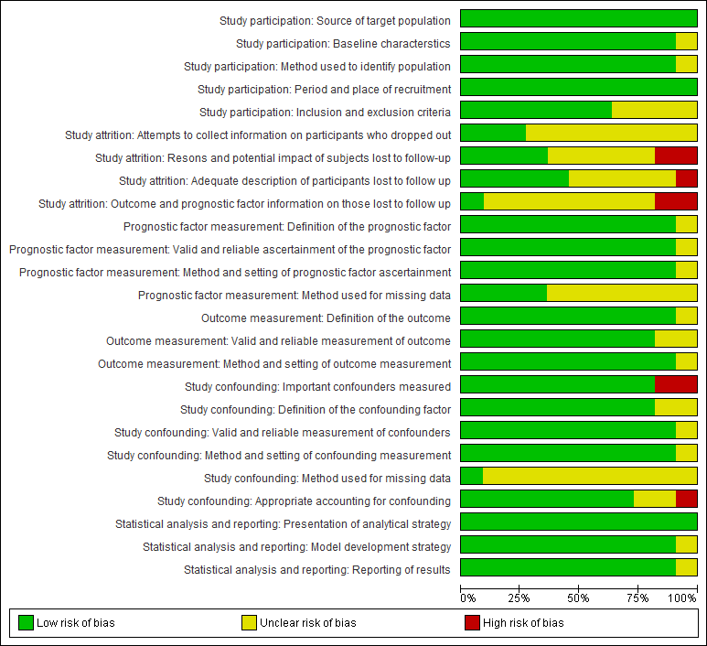
Figure S2. Details on risk of bias assessment using the Quality in Prognosis Studies tool
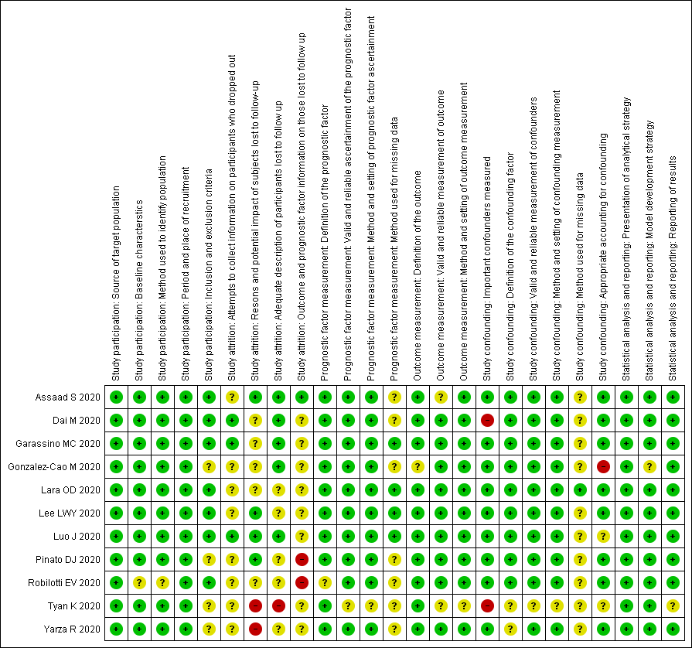

Table S3. Summary of quality of evidence as assessed with the modified GRADE frameworkª
Variable: Exposure to immune checkpoint inhibitor
Outcome | # Cohorts | N | Univariate |  |  | Multivariate |  |  | Phase^{b} | GRADE
Outcome | # Cohorts | N | + | 0 | - | + | 0 | - | Phase^{b} | Study  limit.^{c} | Inconsist.^{d} | Indirectness^{e} | Imprecision^{f} | Publication bias^{g} | Mod-lg ES^{h} | Overall quality
Mortality | 9[5–13] | 2329 | 0 | 9 | 0 | 0 | 5 | 0 | 1&2 | ✓ | ✓ | ✓ | ✗ | ✓ | ✗ | ⊕⊕⊕◯  MODERATE
Mortality | 8[5–12] | 1439 | OR 0.91 (0.60-1.38) |  |  | OR 0.70 (0.40-1.23) |  |  | 1&2 | ✓ | ✓ | ✓ | ✓ | ✓ | ✗ | ⊕⊕⊕⊕  HIGH^{i}
Severity | 7[2, 6, 8, 9, 11, 13, 14] | 1717 | 1 | 5 | 0 | 1 | 3 | 0 | 1&2 | ✗ | ✓ | ✓ | ✗ | ✓ | ✗ | ⊕⊕◯◯  LOW
Severity | 6[2, 6, 11, 13, 14] | 1652 | OR 1.47 (0.95-2.27) |  |  | OR 1.62 (0.48-5.43) |  |  | 1&2 | ✗ | ✗✗ | ✓ | ✗ | ✓ | ✓ | ⊕◯◯◯  VERY LOW^{i,j}
Hospitalization | 6[2, 7–9, 11, 12] | 898 | 1 | 5 | 0 | 1 | 1 | 0 | 1&2 | ✗ | ✗ | ✓ | ✓ | ✓ | ✗ | ⊕⊕◯◯  LOW
Hospitalization | 5[2, 7, 8, 12] | 831 | OR 1.04 (0.49-2.22) |  |  |  |  |  | 1&2 | ✗ | ✗✗ | ✓ | ✓ | ✓ | ✗ | ⊕◯◯◯  VERY LOW^{i,k}
ICU admission | 2[8, 12] | 100 | 0 | 2 | 0 |  |  |  | 2 | ✗✗ | ✓ | ✓ | ✗ | ✗ | ✗ | ⊕◯◯◯  VERY LOW
ICU admission | 2[8, 12] | 100 | OR 3.80 (0.13-1.16) |  |  |  |  |  | 2 | ✗✗ | ✓ | ✓ | ✗ | ✗ | ✗ | ⊕◯◯◯  VERY LOW
Prolonged hospitalization (>8 days) | 1[7] | 58 | 0 | 1 | 0 |  |  |  | 1 | ✓ | Unclear | Unclear | ✗✗ | ✗ | ✗ | ⊕◯◯◯  VERY LOW
ªFor qualitative assessments: +, number of cohorts reporting significant positive effects (i.e. ICI as a risk factor); 0, number of cohorts reporting non-significant effects; -, number of cohorts reporting significant negative effects (i.e. ICI as a protective factor). For GRADE factors: ✓, no serious limitations; ✗, serious limitations (or not present for moderate/large effect size); ✗✗, very serious limitations (downgraded by two levels); Unclear, unable to rate item based on the available information. For overall quality: high, we are very confident that the true effect lies close to that of the estimated effect; moderate, we are moderately confident in the effect estimate and the true effect is likely to be close to the estimate of the effect, but there is a possibility that it is substantially different; low, confidence in the effect estimate is limited and the true effect may be substantially different from the estimate of the effect; very low, we have very little confidence in the effect estimate and the true effect is likely to be substantially different from the estimate of effect. As none of the factors possibly had exposure-response gradient, we decided to exclude the corresponding domain from the table.
^{b}GRADE assessment of outcomes with phase 1 and 2 studies starts with high quality of evidence, while assessment of outcomes with only phase 1 studies starts with moderate quality of evidence.[15]
^{c}Downgraded for study limitation by one level when $≥$50% studies yielded moderate-to-high risk of bias and by two levels when $≥$50% studies yielded high risk of bias
^{d}Downgraded for inconsistency by one level for observed heterogeneity (I²=50-75%) or minimally overlapping confidence intervals (P_{heterogeneity}<0.10) and two levels for substantial unexplained heterogeneity (I²>75%) or no overlapping confidence intervals (P_{heterogeneity}<0.001)
^{e}Downgraded for indirectness in population by one level when the included studies only involved at least two of these: anti-PD-1, anti-PD-L1, anti-CTLA-4; and by two levels when the included studies only involved one of the aforementioned ICI class
^{f}Downgraded for imprecision due to small number of samples/studies and/or wide confidence intervals. As a rule of thumb for qualitative assessment, results were downgraded for imprecision by one level when any of the included studies had less than 10 outcome events in ICI group and by two levels when $≥$50% of the included studies had less than 10 outcome events in ICI group.
^{g}For qualitative summary, results were downgraded for publication bias when the findings were not adjusted for confounders, or when the number of samples/studies were relatively small, yielded wide confidence intervals, or equivocal estimates.
^{h}Upgraded for moderate or large effect size by one level when OR>2.5 and by two levels when OR>4.25[15]
^{i}Not downgraded as publication bias could not be assessed due to insufficient number of studies (n<10)[16]
^{j}Downgraded for inconsistency by two levels as the exclusion of Pinato et al[13] in the leave-one-out sensitivity analysis shifted the overall trend of the model (OR 2.49 [95% CI: 1.28-4.85], I²=0%).
^{k}Downgraded for inconsistency by two levels as the exclusion of Garassino et al[7] in the leave-one-out sensitivity analysis shifted the overall trend of the model (OR 2.14 [95% CI: 1.07-4.29], I²=0%).
GRADE, the Grading of Recommendations Assessment, Development and Evaluation tool; ICI, immune checkpoint inhibitor; ICU, intensive care unit; Inconsist., inconsistency; Indirect., indirectness; Mod-lg ES, moderate or large effect size; N, number of participants; OR, odds ratio; Phase, phase of investigation; Study limit., study limitation.

Table S4. Study-specific estimates on the risks of poor COVID-19 outcomes between cancer patients with and without prior ICI exposure
Outcome | Author; Year | Variable | Adjusted variables | Effect size (95% CI)
 |  |  |  | Ratio | Univariate | Multivariate
Mortality | Assaad S; 2020[10] | ICI |  | OR | 0.75 (0.04-15.84)ª
Mortality | Dai M; 2020[6] | ICI | Age, Sex, Smoking, Clinical (Diabetes, Hypertension, COPD, Cancer type, Metastasis) | OR | 4.45 (0.72-27.44)ª | 3.03 (0.29-31.98)^{b}
Mortality | Garassino MC; 2020[7] | ICI |  | OR | 0.79 (0.40-1.57)ª
Mortality | Gonzalez-Cao M; 2020[8] | ICI |  | OR | 0.58 (0.13-2.64)ª
Mortality | Lara OD; 2020[11] | ICI |  | OR | 2.45 (0.44-13.72)ª
Mortality | Lee LYW; 2020[5, 17] | ICI | Age, Sex, Clinical (Comorbidities) | OR | 0.60 (0.27-1.24) | 0.59 (0.27-1.27)
Mortality | Luo J; 2020[9, 18] | ICI | Sex, Smoking | OR | 1.81 (0.57-6.43) | 1.13 (0.25-5.03)
Mortality | Pinato DJ; 2020[13] | ICI |  | HR | 0.80 (0.46-1.40)
 |  |  |  | OR | 0.85 (0.47-1.54)ª
Mortality | Tyan K; 2020[12] | ICI | Age, Sex, Clinical (COPD), Other cancer treatments (Chemotherapy/Targeted therapy) | OR | 0.69 (0.21-2.29)ª | 0.36 (0.07-1.87)
Mortality | Yarza R; 2020[14] | ICI | Age, Sex, Clinical (COPD, ECOG, Metastasis, Previous VTE) | OR |  | 0.78 (0.17-3.60)^{c}
Mortality | Dai M; 2020[6] | ICI monotherapy |  | OR | 8.90 (0.52-153.5)^{b}
Mortality | Garassino MC; 2020[7] | ICI monotherapy |  | OR | 0.89 (0.40-1.99)ª
Mortality | Gonzalez-Cao M; 2020[8] | ICI monotherapy |  | OR | 0.58 (0.13-2.64)ª
Mortality | Lara OD; 2020[11] | ICI monotherapy |  | OR | 0.42 (0.04-4.76)ª
Mortality | Yarza R; 2020[14] | ICI monotherapy | Age, Sex, Clinical (COPD, ECOG, Metastasis, Previous VTE) | OR |  | 0.15 (0.01-1.65)
Mortality | Dai M; 2020[6] | ICI + chemotherapy |  | OR | 0.64 (0.22-1.87)ª
Mortality | Garassino MC; 2020[7] | ICI + chemotherapy |  | OR | 0.99 (0.28-3.18)ª
Mortality | Lara OD; 2020[11] | ICI + chemotherapy |  | OR | 17.9 (0.70-458.59)ª
Mortality | Yarza R; 2020[14] | ICI + chemotherapy | Age, Sex, Clinical (COPD, ECOG, Metastasis, Previous VTE) | OR |  | 1.96 (0.29-13.18)
Severity | Dai M; 2020[6] | ICI | Age, Sex, Smoking, Clinical (Diabetes, Hypertension, COPD, Cancer type, Metastasis) | OR | 3.50 (0.61-20.06)ª | 2.02 (0.26-15.62)^{b}
Severity | Gonzalez-Cao M; 2020[8] | ICI |  | OR | 0.86 (0.25-2.89)ª
Severity | Lara OD; 2020[11] | ICI |  | OR | 0.82 (0.09-7.32)ª
Severity | Luo J; 2020[9, 18] | ICI | Smoking | OR | 1.18 (0.42-3.40) | 0.83 (0.24-2.82)
Severity | Pinato DJ; 2020[13] | ICI |  | OR | 1.12 (0.59-2.14)
Severity | Robilotti EV; 2020[2] | ICI | Age, Smoking, Clinical (Asthma, COPD, Cancer type, Hypertension, CKD, Corticosteroid), Laboratory (Chronic lymphopenia) | OR | 2.67 (1.24-5.74)^{a,d} | 3.26 (1.37-7.57)^{d}
 |  |  |  | HR | 2.38 (1.29-4.38) | 2.74 (1.37-5.46)
Severity | Yarza R; 2020[14] | ICI | Age, Sex, Clinical (COPD, ECOG, Metastasis, Previous VTE) | OR | 0.97 (0.21-4.49) | 0.53 (0.13-2.15)^{c}
Severity | Dai M; 2020[6] | ICI monotherapy |  | OR | 8.70 (0.41-186.2)^{b}
Severity | Gonzalez-Cao M; 2020[8] | ICI monotherapy |  | OR | 0.86 (0.25-2.89)ª
Severity | Lara OD; 2020[11] | ICI monotherapy |  | OR | 2.50 (0.22-28.99)ª
Severity | Robilotti EV; 2020[2] | ICI monotherapy |  | OR | 1.26 (0.35-4.52)^{a,d}
Severity | Yarza R; 2020[14] | ICI monotherapy | Age, Sex, Clinical (COPD, ECOG, Metastasis, Previous VTE) | OR |  | 0.26 (0.03-1.88)
Severity | Dai M; 2020[6] | ICI + chemotherapy |  | OR | 3.50 (0.31-39.96)^{b}
Severity | Lara OD; 2020[11] | ICI + chemotherapy |  | OR | 14.69 (0.58-374.22)ª
Severity | Robilotti EV; 2020[2] | ICI + chemotherapy |  | OR | 10.29 (2.92-36.27)^{a,d}
Severity | Yarza R; 2020[14] | ICI + chemotherapy | Age, Sex, Clinical (COPD, ECOG, Metastasis, Previous VTE) | OR |  | 0.97 (0.14-6.45)
Hospitalization | Garassino MC; 2020[7] | ICI |  | OR | 1.16 (0.55-2.43)ª
Hospitalization | Gonzalez-Cao M; 2020[8] | ICI |  | OR | 0.58 (0.15-2.23)ª
Hospitalization | Lara OD; 2020[11] | ICI |  | OR | 1.12 (0.24-5.23)ª
Hospitalization | Luo J; 2020[9, 18] | ICI | Sex, Smoking | OR | 1.66 (0.61-4.55) | 1.20 (0.33-4.23)
Hospitalization | Robilotti EV; 2020[2] | ICI | Age, Race, Smoking, Clinical (Asthma, COPD, Cancer type, CVD, Hypertension, CKD, Corticosteroid), Laboratory (Chronic lymphopenia) | OR | 2.53 (1.18-5.67) | 2.84 (1.24-6.72)
Hospitalization | Tyan K; 2020[12] | ICI |  | OR | 0.13 (0.01-1.19)ª
Hospitalization | Garassino MC; 2020[7] | ICI monotherapy |  | OR | 1.07 (0.45-2.58)ª
Hospitalization | Gonzalez-Cao M; 2020[8] | ICI monotherapy |  | OR | 0.58 (0.15-2.23)ª
Hospitalization | Lara OD; 2020[11] | ICI monotherapy |  | OR | 1.68 (0.15-19.03)ª
Hospitalization | Robilotti EV; 2020[2] | ICI monotherapy |  | OR | 1.35 (0.48-3.81)^{a,d}
Hospitalization | Garassino MC; 2020[7] | ICI + chemotherapy |  | OR | 0.62 (0.16-2.63)
Hospitalization | Lara OD; 2020[11] | ICI + chemotherapy |  | OR | 2.52 (0.10-63.17)ª
Hospitalization | Robilotti EV; 2020[2] | ICI + chemotherapy |  | OR | 6.96 (1.48-32.7)^{a,d}
ICU admission | Gonzalez-Cao M; 2020[8] | ICI |  | OR | 0.40 (0.04-4.10)ª
ICU admission | Tyan K; 2020[12] | ICI |  | OR | 0.38 (0.11-1.33)ª
Prolonged hospitalization (>8 days) | Garassino MC; 2020[7] | ICI |  | OR | 1.36 (0.43-4.27)ª
Prolonged hospitalization (>8 days) | Garassino MC; 2020[7] | ICI + chemotherapy |  | OR | 0.40 (0.06-2.24)ª
ªValues were derived from binary data. ^{b}Values were derived from raw data supplemented by the authors. ^{c}Values were derived from the combination of multiple arms (i.e., ICI monotherapy and ICI plus chemotherapy) into a single pair-wise comparison. ^{d}Unpublished data, provided by request. CKD, chronic kidney disease; COPD, chronic obstructive pulmonary disorder; COVID-19, coronavirus disease 2019; CVD, cardiovascular disease; HR, hazard ratio; ICI, immune checkpoint inhibitor; ICU, intensive care unit; OR, odds ratio.

Table S5. Study-specific estimates on the risks of poor COVID-19 outcomes between cancer patients with prior ICI exposure vs other treatmentsª
Outcome | Author; Year | Adjusted variables | Effect size (95% CI)
Outcome | Author; Year | Adjusted variables | Ratio | Univariate | Multivariate
vs No treatment
Mortality | Assaad S; 2020[10] |  | OR | 0.56 (0.02-12.49)
Mortality | Dai M; 2020[6] |  | OR | 4.43 (0.68-28.70)
Mortality | Garassino MC; 2020[7] |  | OR | 1.23 (0.52-2.92)
Mortality | Gonzalez-Cao M; 2020[8] |  | OR | 0.32 (0.06-1.75)
Mortality | Lee LYW; 2020[5, 17] |  | OR | 0.58 (0.27-1.22)
Severity | Dai M; 2020[6] |  | OR | 3.52 (0.60-20.60)
Severity | Gonzalez-Cao M; 2020[8] |  | OR | 1.07 (0.24-4.79)
Severity | Robilotti EV; 2020[2] |  | OR | 2.79 (1.25-6.21)
Hospitalization | Garassino MC; 2020[7] |  | OR | 0.54 (0.20-1.51)
Hospitalization | Gonzalez-Cao M; 2020[8] |  | OR | 1.33 (0.29-6.12)
Hospitalization | Robilotti EV; 2020[2] |  | OR | 2.45 (1.10-5.47)
ICU admission | Gonzalez-Cao M; 2020[8] |  | OR | 0.24 (0.02-2.95)
Prolonged hospitalization (>8 days) | Garassino MC; 2020[7] |  | OR | 0.76 (0.21-2.77)
vs Chemotherapy
Mortality | Assaad S; 2020[10] |  | OR | Not estimable^{b}
Mortality | Dai M; 2020[6] |  | OR | 6.50 (0.46-91.93)
Mortality | Garassino MC; 2020[7] |  | OR | 0.48 (0.21-1.11)
Mortality | Gonzalez-Cao M; 2020[8] |  | OR | 1.11 (0.16-7.52)
Mortality | Lara OD; 2020[11] |  | OR | 1.93 (0.30-12.43)
Mortality | Lee LYW; 2020[5, 17] |  | OR | 0.81 (0.38-1.72)
Severity | Dai M; 2020[6] |  | OR | 3.60 (0.48-27.11)
Severity | Gonzalez-Cao M; 2020[8] |  | OR | 0.71 (0.17-3.03)
Severity | Lara OD; 2020[11] |  | OR | 0.81 (0.08-7.97)
Severity | Robilotti EV; 2020[2] |  | OR | 2.13 (0.93-4.91)
Severity | Yarza R; 2020[14] |  | OR | 2.49 (0.48-12.97)
Hospitalization | Garassino MC; 2020[7] |  | OR | 1.30 (0.53-3.21)
Hospitalization | Gonzalez-Cao M; 2020[8] |  | OR | 0.18 (0.02-1.66)
Hospitalization | Lara OD; 2020[11] |  | OR | 2.56 (0.49-13.33)
Hospitalization | Robilotti EV; 2020[2] |  | OR | 2.42 (1.05-5.56)
ICU admission | Gonzalez-Cao M; 2020[8] |  | OR | 0.71 (0.04-12.35)
Prolonged hospitalization (>8 days) | Garassino MC; 2020[7] |  | OR | 3.57 (0.53-23.95)
vs Targeted therapy
Mortality | Assaad S; 2020[10] |  | OR | 0.52 (0.02-16.83)
Mortality | Dai M; 2020[6] |  | OR | 3.89 (0.14-110.0)
Mortality | Garassino MC; 2020[7] |  | OR | 1.11 (0.40-3.05)
Mortality | Lara OD; 2020[11] |  | OR | 4.80 (0.35-65.76)
Mortality | Lee LYW; 2020[5, 17] |  | OR | 1.03 (0.42-2.53)
Severity | Dai M; 2020[6] |  | OR | 12.60 (0.45-356.39)
Severity | Lara OD; 2020[11] |  | OR | 0.92 (0.07-12.32)
Severity | Robilotti EV; 2020[2] |  | OR | 1.79 (0.73-4.40)
Severity | Yarza R; 2020[14] |  | OR | 3.60 (0.28-46.36)
Hospitalization | Garassino MC; 2020[7] |  | OR | 2.26 (0.84-6.12)
Hospitalization | Lara OD; 2020[11] |  | OR | 2.13 (0.33-13.81)
Hospitalization | Robilotti EV; 2020[2] |  | OR | 2.89 (1.21-6.93)
Prolonged hospitalization (>8 days) | Garassino MC; 2020[7] |  | OR | 3.57 (0.53-23.95)
vs Surgery
Mortality | Dai M; 2020[6] |  | OR | 1.50 (0.15-15.46)
Mortality | Lara OD; 2020[11] |  | OR | 1.80 (0.19-16.98)
Mortality | Lee LYW; 2020[5, 17] |  | OR | 0.92 (0.31-2.79)
Severity | Dai M; 2020[6] |  | OR | 1.20 (0.13-11.05)
Severity | Lara OD; 2020[11] |  | OR | 0.75 (0.05-10.23)
Hospitalization | Lara OD; 2020[11] |  | OR | 3.00 (0.40-22.71)
vs Radiotherapy
Mortality | Dai M; 2020[6] |  | OR | 6.00 (0.42-85.25)
Mortality | Lara OD; 2020[11] |  | OR | 8.63 (0.35-214.62)
Mortality | Lee LYW; 2020[5, 17] |  | OR | 0.95 (0.39-2.29)
Severity | Dai M; 2020[6] |  | OR | 6.67 (0.79-56.22)
Severity | Lara OD; 2020[11] |  | OR | 4.38 (0.15-125.29)
Hospitalization | Lara OD; 2020[11] |  | OR | 3.13 (0.28-25.57)
vs Hormone therapy
Mortality | Lara OD; 2020[11] |  | OR | 8.63 (0.35-214.62)
Mortality | Lee LYW; 2020[5, 17] |  | OR | 0.60 (0.25-1.45)
Severity | Lara OD; 2020[11] |  | OR | 4.38 (0.15-125.29)
Severity | Yarza R; 2020[14] |  | OR | 0.90 (0.13-6.08)
Hospitalization | Lara OD; 2020[11] |  | OR | 3.13 (0.28-25.57)
ªAll effect sizes were calculated from binary data. ^{b}Excluded from analysis as both arms had no event. CI, confidence interval; ICI, immune checkpoint inhibitor; ICU, intensive care unit; OR, odds ratio.
Figure S3. Results of sensitivity analysis on the (A) unadjusted and (B) adjusted effects between prior ICI exposure and mortality and the unadjusted effects between prior ICI exposure with (C) severity and (D) hospitalization.
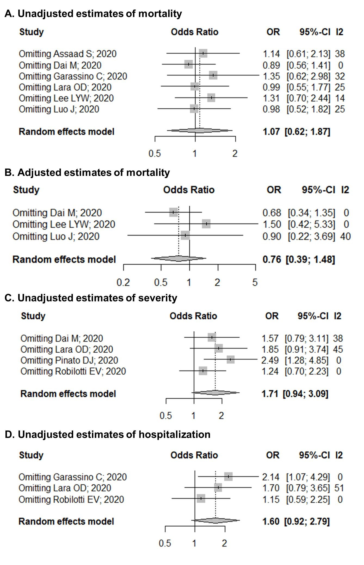
Supplementary References

1. Hayden JA, Côté P, Bombardier C (2006) Evaluation of the quality of prognosis studies in systematic reviews. Ann Intern Med 144:427–437. https://doi.org/10.7326/0003-4819-144-6-200603210-00010
2. Robilotti E V, Babady NE, Mead PA, et al (2020) Determinants of COVID-19 disease severity in patients with cancer. Nat Med 26:1218–1223. https://doi.org/10.1038/s41591-020-0979-0
3. Kuderer NM, Choueiri TK, Shah DP, et al (2020) Clinical impact of COVID-19 on patients with cancer (CCC19): a cohort study. Lancet (London, England) 395:1907–1918. https://doi.org/10.1016/S0140-6736(20)31187-9
4. Mehta V, Goel S, Kabarriti R, et al (2020) Case Fatality Rate of Cancer Patients with COVID-19 in a New York Hospital System. Cancer Discov 10:935 LP-- 941. https://doi.org/10.1158/2159-8290.CD-20-0516
5. Lee LYW, Cazier J-B, Angelis V, et al (2020) COVID-19 mortality in patients with cancer on chemotherapy or other anticancer treatments: a prospective cohort study. Lancet 395:1919–1926. https://doi.org/10.1016/S0140-6736(20)31173-9
6. Dai M, Liu D, Liu M, et al (2020) Patients with cancer sppear more vulnerable to SARS-CoV-2: A multicenter study during the COVID-19 outbreak. Cancer Discov 10:783 LP-- 791. https://doi.org/10.1158/2159-8290.CD-20-0422
7. Garassino MC, Whisenant JG, Huang L-C, et al (2020) COVID-19 in patients with thoracic malignancies (TERAVOLT): first results of an international, registry-based, cohort study. Lancet Oncol 21:914–922. https://doi.org/10.1016/S1470-2045(20)30314-4
8. Gonzalez-Cao M, Antonazas-Basa M, Puertolas T, et al (2020) Cancer immunotherapy does not increase the risk of death by COVID-19 in melanoma patients. medRxiv 2020.05.19.20106971. https://doi.org/10.1101/2020.05.19.20106971
9. Luo J, Rizvi H, Egger J V, et al (2020) Impact of PD-1 blockade on severity of COVID-19 in patients with lung cancers. Cancer Discov 10:1121 LP-- 1128. https://doi.org/10.1158/2159-8290.CD-20-0596
10. Assaad S, Avrillon V, Fournier ML, et al (2020) High mortality rate in cancer patients with symptoms of COVID-19 with or without detectable SARS-COV-2 on RT-PCR. Eur J Cancer 135:251–259. https://doi.org/10.1016/j.ejca.2020.05.028
11. Lara OD, O’Cearbhaill RE, Smith MJ, et al (2020) COVID‐19 outcomes of patients with gynecologic cancer in New York City. Cancer 126:4294–4303. https://doi.org/10.1002/cncr.33084
12. Tyan K, Bui A-T, Giobbie-Hurder A, et al (2020) 481 Impact of COVID-19 on Cancer Patients Receiving Immune Checkpoint Inhibitors. J Immunother Cancer 8:A515–A516. https://doi.org/10.1136/jitc-2020-sitc2020.0481
13. Pinato DJ, Zambelli A, Aguilar-Company J, et al (2020) Clinical portrait of the SARS-CoV-2 epidemic in European patients with cancer. Cancer Discov 10:1465–1474. https://doi.org/10.1158/2159-8290.cd-20-0773
14. Yarza R, Bover M, Paredes D, et al (2020) SARS-CoV-2 infection in cancer patients undergoing active treatment: analysis of clinical features and predictive factors for severe respiratory failure and death. Eur J Cancer 135:242–250. https://doi.org/10.1016/j.ejca.2020.06.001
15. Huguet A, Hayden JA, Stinson J, et al (2013) Judging the quality of evidence in reviews of prognostic factor research: adapting the GRADE framework. Syst Rev 2:71. https://doi.org/10.1186/2046-4053-2-71
16. Higgins JPT, Thomas J, Chandler J, et al (2019) Cochrane handbook for systematic reviews of interventions version 6.0 (updated July 2019), 6th ed. Cochrane
17. (2020) Erratum: Department of Error. Lancet 396:534. https://doi.org/10.1016/S0140-6736(20)31758-X
18. (2021) Correction: Impact of PD-1 blockade on severity of COVID-19 in patients with lung cancers. Cancer Discov 11:520–520. https://doi.org/10.1158/2159-8290.cd-20-1818

