Supplementary List. Full citation list of eligible studies. Gupta 2011 and Cummings III 2019 recruited two types of patients and reported the recurrence data separately; hence, they were regarded as two studies in the quantitative synthesis.
1. Binczak M, Tournay E, Billard V, Rey A, Jayr C. Major abdominal surgery for cancer: Does epidural analgesia have a long-term effect on recurrence-free and overall survival? Ann Fr Anesth Reanim 2013; 32: e81–e88. doi: 10.1016/j.annfar.2013.02.027.
2. Christopherson R, James KE, Tableman M, Marshall P, Johnson FE. Long-term survival after colon cancer surgery: A variation associated with choice of anesthesia. Anesth Analg 2008; 107: 325–332. doi: 10.1213/ane.0b013e3181770f55.
3. Myles PS, Peyton P, Silbert B, Hunt J, Rigg JRA, Sessler DI, et al. Perioperative epidural analgesia for major abdominal surgery for cancer and recurrence-free survival: Randomised trial. BMJ 2011; 342: d1491. doi: 10.1136/bmj.d1491.
4. Cao L, Chang Y, Lin W, Zhou J, Tan H, Yuan Y, et al. Long-term survival after resection of hepatocelluar carcinoma: A potential risk associated with the choice of postoperative analgesia. Anesth Analg 2014;118: 1309–1316. doi: 10.1213/ANE.0000000000000207.
5. Capmas P, Billard V, Gouy S, Lhommé C, Pautier P, Morice P, et al. Impact of epidural analgesia on survival in patients undergoing complete cytoreductive surgery for ovarian cancer. Anticancer Res 2012; 32: 1537–1542.
6. Chang WK, Lee MY, Tai YH, Kuo YM, Tsou MY, Chang KY. Does epidural analgesia improve the cancer outcome in hepatocellular carcinoma after resection surgery? A retrospective analysis. J Chin Med Assoc 2019; 82: 295–299. doi: 10.1097/JCMA.0000000000000054.
7. Chipollini J, Alford B, Boulware DC, Forget P, Gilbert SM, Lockhart JL, et al. Epidural anesthesia and cancer outcomes in bladder cancer patients: Is it the technique or the medication? A matched-cohort analysis from a tertiary referral center. BMC Anesth 2018; 18: 157. doi: 10.1186/s12871-018-0622-5.
8. Choi WJ, Baek S, Joo EY, Yoon SH, Kim E, Hong B, et al. Comparison of the effect of spinal anesthesia and general anesthesia on 5-year tumor recurrence rates after transurethral resection of bladder tumors. Oncotarget 2017; 8: 87667–87674. doi: 10.18632/oncotarget.21034.
9. Cummings KC, Kou TD, Chak A, Schluchter MD, Margevicius S, Cooper GS, et al. Surgical approach and the impact of epidural analgesia on survival after esophagectomy for cancer: A population-based retrospective cohort study. PLoS One 2019; 14: e0211125. doi: 10.1371/journal.pone.0211125.
10. Cummings KC, Xu F, Cummings LC, Cooper GS. A comparison of epidural analgesia and traditional pain management effects on survival and cancer recurrence after colectomy: A Population-based Study. Anesthesiology 2012;116: 797–806. doi: 10.1097/ALN.0b013e31824674f6.
11. de Oliveira Jr GS, Ahmad S, Schink JC, Singh DK, Fitzgerald PC, McCarthy RJ. Intraoperative neuraxial anesthesia but not postoperative neuraxial analgesia is associated with increased relapse-free survival in ovarian cancer patients after primary cytoreductive surgery. Reg Anesth Pain Med 2011; 36: 271–277. doi: 10.1097/AAP.0b013e318217aada.
12. Elias KM, Kang S, Shempp I, Horowitz NS, Frendl G. Epidural analgesia improves disease recurrence free survival following optimal primary cytoreductive surgery for advanced stage ovarian cancer. Int J Gynecol Cancer 2013; 23: 878.
13. Eveno C, Gayat E, Caballero MJ, Schiavone R, Andre T, Pocard M. Positive effect on survival of epidural analgesia in patients undergoing cytoreductive surgery for peritoneal metastasis. J Clin Oncol 2017; 35.
14. Exadaktylos AK, Buggy DJ, Moriarty DC, Mascha E, Sessler DI. Can anesthetic technique for primary breast cancer surgery affect recurrence or metastasis? Anesthesiology 2006;105: 660–664. doi: 10.1097/00000542-200610000-00008.
15. Gao H, Meng XY, Wang HQ, Zhu FF, Guo AL, Zhu M, et al. Association between anaesthetic technique and oncological outcomes after colorectal carcinoma liver metastasis resection. Int J Med Sci 2019; 16: 337–342. doi: 10.7150/ijms.28016.
16. Garland M, Addis D, Russell G, Clark C, Levine E, Howerton R, et al. The effect of regional anesthesia on oncologic outcomes after resection of colorectal hepatic metastases. Am Surg 2018;84: E29–E32.
17. Gayat E, Caballero MJ, Schiavone R, Mebazaa A, Pocard M, Eveno C. Association between epidural analgesia and outcome in patients operated with curative intent of peritoneal carcinomatosis: A cohort study of 606 patients. Pleura Peritoneum 2018; 3: sA13.
18. Gottschalk A, Ford JG, Regelin CC, You J, Mascha EJ, Sessler DI, et al. Association between epidural analgesia and cancer recurrence after colorectal cancer surgery. Anesthesiology 2010;113: 27–34. doi: 10.1097/ALN.0b013e3181de6d0d.
19. Gupta A, Björnsson A, Fredriksson M, Hallböök O, Eintrei C. Reduction in mortality after epidural anaesthesia and analgesia in patients undergoing rectal but not colonic cancer surgery: A retrospective analysis of data from 655 patients in central Sweden. Br J Anaesth 2011; 107: 164–170. doi: 10.1093/bja/aer100.
20. Heinrich S, Janitz K, Merkel S, Klein P, Schmidt J. Short-and long term effects of epidural analgesia on morbidity and mortality of esophageal cancer surgery. Langenbeck’s Arch Surg 2015; 400: 19–26. doi: 10.1007/s00423-014-1248-9.
21. Hiller JG, Hacking MB, Link EK, Wessels KL, Riedel BJ. Perioperative epidural analgesia reduces cancer recurrence after gastro-oesophageal surgery. Acta Anaesthesiol Scand 2014; 58: 281–290. doi: 10.1111/aas.12255.
22. Ismail H, Ho KM, Narayan K, Kondalsamy-Chennakesavan S. Effect of neuraxial anaesthesia on tumour progression in cervical cancer patients treated with brachytherapy: A retrospective cohort study. Br J Anaesth 2010;105: 145–149. doi: 10.1093/bja/aeq156.
23. Koumpan Y, Jaeger M, Mizubuti GB, Tanzola R, Jain K, Hosier G, et al. Spinal anesthesia is associated with lower recurrence rates after resection of nonmuscle invasive bladder cancer. J Urol 2018;199: 940–946. doi: 10.1016/j.juro.2017.11.064.
24. Lacassie HJ, Cartagena J, Brañes J, Assel M, Echevarría GC. The relationship between neuraxial anesthesia and advanced ovarian cancer-related outcomes in the Chilean population. Anesth Analg 2013;117: 653–660. doi: 10.1213/ANE.0b013e3182a07046.
25. Lin L, Liu C, Tan H, Ouyang H, Zhang Y, Zeng W. Anaesthetic technique may affect prognosis for ovarian serous adenocarcinoma: A retrospective analysis. Br J Anaesth 2011;106: 814–822. doi: 10.1093/bja/aer055.
26. Lorimier G, Seegers V, Coudert M, Dupoiron D, Thibaudeau E, Pouplin L, et al. Prolonged perioperative thoracic epidural analgesia may improve survival after cytoreductive surgery with hyperthermic intraperitoneal chemotherapy for colorectal peritoneal metastases: A comparative study. Eur Surg Oncol 2018;44: 1824–1831. doi: 10.1016/j.ejso.2018.08.012.
27. Macleod LC, Turner 2nd RM, Lopa S, Hugar LA, Davies BJ, Ben-David B, et al. Effect of multimodal analgesia with paravertebral blocks on biochemical recurrence in men undergoing open radical prostatectomy. Urol Oncol 2018;36: 364.e9–364.e4. doi: 10.1016/j.urolonc.2018.05.016.
28. Merquiol F, Montelimard AS, Nourissat A, Molliex S, Zufferey PJ. Cervical epidural anesthesia is associated with increased cancer-free survival in laryngeal and hypopharyngeal cancer surgery: A retrospective propensity-matched analysis. Reg Anesth Pain Med 2013;38: 398–402. doi: 10.1097/AAP.0b013e31829cc3fb.
29. Sprung J, Scavonetto F, Yeoh TY, Kramer JM, Karnes RJ, Eisenach JH, et al. Outcomes after radical prostatectomy for cancer: A comparison between general anesthesia and epidural anesthesia with fentanyl analgesia: A Matched Cohort Study. Anesth Analg 2014;119: 859–866. doi: 10.1213/ANE.0000000000000320.
30. Tai YH, Chang WK, Wu HL, Chan MY, Chen HH, Chang KY. The effect of epidural analgesia on cancer progression in patients with stage IV colorectal cancer after primary tumor resection: A retrospective cohort study. PLoS One 2018;13: e0200893. doi: 10.1371/journal.pone.0200893.
31. Tseng JH, Cowan RA, Afonso AM, Zhou Q, Iasonos A, Ali N, et al. Perioperative epidural use and survival outcomes in patients undergoing primary debulking surgery for advanced ovarian cancer. Gynecol Oncol 2018;151: 287–293. doi: 10.1016/j.ygyno.2018.08.024.
32. Tseng KS, Kulkarni S, Humphreys EB, Carter HB, Mostwin JL, Partin AW, et al. Spinal anesthesia does not impact prostate cancer recurrence in a cohort of men undergoing radical prostatectomy: An observational study. Reg Anesth Pain Med 2014;39: 284–288. doi: 10.1097/AAP.0000000000000108.
33. Vogelaar FJ, Abegg R, van der Linden JC, Cornelisse HGJM, van Dorsten FRC, Lemmens VE, et al. Epidural analgesia associated with better survival in colon cancer. Int J Colorectal Dis 2015;30: 1103–1107. doi: 10.1007/s00384-015-2224-8.
34. Wang J, Guo W, Wu Q, Zhang R, Fang J. Impact of combination epidural and general anesthesia on the long-term survival of gastric cancer patients: A retrospective study. Med Sci Monit 2016;22: 2379–2385. doi: 10.12659/msm.899543.
35. Wang Y, Wang L, Chen H, Xu Y, Zheng X, Wang G. The effects of intra-and post-operative anaesthesia and analgesia choice on outcome after gastric cancer resection: A retrospective study. Oncotarget 2017;8: 62658–62665. doi: 10.18632/oncotarget.16724.
36. Wurster EF, Pianka F, Warschkow R, Antony P, Brenner T, Weigand MA, et al. Peridural analgesia does not impact survival in patients after colon cancer resection: A retrospective propensity score-adjusted analysis. Int J Colorectal Dis 2019;34: 1283–1293. doi: 10.1007/s00384-019-03315-0.
37. Zimmitti G, Soliz J, Aloia TA, Gottumukkala V, Cata JP, Tzeng CWD, et al. Positive impact of epidural analgesia on oncologic outcomes in patients undergoing resection of colorectal liver metastases. Ann Surg Oncol 2016;23: 1003–1011. doi: 10.1245/s10434-015-4933-1.
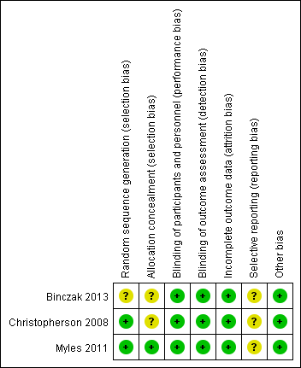
Supplementary Figure 1: Risk of bias assessment in three RCTs. RCTs: Randomized controlled trials.
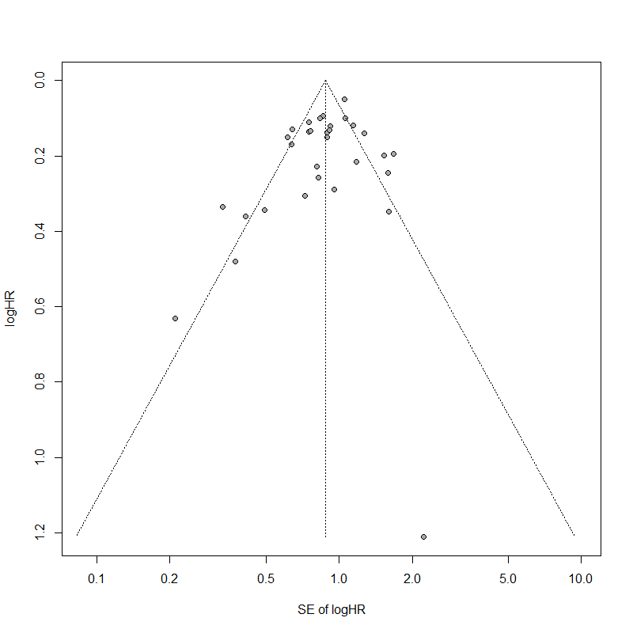
Supplementary Figure 2: Funnel plot for combined HR and standard error of HR for RFS. Potential asymmetry was found through visual inspection of the plot. HR: Hazard ratio; RFS: Recurrence-free survival.

Supplementary Table 1: Literature search in Medline (via Ovid).
No | Term
1 | randomised controlled trials as Topic/
2 | randomised controlled trial/
3 | random allocation/
4 | double blind method/
5 | single blind method/
6 | clinical trial/
7 | clinical trial, phase i.pt.
8 | clinical trial, phase ii.pt.
9 | clinical trial, phase iii.pt.
10 | clinical trial, phase iv.pt.
11 | controlled clinical trial.pt.
12 | randomised controlled trial.pt.
13 | multicenter study.pt.
14 | clinical trial.pt.
15 | exp clinical trials as topic/
16 | or/1-15
17 | (clinical adj trial$).tw.
18 | ((singl$ or doubl$ or treb$ or tripl$) adj (blind$3 or mask$3)).tw.
19 | placebos/
20 | placebo$.tw.
21 | randomly allocated.tw.
22 | (allocated adj2 random$).tw.
23 | or/17–22
24 | 16 or 23
25 | exp cohort studies/
26 | exp cohort analysis/
27 | exp risk factors/
28 | cohort.tw. or cohort.ti,ab. or cohort*.ti,ab. or prospective.ti,ab. or retrospective.ti,ab.
29 | compared.tw. or comparative study.pt.
30 | incidence.ti,ab. or incidence stud*.ti,ab.
31 | followed.ti,ab. or follow-up.ab,ti. or longitudinal.ti,ab.
32 | exp longitudinal studies/
33 | cohort studies.sh.
34 | (odds and ratio*).tw.
35 | (relative and risk).tw.
36 | or/25-35
37 | 24 or 36
38 | case report.tw.
39 | letter/
40 | historical article/
41 | editorial.pt. or news.pt. or newspaper article.pt.
42 | or/38-41
43 | 37 not 42
44 | exp animals/ not humans.sh.
45 | 43 not 44
46 | exp anaesthesia, general/
47 | exp anaesthesia, local/
48 | (“regional anesthe*” or “epidural anesthe*”).ti,ab.
49 | (“general anesthe*” or “anesthe* technique*”).ti,ab.
50 | or/46-49
51 | exp anaesthesia and analgesia/
52 | exp anaesthesia/
53 | Exp analgesia/
54 | Exp analgesia, epidural/
55 | Exp analgesia, patient-controlled/
56 | Exp adjuvants, anaesthesia/
57 | Or/51-56
58 | 50 or 57
59 | Exp neoplasm recurrence, local/
60 | Exp neoplasm invasiveness/
61 | Exp neoplasm metastasis/
62 | Exp cocarcinogenesis/
63 | (recur* or risk* or metasta*).ab,ti.
64 | Or/59-63
65 | (neoplasm* or tumor* or tumour* or cancer* or carcino* or maligna*).ab,ti.
66 | Exp melanoma/
67 | Melano*.ti,ab.
68 | Melano*.tw.
69 | Or/65-68
70 | 64 and 69
71 | 45 and 58 and 70

Supplementary Table 2: Definitions for the late stage of cancer.
Cancer | Definition for an advanced stage of cancer
Larynx/hypopharynx cancer | AJCC prognostic stage groups III or higher
Upper gastrointestinal, esophagus, and esophagogastric junction cancer | T3 or higher; AJCC prognostic stage groups clinical (cTNM) III or higher; regional or distant in the SEER staging system
Carcinomas of stomach | T3 or higher; AJCC prognostic stage groups clinical (cTNM) III or higher; regional or distant stage in SEER
Carcinomas of colon and rectum | AJCC prognostic stage groups III or higher
Hepatocellular cancer | Multiple tumors, diameter of at least one tumor >5 cm; AJCC prognostic stage groups III or higher
Lung cancer | AJCC prognostic stage groups III or higher
Cutaneous melanoma | N ≥ 1; AJCC clinical stage group III or higher
Carcinoma of the breast | AJCC anatomic stage groups III or higher; N category pN2 or pN3
Cervix uteri | FIGO stage IIB or higher; AJCC prognostic stage groups IIB or higher
Carcinoma and carcinosarcoma of corpus uteri | FIGO stage III or higher, AJCC prognostic stage groups III or higher
Carcinoma of ovary, fallopian tube, and primary peritoneal | FIGO stage or AJCC prognostic stage groups III or higher
Prostatic cancer | PSA ≥20; Gleason score ≥8; AJCC prognostic stage groups III or higher
Renal cell carcinoma | AJCC prognostic stage groups III or higher
Urinary bladder | Poorly differentiated urothelial carcinoma; AJCC prognostic stage groups III or higher
AJCC: American Joint Committee on Cancer; FIGO: International Federation of Gynaecology and Obstetrics; SEER: The Surveillance, Epidemiology, and End Results Program.

Supplementary Table 3: Characteristics of eligible studies.
Study identifier | Cancer site | Proportion of advanced stage of cancer (%) | Comparison | Median follow-up (months) | Confounding control | Risk of bias
RCTs
Binczak (2013)^{[1]} | Abdominal cancer | 35.6 | EA/LA/SA vs. GA | 207.6 | Randomization and multivariable regression | See Figure A1 in Appendix
Myles (2011)^{[3]} | Abdominal cancer | 29.8 | EA/LA/SA vs. GA | Not reported | Randomization and multivariable regression | See Figure A1 in Appendix
Christopherson (2008)^{[2]} | Colon cancer | 36.7 | EA/LA/SA vs. GA | Not reported | Randomization and multivariable regression | See Figure A1 in Appendix
Cohort studies
Urinary bladder
Chipollini (2018)^{[7]} | Bladder cancer | 43.5 | EA vs. no EA | 41.4 | Multivariable regression | 8
Choi (2017)^{[8]} | Bladder cancer | 33.7 | EA/LA/SA vs. GA | 35.0 | Propensity score | 6
Koumpan (2018)^{[23]} | Bladder cancer | 53.2 | EA/LA/SA vs. GA | Not reported | Multivariable regression | 6
Carcinoma of the breast
Exadaktylos (2006)^{[14]} | Breast cancer | 33.3 | EA/LA/SA vs. GA | 32.0 | Multivariable regression | 5
Cervix uteri
Ismail (2010)^{[22]} | Cervical cancer | 34.8 | EA/LA/SA vs. GA | Not reported | Multivariable regression | 4
Carcinomas of colon and rectum
Cummings (2012)^{[10]} | Colorectal cancer | 33.1 | EA vs. no EA | 60.0 | Multivariable regression and propensity score | 9
Gao (2019)^{[15]} | Colorectal hepatic metastasis | 89.8 | EA vs. no EA | Not reported | Not reported | 5
Garland (2018)^{[16]} | Colorectal hepatic metastasis | 100.0 | EA vs. no EA | Not reported | Crude | 2
Gottschalk (2010)^{[18]} | Colorectal cancer | 35.8 | EA vs. no EA | 21.6 | Multivariable regression | 5
Gupta (2011) (colon)^{[19]} | Colon cancer | 29.0 | EA vs. no EA | Not reported | Propensity score | 4
Gupta (2011) (rectal)^{[19]} | Rectal cancer | 25.0 | EA vs. no EA | Not reported | Propensity score | 4
Lorimier (2018)^{[26]} | Colorectal peritoneal metastasis | 80.0 | EA vs. no EA | 46.1 | Propensity score | 8
Tai (2018)^{[30]} | Colorectal cancer | 100.0 | EA vs. no EA | 17.9 | Multivariable regression | 6
Vogelaar (2015)^{[33]} | Colon cancer | 41.3 | EA vs. no EA | 53.0 | Not reported | 8
Zimmitti (2016)^{[37]} | Colorectal hepatic metastasis | 100.0 | EA vs. no EA | Not reported | Multivariable regression | 7
Wurster (2019)^{[36]} | Colon cancer | 56.4 | EA/LA/SA vs. GA | 50.4 | Propensity score | 9
Upper gastrointestinal, esophagus, and esophagogastric junction cancer
Cummings III (2019) (transthoracic)^{[9]} | Esophageal cancer | 53.4 | EA vs. no EA | 26.4 | Multivariable regression | 8
Cummings III (2019) (transhiatal)^{[9]} | Esophageal cancer | 53.4 | EA vs. no EA | 26.4 | Multivariable regression | 8
Heinrich (2015)^{[20]} | Esophageal cancer | 45.1 | EA vs. no EA | Not reported | Multivariable regression | 6
Hiller (2014)^{[21]} | Gastro-esophageal cancer | 33.6 | EA vs. no EA | 42.6 | Multivariable regression | 7
Carcinomas of stomach
Wang (2016)^{[34]} | Gastric cancer | 91.9 | EA vs. no EA | Not reported | Not reported | 5
Wang (2017)^{[35]} | Gastric cancer | 66.9 | EA vs. no EA | 40.6 | Not reported | 5
Hepatocellular cancer
Cao (2014)^{[4]} | Hepatocellular cancer | 52.6 | EA vs. no EA | 50.4 | Propensity score | 5
Chang (2019)^{[6]} | Hepatocellular cancer | 37.9 | EA vs. no EA | 64.5 | Propensity score | 8
Larynx/hypopharynx cancer
Merquiol (2013)^{[28]} | Larynx/hypopharynx cancer | 53.8 | EA/LA/SA vs. GA | 54.0 | Propensity score | 8
Carcinoma of ovary, fallopian tube, and primary peritoneal
Capmas (2012)^{[5]} | Ovarian cancer | 100.0 | EA vs. no EA | 72.0 | Multivariable regression and propensity score | 4
Lacassie (2013)^{[24]} | Ovarian cancer | 100.0 | EA vs. no EA | 58.8 | Propensity score | 7
Tseng (2018)^{[31]} | Ovarian cancer | 100.0 | EA vs. no EA | 70.8 | Multivariable regression | 8
de Oliveira (2011)^{[11]} | Ovarian cancer | 67.3 | EA/LA/SA vs. GA | 42.0 | Multivariable regression | 5
Elias (2013)^{[12]} | Ovarian cancer | 100.0 | EA/LA/SA vs. GA | Not reported | Multivariable regression | 2
Lin (2011)^{[25]} | Ovarian cancer | 58.0 | EA/LA/SA vs. GA | Not reported | Propensity score | 8
Prostatic cancer
Macleod (2018)^{[27]} | Prostatic cancer | 27.0 | EA/LA/SA vs. GA | 135.0 | Multivariable regression | 6
Sprung (2014)^{[29]} | Prostatic cancer | 31.1 | EA/LA/SA vs. GA | 15.7 | Matching | 7
Tseng (2014)^{[32]} | Prostatic cancer | 29.2 | EA/LA/SA vs. GA | 54.0 | Propensity score | 8
Multiple cancers
Eveno (2017)^{[13]} | Multiple cancers | 100.0 | EA vs. no EA | 18.0 | Propensity score | 5
Gayat (2018)^{[17]} | Multiple cancers | 100.0 | EA vs. no EA | Not reported | Crude | 0
EA/LA/SA vs. GA: Epidural anesthesia/local anesthesia/spinal anesthesia vs. general anesthesia; EA vs. no EA: Epidural analgesia vs. no epidural analgesia; RCTs: Randomized controlled trials.

