Supplementary Materials
Suppl Fig 1. Risk of bias graph (with color)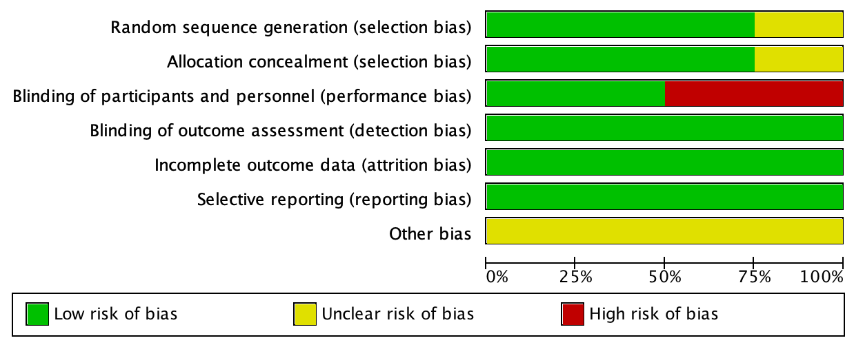
Suppl Fig 2. Risk of bias summary
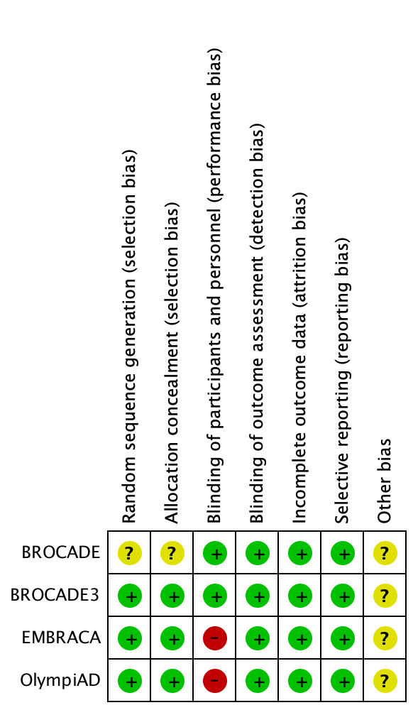

Suppl Fig 3. Funnel plot
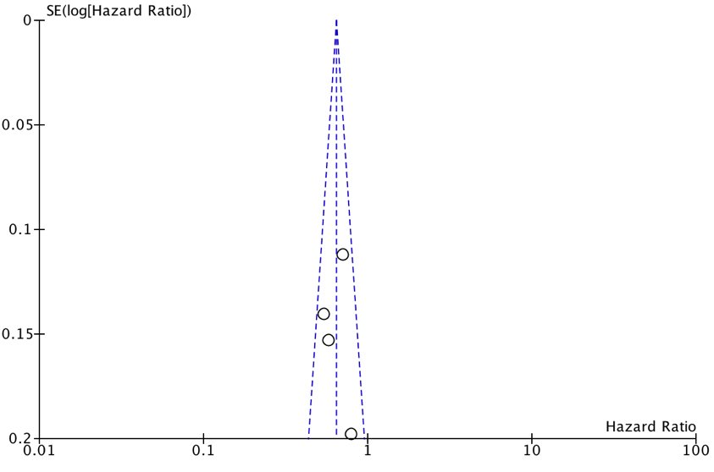
Suppl Fig 4. Forest plot of PFS
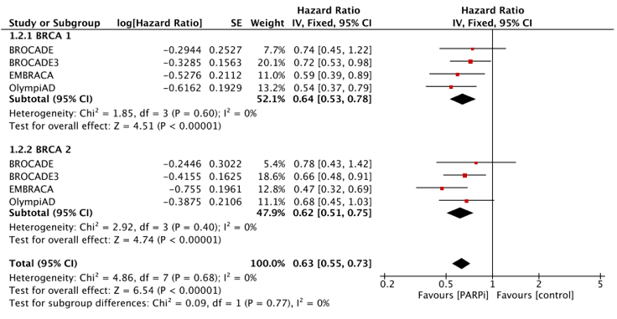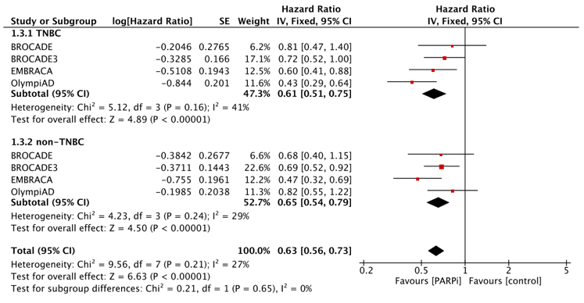
A. BRCA 1-mutated vs BRCA 2-mutated B. TNBC vs non-TNBC
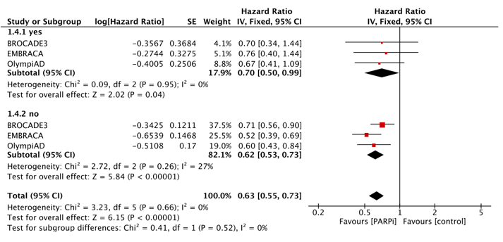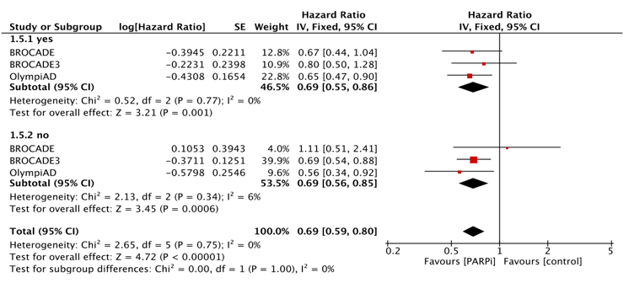
C. prior platinum cohort vs no prior platinum cohort D. prior cytotoxic chemotherapy cohort vs no prior cytotoxic chemotherapy cohort
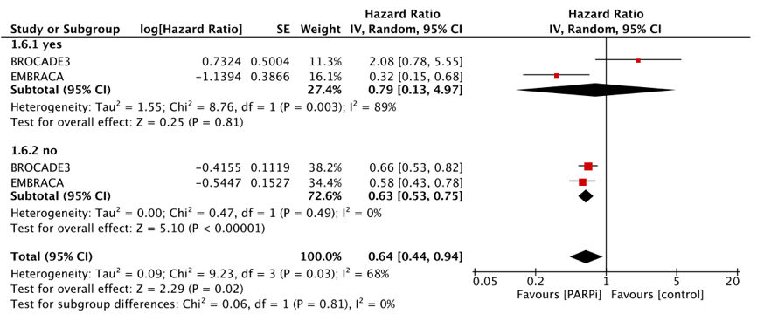
E. CNS metastases vs no CNS metastases

BRCA: breast related cancer antigen; TNBC: triple-negative breast cancer; CNS: central nervous system; PARPi: poly(adenosine diphosphate–ribose) polymerase inhibitor.
Suppl Tab 1. Sensitivity analysis of PFS
Excluded trial | HR | 95% CI
BROCADE3 | 0.60 | 0.50-0.72
OlympiAD | 0.66 | 0.56-0.77
EMBRACA | 0.68 | 0.58-0.80
BROCADE | 0.62 | 0.54-0.72
PFS: progression-free survival; HR: hazard ratio; CI: confidence interval.

Suppl Tab 2. Grade≥3 AEs
AEs | Intervention | No. of | Effect | RR [95% CI] | Heterogeneity |  | Subgroup | Total
 |  | studies | model |  | I² | χ² p | differences (p) | p | Total RR [95% CI]
Any grade≥3 AEs | placebo | 2 | random | 1.00 [0.93-1.07] | 65% | 0.04 | 0.45 | 0.48 | 0.95 [0.83-1.09]
 | TPC | 2 |  | 0.88 [0.65-1.20]
Neutropenia | placebo | 2 | random | 0.97 [0.90-1.05] | 87% | <0.0001 | 0.02 | 0.09 | 0.74 [0.52-1.05]
 | TPC | 2 |  | 0.50 [0.28-0.89]
Thrombocytopenia | placebo | 2 | random | 1.36 [1.07-1.72] | 76% | 0.02 | 0.008 | 0.09 | 1.74 [0.93-3.26]
 | TPC | 1 |  | 9.25 [2.27-37.63]
Anaemia | placebo | 2 | random | 1.05 [0.85-1.30] | 91% | <0.00001 | 0.02 | 0.14 | 2.06 [0.79-5.40]
 | TPC | 2 |  | 4.57 [1.31-15.98]
Leukopenia | placebo | 2 | fixed | 1.11 [0.85-1.46] | 0% | 0.74 | 0.38 | 0.70 | 1.05 [0.82-1.35]
 | TPC | 2 |  | 0.82 [0.44-1.53]
Fatigue | placebo | 2 | fixed | 1.24 [0.66-2.34] | 12% | 0.33 | 1.00 | 0.44 | 1.24 [0.72-2.12]
 | TPC | 2 |  | 1.24 [0.45-3.39]
Asthenia | placebo | 2 | fixed | 1.22 [0.45-3.34] | 0% | 0.90 | 0.71 | 0.58 | 1.31 [0.51-2.40]
 | TPC | 1 |  | 2.23 [0.11-46.05]
Decreased appetite | placebo | 2 | fixed | 2.67 [0.42-17.17] | 0% | 0.56 | 0.29 | 0.50 | 1.65 [0.39-6.97]
 | TPC | 2 |  | 0.44 [0.03-6.99]
Nausea | placebo | 2 | fixed | 1.29 [0.59-2.82] | 24% | 0.27 | 0.07 | 0.90 | 0.96 [0.481.90]
 | TPC | 2 |  | 0.19 [0.03-1.28]
Diarrhoea | placebo | 2 | random | 1.04 [0.39-2.79] | 61% | 0.05 | 0.26 | 0.42 | 0.62 [0.19-2.02]
 | TPC | 2 |  | 0.27 [0.03-2.33]
Vomiting | placebo | 2 | fixed | 1.97 [0.64-6.07] | 0% | 0.46 | 0.23 | 0.53 | 1.28 [0.58-2.82]
 | TPC | 2 |  | 0.74 [0.23-2.34]
Constipation | placebo | 2 | fixed | 0.51 [0.03-8.09] | 0% | 0.87 | 0.60 | 0.93 | 0.93 [0.17-5.12]
 | TPC | 2 |  | 1.33 [0.14-12.75]
Headache | placebo | 2 | fixed | 0.94 [0.26-3.43] | 0% | 0.74 | 0.82 | 0.72 | 0.85 [0.35-2.06]
 | TPC | 2 |  | 0.77 [0.23-2.26]
Dyspnoea | placebo | 2 | fixed | 0.42 [0.10-1.76] | 0% | 0.49 | 0.37 | 0.40 | 0.66 [0.25-1.73]
 | TPC | 1 |  | 1.03 [0.27-3.91]
Back pain | placebo | 2 | fixed | 1.39 [0.40-4.78] | 0% | 0.81 | 0.86 | 0.37 | 1.50 [0.62-3.62]
 | TPC | 2 |  | 1.62 [0.46-5.75]
AE: adverse event; TPC: treatment of physician's choice; RR: risk ratio; CI: confidence interval.

