Supplementary Material

Search strategy
("biotin"[MeSH Terms] OR "vitamin B7"[MeSH Terms] OR biotin"[All fields] OR "vitamin B7"[All fields] OR "vitamin b"[MeSH Terms] OR "vitamin b family"[MeSH Terms] OR "vitamin b"[MeSH Terms] OR "vitamin b complex"[MeSH Terms] OR "water soluble vitamin"[All fields] AND "supplementation"[Title/Abstract] OR "treatment"[Title/Abstract] OR "intervention” [Title/Abstract] OR "intake"[Title/Abstract]) AND ("diabetes mellitus"[MeSH Terms]) OR "diabetes"[MeSH Terms] OR "T2DM"[MeSH Terms] OR "type 2 diabetes mellitus"[All fields] OR "non-insulin dependent diabetes"[All fields] OR "urinary loss"[All fields] OR "urine loss"[All fields] OR "urination"[All fields] OR "HbA1c"[MeSH Terms] OR " glycated hemoglobin "[MeSH Terms] OR "insulin"[MeSH Terms] OR "serum insulin"[All fields] OR "fasting blood glucose"[All fields] OR "FBG"[All fields] OR "plasma glucose"[All fields] OR "FPG"[All fields] OR "cholesterol"[MeSH Terms] OR "TC"[MeSH Terms] OR "triglycerides"[MeSH Terms] OR "TG"[MeSH Terms] OR "low-density lipoprotein"[MeSH Terms] OR "HDL"[MeSH Terms] OR "high-density lipoprotein"[MeSH Terms] OR "LDL"[MeSH Terms] OR "glycemic outcomes"[All fields] OR "glycemic control"[All fields] OR "lipid profile"[All fields]) AND ("randomized" OR "trial" OR "controlled trials" OR "clinical trials" OR "cross-over" OR "parallel")

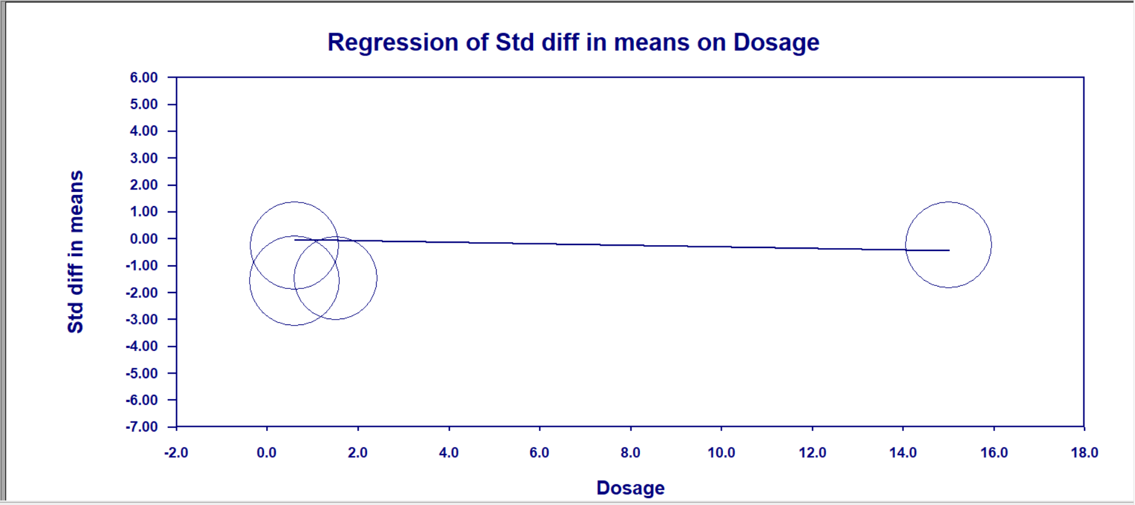
Figure 1. Meta-regression analysis for dosage of biotin supplementation and changes in TC

Figure 2. Subgroup analysis for the effects of biotin supplementation with or without Chromium on FBG

Figure 3. Subgroup analysis for the effects of biotin supplementation with or without Chromium on insulin

