Additional Supplement File.

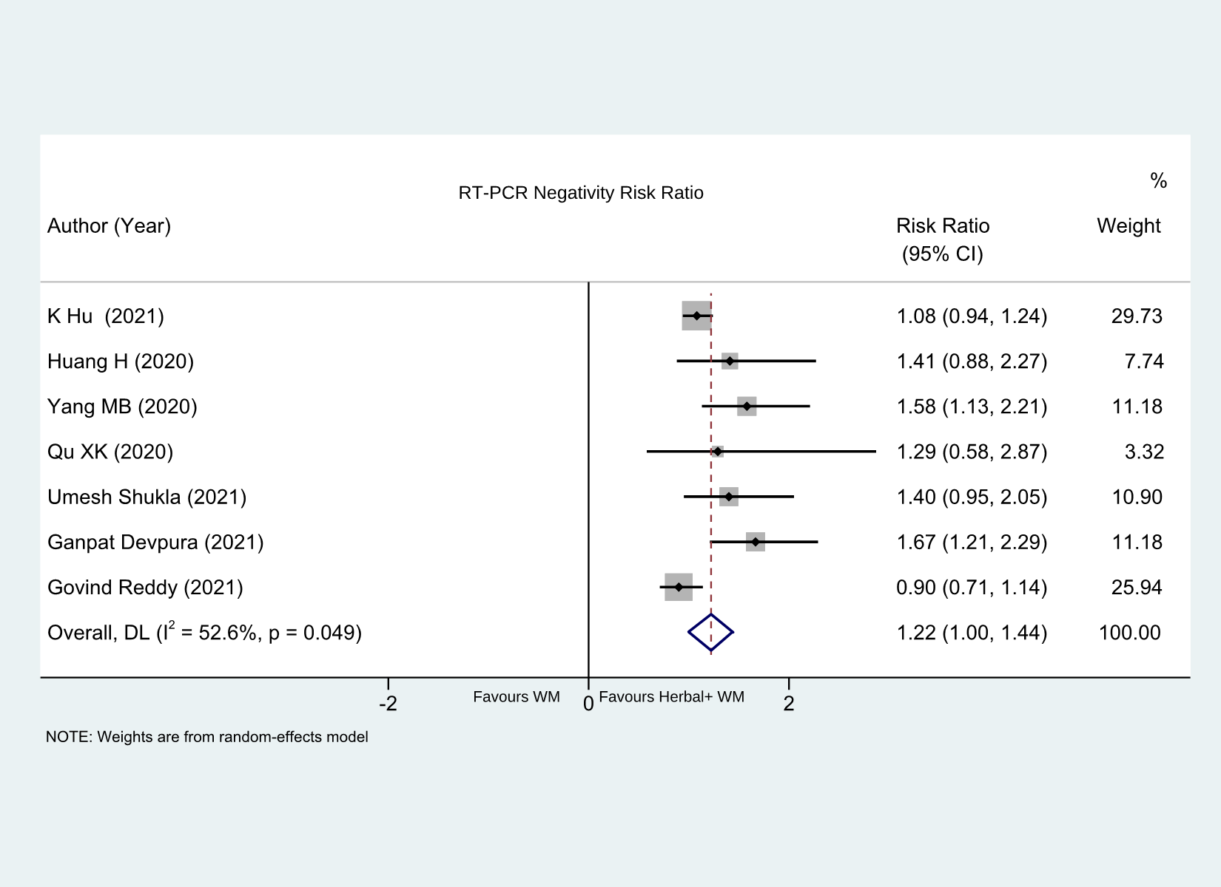
Supplementary Fig. 1. RT-PCR Negativity Forest Plot

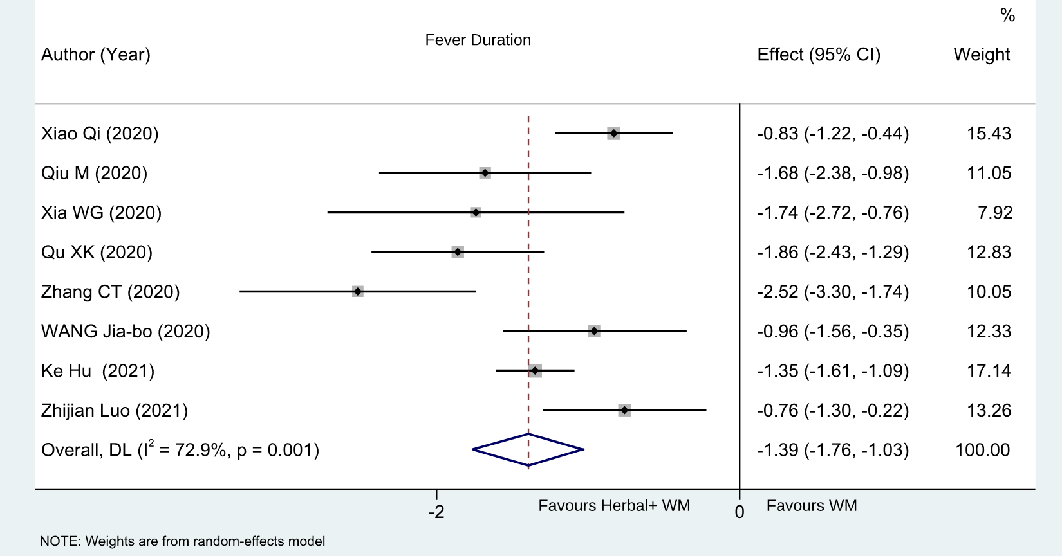
Supplementary Fig. 2 Fever Duration Forest Plot

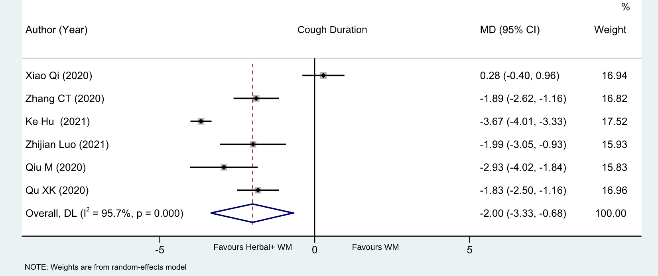
Supplement Fig 3. Cough Duration Forest Plot

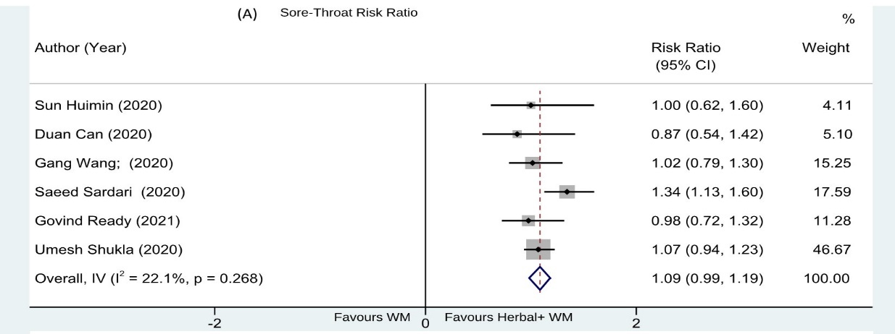
Supplementary Fig 4. Sore Throat Forest Plot.

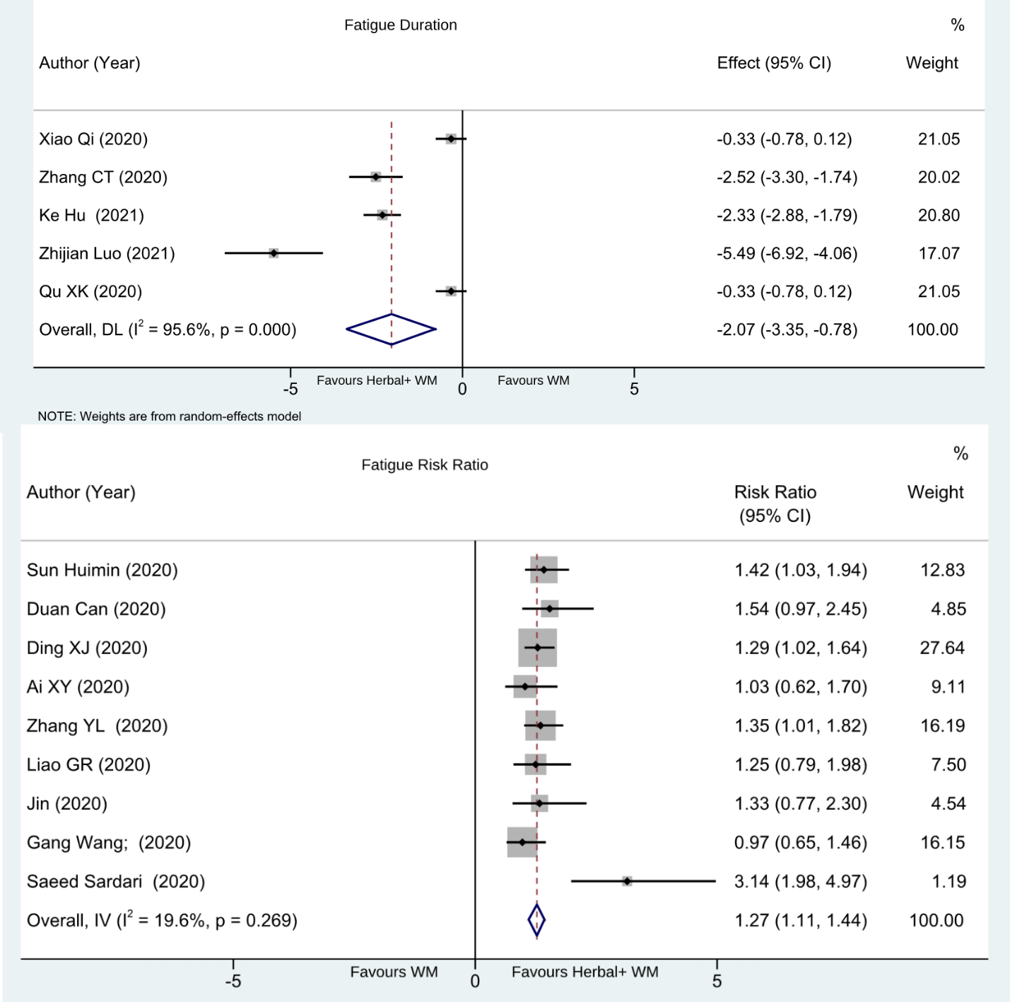
Supplementary Fig. 5. Fatigue Forest Plot.
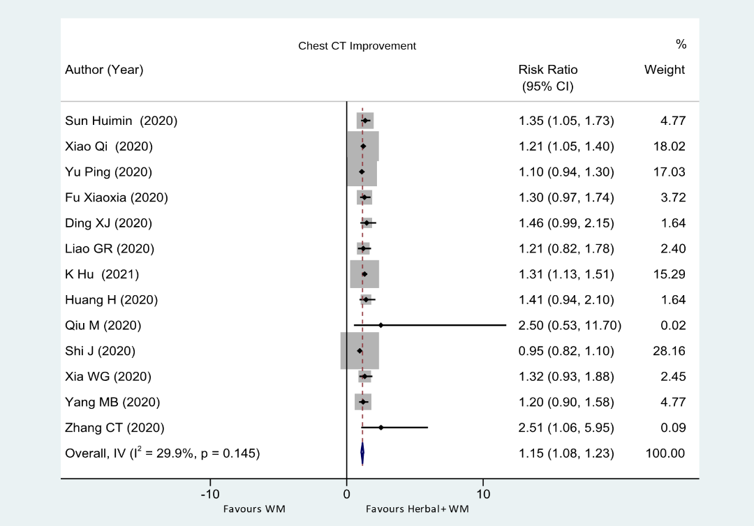
Supplementary Fig 6. Effect on Chest CT improvement Forest Plot.

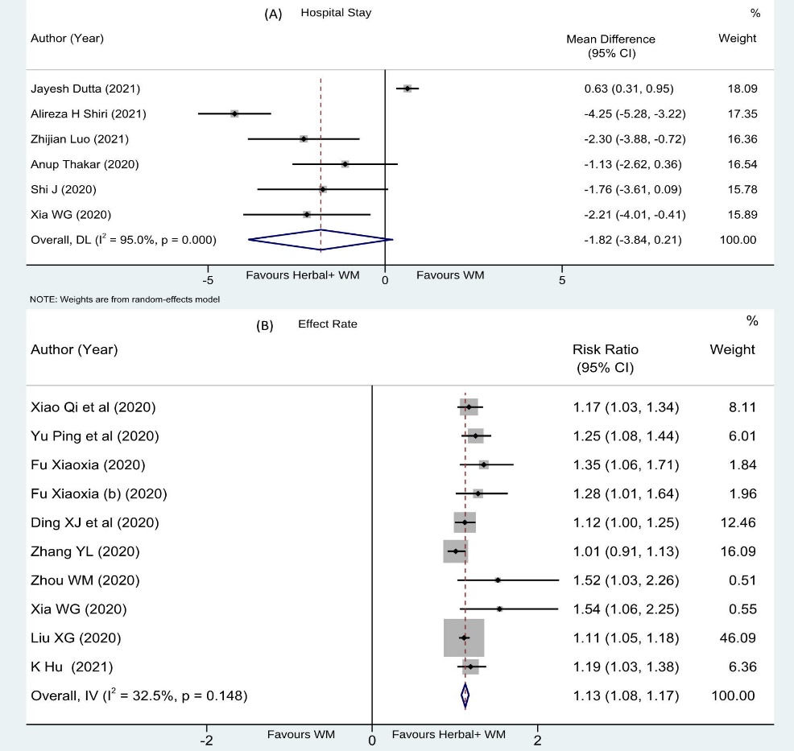
Fig 7. (A) Hospital stay & (B) Effect Rate Forest Plot.
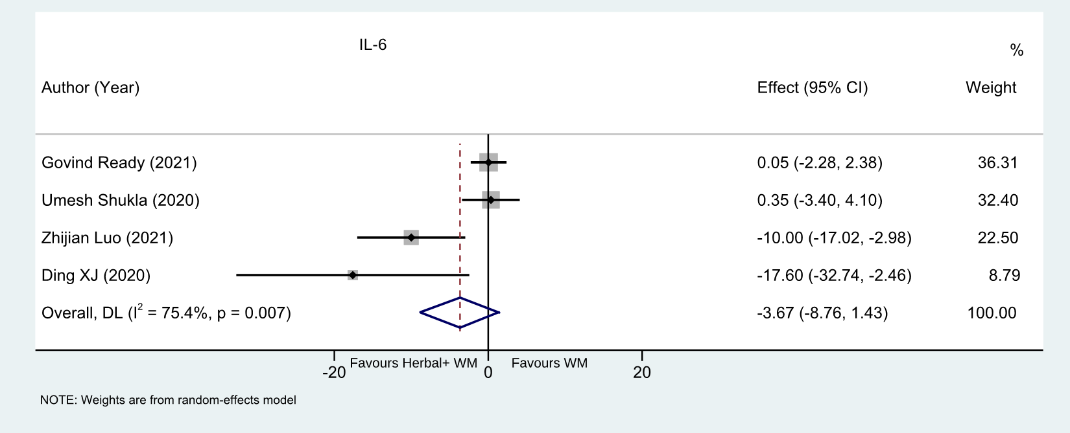
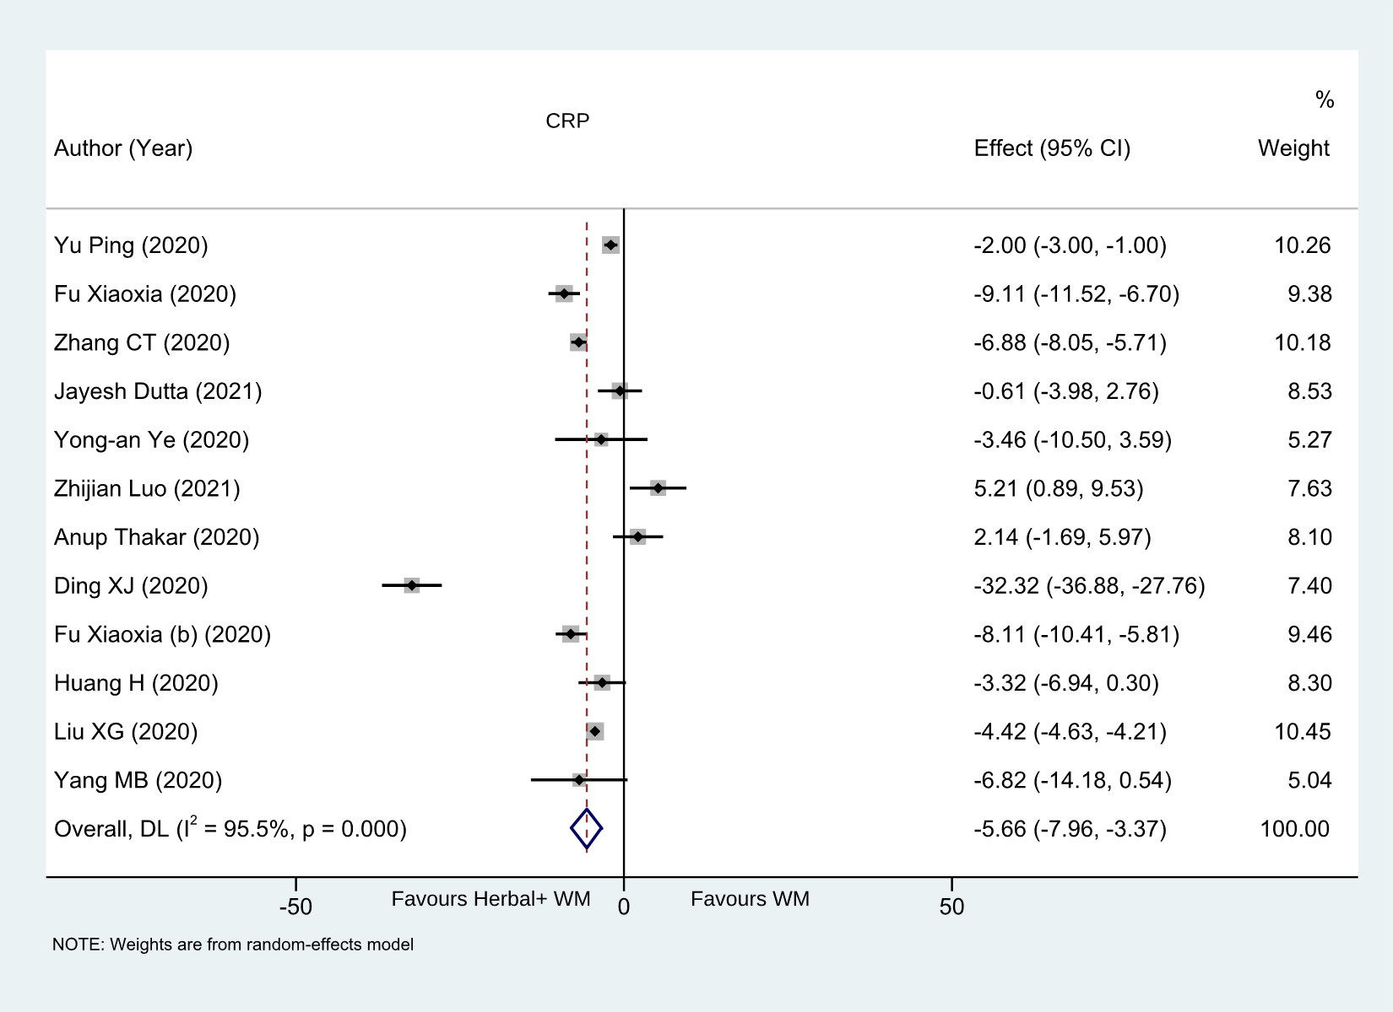
Supplementary Fig 8. Effect on CRP Forest Plot.

Supplementary Fig 9. Effect on IL-6 Level Forest Plot.

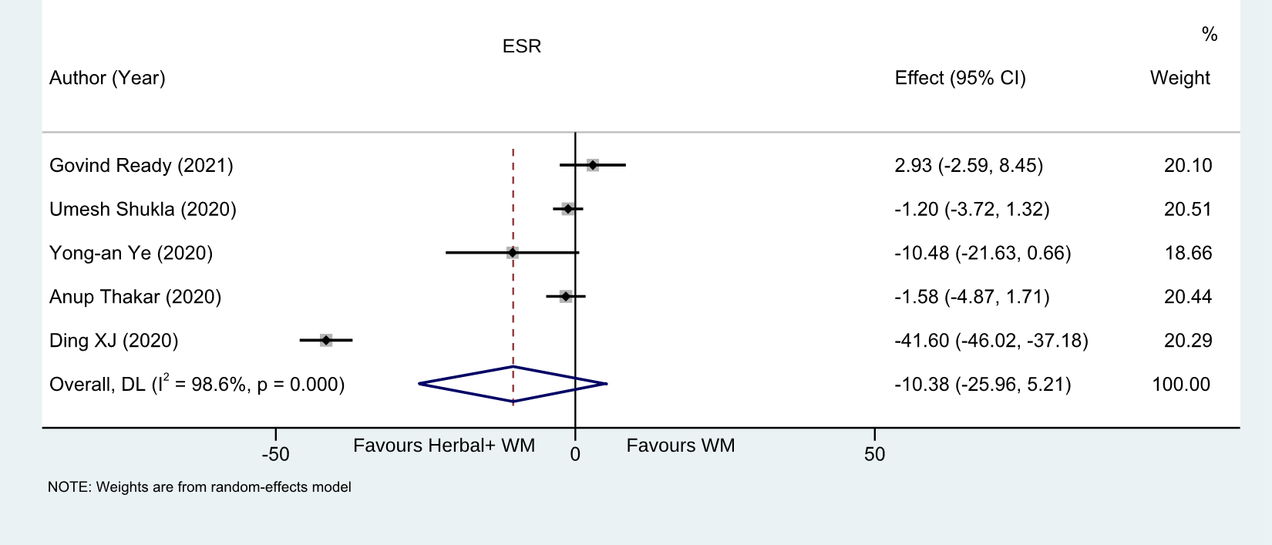
Supplementary Fig 10. Effect on ESR Level Forest Plot.

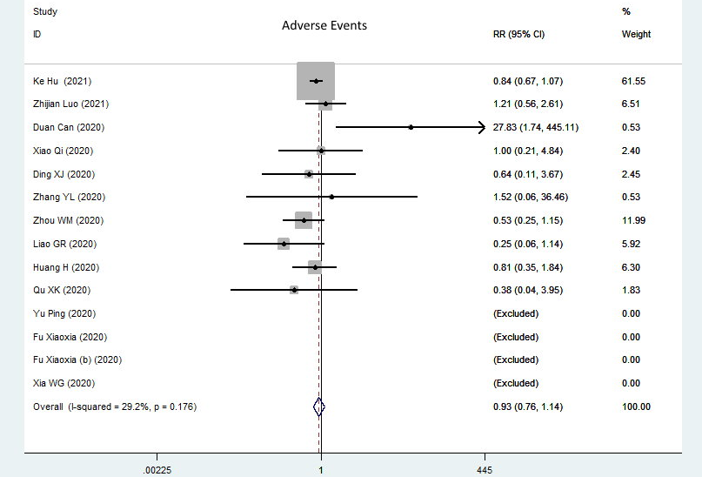
Supplementary Fig. 11: Risk Ratio Forest Plot – Adverse Events.

