Supplementary Material: Text 1. Study Protocol
Strain-specific and outcome-specific efficacy of probiotics for the treatment of Irritable Bowel Syndrome: A systematic review and meta-analysis

Lynne V. McFarland, PhD, M.S., Affiliate Associate Professor, Dept. Medicinal Chemistry, School of Pharmacy, University of Washington, Seattle, Washington 98195 USA, Email: mcfarland.lynne.v@gmail.com phone: 1-206-526-5729.
Tarkan Karakan, M.D. Proffesor, Deparment of Gastroenterology, Gazi University Faculty of Medicine, 06500, Beşevler, Ankara, Turkey
Ali Karatas, M.D Deparment of Gastroenterology, Gazi University Faculty of Medicine, 06500, Beşevler, Ankara Turkey

INTRODUCTION
Irritable bowel syndrome (IBS) is a chronic functional gastrointestinaI disorder characterized by recurrent abdominal pain, bloating and changes in bowel habits. IBS affects 15-20% of adults in developed countries with higher prevalence in developing countries. Symptoms are using to classify sub-types of IBS: diarrhea-predominant IBS (IBS-D), constipation-predominant IBS (IBS-C) or mixed/alternating symptoms (IBS-M). Major risk factors for IBS include female gender, family history of IBS, environmental triggers such as changes in diet or lifestyle or stress.^{1,2} The pathophysiology of IBS involves chronic mucosal inflammation, alterations in intestinal epithelial and immune functions, visceral hypersensitivity, increased intestinal permeability and dysbiosis of the intestinal microflora. Current guidelines recommend medications focused on IBS symptoms, diets low in fermentable types of oligosaccharides, rifaximin and the use of probiotics.^{3,4} Recent meta-analyses have failed to determine which type of probiotics may be more effective due to inappropriate pooling of dissimilar types of probiotics⁵⁻⁷ or the inclusion of non-IBS functional constipation studies.⁸ As the efficacy for probiotics is both disease-specific and strain-specific,¹⁰ there is a need to account for both of these factors when providing guidance for IBS patients. The aim of this study well be to determine which probiotic strains are safe and effective for the treatment of IBS.

MATERIALS AND METHODS
Search strategy and study selection
This review is an update from a prior meta-analysis on IBS, but will include trials and recommendations published in the subsequent 13 years.¹ PubMed, Google Scholar and NIH registry of clinical trials will be searched from database inception to June 2021, unrestricted by language or year of publication. EMBASEW and SCOPUS will also be reviewed if necessary. Non-English papers will be translated. Proposed search strategy was as follows: (“probiotics” [MeSH Terms] OR “probiotics” [All Fields]) AND “irritable bowel syndrome” [MeSH Terms] OR “irritable bowel syndrome” [All Fields] AND “controlled trials”). We will also search for IBS subtypes. Additional searches will be done using known probiotic types. Secondary searches of grey literature will include reference lists, authors, reviews, meeting abstracts websites and clinicaltrials.gov for unpublished trials. A recursive search will be performed, using the bibliographies of all obtained articles.
Inclusion criteria include: randomized, controlled clinical trials (RCTs), blinded or open interventions, adult or pediatric patients and published in peer-reviewed journals. We will include only probiotics fulfilling the standard definition (must be living microbe, of adequate dose and having efficacy for a health effect.¹⁰ This definition excludes dead or heat-killed microbes and prebiotics. Each probiotic type (single strain or multi-species mixture) will be required to have at least two RCTs per type sharing at least one common IBS outcome. As bacterial and fungal taxonomies shift over time, the most current strain designations will be presented in this review and strain identification will be confirmed with the original authors or the manufacturer whenever possible. Exclusion criteria include: non-human studies, early phase 1 or 2 safety or mechanism of action studies, no control group, probiotic not well described, reviews and duplicate reports. Current recommendations require that each type of probiotic be analyzed as a separate sub-group and not to pool dissimilar types of probiotics.^{9,11} We will follow this recommendation and only pooled identical types of probiotic strains or mixtures of the same strains when analyzing efficacy for IBS. The protocol was registered with Prospero (Prospero #: CRD42018109169).
Data extraction
Initial screening of studies and data extraction will be done independently by one author (LM), then independently reviewed by one of the other two co-authors (TK or AK) following the standard methods for systematic reviews and meta-analysis.¹² Any disagreements will be discussed until consensus is reached. The data extracted from each study will use a standard data extraction form for PICOS data: (1) patient population (adult/pediatric, age, country of travel origin, type of IBS), (2) intervention (type of probiotic or controls used, daily doses, formulation, duration and follow-up times), (3) comparisons (type of control group either placebo or open, unblinded), (4) IBS outcomes reported and (5) study design (randomized, controlled trials, either double blinded or open). For data that are required for these analyses but not reported in the published article, we will attempt to contact the author or co-authors to obtain the missing data.
Outcomes assessment
As no consensus has been reached for a standardized outcome to evaluate IBS improvements, we will include the most common outcomes found in the included trials. The primary outcomes that were screened included: (1) “Change in global IBS-SSS scores”, a continuous outcome comparing the change of overall symptom scores from baseline to end of study; (2) “Frequency of Responders”, a dichotomous outcome defined as improvement of global IBS symptoms reported by the end of the study (either by physician assessment or by subject interview or diaries); (3) “Change in abdominal pain scores”, a continuous outcome comparing the change of scores for abdominal pain from baseline to end of study; (4) “Frequency reporting abdominal pain relief”, a dichotomous outcome (either by physician assessment or by subject interview or diaries) by the end of the study; (5) “Change in bloating scores”, a continuous outcome comparing the change in scores for bloating from baseline to end of study and (6) “Change in QoL (quality of life) scores”, a continuous outcome comparing the change of scores for quality of life from baseline to end of study. The secondary outcome will be the number of adverse reactions by group.
Assessment of study quality and risk of bias
Each included RCT will be reviewed and scored independently by at least two of the three co-authors using standard methods.¹² The risk of bias will be graded (high, low or not reported) for each of six types of bias [selection bias (method of randomization and blinded allocation), performance bias (degree of blinding of study personnel and study subjects), detection bias (outcome assessor blinded), attrition bias (attrition different by group), reporting bias (a priori outcomes reported) and other issues (fraud or miscellaneous)].¹³
Data synthesis and statistical methods
We will use the standard PRISMA (Preferred Reporting Items for Systematic reviews and Meta-analysis) guidelines for this review,¹² but will follow more recent recommendations to account for probiotic strain specificity.^{9,11} Statistical analysis and generation of forest plots of pooled summary estimates was performed using Stata software version 16 (Stata Corporation, College Station, Texas) with meta-analysis modules.¹⁴ Summary estimates will be based on the pooled data from RCTs using the same type (species) of probiotic and sharing a common IBS outcome measure. Dichotomous outcomes will be assessed using relative risks (RR) and 95% confidence intervals (C.I.) and continuous outcomes will be assessed using standard mean difference (SMD) and 95% C.I. using standard methods.¹⁵ Heterogeneity across trials will be evaluated using the I² statistic.¹⁶ Random effects models will be used for the meta-analysis if heterogeneity was found (I²>50% for overall effect) or to allow for differences across studies. Publication bias will be assessed using the Egger test.¹⁷ A priori sub-groups will include: sub-type of IBS (IBS-C, IBS-D or IBS-M) and daily doses of probiotic used (<10⁹/day or >10⁹/day), type of study population (adult/pediatric/mixed) and degree of study bias.
References
1. McFarland LV, Dublin S. Meta-analysis of probiotics for the treatment of irritable bowel disease. World J Gastroenterol. 2008; 14(17):2650-61.
2. Van den Houte K, Carbone F, Pannemans J, et al. Prevalence and impact of self-reported irritable bowel symptoms in the general population. United Euro Gastroenterol J. 2019;7(2):307-315. [doi: 10.1177/2050640618821804]
3. Vasant DH, Paine PA, Black CJ, et al. British Society of Gastroenterology guidelines on the management of irritable bowel syndrome. Gut 2021; 70(7):1214-124-. [doi: 10.1136/gutjnl-2021-324598].
4. Altobelli E, Del Negro V, Angeletti PM, Latella G. Low-FODMAP Diet Improves Irritable Bowel Syndrome Symptoms: A Meta-Analysis. Nutrients. 2017; 9(940):1-19. [doi: 10.3390/nu9090940]
5. Ford AC, Harris LA, Lacy BE, Quigley EMM, Moayyedi P. Systematic review with meta-analysis: the efficacy of prebiotics, probiotics, synbiotics and antibiotics in irritable bowel syndrome. Aliment Pharmacol Ther. 2018;48(10):1044-1060. [doi: 10.1111/apt.15001]
6. Liang D, Longgui N, Guoqiang X. Efficacy of different probiotic protocols in irritable bowel syndrome: A network meta-analysis. Medicine 2019;98:27:e16068.
7. Niu H, Xiao J. The efficacy and safety of probiotics in patients with irritable bowel syndrome: Evidence based on 35 randomized controlled trials. Intl J Surg 2020;75:116-127.
8. Wen Y, Li J, Long Q, Yue C, He B, Tang X. The efficacy and safety of probiotics for patients with constipation-predominant irritable bowel syndrome: A systematic review and meta-analysis based on seventeen randomized controlled trials. Intl J Surg 2020; 79:111-119.
9. McFarland LV, Evans CT, Goldstein EJC. Strain-specificity and disease-specificity of probiotic efficacy: a systematic review and meta-analysis. Frontiers in Medicine 2018: 5 (124):1-14. [doi: 10.3389/fmed.2018.00124]
10. Hill C, Guarner F, Reid G, et al. Expert consensus document: The International Scientific Association for Probiotics and Prebiotics consensus statement on the scope and appropriate use of the term probiotic. Nat Rev Gastroenterol Hepatol. 2014; 11(8):506-14. [doi: 10.1038/nrgastro.2014.66]
11. Szajewska H. Pooling data on different probiotics is not appropriate to assess the efficacy of probiotics. Eur J Pediatr. 2014;173(7):975. [doi: 10.1007/s00431-014-2340-4]
12. Moher D, Shamseer L, Clarke M, et al. Preferred reporting items for systematic review and meta-analysis protocols (PRISMA-P) 2015 statement. Syst Rev. 2015;4:1. [doi 10.1186/2046-4053-4-1]
13. McGuinness LA. Robvis: An R package and web application for visualising risk-of-bias assessments, 2019. Available at: https://github.com/mcguinlu/robvis. Accessed June 3, 2019.
14. Palmer TM and Sterne JAC (ed.) Meta-analysis in Stata: an updated collection from the Stata Journal. Second Edition. 2016. Published by Stata Press, College Station, Texas.
15. Der Simonian R, Laird N. Meta-analysis in clinical trials. Control Clin Trials. 1986;7(3):177-88.
16. Ioannidis JP. Interpretation of tests of heterogeneity and bias in meta-analysis. J Evaluation Clin Prac. 2008;14(5):951-7.
17. Egger M, Davey-Smith G, Schneider M, Minder C. Bias in meta-analysis detected by a simple, graphical test. BMJ. 1997; 315:629-634.

Supplementary Table 1. Excluded randomized controlled trials (n=45, 50 treatment arms) in IBS patients treated with probiotics
Reference | Probiotics with only one trial/type
Amirimani B 2013¹ | “Biogaia” L. reuteri DSM17938
Andriulli A 2008² | L. paracasei B21060
Basturk A 2016³ | Bifido. lactis B94
Cappello C 2013⁴ | 9 strains “Probinl” synbiotic: L. acido, L. plantarum, L. rhamnosus, L. gasseri, L. salivarus, L. sporogenes, Bifido. infantis B102, Bifido. longum, Strept thermophilus+ FOS
Choi SC 2011⁵ | 3 strains: L. acido, L. infantis, Strept. thermophilus
Cui S 2012⁶ | 3 strains “Bifido Triple Viable”: L. acidophilus nr, Bifido. longum nr, Enterococcus faecalis nr
Dapoigny M 2012⁷ | L. casei rhamnosus LCR35
Drouault-Holowacz S 2008⁸ | 4 strains “Lactibiane”: Bifido .longum LA101, L. acidophilus LA102, L. lactis LA103, Strept. thermophilus LA104
Enck P 2008⁹ | E. coli DSM17252, Entero. faecalis DSM 16440
Enck P 2009¹⁰ | E. coli 17252
Fanigliulo L 2006¹¹ | Bifido. longum W11
Francavilla R 2018¹² | 5 strains: L. casei LMG 101/37 P-17504, L. plantarum CECT 4528, Bifido. animalis lactis Bi1 LMG P-17502, Bifido. breve Bbr8 LMG P-17501, Bifido. breve B110 LMG P-17500
Gade J 1989¹³ | Entero. faecalis 40371
Giannetti E 2017¹⁴ | Bifido. infantis M63, Bifido. breve M16V, Bifido. longum BB536
Guglielmetti S 2011¹⁵ | Bifido. bifidum MIMBb75
Gupta AK 2021¹⁶ | Bacillus coagulans LBSC
Hod K 2017¹⁷ | 11 strains “Bio25”: L. acidophilus LA1, L. casei LC5, L. rhmanosus LR5, L. paracasei LPC5, L. plantarum LP3, Bifido. bifidum BF3, Bifido. longum BG7, Bifido. breve BR3, Bifido. infantis BT1, Lactococcus lactis SL6, Strept thermo ST3
Hong KS 2009¹⁸ | 4 strains: Bifido. bifidum BGN4, Bifido. lactis AD011, L. acidophilus ADO31, L. casei IBS041
Ishaque SM 2018¹⁹ | 14 strain mixture “Bio-Kult”: Bac. subtilis PXN21, Bifido. bifidum PXN23, Bifido. breve PXN25, Bifido. infantis PXN27, Bifido. longum PXN30, L. acidophilus PXN35, L. bulgaricus PXN39, L. casei PXN37, L. plantarum PXN47, L. rhamnosus PXN54, L. helveticus PXN45, L. salivarius PXN57, Lactococcus lactis PSN63, Strept. thermophilus PPXN66.
Jafari E 2014²⁰ | “4 strains Probio-Tec” : Bifido. animalis Bb12, L. acidophilus La5,  L. delbruckii bulgaricus 27, Strept. thermophilus STY31
Khodadoostan M 2018²¹ | 7 strains “Familact” synbiotic: L. casei, L. acidophilus, L. rhamnosus, L. bulgaricus, Bifido. breve, Bifido. longum, Strept. thermophilus + FOS
Kim YG 2006²² | 2 strains “Medilac DS”: Bac. subtilis RO179, Strept. faecium
Lewis ED 2020²³ | Lactobacillus paracasei HA-196 arm  Bifidobacterium longum R0165 arm
Lorenzo V 2014²⁴ | 3 strains: L. plantarum CECT7484, L. plantarum CECT7485, Pediococcus acidilactic CECT7483
Ludidi 2014²⁵ | 6 strains “Winclove 801”:  Bifido. lactis W52, L. casei W56, L. salivarius W57, L. acidophilus NCFT, L. rhamnosus W71, L. lactis W58
Lyra A 2016²⁶ | L. acidophius NCFM
Martoni CJ 2020²⁷ | Bifidobacterium longum R0175 arm  L. paracasei HA196 arm
Mezzasalma V 2016²⁸ | L acidophilus DSM 24936 arm  L. reuteri 25175 arm
Murakami K 2012²⁹ | L. brevis KB290
Niv E 2005³⁰ | L. reuteri 55730
Oh JH 2019³¹ | 3 strains: L. paracasei, L. salivaricus, L. plantarum
O’Mahony L 2005³² | L. salivaris UCC 4331 arm
Preston K 2018³³ | 3 strains “BioK+”: L. acidophilus CL1285, L casei LBC80R, L. rhamnosus CLR2
Ringel Y 2011³⁴ | L. acidophilus NCFM, Bifido. lactis Bi07
Roberts LM 2013³⁵ | Bifido. lactis DN173010 (CNCM I-2494)
Sadrin S 2020³⁶ | 2 strains: L. acidophilus ATCC SD5221, L. acidophilus helveticus LAFT1
Saggioro A 2004³⁷ | L. acidophilus LAD, L. plantarum LP01
Shavakhi A 2013³⁸ | 7 strains: “Protexin” “Balance” L. acidophilus, L. casei, L. rhamnosus, L. bulgaricus, Bifido. breve, Bifido. longum, Strept thermophilus, FOS
Shin SP 2018³⁹ | L. gasseri BNR17
Sinn DH 2008⁴⁰ | L. acidophilus SDC 2012, 2013
Sisson G 2014⁴¹ | 4 strains “Symprove”: L. rhamnosus 30174, L. plantarum 30173, L. acidophilus 30175, Entero. faecalis 30176
Skrzydio-Radmanska B 2020⁴² | 5 strain synbiotic: L. rhamnosus 19070-2, L. acidophilus DSMZ32418, Bifido. lactis DSMZ32269, Bifido. longum DSMZ32946, Bifido. bifidum DSMZ32403 + FOS
Sun YY 2018⁴³ | Clost. butyricum
Thijssen AY 2016⁴⁴ | L. casei Shirota
Williams EA 2009⁴⁵ | 4 strains “LAB4”: L. acidophilus CUL60, L. acidophilus CUL21, Bifido. lactis CUL34, Bifido. bifidum CUL20
Zeng J 2008⁴⁶ | 4 strains “AB100”: L. acidophilus nr, L. bulgaricus nr, Bifido. longum nr, Strept thermophilus nr

Abbreviations: Bac., Bacillus; Bifido., Bifidobacterium; Clost., Clostridium; E., Escherichia; Entero., Enterococcus; L., Lactobacillus, nr, strain not reported in paper; RCT, randomized controlled trial; Strept, Streptococcus

Excluded IBS references
1. Amirimani B, Nikfam S, Albaji M, et al. Probiotic vs. placebo in irritable bowel syndrome: a randomized controlled trial. Middle East J Dig Dis 2013;5(2): 98-102.
2. Andriulli A, Neri M, Loguercio C, et al. Clinical trial on the efficacy of a new symbiotic formulation, Flortec, in patients with irritable bowel syndrome: a multicenter, randomized study. J Clin Gastroenterol 2008;42 Suppl 3 Pt 2:S218-23. [doi: 10.1097/ MCG.0b013e31817fadd6]
3. Baştürk A, Artan R, Yılmaz A. Efficacy of synbiotic, probiotic, and prebiotic treatments for irritable bowel syndrome in children: A randomized controlled trial. Turk J Gastroenterol 2016 Sep;27(5):439-443. [doi: 10.5152/tjg.2016.163017 strains “Familact” synbiotic: L. casei, L. acidophilus, L. rhamnosus, L. bulgaricus, Bifido. breve, Bifido. longum, Strept. thermophilus + FOS
4. Cappello C, Tremolaterra F, Pascariello A, Ciacci C, Iovino P. A randomised clinical trial (RCT) of a symbiotic mixture in patients with irritable bowel syndrome (IBS): effects on symptoms, colonic transit and quality of life. Int J Colorectal Dis 2013 Mar;28(3):349-58. [doi: 10.1007/s00384-012-1552-1, PMID: 22885882]
5. Choi SC, Kim BJ, Rhee PL, et al. Probiotic Fermented Milk Containing Dietary Fiber Has Additive Effects in IBS with Constipation Compared to Plain Probiotic Fermented Milk. Gut Liver 2011 Mar;5(1):22-8. [doi: 10.5009/gnl.2011.5.1.22. PMID: 21461068]
6. Cui S, Hu Y. Multistrain probiotic preparation significantly reduces symptoms of irritable bowel syndrome in a double-blind placebo-controlled study. Int J Clin Exp Med 2012; 5(3): 238–244.
7. Dapoigny M, Piche T, Ducrotte P, Lunaud B, Cardot JM, Bernalier-Donadille A. Efficacy and safety profile of LCR35 complete freeze-dried culture in irritable bowel syndrome: a randomized, double-blind study. World J Gastroenterol 2012 May 7;18(17):2067-75. [doi: 10.3748/wjg.v18.i17.2067]
8. Drouault-Holowacz S, Bieuvelet S, Burckel A, Cazaubiel M, Dray X, Marteau P. A double blind randomized controlled trial of a probiotic combination in 100 patients with irritable bowel syndrome. Gastroenterol Clin Biol 2008 Feb;32(2):147-52.
9. Enck P, Zimmermann K, Menke G, Müller-Lissner S, Martens U, Klosterhalfen S. A mixture of Escherichia coli (DSM 17252) and Enterococcus faecalis (DSM 16440) for treatment of the irritable bowel syndrome - A randomized controlled trial with primary care physicians. Neurogastroenterol Motil 2008;20(10):1103-9. [doi: 10.1111/j.1365-2982.2008.01156.x]
10. Enck P, Zimmermann K, Menke G, Klosterhalfen S. Randomized controlled treatment trial of irritable bowel syndrome with a probiotic E. coli preparation (DSM17252) compared to placebo. Z Gastroenterol 2009; 2009 Feb;47(2):209-14. [doi: 10.1055/s-2008-1027702]
11. Fanigliulo L, Comparato G, Aragona G, et al. Role of gut microflora and probiotic effects in the irritable bowel syndrome. Acta Biomed 2006 Aug;77(2):85-9.
12. Francavilla R, Piccolo M, Francavilla A, et al. Clinical and Microbiological Effect of a Multispecies Probiotic Supplementation in Celiac Patients With Persistent IBS-type Symptoms: A Randomized, Double-Blind, Placebo-controlled, Multicenter Trial. J Clin Gastroenterol 2018 Apr 23. [doi: 10.1097/MCG.0000000000001023]
13. Gade J, Thorn P. Paraghurt for patients with irritable bowel syndrome. A controlled clinical investigation from general practice. Scand J Prim Health Care 1989 Mar;7(1):23-6.
14. Giannetti E, Maglione M, Alessandrella A, et al. A Mixture of 3 Bifidobacteria Decreases Abdominal Pain and Improves the Quality of Life in Children With Irritable Bowel Syndrome: A Multicenter, Randomized, Double-Blind, Placebo-Controlled, Crossover Trial. J Clin Gastroenterol 2017 Jan;51(1):e5-e10.
15. Guglielmetti S, Mora D, Gschwender M, Popp K. Randomised clinical trial: Bifidobacterium bifidum MIMBb75 significantly alleviates irritable bowel syndrome and improves quality of life – a double-blind, placebo-controlled study. Aliment Pharmacol Ther 2011; 33: 1123–32.
16. Gupta AK, Maity C. Efficacy and safety of Bacillus coagulans LBSC in irritable bowel syndrome. Medicine 2021.100:3(e23641).
17. Hod K, Sperber AD, Ron Y, et al. A double-blind, placebo-controlled study to assess the effect of a probiotic mixture on symptoms and inflammatory markers in women with diarrhea-predominant IBS. Neurogastroenterol Motil 2017 Jul;29(7). [doi: 10.1111/nmo.13037]
18. Hong KS, Kang HW, Im JP, et al. Effect of probiotics on symptoms in Korean adults with irritable bowel syndrome. Gut Liver 2009; 3: 101–7.
19. Ishaque SM, Khosruzzaman SM, Ahmed DS, Sah MP. A randomized placebo-controlled clinical trial of a multi-strain probiotic formulation (Bio-Kult®) in the management of diarrhea-predominant irritable bowel syndrome. BMC Gastroenterol 2018 May 25;18(1):71. [doi: 10.1186/s12876-018-0788-9]
20. Jafari E, Vahedi H, Merat S, Momtahen S, Riahi A. Therapeutic effects, tolerability and safety of a multi-strain probiotic in Iranian adults with irritable bowel syndrome and bloating. Arch Iran Med 2014 Jul;17(7):466-70. [doi: 0141707/AIM.003]
21. Khodadoostan M, Shavakhi A, Sherafat Z, Shavakhi A. Effect of Probiotic Administration Immediately and 1 Month after Colonoscopy in Diarrhea-predominant Irritable Bowel Syndrome Patients. Adv Biomed Res 2018;7:94. [doi: 10.4103/abr.abr_216_17]
22. Kim YG, Moon JT, Lee KM, Chon NR, Park H. [The effects of probiotics on symptoms of irritable bowel syndrome]. Korean J Gastroenterol. 2006;47(6):413-419.
23. Lewis ED, Antony JM, Crowley DC, et al. Efficacy of Lactobacillus paracasei HA-196 and Bifidobacterium longum R0165 in alleviating symptoms of irritable bowel syndrome(IBS): A randomized, placebo-controlled study. Nutrients 2020;12:1159. [doi: 10.3390/nu12041159].
24. Lorenzo-Zúñiga V, Llop E, Suárez C, et al. I.31, a new combination of probiotics, improves irritable bowel syndrome-related quality of life. World J Gastroenterol 2014; 20(26): 8709–8716. [doi 10.3748/wjg.v20.i26.870]
25. Ludidi S, Jonkers DM, Koning CJ, et al. Randomized clinical trial on the effect of a multispecies probiotic on visceroperception in hypersensitive IBS patients. Neurogastroenterol Motil 2014 May;26(5):705-14. [doi: 10.1111/nmo.12320]
26. Lyra A, Hillilä M, Huttunen T, et al. Irritable bowel syndrome symptom severity improves equally with probiotic and placebo. World J Gastroenterol 2016 Dec 28;22(48):10631-10642.
[doi: 10.3748/wjg.v22.i48.10631]
27. Martoni CJ, Srivastava S, Leyer GJ. Lactobacillus acidophilus DDS-1 and Bifidobacterium lactis UAB1a-12 improve abdominal pain severity and symptomology in irritable bowel syndrome: Randomized controlled trial. Nutrients 2020;12:363. [doi: 10.3390/nu12020363].
28.Mezzasalma V, Manfrini E, Ferri E, et al. A Randomized, Double-Blind, Placebo-Controlled Trial: The Efficacy of Multispecies Probiotic Supplementation in Alleviating Symptoms of Irritable Bowel Syndrome Associated with Constipation. Biomed Res Intl 2016;2016:4740907 [doi: 10.1155/2016/4740907]
29. Murakami K, Habukawa C, Nobuta Y, Moriguchi N, Takemura T. The effect of Lactobacillus brevis KB290 against irritable bowel syndrome: a placebo-controlled double-blind crossover trial. Biopsychosoc Med 2012; 6: 16. [doi: 10.1186/1751-0759-6-16]
30. Niv E, Naftali T, Hallak R, Vaisman N. The efficacy of Lactobacillus reuteri ATCC 55730 in the treatment of patients with irritable bowel syndrome--a double blind, placebo-controlled, randomized study. Clin Nutr Dec 2005;24(6):925-931.
31. Oh JH, Jang YS, Kang D, et al. Efficacy and safety of new Lactobacilli probiotics for unconstipated irritable bowel syndrome: A randomized, double-blind, placebo-controlled trial. Nutrients 2019; 11:2887. [doi: 10.3390/nu11122887].
32. O'Mahony L, McCarthy J, Kelly P, et al. Lactobacillus and bifidobacterium in irritable bowel syndrome: symptom responses and relationship to cytokine profiles. Gastroenterology 2005;128(3):541-551.
33. Preston K, Krumian R, Hattner J, et al. Lactobacillus acidophilus CL1285, Lactobacillus casei LBC80R and Lactobacillus rhamnosus CLR2 improve quality-of-life and IBS symptoms: a double-blind, randomised, placebo-controlled study. Benef Microbes 2018 Sep 18;9(5):697-706. [doi: 10.3920/BM2017.0105]
34. Ringel Y, Ringel-Kulka T, Maier D, et al. Clinical trial: Probiotic Bacteria Lactobacillus acidophilus NCFM and Bifidobacterium lactis Bi-07 Versus Placebo for the Symptoms of Bloating in Patients with Functional Bowel Disorders - a Double-Blind Study. J Clin Gastroenterol 2011; 45(6): 518–525. [doi: 10.1097/MCG.0b013e31820ca4d6]
35. Roberts LM, McCahon D, Holder R, Wilson S, Hobbs FDR. A randomised controlled trial of a probiotic ‘functional food’ in the management of irritable bowel syndrome. BMC Gastroenterol. 2013; 13: 45. Published online 2013 Mar 7. [doi: 10.1186/1471-230X-13-45]
36. Sadrin S, Sennoune S, Gout B, et al. A 2-strain mixture of Lactobacillus acidophilus in the treatment of irritable bowel syndrome: A placebo-controlled randomized clinical trial. Dig Liv Dis 2020;52:534-540. [doi: 10.1016/j.gld.2019.12.009]
37. Saggioro A. Probiotics in the treatment of irritable bowel syndrome. J Clin Gastroenterol 2004;38(6 Suppl):S104-106.
38. Shavakhi A, Tabesh E, Yaghoutkar A, et al. The effects of multi-strain probiotic compound on bismuth-containing quadruple therapy for Helicobacter pylori infection: a randomized placebo-controlled triple-blind study Helicobacter 2013 Aug;18(4):280-4. [doi: 10.1111/hel.12047]
39. Shin SP, Choi YM, Kim WH, et al. A double blind, placebo-controlled, randomized clinical trial that breast milk derived-Lactobacillus gasseri BNR17 mitigated diarrhea-dominant irritable bowel syndrome. J Clin Biochem Nutr 2018;62(2):179-186. [doi: 10.3164/jcbn.17-73]
40. Sinn DH, Song JH, Kim HJ, et al. Therapeutic effect of Lactobacillus acidophilus-SDC 2012, 2013 in patients with irritable bowel syndrome. Dig Dis Sci 2008; 53(10):2714-8. [doi 10.1007/s10620-00700196-4]
41. Sisson G, Ayis S, Sherwood RA, Bjarnason I. Randomised clinical trial: A liquid multi-strain probiotic vs. placebo in the irritable bowel syndrome--a 12 week double-blind study. Aliment Pharmacol Ther 2014 Jul;40(1):51-62. [doi: 10.1111/apt.12787]
42. Skrzydio-Radomanska B, Prozorow-Krol B, Cichoz-Lack H, et al. The effectiveness of synbiotic preparation containing Lactobacillus and Bifidobacterium probiotic strains and short chain fructooligosaccharides in patients with diarrhea predominant irritable bowel syndrome-A randomized double-blind, placebo-controlled study. Nutrients 2020;12:1999. [doi: 10.3390/nu12071999].
43. Sun YY, Li M, Li YY, et al. The effect of Clostridium butyricum on symptoms and fecal microbiota in diarrhea-dominant irritable bowel syndrome: a randomized, double-blind, placebo-controlled trial. Sci Rep 2018;14;8(1):2964. [doi: 10.1038/s41598-018-21241-z]
44. Thijssen AY, Clemens CH, Vankerckhoven V, Goossens H, Jonkers DM, Masclee AA. Efficacy of Lactobacillus casei Shirota for patients with irritable bowel syndrome. Eur J Gastroenterol Hepatol 2016;28(1):8-14. [doi: 10.1097/MEG.0000000000000484]
45. Williams EA, Stimpson J, Wang D, et al. Clinical trial: a multistrain probiotic preparation significantly reduces symptoms of irritable bowel syndrome in a double-blind placebo-controlled study. Aliment Pharmacol Ther 2009; 29: 97–103.
46. Zeng J, Li YQ, Zuo XL, Zhen YB, Yang J, Liu CH. Clinical trial: effect of active lactic acid bacteria on mucosal barrier function in patients with diarrhea-predominant irritable bowel syndrome. Aliment Pharmacol Ther 2008;28(8):994-1002. [doi: 10.1111/j.1365-2036.2008.03818.x.Jul 30]

Supplementary Table 2. Study population and intervention characteristics in 42 randomized controlled trials in IBS patients treated with either probiotics or controls.

Probiotic | Study population  [# enrolled, type of subjects, IBS sub-types, country) | Attrition  (%) | Daily dose  (cfu/d) | Formulation | Duration of treatment  (weeks) | Duration follow-up  (weeks) | Referenceª
Bacillus coagulans MTCC5260 | N=154  children (4-12 yrs)  43% female  Rome III  IBS-D (41%)/IBS-C (52%)/IBS-M (7%)  India | 8 | 2 x 10⁹ | tablets | 8 | 2 | Sudha 2018¹⁸
Bacillus coagulans MTCC5260 | N=136  adults (18-60 yrs)  28% female  Rome III  IBS types nr  India | 29 | 2 x 10⁹ | capsules | 8 | 2 | Madempudi 2019¹⁹
Bacillus coagulans MTCC5856 | N=52  adults (18-75 yrs)  65% female  Rome III  IBS types nr  Italy | 0 | 2 x 10⁹ | tablet | 4 | 0 | Urgesi 2014²⁰
Bacillus coagulans MTCC5856 + FOS | N=85  adults (range nr)  78% female  Rome III  IBS-D (32%)/IBS-C (12%)/IBS-M (50%)  Iran | 34 | 4.5 x 10⁸ | tablets | 12 | 36 | Rogha 2014²¹

Probiotic | Study population  [# enrolled, type of subjects, IBS subtypes, country) | Attrition  (%) | Daily dose  (cfu/d) | Formulation | Duration of treatment  (weeks) | Duration follow-up  (weeks) | Reference
Bacillus coagulans MTCC5856 | N=36  adults (18-55 yrs old)  53% female  Rome III  IBS-D (100%)  India | 14 | 2 x 10⁹ | tablet | 12 | 2 | Majeed 2016²²
Bifidobacterium infantis 35624 | N=53  adults (18-75 yrs)  64% female  Rome II  IBS-D (28%)/IBS-C (26%)/IBS-M (45%)  Ireland | 7.5 | 1 x 10¹⁰ | drink | 8 | 4 | O’Mahony 2005²³
Bifidobacterium infantis 35624 | N=362 women  adult (18-65 yrs)  100% female  Rome II  IBS-D (55%)/IBS-C (21%)/IBS-M (24%)  U.K. | 18 | 1 x 10⁶ | capsule | 4 | 2 | Whorwell 2006²⁴ low dose
Bifidobacterium infantis 35624 |  | 20 | 1 x 10⁸ | capsule | 4 | 2 | Whorwell 2006²⁴  medium dose
Bifidobacterium infantis 35624 |  | 21 | 1 x 10¹⁰ | capsule | 4 | 2 | Whorwell 2006²⁴  high dose
Bifidobacterium animalis  DN-173 010 | N=274  adults (18-65 yrs)  74% female  Rome II  IBS-C (100%)  FRANCE | 3 | 2.5 x 10¹⁰ | yogurt | 6 | none | Guyonnet 2007²⁵
Bifidobacterium animalis  DN-173 010 | N=41 women  adults (20-69 yrs)  100% female  Rome III  IBS-C (100%)  U.K. | 16 | 2 x 10¹⁰ | yogurt | 4 | 5 | Agrawal 2009²⁶

Probiotic | Study population  [# enrolled, type of subjects, IBS subtypes, country) | Attrition  (%) | Daily dose  (cfu/d) | Formulation | Duration of treatment  (weeks) | Duration follow-up  (weeks) | Reference
Escherichia coli Nissle 1917 | N=120  adults (18-65 yrs)  77% female  Rome II  IBS-D (34%)/IBS-C (22%)/IBS-M (44%)  Germany | 17.5 | 5 x 10¹⁰ | capsule | 12 | none | Kruis 2012²⁷
Escherichia coli Nissle 1917 | N=150  adults (20-50 yrs)  51% female  Rome II  IBS-D (35%)/IBS-C (40%)/IBS-M (25%)  Iran | 30 | nr | capsule | 6 | none | Faghihi 2015²⁸
Lactobacillus plantarum 299v  DSN9843 | N=60  adults (>18 yrs)  64% female  Rome II  IBS types nr  Sweden | 13 | 2 x 10¹⁰ | drink | 4 | 52 | Nobaek 2000²⁹
Lactobacillus plantarum 299v  DSN9843 | N=40  adults (27-63 yrs)  75% female  Manning criteria  IBS-D (2%), IBS-C (52%), IBS-M (45%)  Poland | 0 | 2 x 10¹⁰ | drink | 4 | none | Niedezielin 2001³⁰
Lactobacillus plantarum 299v  DSN9843 | N=66  adults (range nr)  73% female  Rome II  IBS types nr  Sweden | 12 | 2 x 10¹⁰ | drink | 6 | none | Simren 2006³¹
Lactobacillus plantarum 299v  DSN9843 | N=214  adults (18-70 yrs)  29% female  Rome III  IBS-D (64%)/others nr  India | 5 | 1 x 10¹⁰ | capsule | 4 | 3 | Ducrotte 2012³²

Probiotic | Study population | Attrition (%) | Daily dose  (cfu/d) | Formulation | Duration of treatment  (weeks) | Duration follow-up  (weeks) | Reference
L. plantarum 299v DSN9843 | N=81  adults (>18 yrs)  97% female  Rome II  IBS-D (50%)/IBS-C (50%)  South Africa | 20 | 1 x 10¹⁰ | capsule | 8 | 2 | Stevenson 2014³³
Lactobacillus rhamnosus GG | N=64  children (6-20 yrs)  80% female  Rome II  IBS types nr  U.S.A | 22% | 2 x 10¹⁰ | capsule | 6 | none | Bausserman 2005³⁴
Lactobacillus rhamnosus GG | N=37  children (6-16 yrs)  Rome II  % female nr  IBS types nr  Poland | 0% | 6 x 10⁹ | capsule | 4 | none | Gawronska 2007³⁵
Lactobacillus rhamnosus GG | N=83 IBS sub-group  children (5-14 yrs)  37% female  Rome II  IBS types nr  Italy | 3.5% | 6 x 10⁸ | capsule | 8 | 8 wks | Francavilla 2010³⁶
Lactobacillus rhamnosus GG | N=123  adults (18-74 yrs)  73% female  Rome III  IBS-D (41%)/IBS-C (15%)/IBS-M (38%)  Denmark | 12% | 1.2 x 10¹⁰ | capsule | 6 | none | Pedersen 2014³⁷

Probiotic | Study population  [# enrolled, type of subjects, IBS subtypes, country) | Attiriton (%) | Daily dose  (cfu/d) | Formulation | Duration of treatment (weeks) | Duration follow-up  (weeks) | Reference
Lactobacillus rhamnosus GG | N=60  children (4-18 yrs)  48% female  Rome III  IBS-D (17%)/IBS-C (23%)/IBS-M (60%)  Iran | 13 | 2 x 10¹⁰ | capsule | 4 | none | Kianifar 2015³⁸
S. boulardii CNCM I-745 | N=34  adults (>18 yrs)  41% female  Rome criteria nr  IBS types nr  France | 0 | 9 x 10⁹ | capsule | 4 | none | Maupas 1983³⁹
S. boulardii CNCM I-745 | N=55  adults  69% female  IBS-D (44%)/IBS-C (16%)/IBS-A (29%)  France | 0 | 1 x 10¹⁰ | capsule | 4 | 8 | Bennani 1990⁴⁰
S. boulardii CNCM I-745 | N=90  adults (20-65 yrs)  50% female  Rome II  IBS-D (72%)/IBS-M (28%)  Korea | 26 | 8 x 10¹¹ | capsule | 4 | none | Choi 2011⁴¹
S. boulardii CNCM I-745 | N=70  adults (18-50 yrs)  8% female  Rome II  IBS-D (100%)  Bangladesh | 0 | 1 x 10¹⁰ | sachets | 4 | 4 | Kabir 2011⁴²
S. boulardii CNCM I-745 | N=72  adults (18-60 yrs)  26% female  Rome III  IBS-D (100%)  Pakistan | 11 | 1.5 x 10¹⁰ | capsule | 6 | none | Abbas 2014⁴³

Probiotic | Study population | Attrition  (%) | Daily dose  (cfu/d) | Formulation | Duration of treatment (weeks) | Duration follow-up  (weeks) | Reference
S. cerevisiae I-3856 | N=200  adults (18-75 yrs)  86% female  Rome III  IBS-D (28%)/IBS-C (47%)/IBS-M (25%)  France | 10.5 | 4 x 10⁹ | capsule | 8 | 3 | Pineton de Chambrun 2015⁴⁴
S. cerevisiae I-3856 | N=379  adults (18-75 yrs)  84% female  Rome III  IBS-D (21%),IBS-C (47%), IBS-M (32%)  France | 4 | 8 x 10⁹ | capsule | 12 | none | Spiller 2016 ⁴⁵
S. cerevisiae I-3856 | N=100  adults (>18 yrs)  34% female  Rome III  IBS-D (65%)/IBS-C (24%)/IBS-M (11%)  India | 8 | 4 x 109 | capsule | 8 | 2 | Gayathri 2020⁴⁶

Probiotic | Study population  [# enrolled, type of subjects, IBS subtypes, country) | Attrition  (%) | Daily dose  (cfu/d) | Formulation | Duration of treatment  (weeks) | Duration follow-up  (weeks) | Reference
“Cultura” L. paracasei 19, L. acido La5, Bifi lactis Bb12 | N=118  adults (18-70 yrs)  70% female  Rome II  IBS-D (35%)/IBS-C (15%)/IBS-M (50%)  Sweden | 9.5 | 1 x 10¹⁰ | milk | 8 | 8 | Simren 2010⁴⁷
“Cultura” L. paracasei 19, L. acido La5, Bifi lactis Bb12 | N=64  adults (18-70 yrs)  75% female  Rome II  IBS types nr  Sweden & Denmark | 18.8 | 2.5 x 10¹⁰ | milk | 8 | 8 | Sondergaard 2011⁴⁸
“Cultura” L. paracasei 19, L. acido La5, Bifi lactis Bb12 | N=131  adults (18-50 yrs)  74% female  Rome III  IBS-D (40%)/IBS-C (19%)/IBS-M (38%)  Denmark | 24 | 5.2 x 10¹⁰ | capsule | 244 | 24 | Begtrup 2013⁴⁹
4 strains: L. rhamnosus GG, L. rhamnosus LC705, Bifido. breve Bb99, P. freudenreichii ssp. shermanii JS | N=103  adults (20-65 yrs)  77% female  Rome II  IBS-D (48%)/IBS-C (23%)/IBS-M (29%)  Finland | 21.3 | 8-9 x 10⁹ | capsule | 24 | none | Kajander 2005⁵⁰
4 strains: L. rhamnosus GG, L. rhamnosus LC705, Bifido. breve Bb99, P. freudenreichii ssp. shermanii JS | N=86  adults (20-65 yrs)  95% female  Rome II  IBS-D (45%)/IBS-C (30%)/IBS-M (24%)  Finland | 17 | 4.8 x 10¹⁰ | milk | 20 | 3 | Kajander 2008⁵¹

Probiotic | Study population | Attrition (%) | Daily dose  (cfu/d) | Formulation | Duration of treatment  (weeks) | Duration follow-up  (weeks) | Reference
6 strains “LacClean Mix”: L. acidophilus 11906BP, L. rhamnosus 12202BP, Bifido. bifidum 12199BP, Bifido. lactis 11904 BP, Bifido. longum 12200 BP, Strept. thermophius 11870BP | N=49  adults (19-75 yrs)  65% female  Rome III  IBS-D (53%)/IBS-C (41%)/IBS-M (6%)  Korea | 0 | 1 x 10¹⁰ | capsule | 4 | none | Yoon 2014⁵²
6 strains “LacClean Mix”: L. acidophilus 11906BP, L. rhamnosus 12202BP, Bifido. bifidum 12199BP, Bifido. lactis 11904 BP, Bifido. longum 12200 BP, Strept. thermophius 11870BP | N=95  adults (19-75 yrs)  53% female  Rome III  IBS-D (48%)/IBS-C (18%)/IBS-M (21%)/unknw (12%)  Korea | 15 | 1 x 10¹⁰ | capsule | 4 | none | Yoon 2015⁵³
7 strains: “DuoLac”: Bifido. brevis 11858BP, Bifido. lactis 11903BP, Bifido. longum 11860BP, L. acidophilus 11906BP,L. rhamnosus 11868BP, L. plantarum 11867BP, Strept thermophilus 11870BP | N=50  adults (18-65 yrs)  48% female  Rome III  IBS-D (100%)  Korea | 6 | 2 x 10¹⁰ | capsule | 8 | 2 | Ki Cha 2012⁵⁴
Probiotic mix only vs placebo:  7 strains: “DuoLac”: Bifido. brevis 11858BP, Bifido. lactis 11903BP, Bifido. longum 11860BP, L. acidophilus 11906BP,L. rhamnosus 11868BP, L. plantarum 11867BP, Strept thermophilus 11870BP | N=26  adults (18-75 yrs)  36% female  Rome III  IBS-D (100%)  Korea | 15 | 1 x 10⁹ | capsule | 8 | 2 | Ko 2013⁵⁵
Probiotic mix only vs placebo:  7 strains: “DuoLac”: Bifido. brevis 11858BP, Bifido. lactis 11903BP, Bifido. longum 11860BP, L. acidophilus 11906BP,L. rhamnosus 11868BP, L. plantarum 11867BP, Strept thermophilus 11870BP | N=27  adults (18-75 yrs)  36% female  Rome III  IBS-D (100%)  Korea | 4 | 1 x 10⁹ | capsule | 8 | 2 | Ko 2013⁵⁵

Probiotic | Study population | Attrition (%) | Daily dose  (cfu/d) | Formulation | Duration of treatment  (weeks) | Duration follow-up  (weeks) | Reference
8-strain mix | N=25  adults (18-75 yrs)  72% female  Rome II  IBS-D (100%)  U.S.A. | 4 | 9 x 10¹¹ | powder | 8 | none | Kim 2003⁵⁶
8-strain mix | N=48  adults (18-75 yrs)  94% female  Rome II  IBS-D (42%)/IBS-C (33%)/IBS-M (25%)  U.S.A. | 0 | 8 x 10¹¹ | yogurt | 4 | none | Kim 2005⁵⁷
8-strain mix | N=59  children (4-18 yrs)  47% female  Rome II  IBS-D (37%)/IBS-C (34%)/IBS-M (39%)  India and Italy | 12 | 4-8 x 10¹¹ | sachet | 6 | 2 | Guandalini 2010⁵⁸
8-strain mix | N=104  adults (18-65 yrs)  67% female  Rome III  IBS-D (66%)/IBS-C (0%)/IBS-M (23%)/IBS-unknown (11%)  U.K.. | 16 | 9 x 10¹¹ | sachet | 4 | none | Staudaeher 2017⁵⁹

ª Reference numbers in main paper
Abbreviations: Bifido., Bifidobacterium; L., Lactobacillus; N, number; nr, not reported; P., Propionibacterium; S., Saccharomyces; Strept., Streptococcus; wks, weeks; 8-strain mix,: Bifido. breve DSM24732, Bifido. longum DSM24736, Bifido. infantis DSM24737, L. acidophilus DSM24735, L. plantarum DSM24730, L. paracasei DSM24733, L. delbruckii subsp. bulgaricus DSM24734, Strept. thermophiles DSM24731, originally named VSL#3®, now either Visbiome™ or Vivomixx™ using the De Simone formulation; yrs, years.

Supplementary Table 3. Adverse reactions and safety in 42 randomized controlled trials in IBS patients treated with either probiotics or controls.

Probiotic | Adverse effects (AEs) data | Frequency AEs in probiotic group | Frequency AEs in controls | Types of AEs reported per group | Serious AEs reported in probiotic | Serious AEs reported in controls | Referenceª
B. coagulans MTCC52606 | yes^{b} | nr | nr | nr | 0 (0%) | 0 (0%) | Sudha 2018¹⁸
B. coagulans MTCC5260 | yes^{b} | 0 | 0 | no | 0 (0%) | 0 (0%) | Madempudi 2019¹⁹
B. coagulans MTCC5856 | no | nr | nr | nr | 0 (0%) | 0 (0%) | Urgesi 2014²⁰
B. coagulans MTCC5856 | yes | 41% | 26% | yes | 0 (0%) | 0 (0%) | Rogha 2014²¹
B. coagulans MTCC5856 | yes | 6% | 0% | yes | 0 (0%) | 0 (0%) | Majeed 2016²²
Bifido. infantis 35624 | yes | nr | nr | no | nr | nr | O’Mahony 2005²³
Bifido. infantis 35624 | yes | nr | nr | no | nr | nr | Whorwell 2006²⁴ low dose
Bifido. infantis 35624 | yes | nr | nr | no | nr | nr | Whorwell 2006²⁴ medium dose
Bifido. infantis 35624 | yes | nr | nr | no | nr | nr | Whorwell 2006²⁴ high dose
Bifido. animalis DN-173 010 | yes | 9.6% | 7.6% | yes | 0 (0%) | 2 (1%) | Guyonnet 2007²⁵
Bifido. animalis DN-173 010 | no | nr | nr | no | nr | nr | Agrawal 2009²⁶
E. coli Nissle 1917 | yes | 50% | 45% | yes | 0 (0%) | 1 (2%) | Kruis 2012²⁷
E. coli Nissle 1917 | no | nr | nr | nr | nr | nr | Faghihi 2015²⁸
L. plantarum 299v DSN9843 | yes^{b} | nr | nr | nr | nr | nr | Nobaek 2000²⁹
L. plantarum 299v DSN9843 | yes^{b} | nr | nr | nr | nr | nr | Niedezielin 2001³⁰
L. plantarum 299v DSN9843 | yes^{b} | nr | nr | nr | nr | nr | Simren 2006³¹
L. plantarum 299v DSN9843 | yes | 0.9% | 0% | yes | 0.9% | 0% | Ducrotte 2012³²
L. plantarum 299v DSN9843 | yes | 1.9% | 0% | yes | 0 | 0 | Stevenson 2014³³

Probiotic | Adverse effects (AEs) data | Frequency AEs in probiotic group | Frequency AEs in controls | Types of AEs reported per group | Serious AEs reported in probiotic | Serious AEs reported in controls | Reference
L. rhamnosus GG | yes^{b} | nr | nr | nr | nr | nr | Bausserman 2005³⁴
L. rhamnosus GG | yes^{b} | nr | nr | nr | nr | nr | Gawronska 2007³⁵
L. rhamnosus GG | yes^{b} | nr | nr | nr | nr | nr | Francavilla 2010³⁶
L. rhamnosus GG | no | nr | nr | nr | nr | nr | Pedersen 2014³⁷
L. rhamnosus GG | yes^{b} | nr | nr | nr | nr | nr | Kianifar 2015³⁸
S. boulardii CNCM I-745 | yes^{b} | nr | nr | nr | nr | nr | Maupas 1983³⁹
S. boulardii CNCM I-745 | yes | nr | nr | nr | nr | nr | Bennani 1990⁴⁰
S. boulardii CNCM I-745 | yes | 0% | 2% | yes | nr | nr | Choi 2011⁴¹
S. boulardii CNCM I-745 | no | nr | nr | nr | nr | nr | Kabir 2011⁴²
S. boulardii CNCM I-745 | yes | 51% | 43% | no | 0 (0%) | 0 (0%) | Abbas 2014⁴³
S. cerevisiae CNCM I-3856 | yes | 50% | 50% | no | 0 (0%) | 0 (0%) | Pineton de Chambrun 2015⁴⁴
S. cerevisiae CNCM I-3856 | yes | 7% | 3% | yes | 0 (0%) | 0 (0%) | Spiller 2016 ⁴⁵
S. cerevisiae CNCM I-3856 | yes | 13% | 6% | yes | 0 (0%) | 0 (0%) | Gayathri 2020⁴⁶
L. paracasei 19, L. acido La5, Bifi lactis Bb12 | no | nr | nr | nr | nr | nr | Simren 2010⁴⁷
L. paracasei 19, L. acido La5, Bifi lactis Bb12 | yes^{b} | nr | nr | nr | nr | nr | Sondergaard 2011⁴⁸
L. paracasei 19, L. acido La5, Bifi lactis Bb12 | yes | 3% | 0% | yes | 0 (0%) | 0 (0%) | Begtrup 2013⁴⁹
4 strains: L. rhamnosus GG, L. rhamnosus LC705, Bifido. breve Bb99, P. freudenreichii ssp. shermanii JS | yes | 7% | 2% | yes | nr | nr | Kajander 2005⁵⁰
4 strains: L. rhamnosus GG, L. rhamnosus LC705, Bifido. breve Bb99, P. freudenreichii ssp. shermanii JS | yes | 23% | 35% | yes | nr | nr | Kajander 2008⁵¹

Probiotic | Adverse effects (AEs) data | Frequency AEs in probiotic group | Frequency AEs in controls | Types of AEs reported per group | Serious AEs reported in probiotic | Serious AEs reported in controls | Reference
6 strains: L. acidophilus 11906BP,  L. rhamnosus 12202BP, Bifido. bifidum 12199BP, Bifido. lactis 11904 BP,  Bifido. longum 12200 BP, Strept. thermophilus 11870BP | yes^{b} | nr | nr | nr | nr | nr | Yoon 2014⁵²
6 strains: L. acidophilus 11906BP,  L. rhamnosus 12202BP, Bifido. bifidum 12199BP, Bifido. lactis 11904 BP,  Bifido. longum 12200 BP, Strept. thermophilus 11870BP | no | nr | nr | nr | nr | nr | Yoon 2015⁵³
7 strains: Bifido. brevis 11858BP, Bifido. lactis 11903BP, Bifido. longum 11860BP, L. acidophilus 11906BP,  L. rhamnosus 11868BP, L. plantarum 11867BP, Strept. thermophilus 11870BP | yes | 0% | 8% | yes | 0 (0%) | 0 (0%) | Ki Cha 2012⁵⁴
Probiotic only vs. placebo: 7 strains: Bifido. brevis 11858BP, Bifido. lactis 11903BP, Bifido. longum 11860BP, L. acidophilus 11906BP,  L. rhamnosus 11868BP, L. plantarum 11867BP, Strept. thermophilus 11870BP | yes | nr | nr | no | 0 (0%) | 0 (0%) | Ko 2013⁵⁵
Herbal txt + Probiotic mix only vs Herbal only:  7 strains: Bifido. brevis 11858BP, Bifido. lactis 11903BP, Bifido. longum 11860BP, L. acidophilus 11906BP, L. rhamnosus 11868BP, L. plantarum 11867BP, Strept. thermophilus 11870BP | yes | nr | nr | no | 0 (0%) | 0 (0%) | Ko 2013⁵⁵  DUO + Herbal vs Herbal only control
8 strain mix | yes^{b} | nr | nr | nr | nr | nr | Kim 2003⁵⁶
8 strain mix | yes^{b} | nr | nr | nr | nr | nr | Kim 2005⁵⁷
8 strain mix | yes^{b} | nr | nr | nr | 0 (0%) | 0 (0%) | Guandalini 2010⁵⁸
8 strain mix | yes | 4% | 8% | yes | 0 (0%) | 0 (0%) | Staudaeher 2017⁵⁹

ª Reference numbers in main paper
^{b}only data provided was text similar to “No adverse effects/event were noted in the study”
Abbreviations: AEs, adverse effects; Bifido., Bifidobacterium; L., Lactobacillus; N, number; nr, not reported; P., Propionibacterium; S., Saccharomyces; Strept., Streptococcus; wks, weeks; 8-strain mix, Bifido. breve DSM24732, Bifido. longum DSM24736, Bifido. infantis DSM24737, L. acidophilus DSM24735, L. plantarum DSM24730, L. paracasei DSM24733, L. delbruckii subsp. bulgaricus DSM24734, Strept. thermophiles DSM24731, originally named VSL#3®, now either Visbiome™ or Vivomixx™ using the De Simone formulation.
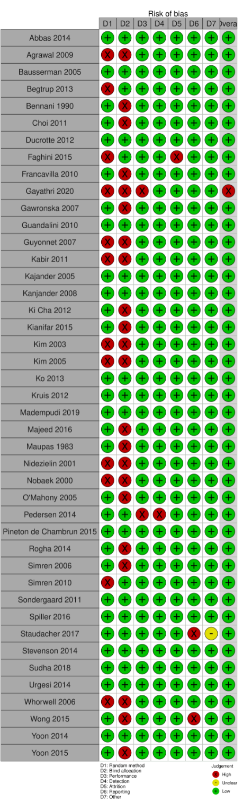

Supplementary Figure 1. Risk of Bias in included trials of probiotics for treatment of IBS.

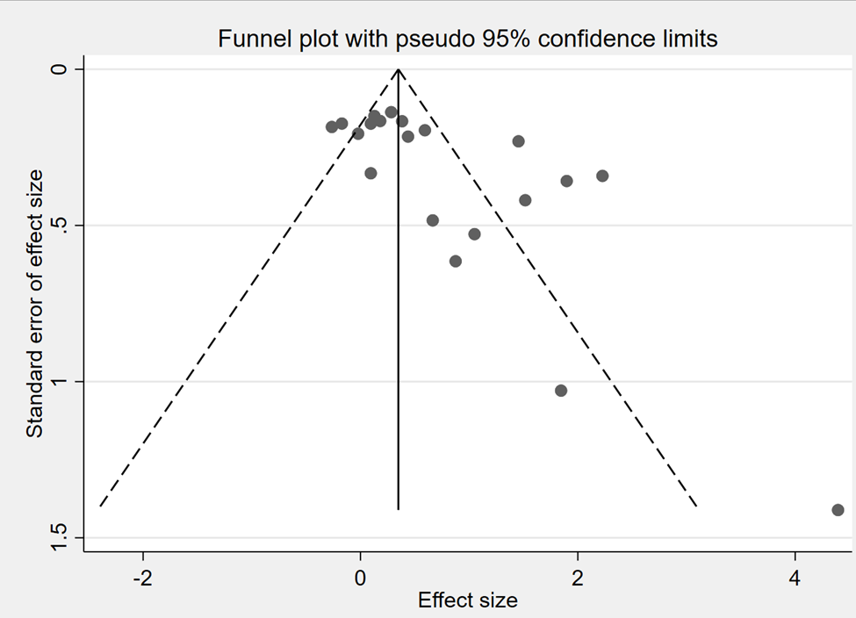

Supplementary Figure 2. Funnel plot for publication bias for IBS probiotic trials with common outcome of “Frequency of no abdominal pain”

Supplementary Figure 3. Forest plot of probiotics for global cure “responders” for IBS.
Abbreviations: B inf 35624, Bifido. infantis 35624; Lp 299v, L. plantarum 299v; S. boulardii I-745, Saccharomyces boulardii CNCM I-745; LpLaBl, L. paracasei 19, L. acido La5, Bifido lactis Bb12; 6 strains: L. acidophilus 11906BP, L. rhamnosus 12202BP, Bifido. bifidum 12199BP, Bifido. lactis 11904 BP, Bifido. longum 12200 BP, Strept. thermophilus 11870BP; VSL#3”: Bifido. breve DSM24732, Bifido. longum DSM24736, Bifido. infantis DSM24737, L. acidophilus DSM24735, L. plantarum DSM24730, L. paracasei DSM24733, L. delbruckii subsp. bulgaricus DSM24734, Strept. thermophilus DSM24731, originally named VSL#3®, now either Visbiome™ or Vivomixx™ using the De Simone formulation.
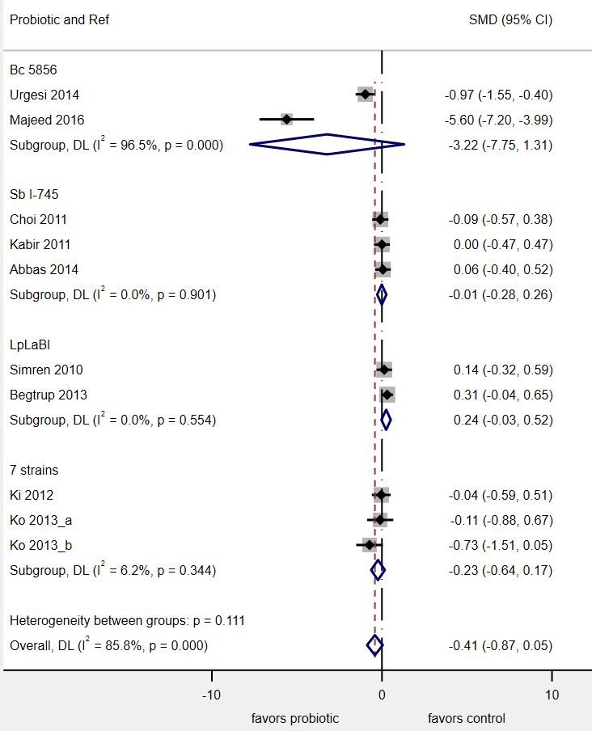

, p<0.001

Supplementary Figure45. Change in IBS bloating scores by probiotic type.
Abbreviations: Bc, Bacillus coagulans; Sb, Saccharomyces boulardii; LpLaBl, L. paracasei 19, L. acido La5, Bifid lactis Bb12; 7 strains, Bif. brevis 11858BP, Bif. lactis 11903BP, B. longum 11860BP, L. acidophilus 11868BP, L. rhamnosus 11868BP, L. plantarum 11867BP and Strept. thermophilus 11870BP.

Supplementary Figure 5. Forest plot of randomized controlled trials in patients with IBS-D.
Abbreviations: Sb, Saccharomyces boulardii; 7 strains, Bif. brevis 11858BP, Bif. lactis 11903BP, B. longum 11860BP, L. acidophilus 11868BP, L. rhamnosus 11868BP, L. plantarum 11867BP and Strept. thermophilus 11870BP.

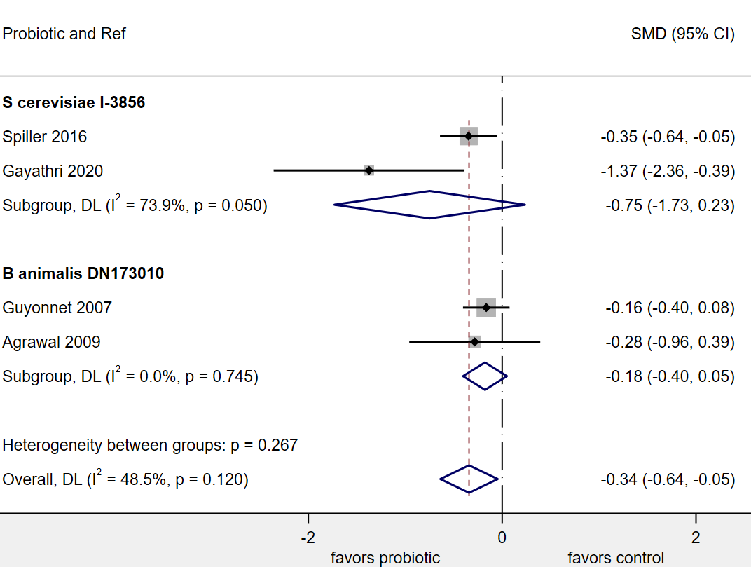

Supplementary Figure 6. Forest plot of randomized controlled trials in patients with IBS-C.

Abbreviations: S, Saccharomyces; B, Bifidobacterium.

