Supplementary Table 1. Newcastle-Ottawa Scale score

First author/year | Selection |  |  |  | Comparability |  | Outcomes |  | Quality score
First author/year | Representativeness of the exposed cohort | Selection of the non-exposed cohort | Ascertainment of exposure | Demonstration that outcome was not present at the start | Comparable for primary items | Comparable for secondary items | Assessment of outcomes | Follow up | Quality score
Alqahtani et al.(1) 2020 | Y | Y | Y | Y | Y | N | Y | Y | 8
Almazeedi et al,(2) 2020 | Y | Y | Y | Y | U | N | Y | Y | 6
Baldelli et al(3), 2021 | Y | Y | Y | Y | Y | N | Y | Y | 7
Brix et al,(4)2021 | Y | Y | Y | Y | Y | N | Y | Y | 7
Cao et al,(5)2020 | Y | Y | Y | Y | Y | N | Y | Y | 7
Daraei et al,(6)2020 | Y | Y | Y | Y | U | N | Y | Y | 6
Gao et al,(7)2020 | Y | Y | Y | Y | Y (age, sex) | Y (duration of COVID, blood oxygen saturation, hs-CRP) | Y | Y | 9
Gong et al,(8) 2021 | Y | Y | Y | Y | Y | Y (inflammatory parameter, blood cell analysis) | Y | Y | 9
Güven et al,(9) 2021 | Y | Y | Y | Y | Y | Y (complete blood count, CRP, D-dimer) | Y | Y | 8
Khoo et al,(10) 2020 | Y | Y | Y | Y | Y | Y (CRP, albumin, cortisol) | Y | Y | 9
Lang et al,(11) 2021 | Y | Y | Y | Y | Y | U | Y | Y | 7
Lui et al,(12) 2020 | Y | Y | Y | Y | Y | Y (basic hematology panel, inflammatory markers) | Y | Y | 8
Muller et al,(13) 2020 | Y | N | Y | Y | Y | Y (CRP) | Y | N | 6
Nguyen et al,(14) 2021 | N/A | N/A | N/A | N/A | N/A | N/A | N/A | N/A | N/A
Sen et al,(15) 2021 | Y | Y | N | Y | N | Y | N | Y | 6
Shabrawishi et al,(16)2020 | Y | Y | Y | Y | N | N | Y | Y | 6
Sisó-Almirall et al,(17) 2020 | Y | Y | Y | Y | Y (age) | N | Y | Y | 7
van Gerwen et al,(18)2020 | Y | Y | Y | Y | Y | Y (race, BMI, smoking status) | Y | Y | 8
Wang et al,(19) 2020 | Y | Y | Y | Y | Y | Y (disease severity) | Y | Y | 9
Zhang et al,(20) 2020 | Y | Y | Y | Y | Y | N | Y | Y | 7
Zhang et al,(21) 2020 | Y | Y | Y | Y | Y | N | Y | Y | 7

Supplementary Table 2. Thyroid hormones cutoff

Authors | Study Design | Setting | Samples | Male (%) | Age (years) | Cutoff | Outcome
Alqahtani et al,(1) 2020 | Retrospective cohort  (cross sectional) | Riyadh, Saudi Arabia | 458 | 86.9 | N/A | N/A | Severity
Almazeedi et al,(2)2020 | Retrospective cohort | Kuwait | 1096 | 81 | 41 | N/A | Severity  (Mortality ICU?)
Baldelli et al(3), 2021 | Retrospective cohort | Rome, Italy | 46 | 69.5 | 59.6 (60.8 vs 58.4 vs 59.1) | fT3: 2.3–4.2 pg/ml  TSH: 0.4–3.5 μIU/ml | ICU
Brix et al,(4) 2021 | Retrospective cohort | Denmark | 16502 | 45.6 | 57.3 | N/A | Mortality
Cao et al,(5) 2020 | Retrospective cohort | Shanghai, China | 198 | 51 | 50.1 | N/A | ICU
Daraei et al,(6) 2020 | Retrospective cohort | Tehran, Iran | 390 | 67.7 | 58.1 | N/A | Mortality
Gao et al,(7) 2020 | Retrospective cohort | Wuhan, China | 100 | 52 | 62.3 | FT3 3.1 - 6.8 pmol/L  FT4 12-22 pmol/L  TSH 0.27 - 4.2 µIU/mL | Severity and Mortality
Gong et al,(8) 2021 | Retrospective cohort | China | 150 | 54 | 69.8 | FT3 3.1 - 6.8 pmol/L  FT4 12-22 pmol/L  TSH 0.27 - 4.2 µIU/mL | Mortality
Güven et al,(9) 2021 | Prospective cohort | Turkey | 250 | 63 | 68 | N/A | ICU
Khoo et al,(10) 2020 | Prospective cohort | UK | 334 | 60.8 | 66.1 | FT4 9 - 23 pmol/L  TSH 0.3 - 4.2 mU/L | Mortality and ICU
Lang et al,(11) 2021 | Retrospective cohort | China | 127 | N/A | N/A | N/A | Mortality
Lui et al,(12) 2020 | Prospective cohort | China | 191 | 51.8 | 53.5 | TSH 0.35 - 4.8 mIU/L  FT4 12 - 23 pmol/L  FT3 3.2 - 6.5 pmol/L | Severity
Muller et al,(13) 2020 | Prospective cohort | Italy | 145 | 61.3 | 66.9 | N/A | ICU
Nguyen et al,(14) 2021 | Cross sectional | California | 6822 | 49.6 | 48 | N/A | Mortality
Sen et al,(15) 2021 | Prospective cohort  (cross-sectional)? | Kolkata, India | 60 | N/A |  | TSH: 0.35-4.6 μIU/ml  ft4 : 0.89-1.80 ng/dl  fT3: 2.3-4.2 pg/ml  T4: 4.6-11.5 μg/dl  T3: 0.81-1.87 ng/ml | Severity
Shabrawishi et al,(16)  2020 | Retrospective cohort | Mecca, Saudia Arabia | 150 | 60 | 46.1 | N/A | Severity
Sisó-Almirall et al,(17) 2020 | Retrospective cohort | Barcelona, Spain | 322 | 50 | 56.7 | N/A | Hospitalization, (Death/ICU admission)
van Gerwen et al,(18)2020 | Retrospective cohort | New York, United States | 3703 | 55.3 | 56,9 ( 65.0 (± 16.9) vs 56.4 (±18.2) | N/A | Hospitalization, (Invasive Mechanical Ventilation, Mortality)
Wang et al,(19) 2020 | Retrospective cohort | Hangzhou, China | 84 | 63.1 | 57.3 ± 14.5 vs 60.1 ± 16.7 vs 57.7 ± 13.0 | TT4 : 62.68–150.84 nmol/L; TT3 : 0.89–2.44 nmol/L; TSH ; 0.35–4.94 nmol/L. | Severity
Zhang et al,(20) 2020 | Retrospective cohort | Wuhan, China | 140 | 50.7 | 56.3 | N/A | Severity
Zhang et al,(21) 2020 | Retrospective cohort | Wuhan, China | 71 | 56.3 | 62.7 | FT3 (normal range: 2.63–5.7 pmol/L), FT4 (normal range: 9–19.18 pmol/L), TSH (normal range: 0.35–4.94 uIU/mL) | Severity and Mortality

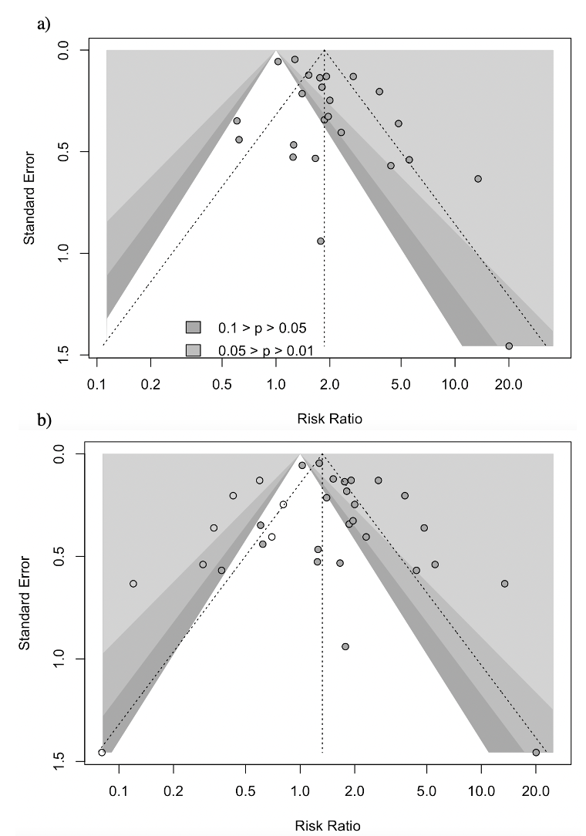

Supplementary Figure 1 Analysis of publication bias. a) Funnel plot and b) trim-and-fill analysis
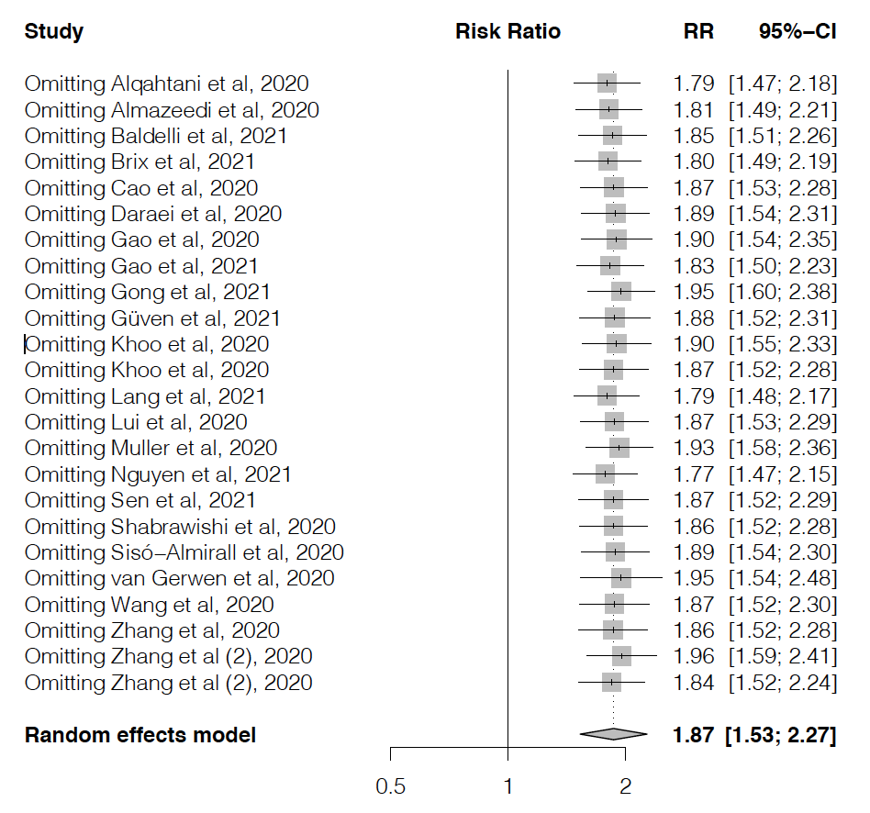

Supplementary Figure 2. Leave-one-out sensitivity analysis

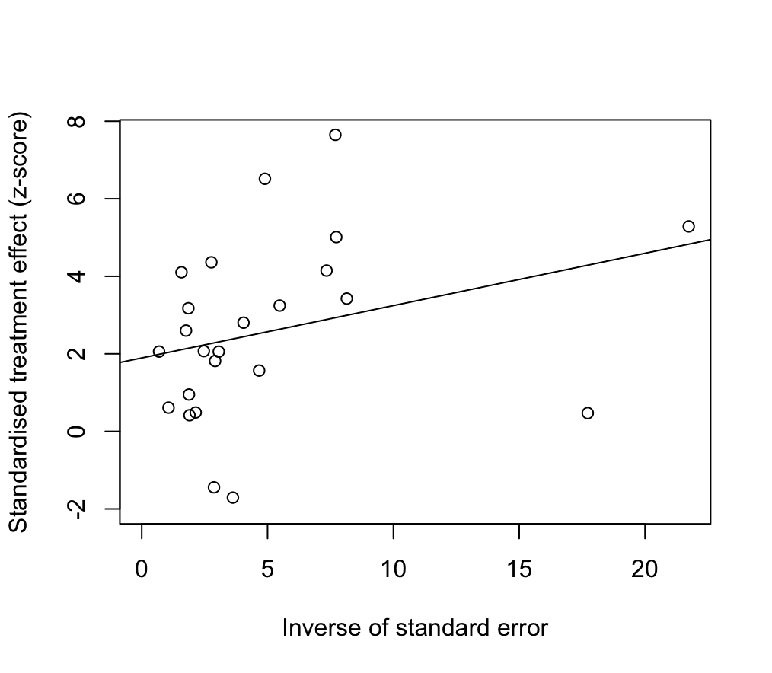
Supplementary Figure 3. Regression-based Harbord’s test

