Supplements
S1 Table 1. Search expression in each database.
Database | Search formula
Pubmed  (338 results) | ((((((Pediatric pulmonary hypertension) OR Pediatric pulmonary artery hypertension) OR "Pediatric pulmonary hypertension"[Mesh]) OR "Pediatric pulmonary hypertension"[Mesh])) AND (((((((((((drug therapy) OR "Drug Therapy"[Mesh]) OR specific therapy) OR "Molecular Targeted Therapy"[Mesh])) OR Pulmonary vasodilators) OR ((((((((Endothelin receptor antagonists) OR "Endothelin Receptor Antagonists"[Mesh]) OR Ambrisentan) OR "ambrisentan" [Supplementary Concept]) OR Bosentan) OR "Bosentan"[Mesh]) OR Macitentan) OR "macitentan" [Supplementary Concept])) OR ((((((((Phosphodiesterase type 5 inhibitors) OR "Phosphodiesterase 5 Inhibitors"[Mesh]) OR Sildenafil) OR "Sildenafil Citrate"[Mesh]) OR Tadalafil) OR "Tadalafil"[Mesh]) OR Vardenafil) OR "Vardenafil Dihydrochloride"[Mesh])) OR (((Soluble guanylate cyclase stimulators) OR riociguat) OR "riociguat" [Supplementary Concept])) OR ((((((((((((Prostacyclin analogues) OR Prostacyclin) OR "benzodioxane prostacyclin" [Supplementary Concept]) OR Beraprost) OR "beraprost" [Supplementary Concept]) OR Epoprostenol) OR "Epoprostenol"[Mesh]) OR synthetic prostacyclin) OR Iloprost) OR "Iloprost"[Mesh]) OR Treprostinil) OR "treprostinil" [Supplementary Concept])) OR (((prostacyclin receptor agonists) OR Selexipag) OR "selexipag" [Supplementary Concept]))) AND ((random*) OR (("Randomized Controlled Trial" [Publication Type]) OR "Randomized Controlled Trials as Topic" [Mesh]))
Embase  (102 results) | ('pediatric pulmonary artery hypertension' OR 'pediatric pulmonary hypertension') AND ('drug therapy' OR 'drug therapy' OR 'specific therapy' OR 'pulmonary vasodilators' OR 'endothelin receptor antagonists' OR 'ambrisentan' OR 'bosentan' OR 'macitentan' OR 'phosphodiesterase inhibitor 5' OR 'phosphodiesterase v inhibitor' OR 'sildenafil' OR 'tadalafil' OR 'vardenafil' OR 'soluble guanylate cyclase stimulators' OR 'riociguat' OR 'prostacyclin analogues' OR 'prostacyclin' OR 'beraprost' OR 'epoprostenol' OR 'prostacyclin derivative' OR 'synthetic prostacyclin' OR 'iloprost' OR 'treprostinil' OR 'prostacyclin receptor agonists' OR 'selexipag') AND (random* OR 'randomized controlled trials')
Cochrane Library  (34 results) | (pediatric pulmonary artery hypertension or pediatric pulmonary hypertension) AND (drug Therapy OR Endothelin receptor antagonists OR bosentan OR phosphodiesterase 5 Inhibitors or sildenafil Citrate OR tadalafil OR Vardenafil Dihydrochloride OR Prostaglandins I OR Epoprostenol OR Iloprost) AND Randomized Controlled Trial

S2 Figure 1. Flow chart of study selection.
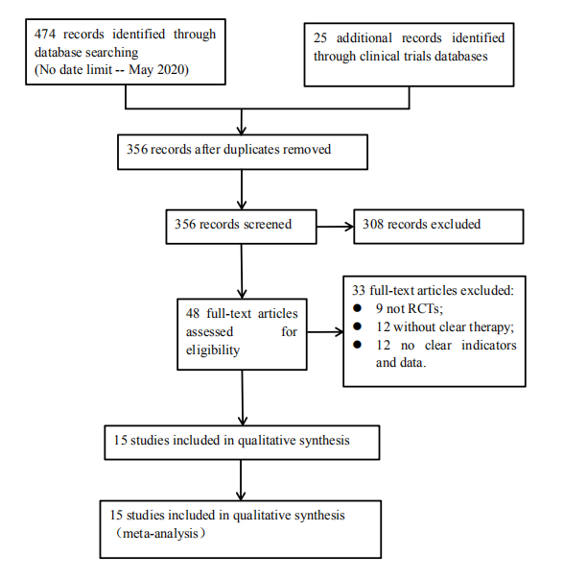

S3 Figure 2. The details of the risk of bias in the included studies.
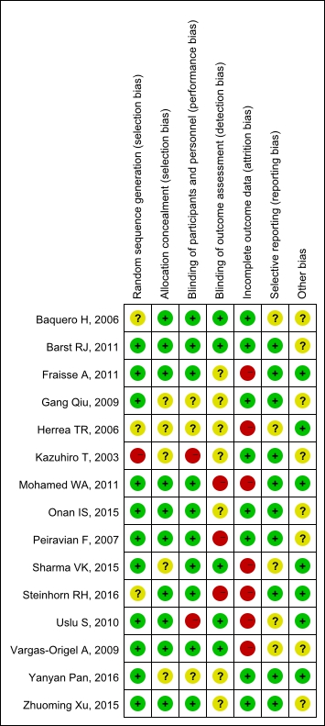

S4 Figure 3. A summary of the risk of bias in the included studies.
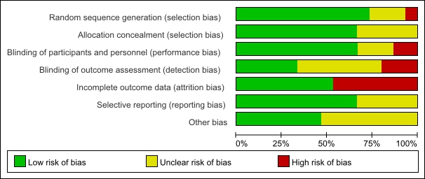

S5 Table 2. Subgroup analysis of pulmonary vasodilators in different types of pediatric pulmonary hypertension patients.
PDE5i-PPHN
Primary Outcomes |  | References | E (Events) |  | E (Total) | C (Events) | C (Total) |  | RR | 95%CI |  | P | I² (%)
Death |  | 5 | 2 |  | 97 | 10 | 86 |  | 0.23 | 0.06 to 0.83 |  | 0.03 | 0
Adverse events |  | 2 | 0 |  | 46 | 0 | 49 |  | NE | NE |  | NA | NA
Secondary Outcomes |  | References | E (Total) |  |  | C (Total) |  |  | MD | 95%CI |  | P | I² (%)
mPAP, mmHg |  | 2 | 46 |  |  | 49 |  |  | -4.43 | -9.14 to 0.27 |  | 0.06 | 65
sPAP, mmHg |  | 0 | - |  |  | - |  |  | - | - |  | - | -
PA/Ao pressure |  | 0 | - |  |  | - |  |  | - | - |  | - | -
OI |  | 3 | 51 |  |  | 51 |  |  | -19.05 | -32.83 to -5.27 |  | 0.007 | 96
PaO₂, mmHg |  | 2 | 30 |  |  | 27 |  |  | -7.42 | -14.05 to -0.79 |  | 0.03 | 36
SpO₂, % |  | 2 | 22 |  |  | 21 |  |  | 10.32 | -7.51 to 28.15 |  | 0.26 | 94
Duration of mechanical ventilation, days |  | 2 | 62 |  |  | 54 |  |  | -1.44 | -2.42 to -0.47 |  | 0.004 | 0
ICU stay, days |  | 0 | - |  |  | - |  |  | - | - |  | - | -
PDE5i-POPH
Primary Outcomes |  | References | E (Events) |  | E (Total) | C (Events) | C (Total) |  | RR | 95%CI |  | P | I² (%)
Death |  | 3 | 0 |  | 55 | 2 | 50 |  | 0.09 | 0.01 to 1.64 |  | 0.1 | NA
Adverse events |  | 3 | 3 |  | 55 | 7 | 50 |  | 0.55 | 0.17 to 1.79 |  | 0.32 | 0
Secondary Outcomes |  | References | E (Total) |  |  | C (Total) |  |  | MD | 95%CI |  | P | I² (%)
mPAP, mmHg |  | 1 | 12 |  |  | 5 |  |  | -13.00 | -26.45 to 0.45 |  | 0.06 | NA
sPAP, mmHg |  | 2 | 32 |  |  | 27 |  |  | -11.19 | -16.50 to -5.88 |  | <0.0001 | 0
PA/Ao pressure |  | 2 | 43 |  |  | 45 |  |  | -0.12 | -0.16 to -0.08 |  | < 0.00001 | 0
OI |  | 0 | - |  |  | - |  |  | - | - |  | - | -
PaO₂, mmHg |  | 0 | - |  |  | - |  |  | - | - |  | - | -
SpO₂, % |  | 0 | - |  |  | - |  |  | - | - |  | - | -
Duration of mechanical ventilation, days |  | 3 | 55 |  |  | 50 |  |  | -5.72 | -12.24 to 0.80 |  | 0.09 | 94
ICU stay, days |  | 3 | 55 |  |  | 50 |  |  | -8.96 | -18.57 to 0.64 |  | 0.07 | 94
PDE5i-PPAH
Primary Outcomes |  | References | E (Events) |  | E (Total) | C (Events) | C (Total) |  | RR | 95%CI |  | P | I² (%)
Death |  | 1 | 0 |  | 174 | 0 | 60 |  | NE | NE |  | NA | NA
Adverse events |  | 1 | 9 |  | 174 | 2 | 60 |  | 1.55 | 0.34 to 6.98 |  | 0.57 | NA
Secondary Outcomes |  | References | E (Total) |  |  | C (Total) |  |  | MD | 95%CI |  | P | I² (%)
mPAP, mmHg |  | 1 | 165 |  |  | 56 |  |  | -3.90 | -8.57 to 0.77 |  | 0.10 | NA
sPAP, mmHg |  | 0 | - |  |  | - |  |  | - | - |  | - | -
PA/Ao pressure |  | 0 | - |  |  | - |  |  | - | - |  | - | -
OI |  | 0 | - |  |  | - |  |  | - | - |  | - | -
PaO₂, mmHg |  | 0 | - |  |  | - |  |  | - | - |  | - | -
SpO₂, % |  | 0 | - |  |  | - |  |  | - | - |  | - | -
Duration of mechanical ventilation, days |  | 0 | - |  |  | - |  |  | - | - |  | - | -
ICU stay, days |  | 0 | - |  |  | - |  |  | - | - |  | - | -
ERAs-PPHN
Primary Outcomes |  | References | E (Events) |  | E (Total) | C (Events) | C (Total) |  | RR | 95%CI |  | P | I² (%)
Death |  | 2 | 1 |  | 30 | 3 | 22 |  | 0.20 | 0.02 to 1.77 |  | 0.15 | NA
Adverse events |  | 2 | 6 |  | 36 | 10 | 22 |  | 0.40 | 0.08 to 1.86 |  | 0.24 | 64
Secondary Outcomes |  | References | E (Total) |  |  | C (Total) |  |  | MD | 95%CI |  | P | I² (%)
mPAP, mmHg |  | 0 | - |  |  | - |  |  | - | - |  | - | -
sPAP, mmHg |  | 0 | - |  |  | - |  |  | - | - |  | - | -
PA/Ao pressure |  | 0 | - |  |  | - |  |  | - | - |  | - | -
OI |  | 1 | 24 |  |  | 23 |  |  | -9.80 | -19.35 to -0.25 |  | 0.04 | NA
PaO₂, mmHg |  | 0 | - |  |  | - |  |  | - | - |  | - | -
SpO₂, % |  | 1 | 24 |  |  | 23 |  |  | 11.08 | 0.30 to 21.86 |  | 0.04 | NA
Duration of mechanical ventilation, days |  | 1 | 24 |  |  | 23 |  |  | -7.20 | -7.64 to -6.76 |  | <0.00001 | NA
ICU stay, days |  | 0 | - |  |  | - |  |  | - | - |  | - | -
ERAs-PPAH
Primary Outcomes |  | References | E (Events) |  | E (Total) | C (Events) | C (Total) |  | RR | 95%CI |  | P | I² (%)
Death |  | 1 | 0 |  | 30 | 0 | 30 |  | NE | NE |  | NA | NA
Adverse events |  | 1 | 0 |  | 30 | 0 | 30 |  | NE | NE |  | NA | NA
Secondary Outcomes |  | References | E (Total) |  |  | C (Total) |  |  | MD | 95%CI |  | P | I² (%)
mPAP, mmHg |  | 1 | 30 |  |  | 30 |  |  | -4.25 | -7.26 to -1.24 |  | 0.006 | NA
sPAP, mmHg |  | 0 | - |  |  | - |  |  | - | - |  | - | -
PA/Ao pressure |  | 0 | - |  |  | - |  |  | - | - |  | - | -
OI |  | 0 | - |  |  | - |  |  | - | - |  | - | -
PaO₂, mmHg |  | 0 | - |  |  | - |  |  | - | - |  | - | -
SpO₂, % |  | 0 | - |  |  | - |  |  | - | - |  | - | -
Duration of mechanical ventilation, days |  | 0 | - |  |  | - |  |  | - | - |  | - | -
ICU stay, days |  | 0 | - |  |  | - |  |  | - | - |  | - | -
PGI₂-POPH
Primary Outcomes |  | References | E (Events) |  | E (Total) | C (Events) | C (Total) |  | RR | 95%CI |  | P | I² (%)
Death |  | 3 | 0 |  | 37 | 0 | 32 |  | NE | NE |  | NA | NA
Adverse events |  | 2 | 8 |  | 30 | 6 | 19 |  | 0.77 | 0.23 to 2.58 |  | 0.67 | 44
Secondary Outcomes |  | References | E (Total) |  |  | C (Total) |  |  | MD | 95%CI |  | P | I² (%)
mPAP, mmHg |  | 3 | 37 |  |  | 32 |  |  | -0.89 | -8.60 to 6.81 |  | 0.82 | 64
sPAP, mmHg |  | 0 | - |  |  | - |  |  | - | - |  | - | -
PA/Ao pressure |  | 2 | 30 |  |  | 19 |  |  | -0.13 | -0.39 to 0.13 |  | 0.34 | 80
OI |  | 1 | 15 |  |  | 15 |  |  | -0.30 | -0.75 to 0.15 |  | 0.19 | NA
PaO₂, mmHg |  | 1 | 15 |  |  | 12 |  |  | -8.70 | -13.90 to -3.50 |  | 0.001 | NA
SpO₂, % |  | 1 | 7 |  |  | 8 |  |  | -1.20 | -6.77 to 4.37 |  | 0.67 | NA
Duration of mechanical ventilation, days |  | 1 | 15 |  |  | 12 |  |  | -0.30 | -4.84 to 4.24 |  | 0.90 | NA
ICU stay, days |  | 1 | 15 |  |  | 12 |  |  | -1.00 | -6.20 to 4.20 |  | 0.71 | NA
RR: Risk Ratio; CI: confidence interval; MD: Mean Difference; NE: Not Estimable; NA: Not Applicable; mPAP: mean pulmonary artery pressure; sPAP: systolic pulmonary artery pressure; PA: pulmonary artery; Ao: aorta; OI: oxygenation index; PaO2: partial pressure of arterial oxygen; SpO2: pulse oxygen saturation; ICU: Intensive Care Unit. Other abbreviations are declared as Table 1 - 2.

S6 Table 3. Subgroup analysis of short and long follow-up duration in pediatric pulmonary hypertension patients with pulmonary vasodilators.
Follow-up duration
Primary Outcomes | References | E (Events) | E (Total) | C (Events) | C (Total) | RR | 95%CI | P | I² (%)
Death
Short-term | 4 | 0 | 79 | 3 | 68 | 0.12 | [0.01, 2.14] | 0.15 | NA
Mid-term | 3 | 0 | 42 | 2 | 24 | 0.09 | [0.01, 1.64] | 0.10 | NA
Long-term | 8 | 3 | 302 | 10 | 188 | 0.25 | [0.07, 0.82] | 0.02 | 0
Adverse events
Short-term | 2 | 3 | 35 | 5 | 37 | 0.66 | [0.18, 2.41] | 0.53 | NA
Mid-term | 3 | 8 | 42 | 6 | 24 | 0.77 | [0.23, 2.58] | 0.67 | 44
Long-term | 6 | 15 | 294 | 14 | 169 | 0.54 | [0.19, 1.55] | 0.25 | 42
Secondary Outcomes | References | E (Total) |  | C (Total) |  | MD | 95%CI | P | I² (%)
mPAP, mmHg
Short-term | 1 | 15 |  | 15 |  | -2.00 | [-6.00, 2.00] | 0.33 | NA
Mid-term | 1 | 27 |  | 24 |  | -3.57 | [-19.46, 12.32] | 0.03 | 80
Long-term | 4 | 233 |  | 133 |  | -4.37 | [-6.59, -2.15] | 0.0001 | 15
sPAP, mmHg
Short-term | 1 | 20 |  | 22 |  | -10.80 | [-16.46, -5.14] | 0.0002 | NA
Mid-term | 1 | 12 |  | 5 |  | -14.00 | [-29.28, 1.28] | 0.07 | NA
Long-term | 0 | - |  | - |  | - | - | - | -
PA/Ao pressure
Short-term | 1 | 20 |  | 22 |  | -0.13 | [-0.18, -0.08] | < 0.00001 | NA
Mid-term | 2 | 30 |  | 19 |  | -0.13 | [-0.39, 0.13] | 0.34 | 80
Long-term | 1 | 23 |  | 23 |  | -0.10 | [-0.16, -0.04] | 0.0007 | NA
OI
Short-term | 1 | 13 |  | 11 |  | -19.50 | [-23.31, -15.69] | < 0.00001 | NA
Mid-term | 1 | 15 |  | 12 |  | -0.30 | [-0.75, 0.15] | 0.19 | NA
Long-term | 3 | 62 |  | 63 |  | -16.08 | [-33.62, 1.46] | 0.07 | 94
PaO₂, mmHg
Short-term | 2 | 28 |  | 26 |  | 9.66 | [-13.24, 32.56] | 0.41 | 93
Mid-term | 1 | 15 |  | 12 |  | -8.70 | [-13.90, -3.50] | 0.001 | NA
Long-term | 0 | - |  | - |  | - | - | - | -
SpO₂, %
Short-term | 1 | 15 |  | 15 |  | 1.40 | [-3.40, 6.20] | 0.57 | NA
Mid-term | 0 | - |  | - |  | - | - | - | -
Long-term | 3 | 38 |  | 37 |  | 9.66 | [-4.42, 23.75] | 0.18 | 91
Duration of mechanical ventilation, days
Short-term | 2 | 51 |  | 42 |  | -4.32 | [-11.80, 3.16] | 0.26 | 78
Mid-term | 2 | 27 |  | 17 |  | -2.26 | [-5.06, 0.54] | 0.11 | 11
Long-term | 3 | 78 |  | 80 |  | -7.18 | [-12.11, -2.25] | 0.004 | 98
ICU stay, days
Short-term | 1 | 20 |  | 22 |  | -0.57 | [-2.29, 1.16] | 0.52 | NA
Mid-term | 2 | 27 |  | 17 |  | -3.89 | [-9.06, 1.28] | 0.14 | 59
Long-term | 1 | 23 |  | 23 |  | -22.10 | [-29.53, -14.67] | < 0.00001 | NA

Abbreviations are declared as S5 Table 2.

S7 Table 4. Quality of the evidence.
Pulmonary vasodilators compared with placebo for pediatric pulmonary hypertension patients
Patient or population: patients with pediatric pulmonary hypertension patients
Settings: Hospital
Intervention: pulmonary vasodilators
Outcomes | Illustrative comparative risks* (95% CI) |  | Relative effect  (95% CI) | No of Participants  (studies) | Quality of the evidence  (GRADE) | Comments
Outcomes | Assumed risk | Corresponding risk
 | Control | Pulmonary vasodilators
Death  Follow-up: 24 hours -15 months | Study population |  | RR 0.2  (0.07 to 0.56) | 703  (15 studies) | ⊕⊕⊕⊝  moderate¹ | Evidence was downgraded due to indirectness.
Death  Follow-up: 24 hours -15 months | 54 per 1000 | 11 per 1000  (4 to 30)
Death  Follow-up: 24 hours -15 months | Moderate
Death  Follow-up: 24 hours -15 months | 0 per 1000 | 0 per 1000  (0 to 0)
Adverse events  Follow-up: 24 hours -15 months | Study population |  | RR 0.63  (0.35 to 1.12) | 601  (11 studies) | ⊕⊕⊝⊝  low^{1,2} | Evidence was downgraded due to indirectness and imprecision.
Adverse events  Follow-up: 24 hours -15 months | 109 per 1000 | 68 per 1000  (38 to 122)
Adverse events  Follow-up: 24 hours -15 months | Moderate
Adverse events  Follow-up: 24 hours -15 months | 87 per 1000 | 55 per 1000  (30 to 97)
OI  Follow-up: 24 hours -15 months |  | The mean oi in the intervention groups was  13.34 lower  (23.89 to 2.8 lower) |  | 176  (5 studies) | ⊕⊕⊝⊝  low^{3,4} | Evidence was downgraded due to inconsistency and imprecision.
PaO2  Follow-up: 24 hours -15 months |  | The mean pao2 in the intervention groups was  8.42 lower  (11.88 to 4.96 lower) |  | 84  (3 studies) | ⊕⊕⊕⊝  moderate⁴ | Evidence was downgraded due to imprecision.
SpO2  Follow-up: 24 hours -15 months |  | The mean spo2 in the intervention groups was  7.34 higher  (2.09 lower to 16.78 higher) |  | 105  (4 studies) | ⊕⊕⊝⊝  low^{3,4} | Evidence was downgraded due to inconsistency and imprecision.
mPAP  Follow-up: 24 hours -15 months |  | The mean mpap in the intervention groups was  3.35 lower  (6.24 to 0.47 lower) |  | 462  (8 studies) | ⊕⊕⊕⊝  moderate⁵ | Evidence was downgraded due to indirectness.
PA/Ao  Follow-up: 24 hours -15 months |  | The mean pa/ao in the intervention groups was  0.11 lower  (0.17 to 0.04 lower) |  | 137  (4 studies) | ⊕⊕⊕⊝  moderate⁵ | Evidence was downgraded due to indirectness.
sPAP  Follow-up: 24 hours -15 months |  | The mean spap in the intervention groups was  11.19 lower  (16.5 to 5.88 lower) |  | 59  (2 studies) | ⊕⊕⊝⊝  low^{4,5} | Evidence was downgraded due to indirectness and imprecision.
Duration of mechanical ventilation  Follow-up: 24 hours -15 months |  | The mean duration of mechanical ventilation in the intervention groups was  3.84 lower  (7.28 to 0.41 lower) |  | 295  (7 studies) | ⊕⊕⊕⊝  moderate³ | Evidence was downgraded due to inconsistency.
ICU stay  Follow-up: 24 hours -15 months |  | The mean icu stay in the intervention groups was  6.8 lower  (13.78 lower to 0.19 higher) |  | 132  (4 studies) | ⊕⊕⊕⊝  moderate³ | Evidence was downgraded due to inconsistency.
*The basis for the assumed risk (e.g. the median control group risk across studies) is provided in footnotes. The corresponding risk (and its 95% confidence interval) is based on the assumed risk in the comparison group and the relative effect of the intervention (and its 95% CI).
CI: Confidence interval; RR: Risk ratio; Other abbreviations are declared as Table 2 and 3.
GRADE Working Group grades of evidence
High quality: Further research is very unlikely to change our confidence in the estimate of effect.
Moderate quality: Further research is likely to have an important impact on our confidence in the estimate of effect and may change the estimate.
Low quality: Further research is very likely to have an important impact on our confidence in the estimate of effect and is likely to change the estimate.
Very low quality: We are very uncertain about the estimate.
¹ The PICO principles are not completely consistent, and in some studies the control group used different drugs.
² There is no uniform standard for adverse events, and the records of some studies are not detailed enough.
³ The I^2 of the five studies more than 75%, P <0.05, with greater heterogeneity.
⁴ The study sample related to this outcome indicator is small.
⁵ The detection methods are not uniform, and some studies are through catheters, and some studies are through cardiac ultrasound.

