First, select “Edit”-”Preferences”.
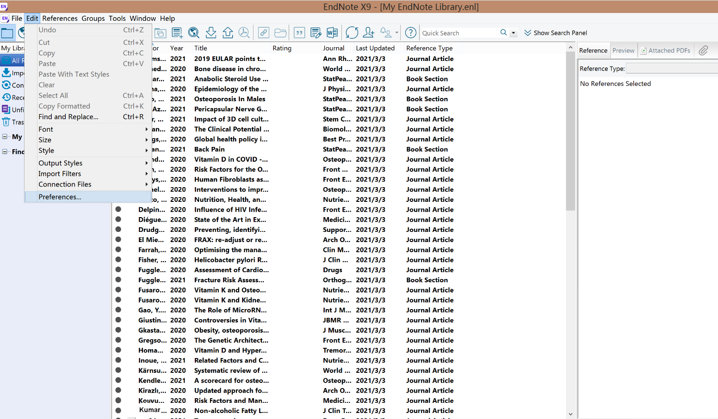

Second, select “Duplication”, then only select “Title”, which mean that the papers with same title
will be found.
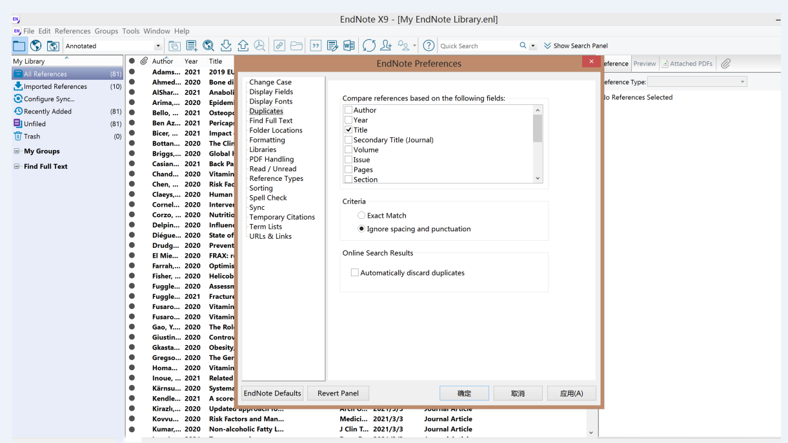

Then, select “References”-”Find Duplication ”
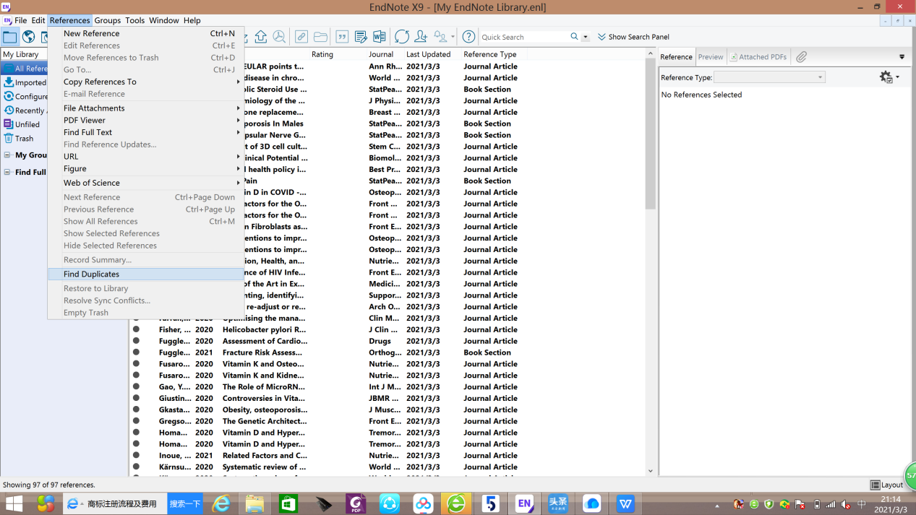

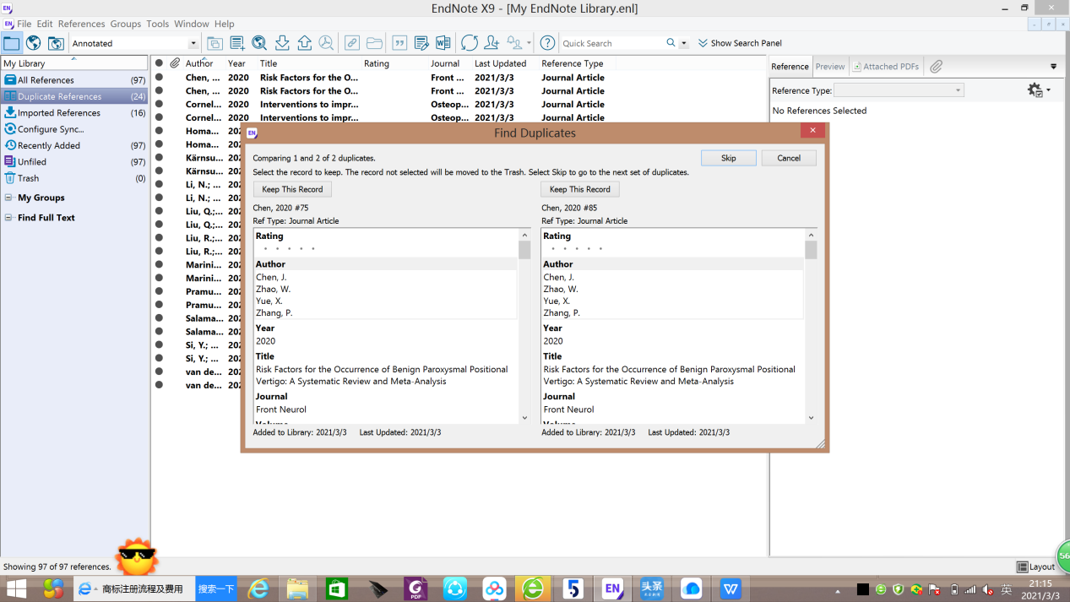
Finally, check whether they are publications.

