Supplementary Item 1
Pubmed searching strategy
#1 | Non-dialysis non-transplantation CKD | "Kidney Failure, Chronic"[Mesh] OR "Renal Insufficiency, Chronic"[Mesh] OR "chronic renal" [Title/Abstract] OR "chronic kidney" [Title/Abstract] OR "chronic kidney disease" [Title/Abstract] OR "renal failure*" [Title/Abstract] OR "kidney failure*" [Title/Abstract] OR "renal insufficienc*"[Title/Abstract] OR "kidney insufficienc*" [Title/Abstract] OR "renal impairment*" [Title/Abstract] OR "kidney impairment*" [Title/Abstract] OR "chronic kidney injury" [Title/Abstract] OR "chronic renal injury" [Title/Abstract] OR "kidney dysfunction" [Title/Abstract] OR "renal dysfunction" [Title/Abstract] OR "reduced renal function" [Title/Abstract] OR "uremia" [Mesh] OR "uremia" [Title/Abstract] OR "azotemia" [Mesh] OR "azotemia" [Title/Abstract] OR "Glomerular Filtration Rate"[Mesh] "glomerular filtration rate" [Title/Abstract] OR "GFR" [Title/Abstract] OR "eGFR" [Title/Abstract] OR "creatinine clearance" [Title/Abstract] OR "creatinine*" [Title/Abstract] OR "CKD" [Title/Abstract] OR "CKF" [Title/Abstract] OR "CRD" [Title/Abstract] OR "CRF" [Title/Abstract] OR "predialysis" [Title/Abstract] OR "pre-dialysis" [Title/Abstract] OR "glomerular disease*" [Title/Abstract] OR "glomerular nephritis" [Title/Abstract] OR "kidney disease*" [Title/Abstract] OR "diabetic nephropathies" [Mesh] OR "diabetic nephropath*" [Title/Abstract] OR "Hypertension, Renal"[Mesh] OR "lupus nephritis" [Mesh] OR "lupus nephritis" [Title/Abstract] OR "nephrosclerosis" [Mesh] OR "glomerulosclerosis" [Title/Abstract] OR "glomerulo*” [Title/Abstract] OR "glomerulonephritis" [Mesh] OR "glomerulonephritis" [Title/Abstract] OR "glomerulitis" [Title/Abstract] OR "glomerulopathy" [Mesh] OR “glomerulopath*" [Title/Abstract] OR "nephritis" [Mesh] OR "nephriti*" [Title/Abstract] OR "nephropath*" [Title/Abstract] OR "kidney amyloidosis" [Title/Abstract] OR "podocyte disease*" [Title/Abstract] OR "antiglomerular basement membrane disease" [Mesh] OR "nephrotic syndrome" [Mesh] OR "nephrotic syndrome*" [Title/Abstract] OR "Nephrosis" [Mesh] OR “nephrosi*" [Title/Abstract] OR "Proteinuria"[Mesh] OR "Proteinuri*"[Title/Abstract] OR "Albuminuria"[Mesh] OR "Albuminuri*"[Title/Abstract] OR "microalbuminuri*" [Title/Abstract] OR "cardio-renal syndrome" [Mesh] OR "cardio-renal" [Title/Abstract] OR "Kimmelstiel-Wilson" [Title/Abstract]
#2 | AKI | ("Acute Kidney Injury"[Mesh] OR "Kidney Tubular Necrosis, Acute" [Mesh] OR "acute kidney tubular necrosis" [Title/Abstract] OR "acute tubular necrosis" [Title/Abstract] OR "acute renal failure*" [Title/Abstract] OR "acute kidney failure*" [Title/Abstract] OR "acute renal injur*" [Title/Abstract] OR "acute kidney injur*" [Title/Abstract] OR "ARF" [Title/Abstract] OR "AKF" [Title/Abstract] OR "ATN" [Title/Abstract] OR "AKI" [Title/Abstract])
#3 | Mortality | "Mortality"[Mesh] OR "mortality"[Title/Abstract] OR "death*"[Title/Abstract]
#4 | RTI(severe RTI, include common cold, rhinitis, etc.) | "Respiratory Tract Infections"[Mesh] OR "lower respiratory tract infection*" [Title/Abstract] OR "lower respiratory infection*" [Title/Abstract] OR "LRTI*" [Title/Abstract] OR "pneumonia" [Mesh] OR "pneumonia, bacterial" [Mesh] OR "chlamydial pneumonia" [Mesh] OR "pneumonia,mycoplasma" [Mesh] OR "pneumonia, pneumococcal" [Mesh] OR "pneumonia, rickettsial" [Mesh] OR "pneumonia, staphylococcal" [Mesh] OR "pneumonia, pneumocystis" [Mesh] OR "pneumonia,viral" [Mesh] OR "pneumonia*" [Title/Abstract] OR "tracheitis" [Mesh] OR "tracheit*" [Title/Abstract] OR "bronchiolitis" [Mesh] OR "Bronchiolitis, Viral" [Mesh] OR "bronchit*" [Title/Abstract] OR "bronchopneumonia" [Mesh] OR "bronchopneumonia*" [Title/Abstract] OR "pleuropneumonia" [Mesh] OR "pleuropneumonia*" [Title/Abstract] OR "empyema, pleural" [Mesh] OR "pleural empyema" [Title/Abstract] OR "legionellosis" [Mesh] or "legionnaires'disease" [Mesh] OR "legionellosis" [Title/Abstract] OR "lung abscess" [Mesh] OR "lung abscess" [Title/Abstract] OR "lung diseases, fungal" [Mesh] OR "severe acute respiratory syndrome" [Mesh] OR "pharyngit" [Mesh] OR "pharyngit*" [Title/Abstract] OR "influenza, human" [Mesh] OR "influenza*" [Title/Abstract] OR "flu" [Title/Abstract] OR “Common Cold” [Mesh] OR “Laryngitis” [Mesh] OR “Pharyngitis” [Mesh] OR “Sinusitis” [Mesh] OR “common cold*” [Title/Abstract] OR “coryza” [Title/Abstract] OR “influenza*” [Title/Abstract] OR “otitis media*” [Title/Abstract] OR “sinusit*” [Title/Abstract] OR “tonsillit*” [Title/Abstract] OR “laryngit*” [Title/Abstract] OR “pharyngit*” [Title/Abstract]
#5 | Case Report | "Case Reports" [Publication Type] OR "Case Report*"
#6 | #1 + #3 + #4 NOT #5 | CKD + mortality + RTI  Filter: limited to English, human and adult (age19+ years)  Not case report
#7 | #1 + #2 + #4 NOT #5 | AKI + mortality + RTI  Filter: limited to English, human and adult (age19+ years)  Not case report

Supplementary item 2: Quality assessment tool
Suggested criteria | Selection bias- loss to follow up | Selection bias - in hospital mortality | Non-differential misclassification of exposure (CKD) | Information bias (CKD) | Non differential misclassification of outcome (mortality) | Information bias (mortality) | Confounding
LOW RISK | LOW RISK  (a) Automated follow up (e.g. linkage to national death registrations) or  (b) >=95% follow up (to primary outcome e.g. if one year mortality is primary outcome, follow up to 1 year even if some patients followed for longer) or  (c) 80 to 94% follow up with comparison of baseline characteristics of included/lost to follow up indicating similar CKD status, age and sex | LOW RISK  Outcome is 'in hospital mortality', but (a) no variation in length of stay or (b) length of stay compared according to baseline renal status and no difference | LOW RISK  CKD status prospectively determined from blood tests pre-admission | LOW RISK  CKD status prospectively determined from blood tests or medical diagnosis prior to infection onset (including pre-existing medical diagnosis recorded on admission) | LOW RISK  Automated or active follow up to ascertain death | LOW RISK  Automated or active regular follow up to ascertain death, irrespective of CKD status | LOW RISK  Addresses confounding (including any combination of restricting study population, matching, stratification, regression, standardisation) for age, sex and at least three comorbidities or a combined comorbidity score
MODERATE | MODERATE  (a) 80-94% follow up without comparison of baseline characteristics, or comparison shows different baseline characteristics  (b) 70-80% follow up with comparison of baseline characteristics of included/lost to follow up indicating similar CKD status, age and sex |  | MODERATE  CKD status determined from blood tests at start of LRTI (e.g on admission) | MODERATE  CKD status determined from blood tests at start of LRTI (e.g on admission) - more severe illness may be associated with acute increase in eGFR - but tested among all patients as routine for that study population |  |  | MODERATE  Addresses confounding (e.g. by restricting study population, matching, or multivariable analysis) for age and sex; Each variable considered a risk factor, and with a p value <0.05 in the univariate analysis, it was entered into the multivariate model.
HIGH RISK | HIGH RISK  (a)70-80% follow up without comparison of baseline characteristics, or comparison shows different baseline characteristics  (b) <70% follow up | HIGH RISK  Outcome is in hospital mortality, and there is variation in length of stay with evidence that this varied by baseline renal status | HIGH RISK  Classification of CKD relies on medical diagnosis of chronic renal disease (e.g. in medical records or /insurance claims/from participant interview) | HIGH RISK: Any of:  (a) Recall bias: CKD status ascertained by recall after death, e.g. questionnaire to family after death  (b) Ascertainment bias: CKD ascertainment likely to be affected by mortality status or severity of illness, e.g. decision to test creatinine dependent on severity of illness or hospitalisation status  (c) Observer bias: CKD status determined after death by case note review, and case note reviewer not blinded to patient outcome e.g. GP questionnaire after patient death | HIGH RISK  Ascertainment of death ad hoc or unreliable, e.g. community physicians or family asked to notify study team if patient dies | HIGH RISK  Ascertainment of death likely to differ according to CKD status - e.g. more or less regular follow up according to CKD status | HIGH RISK  Does not address confounding by age and sex (may address one or the other)
NOT REPORTED | N/R  Insufficient information reported to make assessment | N/R  Insufficient information reported to make assessment | N/R  Insufficient information reported to make assessment | N/R  Insufficient information reported to make assessment | N/R  Insufficient information reported to make assessment | N/R  Insufficient information reported to make assessment | N/R  Insufficient information reported to make assessment
NOT APPLICABLE |  | Not applicable  Mortality is measured for a fixed follow up length.

Supplementary Table S1. Quality assessment of the included studies
Identity | Selection bias- loss to follow up | Selection bias - in hospital mortality | Non-differential misclassification of exposure (CKD) | Information bias (CKD) | Information bias (AKI) | Non differential misclassification of outcome (mortality) | Information bias (mortality) | Confounding
Zhang 2017 | Low | High | High | High | NA | Low | Low | Moderate
Cockatoo 2017 | Low | High | High | High | High | Low | Low | Low
Su 2017 | Low | High | Low | Low | NA | Low | Low | Low
Cilloniz 2016 | Low | High | Low | Low | NA | Low | Low | Moderate
Mata-Marin 2015 | Uncertain: selection criteria for controls do appear to reflect population at risk of becoming cases (this study could be counted as a nested case-control) but individual consent was required, and participation is not reported. | High (outcome is in hospital mortality and no comparison of length of stay by renal status) | Moderate: CKD tested on or during admission, and timing unclear | Moderate-high: CKD status determined from blood tests during infection, and not reported whether serum creatinine routinely tested for cases and controls | NA | Low | Low | High
McDonald 2015 | Low | N/A (28 day mortality) | Low | Low | NA | Low | Low | Low
Shah 2015 | Low | High | High | High (medical diagnosis of CKD extracted from medical notes by physician aware of patient outcome) | NA | Low | Low | High
Soub 2014 | Low | High | Moderate | Moderate | NA | NA | Low | High
Sirvent 2013 | Low | High | High | High | NA | Low | Low | High
Mongardon 2012 | Low | High | High | High | NA | Low | Low | High
Chang 2011 | High | High | Moderate | Low | NA | Low | Low | Moderate
James 2009 | Low | N/A (28 day mortality) | Low | Low | NA | Low | Low | Low
Arozullah 2003 | Low | High | High | High | NA | Low | Low | High
Laurichesse 2001 | Low | N/A(30day) | High | High | NA | Low | Low | Low
Conte 1999 | Low | N/R | High | High | NA | Low | Low | Low
El-Ebiary 1997 | Low | N/R | High | High | NA | Low | Low | High
Leroy 1996 | Low | N/A(ICU death) | High | High | NA | Low | Low | High
Leroy 1995 | Low | N/A(ICU death) | High | High | NA | Low | Low | High

Supplementary Figure S1. Forest plot depicting the meta-association between presence of kidney disease and risk of death in patients with respiratory tract infections by different types of infections
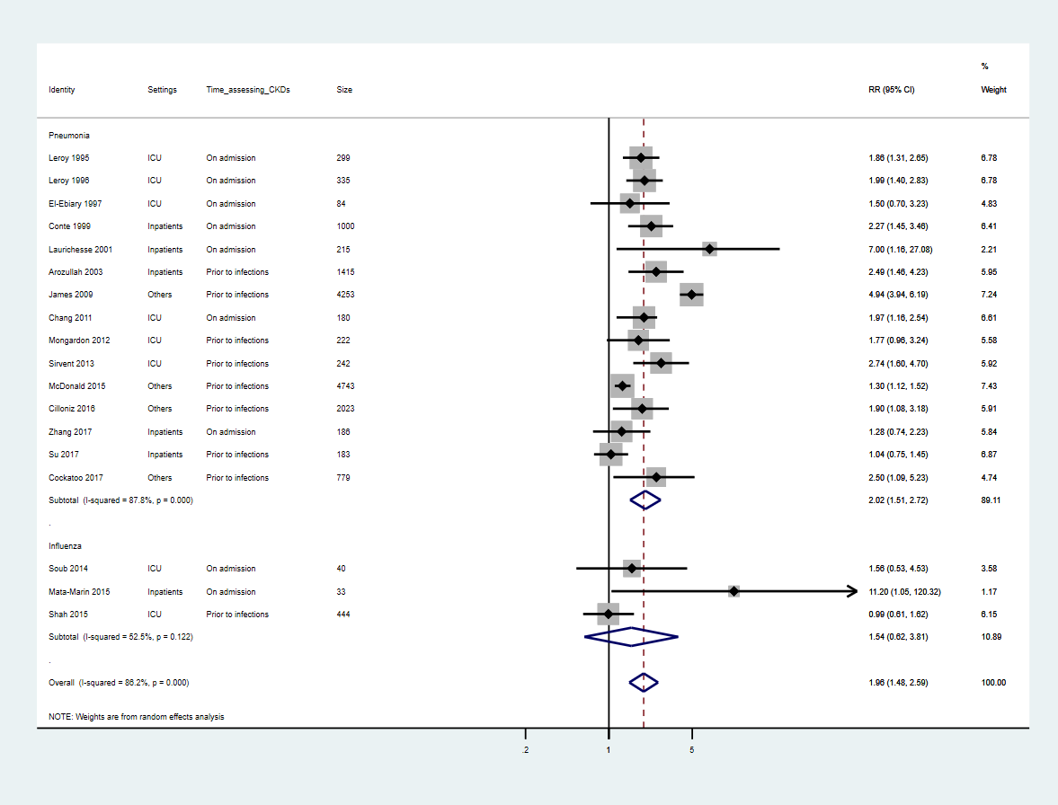

Supplement Figure S2: Forest plot depicting the meta-association between presence of kidney disease and risk of death in patient with pneumonia by the timing of kidney disease assessment (Prior to infections, on admission)

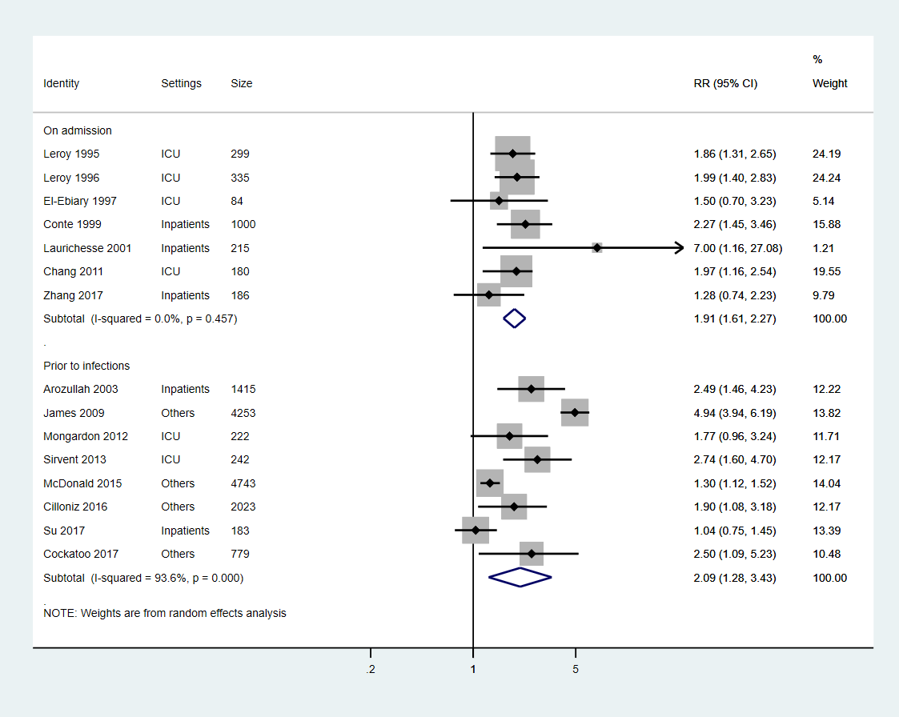

Supplementary Figure S3. Forest plot depicting the meta-association between presence of kidney disease and risk of death in patients with pneumonia by different provenances (Community-acquired, hospital-associated, undefined)
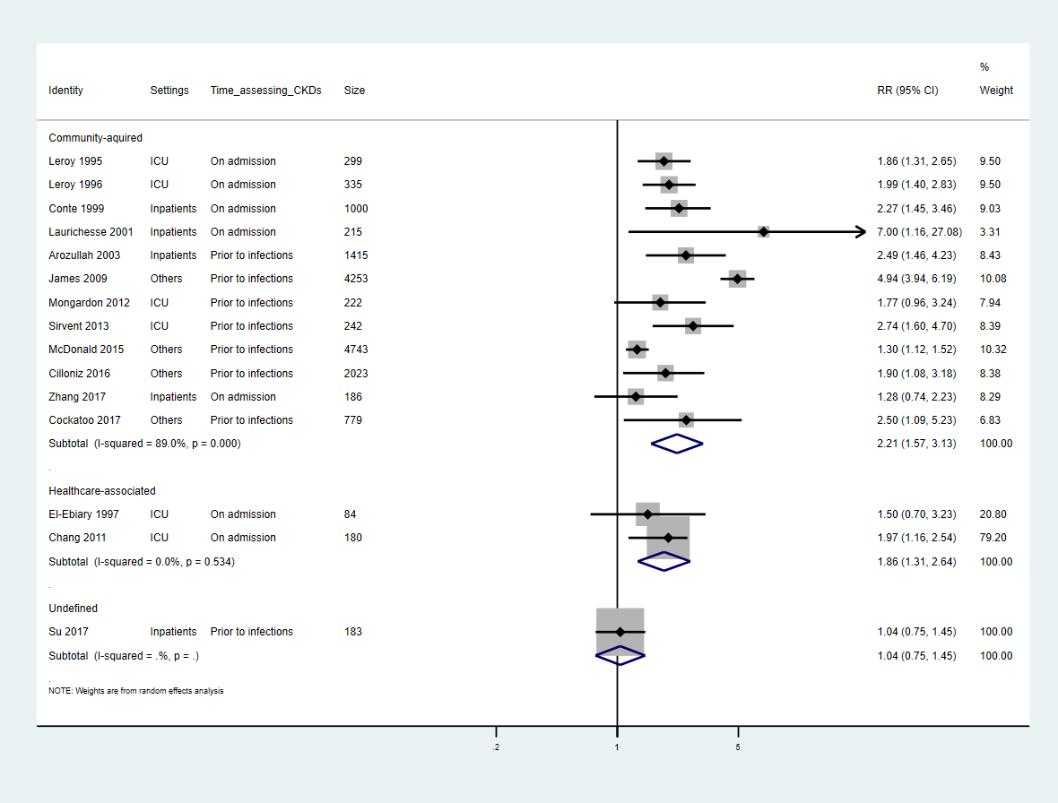

Supplementary Figure S4. Forest plot depicting the meta-association between presence of kidney disease and risk of death in patients with pneumonia by different types of mortality follow-up
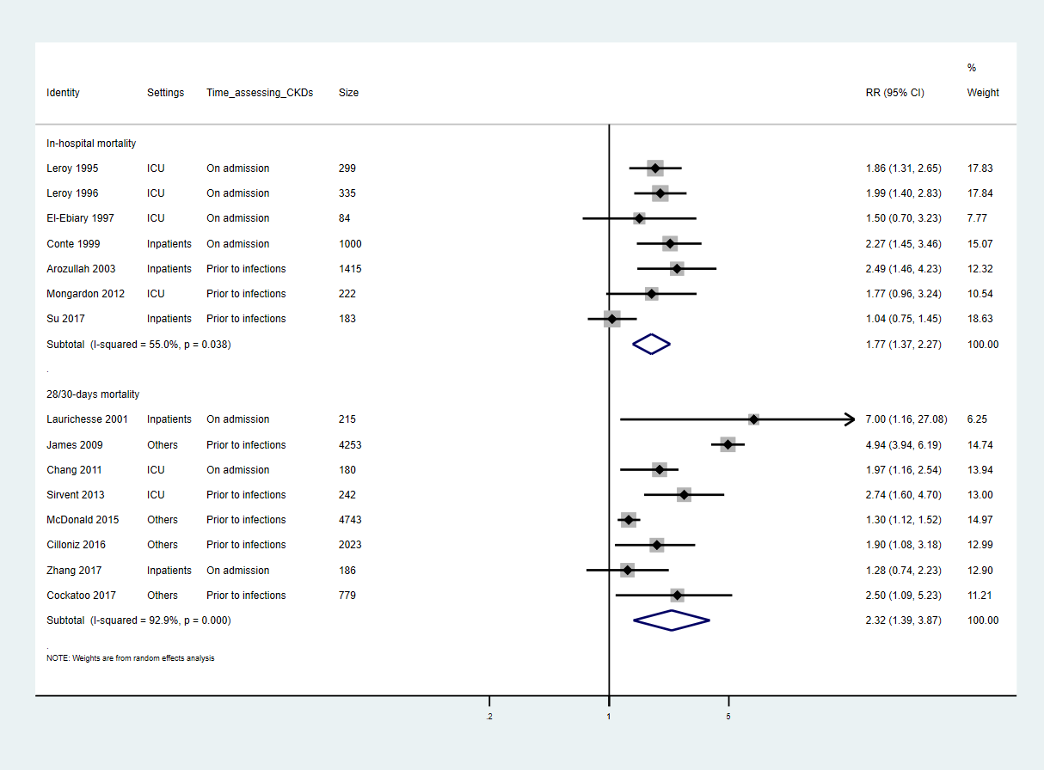

Supplementary Figure S5: Sensitivity analysis: Forest plot depicting the meta-association between presence of kidney disease and risk of death in patients with respiratory tract infections (only included without odds ratio transformation)
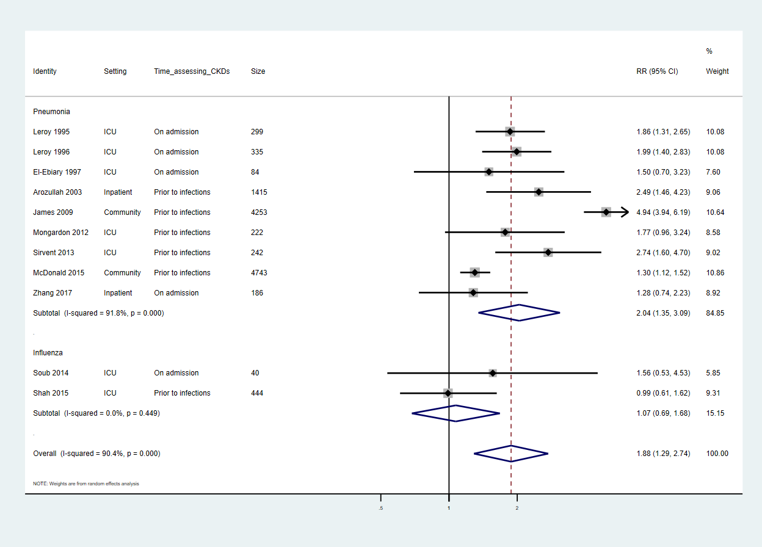

Supplementary Figure S6. Funnel plot depicting publication bias in included studies investigating the association between the presence of kidney disease and risk of death in patients with respiratory tract infections



