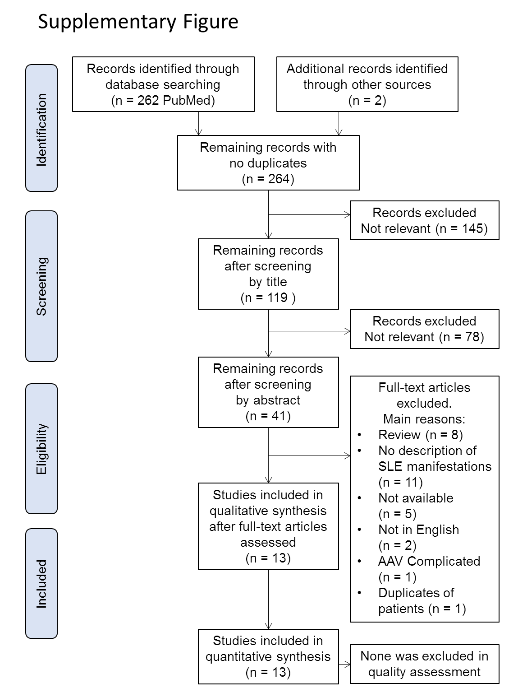
Supplementary Figure
Flow chart of search and selection of studies included in the systematic review (AAV: ANCA-associated vasculitis)

