Supplementary file
Authors: Paulo Ricardo Martins-Filho, Lis Campos Ferreira, Luana Heimfarth, Adriano Antunes de Souza Araújo, Lucindo José Quintans-Júnior.
Title: Efficacy and safety of hydroxychloroquine as pre-and post-exposure prophylaxis and treatment of COVID-19. Systematic review and meta-analysis of blinded, placebo-controlled, randomized clinical trials.

Search strategy

PubMed:
(Chloroquine OR Chlorochin OR Arequin OR Aralen OR Arechine OR Nivaquine OR Chingamin OR Hydroxychloroquine OR Hydroxychlorochin OR Oxychlorochin OR Plaquenil) AND (COVID-19 OR “2019-nCoV Infection” OR “Coronavirus Disease-19” OR “2019-nCoV Disease” OR SARS-CoV-2) AND (randomized controlled trial[Publication Type] OR (randomized[Title/Abstract] AND controlled[Title/Abstract] AND trial[Title/Abstract]))

Embase:
(Chloroquine OR Chlorochin OR Arequin OR Aralen OR Arechine OR Nivaquine OR Chingamin OR Hydroxychloroquine OR Hydroxychlorochin OR Oxychlorochin OR Plaquenil) AND (COVID-19 OR “2019-nCoV Infection” OR “Coronavirus Disease-19” OR “2019-nCoV Disease” OR SARS-CoV-2) AND ('crossover procedure':de OR 'double-blind procedure':de OR 'randomized controlled trial':de OR 'single-blind procedure':de OR (random* OR factorial* OR crossover* OR cross NEXT/1 over* OR placebo* OR doubl* NEAR/1 blind* OR singl* NEAR/1 blind* OR assign* OR allocat* OR volunteer*):de,ab,ti)

Web of Science:
(Chloroquine OR Chlorochin OR Arequin OR Aralen OR Arechine OR Nivaquine OR Chingamin OR Hydroxychloroquine OR Hydroxychlorochin OR Oxychlorochin OR Plaquenil) AND (COVID-19 OR “2019-nCoV Infection” OR “Coronavirus Disease-19” OR “2019-nCoV Disease” OR SARS-CoV-2) AND (TS= clinical trial* OR TS=research design OR TS=comparative stud* OR TS=evaluation stud* OR TS=controlled trial* OR TS=follow-up stud* OR TS=prospective stud* OR TS=random* OR TS=placebo* OR TS=(single blind*) OR TS=(double blind*))

Lilacs:
(Chloroquine OR Chlorochin OR Arequin OR Aralen OR Arechine OR Nivaquine OR Chingamin OR Hydroxychloroquine OR Hydroxychlorochin OR Oxychlorochin OR Plaquenil) AND (COVID-19 OR “2019-nCoV Infection” OR “Coronavirus Disease-19” OR “2019-nCoV Disease” OR SARS-CoV-2) AND (“clinical trial” OR placebo OR “controlled trial” OR “double blind”)

medRxiv:
(Chloroquine OR Hydroxychloroquine) AND (COVID-19 OR SARS-CoV-2) AND (“clinical trial” OR placebo OR “controlled trial”)

Hydroxychloroquine as pre-exposure prophylaxis to prevent SARS-CoV-2 infection

Table S1. Blinded, placebo-controlled, randomized clinical trials evaluating the efficacy and safety of hydroxychloroquine as prophylactic medication pre-exposure to COVID-19.
Author | Study | Country | Protocol and Phase | Population | Intervention | Control | Outcomes of interest  (Time of evaluation)
Abella  2021 | Efficacy and Safety of Hydroxychloroquine vs Placebo for Pre-exposure SARS-cov-2 Prophylaxis Among Health Care Workers: A Randomized Clinical Trial | USA | NCT04329923  (Phase 2) | Healthcare workers at high-risk for SARS-CoV-2 infection | HCQ 600mg/day for 8 weeks  (n = 66) | Placebo  (n = 66) | Incidence of SARS-CoV-2 infection and adverse events  (8 weeks)
Rojas-Serrano  2021 | Hydroxychloroquine for Prophylaxis Of COVID-19 in Health Workers: A Randomized Clinical Trial | Mexico | NCT04318015  (Phase 3) | Healthcare workers at high-risk for SARS-CoV-2 infection | HCQ 200mg/day for 8 weeks  (n = 62) | Placebo  (n = 65) | Incidence of SARS-CoV-2 infection and adverse events  (8 weeks)
Syed  2021 | Pre-Exposure Prophylaxis with Various Doses of Hydroxychloroquine among high-risk COVID 19 Healthcare Personnel: CHEER randomized controlled trial | Pakistan | NCT04359537  (Phase 2) | Healthcare workers at high-risk for SARS-CoV-2 infection | A: HCQ 400mg, 2x/day in the first day + 400mg 1x/week for 12 weeks  B: HCQ 400mg, once every 3 weeks  C: HCQ 200mg, once every 3 weeks  (A: n = 48)  (B: n = 51)  (C: n = 55) | Placebo  (n = 46) | Incidence of SARS-CoV-2 infection and adverse events  (12 weeks)
Rajasingham  2020 | Hydroxychloroquine as pre-exposure prophylaxis for COVID-19 in healthcare workers: a randomized trial | USA and Canada | NCT04328467  (Phase 3) | Healthcare workers at high-risk for SARS-CoV-2 infection | A: HCQ 400mg loading dose + 400mg 1x/week for 12 weeks  B: HCQ 400mg loading dose + 400mg 2x/weeks for 12 weeks  (A: n = 494)  (B: n = 495) | Placebo  (n = 494) | Incidence of SARS-CoV-2 infection and adverse events  (12 weeks)
HCQ, hydroxychloroquine.

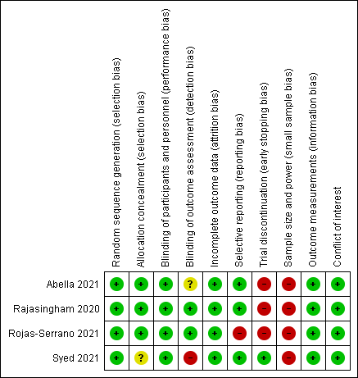
Fig. S1. Risk of bias assessment on the use of hydroxychloroquine as prophylactic medication pre-exposure to COVID-19.

Table S2. Individual results of studies evaluating the efficacy and safety of hydroxychloroquine as prophylactic medication pre-exposure to COVID-19.
Author | Cases of COVID-19 | Any adverse events | Conclusion
Abella  2021 | HCQ: 4/64 (6.3%)  Placebo: 4/61 (6.6%) | HCQ: 29/65 (44.6%)  Placebo: 17/65 (26.2%) | “There was no clinical benefit of hydroxychloroquine administered daily for 8 weeks as pre-exposure prophylaxis in hospital-based HCWs exposed to patients with COVID-19.”
Rojas-Serrano  2021 | HCQ: 1/62 (1.6%)  Placebo: 6/65 (9.2%) | HCQ: 32/62 (51.6%)  Placebo: 38/65 (58.5%) | “No beneficial effect or significant harm could be demonstrated in our randomized controlled trial including 127 participants, using relatively low doses of HCQ compared with placebo in health personnel.”
Syed  2021 | A: HCQ 400mg, 1x/week: 15/48 (31.3%)  B: 400mg, once every 3 weeks: 19/51 (37.3%)  C: 200mg, once every 3 weeks: 8/55 (14.5%)  Placebo: 7/46 (15.2%) | A: HCQ 400mg, 1x/week: 5/48 (10.4%)  B: 400mg, once every 3 weeks: 1/51 (2.0%)  C: 200mg, once every 3 weeks: 3/55 (5.5%)  Placebo: 1/46 (2.2%) | “There was no significant reduction in the SARS-CoV-2 transmission with PrEP administration of hydroxychloroquine among the enrolled healthcare personnel.”
Rajasingham  2020 | A: HCQ 400mg, 1x/week: 29/494 (5.9%)  B: HCQ 400mg, 2x/week: 29/495 (5.9%)  Placebo: 39/494 (7.9%) | A: HCQ 400mg, 1x/week: 148/473 (31.3%)  B: HCQ 400mg, 2x/week: 168/463 (36.3%)  Placebo: 100/469 (21.3%) | “Pre-exposure prophylaxis with hydroxychloroquine once or twice weekly did not significantly reduce laboratory-confirmed COVID-19 or COVID-19–compatible illness among healthcare workers.”
HCQ, hydroxychloroquine.

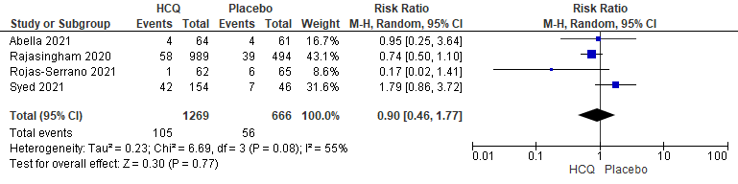
Fig. S2. Forest plot showing the risk of SARS-CoV-2 infection for individuals using hydroxychloroquine as prophylactic medication pre-exposure to COVID-19.

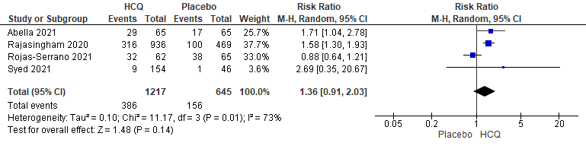
Fig. S3. Forest plot showing the risk of any adverse events for individuals using hydroxychloroquine as prophylactic medication pre-exposure to COVID-19.

Table S3. Sensitivity analysis of studies evaluating the efficacy and safety of hydroxychloroquine as prophylactic medication pre-exposure to COVID-19.
Outcomes | RR (95% CI) | I² | Risk of bias | Inconsistency | Indirectness | Imprecision | Influence of  small trials | Large effect | Quality of evidence
SARS-CoV-2 infection
Peer-reviewed studies | 0.76 (0.52 to 1.10) | 0% | Not serious | Not serious | Not serious | Serious | Not serious | No | ⨁⨁⨁◯
Non-peer reviewed studies | 0.69 (0.07 to 6.73) | 77% | Serious | Serious | Not serious | Serious | Strongly suspect | No | ⨁◯◯◯
Any adverse events
Peer-reviewed studies | 1.60 (1.33 to 1.92) | 0% | Serious | Not serious | Not serious | Not serious | Not serious | No | ⨁⨁⨁⨁
Non-peer reviewed studies | 1.00 (0.49 to 2.05) | 18% | Serious | Serious | Not serious | Serious | Not serious | No | ⨁◯◯◯
Certainty: ⨁ very-low; ⨁⨁ low; ⨁⨁⨁ moderate; ⨁⨁⨁⨁ high.

Hydroxychloroquine as post-exposure prophylaxis to prevent SARS-CoV-2 infection

Table S4. Blinded, placebo-controlled, randomized clinical trials evaluating the efficacy and safety of hydroxychloroquine as prophylactic medication post-exposure to COVID-19.
Author | Study | Country | Protocol and Phase | Population | Intervention | Control | Outcomes of interest  (Time of evaluation)
Barnabas  2020 | Hydroxychloroquine as Postexposure Prophylaxis to Prevent Severe Acute Respiratory Syndrome Coronavirus 2 Infection: A Randomized Trial | USA | NCT04328961  (Phase 3) | Asymptomatic adults who had close contact (occupational or household exposure) with a person with recent known SARS-CoV-2 infection | HCQ 400mg/day per 3 days + 200mg/day for 11 days  (n = 407) | Placebo  (n = 422) | Incidence of SARS-CoV-2 infection and adverse events  (14 days)
Boulware  2020 | A Randomized Trial of Hydroxychloroquine as Postexposure Prophylaxis for Covid-19 | USA and Canada | NCT04308668  (Phase 3) | Asymptomatic adults who had close contact (occupational or household exposure) with a person with recent known SARS-CoV-2 infection | HCQ 800mg loading dose followed by 600mg in 6 to 8h + 600mg/day for 4 days  (n = 414) | Placebo  (n = 407) | Incidence of SARS-CoV-2 infection and adverse events  (14 days)
HCQ, hydroxychloroquine.

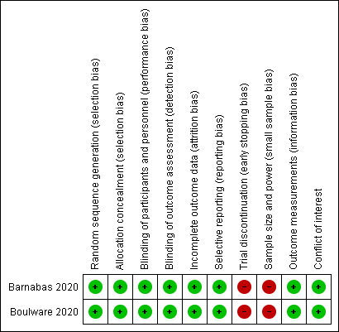
Fig. S4. Risk of bias assessment on the use of hydroxychloroquine as prophylactic medication post-exposure to COVID-19.

Table S5. Individual results of studies evaluating the efficacy and safety of hydroxychloroquine as prophylactic medication post-exposure to COVID-19.
Author | Cases of COVID-19 | Any adverse events | Conclusion
Barnabas  2020 | HCQ: 53/353 (15.0%)  Placebo: 45/336 (13.4%) | HCQ: 66/407 (16.2%)  Placebo: 46/422 (10.9%) | “This rigorous randomized controlled trial among persons with recent exposure excluded a clinically meaningful effect of hydroxychloroquine as postexposure prophylaxis to prevent SARS-CoV-2 infection.”
Boulware  2020 | HCQ: 49/414 (11.8%)  Placebo: 58/407 (14.3%) | HCQ: 140/349 (40.1%)  Placebo: 59/351 (16.8%) | “This randomized trial did not demonstrate a significant benefit of hydroxychloroquine as postexposure prophylaxis for Covid-19.”
HCQ, hydroxychloroquine.

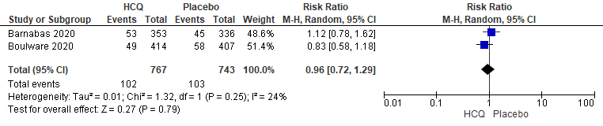
Fig. S5. Forest plot showing the risk of SARS-CoV-2 infection for individuals using hydroxychloroquine as prophylactic medication post-exposure to COVID-19.

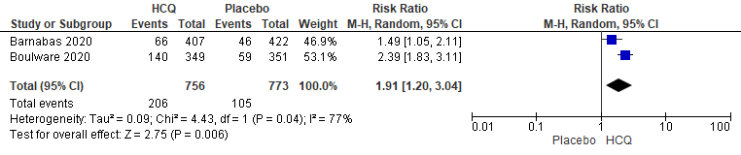
Fig. S6. Forest plot showing the risk of any adverse events for individuals using hydroxychloroquine as prophylactic medication post-exposure to COVID-19.

Hydroxychloroquine as treatment for non-hospitalized patients with COVID-19

Table S6. Blinded, placebo-controlled, randomized clinical trials evaluating the efficacy and safety of hydroxychloroquine as treatment for non-hospitalized patients with COVID-19.
Author | Study | Country | Protocol and  Phase | Population | Intervention | Control | Outcomes of interest  (Time of evaluation)
Skipper  2020 | Hydroxychloroquine in Nonhospitalized Adults with Early COVID-19: A Randomized Trial | USA and Canada | NCT04308668  (Phase 3) | Symptomatic, non-hospitalized patients with RT-PCR diagnosis of COVID-19 or compatible symptoms after a high-risk exposure to a person with known COVID-19  - HCQ group: median age 41y (IQR 33-49). Sex: 42.0% male. Medical conditions: hypertension 10.8%, diabetes 3.8%.  - Placebo: median age 39y (IQR 31-50). Sex: 45.5% male. Medical conditions: hypertension 10.9%, diabetes 3.3%. | HCQ 800mg loading dose followed by 600mg in 6 to 8h + 600mg/day for 4 days (n = 212) | Placebo  (n = 211) | Hospitalization, death, and adverse events  (14 days)
Reis  2021 | Effect of Early Treatment with Hydroxychloroquine or Lopinavir and Ritonavir on Risk of Hospitalization Among Patients With COVID-19. The TOGETHER Randomized Clinical Trial | Brazil | NCT04403100  (Phase 3) | Symptomatic, non-hospitalized patients with RT-PCR diagnosis of COVID-19 or a clinical condition compatible with COVID-19 and respiratory symptoms  - HCQ group: median age 53y (IQR 18-81). Sex: 43.0% male. Medical conditions: hypertension 47.2%, diabetes: 19.2%, heart disease: 2.8%.  - Placebo: median age 53y (IQR 18-80). Sex: 46.7% male. Medical conditions: hypertension 48.0%, diabetes: 21.1%, heart disease: 3.5% | HCQ 800mg loading dose + 400mg/day  for 9 days  (n = 214) | Placebo  (n = 227) | Hospitalization, death, and adverse events  (90 days)
Johnston  2021 | Hydroxychloroquine with or without azithromycin for treatment of early SARS-CoV-2 infection among high-risk outpatient adults: A randomized clinical trial | USA | NCT04354428  (Phase 3) | Symptomatic (> 92%), non-hospitalized patients with RT-PCR diagnosis of COVID-19  - HCQ group: median age 36y (range 19-78). Sex: 45.1% male. Medical conditions: hypertension 11.3%, diabetes 7.0%.  - Placebo: median age 38y (range 18-70). Sex: 45.8% male. Medical conditions: hypertension 8.4%, diabetes 6.0%. | HCQ 400mg, 2x/day in the first day + 200mg, 2x/day for 9 days  (n = 71) | Placebo  (n = 83) | Hospitalization, death, and adverse events  (28 days)
HCQ, hydroxychloroquine. IQR, interquartile range.

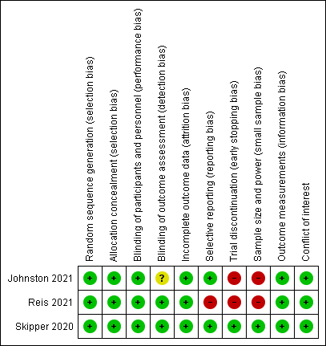
Fig. S7. Risk of bias assessment on the use of hydroxychloroquine as treatment for non-hospitalized patients with COVID-19.

Table S7. Individual results of studies evaluating the efficacy and safety of hydroxychloroquine as treatment for non-hospitalized patients with COVID-19.
Author | Need of hospitalization | Death | Any adverse events | Conclusion
Skipper  2020 | HCQ: 4/212 (1.9%)  Placebo: 8/211 (3.8%) | HCQ: 1/212 (0.5%)  Placebo: 1/211 (0.5%) | HCQ: 92/212 (43.4%)  Placebo: 46/211 (21.8%) | “Hydroxychloroquine did not substantially reduce symptom severity in outpatients with early, mild COVID-19.”
Reis  2021 | HCQ: 8/214 (3.7%)  Placebo: 11/227 (4.9%) | HCQ: 0/214  Placebo: 1/227 (0.4%) | HCQ: 46/207 (22.2%)  Placebo: 46/220 (20.9%) | “In this randomized clinical trial, neither hydroxychloroquine nor lopinavir-ritonavir showed any significant benefit for decreasing COVID-19–associated hospitalization or other secondary clinical outcomes.”
Johnston  2021 | HCQ: 2/71 (2.8%)  Placebo: 4/83 (4.8%) | HCQ: 0/71  Placebo: 0/83 | HCQ: 5/71 (7.0%)  Placebo: 5/83 (6.0%) | “HCQ and HCQ/AZ are not effective therapies for outpatient treatment of SARV-CoV-2 infection.”
HCQ, hydroxychloroquine.

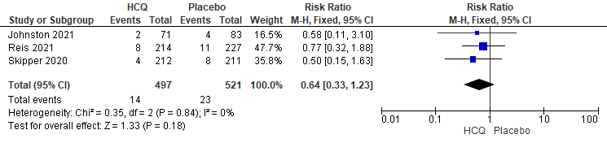
Fig. S8. Forest plot showing the risk of hospitalization for non-hospitalized COVID-19 patients treated with hydroxychloroquine.

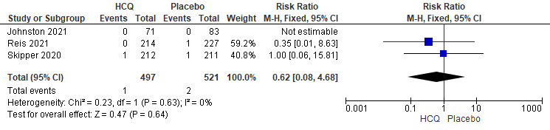
Fig. S9. Forest plot showing the risk of death for non-hospitalized COVID-19 patients treated with hydroxychloroquine.

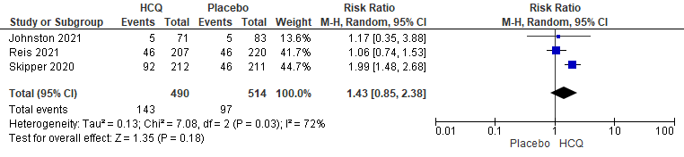
Fig. S10. Forest plot showing the risk of any adverse events for non-hospitalized COVID-19 patients treated
with hydroxychloroquine.

Hydroxychloroquine as treatment for hospitalized patients with COVID-19

Table S8. Blinded, placebo-controlled, randomized clinical trials evaluating the efficacy and safety of hydroxychloroquine as treatment for hospitalized patients with COVID-19.
Author | Study | Country | Protocol and  Phase | Population | Intervention | Control | Outcomes of interest  (Time of evaluation)
Dubée  2021 | Hydroxychloroquine in mild-to-moderate COVID-19: a placebo-controlled double-blind trial | France | NCT04325893  (Phase 3) | Non-critically ill patients with COVID-19 requiring hospitalization with/without need for supplemental oxygen. Cases requiring oxygen therapy >3 L/min or intensive care were excluded.  - HCQ group: median age 76y (IQR 60-85). Sex: 52.0% male. Medical conditions: hypertension 52.0%, diabetes 16.0%, heart disease 27.2%. Concomitant medications: corticosteroids 10.4%.  - Placebo: median age 78y (IQR 57-87). Sex: 44.8% male. Medical conditions: hypertension 54.8%, diabetes 18.6%, heart disease 30.7%. Concomitant medications: corticosteroids 8.8%. | HCQ 200mg, 2x/day in the first day + 200mg, 2x/day for 8 days  (n = 124) | Placebo  (n = 123) | Need for mechanical ventilation, death, and adverse events  (14 and 28 days)
Hernandez-Cardenas  2021 | Hydroxychloroquine for the treatment of severe respiratory infection by COVID-19: a randomized controlled trial | Mexico | NCT04315896  (Phase 3) | Critically ill patients with COVID-19 requiring hospitalization with/without need for mechanical ventilation.  - HCQ group: mean age 50y (SD 11). Sex: 82.1% male. Medical conditions: hypertension 16.0%, diabetes 18.9%. Concomitant medications: corticosteroids 51.9%, anticoagulants 54.7%, tocilizumab 2.8%.  - Placebo: mean age 49y (SD 11). Sex: 68.5% male. Medical conditions: hypertension: 17.6%, diabetes 13.0%. Concomitant medications: corticosteroids 48.1%, anticoagulants 57.4%, tocilizumab 1.9%. | HCQ 200mg, 2x/day  for 10 days  (n = 106) | Placebo  (n = 108) | Days of hospitalization, death, and  adverse events  (30 days)
Gonzalez  2021 | Efficacy and safety of Ivermectin and Hydroxychloroquine in patients with severe COVID-19. A randomized controlled trial | Mexico | NCT04391127  (Phase 3) | Non-critically ill patients with COVID-19 requiring hospitalization with need for supplemental oxygen. Cases requiring oxygen therapy >10 L/min or mechanical ventilation were excluded.  - HCQ group: mean age 48.9y (SD 15.3). Sex: 66.6% male. Medical conditions: hypertension 24.2%, diabetes 33.3%. Concomitant medications: corticosteroids 63.6%, anticoagulants 90.9%.  - Placebo: mean age 53.8y (SD 16.9). Sex: 62.1% male. Medical conditions: hypertension 37.8%, diabetes 43.2%. Concomitant medications: corticosteroids 51.3%, anticoagulants 94.5%. | HCQ 400mg, 2x/day in the first day + 200mg, 2x/day for 4 days  (n = 33) | Placebo  (n = 37) | Days of hospitalization, death, and  adverse events  (30 days)

Table S8 (continuation). Blinded, placebo-controlled, randomized clinical trials evaluating the efficacy and safety of hydroxychloroquine as treatment for hospitalized patients with COVID-19.
Author | Study | Country | Protocol and  Phase | Population | Intervention | Control | Outcomes of interest  (Time of evaluation)
Ulrich  2020 | Treating COVID-19 With Hydroxychloroquine (TEACH): A Multicenter, Double-Blind Randomized Controlled Trial in Hospitalized Patients | USA | NCT04369742  (Phase 2) | Non-critically ill patients with COVID-19 requiring hospitalization with/without need for supplemental oxygen. Cases requiring mechanical ventilation or intensive care on enrollment were excluded.  - HCQ group: mean age 66.5y (SD 16.4). Sex: 67.2% male. Medical conditions: hypertension 53.7%, diabetes 28.4%, heart disease 31.3%. Concomitant medications: corticosteroids 10.4%, anticoagulants 32.8%, remdesivir 1.5%, tocilizumab 4.5%.  - Placebo: mean age 65.8y (SD 16.0). Sex: 50.8% male. Medical conditions: hypertension 62.3%, diabetes 36.1%. Concomitant medications: corticosteroids 9.8%, anticoagulants 39.8%, remdesivir 0, tocilizumab 3.3%. | HCQ 400mg, 2x/day in the first day + 200mg, 2x/day for 4 days  (n = 67) | Placebo  (n = 61) | Need for mechanical ventilation, days of hospitalization, death, and adverse events  (14 and 30 days)
Self  2020 | Effect of Hydroxychloroquine on Clinical Status at 14 Days in Hospitalized Patients With COVID-19: A Randomized Clinical Trial | USA | NCT04332991  (Phase 3) | Critically and non-critically patients with COVID-19 requiring hospitalization with/without intensive care.  - HCQ group: median age 58y (IQR 45-69). Sex: 55.8% male. Medical conditions: hypertension 56.2%, diabetes 36.4%, heart disease 7.9%. Concomitant medications: corticosteroids 16.1%, remdesivir 23.1%, tocilizumab 4.1%.  - Placebo: median age 57y (IQR 43-68). Sex: 55.7% male. Medical conditions: hypertension 49.4%, diabetes 32.9%, heart disease 9.7%. Concomitant medications: corticosteroids 20.7%, remdesivir 20.3%, tocilizumab 7.2%. | HCQ 400mg, 2x/day in the first day + 200mg, 2x/day for 4 days  (n = 242) | Placebo  (n = 237) | Need for mechanical ventilation, death, and adverse events  (14 and 28 days)
HCQ, hydroxychloroquine. IQR, interquartile range.

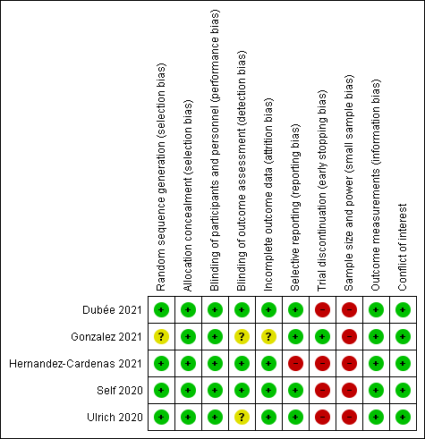
Fig. S11. Risk of bias assessment on the use of hydroxychloroquine as treatment for hospitalized patients with COVID-19.

Table S9. Individual results of studies evaluating the efficacy and safety of hydroxychloroquine as treatment for hospitalized patients with COVID-19.
Author | Days of hospitalization | Mechanical ventilation | Death | Any adverse events | Conclusion
Dubée  2021 | - | 14 days  HCQ: 3/124 (2.4%)  Placebo: 3/123 (2.4%)  28 days  HCQ: 3/124 (2.4%)  Placebo: 4/123 (3.3%) | 14 days  HCQ: 6/124 (4.8%)  Placebo: 6/123 (4.9%)  28 days  HCQ: 6/124 (4.8%)  Placebo: 11/123 (8.9%) | 28 days  HCQ: 70/124 (56.5%)  Placebo: 61/120 (50.8%) | “Patients treated with hydroxychloroquine did not experience better clinical or virological outcomes than those receiving the placebo.”
Hernandez-Cardenas  2021 | HCQ: 17.8 ± 11.0 days*  Placebo: 18.1 ± 12.0 days | - | 30 days  HCQ: 40/106 (37.7%)  Placebo: 44/108 (40.7%) | Data on adverse events were unclear and could not be extracted | “No beneficial effect or significant harm could be demonstrated in our randomized controlled trial including 214 patients, using relatively low doses of HCQ compared with placebo in hospitalized patients with severe COVID-19.”
Gonzalez  2021 | HCQ: 7 (3 – 9) days**  Placebo: 5 (4 –7) days | - | 30 days  HCQ: 2/33 (6.1%)  Placebo: 6/37 (16.2%) | Data on adverse events were unclear and could not be extracted | “In non-critical hospitalized patients with COVID-19 pneumonia, neither ivermectin nor hydroxychloroquine decreases the number of in-hospital days, respiratory deterioration, or deaths.”
Ulrich  2020 | HCQ: 9.8 ± 10.3 days*  Placebo: 6.8 ± 5.9 days | 14 days  HCQ: 5/67 (7.5%)  Placebo: 4/61 (6.6%)  30 days  HCQ: 5/67 (7.5%)  Placebo: 3/61 (4.9%) | 14 days  HCQ: 3/67 (4.5%)  Placebo: 5/61 (8.2%)  30 days  HCQ: 7/67 (10.4%)  Placebo: 6/61 (9.8%) | 30 days  HCQ: 38/67 (56.7%)  Placebo: 36/61 (59.0%) | “In hospitalized patients with COVID-19, our data suggest that HCQ does not prevent severe outcomes or improve clinical scores.”
Self  2020 | - | 14 days  HCQ: 18/242 (7.4%)  Placebo: 24/237 (10.1%)  28 days  HCQ: 11/242 (4.5%)  Placebo: 12/237 (5.1%) | 14 days  HCQ: 18/242 (7.4%)  Placebo: 14/237 (5.9%)  28 days  HCQ: 25/242 (10.3%)  Placebo: 25/237 (10.5%) | 28 days  HCQ: 14/242 (5.8%)  Placebo: 11/237 (4.6%) | “These findings do not support the use of hydroxychloroquine for treatment of COVID-19 among hospitalized adults.”
HCQ, hydroxychloroquine. * Data were reported in mean and standard deviation. ** Data were reported in median and interquartile range.

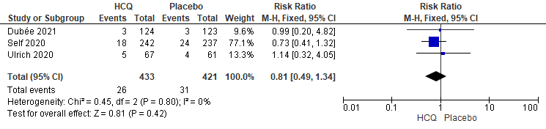
Fig. S12. Forest plot showing the risk of mechanical ventilation at two weeks for hospitalized COVID-19 patients
treated with hydroxychloroquine.

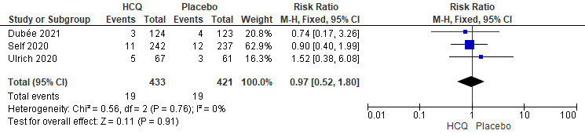
Fig. S13. Forest plot showing the risk of mechanical ventilation at four weeks for hospitalized COVID-19 patients
treated with hydroxychloroquine.

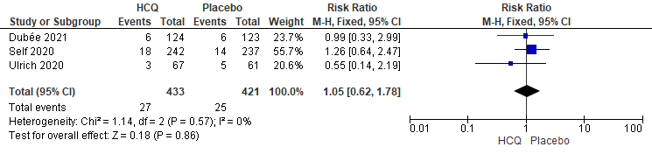
Fig. S14. Forest plot showing the risk of death at two weeks for hospitalized COVID-19 patients
treated with hydroxychloroquine.

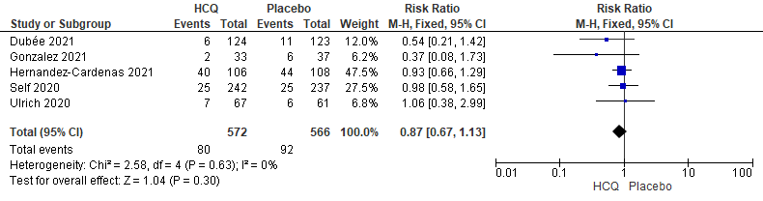
Fig. S15. Forest plot showing the risk of death at four weeks for hospitalized COVID-19 patients
treated with hydroxychloroquine.

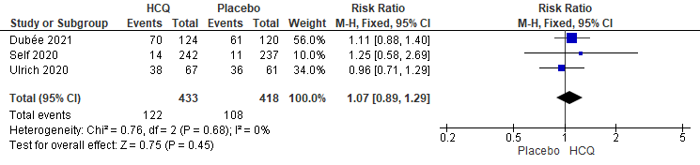
Fig. S16. Forest plot showing the risk of any adverse events for hospitalized COVID-19 patients
treated with hydroxychloroquine.

Table S10. Sensitivity analysis of studies evaluating the efficacy and safety of hydroxychloroquine as treatment for hospitalized patients with COVID-19.
Outcomes | RR (95% CI) | I² | Risk of bias | Inconsistency | Indirectness | Imprecision | Influence of  small trials | Large effect | Quality of evidence
Death (4 weeks)
Peer-reviewed studies | 0.88 (0.58 to 1.33) | 0% | Not serious | Not serious | Not serious | Serious | Not serious | No | ⨁⨁⨁◯
Non-peer reviewed studies | 0.80 (0.42 to 1.55) | 24% | Not serious | Not serious | Not serious | Serious | Not serious | No | ⨁⨁⨁◯
Certainty: ⨁ very-low; ⨁⨁ low; ⨁⨁⨁ moderate; ⨁⨁⨁⨁ high.

Risk of adverse events for individuals using hydroxychloroquine compared to placebo

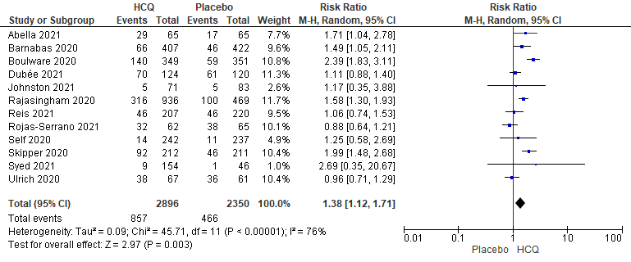
Fig. S17. Forest plot showing the risk of any adverse events for patients treated with hydroxychloroquine.

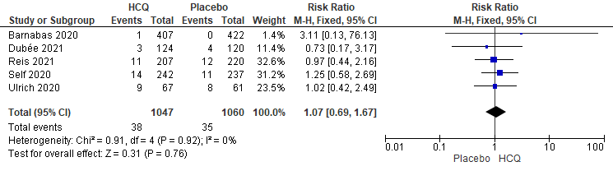

Fig. S18. Forest plot showing the risk of serious adverse events for patients treated with hydroxychloroquine.

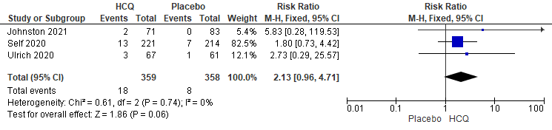
Fig. S19. Forest plot showing the risk of QTc interval > 500ms for patients treated with hydroxychloroquine.

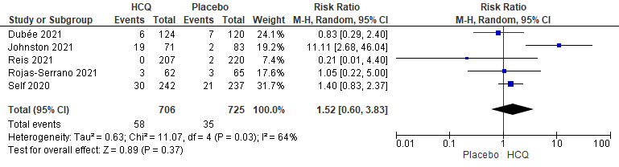
Fig. S20. Forest plot showing the risk of cardiac manifestations for patients treated with hydroxychloroquine.

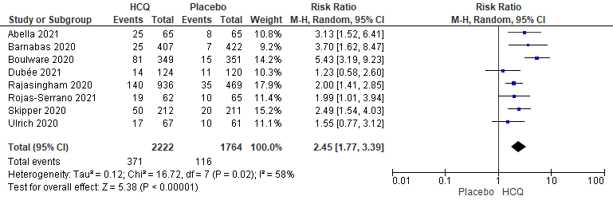
Fig. S21. Forest plot showing the risk of gastrointestinal symptoms for patients treated with hydroxychloroquine.

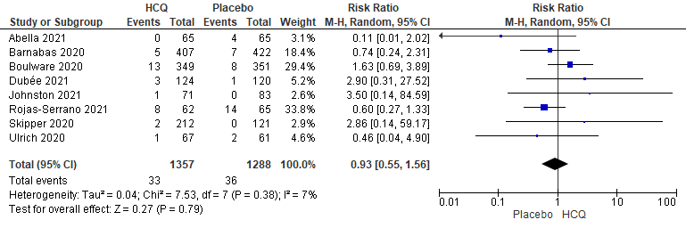
Fig. S22. Forest plot showing the risk of headache for patients treated with hydroxychloroquine.

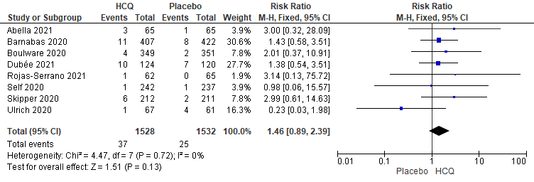
Fig. S23. Forest plot showing the risk of skin rash for patients treated with hydroxychloroquine.

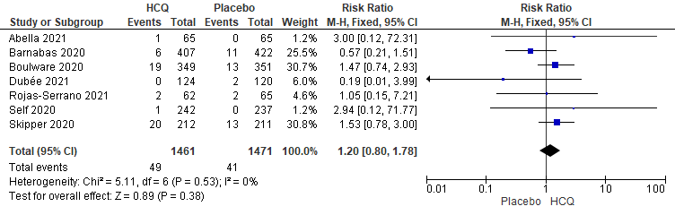
Fig. S24. Forest plot showing the risk of neurologic reactions for patients treated with hydroxychloroquine.

PRISMA 2020 Checklist.

Section and Topic | Item # | Checklist item | Location where item is reported
TITLE
Title | 1 | Identify the report as a systematic review. | Page 1
ABSTRACT
Abstract | 2 | See the PRISMA 2020 for Abstracts checklist. | Page 2
INTRODUCTION
Rationale | 3 | Describe the rationale for the review in the context of existing knowledge. | Page 3
Objectives | 4 | Provide an explicit statement of the objective(s) or question(s) the review addresses. | Page 3
METHODS
Eligibility criteria | 5 | Specify the inclusion and exclusion criteria for the review and how studies were grouped for the syntheses. | Page 4
Information sources | 6 | Specify all databases, registers, websites, organisations, reference lists and other sources searched or consulted to identify studies. Specify the date when each source was last searched or consulted. | Page 3
Search strategy | 7 | Present the full search strategies for all databases, registers and websites, including any filters and limits used. | Suppl
Selection process | 8 | Specify the methods used to decide whether a study met the inclusion criteria of the review, including how many reviewers screened each record and each report retrieved, whether they worked independently, and if applicable, details of automation tools used in the process. | Page 4
Data collection process | 9 | Specify the methods used to collect data from reports, including how many reviewers collected data from each report, whether they worked independently, any processes for obtaining or confirming data from study investigators, and if applicable, details of automation tools used in the process. | Page 4
Data items | 10a | List and define all outcomes for which data were sought. Specify whether all results that were compatible with each outcome domain in each study were sought (e.g. for all measures, time points, analyses), and if not, the methods used to decide which results to collect. | Page 4
Data items | 10b | List and define all other variables for which data were sought (e.g. participant and intervention characteristics, funding sources). Describe any assumptions made about any missing or unclear information. | Page 4
Study risk of bias assessment | 11 | Specify the methods used to assess risk of bias in the included studies, including details of the tool(s) used, how many reviewers assessed each study and whether they worked independently, and if applicable, details of automation tools used in the process. | Page 5
Effect measures | 12 | Specify for each outcome the effect measure(s) (e.g. risk ratio, mean difference) used in the synthesis or presentation of results. | Page 5
Synthesis methods | 13a | Describe the processes used to decide which studies were eligible for each synthesis (e.g. tabulating the study intervention characteristics and comparing against the planned groups for each synthesis (item #5)). | Page 5
Synthesis methods | 13b | Describe any methods required to prepare the data for presentation or synthesis, such as handling of missing summary statistics, or data conversions. | Page 5
Synthesis methods | 13c | Describe any methods used to tabulate or visually display results of individual studies and syntheses. | Page 5
Synthesis methods | 13d | Describe any methods used to synthesize results and provide a rationale for the choice(s). If meta-analysis was performed, describe the model(s), method(s) to identify the presence and extent of statistical heterogeneity, and software package(s) used. | Page 5
Synthesis methods | 13e | Describe any methods used to explore possible causes of heterogeneity among study results (e.g. subgroup analysis, meta-regression). | Page 5
Synthesis methods | 13f | Describe any sensitivity analyses conducted to assess robustness of the synthesized results. | Page 6
Reporting bias assessment | 14 | Describe any methods used to assess risk of bias due to missing results in a synthesis (arising from reporting biases). | Page 6
Certainty assessment | 15 | Describe any methods used to assess certainty (or confidence) in the body of evidence for an outcome. | Page 6
RESULTS
Study selection | 16a | Describe the results of the search and selection process, from the number of records identified in the search to the number of studies included in the review, ideally using a flow diagram. | Page 7,  Fig 1
Study selection | 16b | Cite studies that might appear to meet the inclusion criteria, but which were excluded, and explain why they were excluded. | Fig 1
Study characteristics | 17 | Cite each included study and present its characteristics. | Pages 7-9, Suppl
Risk of bias in studies | 18 | Present assessments of risk of bias for each included study. | Pages 7-9, Suppl
Results of individual studies | 19 | For all outcomes, present, for each study: (a) summary statistics for each group (where appropriate) and (b) an effect estimate and its precision (e.g. confidence/credible interval), ideally using structured tables or plots. | Pages 7-9, Suppl
Results of syntheses | 20a | For each synthesis, briefly summarise the characteristics and risk of bias among contributing studies. | Pages 7-9, Suppl
Results of syntheses | 20b | Present results of all statistical syntheses conducted. If meta-analysis was done, present for each the summary estimate and its precision (e.g. confidence/credible interval) and measures of statistical heterogeneity. If comparing groups, describe the direction of the effect. | Pages 7-9, Suppl
Results of syntheses | 20c | Present results of all investigations of possible causes of heterogeneity among study results. | Pages 7-9, Suppl
Results of syntheses | 20d | Present results of all sensitivity analyses conducted to assess the robustness of the synthesized results. | Pages 7-9, Suppl
Reporting biases | 21 | Present assessments of risk of bias due to missing results (arising from reporting biases) for each synthesis assessed. | Pages 7-9, Suppl
Certainty of evidence | 22 | Present assessments of certainty (or confidence) in the body of evidence for each outcome assessed. | Pages 7-9, Suppl
DISCUSSION
Discussion | 23a | Provide a general interpretation of the results in the context of other evidence. | Pages 10-12
Discussion | 23b | Discuss any limitations of the evidence included in the review. | Page 12
Discussion | 23c | Discuss any limitations of the review processes used. | Page 12
Discussion | 23d | Discuss implications of the results for practice, policy, and future research. | Page 12
OTHER INFORMATION
Registration and protocol | 24a | Provide registration information for the review, including register name and registration number, or state that the review was not registered. | -
Registration and protocol | 24b | Indicate where the review protocol can be accessed, or state that a protocol was not prepared. | -
Registration and protocol | 24c | Describe and explain any amendments to information provided at registration or in the protocol. | -
Support | 25 | Describe sources of financial or non-financial support for the review, and the role of the funders or sponsors in the review. | Page 12
Competing interests | 26 | Declare any competing interests of review authors. | Page 12
Availability of data, code and other materials | 27 | Report which of the following are publicly available and where they can be found: template data collection forms; data extracted from included studies; data used for all analyses; analytic code; any other materials used in the review. | Suppl
From: Page MJ, McKenzie JE, Bossuyt PM, Boutron I, Hoffmann TC, Mulrow CD, et al. The PRISMA 2020 statement: an updated guideline for reporting systematic reviews. BMJ 2021;372:n71. doi: 10.1136/bmj.n71

