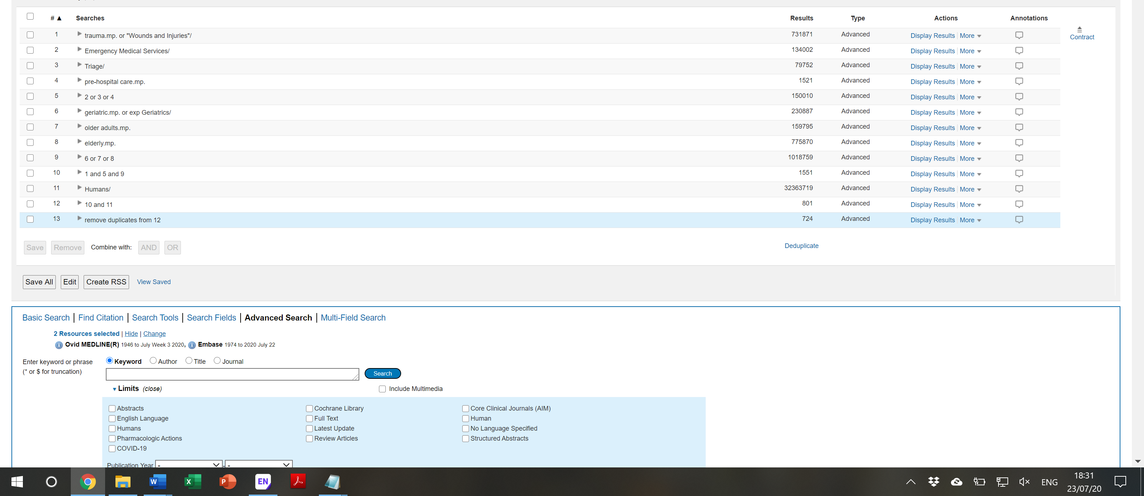
Supplementary File 1 Screenshot of search

