Rhythm monitoring strategies for atrial fibrillation detection in patients with cryptogenic stroke: a systematic review and meta-analysis

APPENDIX

List of supplementary tables and figures
Supplementary Table 1. Search strategies 3
Supplementary Table 2. Summarized study characteristics 5
Supplementary Table 3. General characteristics of included studies 6
Supplementary Table 4. Clinical characteristics of participants in the included studies 16
Supplementary Table 5. Risk of bias assessment 18
Supplementary Table 6. Potential predictors of atrial fibrillation detection in patients with cryptogenic stroke or ESUS 20
Supplementary Table 7. Atrial fibrillation detection rates with non-invasive cardiac monitoring in patients with cryptogenic stroke 24
Supplementary Figure 1. Study selection 27
Supplementary Figure 2. Rates of atrial fibrillation detected by implantable cardiac monitor at 3 months in patients with cryptogenic stroke versus ESUS 28
Supplementary Figure 3. Rates of atrial fibrillation detected by implantable cardiac monitor at 6 months in patients with cryptogenic stroke versus ESUS 29
Supplementary Figure 4. Rates of atrial fibrillation detected by implantable cardiac monitor at 12 months in patients with cryptogenic stroke versus ESUS 30
Supplementary Figure 5. Rates of atrial fibrillation detected by implantable cardiac monitor at 24 months in patients with cryptogenic stroke versus ESUS 31
Supplementary Figure 6. Rates of atrial fibrillation detected by implantable cardiac monitor at 3 months according to minimal duration of atrial fibrillation episode 32
Supplementary Figure 7. Rates of atrial fibrillation detected by implantable cardiac monitor at 6 months according to minimal duration of atrial fibrillation episode 33
Supplementary Figure 8. Rates of atrial fibrillation detected by implantable cardiac monitor at 9 months according to minimal duration of atrial fibrillation episode 34
Supplementary Figure 9. Rates of atrial fibrillation detected by implantable cardiac monitor at 12 months according to minimal duration of atrial fibrillation episode 35
Supplementary Figure 10. Rates of atrial fibrillation detected by implantable cardiac monitor at 24 months according to minimal duration of atrial fibrillation episode 36
Supplementary Figure 11. Rates of atrial fibrillation detected by implantable cardiac monitor at 3 months by device type 37
Supplementary Figure 12. Rates of atrial fibrillation detected by implantable cardiac monitor at 6 months by device type 38
Supplementary Figure 13. Rates of atrial fibrillation detected by implantable cardiac monitor at 12 months by device type 39
Supplementary Figure 14. Rates of atrial fibrillation detected by implantable cardiac monitor at 24 months by device type 40
Supplementary Figure 15. Funnel plot for the meta-analysis of rates of atrial fibrillation detected by implantable cardiac monitor at 3 months in patients with cryptogenic stroke 41
Supplementary Figure 16. Funnel plot for the meta-analysis of rates of atrial fibrillation detected by implantable cardiac monitor at 6 months in patients with cryptogenic stroke 42
Supplementary Figure 17. Funnel plot for the meta-analysis of rates of atrial fibrillation detected by implantable cardiac monitor at 12 months in patients with cryptogenic stroke 43
Supplementary Figure 18. Funnel plot for studies reporting atrial fibrillation detection rates at 24 months on implantable cardiac monitor in patients with cryptogenic stroke 44
Supplementary Figure 19. Meta-regression of atrial fibrillation detection rates at 3 months on implantable cardiac monitor in patients with cryptogenic stroke 45
Supplementary Figure 20. Metaregression of atrial fibrillation detection rates at 6 months on implantable cardiac monitor in patients with cryptogenic stroke 46
Supplementary Figure 21. Metaregression of atrial fibrillation detection rates at 12 months on implantable cardiac monitor in patients with cryptogenic stroke 47
Supplementary Figure 22. Metaregression of atrial fibrillation detection rates at 24 months on implantable cardiac monitor in patients with cryptogenic stroke 48
Supplementary Figure 23. Influencer analysis of AF detection rates at 3 months on implantable cardiac monitor in patients with cryptogenic stroke 49
Supplementary Figure 24. Influencer analysis of AF detection rates at 6 months on implantable cardiac monitor in patients with cryptogenic stroke 50
Supplementary Figure 25. Influencer analysis of AF detection rates at 12 months on implantable cardiac monitor in patients with cryptogenic stroke 51
Supplementary Figure 26. Influencer analysis of AF detection rates at 24 months on implantable cardiac monitor in patients with cryptogenic stroke 52
Supplementary Figure 27. Influencer analysis of the univariable association between female sex and AF detection in patients with cryptogenic stroke 53
List of included studies 54

Supplementary Table 1. Search strategies
 | Search strategy for PubMed
#P1 | Holter OR electrocardiography OR electrocardiogram OR electrocardiographic OR ECG OR EKG OR telemetry OR telemetric OR “loop recorder” OR “loop recording” OR “cardiac monitor”
#P2 | “cryptogenic stroke” OR “embolic stroke of undetermined source” OR ESUS OR “cryptogenic transient ischemic attack” OR “cryptogenic transient ischaemic attack” OR “cryptogenic TIA” OR “cryptogenic cerebrovascular event” OR “cryptogenic CVA” OR “cryptogenic cerebral infarct” OR “cryptogenic brain infarct” OR “stroke of undetermined etiology” OR “stroke of undetermined aetiology” OR “stroke of undetermined cause”
#P3 | “atrial fibrillation” OR “auricular fibrillation” OR “AF” OR “Afib” OR “atrial flutter” OR tachyarrhythmia OR arrhythmia
#P4 | #P1 AND #P2 AND #P3
 | Search strategy for EMBASE
#E1 | holter:ab,ti OR electrocardiography:ab,ti OR electrocardiogram:ab,ti OR electrocardiographic:ab,ti OR ecg:ab,ti OR ekg:ab,ti OR telemetry:ab,ti OR telemetric:ab,ti OR 'loop recorder':ab,ti OR 'loop recording':ab,ti OR 'cardiac monitor':ab,ti
#E2 | 'cryptogenic stroke':ab,ti OR 'embolic stroke of undetermined source':ab,ti OR esus:ab,ti OR 'cryptogenic transient ischemic attack':ab,ti OR 'cryptogenic transient ischaemic attack':ab,ti OR 'cryptogenic tia':ab,ti OR 'cryptogenic cerebrovascular event':ab,ti OR 'cryptogenic cva':ab,ti OR 'cryptogenic cerebral infarct':ab,ti OR 'cryptogenic brain infarct':ab,ti OR 'stroke of undetermined etiology':ab,ti OR 'stroke of undetermined aetiology':ab,ti OR 'stroke of undetermined cause':ab,ti
#E3 | 'atrial fibrillation':ab,ti OR 'auricular fibrillation':ab,ti OR af:ab,ti OR afib:ab,ti OR 'atrial flutter':ab,ti OR tachyarrhythmia:ab,ti OR arrhythmia:ab,ti
#E4 | holter:ab,ti OR electrocardiography:ab,ti OR electrocardiogram:ab,ti OR electrocardiographic:ab,ti OR ecg:ab,ti OR ekg:ab,ti OR telemetry:ab,ti OR telemetric:ab,ti OR 'loop recorder':ab,ti OR 'loop recording':ab,ti OR 'cardiac monitor':ab,ti
#E5 | #E1 AND #E2 AND #E3 AND #E4
 | Search strategy for Web of Science
#W1 | Holter OR electrocardiography OR electrocardiogram OR electrocardiographic OR ECG OR EKG OR telemetry OR telemetric OR “loop recorder” OR “loop recording” OR “cardiac monitor”
#W2 | “cryptogenic stroke” OR “embolic stroke of undetermined source” OR ESUS OR “cryptogenic transient ischemic attack” OR “cryptogenic transient ischaemic attack” OR “cryptogenic TIA” OR “cryptogenic cerebrovascular event” OR “cryptogenic CVA” OR “cryptogenic cerebral infarct” OR “cryptogenic brain infarct” OR “stroke of undetermined etiology” OR “stroke of undetermined aetiology” OR “stroke of undetermined cause”
#W3 | “atrial fibrillation” OR “auricular fibrillation” OR “AF” OR “Afib” OR “atrial flutter” OR tachyarrhythmia OR arrhythmia
#W4 | #W1 AND #W2 AND #W3

Supplementary Table 2. Summarized study characteristics
Characteristics | N = 47
Total population | 8 215
Year of publication, range | 2008-2020
Period of inclusion of participants, range | 2003-2019
Design
- Cohort | 42
- Randomized controlled trial | 5
Data collection
- Prospective | 35
- Retrospective | 12
Regions
- Europe | 26
- Northern America | 17
- Asia | 2
- Multiregional | 2
Countries
- US | 16
- Germany | 9
- Spain | 5
- Italy | 4
- France | 3
- Multinational | 2
- Japan | 1
- Canada | 1
- Finland | 1
- UK | 1
- Portugal | 1
- Denmark | 1
- Singapore | 1
Sampling
- Consecutive | 42
- Random | 5
Risk of bias
- Low | 28
- Moderate | 18
- High | 1

Supplementary Table 3. General characteristics of included studies
Author | Year | Recruitment Period | Country | Design | Sampling | Data Collection | Population | Etiological Investigations | Definition CS | Diagnostic Modality (AF) | Device | AF Diagnostic Criteria | Mean/Median time from stroke to monitoring initiation | Mean/Median Recording Duration | Mean/Median Time to AF diagnosis  (days) | Sample Size
Chorin | 2020 | 2014-2018 | USA | Cohort | Consecutive | Retrospective | Cryptogenic stroke/TIA | NR | NR | ICM | Reveal LINQ and TruRhythm LINQ | AF duration > 30 s | NR | 28 (SD 12) months | 7.4 (12.3) months | 145
Jordan | 2019 | NR | USA | Cohort | Consecutive | Prospective | ESUS | Neuroimaging, 12-lead EKG, transthoracic echocardiography (TTE), and cardiac telemetry monitoring for at least 24 hours, laboratory testing | NR | MCOT | NR | AF duration > 30 s | NR | 28 days | NR | 99
Riordan | 2020 | 2013-2018 | USA | Cohort | Consecutive | Retrospective | Cryptogenic stroke | Electrocardiographic and telemetry monitoring, transesophageal echocardiography, laboratory testing for thrombophilia, and imaging studies of the head and neck vasculature often including magnetic resonance imaging | NR | ICM | Reveal LINQ | AF duration > 120 s | Within 30 days | 22 (SD 12) months | NR | 293
Tayal | 2008 | 2006-2007 | USA | Cohort | Consecutive | Retrospective | Cryptogenic stroke/TIA | Brain imaging, admission ECG, inpatient cardiac telemetry monitoring or 24-hour Holter, MRA or CTA head and neck, transthoracic or transesophageal echocardiography | TOAST criteria | MCOT | CardioNet | AF duration > 30 s | NR | 21 (range 5-21) days | NR | 56
Flint | 2012 | 2008-2011 | USA | Cohort | Consecutive | Prospective | Cryptogenic stroke | NR | NR | MCOT | CardioPAL SAVI | AF duration > 30 s | NR | 28 (IQR 20-30) days | NR | 239
Gaillard | 2010 | 2003-2006 | France | Cohort | Consecutive | Retrospective | Cryptogenic stroke | Brain imaging, 24-hour Holter ECG, cervical artery duplex ultrasound, transthoracic or transesophageal echocardiography | NR | Transtelephonic ECG (at least daily ECG) | Cardiomemo | AF duration > 30 s | NR | 1 month | NR | 82
Miller | 2013 | 2009-2011 | USA | Cohort | Consecutive | Retrospective | Cryptogenic stroke | Brain imaging, transthoracic or transesophageal echocardiography | TOAST criteria | MCOT | CardioNet | AF duration > 30 s | 32.7 (SD 36) days | 21 (range 1-20) days | 8.8 days | 118
Ziegler | 2017 | 2014-2016 | USA | Cohort | Consecutive | Retrospective | Cryptogenic stroke | NR | NR | ICM | Reveal LINQ | AF duration > 120 s | NR | 579 (SD 222) days | NR | 1247
Yayehd | 2015 | 2011-2012 | France | Cohort | Consecutive | Prospective | Cryptogenic stroke | Brain imaging, 24-hour ECG recording, biological tests, transthoracic echocardiography and carotid Doppler assessment; transoesophageal echocardiography and limb venous Doppler assessment if required. | NR | MCOT | SpiderFlash | AF duration > 30 s | 34 (range 22-57) days | 20 (SD 3) days | NR | 39
Watson | 2020 | 2012-2019 | USA | Cohort | Consecutive | Prospective | Cryptogenic stroke | Brain imaging, CTA or MRA of the head and neck by computed, transthoracic/transesophageal echocardiography cardiac telemetry, electrocardiography, and basic lab testing | NR | ICM | Reveal LINQ | AF duration > 120 s | 21 days | NR | NR | 227
Seow | 2018 | 2014-2017 | Singapore | Cohort | Consecutive | Prospective | Cryptogenic stroke | Brain imaging, 12-lead ECG, 24-hour in-hospital ECG monitoring, 24-hour outpatient ECG Holter, transthoracic echocardiography, ultrasonography of cervical arteries and transcranial Doppler ultrasonography of intracranial vessels | NR | ICM | Reveal LINQ | AF duration > 120 s | 66 days | 345 (SD 229) days | 50 days | 71
Sanna | 2014 | 2009-2012 | Europe, USA, Canada | Cohort | Random | Prospective | Cryptogenic stroke/TIA | Brain imaging, 12-lead ECG, 24 hours or more of ECG monitoring, screening for thrombophilic states (in patients <55 years of age), transesophageal echocardiography, ultrasonography of cervical arteries and transcranial Doppler ultrasonography of intracranial vessels or MRA/CTA of head and neck | NR | ICM | Reveal XT | AF duration > 30 s | Within 10 days after randomization which occurred at a mean of 38.1 (SD 27.6) days | NR | NR | 221
Rojo-Martinez | 2013 | NR | Spain | Cohort | Consecutive | Prospective | ESUS | 24-hours ECG monitoring, transthoracic echocardiography, screening for thrombophilic states (under 55 years of age), transcranial and neck Doppler ultrasound, magnetic resonance angiography, computed tomography angiography of the head and neck | NR | ICM | Reveal XT | AF duration > 120 s | NR | 281 (212) days | 102 (range 26-240) | 101
Ritter | 2013 | 2010-2012 | Germany | Cohort | Consecutive | Prospective | Cryptogenic stroke | Brain imaging, Duplex ultrasound, and computed tomography angiography or magnetic resonance angiography of brain-supplying arteries, routine ECG, 72-hour continuous rhythm monitoring on the stroke unit and manual reevaluation of the signal, and additional 24-h Holter ECG | TOAST criteria | ICM | Reveal XT | AF duration > 30 s | 13 (IQR 10-67) days | 382 (IQR 89-670) days | 64 (range 1-556) days | 60
Rabenstein | 2013 | 2009-2011 | USA | Cohort | Consecutive | Prospective | Cryptogenic stroke | NR | The Causative Classification of Stroke system | MCOT | CardioNet | AF duration > 30 s | Within about 3 months | 21 days | 3 (range 0-20) days | 64
Pecha | 2020 | 2014-2018 | Germany | Cohort | Consecutive | Retrospective | Cryptogenic stroke | Brain imaging, vascular ultrasound of carotid arteries, echo and 24 h-Holter ECG | NR | ICM | Reveal XT | AF duration > 30 s | NR | 419 (309) days | NR | 64
Öner | 2020 | 2016-2018 | Germany | Cohort | Consecutive | Prospective | Cryptogenic stroke | Brain imaging, CTangiography of the head and neck, duplex ultrasonography of extra- and intracranial brain supplying arteries, resting electrocardiogram (ECG), 24-h Holter-ECG, and 72-h ECG-monitoring on the stroke unit, transthoracic or transesophageal echocardiography, screening for thrombophilic states or vasculitis | NR | ICM | Biomonitor2-AF, Reveal LINQ, Reveal XT, SJM confirm | NR | NR | 21.5 (range: 1–33) months | NR | 88
Milstein | 2020 | NR | USA | Cohort | Consecutive | Prospective | Cryptogenic stroke | Brain imaging, MRA, transthoracic echocardiogram, and/or transesophageal echocardiogram, in-hospital telemetry | NR | ICM | Reveal LINQ | AF duration > 120 s | 3.7 (SD 1.7) days | 30 days | 121 (101) days | 343
Manina | 2014 | 2009-2011 | Italy | Cohort | Consecutive | Prospective | Cryptogenic stroke/TIA | Brain imaging, 12-lead ECG, 24-hour ECG monitoring | NR | 96-hour Holter | Spider View recorder | AF of any duration | Within the first 30 days | 4 days | NR | 114
Lumikari | 2019 | NR | Finland | Cohort | Consecutive | Prospective | ESUS | Brain imaging, CT‐ or MR‐angiography, transthoracic/transoesophageal echocardiography, electrocardiography, 24‐ or 48‐hr ECG monitoring | NR | MCOT | Bittium Faros | AF duration > 30 s | 8 (IQR 4-44) days | 4 weeks | NR | 57
Kass-Hout | 2018 | 2009-2013 | USA | Cohort | Consecutive | Retrospective | Cryptogenic stroke/TIA | Brain imaging, noninvasive angiography, echocardiography, electrocardiography, inpatient telemetry, hematologic, and inflammatory tests | TOAST criteria | MCOT | NR | AF duration > 30 s | NR | 25 days | NR | 132
Kalani | 2015 | 2009-2014 | USA | Cohort | Consecutive | Retrospective | Cryptogenic stroke | Brain imaging, 12-lead ECG, MR angiography or computed tomography angiography of head and neck vessels, transthoracic/transoesophageal echocardiography | TOAST criteria | MCOT | Lifestar ACT, Lifestar AF Express or Cardiomedix | AF duration > 30 s | 10 days | 30 days | NR | 85
Jorfida | 2014 | 2010-2013 | Italy | Cohort | Consecutive | Prospective | ESUS | 12-lead ECG, 48 h of inhospital continuous telemetry, 24 h Holter monitoring, transthoracic echocardiography, cerebral computed tomography (CT) or MRI scans, carotid and vertebro-basilar systems ultrasound or angio-MRI, haematological and inflammatory tests | A-S-C-O and TOAST criteria | ICM | Reveal Plus XT 9526 | AF duration > 300 s | NR | 14.5 (IQR 8.7–22.5) months | NR | 54
Iwata | 2019 | 2016-2018 | Japan | Cohort | Consecutive | Prospective | ESUS | Brain imaging, 12-lead ECG, 7 days cardiac monitoring, ambulatory ECG monitoring using a monitor for at least 24 hours, angiography of carotid/intracranial arteries and echocardiography | A-S-C-O classification of stroke | ICM | Reveal LINQ | AF duration > 120 s | 31.5 (range: 1-318) days | 221.5 (range: 93-365) days | NR | 84
Israel | 2017 | 2013-2015 | Germany | Cohort | Consecutive | Prospective | ESUS | Brain imaging, 12-lead electrocardiography, ultrasound of brain-supplying arteries, and transthoracic and transoesophageal echocardiographic, 24-72 hour Holter | TOAST criteria | ICM | BioMonitor or Reveal XT | AF duration > 120 s | 20 days | 12.7 (SD5.5) months | NR | 123
Gladstone | 2014 | 2009-2011 | Canada | RCT | Random | Prospective | Cryptogenic stroke/TIA | 12-lead ECG, ambulatory ECG monitoring with the use of a Holter monitor for a minimum of 24 hours, brain and neurovascular imaging, and echocardiography | TOAST criteria | MCOT | ER910AF Cardiac Event Monitor, Braemar | AF duration > 30 s | NR | 90 days | NR | 571
Fonseca | 2013 | 2009-2012 | Portugal | Cohort | Consecutive | Prospective | Cryptogenic stroke | Brain imaging, 12-lead electrocardiography, transcranial Doppler, carotid and vertebral duplex scanning, and transthoracic echocardiographic, 24-hour Holter | TOAST criteria | Post-stroke F/U with 24-h Holter at 3 and 6 months | NR | AF duration > 30 s | NR | NR | NR | 80
De Angelis | 2020 | 2016-2019 | Italy | Cohort | Consecutive | Prospective | Cryptogenic stroke | 24-hours ECG monitoring, transthoracic echocardiography, screening for thrombophilic states (under 55 years of age), transcranial and neck Doppler ultrasound, magnetic resonance angiography, computed tomography angiography of the head and neck | NR | ICM | Reveal LINQ | AF duration > 120 s | 83 (SD 64) days | NR | 6 months | 58
Cotter | 2013 | 2010-2011 | UK | Cohort | Consecutive | Prospective | Cryptogenic stroke | Brain imaging, 12-lead electrocardiography, transthoracic or transesophageal echocardiography, and cardiac monitoring at least for 24 hours | TOAST criteria | ICM | Reveal XT | AF duration > 120 s | 174 (134) days | NR | 48 (34-118) days | 51
Christensen | 2014 | 2010-2012 | Denmark | Cohort | Consecutive | Prospective | Cryptogenic stroke/TIA | NR | NR | ICM | Reveal XT | AF duration > 120 s | 107 (SD 117) days | 569 (310) days | NR | 87
Asaithambi | 2018 | 2014-2017 | USA | Cohort | Consecutive | Prospective | Cryptogenic stroke | NR | NR | ICM | Reveal LINQ | NR | 4 days | 536 (282-848) days | 94.5 (16-239) days | 234
Victor | 2018 | 2013-2017 | Spain | Cohort | Consecutive | Prospective | ESUS | Blood tests, chest X-ray, supra-aortic vessels echo-Doppler, transcranial Doppler, and CT angiography or angio-MRI, if needed. A 12 lead Electrocardiogram (ECG) was also performed, 24-hour Holter monitoring, transthoracic or transesophageal echocardiogram or thrombophilia screening (in subjects under 55 years) | NR | ICM | Reveal XT or Reveal LINQ | AF duration > 30 s (Reveal XT) or 120 s (Reveal LINQ) | 56 days | 17.1 (SD10.7) months | 31 days | 65
Thijs | 2016 | 2009-2012 | Multinational | RCT | Random | Prospective | Cryptogenic stroke/TIA | 12-lead ECG, 24-hour ECG monitoring (Holter or telemetry), transesophageal echocardiography, screening for thrombophilic states (in patients younger than 55 years), and detailed vascular imaging | NR | ICM | Reveal XT | NR | NR | NR | NR | 221
Poli | 2016 | 2012-2014 | Germany | Cohort | Consecutive | Prospective | Cryptogenic stroke/TIA | computed tomography, including CT angiography, or magnetic resonance imaging, including MR angiography, neurosonology, transesophageal echocardiography, ECG monitoring for 72 h plus at least one 24 h Holter ECG recording, and screening for thrombophilia (in patients <55 years) | TOAST criteria | ICM | Reveal XT or Reveal LINQ | AF duration > 120 s | 27 (SD 24) days | 311 (SD 251) days | 105 (SD 135) days | 75
Pagola | 2020 | 2015-2017 | Spain | Cohort | Consecutive | Prospective | Cryptogenic stroke | Brain imaging, 12-lead electrocardiography, CT angiography, transthoracic echocardiography | NR | MCOT | wearable Holter (Nuubo System®) | No cutoff | 2 to 3 days | 28 days | NR | 264
Mendieta | 2020 | 2015-2017 | Spain | Cohort | Consecutive | Retrospective | ESUS | Brain imaging (CT and MRI), CT/MR angiography or ultrasonography, twelve-lead electrocardiography, transthoracic or transesophageal echocardiography, and cardiac monitoring at least for 72 hours | TOAST criteria | Post-stroke F/U (1, 6, 12 by neurologist and every 6 months by GP ) with ECG or MCOT | NR | AF duration > 30 s | NR | 521 (SD306) days | NR | 75
Bugnicourt | 2013 | NR | France | Cohort | Consecutive | Prospective | Cryptogenic stroke | Computed tomography, electrocardiogram, Doppler ultrasonography of neck vessels, transthoracic echocardiography, and standard laboratory tests in all patients; Holter ECG monitoring, magnetic resonance imaging , and/or angiography were performed in selected patients | A-S-C-O classification of stroke | Post-stroke F/U (6, 12 then yearly) with ECG or MCOT | NR | AF duration > 30 s | NR | 352 (SD105) days | 806 (SD172) days | 164
Ntaios | 2020 | NR | Greece, Switzerland, UK | Cohort | Consecutive | Prospective | ESUS | NR | Cryptogenic Stroke/ESUS International Working Group | Post-stroke F/U (6, 12 then yearly) with ECG or MCOT | NR | No cutoff | NR | 24.3 months | NR | 839
Muller | 2017 | 2013-2015 | Germany | RCT | Consecutive | Prospective | Cryptogenic stroke | Brain imaging, 12-lead electrocardiography, transthoracic or transesophageal echocardiography, and cardiac monitoring at least for 24 hours | TOAST criteria | ICM | Reveal XT | AF duration > 30 s | NR | 331 (SD186) days | 30 days | 90
Makimoto | 2017 | 2011-2016 | Germany | Cohort | Consecutive | Prospective | ESUS | Brain imaging, twelve-lead electrocardiography, transthoracic or transesophageal echocardiography, and cardiac monitoring at least for 24 hours | Cryptogenic Stroke/ESUS International Working Group | ICM | NR | AF duration > 30 s | NR | 387 days | NR | 146
Favilla | 2015 | 2010-2012 | USA | Cohort | Consecutive | Retrospective | Cryptogenic stroke/TIA | Brain imaging (magnetic resonance imaging [MRI] or computed tomography [CT]), echocardiography | TOAST criteria | MCOT | CardioNet MCOT | AF duration > 30 s | NR | 28 days | NR | 227
Carrazco | 2018 | 2013-2015 | USA | Cohort | Consecutive | Retrospective | Cryptogenic stroke | Brain imaging (magnetic resonance imaging [MRI] or computed tomography [CT]), cervical and cerebral vascular imaging (magnetic resonance angiography or computed tomography  angiography), echocardiography (transthoracic and/or transesophageal), a minimum of 24 hours of cardiac telemetry monitoring, ECG, and standard poststroke blood work | Patients with nonlacunar strokes and no identifiable stroke source | ICM | Reveal LINQ ICM (90%) and Reveal XT (10%) | AF duration > 120 s | 4.2 (SD 2.6) days | NR | 108 days | 100
Campal | 2020 | 2016-2018 | Spain | Cohort | Consecutive | Prospective | ESUS | 12-lead ECG, brain and neurovascular imaging (magnetivc resonance imaging or plain computed tomography scan, angio computed tomography scan when needed, transcranial and supra-aortic vessel Doppler ultrasound), routine transthoracic and transesophageal echocardiography and basic biochemical and hematologic determinations | TOAST criteria | 21-days Holter | Textile wearable Holter (Nuubo, Valencia, Spain) | AF duration > 30 s | NR | 21 days | NR | 100
Bhatt | 2011 | 2007-2010 | USA | Cohort | Consecutive | Prospective | Cryptogenic stroke/TIA | MRI scan with DWI imaging, transesophageal echocardiogram, transthoracic echocardiogram, a CT angiogram, EKG on admission and at least 24 hours of cardiac telemetry | NR | MCOT | CardioNet MCOT | AF duration > 30 s | NR | 28 days | NR | 62
Bettin | 2018 | 2010-2014 | Germany | RCT | Random | Prospective | Cryptogenic stroke | cerebral imaging (MRI or CT), a 12-lead ECG recording upon admission, a 24-h-Holter ECG, a duplex and Doppler ultrasound of the carotid and vertebral arteries and a transesophageal echocardiography | TOAST criteria | ICM | Reveal XT | AF duration > 30 s | 35.5 (SD 47.5) days | 24.8(SD11.5) months | 10.7 (SD11.4) months | 173
Acampa | 2019 | NR | Italy | Cohort | Consecutive | Prospective | Cryptogenic stroke | neuroimaging examination (brain computed tomography [CT] with angio-CT scan including the aortic arch and intra-extracranial arteries; and/or brain magnetic resonance imaging), extracranial and transcranial arterial ultrasound examination, transthoracic echocardiography, 12-lead resting ECG at admission | TOAST criteria | 7-day in-hospital telemetry | NR | irregular tachycardia lasting >5 minutes with no visible P wave or with unorganised F wavelets | NR | 7 days | NR | 222
Reinke | 2018 | 2013-2014 | Germany | RCT | Random | Prospective | Cryptogenic stroke | cerebral imaging (MRI or CT), a 12-lead ECG recording upon admission, a 24-h-Holter ECG, a duplex and Doppler ultrasound of the carotid and vertebral arteries and a transesophageal echocardiography | TOAST criteria | ICM | Reveal XT | AF duration > 30 s | Within the first 4 weeks | NR | 31 (IQR 72.5-338) days | 105

NR: not reported; AF: atrial fibrillation; CT: computed tomography; ECG: electrocardiographic; ESUS: embolic stroke of undetermined source; ICM: implantable cardiac monitor; IQR: interquartile range; MCOT: mobile outpatient telemetry; MRI: magnetic resonance imaging; RCT: randomized controlled trial; SD: standard deviation; TIA: transient ischemic attack;

Supplementary Table 4. Clinical characteristics of participants in the included studies
Author | Year | Mean Age | Male (%) | Index Stroke (%) | Index TIA (%) | Recurrent  Stroke/TIA (%) | Hypertension (%) | Diabetes (%) | Dyslipidaemia (%) | Smokers (%) | OSA (%) | CAD (%) | Heart Failure (%)
Chorin | 2020 | 67 | 57 | 83 | 17 | NR | 73 | 27 | NR | NR | NR | 26 | 6
Jordan | 2019 | NR | NR | NR | NR | NR | NR | NR | NR | NR | NR | NR | NR
Riordan | 2020 | 68.7 | 57.3 | NR | NR | 20.5 | 75 | 32.8 | NR | NR | NR | 23.2 | 6.5
Tayal | 2008 | 66 | 51 | 86 | 14 | NR | 77 | 16 | 75 | 36 | NR | 14 | 2
Flint | 2012 | 64.6 | 60.5 | NR | NR | 18.8 | 66 | 14.7 | 90.8 | NR | NR | NR | 4.6
Gaillard | 2010 | NR | NR | NR | NR | NR | NR | NR | NR | NR | NR | NR | NR
Miller | 2013 | 68.5 | 50 | NR | NR | NR | 87 | 42 | 63 | 21 | NR | 24 | 8
Ziegler | 2017 | NR | 53 | NR | NR | NR | NR | NR | NR | NR | NR | NR | NR
Yayehd | 2015 | 47 | 62 | NR | NR | 8 | 20.5 | 3 | 23 | 31 | NR | 3 | NR
Watson | 2020 | 64.7 | 51.5 | NR | NR | NR | 66.8 | NR | 54.3 | NR | NR | NR | NR
Seow | 2018 | 61.9 | 77.5 | NR | NR | NR | 74.7 | 39.4 | NR | NR | NR | NR | NR
Sanna | 2014 | 61.6 | 64.3 | 90.5 | 9.5 | 16.7 | 65.2 | 15.4 | 56.6 | 19.5 | NR | 7.2 | NR
Rojo-Martinez | 2013 | 67 | 46.5 | 90.1 | 9.9 | NR | 55.4 | 19.8 | 52.5 | 23.8 | NR | NR | NR
Ritter | 2013 | 63 | 56.7 | NR | NR | NR | 70 | 11.7 | NR | NR | NR | NR | NR
Rabenstein | 2013 | 67.9 | 65.6 | NR | NR | 31.3 | 65.6 | 7.8 | 81.2 | 6.3 | 14.1 | 18.8 | 6.3
Pecha | 2020 | 65.4 | 50 | NR | NR | NR | 75 | 25 | 29 | NR | NR | 14 | NR
Öner | 2020 | 66.5 | 61.4 | 90.9 | 9.1 | NR | 67 | 22.7 | NR | 28.4 | NR | NR | 3.4
Milstein | 2020 | 68.1 | 55 | NR | NR | 30 | 85 | 38 | NR | NR | NR | NR | 4
Manina | 2014 | 63.1 | NR | 91.2 | 8.8 | NR | 52.6 | 9.6 | 27.2 | 13.1 | NR | NR | NR
Lumikari | 2019 | 64.5 | 52.6 | NR | NR | 21.1 | 61.4 | NR | NR | 10.5 | NR | NR | NR
Kass-Hout | 2018 | 70 | 50 | 72 | 28 | NR | 75.8 | 32.6 | 64.4 | NR | NR | NR | NR
Kalani | 2015 | 65.6 | 50.6 | 83.5 | 16.5 | 18.8 | 58.8 | 15.3 | 50.6 | 30.6 | NR | 15.3 | 2.4
Jorfida | 2014 | 67.8 | 57.4 | NR | NR | 27.8 | 88.7 | 18.5 | NR | NR | NR | NR | NR
Iwata | 2019 | 70 | 76.2 | NR | NR | NR | NR | NR | NR | NR | NR | NR | NR
Israel | 2017 | 65 | 60.2 | NR | NR | NR | 82.9 | 24.4 | NR | NR | NR | 33.3 | NR
Gladstone | 2014 | 72.7 | 55 | 63 | 37 | 14.2 | 69.2 | 19.3 | 64.4 | NR | NR | NR | 2.1
Fonseca | 2013 | NR | NR | NR | NR | NR | NR | NR | NR | NR | NR | NR | NR
De Angelis | 2020 | 68.1 | 67 | NR | NR | 14 | 67 | 26 | 62 | 16 | NR | 12 | NR
Cotter | 2013 | 51.5 | 54.9 | NR | NR | NR | NR | NR | NR | NR | NR | NR | NR
Christensen | 2014 | 56.7 | 55.2 | 72.4 | NR | NR | 44.8 | 6.9 | NR | NR | NR | NR | NR
Asaithambi | 2018 | 72 | 55 | NR | NR | NR | 85 | 28 | NR | 44 | 24 | NR | 11
Victor | 2018 | 65.4 | 55.4 | NR | NR | NR | 56.9 | 15.4 | 26.2 | 28.2 | NR | 6.2 | NR
Thijs | 2016 | 61.6 | 64.3 | 90.5 | 9.5 | 16.5 | 65.2 | 15.4 | 56.6 | NR | NR | 7.2 | 3.2
Poli | 2016 | 66.4 | 47 | 89 | 11 | NR | 79 | 15 | NR | NR | NR | NR | NR
Pagola | 2020 | 74.5 | 50.2 | NR | NR | NR | 76.7 | 26.2 | NR | NR | NR | NR | NR
Mendieta | 2020 | 73 | 48 | NR | NR | NR | NR | NR | NR | NR | NR | NR | NR
Bugnicourt | 2013 | 65.4 | 52 | NR | NR | 15 | 60 | 23 | 35 | NR | NR | 16 | NR
Ntaios | 2020 | 56.9 | NR | NR | NR | NR | NR | NR | NR | NR | NR | NR | NR
Muller | 2017 | 57.7 | 52 | NR | NR | NR | 70 | 18 | NR | NR | NR | 7 | NR
Makimoto | 2017 | 62.0 | 57.5 | NR | NR | NR | 73.3 | NR | NR | NR | NR | 11.6 | NR
Favilla | 2015 | 62.9 | 41.9 | 78.9 | 21.1 | NR | NR | NR | NR | NR | NR | NR | NR
Carrazco | 2018 | 65.8 | 47.5 | NR | NR | 15 | 78 | 27 | 78 | 27 | NR | NR | 4
Campal | 2020 | 69 | 56 | 100 | 0 | NR | 72 | 21 | NR | 21 | NR | NR | NR
Bhatt | 2011 | 61 | 51.6 | 80.6 | 19.4 | NR | 25.8 | 4.8 | 41.9 | NR | NR | 12.9 | NR
Bettin | 2018 | 61.5 | 57.8 | 100 | 0 | NR | 71.1 | 17.9 | NR | NR | NR | NR | 4.1
Acampa | 2019 | NR | 48.6 | 100 | 0 | 6.8 | 58.1 | 19.8 | 37.8 | 32.9 | NR | 8.6 | NR
Reinke | 2018 | 64.4 | 46.2 | 100 | 0 | NR | 71.1 | 17.9 | NR | NR | NR | NR | 4.1
NR: not reported; TIA: transient ischemic attack; OSA: obstructive sleep apnea; CAD: coronary artery disease

Supplementary Table 5. Risk of bias assessment
Author | Year | Item 1 | Item 2 | Item 3 | Item 4 | Item 5 | Item 6 | Item 7 | Item 8 | Item 9 | RoB | Level of bias
Jordan | 2019 | 0 | 0 | 1 | 1 | 1 | 0 | 1 | 1 | 1 | 6 | Moderate
Riordan | 2020 | 0 | 1 | 1 | 1 | 0 | 1 | 1 | 1 | 1 | 7 | Low
Chorin | 2020 | 0 | 0 | 1 | 1 | 0 | 1 | 0 | 1 | 1 | 5 | Moderate
Tayal | 2008 | 0 | 0 | 1 | 1 | 0 | 1 | 0 | 1 | 1 | 5 | Moderate
Flint | 2012 | 0 | 1 | 1 | 1 | 1 | 1 | 0 | 1 | 1 | 7 | Low
Gaillard | 2010 | 0 | 0 | 1 | 0 | 0 | 1 | 0 | 1 | 1 | 4 | Moderate
Miller | 2013 | 0 | 0 | 1 | 1 | 0 | 1 | 0 | 1 | 0 | 4 | Moderate
Ziegler | 2017 | 1 | 1 | 1 | 1 | 0 | 1 | 1 | 1 | 1 | 8 | Low
Yayehd | 2015 | 0 | 0 | 1 | 0 | 1 | 1 | 0 | 1 | 1 | 5 | Moderate
Watson | 2020 | 0 | 1 | 1 | 1 | 0 | 1 | 1 | 1 | 1 | 7 | Low
Seow | 2018 | 0 | 0 | 1 | 1 | 1 | 1 | 1 | 1 | 1 | 7 | Low
Sanna | 2014 | 1 | 1 | 1 | 1 | 1 | 1 | 1 | 1 | 1 | 9 | Low
Rojo-Martinez | 2013 | 0 | 1 | 1 | 1 | 1 | 1 | 1 | 1 | 1 | 8 | Low
Ritter | 2013 | 0 | 0 | 1 | 1 | 1 | 1 | 1 | 1 | 1 | 7 | Low
Rabenstein | 2013 | 0 | 0 | 1 | 1 | 0 | 1 | 0 | 1 | 1 | 5 | Moderate
Pecha | 2020 | 0 | 0 | 1 | 1 | 0 | 1 | 1 | 1 | 1 | 6 | Moderate
Öner | 2020 | 0 | 1 | 1 | 1 | 1 | 1 | 1 | 1 | 1 | 8 | Low
Milstein | 2020 | 0 | 1 | 1 | 1 | 1 | 1 | 1 | 1 | 1 | 8 | Low
Manina | 2014 | 0 | 1 | 1 | 1 | 1 | 1 | 0 | 1 | 1 | 7 | Low
Lumikari | 2019 | 0 | 0 | 1 | 1 | 1 | 1 | 0 | 1 | 1 | 6 | Moderate
Kass-Hout | 2018 | 0 | 1 | 1 | 1 | 0 | 1 | 0 | 0 | 1 | 5 | Moderate
Kalani | 2015 | 0 | 0 | 1 | 1 | 0 | 1 | 0 | 0 | 0 | 3 | High
Jorfida | 2014 | 0 | 0 | 1 | 1 | 1 | 1 | 1 | 1 | 1 | 7 | Low
Iwata | 2019 | 0 | 1 | 1 | 1 | 1 | 1 | 1 | 1 | 1 | 8 | Low
Israel | 2017 | 0 | 1 | 1 | 1 | 1 | 1 | 1 | 1 | 1 | 8 | Low
Gladstone | 2014 | 1 | 1 | 1 | 1 | 1 | 1 | 0 | 1 | 1 | 8 | Low
Fonseca | 2013 | 0 | 0 | 1 | 1 | 0 | 1 | 0 | 1 | 1 | 5 | Moderate
De Angelis | 2020 | 0 | 1 | 1 | 1 | 1 | 1 | 1 | 1 | 1 | 8 | Low
Cotter | 2013 | 0 | 0 | 1 | 1 | 1 | 1 | 1 | 1 | 1 | 7 | Low
Christensen | 2014 | 0 | 1 | 1 | 1 | 1 | 1 | 1 | 1 | 1 | 8 | Low
Asaithambi | 2018 | 0 | 1 | 1 | 1 | 1 | 1 | 1 | 1 | 1 | 8 | Low
Victor | 2018 | 0 | 0 | 1 | 1 | 1 | 1 | 1 | 1 | 1 | 7 | Low
Thijs | 2016 | 1 | 1 | 1 | 1 | 1 | 1 | 1 | 1 | 1 | 9 | Low
Poli | 2016 | 0 | 1 | 1 | 1 | 1 | 1 | 1 | 1 | 1 | 8 | Low
Pagola | 2020 | 0 | 1 | 1 | 1 | 0 | 1 | 0 | 1 | 1 | 6 | Moderate
Mendieta | 2020 | 0 | 0 | 1 | 1 | 0 | 1 | 0 | 1 | 1 | 5 | Moderate
Bugnicourt | 2013 | 0 | 0 | 1 | 1 | 1 | 1 | 0 | 1 | 1 | 6 | Moderate
Ntaios | 2020 | 1 | 1 | 1 | 1 | 0 | 1 | 0 | 1 | 1 | 7 | Low
Muller | 2017 | 0 | 1 | 1 | 1 | 1 | 1 | 1 | 1 | 1 | 8 | Low
Makimoto | 2017 | 0 | 1 | 1 | 1 | 0 | 1 | 1 | 1 | 1 | 7 | Low
Favilla | 2015 | 0 | 1 | 1 | 1 | 0 | 1 | 0 | 1 | 1 | 6 | Moderate
Carrazco | 2018 | 0 | 0 | 1 | 1 | 0 | 1 | 1 | 1 | 1 | 6 | Moderate
Campal | 2020 | 0 | 0 | 1 | 1 | 1 | 1 | 0 | 1 | 1 | 6 | Moderate
Bhatt | 2011 | 0 | 0 | 1 | 1 | 1 | 1 | 0 | 1 | 1 | 6 | Moderate
Bettin | 2018 | 1 | 1 | 1 | 1 | 1 | 1 | 1 | 1 | 1 | 9 | Low
Acampa | 2019 | 1 | 1 | 1 | 1 | 1 | 1 | 0 | 1 | 1 | 8 | Low
Reinke | 2018 | 0 | 1 | 1 | 1 | 1 | 1 | 1 | 1 | 1 | 8 | Low
RoB: risk of bias
Interpretation of the score
7 – 9: Low Risk of Bias / High-quality study. Further research is very unlikely to change our confidence in the estimate.
4 – 6: Moderate Risk of Bias / Moderate-quality study. Further research is likely to have an important impact on our confidence in the estimate and may change the estimate.
3 or less: High Risk of Bias / Low-quality study. Further research is very likely to have an important impact on our confidence in the estimate and is likely to change the estimate. Further research is mandatory.

Supplementary Table 6. Potential predictors of atrial fibrillation detection in patients with cryptogenic stroke or ESUS
Study | Monitoring strategy | Study population | Sample size | Number of AF cases | Mean duration of follow up | Device used | Adjustment for | Potential predictors of AF | Adjusted risk estimate
Acampa, 2019 | 7-day in-hospital telemetry | Cryptogenic stroke | 222 | 44 | 7 days | NR | age, atrial size, all ECG parameters (PWD, P  max, P min, P-wave index, PR interval, P-wave axis) | Age (5 years) | OR 1.41 (95% CI 1.15-1.72)
 |  |  |  |  |  |  |  | Abnormal P wave axis | OR 3.31 (95% CI 1.49-7.35)
 |  |  |  |  |  |  |  | P wave dispersion | OR 1.92 (95% CI 1.45-2.55)
 |  |  |  |  |  |  |  | P wave max | OR 1.01 (95% CI 0.99-1.03)
 |  |  |  |  |  |  |  | PR interval | OR 1.00 (95% CI 0.99-1-01)
 |  |  |  |  |  |  |  | Atrial size | OR 1.00 (95% CI 0.93-1.07)
 |  |  |  |  |  |  |  | Smoking | OR 1.52 (95% CI 0.54-4.14)
 |  |  |  |  |  |  |  | C reactive protein | OR 1.06 (95% CI 0.92-1.22)
Ntaios, 2020 | Post-stroke F/U (6, 12 then yearly) with ECG or MCOT | ESUS | 839 | 125 | 24.3 months | NR | Age, hypertension, LVH, LA diameter, LVEF, SVE, subcortical infarct | Age 60-70 years | OR 1.71 (95% CI 0.96-2.47)
 |  |  |  |  |  |  |  | Age ˃ 70-80 years | OR 1.60 (95% CI 0.85-2.35)
 |  |  |  |  |  |  |  | Age ˃ 80 years | OR 1.66 (95% CI 0.82-2.50)
 |  |  |  |  |  |  |  | Hypertension | OR 0.90 (95% CI 0.33-1.47)
 |  |  |  |  |  |  |  | LVH | OR -0.65 (95% CI -1.16 to -0.14)
 |  |  |  |  |  |  |  | LA diameter ˃ 40 mm | OR 0.95 (95% CI 0.46-1.43)
 |  |  |  |  |  |  |  | LVEF < 35% | OR -1.34 (95% CI -2.33 to -0.34)
 |  |  |  |  |  |  |  | Any SVE | OR 0.64 (95% CI 0.16-1.11)
 |  |  |  |  |  |  |  | Subcortical infarct | OR -0.81 (95% CI -1.30 to -0.33)
 |  |  |  |  |  |  |  | Non-stenotic CP | OR -1.42 (95% CI -1.93 to -0.91)
Campal, 2020 | 21-day Holter | ESUS | 100 | 22 | 21 days | Textile wearable Holter (Nuubo, Valencia, Spain) | Age, LA enlargement, renal impairment, CHA₂DS₂-VASc score | Sinus heart rate ≤ 60 | OR 104.9 (95% CI 9.7-1127)
Pagola, 2020 | MCOT | Cryptogenic stroke | 264 | 61 | 28 days | wearable Holter (Nuubo System®) | Age, large vessel occlusion, hemorrhagic transformation, LAVI, BNP | Age | OR 1.06 (95% CI 1.00-1.16)
 |  |  |  |  |  |  |  | Large vessel occlusion | OR 4.58 (95% CI 2.27-21.38)
 |  |  |  |  |  |  |  | Hemorrhagic transformation | OR 2.11 (95% CI 0.62-10.84)
 |  |  |  |  |  |  |  | LAVI | OR 1.01 (95% CI 0.97-1.05)
 |  |  |  |  |  |  |  | BNP | OR 1.00 (95% CI 0.994-1004)
Favilla, 2015 | MCOT | Cryptogenic stroke | 227 | 31 | 28 days | CardioNet MCOT | Age, sex, race, previous stroke | Age ˃ 60 years | OR 8.9 (95% CI 1.07-74)
 |  |  |  |  |  |  |  | Previous stroke | OR 5.6 (95% CI 1.4-22)
Carrazco, 2018 | Implantable cardiac monitor | Cryptogenic stroke | 100 | 31 | NR | Reveal LINQ ICM (90%) and Reveal XT (10%) | Age | Obesity (BMI ≥ 30) | OR 1.24 (95% CI 1.12-1.36)
Bettin, 2018 | Implantable cardiac monitor | Cryptogenic stroke | 173 | 33 | 24.8 (SD11.5) months | Reveal XT | Age, sex, hypertension, diabetes, CAD | Age | OR 1.06 (95% CI 1.02-1.11)
 |  |  |  |  |  |  |  | Male | OR 1.31 (95% CI 0.59-2.94)
 |  |  |  |  |  |  |  | Hypertension | OR 0.96 (95% CI 0.33-2.75)
 |  |  |  |  |  |  |  | Diabetes | OR 1.55 (95% CI 0.53-4.52)
 |  |  |  |  |  |  |  | CAD | OR 2.23 (95% CI 0.58-8.53)
Makimoto, 2017 | Implantable cardiac monitor | ESUS | 146 | 33 | 387 days | NR | Age, sex, hypertension, diabetes, CAD, PFO, Infarct location, | Posterior cerebral artery territory | OR 2.27 (95% CI 1.09-4.57)
 |  |  |  |  |  |  |  | Age (1 year increase) | OR 1.02 (95% CI 1.00-1.06)
Muller, 2017 | Implantable cardiac monitor | Cryptogenic stroke | 90 | 16 | 331 (SD 186) days | Reveal XT | PA-TDI interval, P wave max, LA diameter, CHA₂DS₂-VASc score | PA-TDI interval (10 ms increase) | HR 3.51 (95% CI 2.05-6.71)
 |  |  |  |  |  |  |  | P wave max (10 ms increase) | HR 1.64 (95% CI 1.00-2.80)
 |  |  |  |  |  |  |  | CHA₂DS₂-VASc score (1 point increase) | HR 1.86 (95% CI 1.21-294)
Poli, 2016 | Implantable cardiac monitor | Cryptogenic stroke | 75 | 25 | 311 (SD 251) days | Reveal XT or Reveal LINQ | CHA₂DS₂-VASc score, LA size, SEC in LAA, atrial runs at baseline | CHA₂DS₂-VASc score (1 point increase) | HR 1 (95% CI 0.8-1.4)
 |  |  |  |  |  |  |  | Atrial runs | HR 2.7 (95% CI 1.2-6.7)
 |  |  |  |  |  |  |  | LA size ˃ 45 mm | HR 3.6 (95% CI 1.6-8.4)
 |  |  |  |  |  |  |  | SEC in LAA | HR 1.4 (95% CI 0.5-3.8)
Thijs, 2016 | Implantable cardiac monitor | Cryptogenic stroke | 221 |  | 36 | Reveal XT | Age, diabetes, CHADS₂ score, PAC, PR interval | Age (10 years) | HR 1.84 (95% CI 1.33-2.52)
 |  |  |  |  |  |  |  | PR interval (10 ms) | HR 1.41 (95% CI 1.21-1.64)
95% CI: 95% confidence interval; HR: hazard ratio; OR: odds ratio; SD: standard deviation: ESUS: embolic stroke of undetermined source; F/U: follow-up; MCOT: mobile cardiac outpatient telemetry; SVE: supraventricular extrasystole; CAD: coronary artery disease; LVEF: left ventricular ejection fraction; LVH: left ventricular hypertrophy; LA: left atrium; LAA: left atrial appendage; SEC: spontaneous echo-contrast; CP: carotid plaque; LAVI: left atrial volume index; BNP: brain natriuretic peptide; PAC; premature atrial contractions.

Supplementary Table 7. Atrial fibrillation detection rates with non-invasive cardiac monitoring in patients with cryptogenic stroke
Author | Country | Monitoring strategies | Population | Time point (ILR) | AF duration cut-off | Total population | Number of AF cases | AF detection rate (%)
Manina, 2014 | Italy | Holter | Cryptogenic stroke/TIA | 4 days | No cut-off | 85 | 29 | 34.1
Campal, 2020 | Spain | Holter | ESUS | 3 weeks | > 30 sec | 100 | 14 | 14.0
Acampa, 2019 | Italy | MCOT | Cryptogenic stroke | 1 week | > 300 sec | 222 | 44 | 19.8
Ritter, 2013 | Germany | MCOT | Cryptogenic stroke | 1 week | > 30 sec | 60 | 1 | 1.7
Tayal, 2008 | USA | MCOT | Cryptogenic stroke | 3 weeks | > 30 sec | 56 | 3 | 5.4
Miller, 2013 | USA | MCOT | Cryptogenic stroke | 3 weeks | > 30 sec | 118 | 9 | 7.6
Lumikari, 2019 | Finland | MCOT | ESUS | 3 weeks | > 30 sec | 57 | 6 | 10.5
Rabenstein | USA | MCOT | Cryptogenic stroke | 3 weeks | > 30 sec | 64 | 3 | 4.7
Bhatt, 2011 | USA | MCOT | Cryptogenic stroke/TIA | 3 weeks | > 30 sec | 62 | 14 | 22.6
Flint, 2012 | USA | MCOT | Cryptogenic stroke | 1 month | > 30 sec | 239 | 18 | 7.5
Lumikari, 2019 | Finland | MCOT | ESUS | 1 month | > 30 sec | 57 | 7 | 12.3
Kass-Hout, 2018 | USA | MCOT | Cryptogenic stroke/TIA | 1 month | > 30 sec | 132 | 17 | 12.9
Kalani, 2015* | USA | MCOT | Cryptogenic stroke/TIA | 1 month | > 30 sec | 85 | 4 | 4.7
Pagola, 2020 | Spain | MCOT | Cryptogenic stroke | 1 month | No cut-off | 264 | 61 | 23.1
Favilla, 2015 | USA | MCOT | Cryptogenic stroke/TIA | 1 month | > 30 sec | 227 | 31 | 13.7
Jordan, 2019 | USA | MCOT | ESUS | 1 month | > 30 sec | 99 | 18 | 18.1
Bhatt, 2011 | USA | MCOT | Cryptogenic stroke/TIA | 1 month | > 30 sec | 62 | 15 | 24.2
Gladstone, 2014 | Canada | MCOT | Cryptogenic stroke/TIA | 3 months | > 30 sec | 286 | 45 | 15.7
Gladstone, 2014 | Canada | Post-stroke F/U with an additional 24-h Holter | Cryptogenic stroke/TIA | 3 months | > 30 sec | 285 | 9 | 3.2
Sanna, 2014 | Europe, USA, Canada | Post-stroke F/U with ECG at visit | Cryptogenic stroke/TIA | 6 months | > 30 sec | 214 | 3 | 1.4
Fonseca, 2013 | Portugal | Post-stroke F/U with 24-h Holter at 3 and 6 months | Cryptogenic stroke | 6 months | > 30 sec | 80 | 14 | 17.5
Bugnicourt, 2013 | France | Post-stroke F/U | Cryptogenic stroke | 12 months | > 30 sec | 164 | 6 | 3.7
Sanna, 2014 | Europe, USA, Canada | Post-stroke F/U with ECG at visit | Cryptogenic stroke/TIA | 12 months | > 30 sec | 200 | 4 | 2.0
Bugnicourt, 2013 | France | Post-stroke F/U | Cryptogenic stroke | 24 months | > 30 sec | 164 | 11 | 6.7
Sanna, 2013 | Europe, USA, Canada | Post-stroke F/U with ECG at visit | Cryptogenic stroke/TIA | 36 months | > 30 sec | 167 | 5 | 3.0
Bugnicourt, 2013 | France | Post-stroke F/U | Cryptogenic stroke | 36 months | > 30 sec | 164 | 22 | 13.4
Mendieta, 2020 | Spain | Post-stroke F/U | ESUS | NR | > 30 sec | 75 | 14 | 18.7
Ntaios, 2020 | Greece, Switzerland, UK | Post-stroke F/U | ESUS | NR | No cut-off | 839 | 125 | 14.9
ESUS: embolic stroke of undetermined source; TIA: transient ischemic attack; F/U: follow-up; ECG: electrocardiographic; NR: not reported
MCOT = mobile cardiac output telemetry
*Some patients discontinued monitoring before 1 month of MCOT, for a reason other than AF detection

Supplementary Figure 1. Study selection
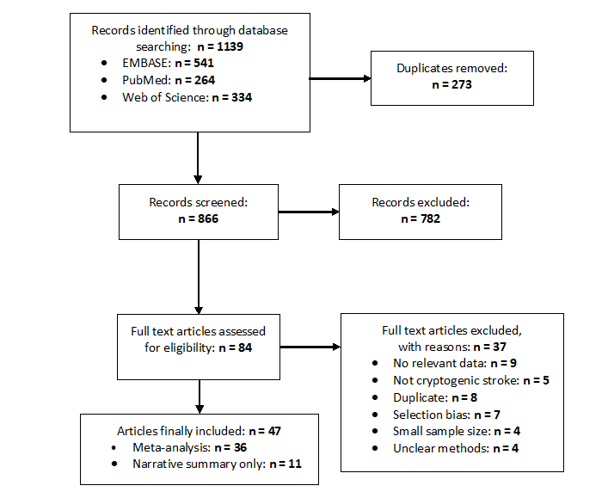

Supplementary Figure 2. Rates of atrial fibrillation detected by implantable cardiac monitor at 3 months in patients with cryptogenic stroke versus ESUS

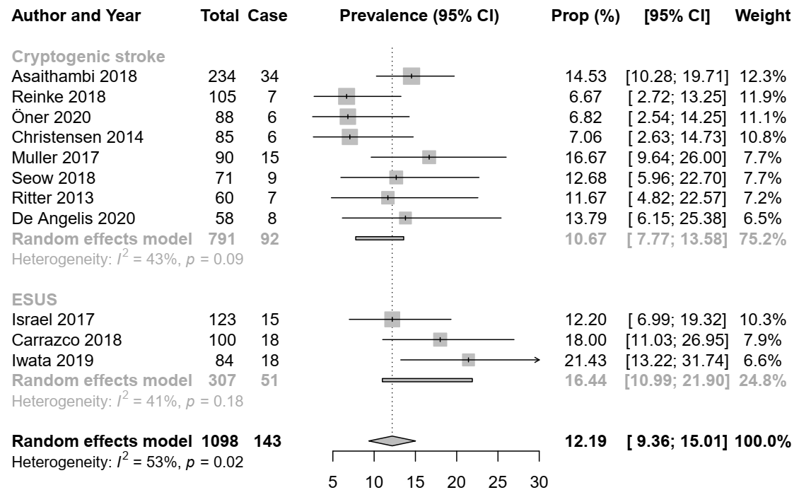

Supplementary Figure 3. Rates of atrial fibrillation detected by implantable cardiac monitor at 6 months in patients with cryptogenic stroke versus ESUS

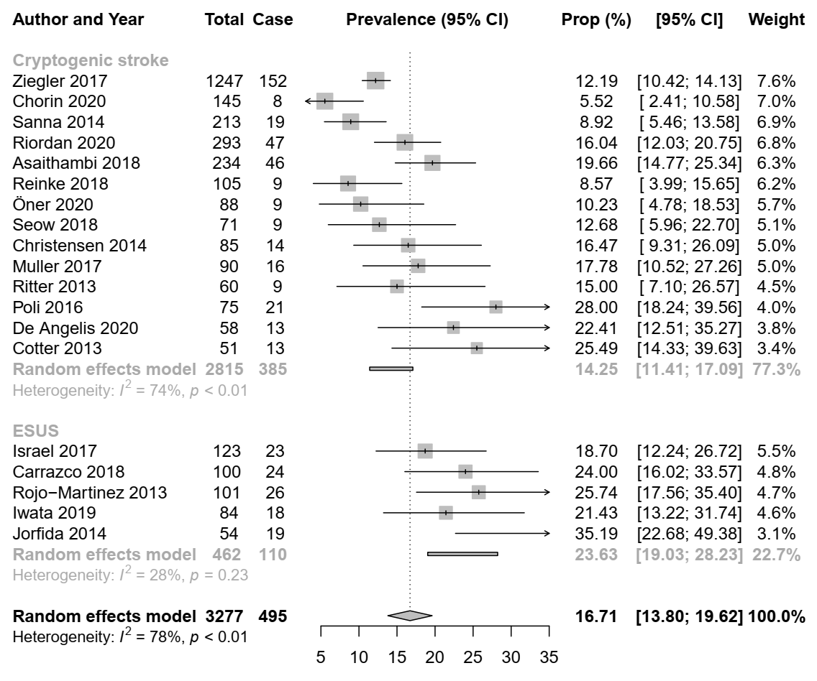

Supplementary Figure 4. Rates of atrial fibrillation detected by implantable cardiac monitor at 12 months in patients with cryptogenic stroke versus ESUS

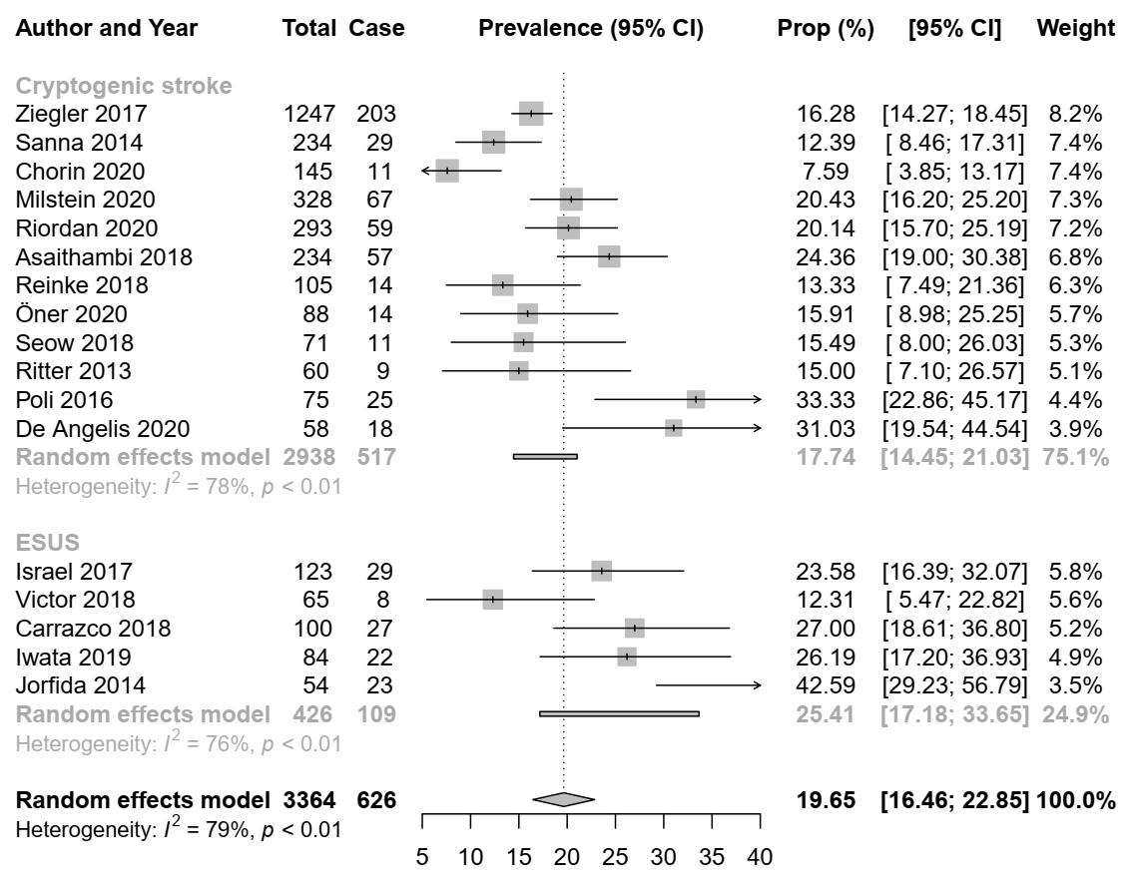

Supplementary Figure 5. Rates of atrial fibrillation detected by implantable cardiac monitor at 24 months in patients with cryptogenic stroke versus ESUS

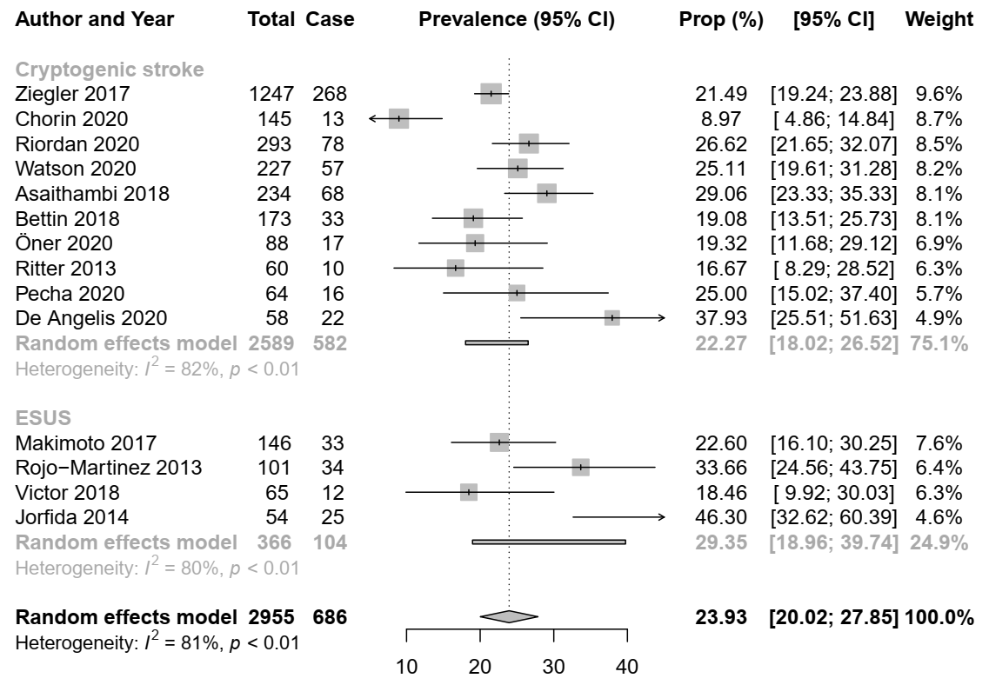

Supplementary Figure 6. Rates of atrial fibrillation detected by implantable cardiac monitor at 3 months according to minimal duration of atrial fibrillation episode

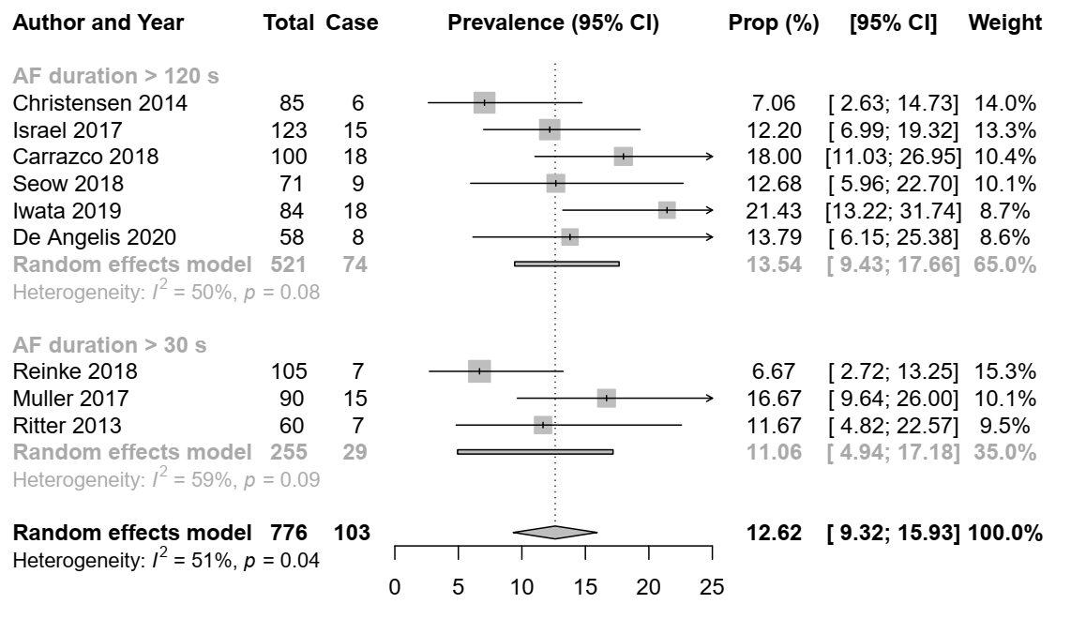

Supplementary Figure 7. Rates of atrial fibrillation detected by implantable cardiac monitor at 6 months according to minimal duration of atrial fibrillation episode

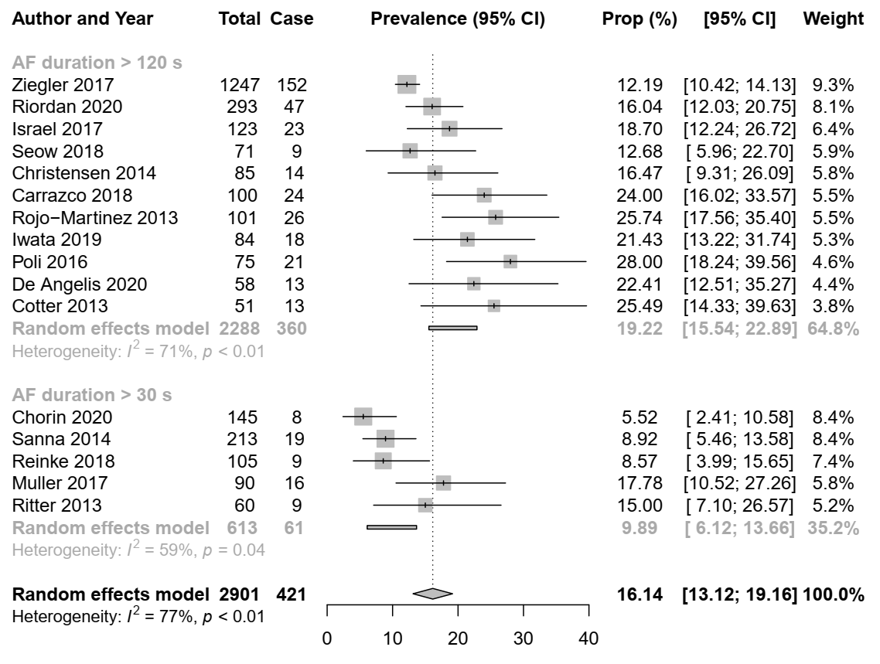

Supplementary Figure 8. Rates of atrial fibrillation detected by implantable cardiac monitor at 9 months according to minimal duration of atrial fibrillation episode

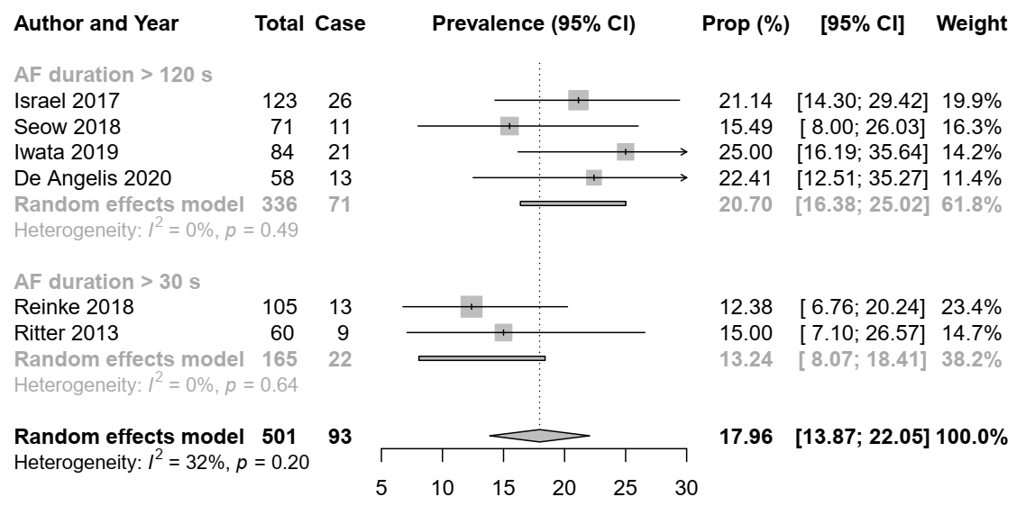

Supplementary Figure 9. Rates of atrial fibrillation detected by implantable cardiac monitor at 12 months according to minimal duration of atrial fibrillation episode

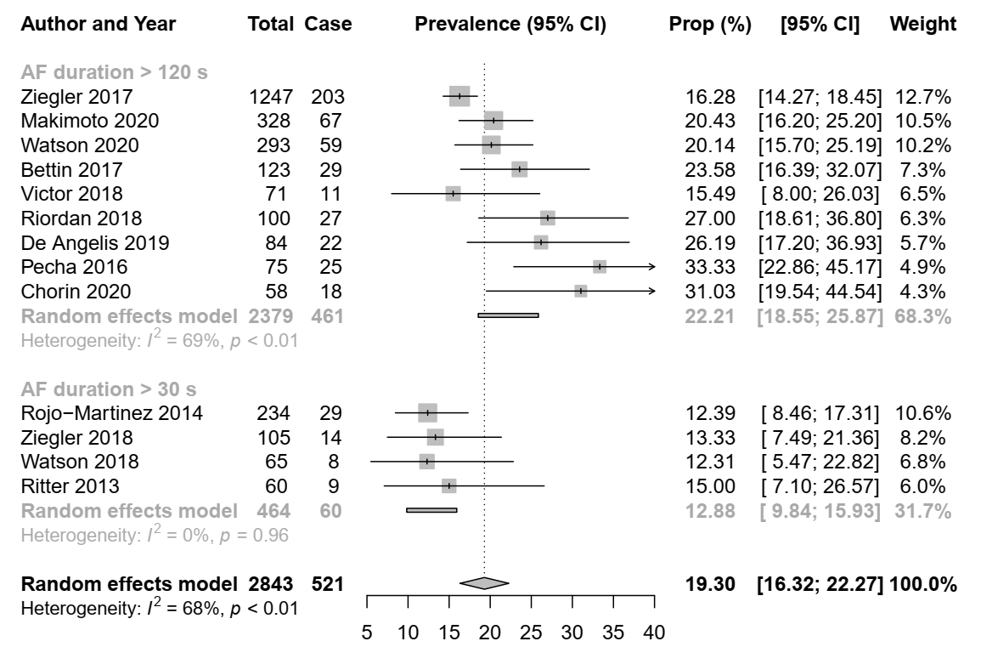

Supplementary Figure 10. Rates of atrial fibrillation detected by implantable cardiac monitor at 24 months according to minimal duration of atrial fibrillation episode

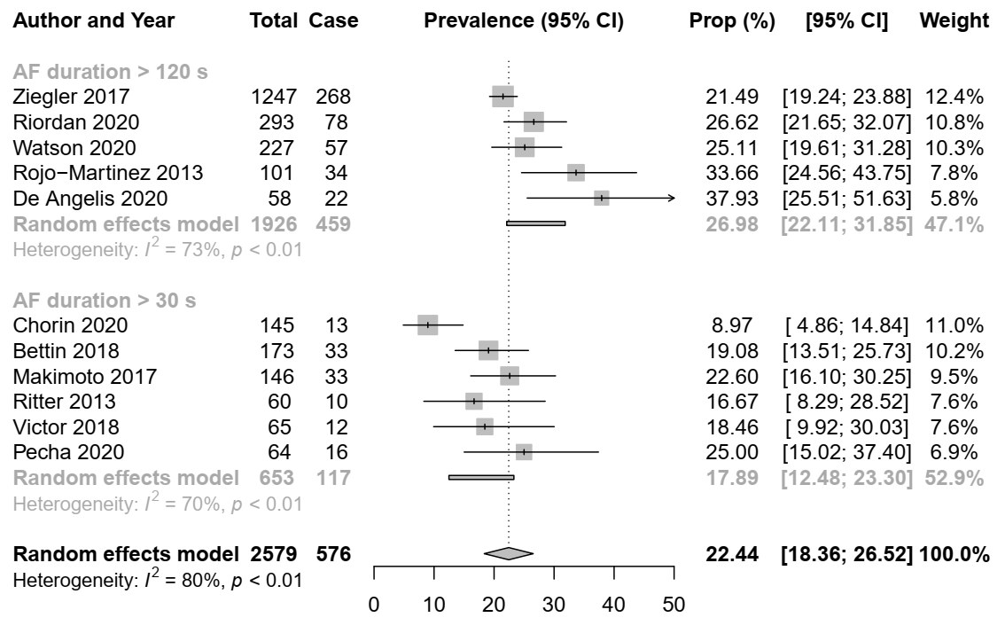

Supplementary Figure 11. Rates of atrial fibrillation detected by implantable cardiac monitor at 3 months by device type

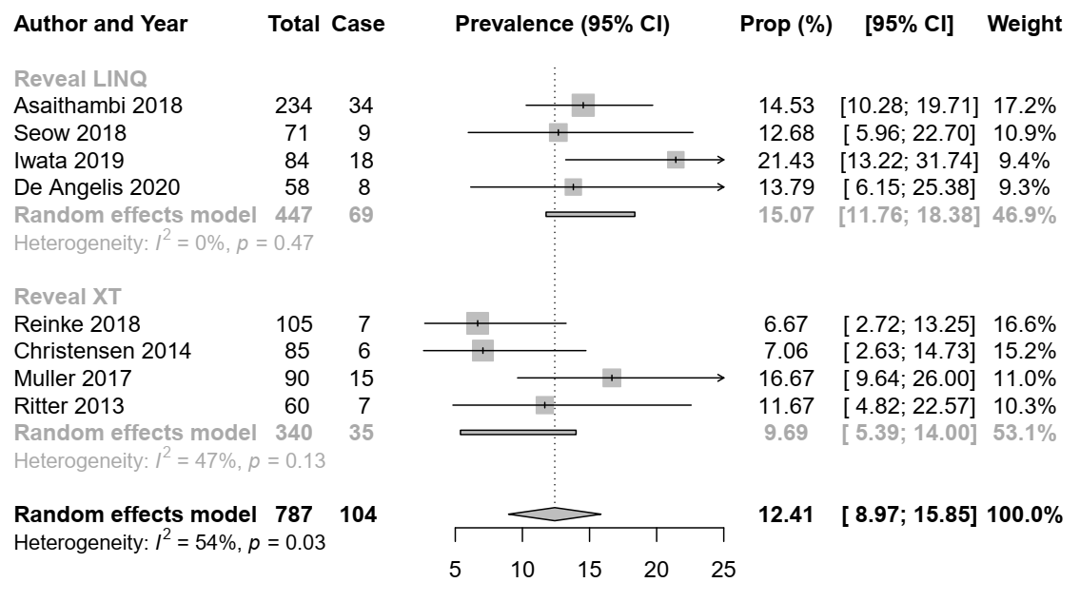

Supplementary Figure 12. Rates of atrial fibrillation detected by implantable cardiac monitor at 6 months by device type

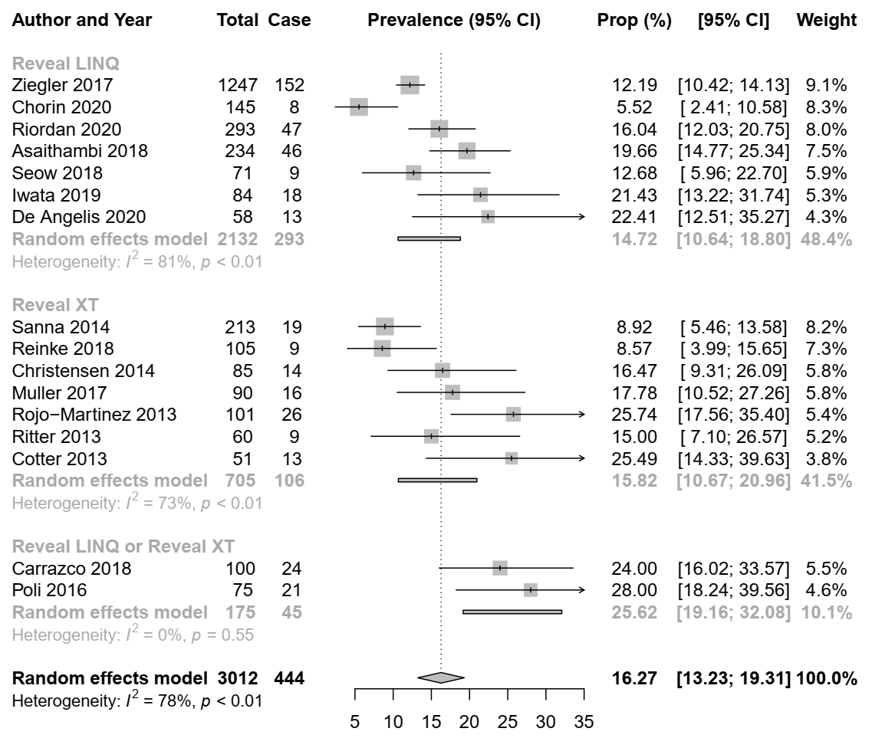

Supplementary Figure 13. Rates of atrial fibrillation detected by implantable cardiac monitor at 12 months by device type
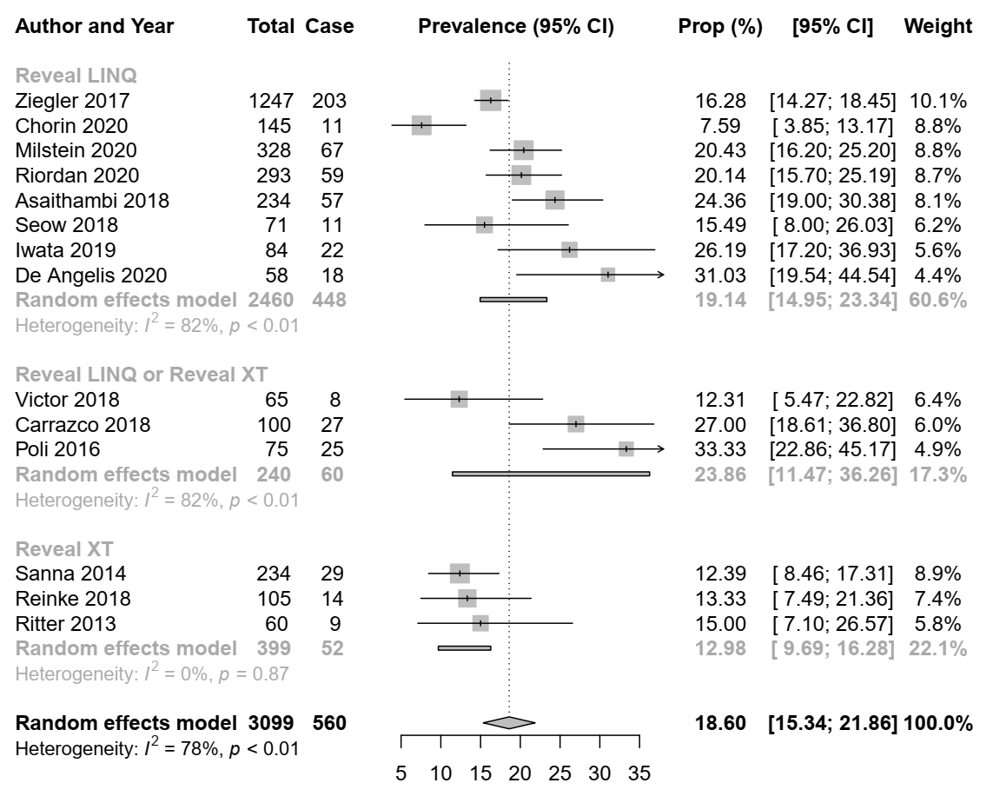

Supplementary Figure 14. Rates of atrial fibrillation detected by implantable cardiac monitor at 24 months by device type

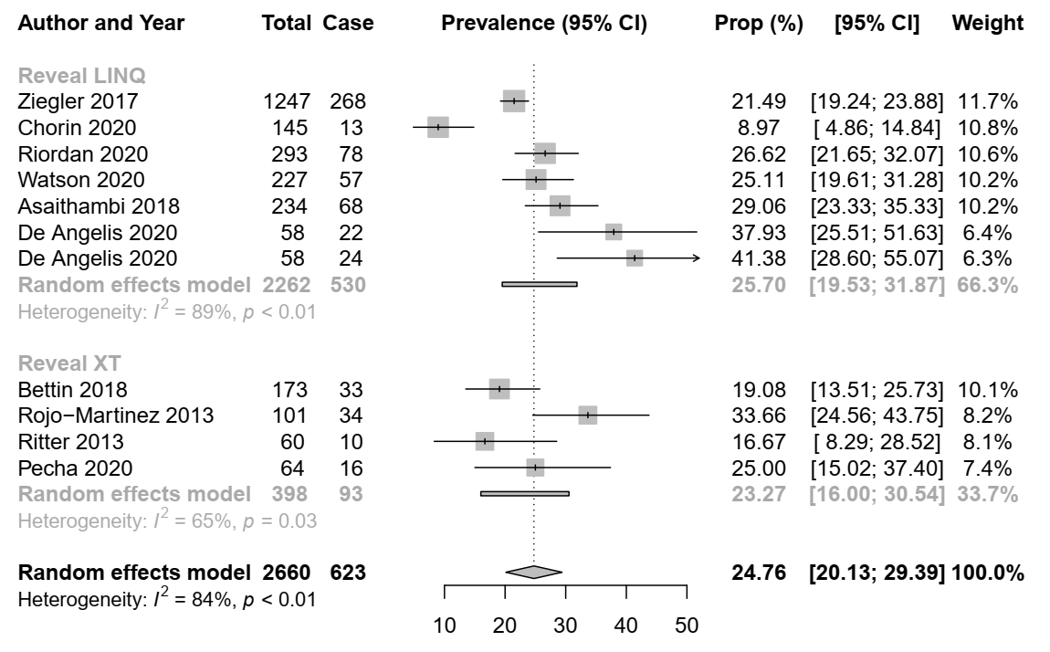

Supplementary Figure 15. Funnel plot for the meta-analysis of rates of atrial fibrillation detected by implantable cardiac monitor at 3 months in patients with cryptogenic stroke

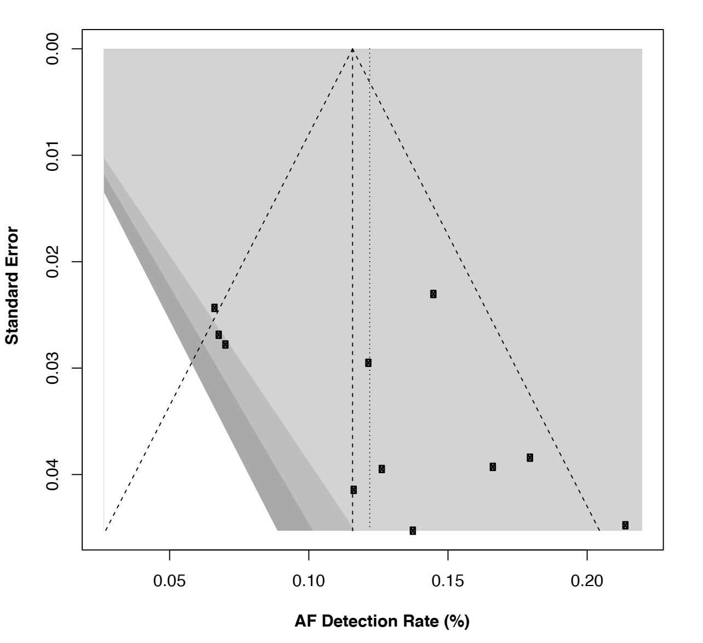

Supplementary Figure 16. Funnel plot for the meta-analysis of rates of atrial fibrillation detected by implantable cardiac monitor at 6 months in patients with cryptogenic stroke

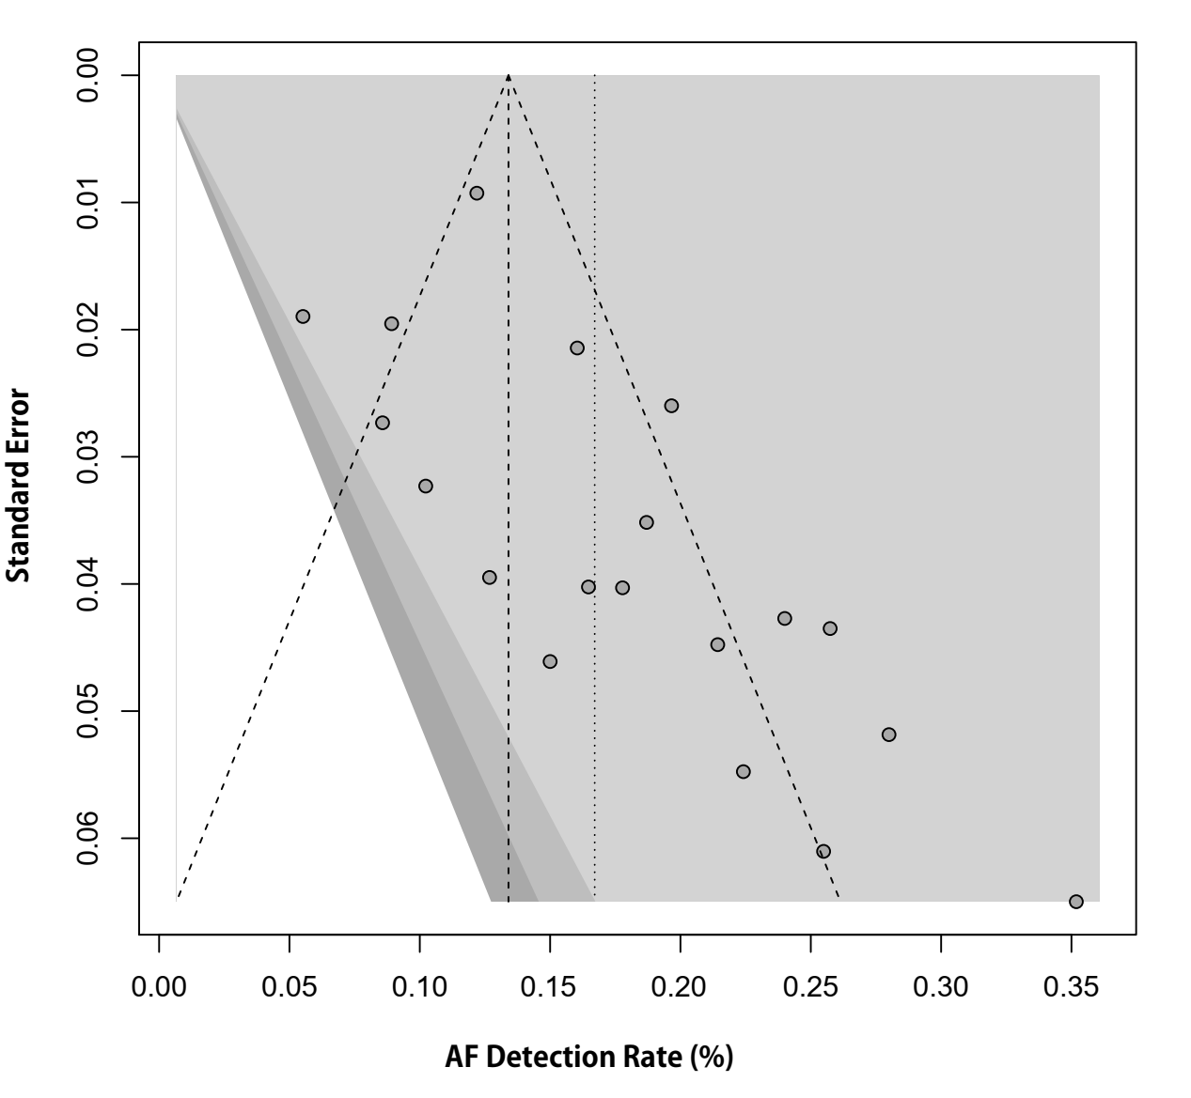

Supplementary Figure 17. Funnel plot for the meta-analysis of rates of atrial fibrillation detected by implantable cardiac monitor at 12 months in patients with cryptogenic stroke

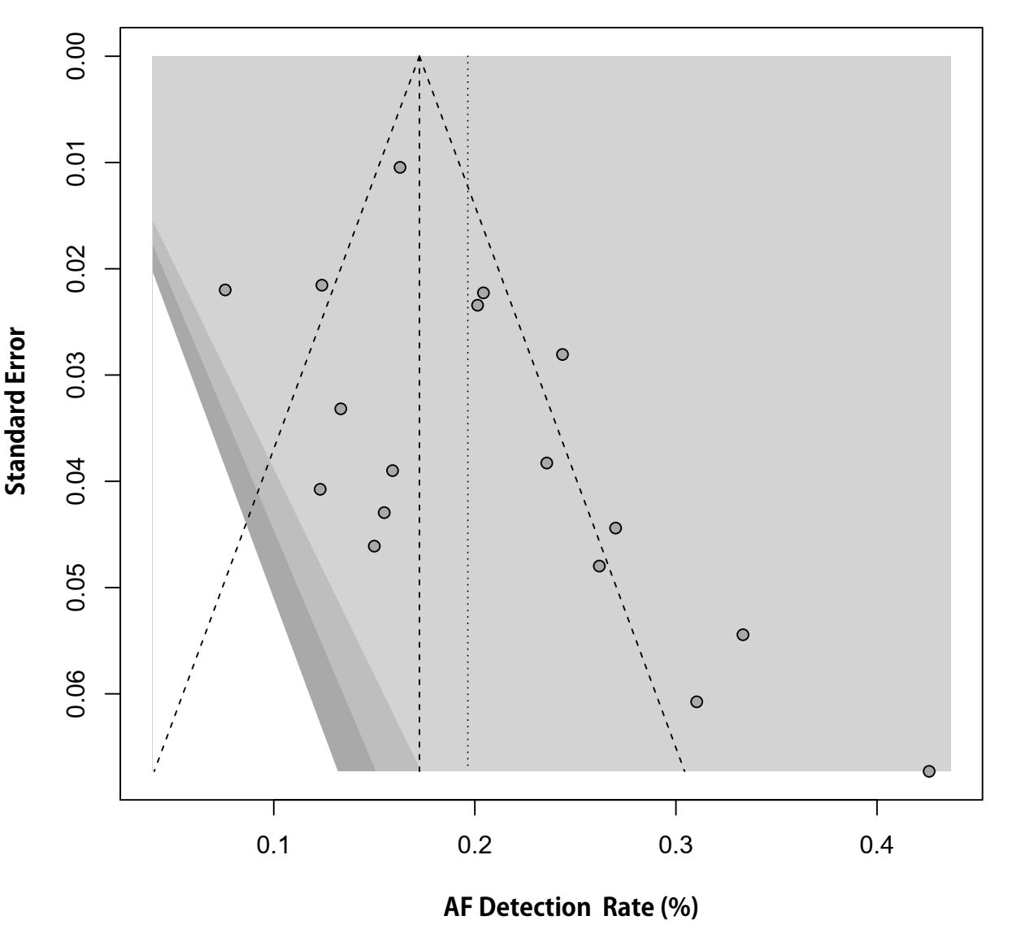

Supplementary Figure 18. Funnel plot for studies reporting atrial fibrillation detection rates at 24 months on implantable cardiac monitor in patients with cryptogenic stroke
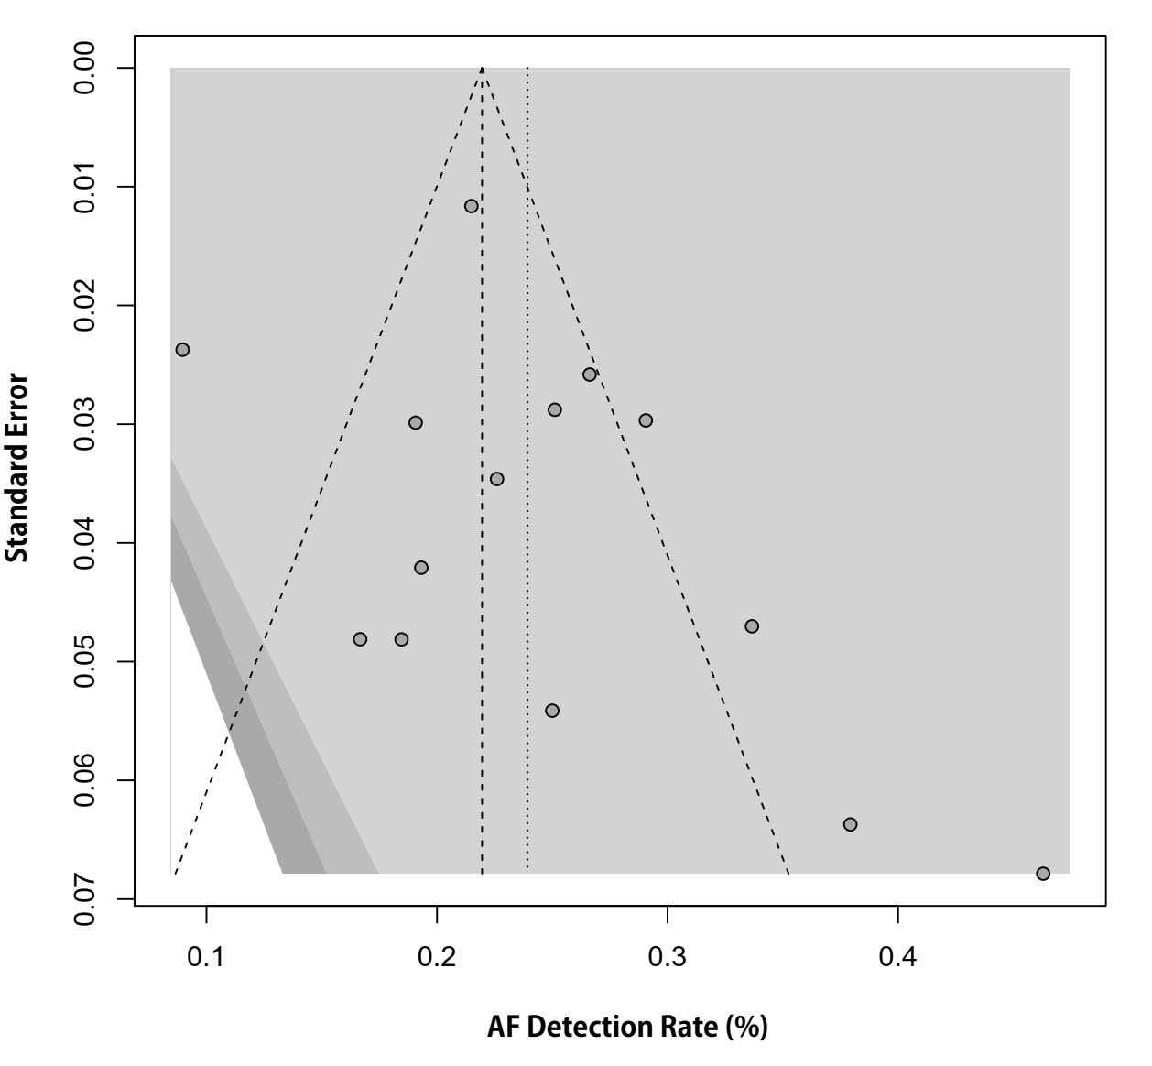

Supplementary Figure 19. Meta-regression of atrial fibrillation detection rates at 3 months on implantable cardiac monitor in patients with cryptogenic stroke

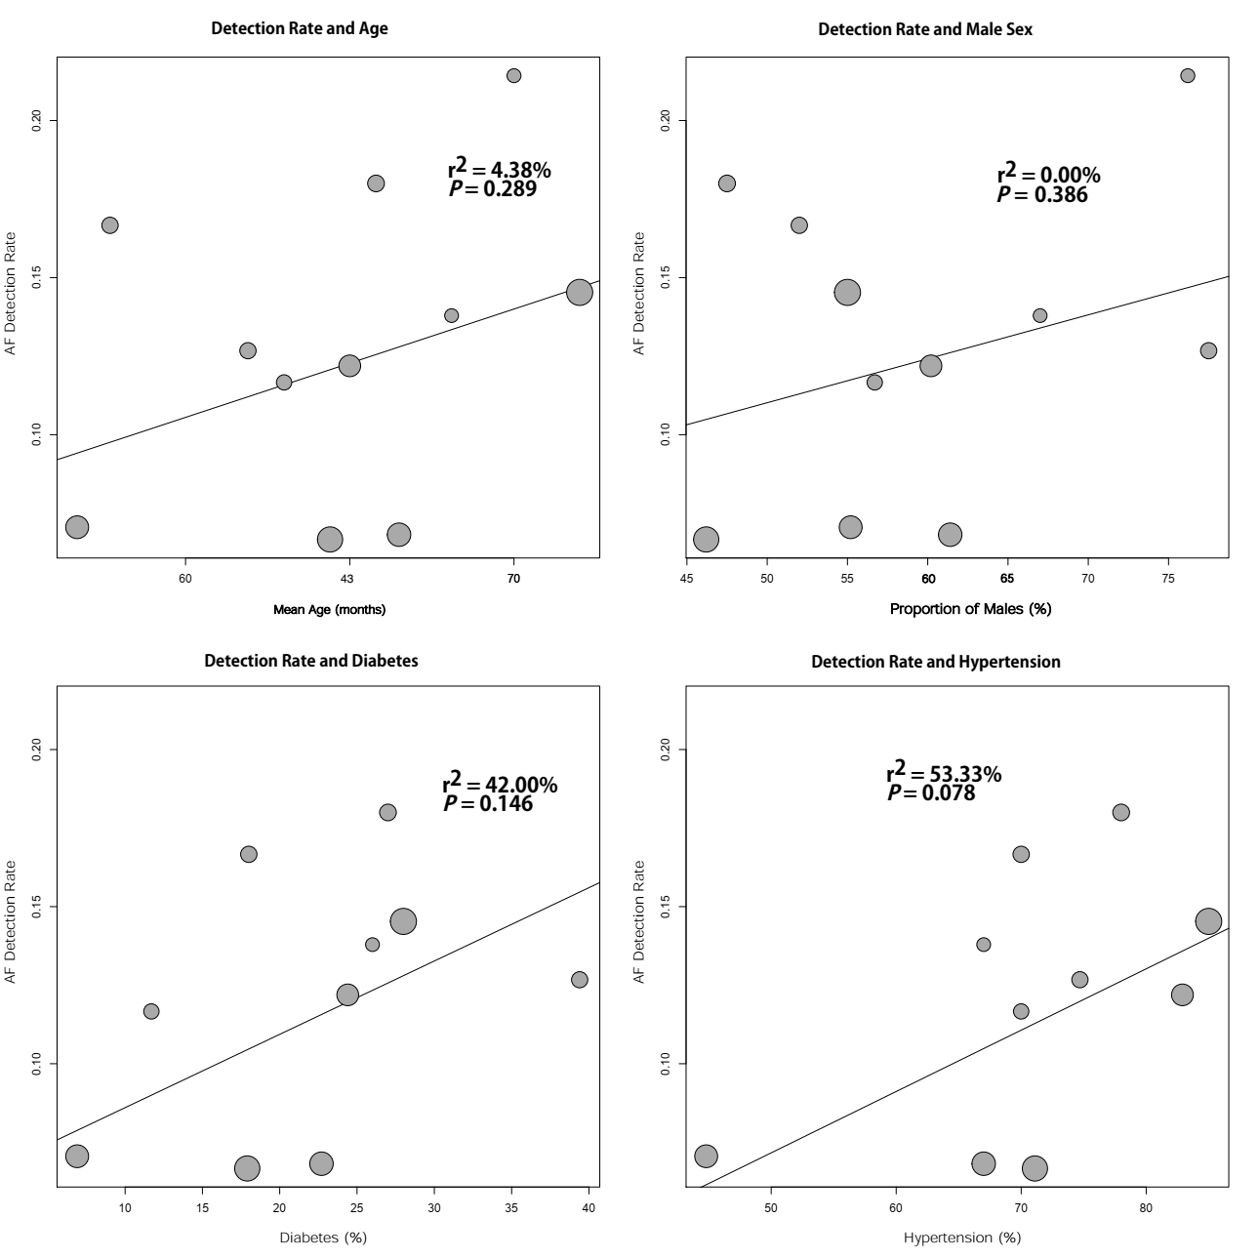

Supplementary Figure 20. Metaregression of atrial fibrillation detection rates at 6 months on implantable cardiac monitor in patients with cryptogenic stroke

Supplementary Figure 21. Metaregression of atrial fibrillation detection rates at 12 months on implantable cardiac monitor in patients with cryptogenic stroke

Supplementary Figure 22. Metaregression of atrial fibrillation detection rates at 24 months on implantable cardiac monitor in patients with cryptogenic stroke

Supplementary Figure 23. Influencer analysis of AF detection rates at 3 months on implantable cardiac monitor in patients with cryptogenic stroke

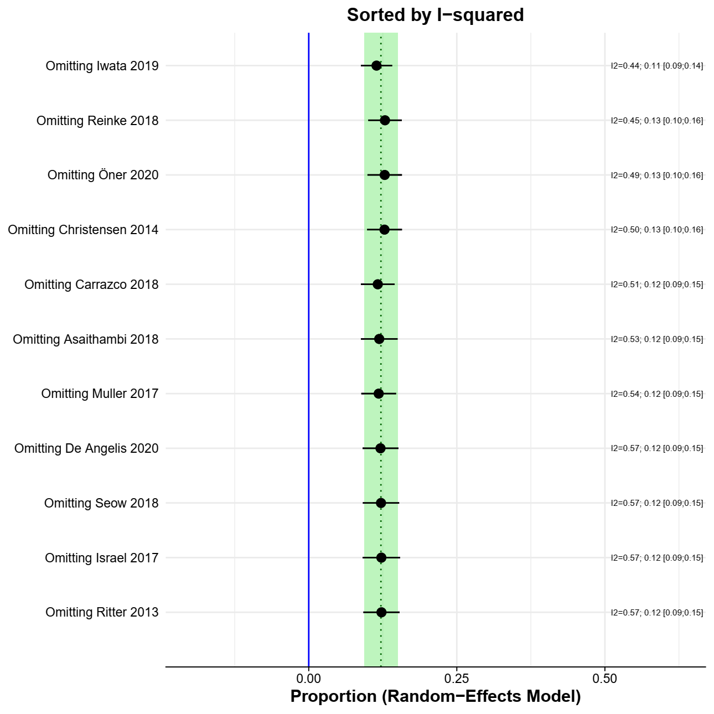

Supplementary Figure 24. Influencer analysis of AF detection rates at 6 months on implantable cardiac monitor in patients with cryptogenic stroke

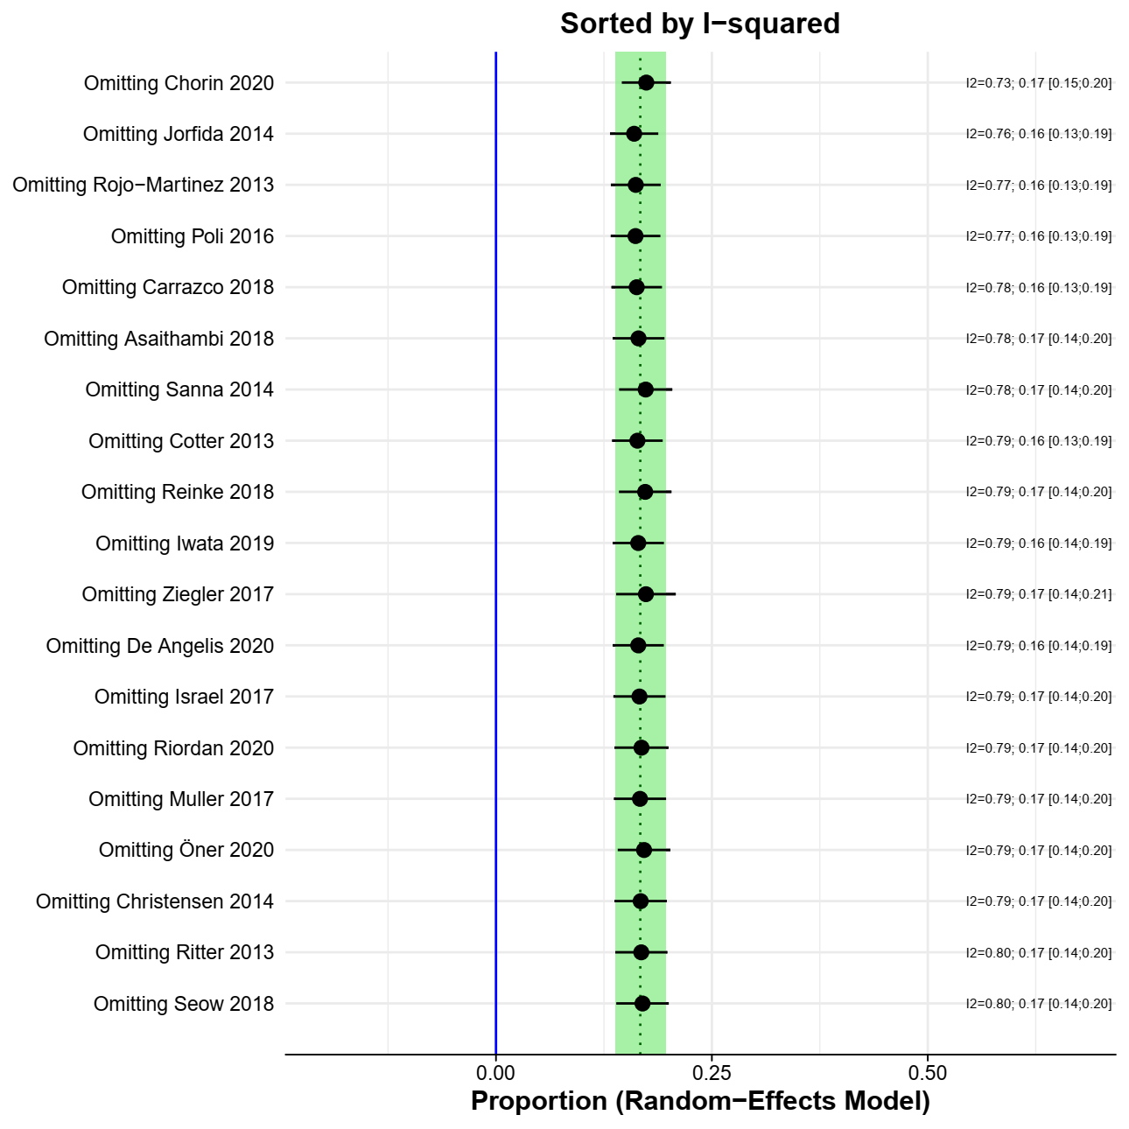

Supplementary Figure 25. Influencer analysis of AF detection rates at 12 months on implantable cardiac monitor in patients with cryptogenic stroke

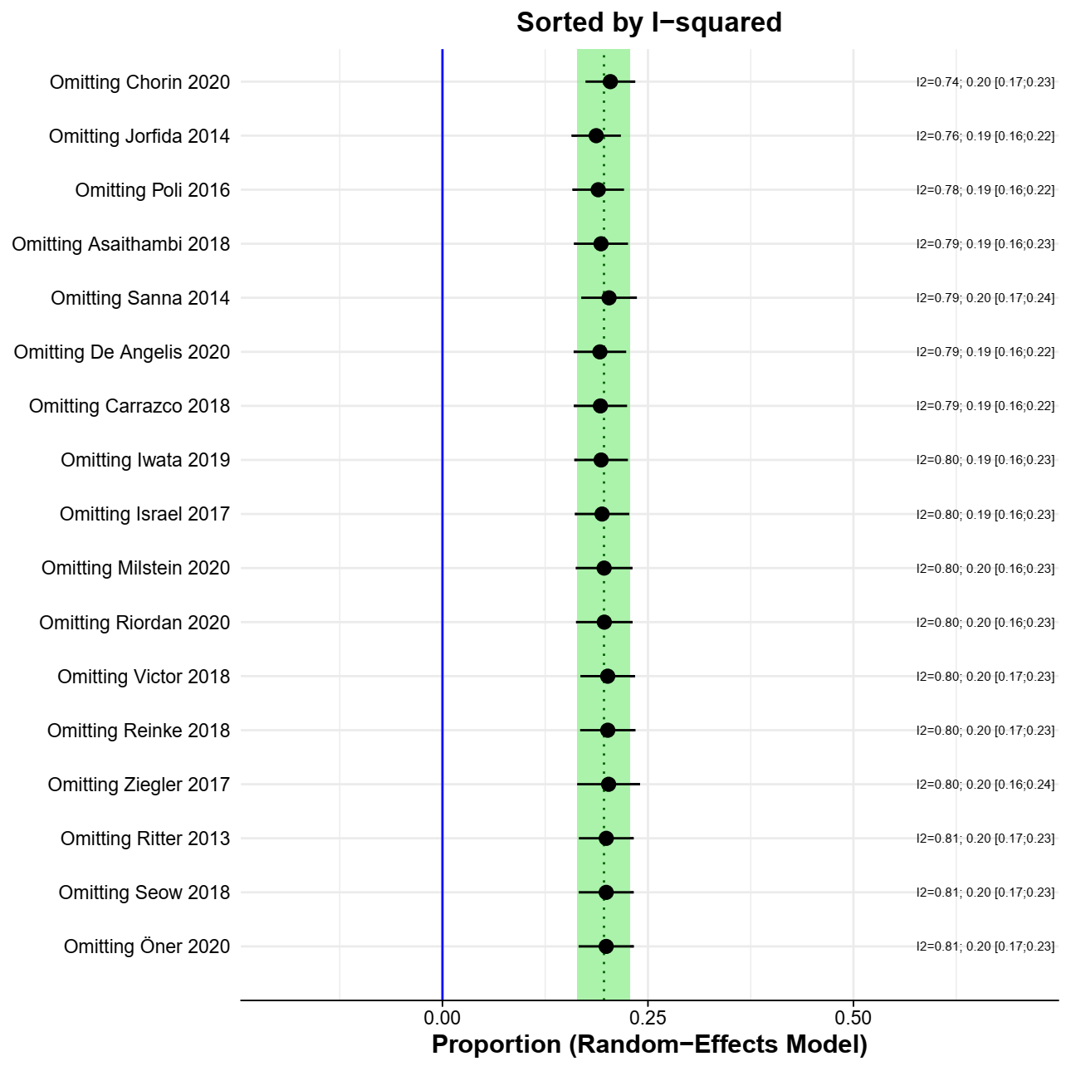

Supplementary Figure 26. Influencer analysis of AF detection rates at 24 months on implantable cardiac monitor in patients with cryptogenic stroke

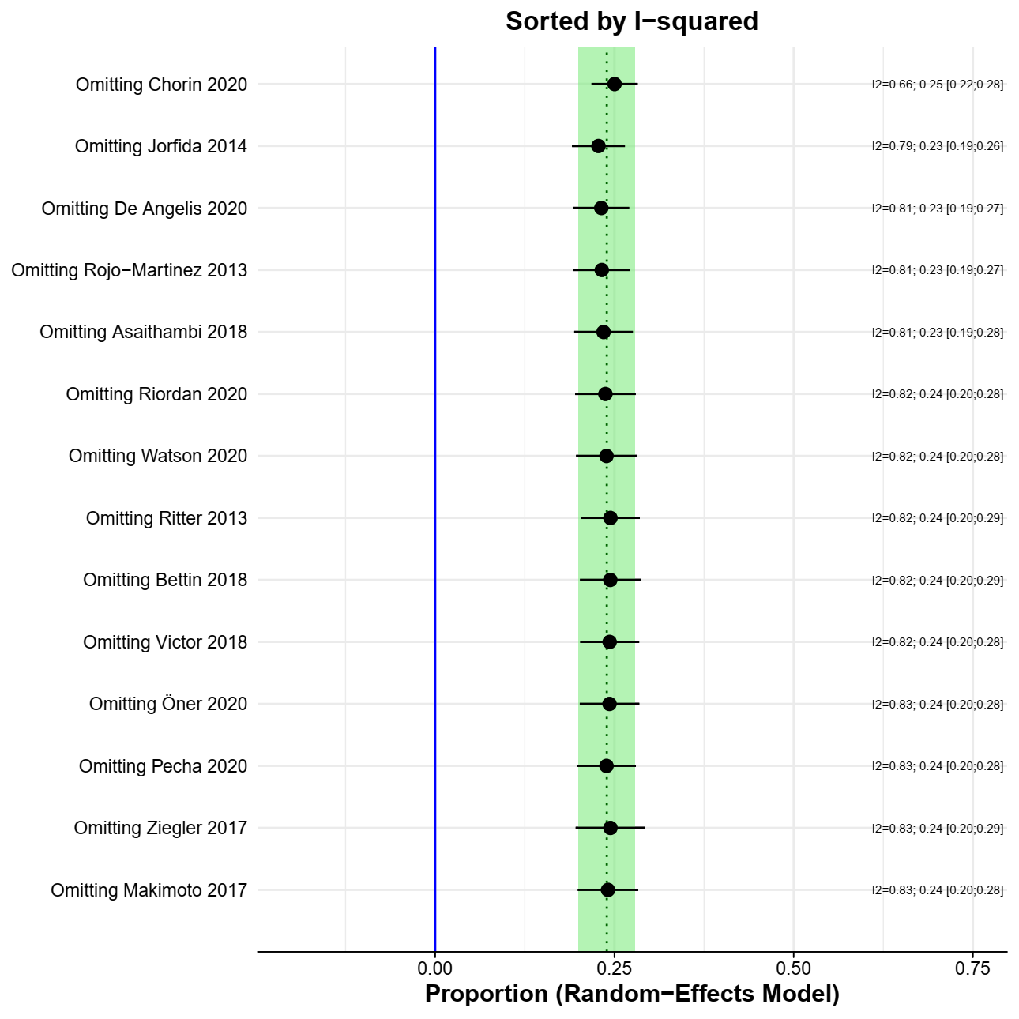

Supplementary Figure 27. Influencer analysis of the univariable association between female sex and AF detection in patients with cryptogenic stroke

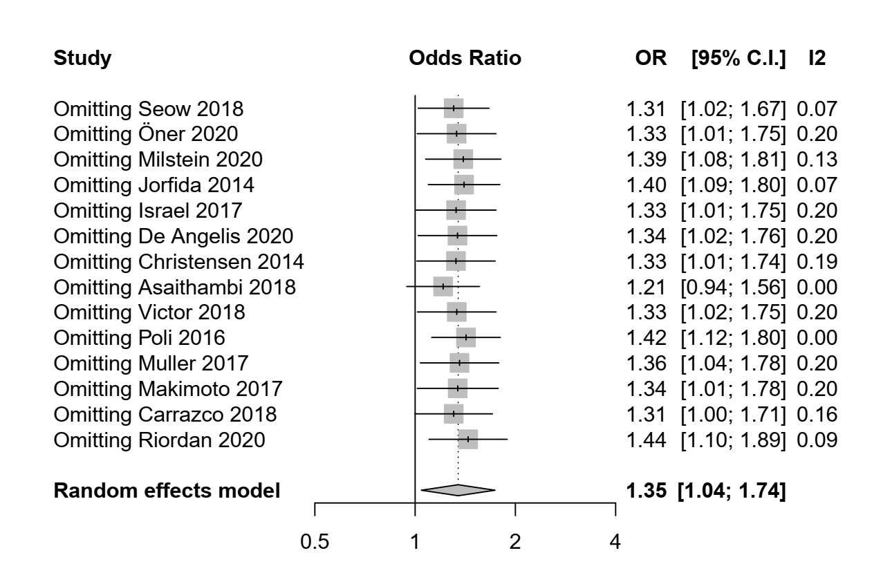

List of included studies
1. Acampa M, Lazzerini PE, Guideri F, Tassi R, Andreini I, Domenichelli C, et al. Electrocardiographic Predictors of Silent Atrial Fibrillation in Cryptogenic Stroke. Heart Lung and Circulation. 2019;28(11):1664-9. English.
2. Asaithambi G, Monita JE, Annamalai MR, Ho BM, Marino EH, Hanson SK. Prevalence of atrial fibrillation with insertable cardiac monitors in cryptogenic stroke: A single-center experience. Journal of Electrocardiology. 2018;51(6):973-6. English.
3. Bettin M, Dechering D, Kochhauser S, Bode N, Eckardt L, Frommeyer G, et al. Extended ECG monitoring with an implantable loop recorder in patients with cryptogenic stroke: time schedule, reasons for explantation and incidental findings (results from the TRACK-AF trial). Clinical Research in Cardiology. 2019 Mar;108(3):309-14. PubMed PMID: WOS:000459158700010.
4. Bhatt A, Majid A, Razak A, Kassab M, Hussain S, Safdar A. Predictors of Occult Paroxysmal Atrial Fibrillation in Cryptogenic Strokes Detected by Long-TermNoninvasive Cardiac Monitoring. Stroke Research and Treatment. 2011;2011. PubMed PMID: WOS:000214672300004.
5. Bugnicourt JM, Flament M, Guillaumont MP, Chillon JM, Leclercq C, Canaple S, et al. Predictors of newly diagnosed atrial fibrillation in cryptogenic stroke: a cohort study. European Journal of Neurology. 2013 Oct;20(10):1352-9. PubMed PMID: WOS:000324304500008.
6. Campal JMR, Torres MAG, Borque PS, Vinagre IN, Capdepon IZ, Blanco AM, et al. Detecting Atrial Fibrillation in Patients With an Embolic Stroke of Undetermined Source (from the DAF-ESUS registry). American Journal of Cardiology. 2020 Feb;125(3):409-14. PubMed PMID: WOS:000510968000016.
7. Carrazco C, Golyan D, Kahen M, Black K, Libman RB, Katz JM. Prevalence and Risk Factors for Paroxysmal Atrial Fibrillation and Flutter Detection after Cryptogenic Ischemic Stroke. Journal of stroke and cerebrovascular diseases : the official journal of National Stroke Association. 2018 Jan;27(1):203-9. PubMed PMID: 29032886. Epub 2017/10/17. eng.
8. Chorin E, Peterson C, Kogan E, Barbhaiya C, Aizer A, Holmes D, et al. Comparison of the Effect of Atrial Fibrillation Detection Algorithms in Patients With Cryptogenic Stroke Using Implantable Loop Recorders. The American journal of cardiology.
9. Christensen LM, Krieger DW, Højberg S, Pedersen OD, Karlsen FM, Jacobsen MD, et al. Paroxysmal atrial fibrillation occurs often in cryptogenic ischaemic stroke. Final results from the SURPRISE study. European Journal of Neurology. 2014;21(6):884-9. English.
10. Cotter PE, Martin PJ, Ring L, Warburton EA, Belham M, Pugh PJ. Incidence of atrial fibrillation detected by implantable loop recorders in unexplained stroke. Neurology. 2013 Apr 23;80(17):1546-50. PubMed PMID: 23535493. Pubmed Central PMCID: PMC3662328. Epub 2013/03/29. eng.
11. De Angelis MV, Di Stefano V, Franciotti R, Furia N, Di Girolamo E, Onofrj M, et al. Cryptogenic stroke and atrial fibrillation in a real-world population: the role of insertable cardiac monitors. Scientific reports. 2020;10(1):3230. English.
12. Favilla CG, Ingala E, Jara J, Fessler E, Cucchiara B, Messe SR, et al. Predictors of Finding Occult Atrial Fibrillation After Cryptogenic Stroke. Stroke. 2015 May;46(5):1210-5. PubMed PMID: WOS:000353559800026.
13. Flint AC, Banki NM, Ren X, Rao VA, Go AS. Detection of paroxysmal atrial fibrillation by 30-day event monitoring in cryptogenic ischemic stroke: the Stroke and Monitoring for PAF in Real Time (SMART) Registry. Stroke. 2012 Oct;43(10):2788-90. PubMed PMID: 22871679. Epub 2012/08/09. eng.
14. Fonseca AC, Brito D, Melo TPE, Geraldes R, Canhao P, Caplan LR, et al. N-terminal pro-brain natriuretic peptide shows diagnostic accuracy for detecting atrial fibrillation in cryptogenic stroke patients. International Journal of Stroke. 2014 Jun;9(4):419-25. PubMed PMID: WOS:000335664900011.
15. Gaillard N, Deltour S, Vilotijevic B, Hornych A, Crozier S, Leger A, et al. Detection of paroxysmal atrial fibrillation with transtelephonic EKG in TIA or stroke patients. Neurology. 2010 May 25;74(21):1666-70. PubMed PMID: 20498434. Epub 2010/05/26. eng.
16. Gladstone DJ, Spring M, Dorian P, Panzov V, Thorpe KE, Hall J, et al. Atrial Fibrillation in Patients with Cryptogenic Stroke. New England Journal of Medicine. 2014 Jun;370(26):2467-77. PubMed PMID: WOS:000337804400004.
17. Israel C, Kitsiou A, Kalyani M, Deelawar S, Ejangue LE, Rogalewski A, et al. Detection of atrial fibrillation in patients with embolic stroke of undetermined source by prolonged monitoring with implantable loop recorders. Thrombosis and haemostasis. 2017 Oct;117(10):1962-9. PubMed PMID: WOS:000412794200017.
18. Iwata T, Todo K, Yamagami H, Morimoto M, Hashimoto T, Doijiri R, et al. High Detection Rate of Atrial Fibrillation With Insertable Cardiac Monitor Implantation in Patients With Cryptogenic Stroke Diagnosed by Magnetic Resonance Imaging. Journal of Stroke and Cerebrovascular Diseases. 2019;28(9):2569-73. English.
19. Jordan N, Ghosh S, Cunningham J, Alvaro A. Usefulness of Holter monitoring, thrombophilia and vasculitis screening tests in the investigation of a heterogenous group of ischaemic stroke patients. Cerebrovascular Diseases. 2009;27:227. English.
20. Jorfida M, Antolini M, Cerrato E, Caprioli MG, Castagno D, Garrone P, et al. Cryptogenic ischemic stroke and prevalence of asymptomatic atrial fibrillation: A prospective study. Journal of Cardiovascular Medicine. 2016;17(12):863-9. English.
21. Kalani R, Bernstein R, Passman R, Curran Y, Ruff I, Prabhakaran S. Low Yield of Mobile Cardiac Outpatient Telemetry after Cryptogenic Stroke in Patients with Extensive Cardiac Imaging. Journal of Stroke and Cerebrovascular Diseases. 2015;24(9):2069-73. English.
22. Kass-Hout O, Kass-Hout T, Parikh A, Hoskins M, Clements SD, Jr., Rangaraju S, et al. Atrial Fibrillation Predictors on Mobile Cardiac Telemetry in Cryptogenic Ischemic Stroke. The Neurohospitalist. 2018 Jan;8(1):7-11. PubMed PMID: 29276556. Pubmed Central PMCID: PMC5734506. Epub 2017/12/26. eng.
23. Lumikari TJ, Putaala J, Kerola A, Sibolt G, Pirinen J, Pakarinen S, et al. Continuous 4-week ECG monitoring with adhesive electrodes reveals AF in patients with recent embolic stroke of undetermined source. Annals of Noninvasive Electrocardiology. 2019;24(5). English.
24. Makimoto H, Kurt M, Gliem M, Lee JI, Schmidt J, Muller P, et al. High Incidence of Atrial Fibrillation After Embolic Stroke of Undetermined Source in Posterior Cerebral Artery Territory. Journal of the American Heart Association. 2017 Dec;6(12). PubMed PMID: WOS:000418951100067.
25. Manina G, Agnelli G, Becattini C, Zingarini G, Paciaroni M. 96 hours ECG monitoring for patients with ischemic cryptogenic stroke or transient ischaemic attack. Internal and emergency medicine. 2014;9(1):65-7. English.
26. Mendieta G, Guasch E, Weir D, Aristizabal D, Escobar-Robledo LA, Llull L, et al. Advanced interatrial block: A predictor of covert atrial fibrillation in embolic stroke of undetermined source. Journal of Electrocardiology. 2020;58:113-8. English.
27. Miller DJ, Khan MA, Schultz LR, Simpson JR, Katramados AM, Russman AN, et al. Outpatient cardiac telemetry detects a high rate of atrial fibrillation in cryptogenic stroke. Journal of the Neurological Sciences. 2013;324(1-2):57-61. English.
28. Milstein NS, Musat DL, Allred J, Seiler A, Pimienta J, Oliveros S, et al. Detection of atrial fibrillation using an implantable loop recorder following cryptogenic stroke: implications for post-stroke electrocardiographic monitoring. Journal of Interventional Cardiac Electrophysiology. 2020;57(1):141-7. English.
29. Muller P, Ivanov V, Kara K, Klein-Wiele O, Forkmann M, Piorkowski C, et al. Total atrial conduction time to predict occult atrial fibrillation after cryptogenic stroke. Clinical Research in Cardiology. 2017 Feb;106(2):113-9. PubMed PMID: WOS:000394132600005.
30. Ntaios G, Perlepe K, Lambrou D, Sirimarco G, Strambo D, Eskandari A, et al. Identification of patients with embolic stroke of undetermined source and low risk of new incident atrial fibrillation: The AF-ESUS score. International journal of stroke : official journal of the International Stroke Society. 2020 May 19:1747493020925281. PubMed PMID: 32423317. Epub 2020/05/20. eng.
31. Öner A, Lips T, Walter U, Storch A, Ince H, Caglayan E, et al. Detection of arrhythmia using an implantable cardiac monitor following a cryptogenic stroke: a single-center observational study. European journal of medical research. 2020 Jun 29;25(1):25. PubMed PMID: 32600384. Pubmed Central PMCID: PMC7325047. Epub 2020/07/01. eng.
32. Pagola J, Juega J, Francisco-Pascual J, Bustamante A, Penalba A, Pala E, et al. Large vessel occlusion is independently associated with atrial fibrillation detection. European Journal of Neurology. 2020. English.
33. Pecha S, Wilke I, Yildirim Y, Reichenspurner H, Aydin MA. Implantable loop recorder monitoring in patients with cryptogenic stroke - Detection and treatment of different clinically relevant arrhythmias. Journal of Electrocardiology. 2020;60:102-6. English.
34. Poli S, Diedler J, Hartig F, Gotz N, Bauer A, Sachse T, et al. Insertable cardiac monitors after cryptogenic stroke - a risk factor based approach to enhance the detection rate for paroxysmal atrial fibrillation. European Journal of Neurology. 2016 Feb;23(2):375-81. PubMed PMID: WOS:000368797100033.
35. Rabinstein AA, Fugate JE, Mandrekar J, Burns JD, Seet RC, Dupont SA, et al. Paroxysmal atrial fibrillation in cryptogenic stroke: a case-control study. Journal of stroke and cerebrovascular diseases : the official journal of National Stroke Association. 2013 Nov;22(8):1405-11. PubMed PMID: 23791469. Epub 2013/06/25. eng.
36. Reinke F, Bettin M, Ross LS, Kochhauser S, Kleffner I, Ritter M, et al. Refinement of detecting atrial fibrillation in stroke patients: results from the TRACK-AF Study. European Journal of Neurology. 2018 Apr;25(4):631-6. PubMed PMID: WOS:000428397200011.
37. Riordan M, Yoruk A, Younis A, Ali A, Opaskar A, Sahin B, et al. Predictors of atrial fibrillation during long-term arrhythmia monitoring following cryptogenic stroke. Journal of the American College of Cardiology. 2020;75(11):497. English.
38. Ritter MA, Kochhauser S, Duning T, Reinke F, Pott C, Dechering DG, et al. Occult Atrial Fibrillation in Cryptogenic Stroke Detection by 7-Day Electrocardiogram Versus Implantable Cardiac Monitors. Stroke. 2013 May;44(5):1449-+. PubMed PMID: WOS:000318030000057.
39. Rojo-Martinez E, Sandin-Fuentes M, Calleja-Sanz AI, Cortijo-Garcia E, Garcia-Bermejo P, Ruiz-Pinero M, et al. High performance of an implantable Holter monitor in the detection of concealed paroxysmal atrial fibrillation in patients with cryptogenic stroke and a suspected embolic mechanism. Revista De Neurologia. 2013 Sep;57(6):251-7. PubMed PMID: WOS:000324906200002.
40. Sanna T, Diener HC, Passman RS, Di Lazzaro V, Bernstein RA, Morillo CA, et al. Cryptogenic stroke and underlying atrial fibrillation. New England Journal of Medicine. 2014;370(26):2478-86. English.
41. Seow SC, How AK, Chan SP, Teoh HL, Lim TW, Singh D, et al. High Incidence of Occult Atrial Fibrillation in Asian Patients with Cryptogenic Stroke. Journal of stroke and cerebrovascular diseases : the official journal of National Stroke Association. 2018 Aug;27(8):2182-6. PubMed PMID: 29678635. Epub 2018/04/22. eng.
42. Tayal AH, Tian M, Kelly KM, Jones SC, Wright DG, Singh D, et al. Atrial fibrillation detected by mobile cardiac outpatient telemetry in cryptogenic TIA or stroke. Neurology. 2008;71(21):1696-701. English.
43. Thijs VN, Brachmann J, Morillo CA, Passman RS, Sanna T, Bernstein RA, et al. Predictors for atrial fibrillation detection after cryptogenic stroke: Results from CRYSTAL AF. Neurology. 2016;86(3):261-9. English.
44. Víctor CU, Carolina PE, Jorge TR, Joaquín CR, Manuel SG, Marta CM, et al. Incidence and Predictive Factors of Hidden Atrial Fibrillation Detected by Implantable Loop Recorder After an Embolic Stroke of Undetermined Source. J Atr Fibrillation. 2018 Oct-Nov;11(3):2078. PubMed PMID: 31139276. Pubmed Central PMCID: PMC6533811. Epub 2019/05/30. eng.
45. Watson RA, Wellings J, Hingorani R, Zhan T, Frisch DR, Ho RT, et al. Atrial fibrillation post central retinal artery occlusion:role of implantable loop recorders. Pacing and clinical electrophysiology : PACE. 2020 Jun 21. PubMed PMID: 32567072. Epub 2020/06/23. eng.
46. Yayehd K, Irles D, Akret C, Vadot W, Rodier G, Berremili T, et al. Detection of paroxysmal atrial fibrillation by prolonged electrocardiographic recording after ischaemic stroke in patients aged < 60 years: A study with 21-day recording using the SpiderFlash® monitor. Archives of Cardiovascular Diseases. 2015;108(3):189-96. English.
47. Ziegler PD, Rogers JD, Ferreira SW, Nichols AJ, Richards M, Koehler JL, et al. Long-term detection of atrial fibrillation with insertable cardiac monitors in a real-world cryptogenic stroke population. International Journal of Cardiology. 2017;244:175-9. English.

