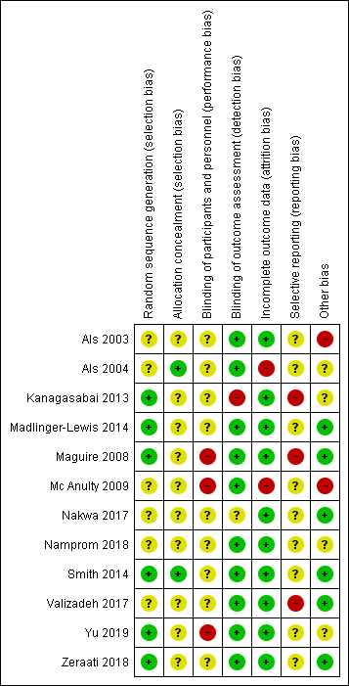
Figure S1. Risk of bias summary: review authors' judgements about each risk of bias item for each included study.

