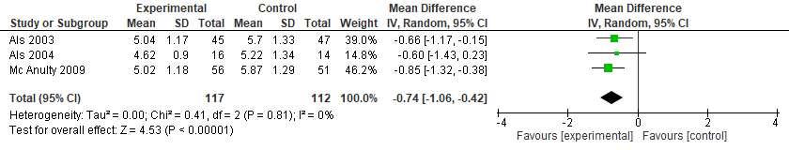
Figure S2. NIDCAP vs. Standard Care for the Neurobehavioral Development (state system - APIB)

