Additional Files
Additional file 1: Figure S1. Funnel plot of the outcome (all-cause mortality).
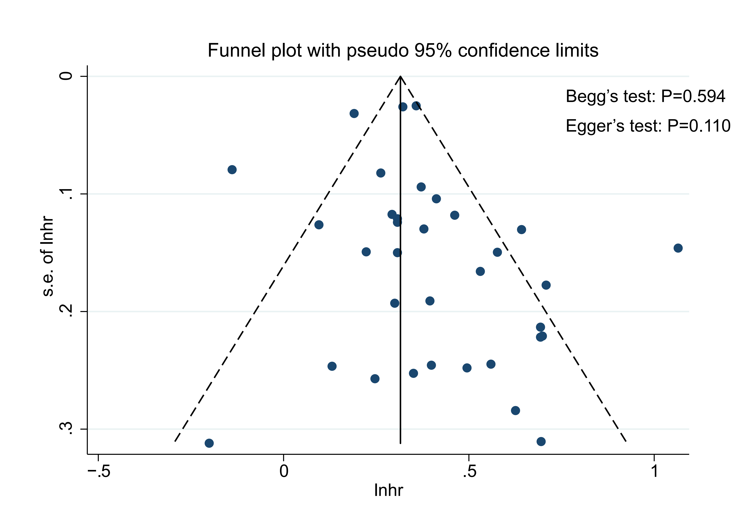

Additional file 1: Figure S2. Sensitivity of the outcome (all-cause mortality).


