Appendix3 Risk of bias graph and funnel plots
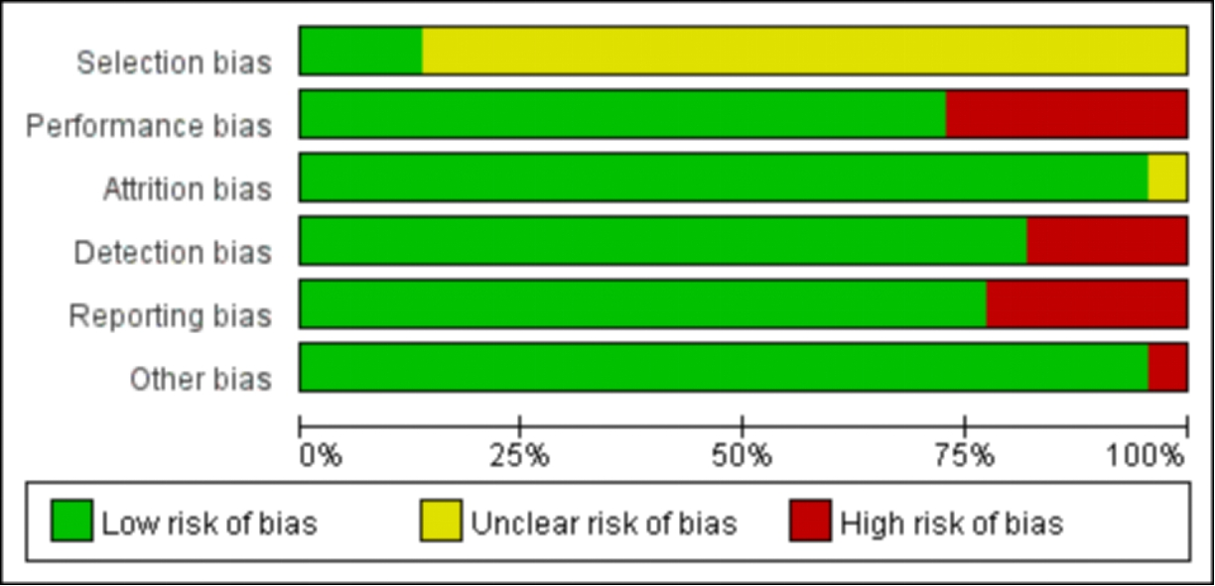
Figure1 Risk of bias graph

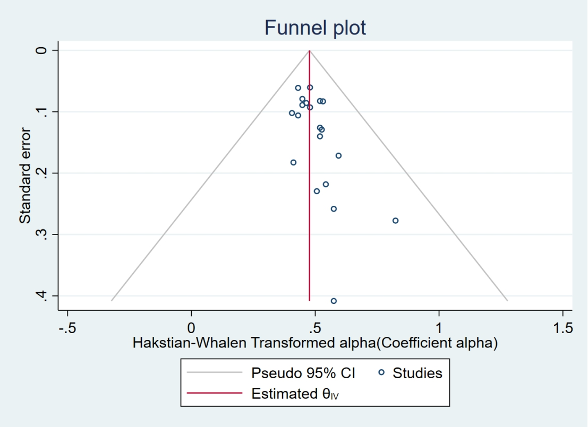
Figure 2 Funnel plots for the internal consistency of the ASQOL questionnaire
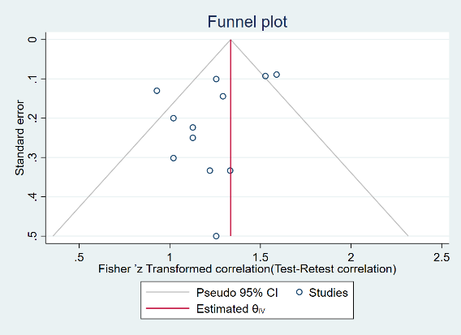
Figure 3 Funnel plots for test-retest reliability of the ASQOL questionnaire
Abbreviation: Left: Spearman’s correlation coefficient. Right: ICC, intraclass correlation coefficient.
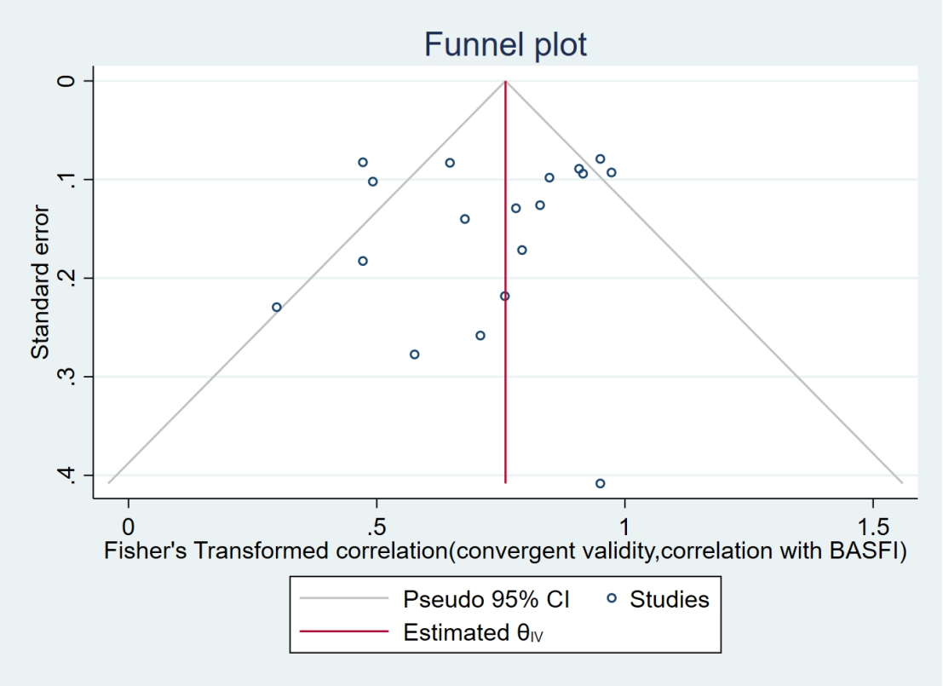
Figure 4 Funnel plots for correlations of the ASQOL questionnaire and BASFI.
Abbreviations: CI: confidence interval; BASFI: Bath Ankylosing Spondylitis Functional Index.

