Figure S1 Summary and risk of bias graph
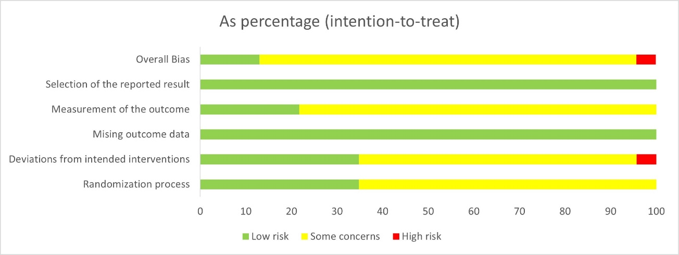

Figure S2 Risk of bias figure
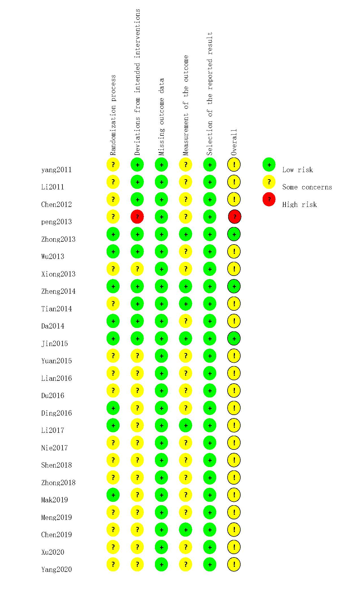
Figure S3 Drapery plot of anxiety (Acupuncture VS Sham acupuncture)
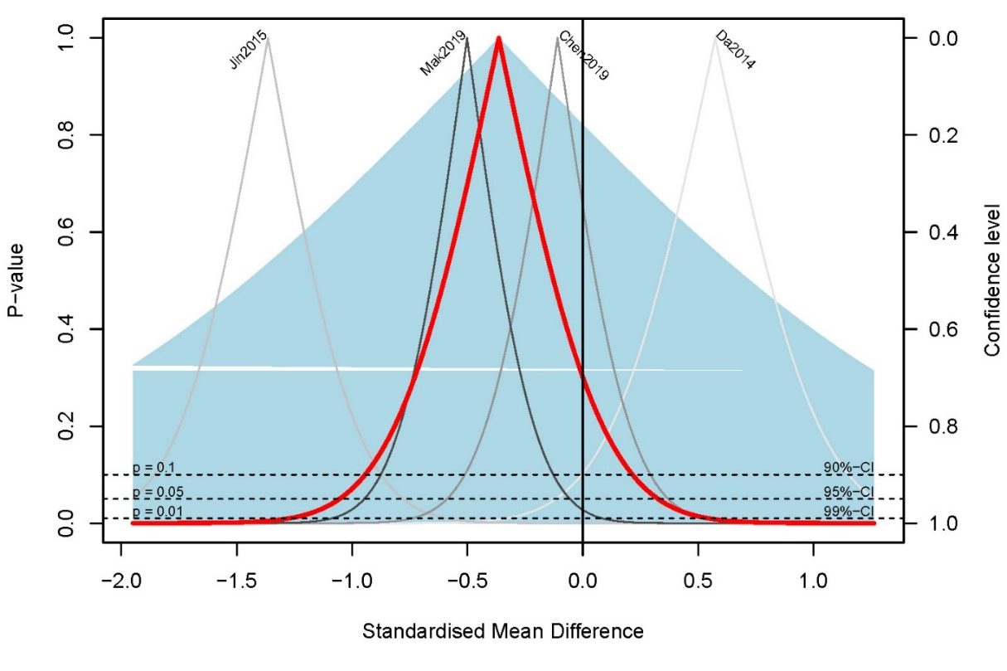

Figure S4 Sensitivity analyses of anxiety (Acupuncture VS Sham acupuncture)
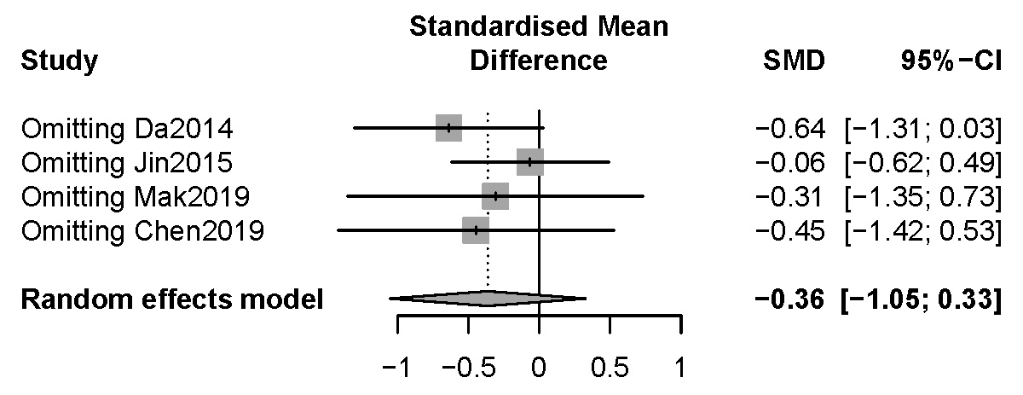

Figure S5 Subgroup analyses of anxiety base on include acupoints for tranquillization or not (Acupuncture VS Sham acupuncture)
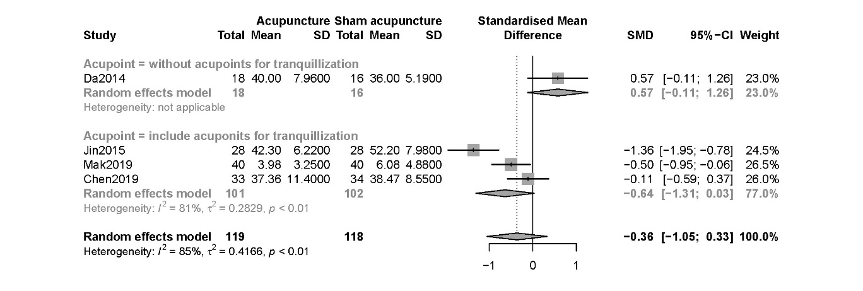

Figure S6 Subgroup analyses of anxiety base on acupuncture type (Acupuncture VS Sham acupuncture)
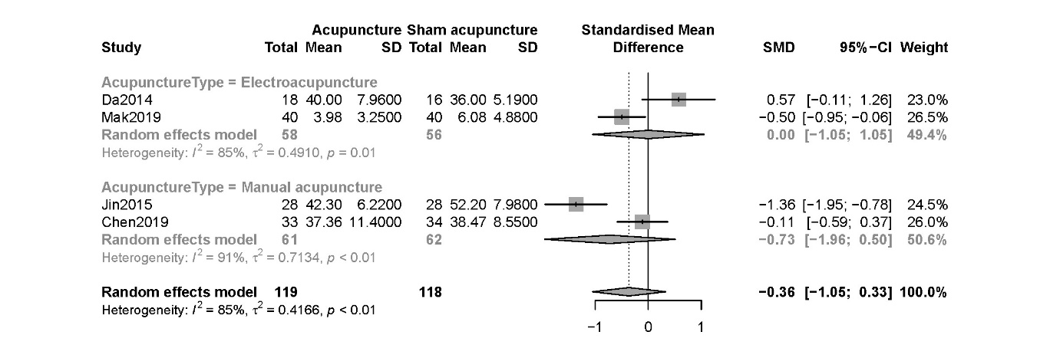
Figure S7 Drapery plot of depression (Acupuncture VS Sham acupuncture)
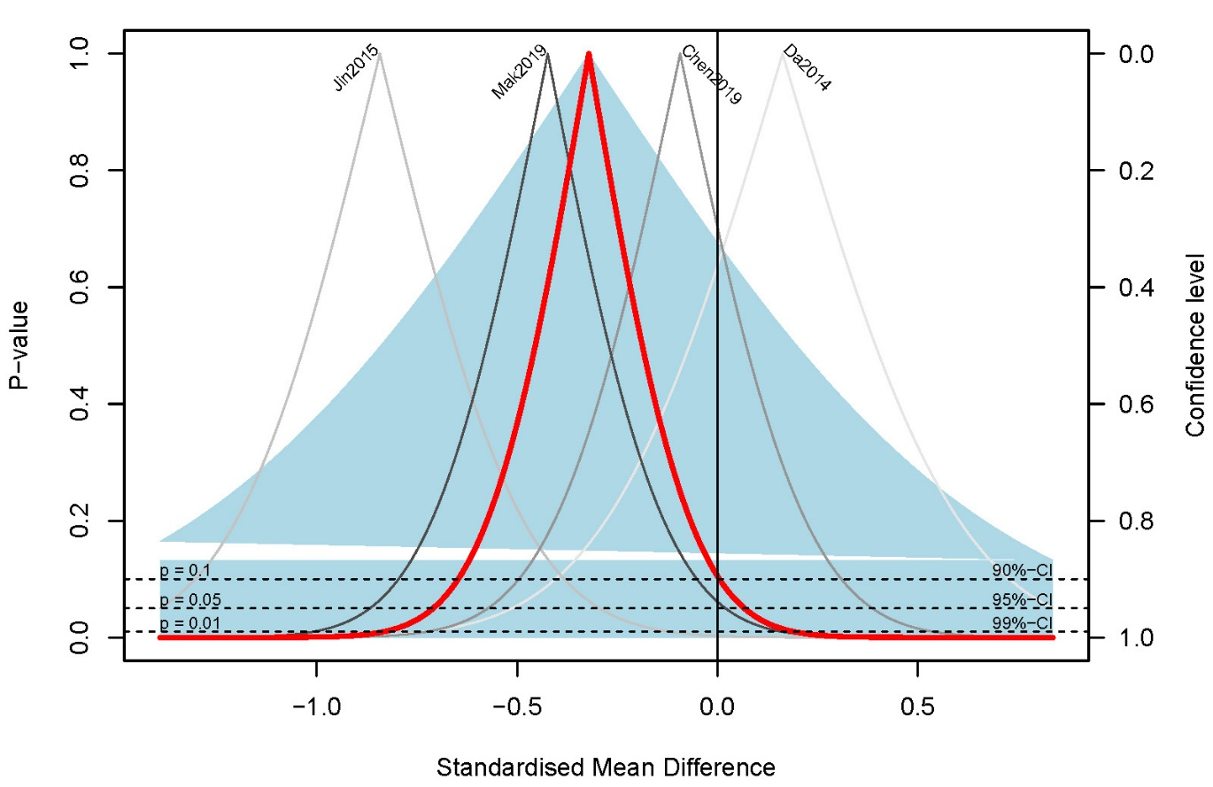
Figure S8 Sensitivity analyses of depression (Acupuncture VS Sham acupuncture)

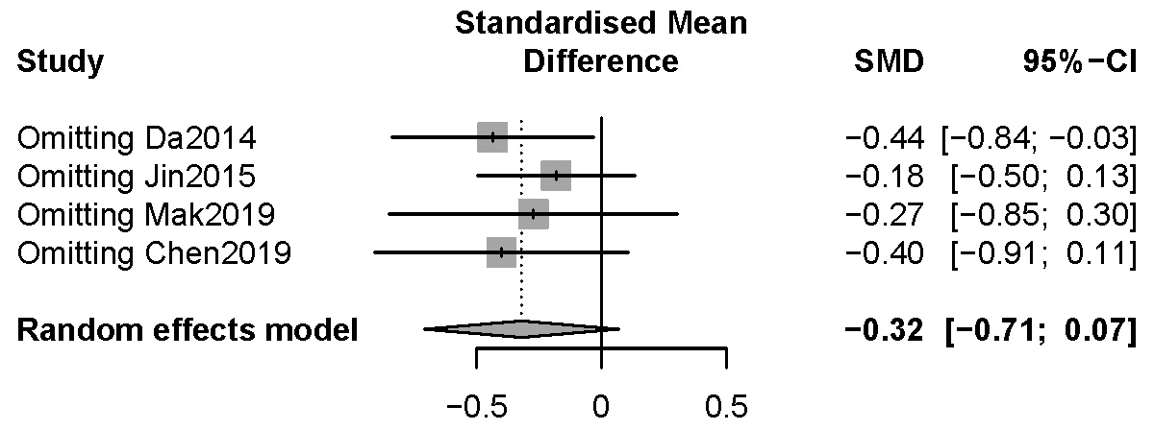

Figure S9 Subgroup analyses of depression base on include acupoints for tranquillization or not (Acupuncture VS Sham acupuncture)
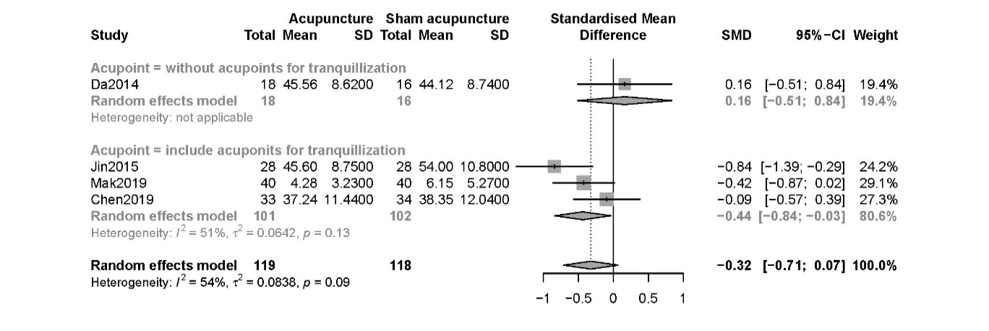
Figure S10 Subgroup analyses of depression base on acupuncture type (Acupuncture VS Sham acupuncture)
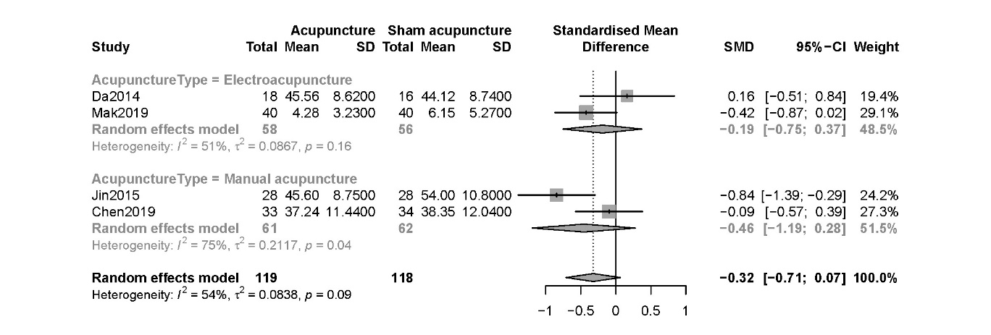
Figure S11 Drapery plot of anxiety (Acupuncture VS Pharmacotherapy)

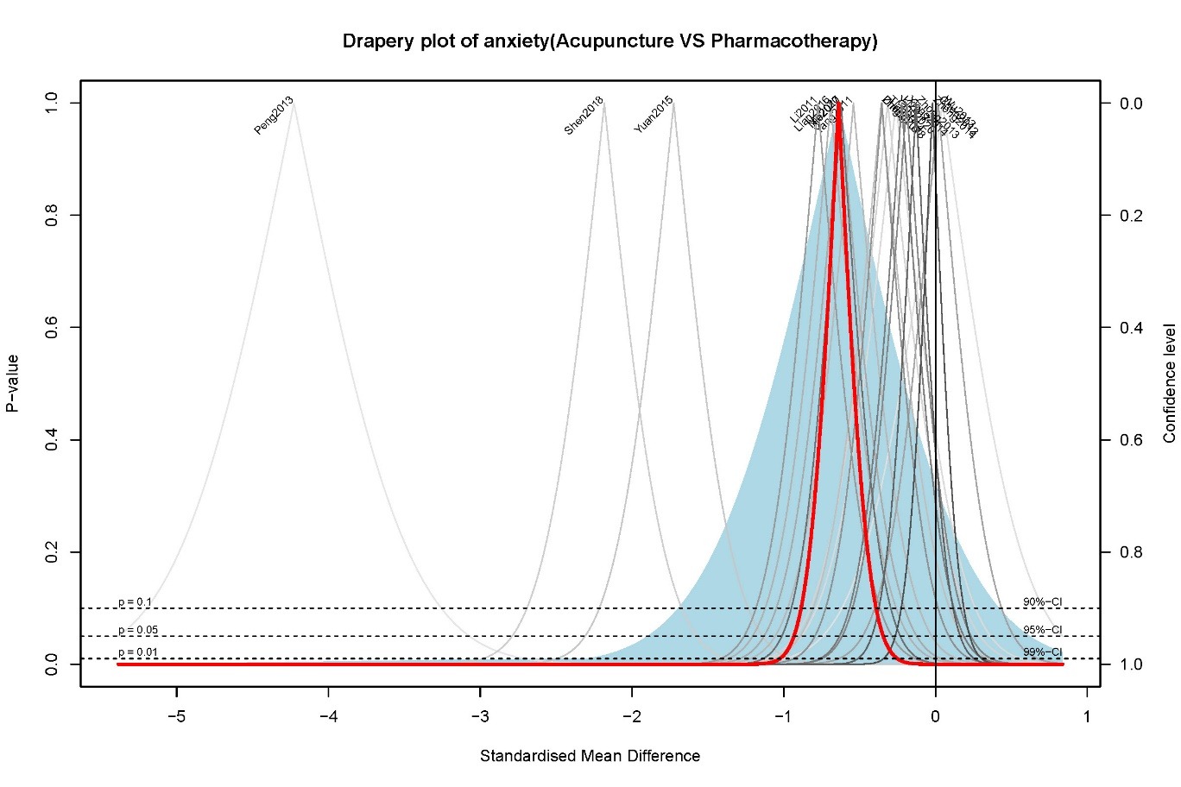

Figure S12 Sensitivity analyses of anxiety (Acupuncture VS Pharmacotherapy)
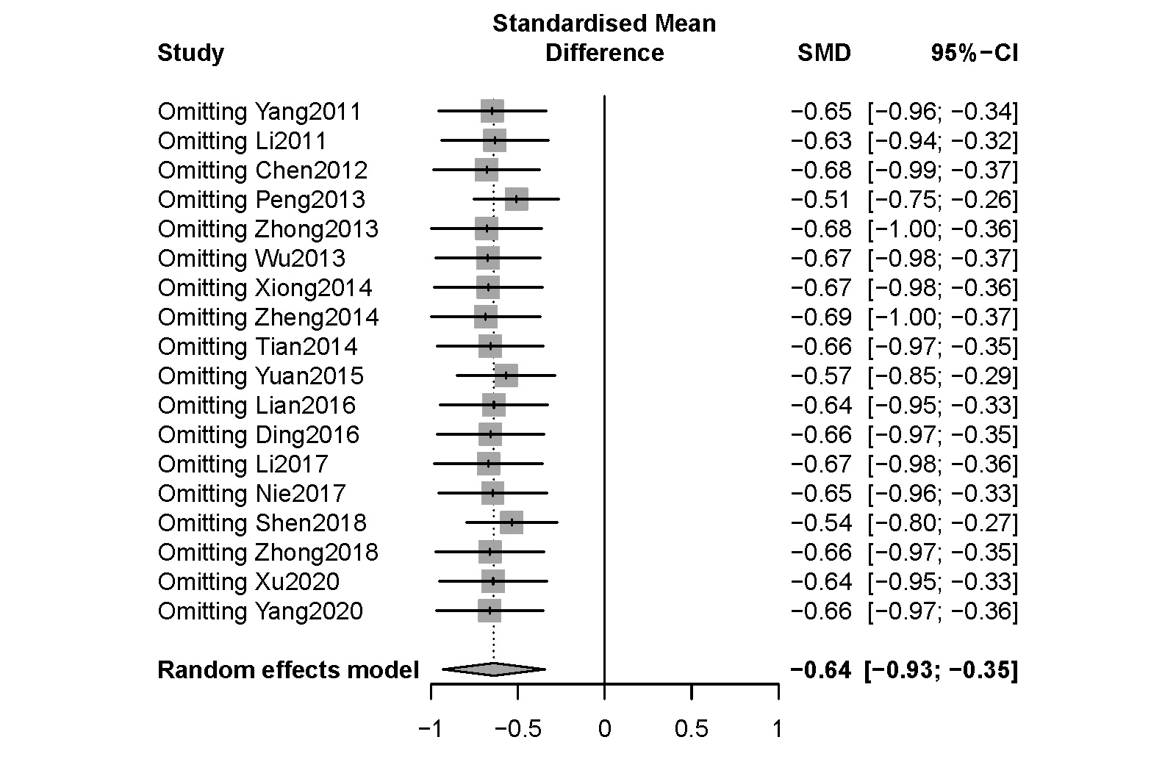
Figure S13 Subgroup analyses of anxiety base on include acupoints for tranquillization or not (Acupuncture VS Pharmacotherapy)
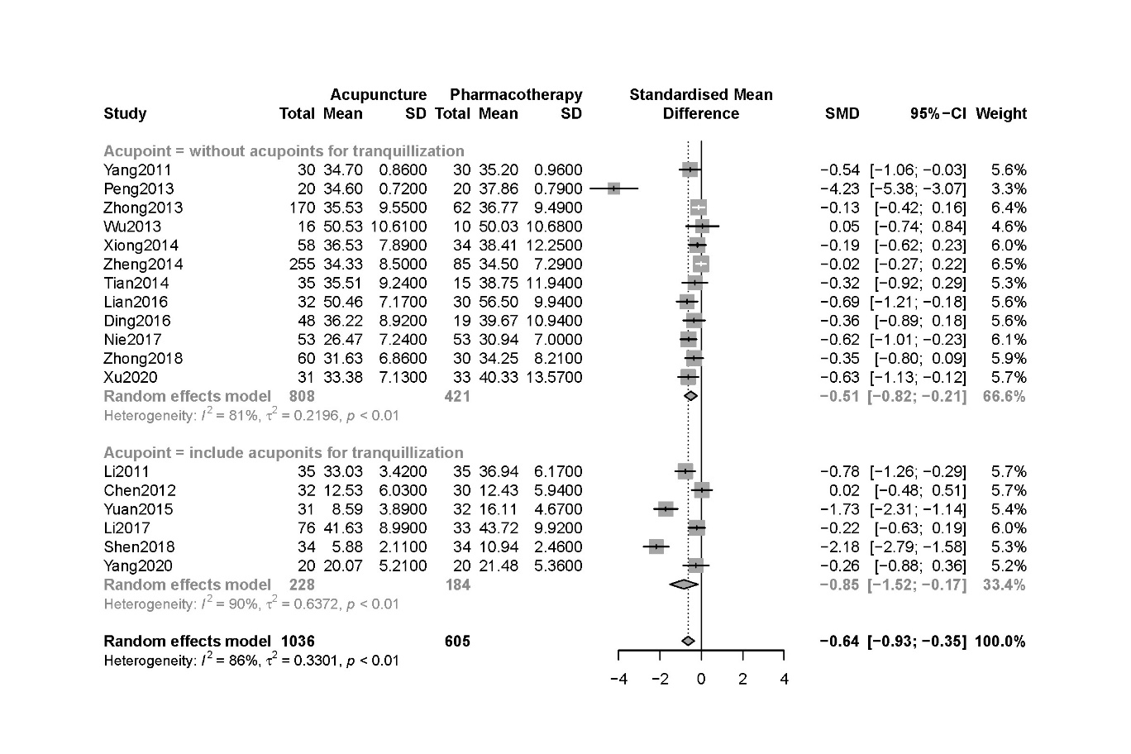

Figure S14 Subgroup analyses of anxiety base on acupuncture type (Acupuncture VS Pharmacotherapy)
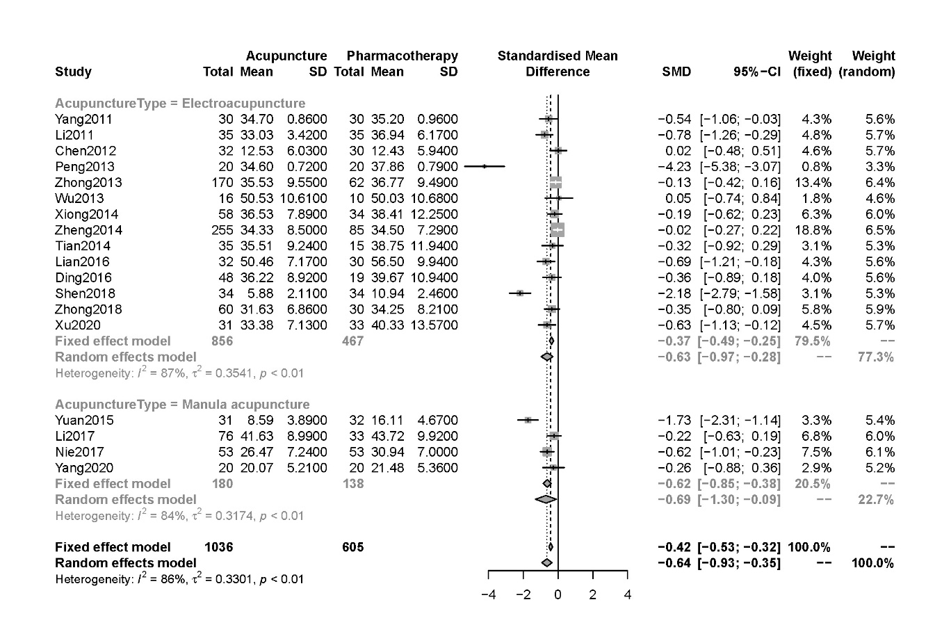
Figure S15 Drapery plot of depression (Acupuncture VS Pharmacotherapy)
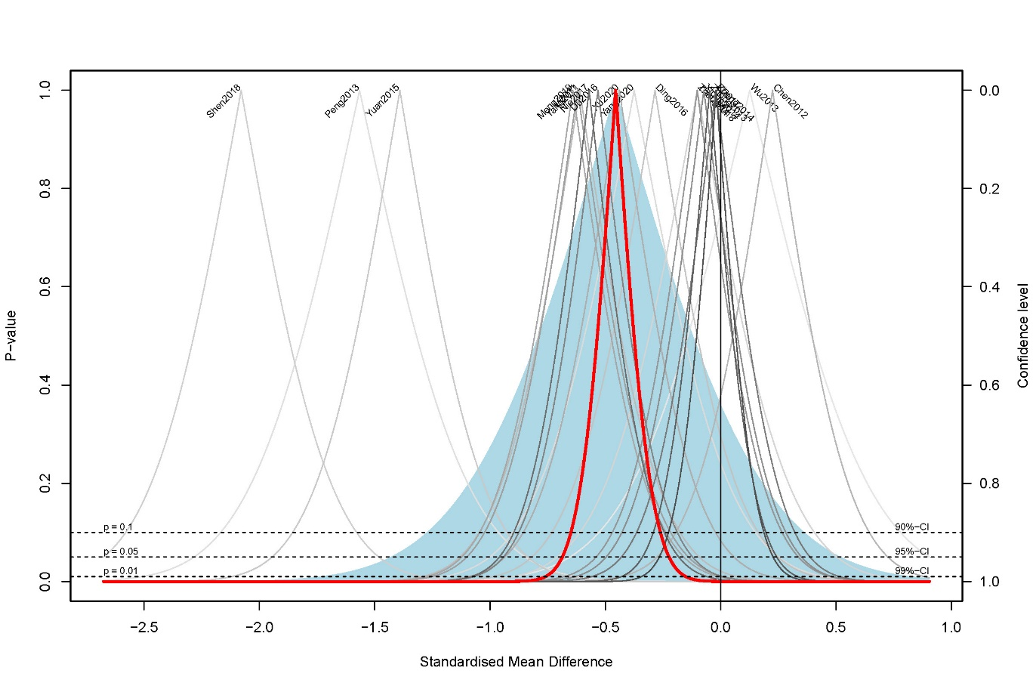

Figure S16 Sensitivity analyses of depression (Acupuncture VS Pharmacotherapy)
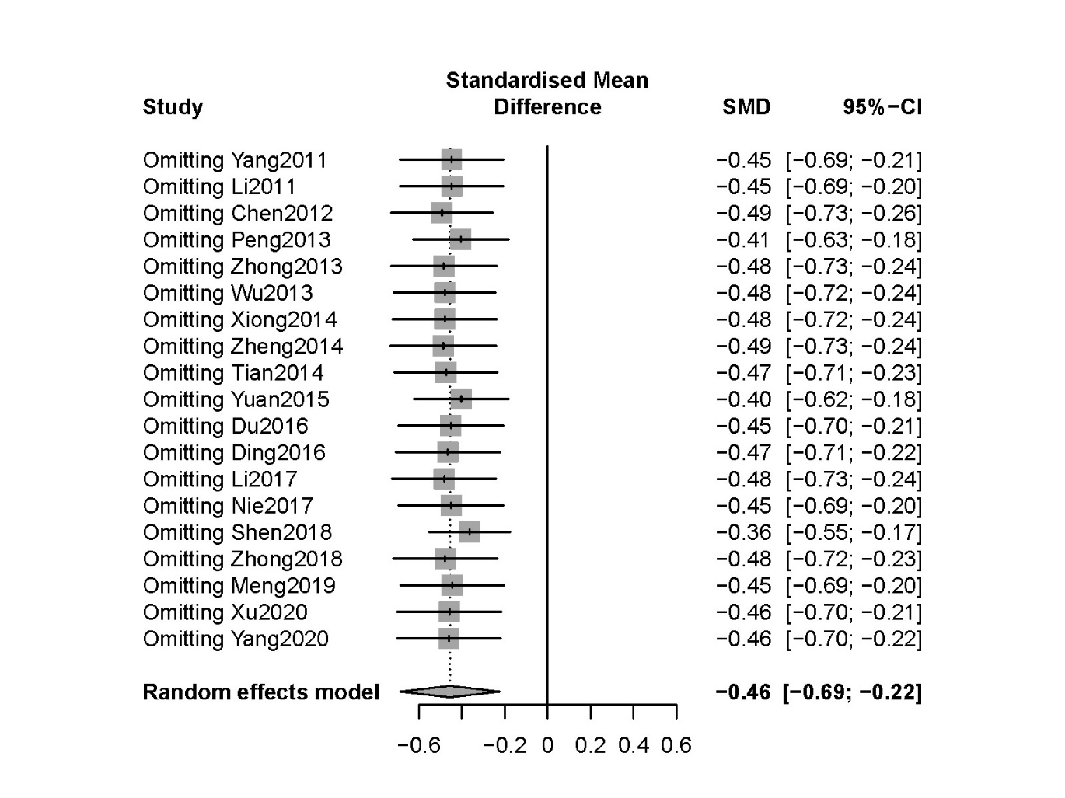Figure S17 Subgroup analyses of depression base on include acupoints for tranquillization or not (Acupuncture VS Pharmacotherapy)

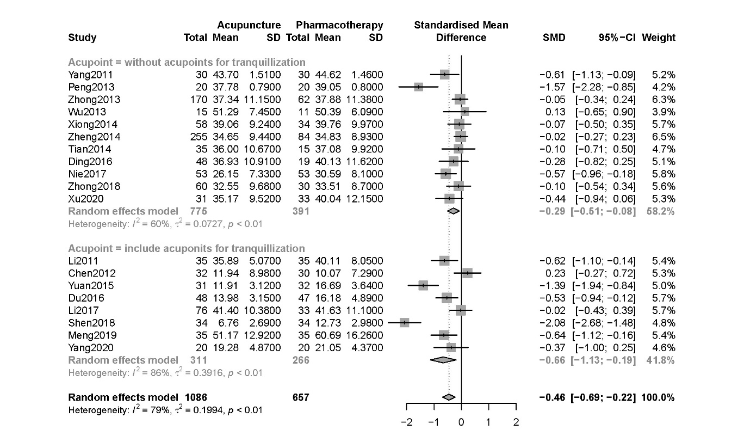

Figure S18 Subgroup analyses of depression base on acupuncture type (Acupuncture VS Pharmacotherapy)
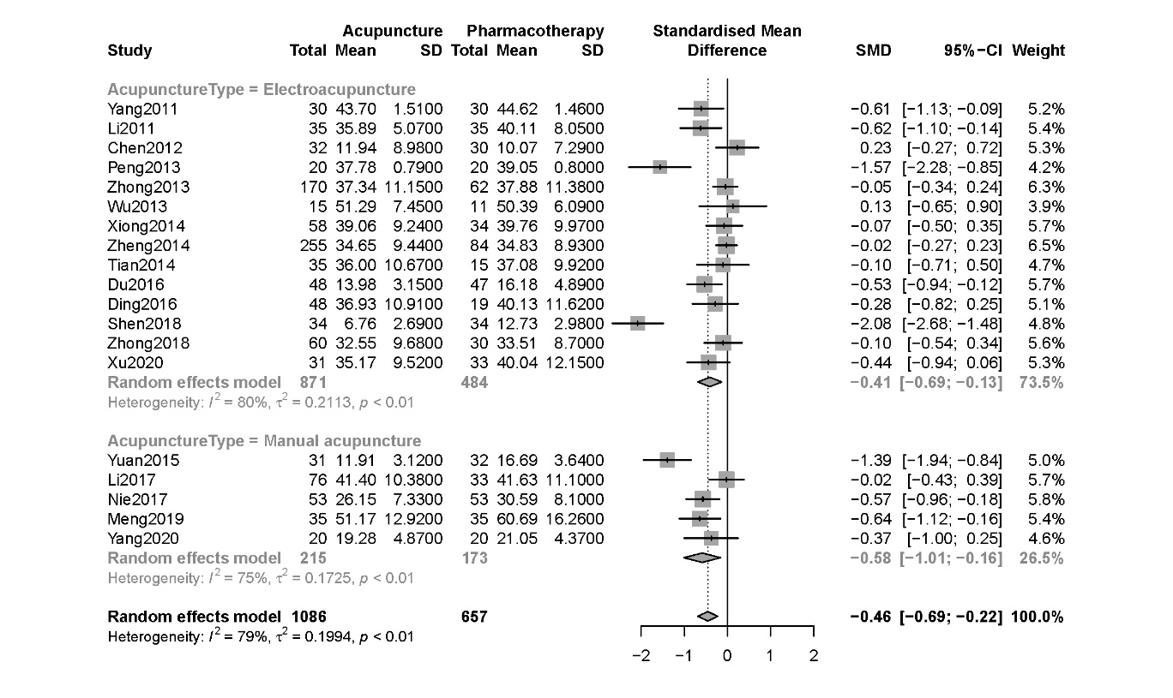
Figure S19 Contour-enhanced funnel plot of anxiety (Acupuncture VS Pharmacotherapy)
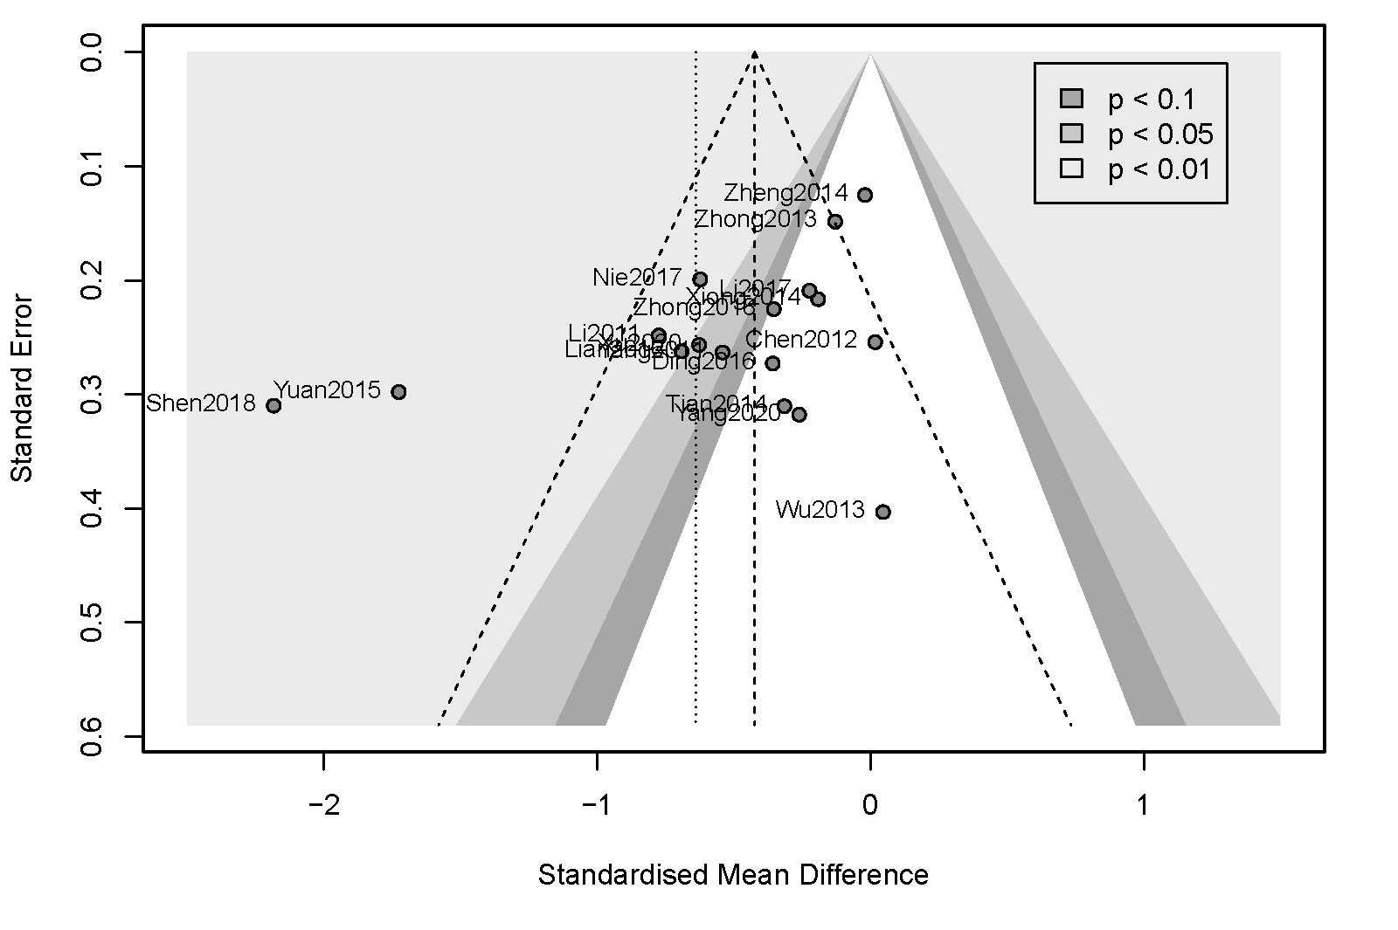

Figure S20 Contour-enhanced funnel plot of depression (Acupuncture VS Pharmacotherapy)
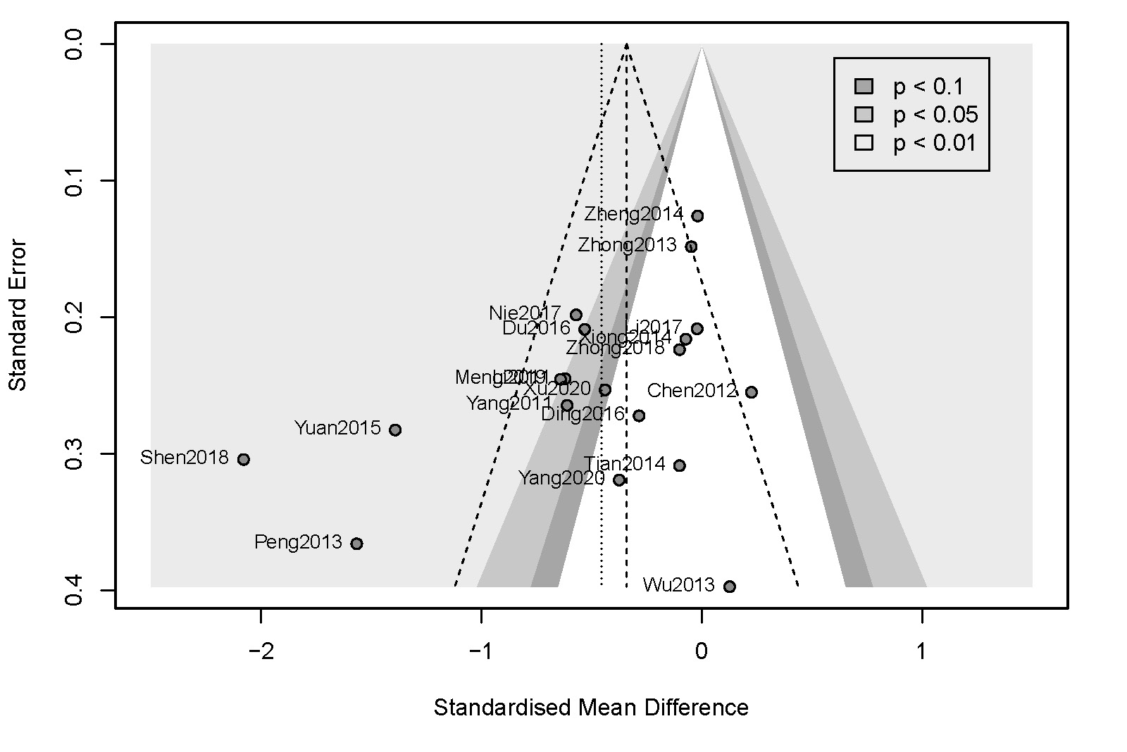
Figure S21 Contour-enhanced funnel plot of anxiety (Acupuncture VS Pharmacotherapy) after trim-and-fill analysis
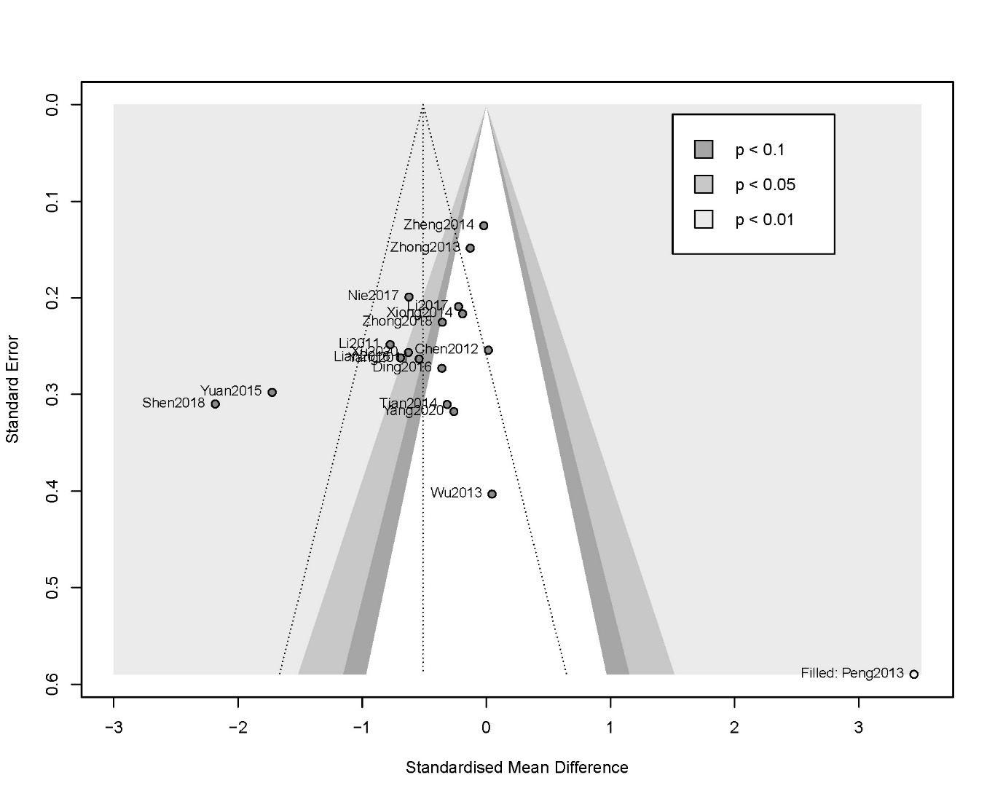

Figure S22 Contour-enhanced funnel plot of depression (Acupuncture VS Pharmacotherapy) after trim-and-fill analysis
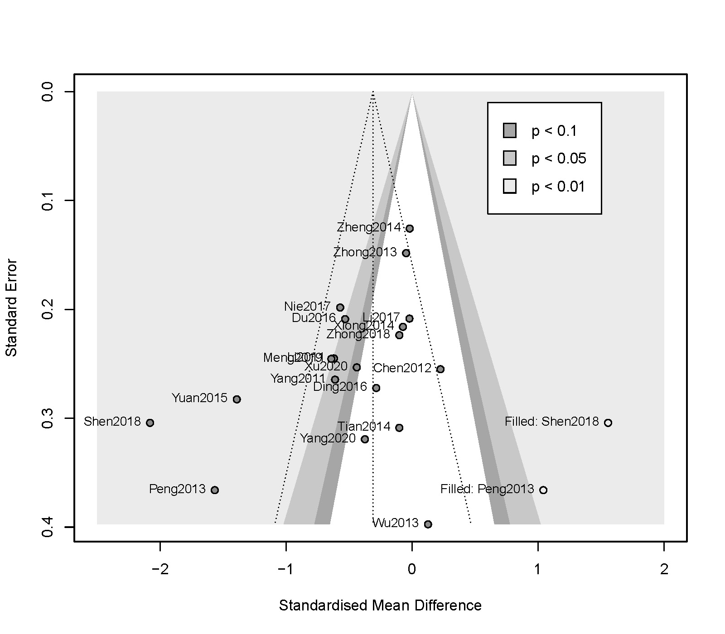

Table S1 PubMed search strategy
NO. | Searchs
#1 | IBS [Title/Abstract]
#2 | Irritable Bowel Syndrome [Title/Abstract]
#3 | Irritable Bowel Syndrome [MeSH]
#4 | Functional dyspepsia [Title/Abstract]
#5 | Functional dyspepsia [MeSH]
#6 | functional diarrhoea [Title/Abstract]
#7 | functional diarrhoea [MeSH]
#8 | functional constipation [Title/Abstract]
#9 | functional constipation [MeSH]
#10 | #1 OR #2 OR #3 OR #4 OR #5 OR #6 OR #7 OR #8 OR #9
#11 | Acupuncture [MeSH]
#12 | Acupuncture [Title/Abstract]
#13 | Electroacupuncture [Title/Abstract]
#14 | electro-acupuncture [Title/Abstract]
#15 | acupuncture therapy [Title/Abstract]
#16 | point injection [Title/Abstract]
#17 | Acupoint [Title/Abstract]
#18 | #11 OR #12 OR #13 OR #14 OR #15 OR #16 OR #17
#19 | Randomized controlled trial [Publication Type]
#20 | Randomized [Title/Abstract]
#21 | #19 OR #20
#22 | #10 AND # 18 AND #21

E: Experimental Group; C: Control Group; MA: Manual acupuncture; EA: Electroacupuncture; SA: Sham acupuncture; NR: Not report; SAS: Self-Rating Anxiety Scale; SDS: Self-Rating depression Scale; HAMA: Hamilton Rating Scale for Anxiety; HAMD: Hamilton Rating Scale for Depression; PHQ-9: Patient Health Questionnaire-9 items; GAD-7: Generalized Anxiety Disorder-7 items

Table S2 Excluded studies

Exclude studies | Reason for exclusion
Arvidsdotter T, Marklund B, Taft C. Effects of an integrative treatment, therapeutic acupuncture and conventional treatment in alleviating psychological distress in primary care patients--a pragmatic randomized controlled trial. BMC Complement Altern Med. 2013 Nov 7;13:308. doi: 10.1186/1472-6882-13-308. | not meet the inclusion criteria of the disease
Cao H M, Deng M J, Liang J B, et al. Thread-embedding Therapy in the Treatment of Irritable Bowel Syndrome of Liver Stagnation and Spleen Deficiency[J]. Shaanxi Journal of Traditional Chinese Medicine, 2018,39(2):262-264. | not meet the inclusion criteria of the acupuncture group
Central mechanism of acupuncture treating for functional constipation ChiCTR1800016658 | no specific data reported
Chen L, Sun J H, Han G H, et al. Clinical Study on Treatment of Functional Constipation by Deep Needling Tianshu and Abdominal Jie Points Combined with Electroacupuncture[J]. Shanghai Journal of Acupuncture and Moxibustion, 2016,35(03):287-290. | not meet the inclusion criteria of the outcomes
Chen Q, Zhou Y, Zhang M, et al. Efficacy Observation of Acupuncture Combined with Salt-partitioned Moxibustion for IBS-D of Spleen Deficiency Pattern[J]. Shanghai Journal of Acupuncture and Moxibustion, 2021,40(4):400-405. | not meet the inclusion criteria of the acupuncture group
Chen W C, Ye Y S, Hou X Y, et al. Effect of transcutaneous vagus nerve stimulation on local consistency of brain in patients with functional dyspepsia[J]. Chinese Imaging Journal of Integrated Traditional and Western Medicine, 2021,19(01):6-10. | not meet the inclusion criteria of the acupuncture group
Chen X L, Chen X, She L J, et al. Mechanism of transcutaneous electrical acupoint stimulation in improving the symptoms and gastric accommodation in patients with functional dyspepsia[J]. Chinese Journal of Digestion, 2021,41:16-22. | not meet the inclusion criteria of the acupuncture group
Chen Y H, Chen X K, Yin X J. Comparison of the therapeutic effects of electroacupuncture and probiotics combined with deanxit in treating diarrhea-predominant irritable bowel syndrome[J]. 2012,32(5):594-598. | data come from the same study included in qualitative synthesis
Effect of Acupuncture on Patients With Functional Dyspepsia: a Multi-center, Randomized, Waitlist-controlled Trial. ClinicalTrials.gov Identifier: NCT01921504 | no specific data reported
Electrical Stimulation Over Acupuncture Points in Reduction of Rectal Discomfort Distension. ClinicalTrials.gov Identifier: NCT01551654 | no specific data reported
Forbes A, Jackson S, Walter C, et al. Acupuncture for irritable bowel syndrome: A blinded placebo-controlled trial[J]. World Journal of Gastroenterology, 2005,11(26):4040-4044. | no specific data reported
Geng H, Yang Q H. Observation on Curative Effect of Tongyuan Warming Acupuncture Method, Tongyuan Acupuncture Method and Acupuncture Method on Diarrhea-Type Irritable Bowel Syndrome (Stagnation of Liver and Spleen Type)[J]. Journal of Sichuan of Traditional Chinese Medicine, 2018,36(2):185-188. | not meet the inclusion criteria of the control group
Han G H. A Randomized Controlled Study of Deep Needling Tianshu and Abdominal Jie Points for Treatment of Severe Functional Constipation[D]. Nanjing University Of Chinese Medicine, 2014. | not meet the inclusion criteria of the outcomes
Huang T. Clinical study on acupuncture treatment of diarrhea-type irritable bowel syndrome[D]. Nanjing University Of Chinese Medicine, 2017. | not meet the inclusion criteria of the outcomes
Jiang W. Clinical study of catgut embedding on acupoints for the treatment of liver-stomach discordant functional dyspepsia and postprandial discomfort syndrome[D]. Hubei University of Chinese Medicine, 2020. | not meet the inclusion criteria of the acupuncture group
Jin W J. Evaluation of Therapeutic Effect of Transcutaneous Electrical Acupoint Stimulation on Patients with Irritable Bowel Syndrome[J]. Shaanxi Journal of Traditional Chinese Medicine, 2016,37:478-479. | not meet the inclusion criteria of the acupuncture group
Kim S K, Lee H, Kuo B, et al. Does realistic clinical acupuncture treatment have an effect on functional dyspepsia?[J]. Gastroenterology, 2015,148(4):S820-S821. | not meet the inclusion criteria of the control group
Ko S J, Kim S K, Kim M J, et al. The effect of acupuncture treatment on functional dyspepsia: Pilot study[J]. Integrative Medicine Research, 2015,4(1):20. | not meet the inclusion criteria of the control group
Ko S J, Kuo B, Kim S K, et al. Individualized acupuncture for symptom relief in functional dyspepsia: A randomized controlled trial[J]. Journal of Alternative and Complementary Medicine, 2016,22(12):997-1006. | not meet the inclusion criteria of the control group
Li L, Li Y, Bao X Y, et al. RCTs of Feiteng Bafa Acupuncture Treating IBS-D of Deficiency of Spleen and Stomach[J]. Journal of Clinical Acupuncture and Moxibustion, 2018,34(6):12-15. | not meet the inclusion criteria of the control group
Li R G, Wang W, Jing Q, et al. Effect of Electroacupuncture on Colonic Transfusion and Mental State of Patients with Anxiety and Depression with Irritable Bowel Syndrome: 2016 The 8th National Academic Conference of the Mental Disease Branch of the Chinese Society of Chinese Medicine, Harbin, 2016[C]. | unable to get full-text information
Li S L, Zhou C, Sun Y Z. Study on the Application of the Method of Regulating the Mind in the Treatment of Diarrhea-type Irritable Bowel Syndrome[J]. Journal of Clinical Acupuncture and Moxibustion, 2020,36(01):17-20. | not meet the inclusion criteria of the acupuncture group
Li W. Intervention effect of electroacupuncture on Shumu points of Dachangchang on patients with functional diarrhea[D]. Hunan University of Chinese Medicine, 2012. | data come from the same study included in qualitative synthesis
Li Y B, Zhu Y P, Luo Z Q, et al. Efficiency observation of Anchang Zhixie recipe and acupuncture on irritable bowel syndrome of spleen deficiency and overabundance dampness type[J]. Shanxi Journal of Traditional Chinese Medicine, 2020,36(2):30-32. | not meet the inclusion criteria of the acupuncture group
Li Z M. Acupuncture treatment of diarrhea-type irritable bowel syndrome (liver stagnation and spleen deficiency syndrome) clinical research[D]. Liaoning University Of Traditional Chinese Medicine, 2012. | not meet the inclusion criteria of the outcomes
Liao W, Wang H, Wang J, et al. Observation on Therapeutic Effect of Acupuncture on Refractory Functional Dyspepsia in Soldiers[J]. People's Military Surgeon, 2012,55(11):1051-1052. | not meet the inclusion criteria of the disease
Lin L, Dai R S, Wang Q L, et al. 20 Cases of Chronic Functional Constipation Treated with Acupuncture Combined with Mosapride[J]. Chinese and Foreign Medical Research, 2020,18(36):123-125. | not meet the inclusion criteria of the acupuncture group
Liu S S. Observation and Study on Therapeutic Effect of Acupuncture and Moxibustion on Functional Dyspepsia with Mood Disorder[J]. Medical Community, 2020,0(12):132-133. | not meet the inclusion criteria of the outcomes
Liu Z Z. Observation on the clinical curative effect of combined acupuncture points in the treatment of functional diarrhea[D]. Changchun University of Chinese Medicine, 2014. | data come from the same study included in qualitative synthesis
Luigi G, Vittorio M, Alfredo V, et al. Randomised controlled trial comparing acupuncture with placebo acupuncture for the treatment of irritable bowel syndrome[J]. European Journal of Integrative Medicine, 2012,4:121. | unable to get full-text information
Mao W. Observation on the clinical effect of electroacupuncture on constipation-type irritable bowel syndrome[D]. Hubei University of Chinese Medicine, 2018. | not meet the inclusion criteria of the outcomes
Mao Y D. Clinical Observation on the Treatment of Functional Dyspepsia with Electroacupuncture and Mosapride[D]. Hubei University of Chinese Medicine, 2014. | not meet the inclusion criteria of the acupuncture group
Meng X L, Wang S. Study on the Therapeutic Effect of "Tiao Shen Chang Qing Three Six Nine" Acupuncture Therapy on Functional Constipation[J]. Heilongjiang Journal of Traditional Chinese Medicine, 2019,48(2):213-215. | not meet the inclusion criteria of the control group
Peng K M, Luo P. Observation on Therapeutic Effect of Acupuncture and Moxibustion on Functional Dyspepsia Accompanied by Mood Disorder[J]. Journal of Clinical Acupuncture and Moxibustion, 2016,32(06):1-4. | not meet the inclusion criteria of the acupuncture group
Peng S F, Shi Z H, Mei Z M, et al. Effect of electroacupuncture at Neiguan and Zusanli on the symptoms, mental state and quality of life of patients with functional dyspepsia: The 21st National Conference on Digestive System Diseases of Integrated Traditional Chinese and Western Medicine, Nanning, 2009[C]. | data come from the same study included in qualitative synthesis
Peng S F, Yang J Y, Shi Z H, et al. Electroacupuncture improves gastric motility, autonomic nerve function and mental state in functional dyspepsia[J]. World Chinese Journal of Digestology, 2008,16(36):4105-4109. | no specific data reported
Peng S, Yang J, Shi Z. Electroacupuncture improves gastric motility, autonomic nerve activity and psychological state in patients with functional dyspepsia[J]. 2008,16(36):4105-4109. | data come from the same study included in qualitative synthesis
Qi R X. Clinical Study on "Promoting Qi and Eliminating Pi" in Treating Post-stroke Dyspepsia (Postprandial Discomfort Syndrome)[D]. Tianjin University of Traditional Chinese Medicine, 2018. | not meet the inclusion criteria of the disease
Qiu M X. Study on the Effect and Mechanism of Transcutaneous Electrical Nerve Stimulation at Zusanli Point on Patients with Slow Transit Type Functional Constipation[D]. Huazhong University of Science and Technology, 2009. | not meet the inclusion criteria of the acupuncture group
Rafiei R, Ataie M, Ramezani M A, et al. A new acupuncture method for management of irritable bowel syndrome: A randomized double blind clinical trial[J]. Journal of Research in Medical Sciences, 2014,19(10):913-917. | not meet the inclusion criteria of the acupuncture group
Reynolds J A, Bland J M, MacPherson H. Acupuncture for irritable bowel syndrome[J]. ACUPUNCTURE IN MEDICINE, 2008,1(26):8-16. | no specific data reported
Shang F T. Effects of transcutaneous electroacupuncture therapy on sepsis patients with functional dyspepsia after ICU discharge: a cross-sectional study and randomized controlled trial(ChiCTR1800019475 ). 2018. | not meet the inclusion criteria of the acupuncture group
Wang J. Analysis of clinical curative effect of acupuncture on functional bowel disease[D]. Guangzhou University of Chinese Medicine, 2014. | data come from the same study included in qualitative synthesis
Wang J. Comparative study of electroacupuncture and prucalopride in the treatment of severe chronic constipation in women[D]. Guangzhou University of Chinese Medicine, 2016. | not meet the inclusion criteria of the outcomes
Wang X Y. Clinical Study on Acupuncture Treatment of Functional Dyspepsia with Mood Disorder[J]. Shenzhen Journal of Integrated Traditional Chinese and Western Medicine, 2019,29(12):153-154. | not meet the inclusion criteria of the acupuncture group
Wong R K, Fang S Q, Lee T L, et al. Acupuncture therapy improves bloating in functional dyspepsia patients: A randomized controlled trial of sham vs. real acupuncture[J]. Gastroenterology, 2009,136(5):A182. | unable to get full-text information
Wu D, Peng T, Rong P J, et al. Efficacy of electro-acupuncture on ear concha in the treatment of diarrhea-type irritable bowel syndrome[J]. World Chinese Medicine, 2021,16(11):1721-1725. | not meet the inclusion criteria of the acupuncture group
Wu D, Rong P J, Wang H C, et al. Efficacy Observation on 90 Cases of Functional Dyspepsia Treated by Electroacupuncture at Concha Auriculae[J]. World Chinese Medicine, 2020,15:627-631 | not meet the inclusion criteria of the acupuncture group
Wu D, Wang Y, Zhang J L, et al. Transcutaneous auricular vagus nerve stimulation for functional dyspepsia: A randomized controlled trial[J]. World Journal of Acupuncture - Moxibustion, 2021. | data come from the same study included in qualitative synthesis
Wu D. Study on the effect and mechanism of ear concha electroacupuncture on functional dyspepsia based on p38MAPK/NF-κB signal pathway[D]. China Academy of Chinese Medical Sciences, 2020. | data come from the same study included in qualitative synthesis
Wu J N. A Randomized Controlled Trial of Comparison of the Efficacy of Electroacupuncture at Different Acupoints in the Treatment of Functional Constipation[D]. China Academy of Chinese Medical Sciences, 2013. | data come from the same study included in qualitative synthesis
Wu X. Observation on the clinical curative effect of different intensity electroacupuncture in the treatment of functional constipation and preliminary study on its effect on patients' serum metabolic components[D]. Huazhong University of Science and Technology, 2017. | no specific data reported
Yang F. Discussion on Clinical Application Value of Tongyuan Warming Acupuncture Method and Acupuncture Method in Diarrhea-type Irritable Bowel Syndrome[J]. Journal of Sichuan of Traditional Chinese Medicine, 2017,35(6):187-190. | not meet the inclusion criteria of the control group
Yang J W, Wang L Q, Zou X, et al. Effect of Acupuncture for Postprandial Distress Syndrome: A Randomized Clinical Trial[J]. Annals of internal medicine, 2020,172(12):777-785. | not meet the inclusion criteria of the outcomes
Yang J Y, Peng S F, Shi Z H, et al. The influence of electroacupuncture acupoint stimulation on the symptoms, mental state and quality of life of patients with functional dyspepsia: The First International Academic Conference on Digestive Diseases of the Digestive Disease Professional Committee of the World Federation of Chinese Medicine Societies, Beijing , 2010[C]. | data come from the same study included in qualitative synthesis
Yang L J, Wang X X, Li B, et al. Effect of Acupuncture on the Acupoint Pain Threshold in Patients with Irritable Bowel Syndrome[J]. Shanghai Journal of Acupuncture and Moxibustion, 2018,37:1030-1036. | not meet the inclusion criteria of the outcomes
Yang T. Clinical Observation on Acupuncture of "Shenque Bazhen" in Treating Irritable Bowel Syndrome of Spleen Deficiency and Dampness[D]. Chengdu University of TCM, 2020. | not meet the inclusion criteria of the acupuncture group
Ye K S, Chen M X, Jin M, et al. Application of TCM Syndrome Scale to Evaluate the Efficacy of TEAS in the Treatment of Functional Dyspepsia[J]. Chinese Journal of Traditional Medical Science and Technology, 2013,20:507-508. | not meet the inclusion criteria of the acupuncture group
Yin P, Gao N, Dong B, et al. Efficacy and safety of acupuncture on the treatment of functional constipation: study protocol for a randomized controlled trial[J]. 2019,29(2):145-152. | protocol
Yu C D. Analysis of TCM Syndrome Types of Refractory Functional Dyspepsia and Observation of Acupuncture Efficacy[D]. Hubei University of Chinese Medicine, 2020. | not meet the inclusion criteria of the outcomes
Yu L M, Zhang Y L, Wang Y W, et al. Umbilicus acupuncture for treatment of diarrhea-type irritable bowel syndrome: Efficacy and impact on brain-gut peptides[J]. World Chinese Journal of Digestology, 2020,28(13):538-543. | not meet the inclusion criteria of the acupuncture group
Zhan D W. Effect of acupuncture with the method of soothing the liver and strengthening the spleen on the changes of serum 5-HT, NPY and CGRP levels in patients with diarrheal irritable bowel syndrome[D]. Nanjing University Of Chinese Medicine, 2013. | not meet the inclusion criteria of the outcomes
Zhang B Y. Preliminary comparison of the curative effect of different acupoints in relieving symptoms of functional diarrhea[D]. Beijing University of Chinese Medicine, 2014. | data come from the same study included in qualitative synthesis
Zhang L W. A Randomized Controlled Preliminary Clinical Study on Acupuncture "Old Ten Needles" Modified and Subtracted Recipe in Treating Postprandial Discomfort Syndrome[D]. Shandong university of traditional chinese medicine , 2017. | not meet the inclusion criteria of the outcomes
Zhang W, Chen Y. Effect of Acupuncture on Psychological Factors and Serum Ghrelin Level in Patients with Functional Dyspepsia[J]. Shanghai Journal of Acupuncture and Moxibustion, 2018,37(01):37-41. | not meet the inclusion criteria of the outcomes
Zhang X, Ding M, Feng Y, et al. Acupuncture with Du's heat-reinforcing method for diarrhea-predominant irritable bowel syndrome:a randomized controlled trial[J]. Journal of Acupuncture and Tuina Science, 2019,17:124-130. | not meet the inclusion criteria of the outcomes
Zhou J. Observation on the effect of electroacupuncture on severe chronic functional constipation in women[D]. Beijing University of Chinese Medicine, 2016. | not meet the inclusion criteria of the outcomes
Zhou S F. Observation of the effect of percutaneous vagus nerve stimulation on functional dyspepsia and fMRI study of central mechanism[D]. Guangzhou University of Chinese Medicine, 2020. | not meet the inclusion criteria of the acupuncture group
Zhou Y. a clinical study on acupuncture and moxibustion treatment of slow transit constipation based on brain-gut axis theory[D]. Yunnan University of Chinese Medicine, 2019. | not meet the inclusion criteria of the disease
Zhu R X. Observation on the clinical curative effect of Dachangjing, Fu-organs and acupoints in the treatment of functional constipation[D]. Hunan University of Chinese Medicine, 2012. | data come from the same study included in qualitative synthesis

