Supplementary appendix
Table S1. Keywords for article searches
Table S2. Grading of Recommendations Assessment, Development and Evaluation (GRADE) rating in randomized controlled studies

Table S3. Grading of Recommendations Assessment, Development and Evaluation (GRADE) rating in non-randomized controlled studies

Figure S1. Overall risk of bias assessed using RoB 2 for randomized controlled studies
Figure S2. Overall risk of bias assessed using ROBINS-I tool for non-randomized controlled studies
Figure S3. Forest plots of subgroup analysis of changes of plasma aldosterone concentration after SGLT2i use in non-randomized controlled studies by (A) study type (B) duration of SGLT2i use and (C) the constancy of the dosage of anti-hypertensive medications during the study
Figure S4. Forest plots of subgroup analysis of the changes of plasma renin activity after SGLT2i use in non-randomized controlled studies by (A) study type (B) duration of SGLT2i use and (C) the constancy of the dosage of anti-hypertensive medications during the study
Figure S5. Funnel plots in non-randomized controlled studies (A) plasma aldosterone concentration (B) plasma renin activity

Table S1 Keywords for article searches
Keywords | Number of articles
Embase | 2297
'sodium glucose cotransporter 2 inhibitor'/exp AND ('aldosterone'/exp OR 'renin'/exp OR 'plasma volume'/exp OR 'hypertension'/exp) | 2297
Scopus | 799
(("Sodium-Glucose Transporter 2 Inhibitors") AND ("Aldosterone" OR "Renin" OR "Hypertension" OR "Plasma Volume" OR volume)) | 799
PubMed | 519
(("Sodium-Glucose Transporter 2 Inhibitors"[Mesh]) AND ("Aldosterone"[Mesh] OR "Renin"[Mesh] OR "Hypertension"[Mesh] OR "Plasma Volume"[Mesh] OR volume)) | 519
Cochrane | 492
"Sodium-Glucose Transporter 2 Inhibitors") AND ("Aldosterone" OR "Renin" OR "Hypertension" OR "Plasma Volume" OR volume)) | 492

Table S2. Grading of Recommendations Assessment, Development and Evaluation (GRADE) rating in randomized controlled studies

Outcome | Certainty assessment |  |  |  |  |  |  | Absolute effect (95% CI) | Certainty
Outcome | No. of studies | Study design | Risk of bias | Inconsistency | Indirectness | Imprecision | Other considerations | Absolute effect (95% CI) | Certainty
Plasma aldosterone concentration | 2 | RCT | Not serious | Not serious | Not serious | Serious | None | 0.30 (-0.04, 0.64). | Moderate
Plasma renin activity | 2 | RCT | Not serious | Not serious | Not serious | Not serious | None | 0.40 (0.06, 0.74) | High

Table S3. Grading of Recommendations Assessment, Development and Evaluation (GRADE) rating in non-randomized controlled studies

Outcome | Certainty assessment |  |  |  |  |  |  | Absolute effect (95% CI) | Certainty
Outcome | No. of studies | Study design | Risk of bias | Inconsistency | Indirectness | Imprecision | Other considerations | Absolute effect (95% CI) | Certainty
Plasma aldosterone concentration | 8 | Non-RCT | Serious | Not serious | Not serious | Serious | None | 0.08 (-0.16, 0.32). | Low
Plasma renin activity | 8 | Non-RCT | Serious | Not serious | Not serious | Not serious | None | 0.36 (0.17, 0.55) | Moderate

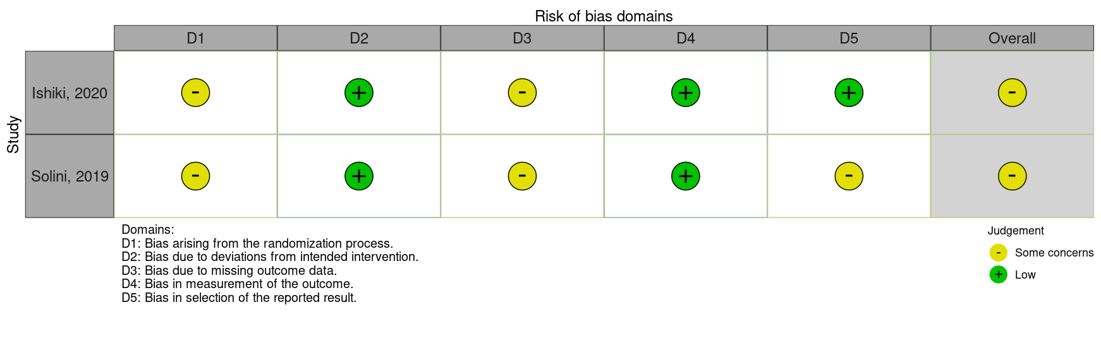

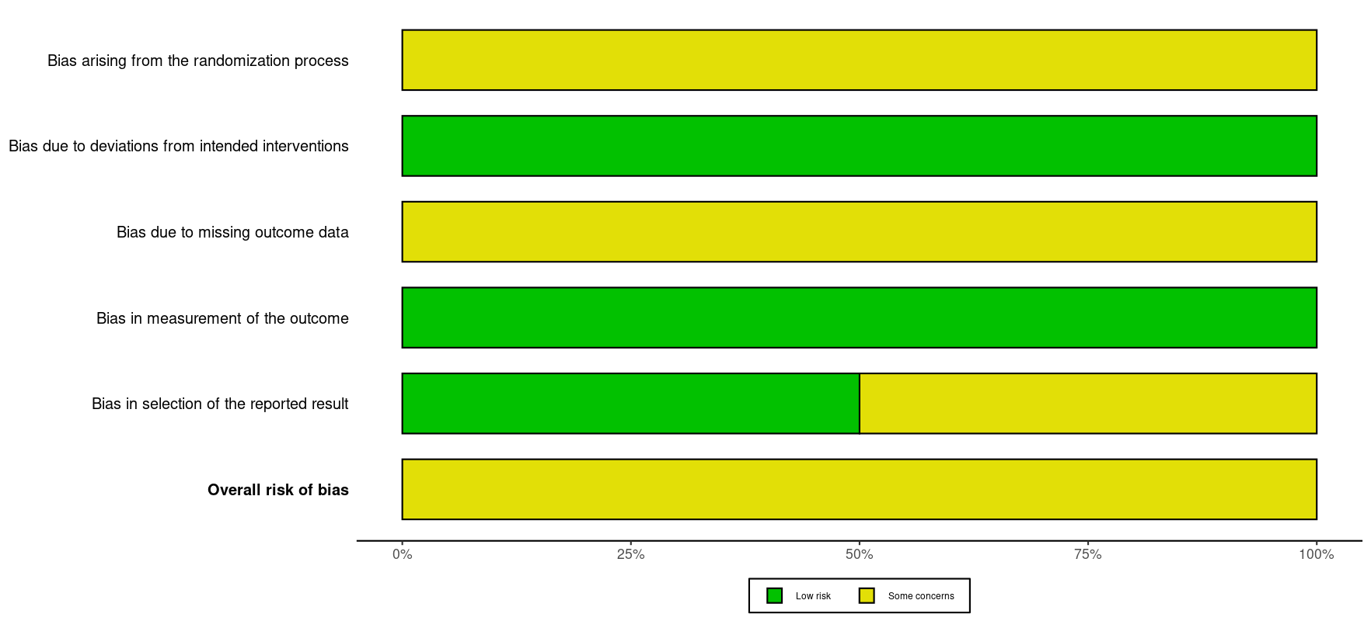

Figure S1. Overall risk of bias assessed using RoB 2 (A) traffic light plot and (B) summary plot

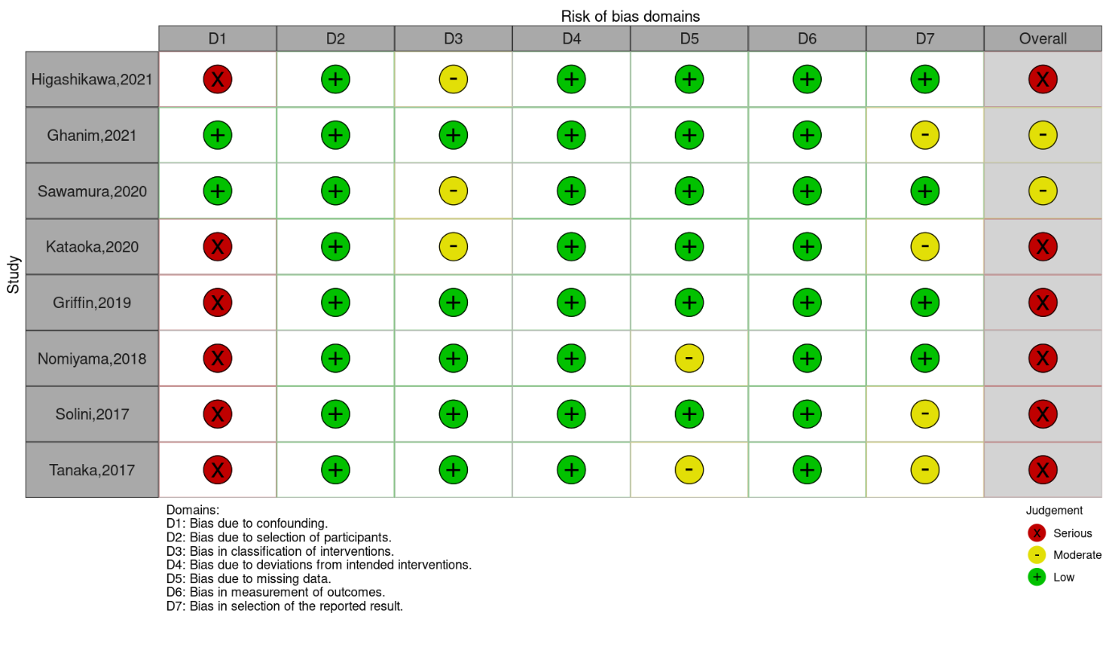
A
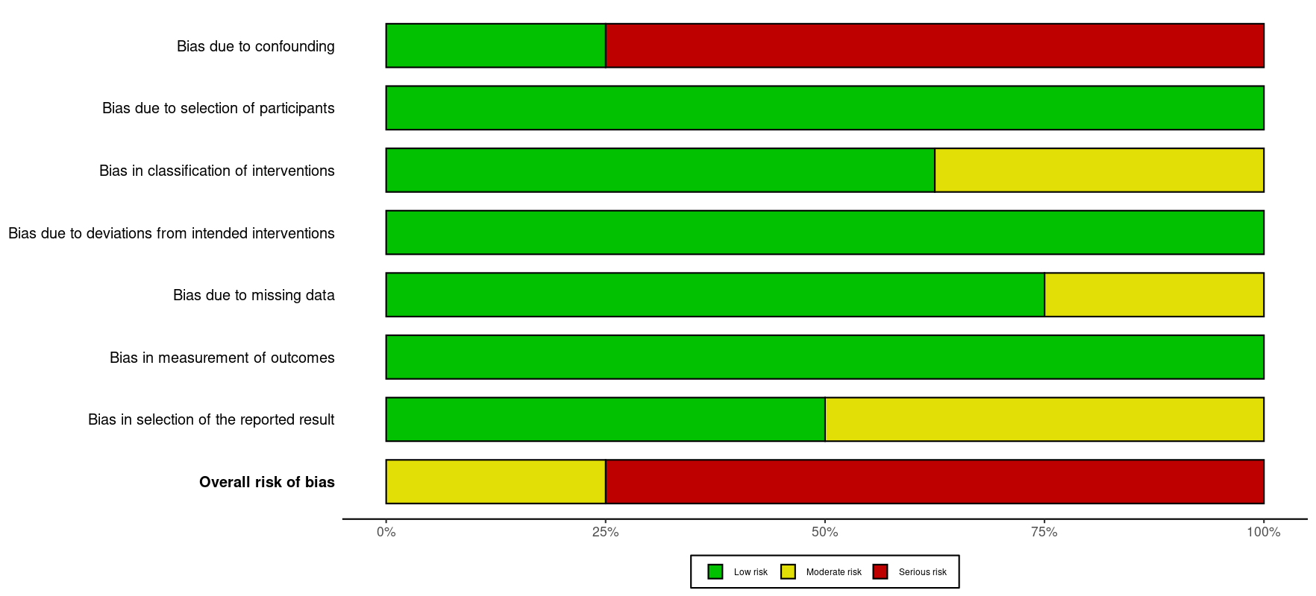
B

Figure S2 Overall risk of bias assessed by ROBINS-I tool (A) traffic light plot and (B) summary plot

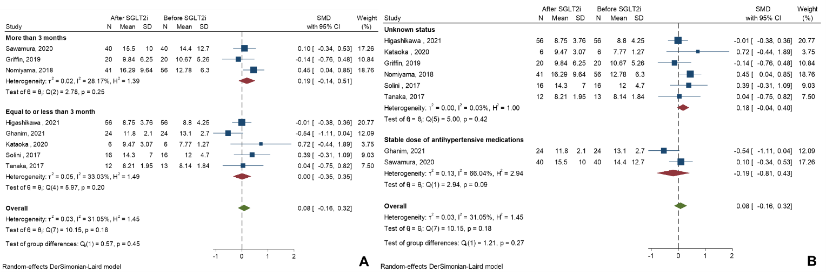

Figure S3 Forest plots of subgroup analysis of the changes of plasma aldosterone concentration after SGLT2i use in non-randomized controlled studies by (A) duration of SGLT2i use and (B) the stability of the dosage of anti-hypertensive medications during the study

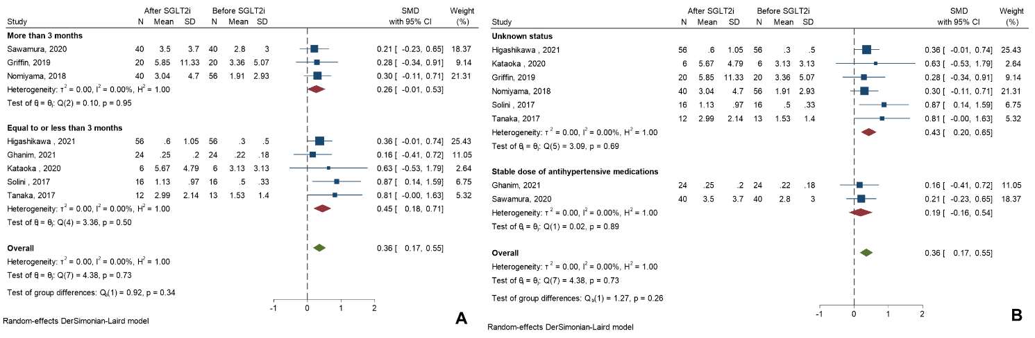

Figure S4 Forest plots of subgroup analysis of the changes of plasma renin activity after SGLT2i use in non-randomized controlled studies by (A) duration of SGLT2i use and (B) the stability of the dosage of anti-hypertensive medications during the study

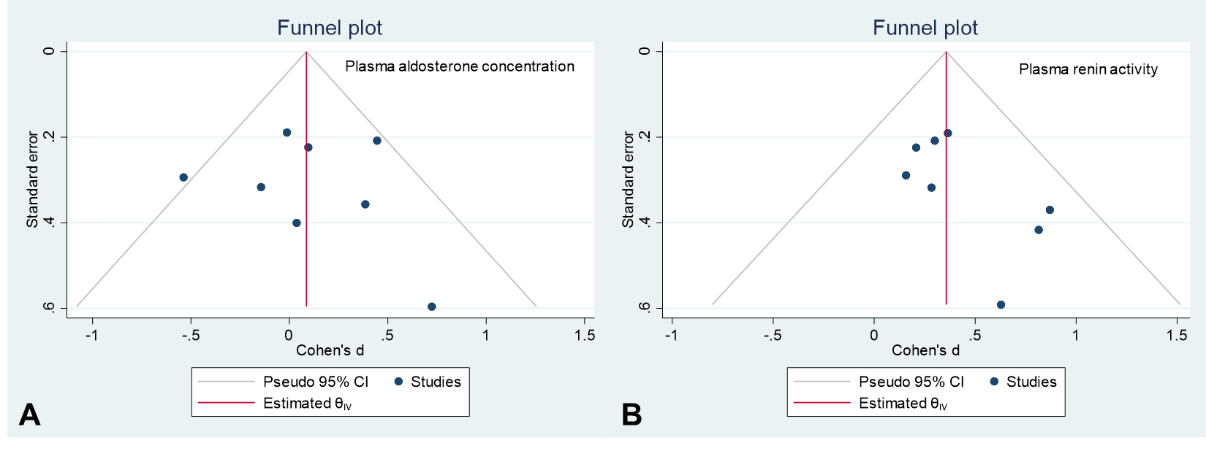
Figure S5 Funnel plots of non-randomized controlled studies (A) plasma aldosterone concentration (B) plasma renin activity

