Supplementary figure 1: Forest plot of poor sleep in those with clinically inactive inflammatory bowel disease and controls. Standardised mean difference used as effect size. Outliers excluded.
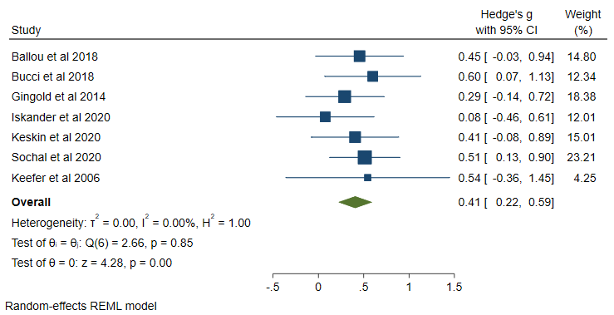
Supplementary Figure 2: Funnel plot of meta-analysis of poor sleep in those with clinically inactive inflammatory bowel disease and controls. Standardised mean difference used as effect size.
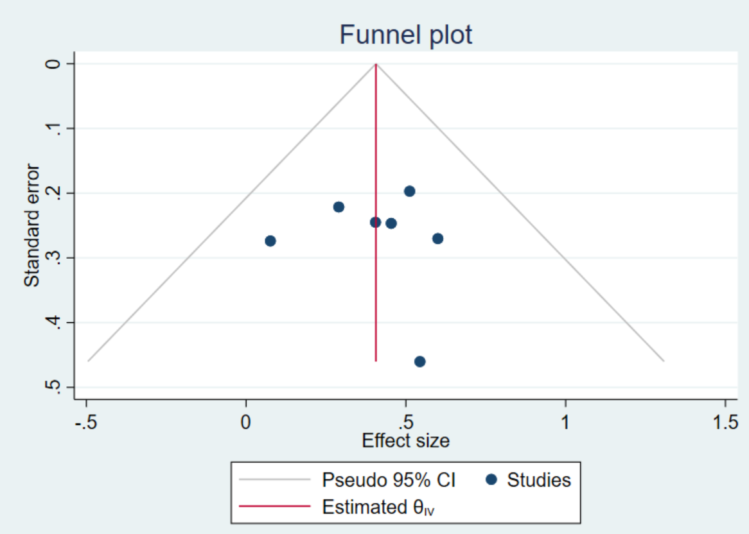

Supplementary table 1: Study quality scored according to the Newcastle-Ottawa scale with sub-scores and associated study quality detailed.
Study | Year | Selection | Comparability | Outcome | Study quality
Ballou et al | 2018 | 2 | 1 | 2 | Fair
Bucci et al | 2018 | 2 | 1 | 2 | Fair
Gîlc-Blanariu et al | 2020 | 4 | 1 | 3 | Good
Gingold-Belfer et al | 2014 | 3 | 1 | 3 | Good
Iskandar et al | 2020 | 2 | 2 | 3 | Fair
Keefer et al | 2006 | 2 | 2 | 2 | Fair
Keskin et al | 2020 | 2 | 1 | 2 | Fair
Sochal et al | 2020 | 3 | 1 | 3 | Good
Zhang et al | 2020 | 2 | 2 | 2 | Fair

