Additional file 4
A4. Meta-analysis for proportions of MCH workers with different education levels
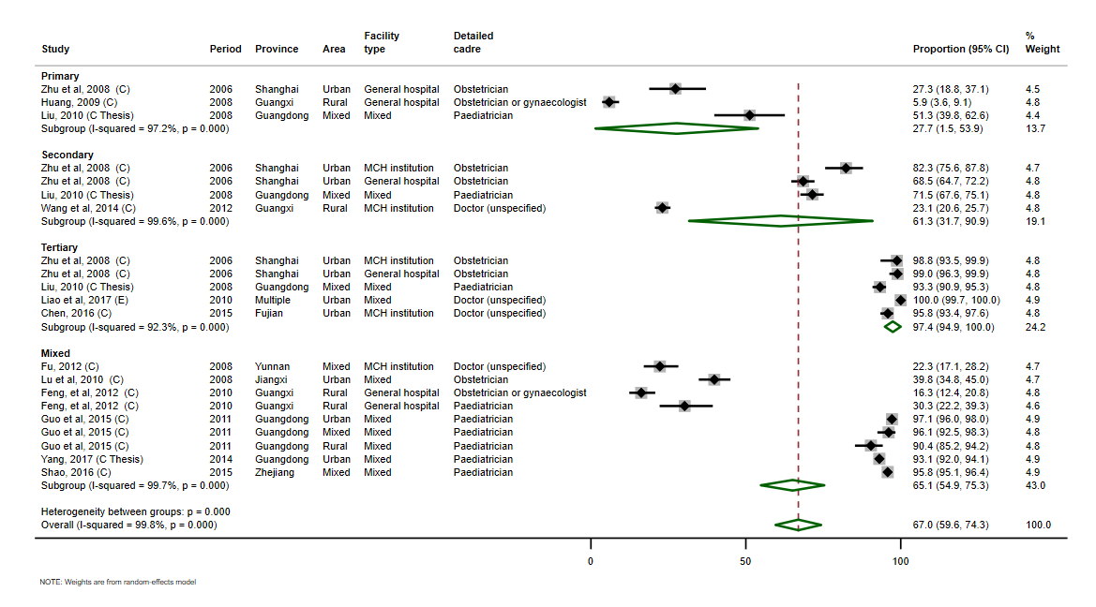
Figure A4.1. Forest plot showing the proportion of doctors holding bachelor or higher-level degrees

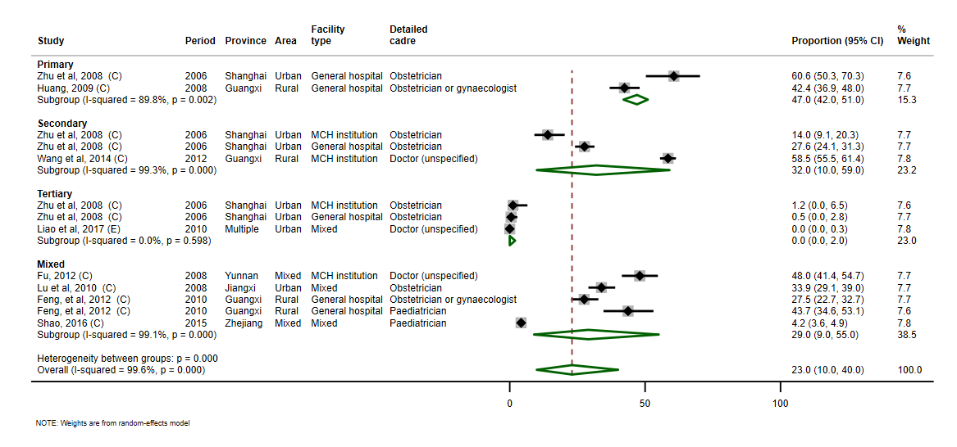
Figure A4.2. Forest plot showing the proportion of doctors holding junior college education

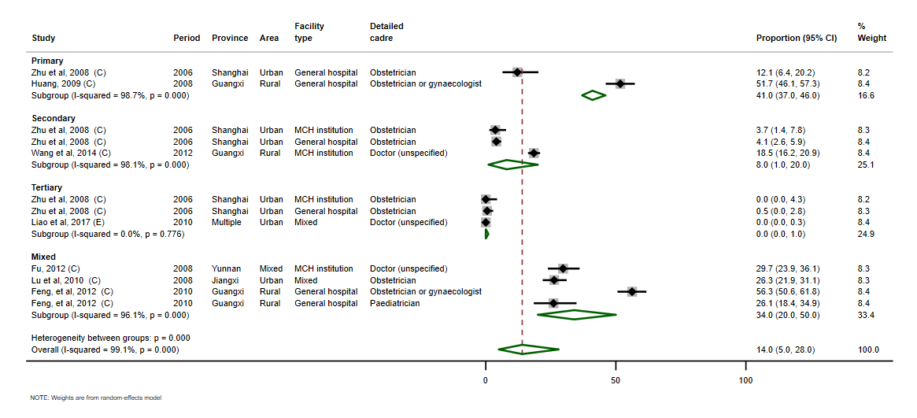
Figure A4.3. Forest plot showing the proportion of doctors with secondary technical school education or below

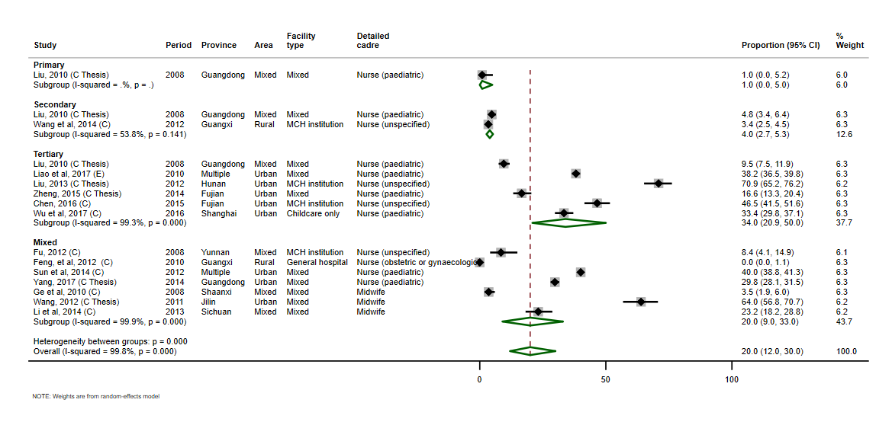
Figure A4.4. Forest plot showing the proportion of nurses (including midwives) holding bachelor or higher-level degrees

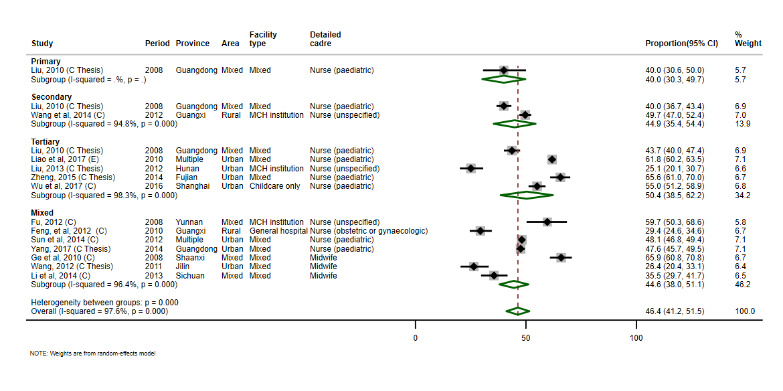
Figure A4.5. Forest plot showing the proportion of nurses (including midwives) holding junior college education

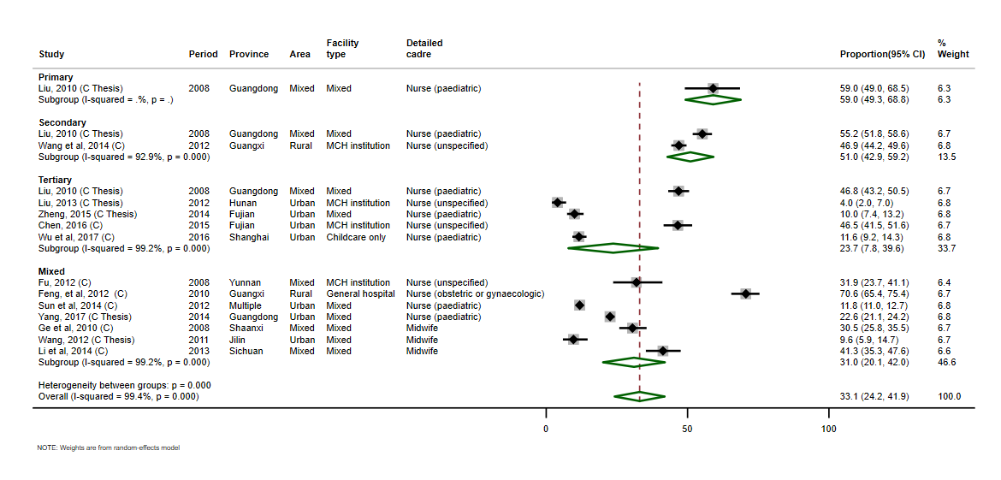
Figure A4.6. Forest plot showing the proportion of nurses (including midwives) with secondary technical school education or below

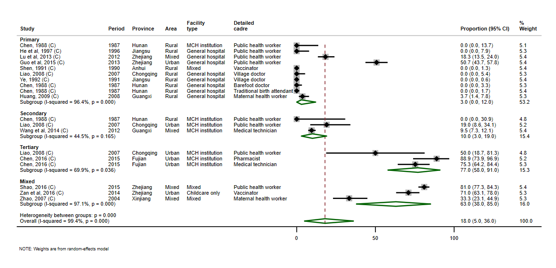
Figure A4.7. Forest plot showing the proportion of other health workers holding bachelor or higher-level degrees
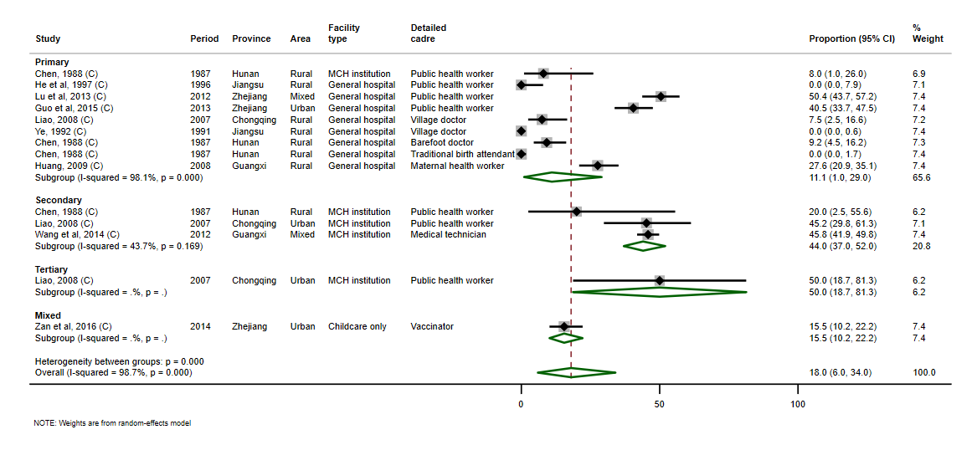
Figure A4.8. Forest plot showing the proportion of other health workers holding junior college education

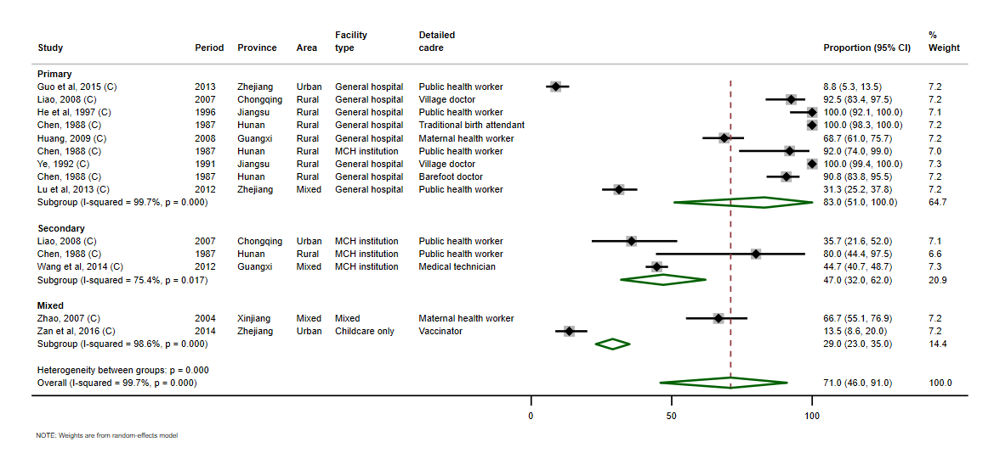
Figure A4.9. Forest plot showing the proportion of other health workers with secondary technical school education or below

