Table A1: Searching detail, MeSH terms and alternative terms used in this study
PubMed | SCOPUS | Google Scholar
(“Vitamin D Deficiency”[MeSH]) AND Bangladesh[MeSH] AND healthy adults [MeSH]  (“Vitamin D”[MeSH]) AND Bangladesh[MeSH] AND healthy adults [MeSH]  (“Vitamin D”[MeSH]) AND Bangladesh[MeSH] AND Prevalence [MeSH] AND healthy adults [MeSH]  (“Vitamin D Deficiency”[MeSH]) AND Bangladesh[MeSH] AND young adults[MeSH]  (“Vitamin D”[MeSH]) AND Bangladesh[MeSH] AND Prevalence [MeSH] AND young adults [MeSH]  (“Vitamin D”[MeSH]) AND Bangladesh[MeSH] AND young adults [MeSH]  (“Vitamin D Deficiency”[MeSH]) AND Bangladesh[MeSH] AND adults Males [MeSH]  (“Vitamin D”[MeSH]) AND Bangladesh[MeSH] AND adult Males [MeSH]  (“Vitamin D”[MeSH]) AND Bangladesh[MeSH] AND Prevalence [MeSH] AND adult Males [MeSH]  (“Vitamin D Deficiency”[MeSH]) AND Bangladesh[MeSH] AND adults Females [MeSH]  (“Vitamin D”[MeSH]) AND Bangladesh[MeSH] AND adult Females [MeSH]  (“Vitamin D”[MeSH]) AND Bangladesh[MeSH] AND Prevalence [MeSH] AND adult Females [MeSH]  (“Vitamin D Deficiency”[MeSH]) AND Bangladesh[MeSH] AND Premenopausal women [MeSH]  (“Vitamin D”[MeSH]) AND Bangladesh[MeSH] AND Premenopausal women [MeSH] | (INDEXTERMS(“Vitamin D Deficiency”) AND INDEXTERMS(BANGLADESH) AND INDEXTERMS(Healthy adults)) OR (TITLE-ABS-KEY(“Vitamin D”) AND TITLE-ABS-KEY(BANGLADESH) AND TITLE-ABS-KEY(Healthy adults)) OR INDEXTERMS (“Vitamin D”) AND INDEXTERMS(BANGLADESH) AND TITLE-ABS-KEY (Prevalence) AND TITLE-ABS-KEY (Healthy adults)  (INDEXTERMS(“Vitamin D Deficiency”) AND INDEXTERMS(BANGLADESH) AND INDEXTERMS(Young adults)) OR (TITLE-ABS-KEY(“Vitamin D”) AND TITLE-ABS-KEY(BANGLADESH) AND TITLE-ABS-KEY(Young adults)) OR INDEXTERMS (“Vitamin D”) AND INDEXTERMS(BANGLADESH) AND TITLE-ABS-KEY (Prevalence) AND TITLE-ABS-KEY (Young adults)  (INDEXTERMS(“Vitamin D Deficiency”) AND INDEXTERMS(BANGLADESH) AND INDEXTERMS(adult Males)) OR (TITLE-ABS-KEY(“Vitamin D”) AND TITLE-ABS-KEY(BANGLADESH) AND TITLE-ABS-KEY(adult Males)) OR INDEXTERMS (“Vitamin D”) AND INDEXTERMS(BANGLADESH) AND TITLE-ABS-KEY (Prevalence) AND TITLE-ABS-KEY (adult Males)  (INDEXTERMS(“Vitamin D Deficiency”) AND INDEXTERMS(BANGLADESH) AND INDEXTERMS(adult Females)) OR (TITLE-ABS-KEY(“Vitamin D”) AND TITLE-ABS-KEY(BANGLADESH) AND TITLE-ABS-KEY(adult Females))  (INDEXTERMS(“Vitamin D Deficiency”) AND INDEXTERMS(BANGLADESH) AND INDEXTERMS(Premenopausal women)) OR (TITLE-ABS-KEY(“Vitamin D”) AND TITLE-ABS-KEY(BANGLADESH) AND TITLE-ABS-KEY(Premenopausal women)) | ((“Vitamin D”) OR (“Vitamin D3”)) AND ((prevalence) OR (deficiency)) AND (healthy adults) AND (Bangladesh)  ((“Vitamin D”) OR (“Vitamin D3”)) AND ((prevalence) OR (deficiency)) AND (young adults) AND (Bangladesh)  ((“Vitamin D”) OR (“Vitamin D3”)) AND ((prevalence) OR (deficiency)) AND (elderly) AND (Bangladesh)  ((“Vitamin D”) OR (“Vitamin D3”)) AND ((prevalence) OR (deficiency)) AND (adult Males) AND (Bangladesh)  ((“Vitamin D”) OR (“Vitamin D3”)) AND ((prevalence) OR (deficiency)) AND (adult Females) AND (Bangladesh)  ((“Vitamin D”) OR (“Vitamin D3”)) AND ((prevalence) OR (deficiency)) AND (Premenopausal women) AND (Bangladesh)  ((“Vitamin D”) OR (“Vitamin D3”)) AND ((prevalence) OR (deficiency)) AND (Postmenopausal women) AND (Bangladesh)
PubMed | SCOPUS | Google Scholar
(“Vitamin D”[MeSH]) AND Bangladesh[MeSH] AND Prevalence [MeSH] AND Premenopausal women [MeSH]  (“Vitamin D Deficiency”[MeSH]) AND Bangladesh[MeSH] AND Postmenopausal women [MeSH]  (“Vitamin D”[MeSH]) AND Bangladesh[MeSH] AND Postmenopausal women [MeSH] | INDEXTERMS(BANGLADESH) AND TITLE-ABS-KEY (Prevalence) AND TITLE-ABS-KEY (Premenopausal women)  (INDEXTERMS(“Vitamin D Deficiency”) AND INDEXTERMS(BANGLADESH) AND INDEXTERMS(Postmenopausal women)) OR (TITLE-ABS-KEY(“Vitamin D”) AND TITLE-ABS-KEY(BANGLADESH) AND TITLE-ABS-KEY(Postmenopausal women)) OR INDEXTERMS (“Vitamin D”) AND | ((“Vitamin D”) OR (“Vitamin D3”)) AND ((prevalence) OR (deficiency)) AND (Lactating women) AND (Bangladesh)  ((“Vitamin D”) OR (“Vitamin D3”)) AND ((prevalence) OR (deficiency)) AND (Elderly) AND (Bangladesh)
(“Vitamin D”[MeSH]) AND Bangladesh[MeSH] AND Prevalence [MeSH] AND Postmenopausal women [MeSH]  (“Vitamin D Deficiency”[MeSH]) AND Bangladesh[MeSH] AND Lactating women [MeSH]  (“Vitamin D”[MeSH]) AND Bangladesh[MeSH] AND Lactating women [MeSH]  (“Vitamin D”[MeSH]) AND Bangladesh[MeSH] AND Prevalence [MeSH] AND Lactating women [MeSH]  (“Vitamin D Deficiency”[MeSH]) AND Bangladesh[MeSH] AND Elderly[MeSH]  (“Vitamin D”[MeSH]) AND Bangladesh[MeSH] AND Elderly [MeSH]  (“Vitamin D”[MeSH]) AND Bangladesh[MeSH] AND Prevalence [MeSH] AND Elderly [MeSH]  Same types of search terms was used for seven other south Asian countries, by replacing the country name (e.g. India, Pakistan Sri Lanka etc.) to complete search procedures. | INDEXTERMS(BANGLADESH) AND TITLE-ABS-KEY (Prevalence) AND TITLE-ABS-KEY (Postmenopausal women)  (INDEXTERMS(“Vitamin D Deficiency”) AND INDEXTERMS(BANGLADESH) AND INDEXTERMS(lactating women)) OR (TITLE-ABS-KEY(“Vitamin D”) AND TITLE-ABS-KEY(BANGLADESH) AND TITLE-ABS-KEY(lactating women)) OR INDEXTERMS (“Vitamin D”) AND INDEXTERMS(BANGLADESH) AND TITLE-ABS-KEY (Prevalence) AND TITLE-ABS-KEY (Lactating women)  (INDEXTERMS(“Vitamin D Deficiency”) AND INDEXTERMS(BANGLADESH) AND INDEXTERMS(Elderly)) OR (TITLE-ABS-KEY(“Vitamin D”) AND TITLE-ABS-KEY(BANGLADESH) AND TITLE-ABS-KEY(Elderly)) OR INDEXTERMS (“Vitamin D”) AND INDEXTERMS(BANGLADESH) AND TITLE-ABS-KEY (Prevalence) AND TITLE-ABS-KEY (Elderly)

Table A2: Quality assessment of selected studies (Q1, Q2, Q3……Q10 denotes ten parameters described by Hoy et al for-quality assessment)
Authors | Q1 | Q2 | Q3 | Q4 | Q5 | Q6 | Q7 | Q8 | Q9 | Q10 | Total score | Quality
Arya et al [27] | 1 | 1 | 1 | 0 | 0 | 0 | 0 | 0 | 1 | 0 | 4 | Moderate
Malhotra et al [28] | 1 | 1 | 1 | 0 | 0 | 0 | 0 | 0 | 1 | 0 | 4 | Moderate
Harinarayan et al [29] | 0 | 1 | 0 | 0 | 0 | 0 | 0 | 0 | 1 | 0 | 2 | Low
Agrawal et al [30] | 0 | 0 | 0 | 0 | 0 | 0 | 0 | 0 | 1 | 0 | 1 | Low
Vupputuri et al [31] | 1 | 0 | 0 | 0 | 0 | 0 | 0 | 0 | 1 | 0 | 2 | Low
Suryanarayana et al [32] | 1 | 0 | 0 | 0 | 0 | 0 | 0 | 0 | 1 | 0 | 2 | Low
Shivane et al [33] | 0 | 1 | 1 | 0 | 0 | 0 | 0 | 0 | 0 | 0 | 2 | Low
Harinarayan et al [34] | 1 | 1 | 1 | 0 | 0 | 0 | 0 | 0 | 1 | 0 | 4 | Moderate
Shukla et al [35] | 1 | 1 | 1 | 0 | 0 | 0 | 0 | 0 | 1 | 0 | 4 | Moderate
Sanket et al [36] | 1 | 1 | 1 | 0 | 0 | 0 | 0 | 0 | 1 | 0 | 4 | Moderate
Karoli et al [37] | 1 | 1 | 1 | 0 | 0 | 0 | 0 | 0 | 1 | 0 | 4 | Moderate
Laway et al [38] | 1 | 1 | 0 | 0 | 0 | 0 | 0 | 0 | 1 | 1 | 4 | Moderate
Gupta et al [39] | 1 | 1 | 0 | 0 | 0 | 0 | 0 | 0 | 1 | 0 | 3 | Low
Bhatt et al [40] | 0 | 0 | 0 | 0 | 0 | 1 | 0 | 0 | 1 | 1 | 3 | Low
Marwaha et al [41] | 1 | 1 | 1 | 0 | 0 | 0 | 0 | 0 | 1 | 0 | 4 | Moderate
Goswami et al [42] | 0 | 0 | 0 | 0 | 0 | 0 | 0 | 0 | 1 | 1 | 2 | Low
Zargar et al [43] | 1 | 1 | 1 | 0 | 0 | 0 | 0 | 1 | 0 | 0 | 4 | Moderate
Harinarayan et al [44] | 1 | 0 | 0 | 0 | 0 | 0 | 0 | 1 | 0 | 0 | 2 | Low
Sofi et al [45] | 1 | 1 | 1 | 0 | 0 | 0 | 0 | 1 | 0 | 0 | 4 | Moderate
Beloyartseva et al [46] | 1 | 0 | 0 | 0 | 0 | 0 | 0 | 1 | 0 | 0 | 2 | Low
Singh et al [47] | 0 | 1 | 1 | 0 | 0 | 0 | 0 | 1 | 0 | 0 | 3 | Low
Shetty et al [48] | 1 | 0 | 0 | 0 | 0 | 0 | 0 | 1 | 0 | 0 | 2 | Low
Kajale et al [49] | 1 | 1 | 1 | 0 | 0 | 0 | 0 | 1 | 0 | 0 | 4 | Moderate
Goswami et al [50] | 1 | 1 | 1 | 0 | 0 | 0 | 0 | 1 | 0 | 0 | 4 | Moderate
Kiran et al [51] | 1 | 1 | 1 | 0 | 0 | 0 | 0 | 1 | 0 | 0 | 4 | Moderate
Kumar et al [52] | 1 | 1 | 1 | 0 | 0 | 0 | 0 | 1 | 0 | 0 | 4 | Moderate
Goswami et al [53] | 1 | 1 | 1 | 0 | 0 | 0 | 0 | 1 | 1 | 0 | 5 | Moderate
Meena et al [54] | 1 | 1 | 1 | 0 | 0 | 0 | 0 | 1 | 0 | 0 | 4 | Moderate
Singh et al [55] | 1 | 0 | 0 | 0 | 0 | 0 | 0 | 0 | 1 | 0 | 2 | Low
Garg et al [56] | 1 | 0 | 0 | 0 | 0 | 0 | 0 | 0 | 1 | 0 | 2 | Low
Harinarayan et al [57] | 1 | 1 | 1 | 0 | 0 | 0 | 0 | 0 | 1 | 0 | 4 | Moderate
Paul et al [58] | 1 | 1 | 0 | 0 | 0 | 0 | 0 | 0 | 1 | 1 | 4 | Moderate
Srimani et al [59] | 1 | 0 | 0 | 0 | 0 | 0 | 0 | 0 | 1 | 0 | 2 | Low
Harinarayan et al [60] | 0 | 1 | 0 | 0 | 0 | 0 | 0 | 0 | 1 | 1 | 3 | Low
Agarwal et al [61] | 1 | 1 | 1 | 0 | 0 | 0 | 0 | 0 | 1 | 0 | 4 | Moderate
Mitra et al [62] | 1 | 1 | 1 | 0 | 0 | 0 | 0 | 0 | 1 | 0 | 4 | Moderate
Agarwal et al [63] | 1 | 1 | 1 | 0 | 0 | 0 | 0 | 0 | 1 | 0 | 4 | Moderate
Dixit et al [64] | 1 | 1 | 1 | 0 | 0 | 0 | 0 | 0 | 1 | 0 | 4 | Moderate
Kadam et al [65] | 1 | 1 | 1 | 0 | 0 | 0 | 0 | 0 | 1 | 1 | 5 | Moderate
Mahmood et al [66] | 1 | 1 | 1 | 0 | 0 | 0 | 0 | 0 | 1 | 0 | 4 | Moderate
Islam et al [67] | 1 | 1 | 1 | 0 | 0 | 0 | 0 | 0 | 1 | 0 | 4 | Moderate
Islam et al [68] | 0 | 0 | 0 | 0 | 0 | 0 | 0 | 0 | 1 | 1 | 2 | Low
Islam et al [69] | 1 | 0 | 0 | 0 | 0 | 1 | 0 | 0 | 1 | 1 | 4 | Moderate
Acherjya et al [70] | 0 | 1 | 1 | 0 | 0 | 1 | 0 | 0 | 1 | 0 | 4 | Moderate
Authors | Q1 | Q2 | Q3 | Q4 | Q5 | Q6 | Q7 | Q8 | Q9 | Q10 | Total score | Quality
Mubashir et al [71] | 1 | 1 | 1 | 0 | 0 | 0 | 0 | 0 | 1 | 0 | 4 | Moderate
Junaid et al [72] | 1 | 1 | 1 | 0 | 0 | 1 | 0 | 0 | 1 | 1 | 6 | Moderate
Roomi et al [73] | 1 | 1 | 1 | 0 | 0 | 0 | 0 | 0 | 1 | 0 | 4 | Moderate
Junaid et al [74] | 0 | 0 | 0 | 0 | 0 | 1 | 0 | 0 | 0 | 0 | 1 | Low
Sheikh et al [75] | 0 | 0 | 0 | 0 | 0 | 0 | 0 | 0 | 1 | 0 | 1 | Low
Mehboobali et al [76] | 1 | 0 | 0 | 0 | 0 | 0 | 0 | 0 | 1 | 0 | 2 | Low
Mansoor et al [77] | 1 | 1 | 1 | 0 | 0 | 0 | 0 | 0 | 0 | 0 | 3 | Low
Mustafa et al [78] | 1 | 1 | 1 | 0 | 0 | 0 | 0 | 0 | 1 | 1 | 5 | Moderate
Rehman et al [79] | 1 | 1 | 1 | 0 | 0 | 0 | 1 | 0 | 1 | 1 | 6 | Moderate
Khan et al [80] | 1 | 1 | 1 | 0 | 0 | 0 | 0 | 0 | 1 | 0 | 4 | Moderate
Nadeem et al [81] | 1 | 1 | 1 | 0 | 0 | 0 | 1 | 0 | 1 | 0 | 5 | Moderate
Iqbal et al [82] | 1 | 1 | 1 | 0 | 0 | 0 | 0 | 0 | 1 | 0 | 4 | Moderate
Mahmood et al [83] | 0 | 1 | 1 | 0 | 0 | 1 | 0 | 0 | 1 | 0 | 4 | Moderate
Afsar et al [84] | 1 | 1 | 1 | 0 | 0 | 1 | 1 | 0 | 1 | 0 | 6 | Moderate
Kumar et al [85] | 1 | 1 | 1 | 0 | 0 | 0 | 0 | 0 | 1 | 1 | 5 | Moderate
Sharif et al [86] | 1 | 1 | 1 | 0 | 0 | 0 | 0 | 0 | 1 | 1 | 5 | Moderate
Khan et al [87] | 1 | 1 | 1 | 0 | 0 | 0 | 0 | 0 | 1 | 1 | 5 | Moderate
Dar et al [88] | 1 | 1 | 1 | 0 | 0 | 0 | 0 | 0 | 1 | 0 | 4 | Moderate
Meyer et al [89] | 1 | 0 | 0 | 0 | 0 | 0 | 0 | 0 | 1 | 1 | 3 | Low
Haugen et al [90] | 1 | 0 | 0 | 0 | 0 | 1 | 0 | 0 | 1 | 1 | 4 | Moderate
Sherchand et al [91] | 1 | 1 | 1 | 0 | 0 | 0 | 0 | 0 | 1 | 0 | 4 | Moderate

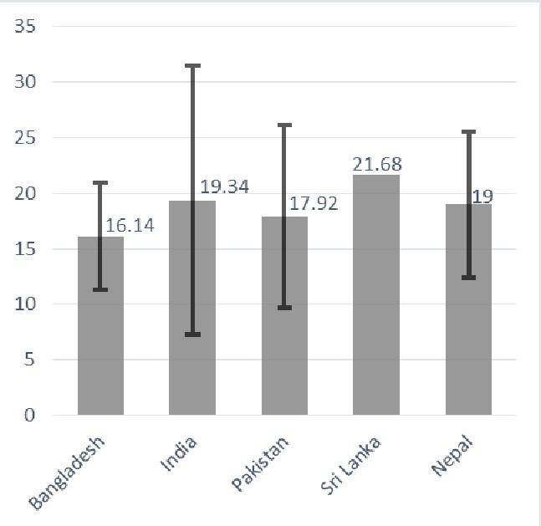
Figure A1: Weighted mean level of serum vitamin D (ng/mL) among South Asian adult population (on the Y-axis). X-axis represent the name of the South Asian countries. Error bars represent the weighted standard deviations.
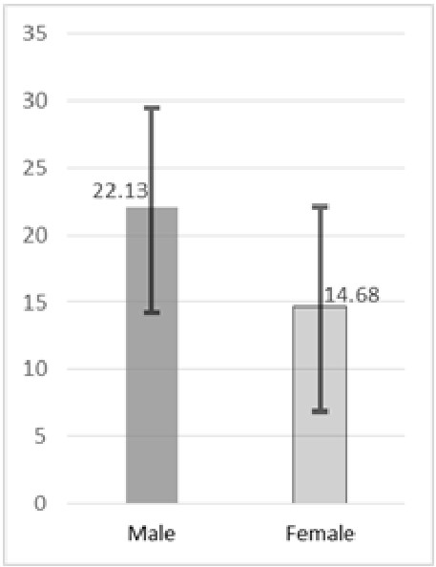
Figure A2: Weighted mean level of serum vitamin D (ng/mL; on the Y-axis) among South Asian adult male and female population. X-axis represents gender. Error bars represent the weighted standard deviations.
Figure A3: Funnel plot shows publication bias of the selected studies. Each dots of the funnel plot represent a single study. Y-axis represents the standard error of the effect estimates, and the X-axis shows prevalence for the corresponding studies.

