Comparative efficacy and safety of anti-SARS-CoV-2 antibody therapies for the management of COVID-19: A systematic review and network meta-analysis

Supplementary Material: Additional Figures
Figure S1 to S29

Figure S1 Mortality incidence, network and forest plots for subgroup analysis including patients with nonsevere COVID-19 (I² = 0%)

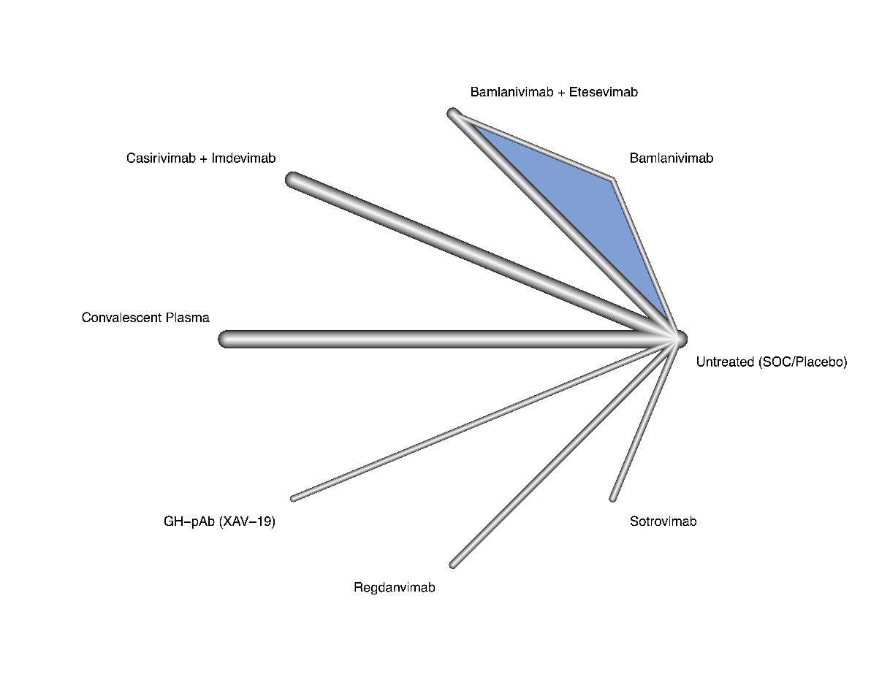
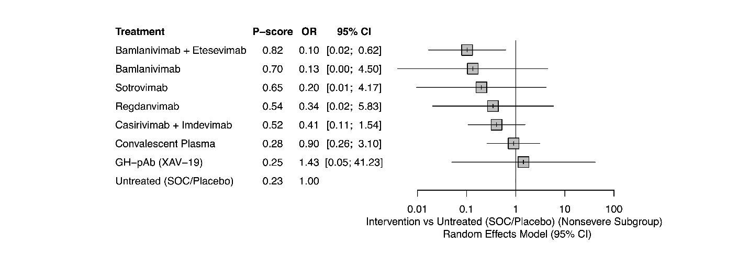
Figure S2 Mortality incidence, forest plot for subgroup analysis including patients with severe COVID-19 (I² = 12%)
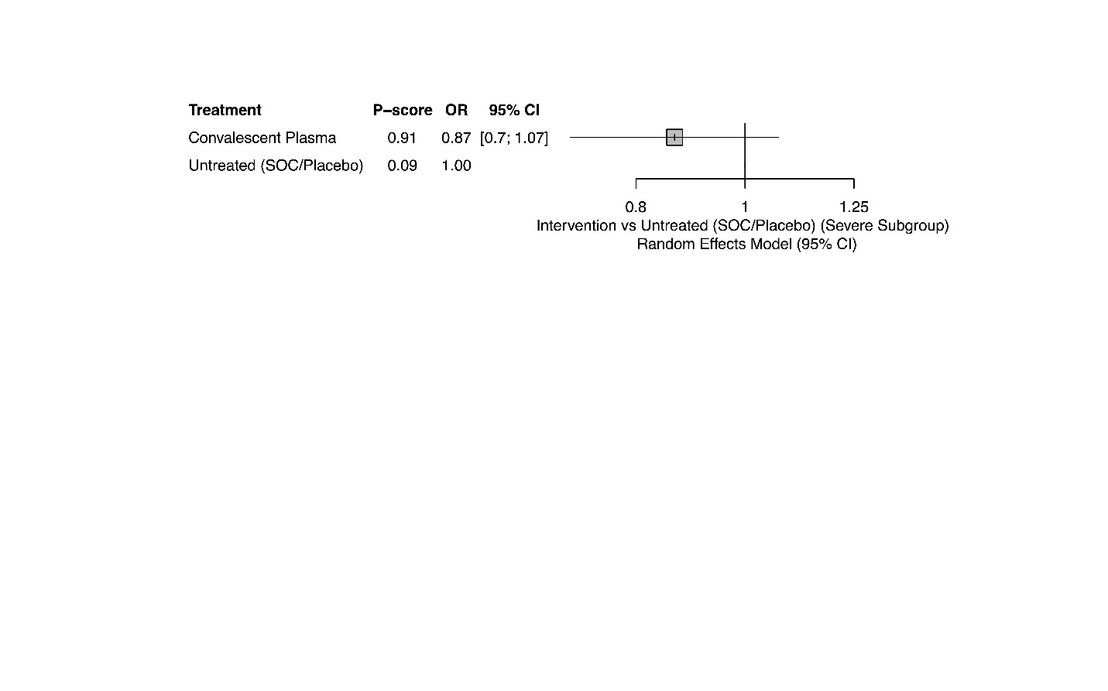
Figure S3 Mortality incidence, network and forest plots for subgroup analysis including inpatients only (I² = 15.8%)

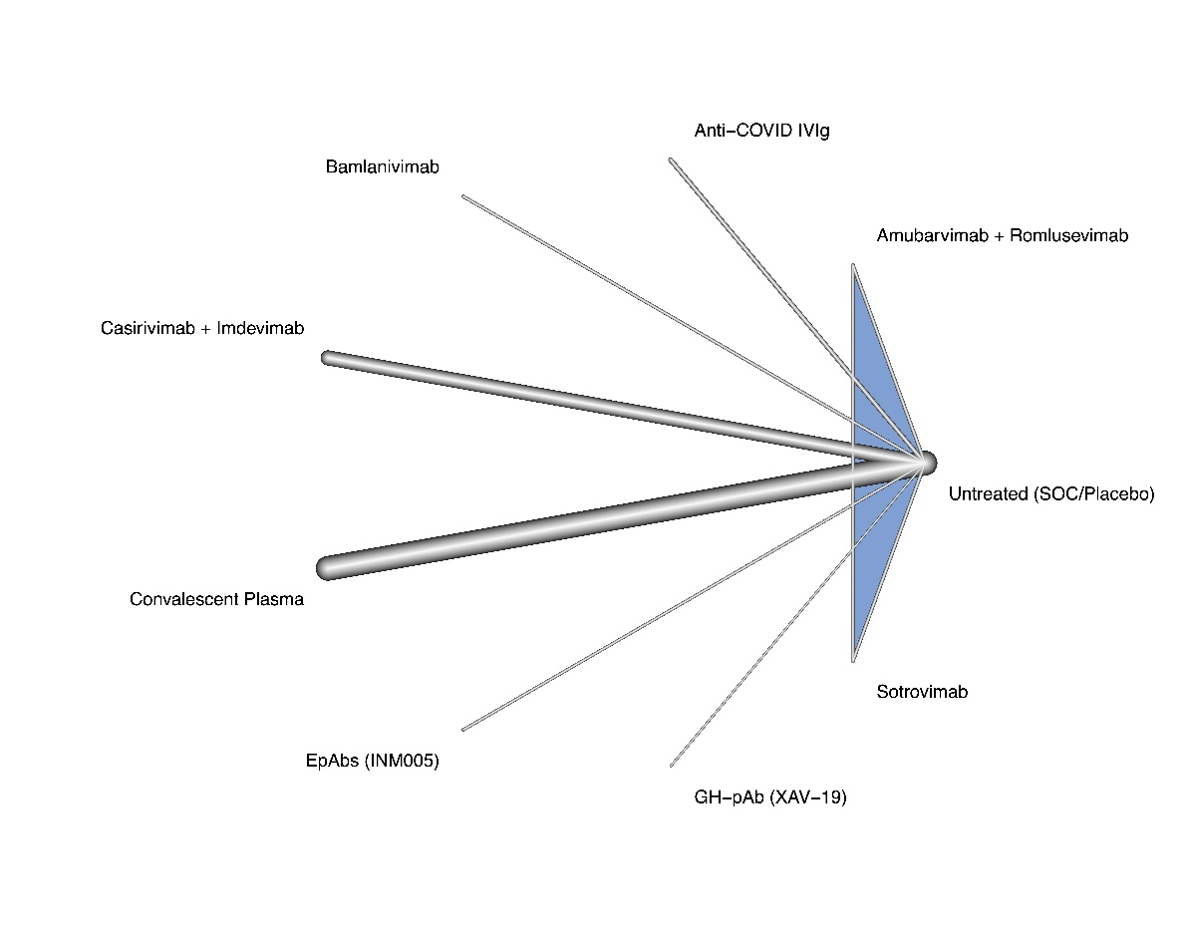
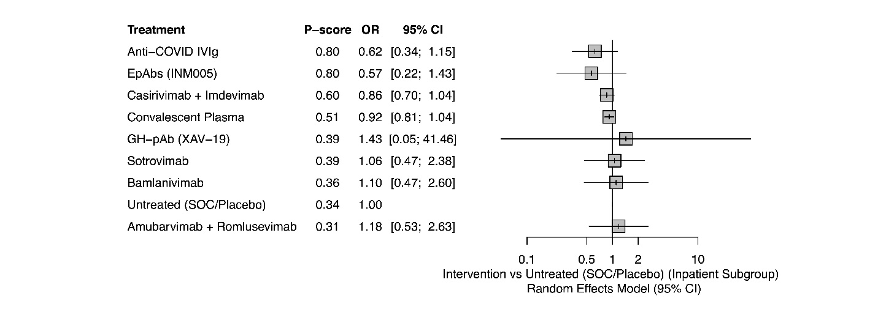
Figure S4 Mortality incidence, network and forest plots for subgroup analysis including outpatients only (I² = 0%)

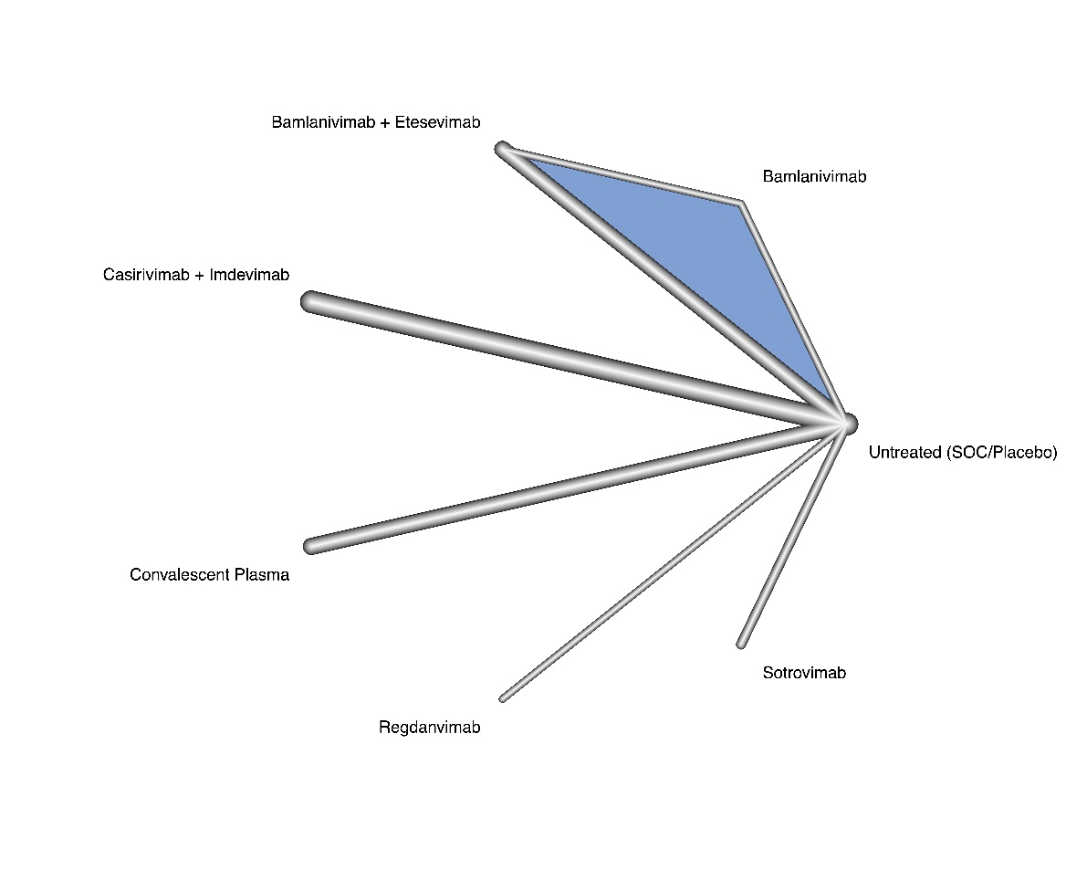
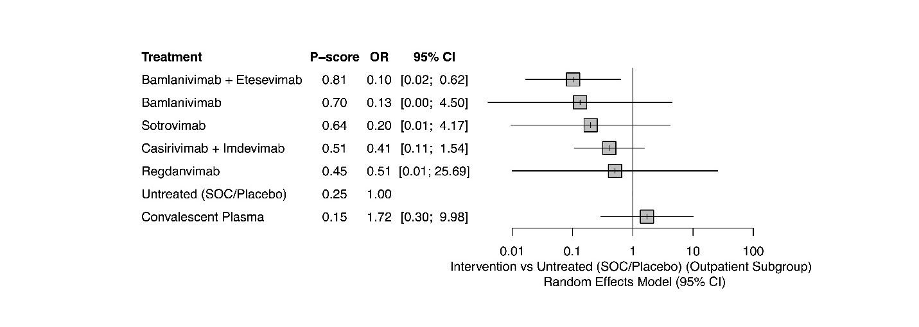
Figure S5 Mortality incidence, network and forest plots for sensitivity analysis limiting the follow up duration to one month (I² = 10.8%)

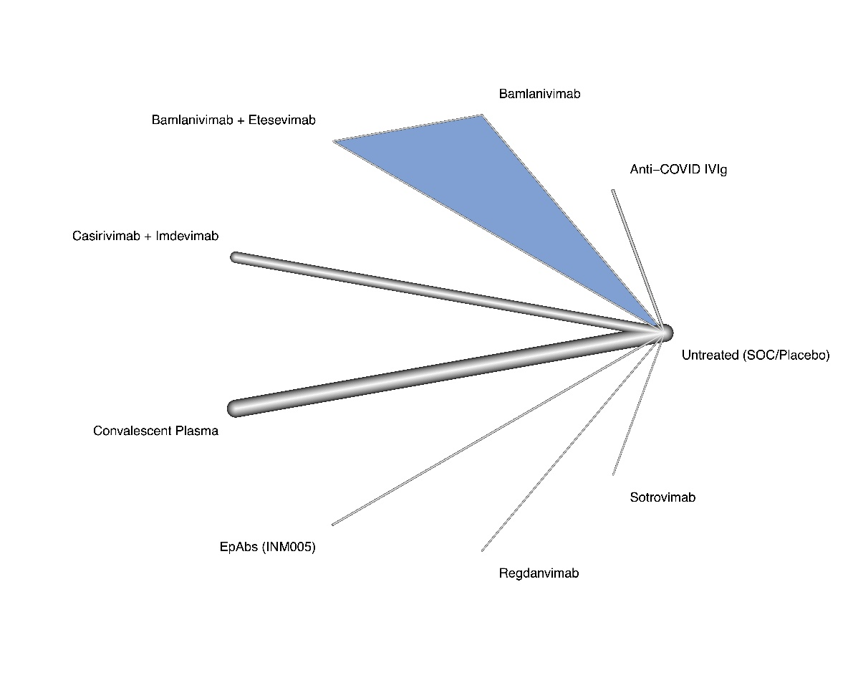
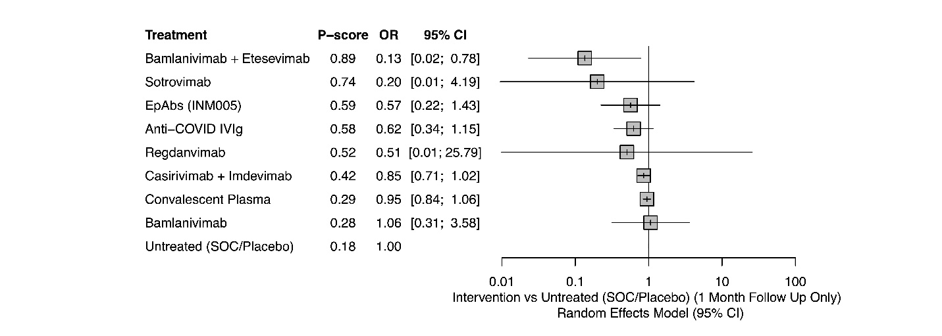
Figure S6 Mortality incidence, network and forest plots for subgroup analysis including patients who are seronegative at baseline (I² = 29.1%)

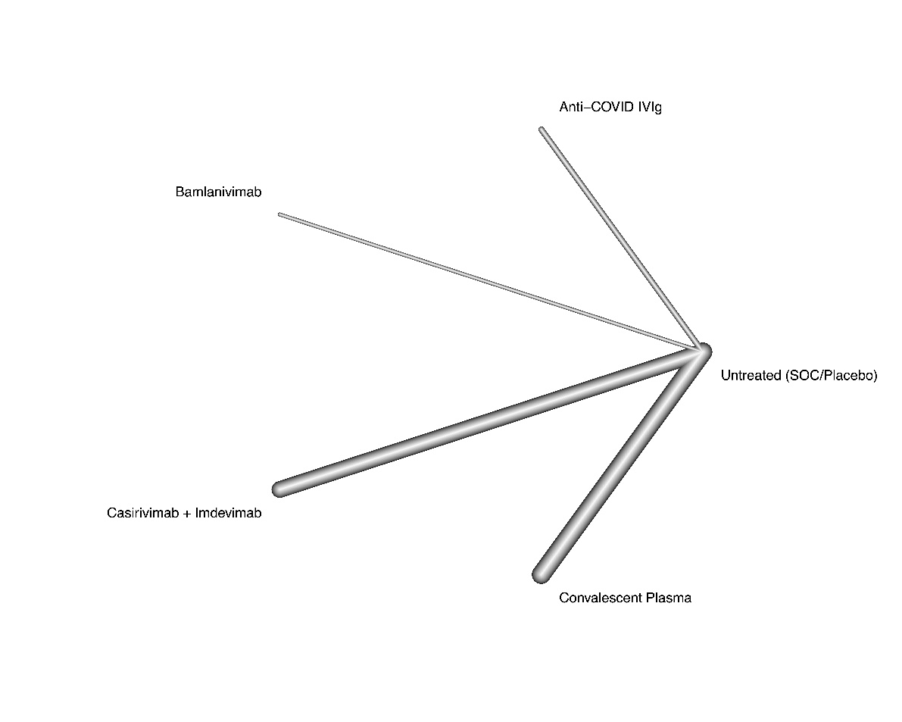
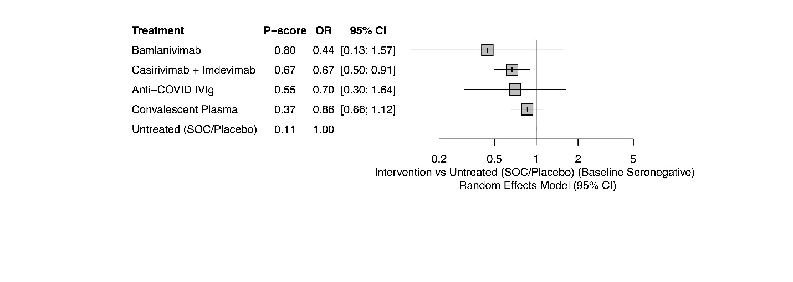
Figure S7 Mortality incidence, network and forest plots for subgroup analysis including patients who are seropositive at baseline (I² = 0%)

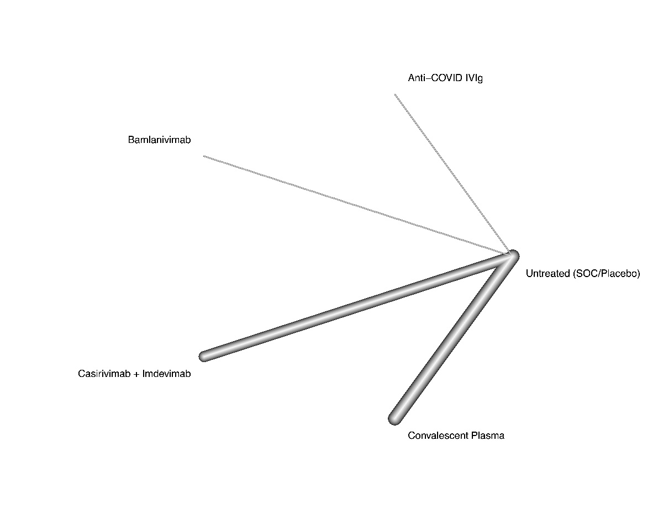
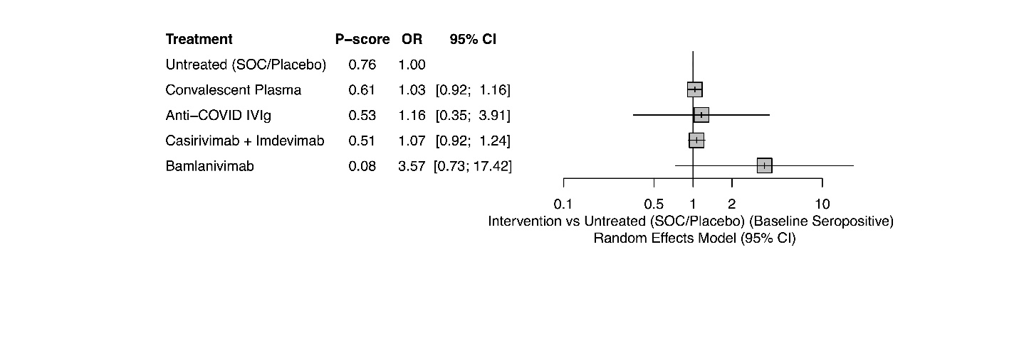
Figure S8 Incidence of invasive mechanical ventilation/ECMO, network and forest plots for subgroup analysis including patients with nonsevere COVID-19 (I² = 0%)

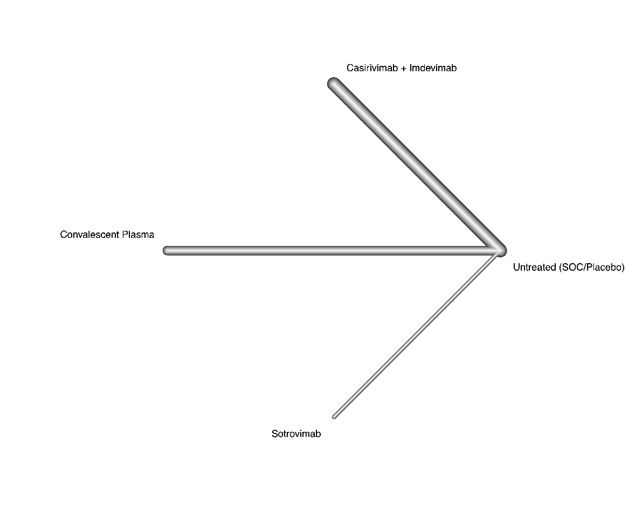
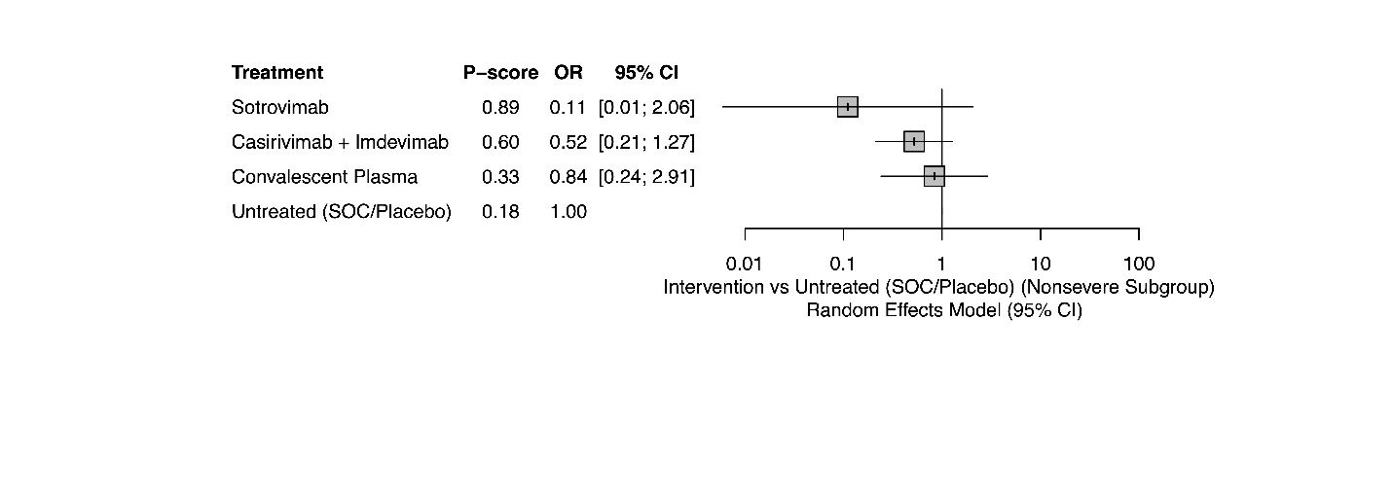
Figure S9 Incidence of invasive mechanical ventilation/ECMO, forest plot for subgroup analysis including patients with severe COVID-19 (I² = 13.4%)

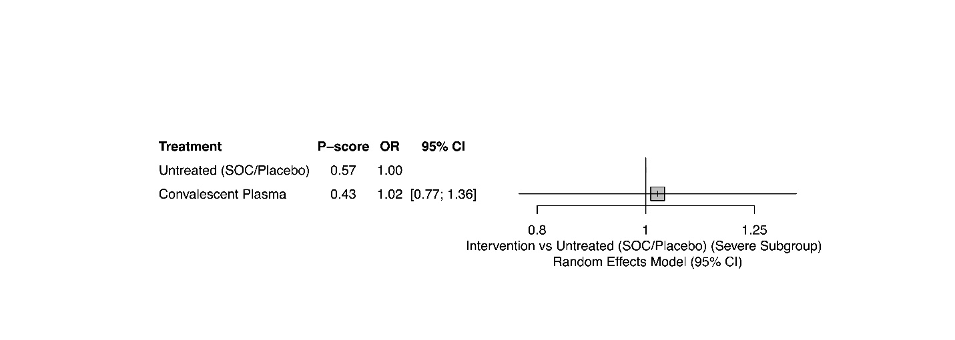
Figure S10 Incidence of invasive mechanical ventilation/ECMO, network and forest plots for subgroup analysis including inpatients only (I² = 0%)

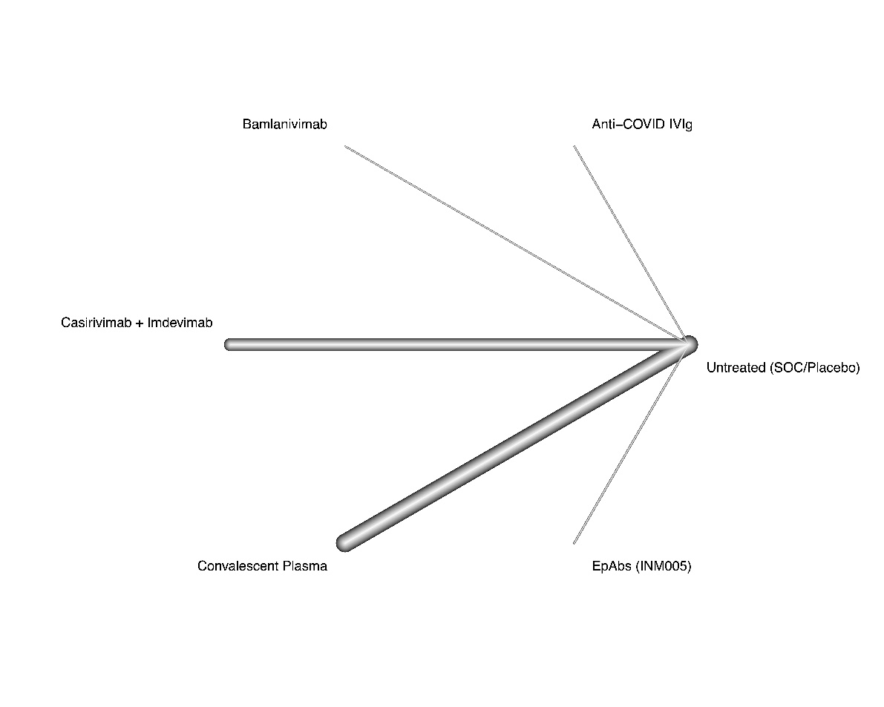
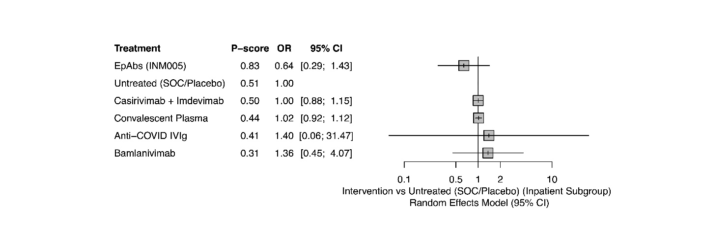
Figure S11 Incidence of invasive mechanical ventilation/ECMO, network and forest plots for subgroup analysis including outpatients only (I² = NA)

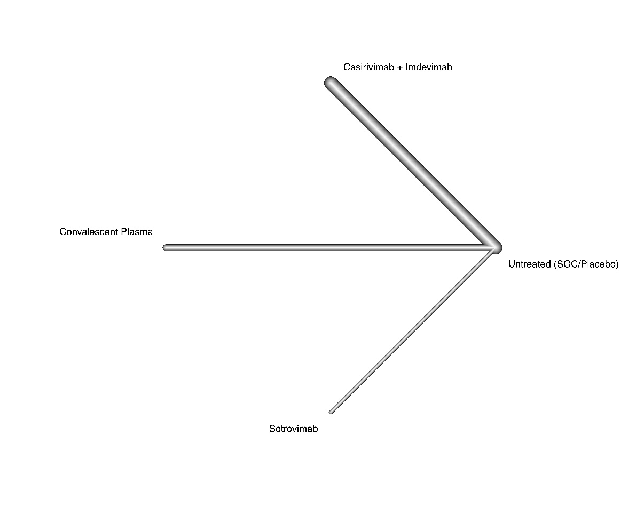
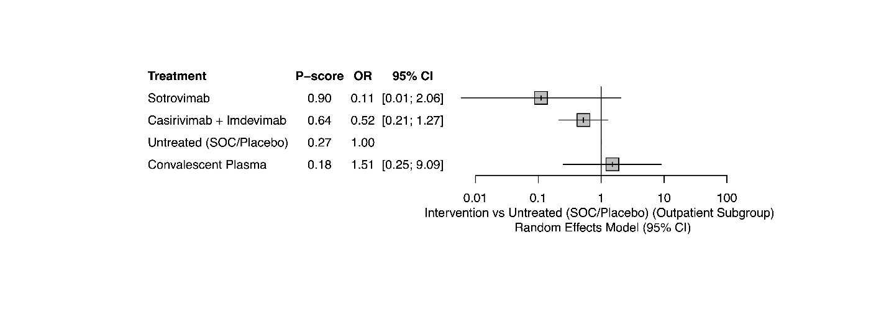
Figure S12 Duration of hospitalization, network and forest plots for subgroup analysis including patients with nonsevere COVID-19 (I² = 0%)

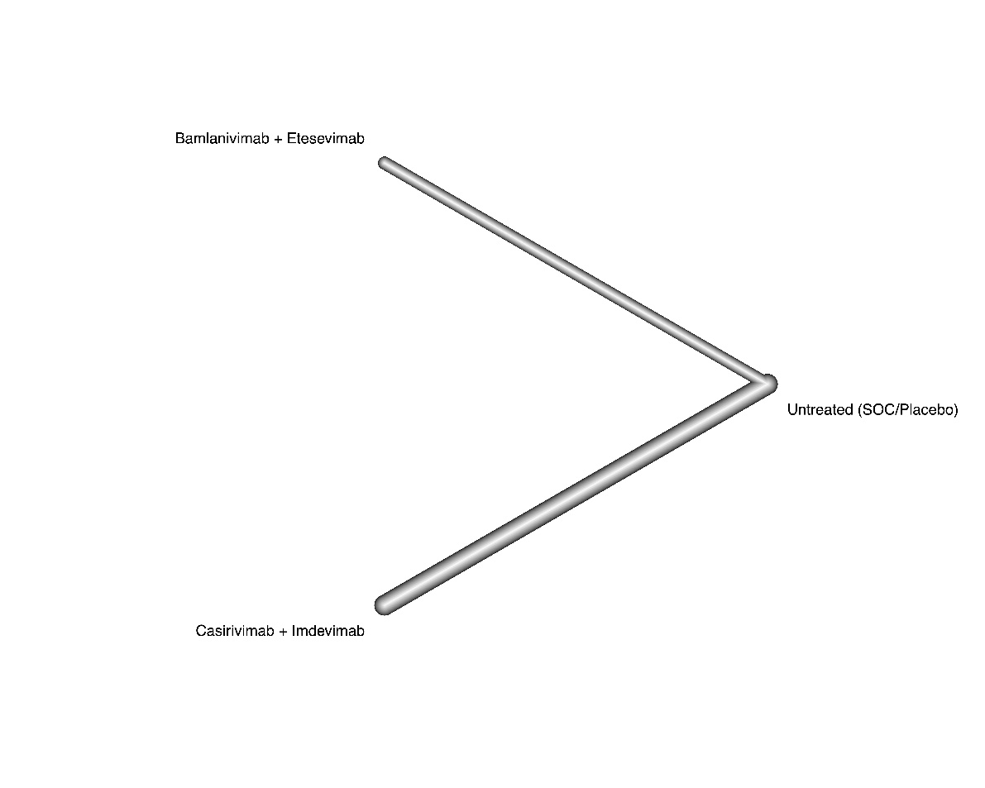
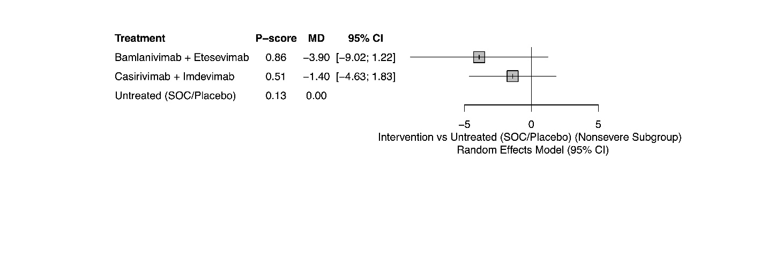
Figure S13 Duration of hospitalization, network and forest plots for subgroup analysis including patients with severe COVID-19 (I² = 66.1%)

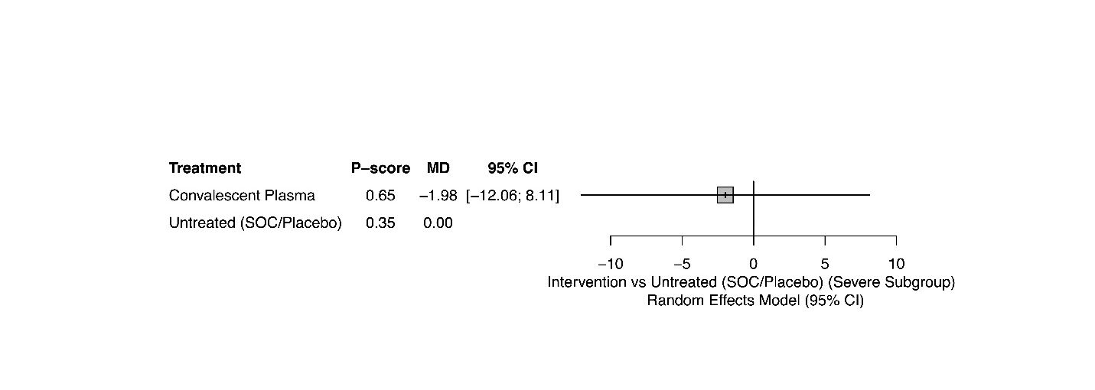
Figure S14 Duration of hospitalization, network and forest plots for subgroup analysis including inpatients only (I² = 90%)

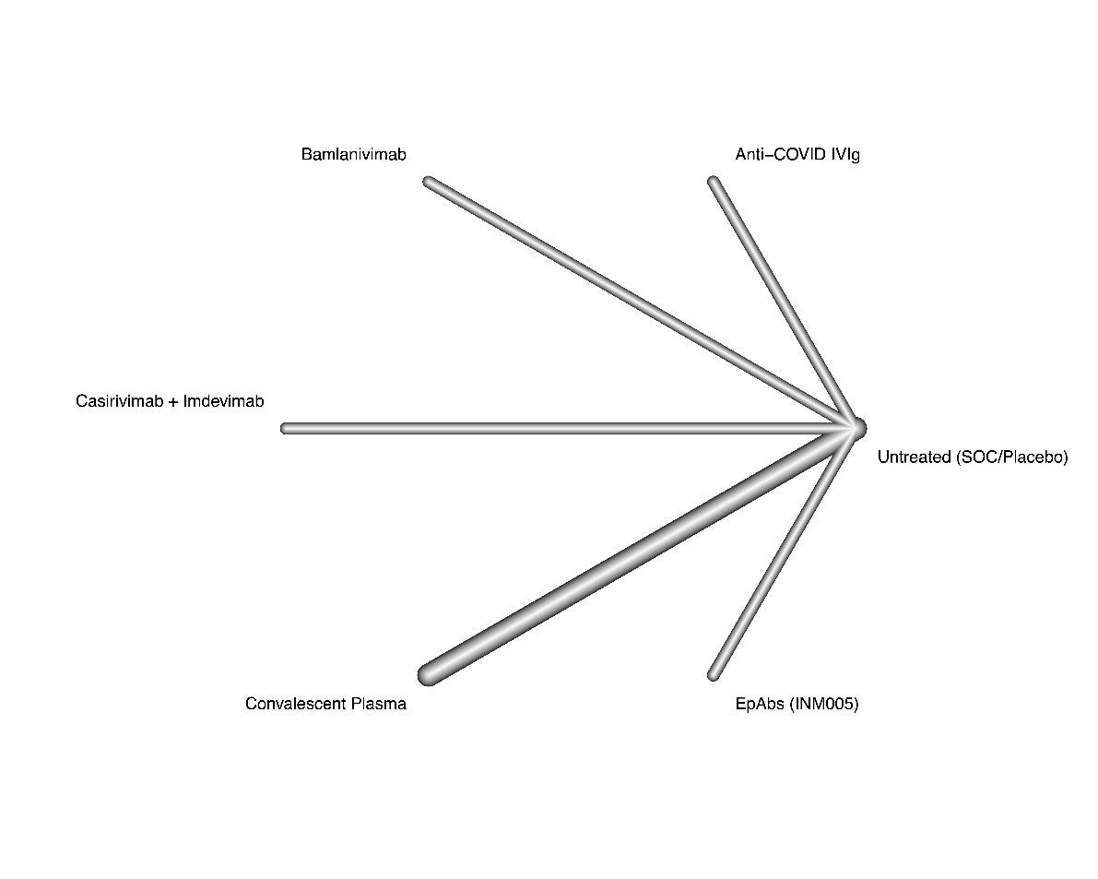
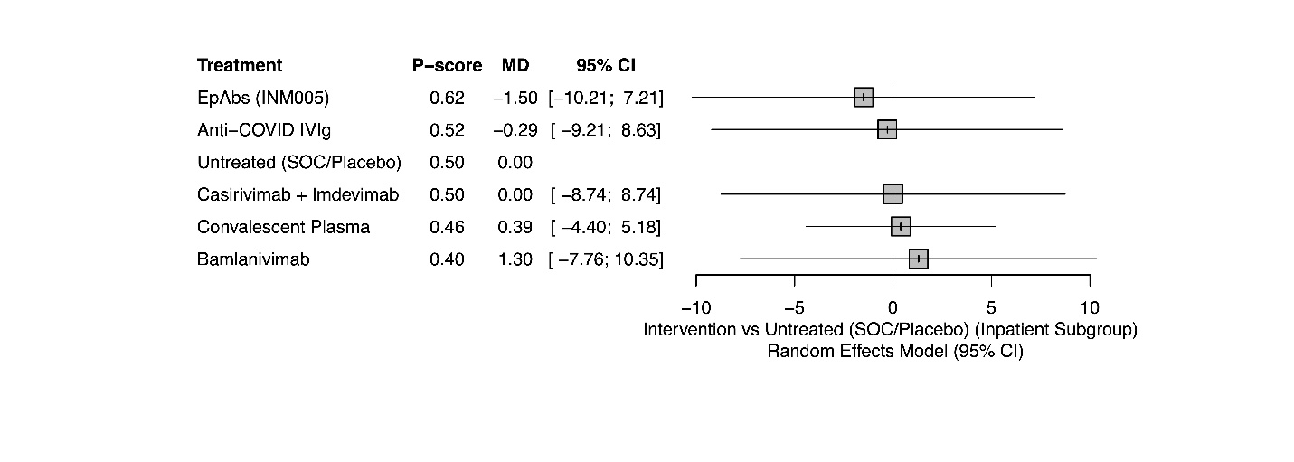
Figure S15 Duration of hospitalization, network and forest plots for subgroup analysis including outpatients only (I² = 0%)

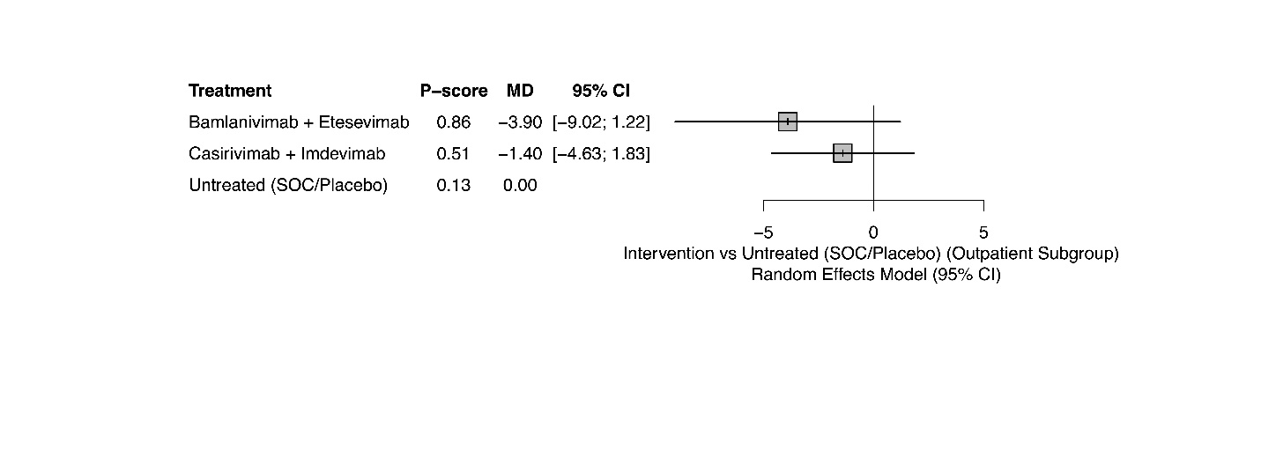
Figure S16 Incidence of adverse events, network and forest plots for subgroup analysis including patients with nonsevere disease (I² = 29.5%)

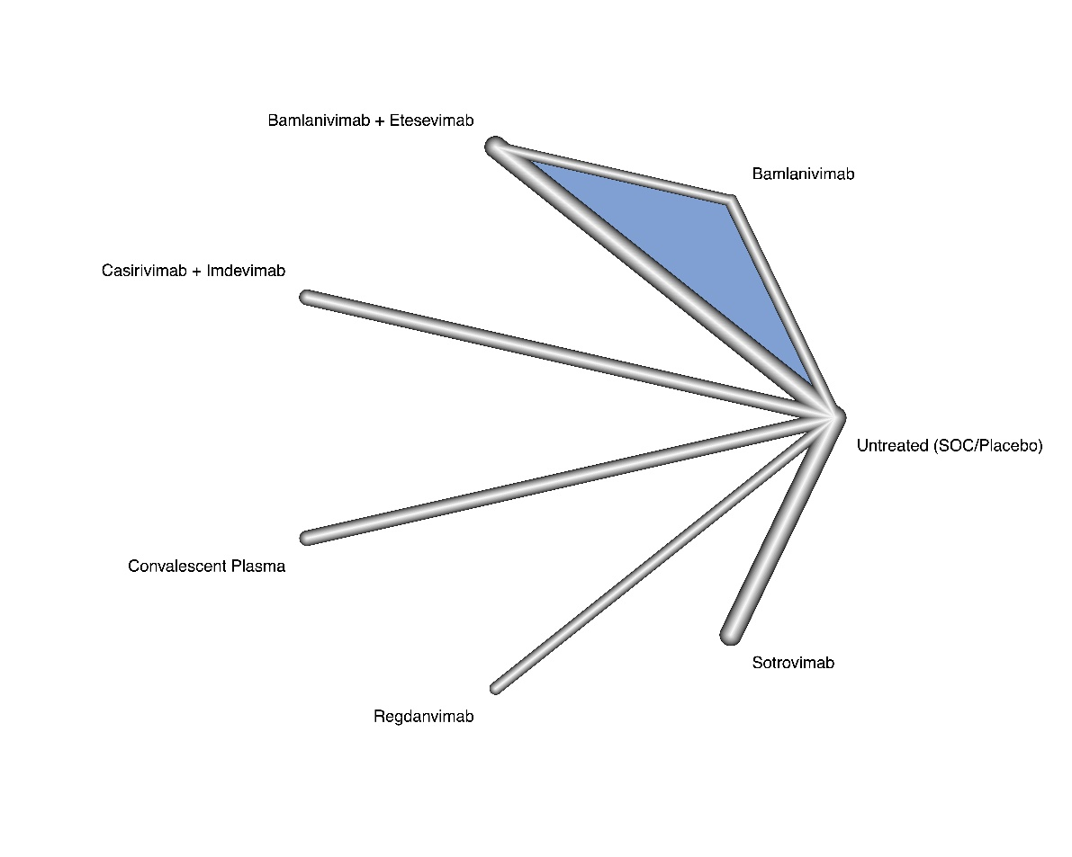
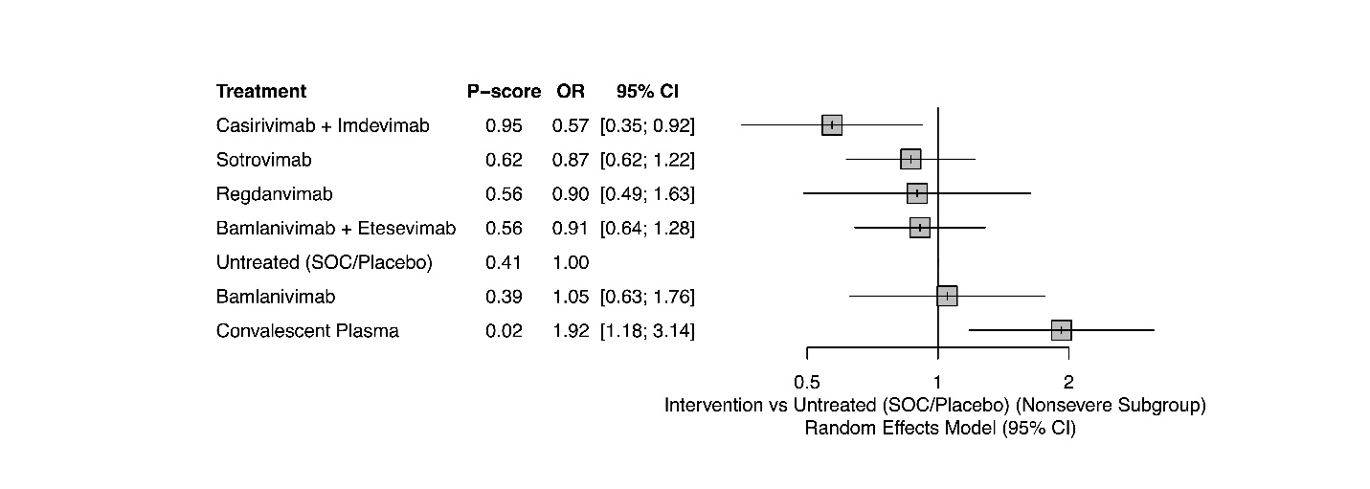
Figure S17 Incidence of adverse events, forest plot for subgroup analysis including patients with severe disease (I² = 0%)

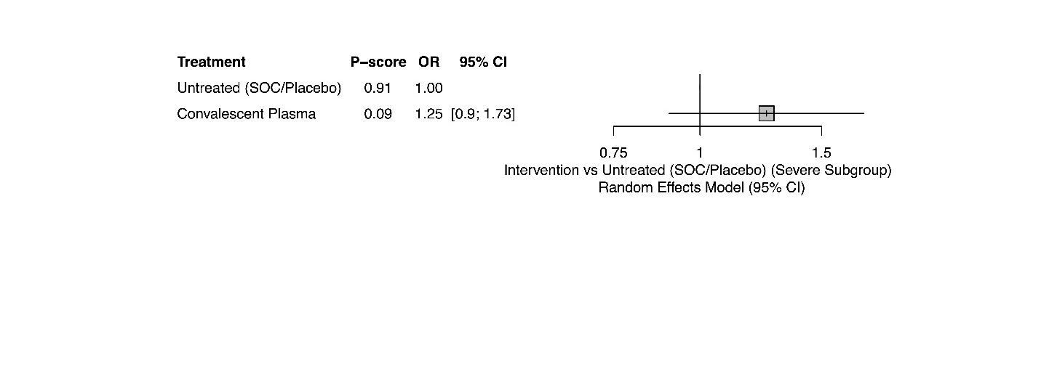
Figure S18 Incidence of adverse events, network and forest plots for subgroup analysis including inpatients only (I² = 0%)

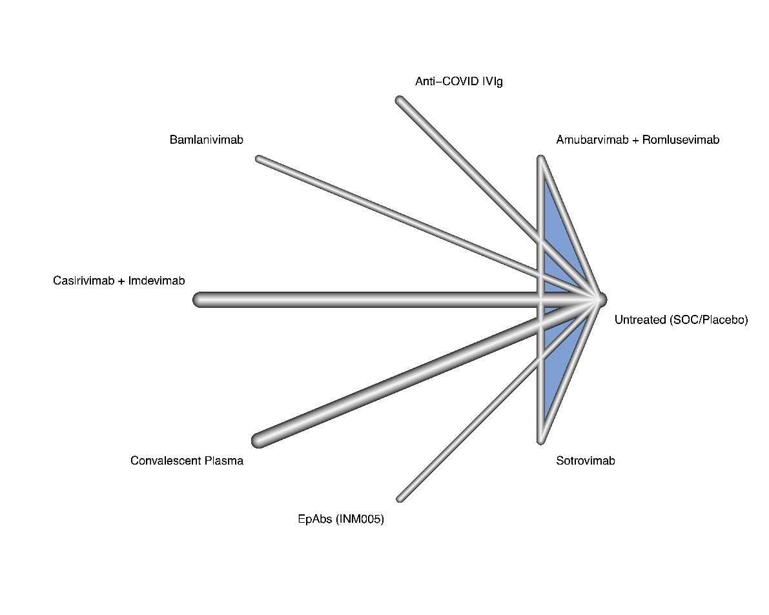
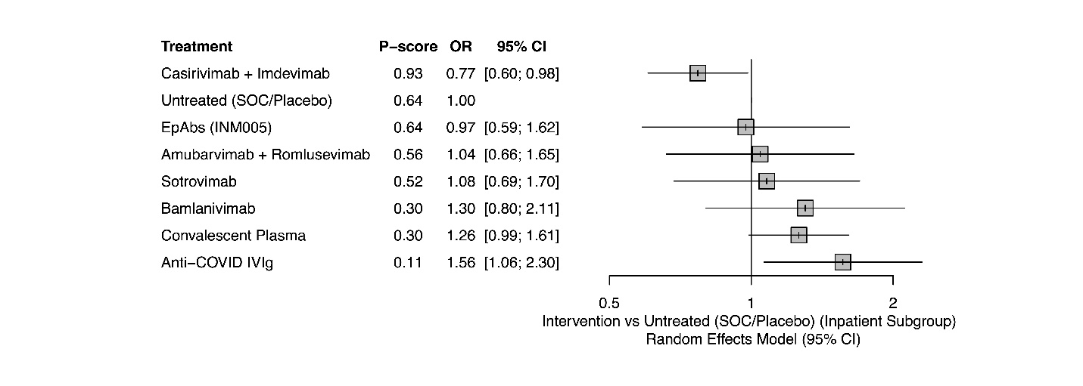
Figure S19 Incidence of adverse events, network and forest plots for subgroup analysis including outpatients only (I² = 41.2%)

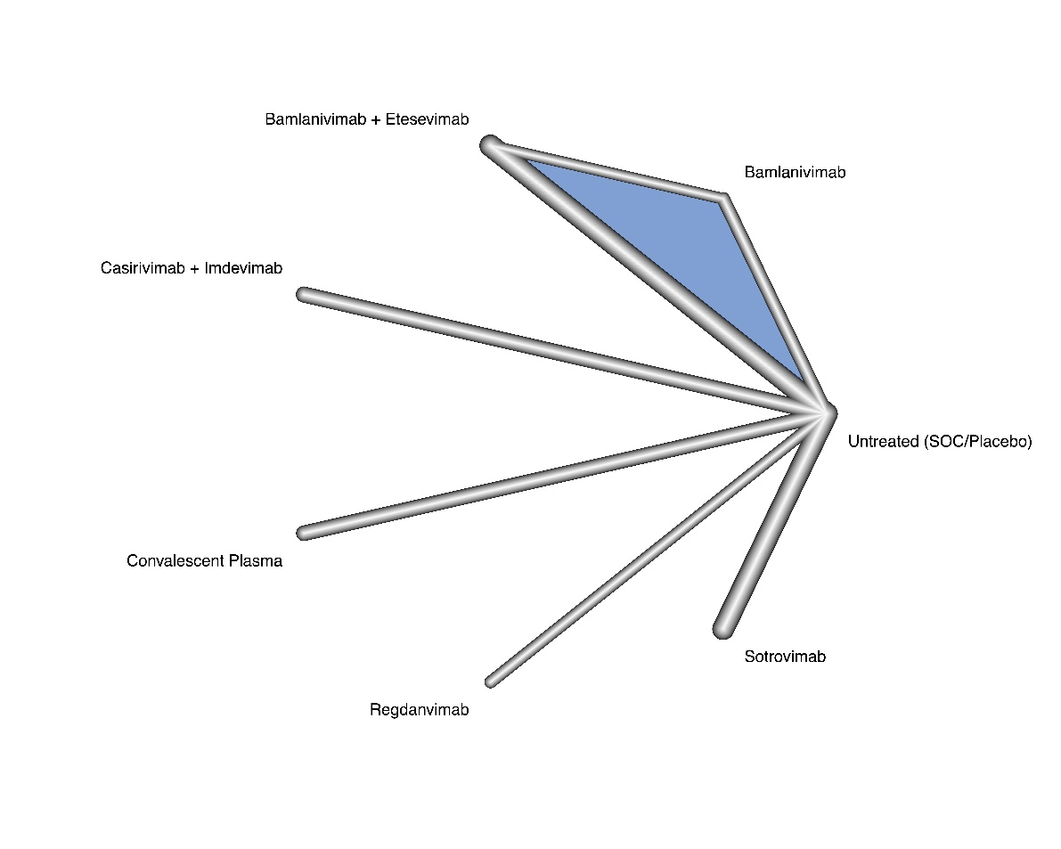
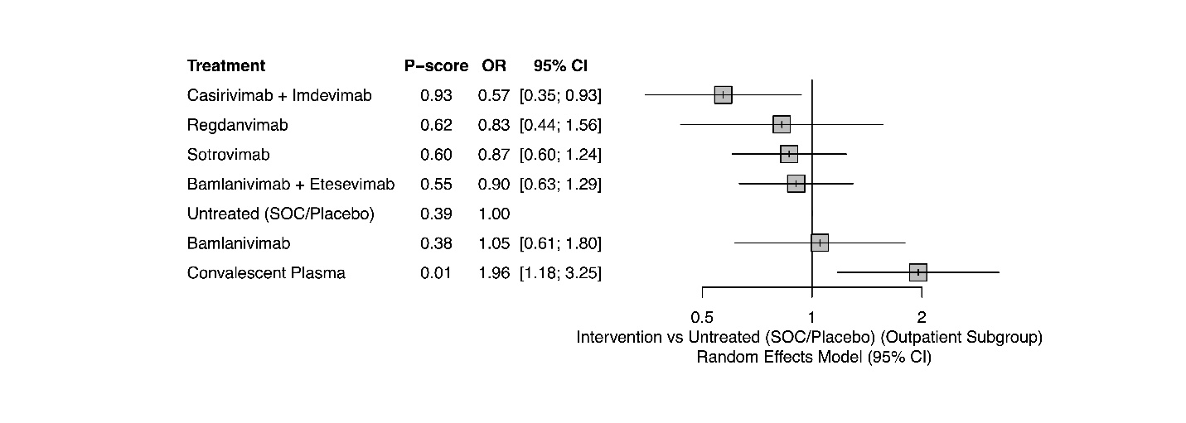
Figure S20 Incidence of serious adverse events, network and forest plots for subgroup analysis including patients with nonsevere COVID-19 (I² = 0%)

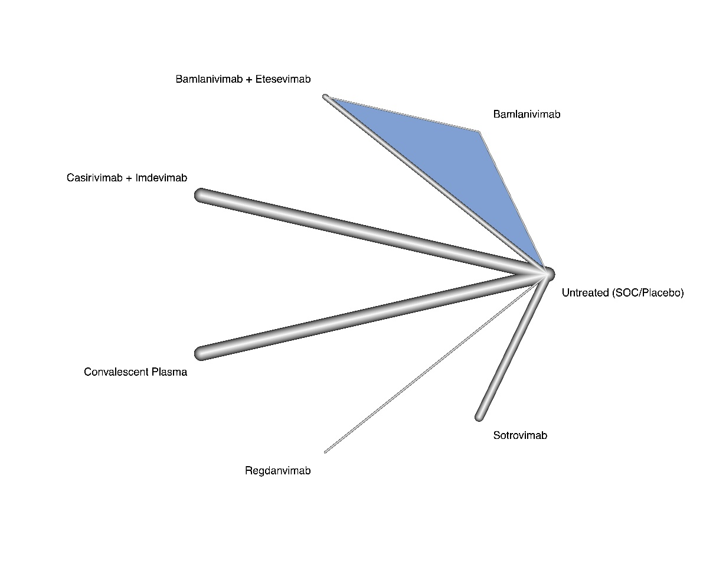
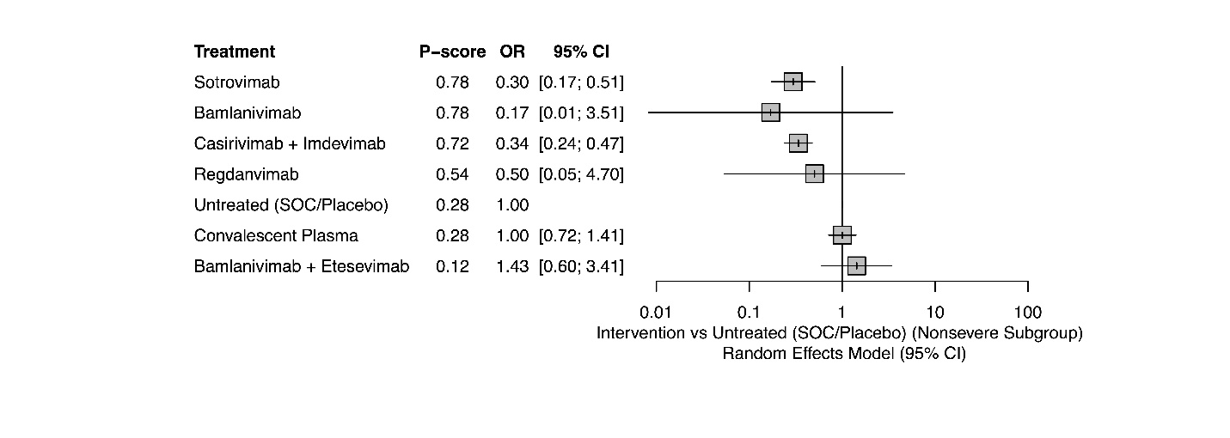
Figure S21 Incidence of serious adverse events, forest plot for subgroup analysis including patients with severe COVID-19 (I² = 25.5%)

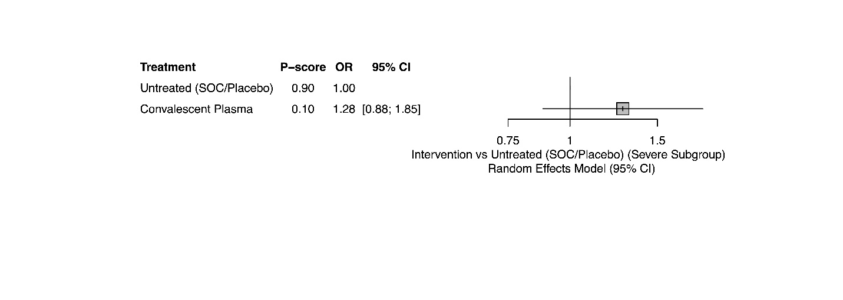
Figure S22 Incidence of serious adverse events, network and forest plots for subgroup analysis including inpatients only (I² = 10.8%)

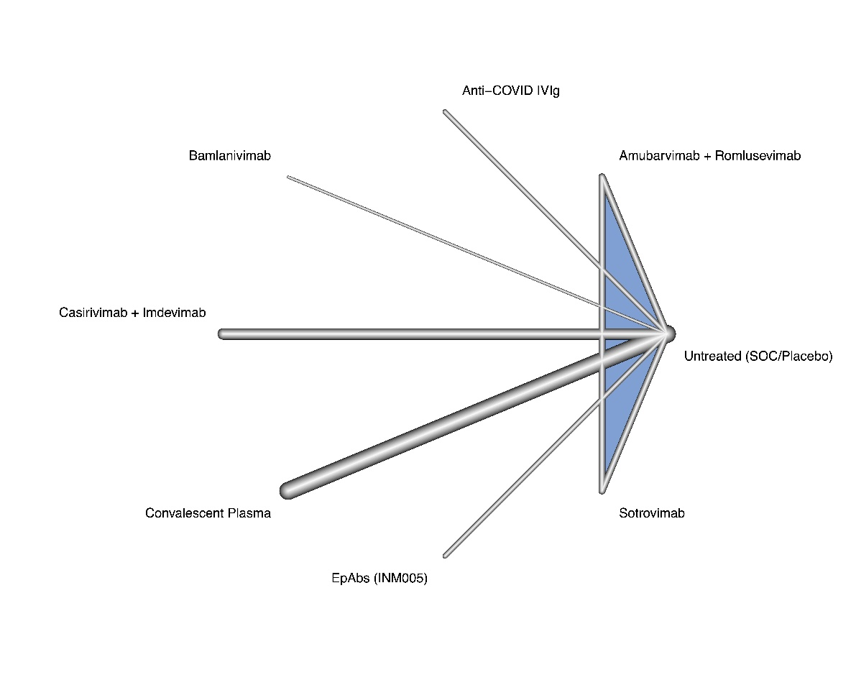
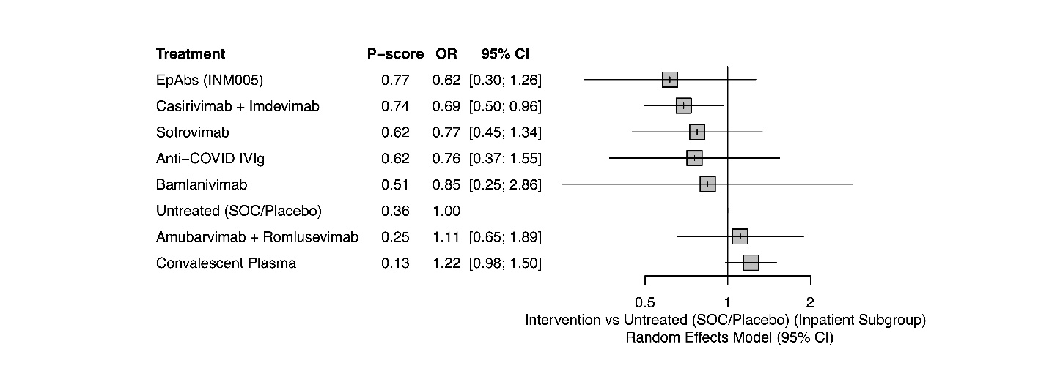
Figure S23 Incidence of serious adverse events, network and forest plots for subgroup analysis including outpatients only (I² = 0%)

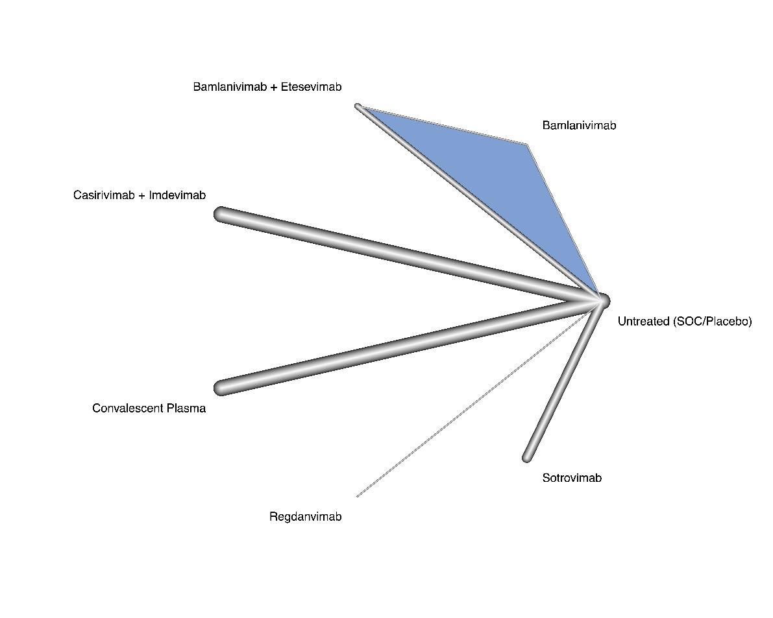
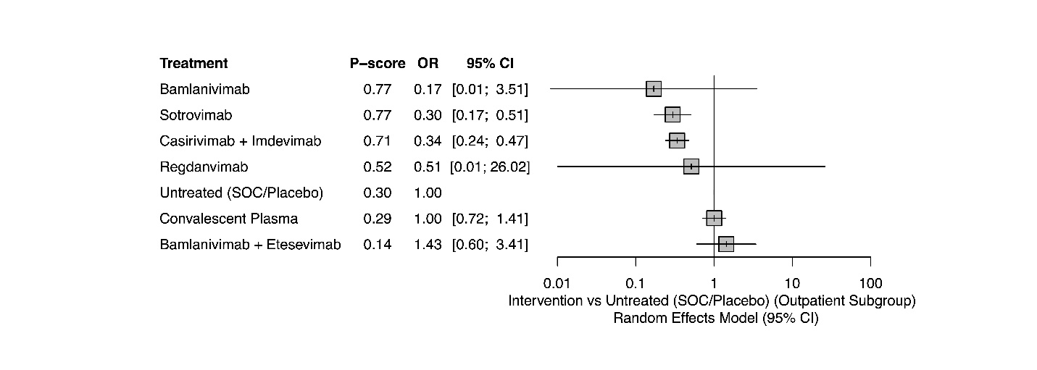
Figure S24 Mortality incidence, comparison-adjusted funnel plot
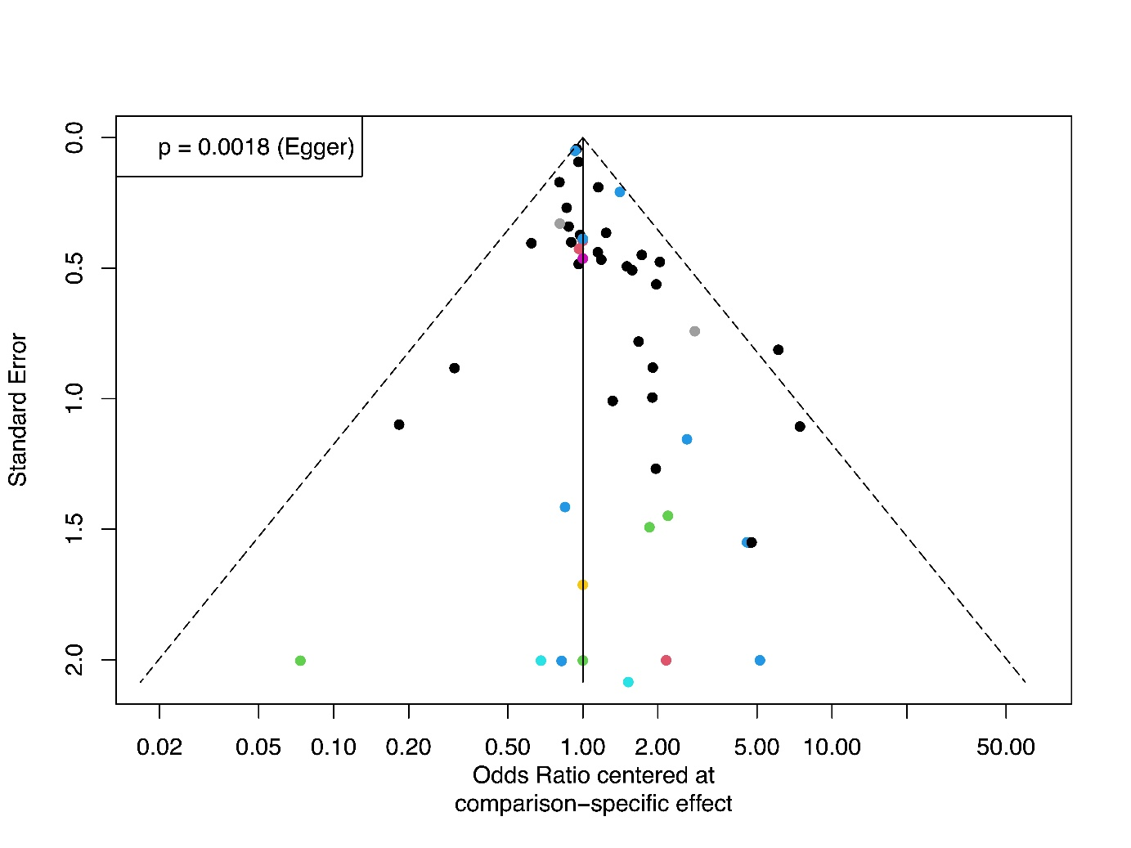
Figure S25 Incidence of hospitalization, comparison-adjusted funnel plot
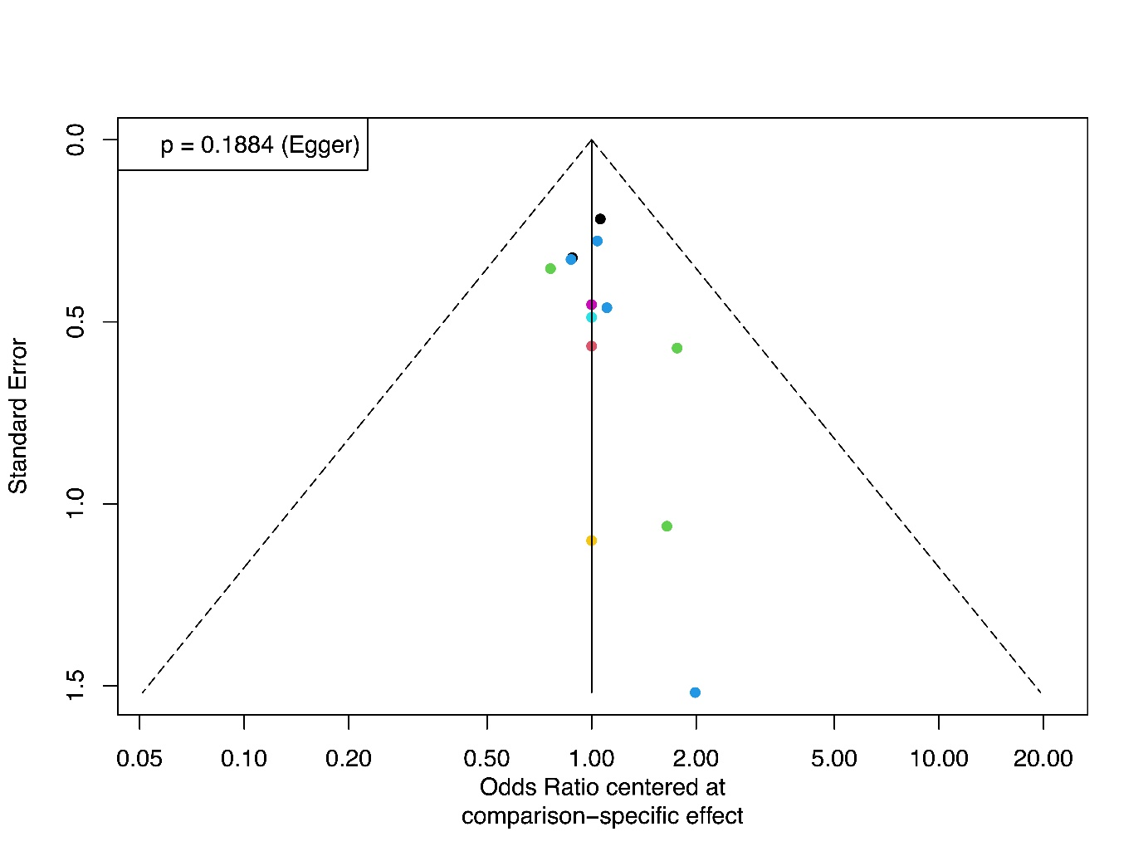
Figure S26 Incidence of invasive mechanical ventilation/ECMO, comparison-adjusted funnel plot
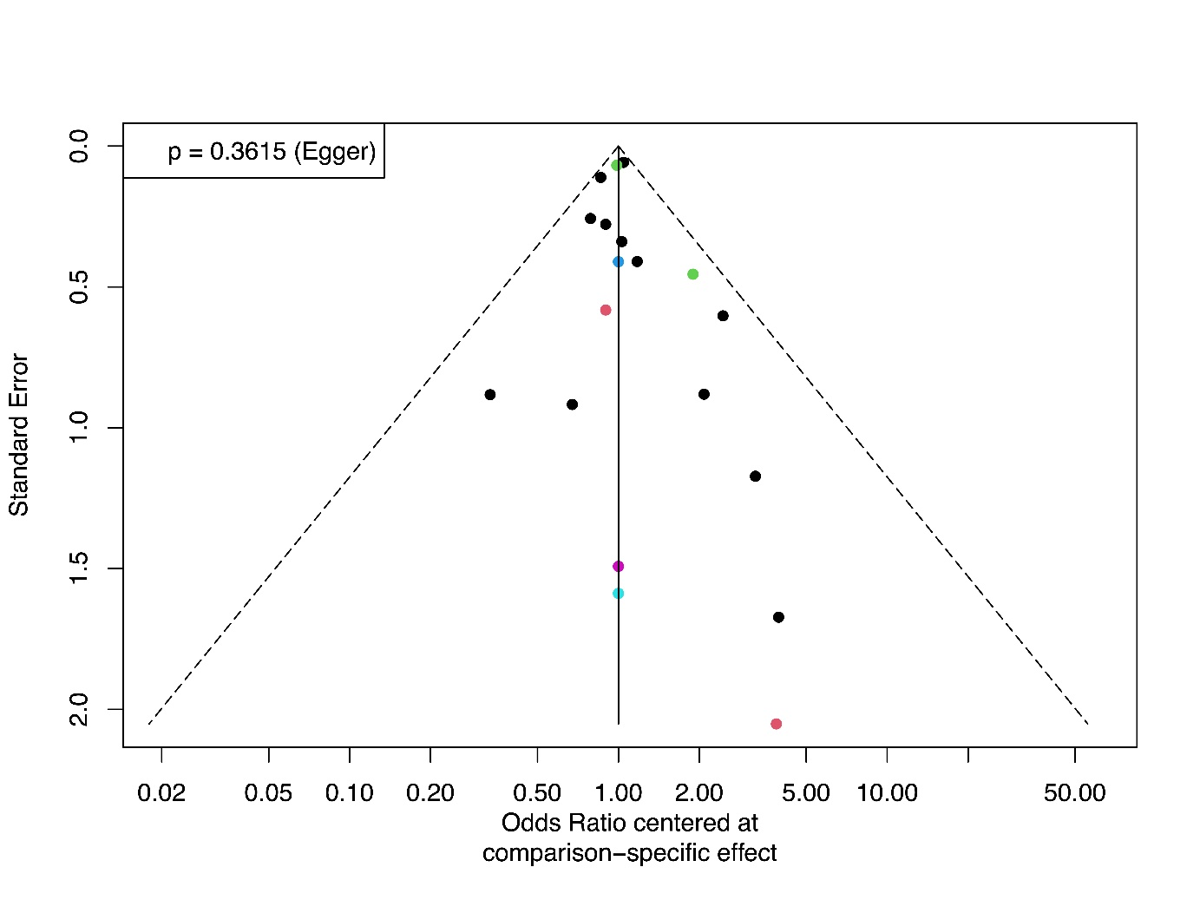
Figure S27 Duration of hospitalization, comparison-adjusted funnel plot
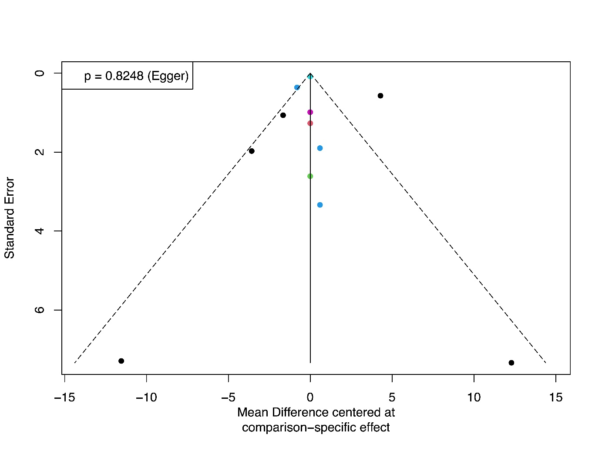
Figure S28 Incidence of adverse events, comparison-adjusted funnel plot
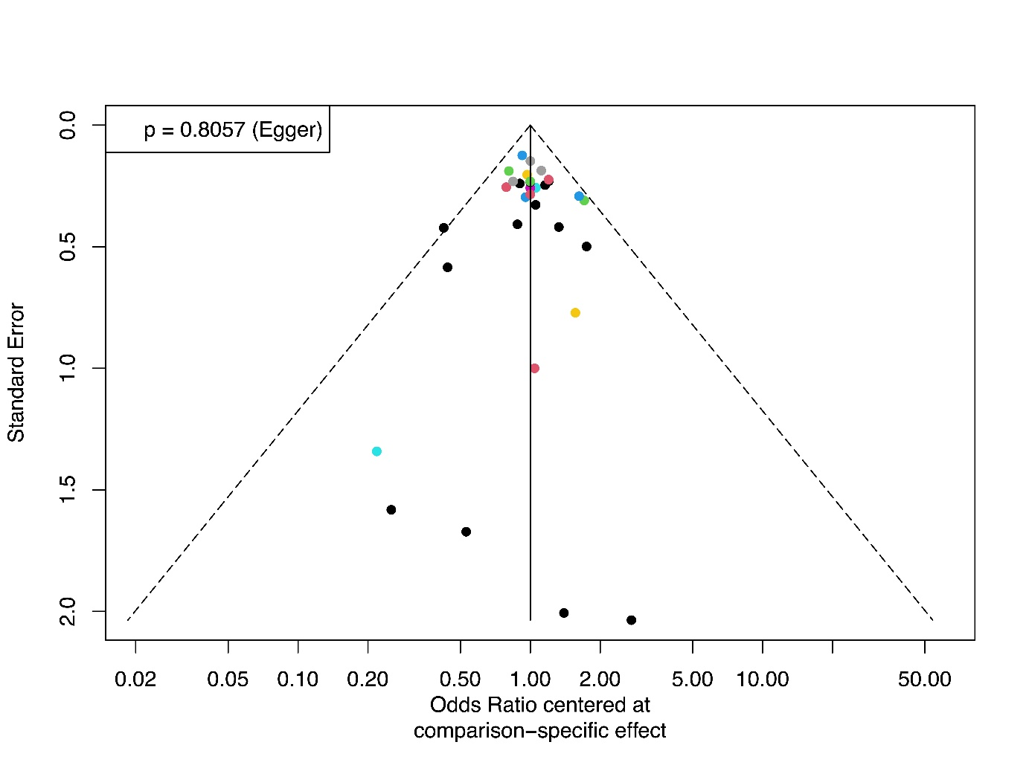
Figure S29 Incidence of serious adverse events, comparison-adjusted funnel plot


