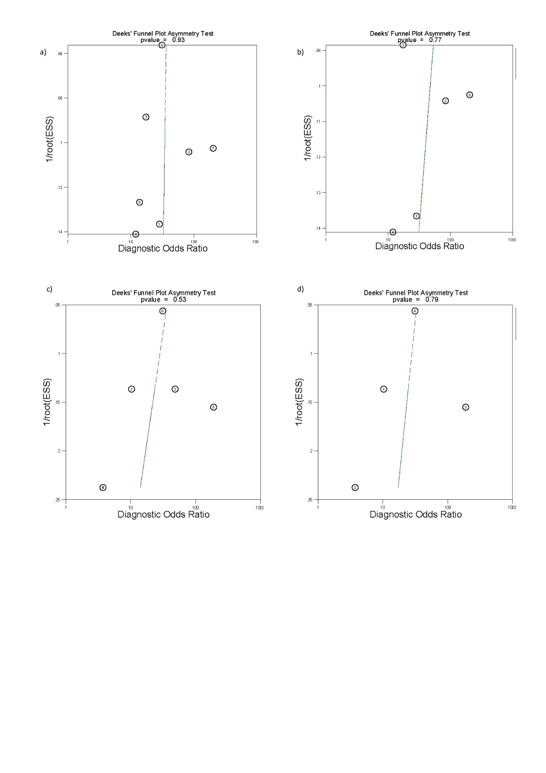Supplementary Figure S1 Deeks funnel plots of studies included for the evaluation of uterosacral ligaments/torus uterinus deep endometriosis, showing no publication bias. Imaging modalities analysed include (a) ALL transvaginal ultrasound (TVS) (b) sub-analysis of 2-D transvaginal ultrasound (c) ALL MRI and (d) sub-analysis of 2-D MRI. ESS, effective sample size.

