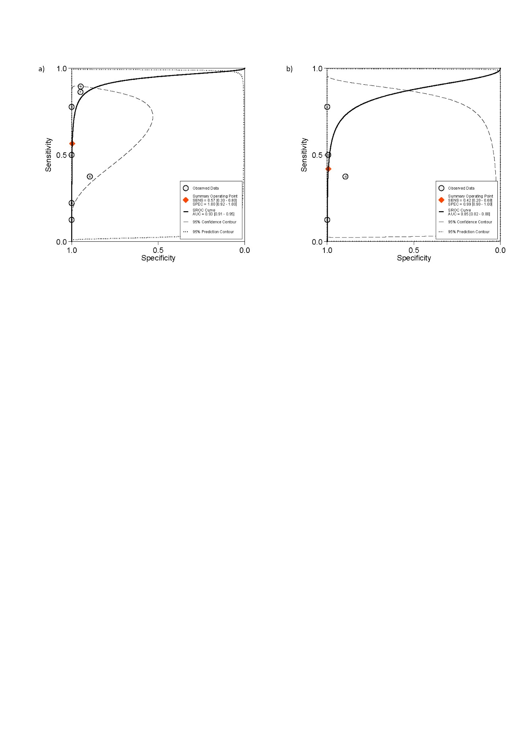
Supplementary Figure S2 Summary receiver-operating characteristic curves of studies included for the evaluation of rectovaginal septum deep endometriosis. Imaging modalities analysed are (a) ALL TVS and (b) sub-analysis of 2-D TVS. SROC: summary receiver-operating characteristic, SENS: sensitivity, SPEC: specificity

