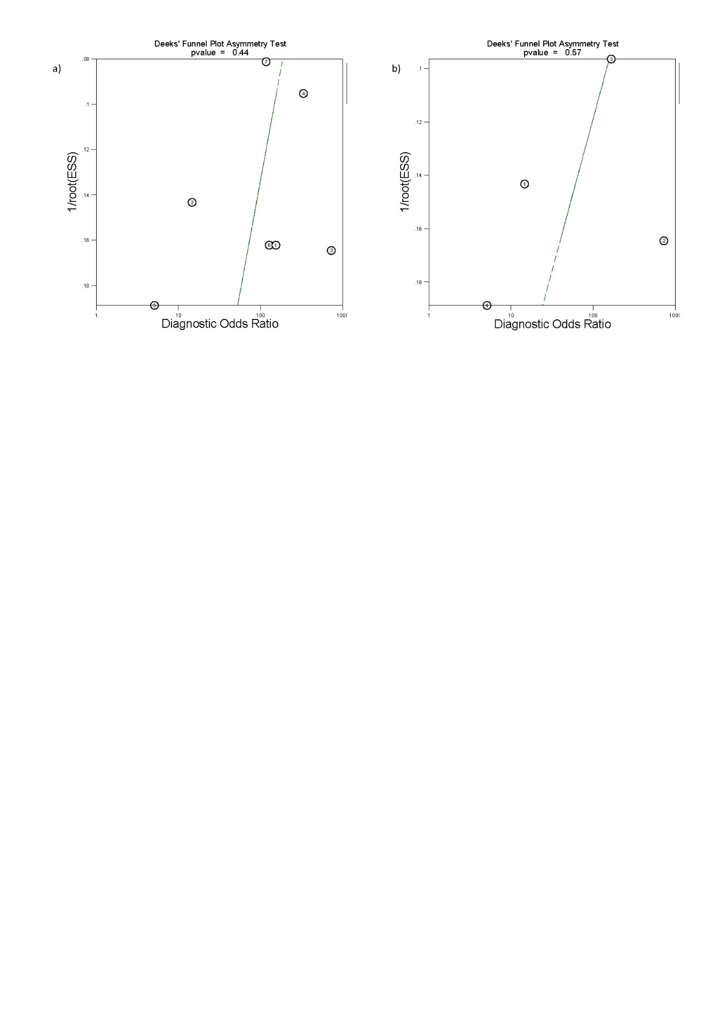
Supplementary Figure S3 Deeks funnel plots of studies included for the evaluation of rectovaginal septum deep endometriosis, showing no publication bias. Imaging modalities analysed include (a) ALL TVS and (b) sub-analysis of 2-D TVS.

