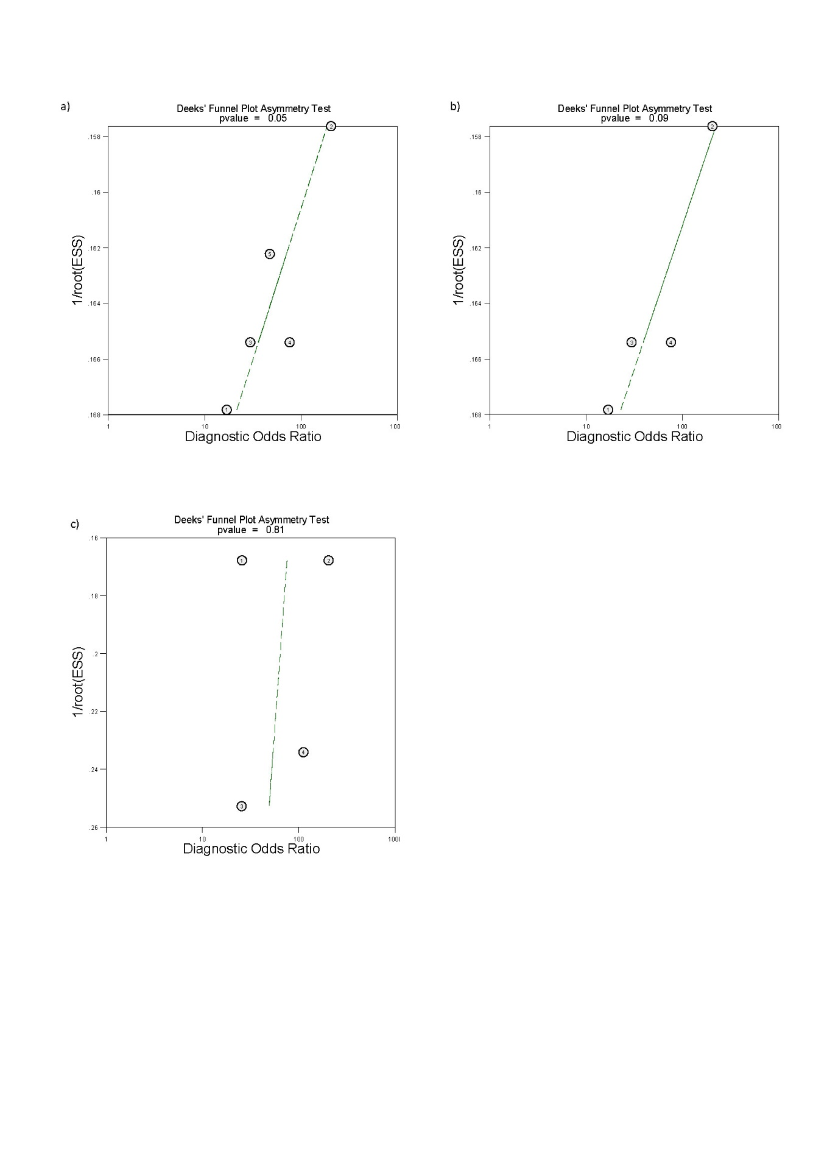
Supplementary Figure S4 Deeks funnel plots of studies included for the evaluation of vaginal endometriosis, showing no publication bias. Imaging modalities analysed include (a) ALL TVS (b) sub-analysis of 2-D TVS and (c) ALL MRI. ESS, effective sample size.

