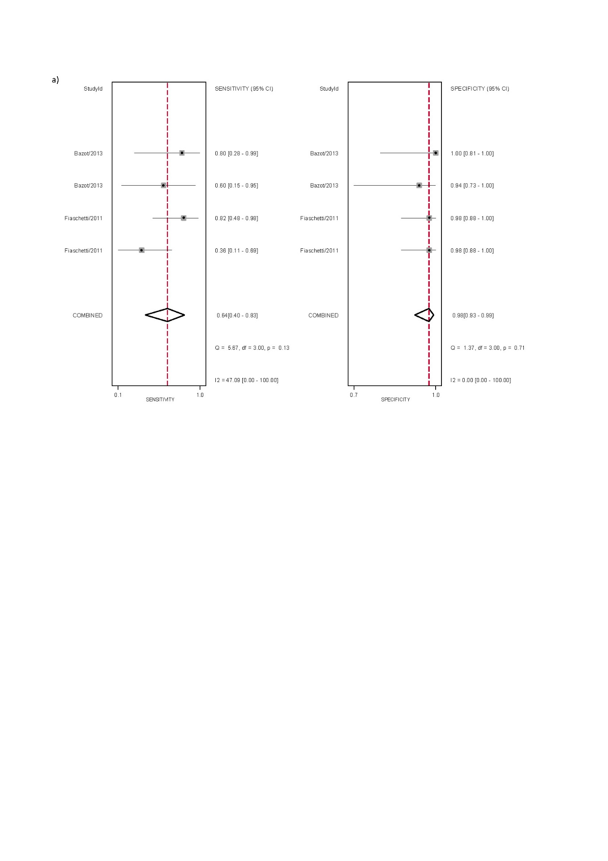
Supplementary Figure S5 Forest plots of studies included for the evaluation of vaginal deep endometriosis for ALL MRI, displaying the pooled sensitivity, specificity and heterogeneity statistics (Cochran’s Q and I²).

