Calorie Restriction with Exercise Intervention Improves Inflammatory Response in Overweight and Obese Adults: A Systematic Review and Meta-Analysis
Yubo Liu, Feng Hong, Veeranjaneya Reddy Lebaka, Arifullah Mohammed, Lei Ji,
Yean Zhang and Mallikarjuna Korivi
Supplementary Figures:

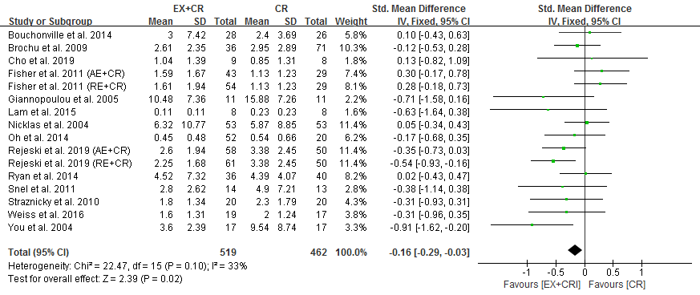
Figure 1S. Forest plot of the effects of exercise plus calorie restriction (EX+CR) intervention and CR alone on CRP changes in overweight and obese adults.

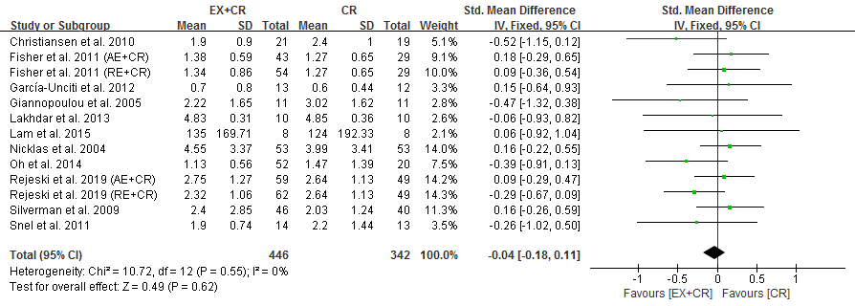
Figure 2S. Forest plot of the effects of exercise plus calorie restriction (EX+CR) intervention and CR alone on IL-6 changes in overweight and obese adults.

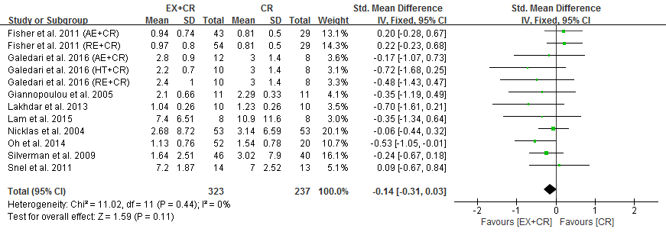
Figure 3S. Forest plot of the effects of exercise plus calorie restriction (EX+CR) intervention and CR alone on TNF-α changes in overweight and obese adults.

