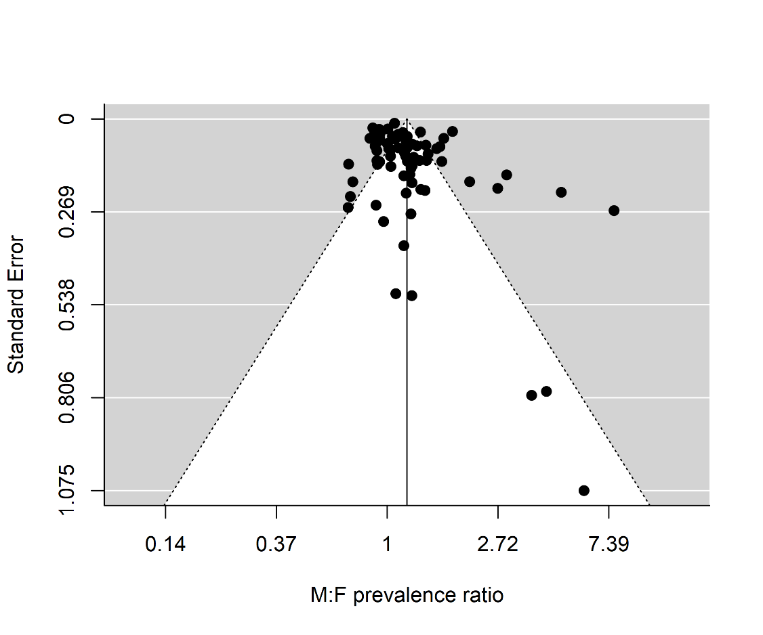
S1 Fig : Funnel plot for assessing publication bias in meta-analysis of 71 epidemiological studies in Africa of S. haematobium. The funnel graph shows the effect measure ($M:F$ prevalence ratio) and standard error (S.E.) for each study.

