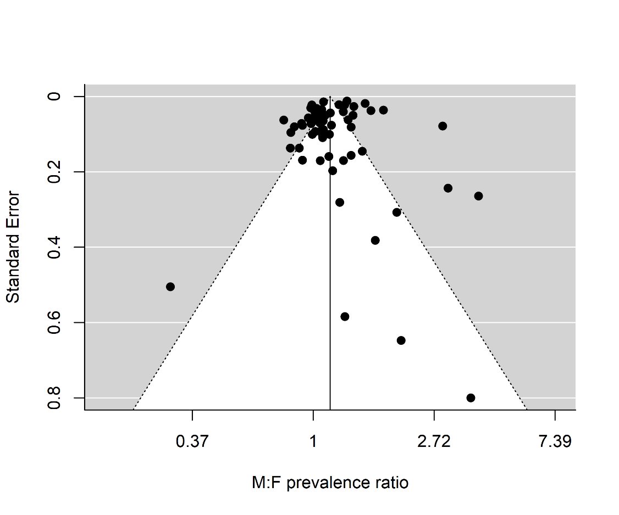
S2 Fig: Funnel plot for assessing publication bias in meta-analysis of 61 epidemiological studies in Africa of S. mansoni. The funnel graph shows the effect measure ($M:F$ prevalence ratio) and standard error (S.E.) for each study.

