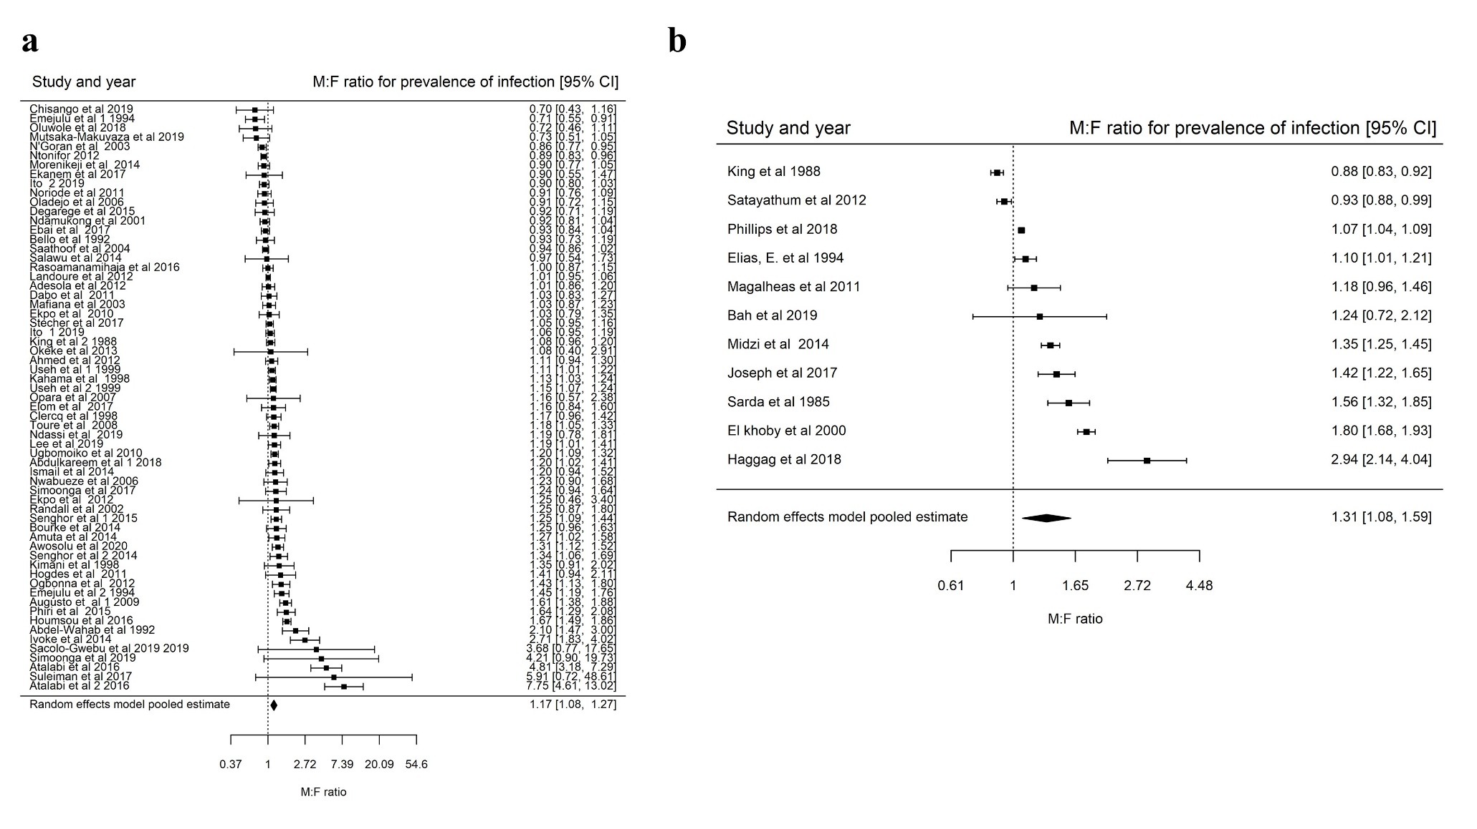
S3 Fig : Forest plots showing the $M:F$ prevalence ratios and 95% CI for S. haematobium according to sample size; a) Studies with sample size less than 2251(mean sample size of included studies), pooled $M:F$ prevalence ratio is $1.17 \left(95\% CI 1.08-1.27\right), I^{2}=93.15\%$, and b) studies with sample size greater than 2251; $M:F$ prevalence of infection ratio is $1.31 \left(95\% CI 1.08-1.59\right), I^{2}=98\%$.

