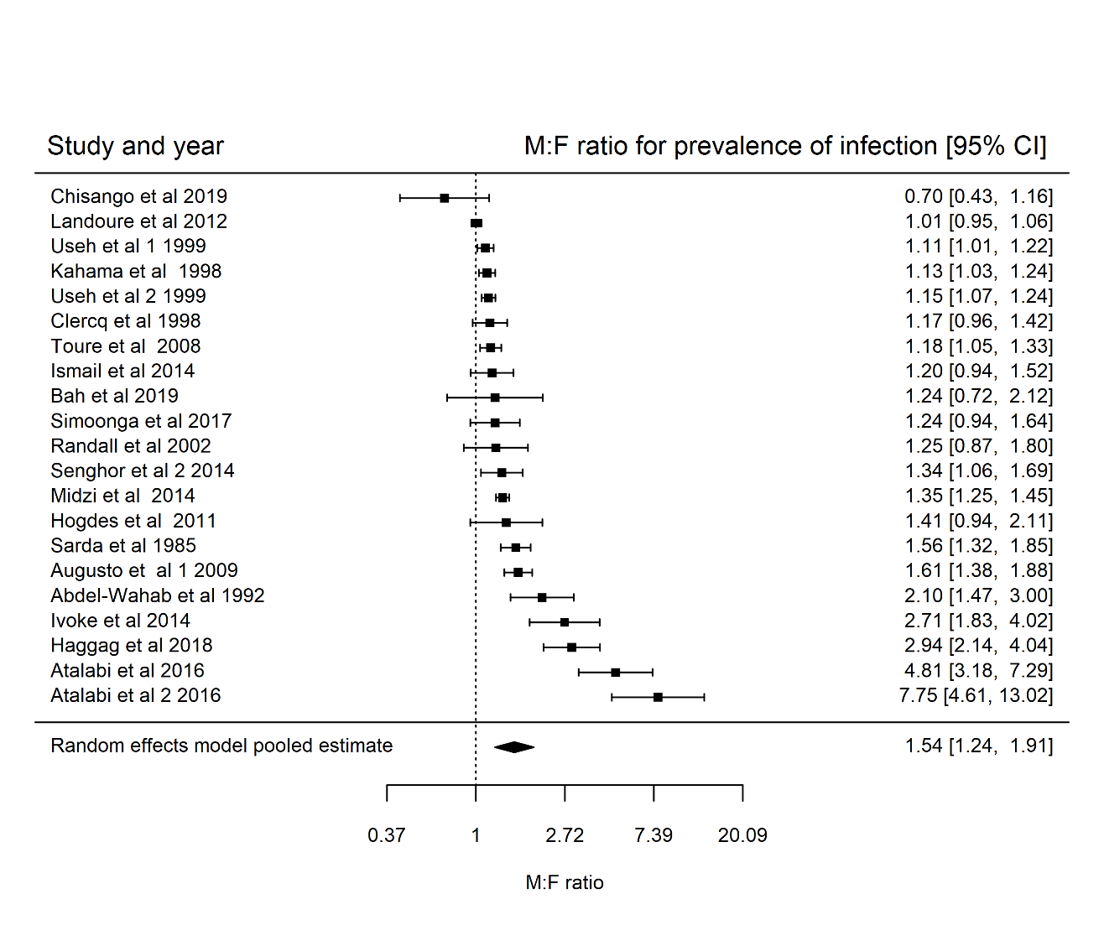
S4 Fig : Forest plots showing the $M:F$ prevalence ratios and 95% CI for S. haematobium for studies where the lower age limit is greater than 5 years (21 communities and $n= 19$ studies, pooled $M:F$ prevalence ratio is $1.54 \left(95\% CI 1.24-1.91\right),$ heterogeneity: $I^{2} = 97.85\%$). Analysis includes studies that report the number of individuals who were screened for S. haematobium infection and the fraction who tested positive distributed by sex regardless of the reported significance of the difference in $M:F$ prevalence ratios.

