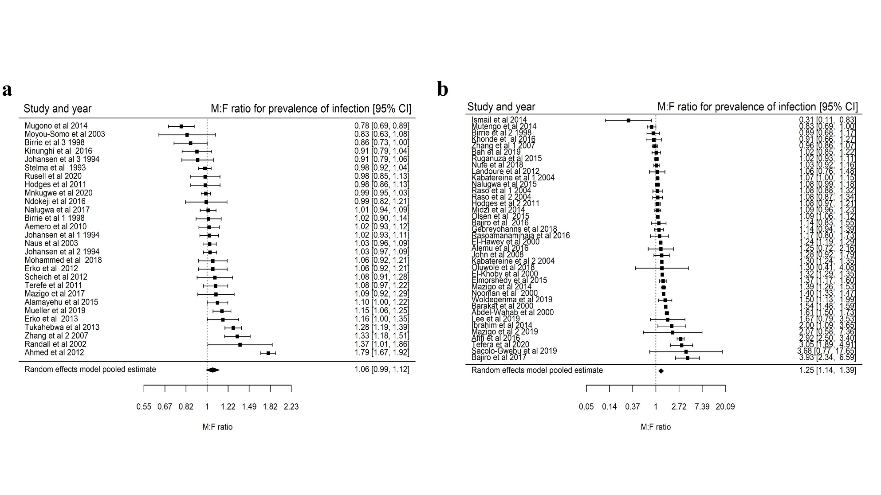

S6 Fig: Forest plots showing the $M:F$ prevalence ratios and 95% CI for S. mansoni according to baseline prevalence; a) Studies with baseline prevalence greater than 50% pooled $M:F$ prevalence ratio is $1.06 \left(95\% CI 0.99-1.12\right), I^{2}=90.38\%$, and b) studies with baseline prevalence less than 50%; $M:F$ prevalence of infection ratio is $1.25 \left(95\% CI 1.14-1.39\right), I^{2}=97.84\%$.

