Supplementary Table 1. Quality assessment of included studies

 | 1. Target population is clearly defined | 2. Probability sampling OR entire population surveyed | 3. Is the response rate ≥80%? | 4. Are non-responders clearly described? | 5. Is the sample representative of the target population? | 6. Were data collection methods standardized? | 7. Were validated criteria used to diagnose MDD? | 8. Are the prevalence estimates given with confidence intervals and detailed by subgroups  (if applicable)? | Total score
Li (Xuanpei Li, 1996) | 1 | 0 | 0 | 0 | 1 | 1 | 1 | 0 | 4
Li (Xianyun Li, 2006) | 1 | 1 | 0 | 1 | 1 | 1 | 1 | 0 | 6
Söderholm (Soderholm et al., 2020) | 1 | 1 | 0 | 1 | 1 | 1 | 1 | 0 | 6
Salloum (Salloum et al., 1995) | 1 | 0 | 0 | 0 | 1 | 1 | 1 | 0 | 4
Choi (Choi et al., 2019) | 1 | 1 | 1 | 1 | 1 | 1 | 1 | 0 | 7
Moffitt (Moffitt et al., 2007) | 1 | 1 | 1 | 0 | 1 | 1 | 1 | 0 | 6
Holmstrand (Holmstrand et al., 2008) | 1 | 0 | 0 | 0 | 1 | 1 | 1 | 0 | 4
Chen (Chen & Dilsaver, 1996) | 1 | 0 | 0 | 0 | 1 | 1 | 1 | 0 | 4
Li (Li et al., 2017) | 1 | 0 | 1 | 1 | 1 | 1 | 1 | 0 | 6
Goldney (Goldney et al., 2002) | 1 | 0 | 0 | 0 | 1 | 1 | 1 | 0 | 4
Sagud (Sagud et al., 2020) | 1 | 0 | 0 | 0 | 1 | 1 | 1 | 0 | 4
Ma (Ma et al., 2009) | 1 | 1 | 1 | 1 | 1 | 1 | 1 | 0 | 7
Bronisch (Bronisch & Wittchen, 1994) | 1 | 0 | 0 | 1 | 1 | 1 | 1 | 0 | 5
Areen (Omary, 2020) | 1 | 1 | 1 | 1 | 1 | 1 | 1 | 0 | 7
Axelsson (Axelsson & Lagerkvist-Briggs, 1992) | 1 | 0 | 0 | 0 | 1 | 1 | 1 | 0 | 4

Supplementary Figure 1. Publication bias of the included studies reporting lifetime prevalence of SA in MDD compared with non-MDD groups. (Plotted by random effects)

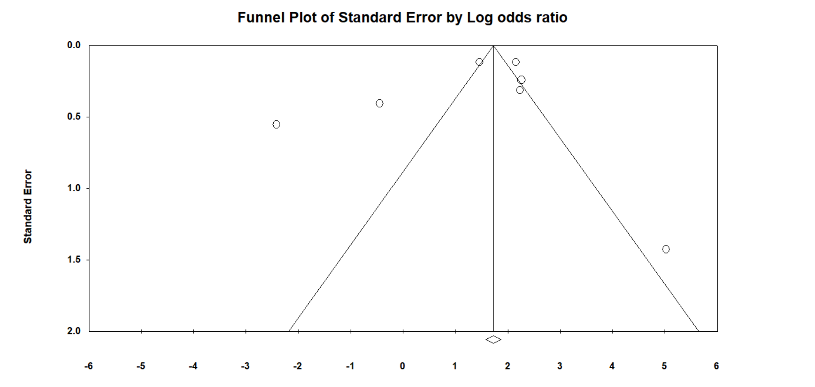

Egger’s test: t = -2.37, p=0.47

