Supplementary Material

Supplementary Methods section
The following PICOS criteria were used for our search:
Population: Studies with healthy participants and various patient populations were included.
Intervention: To be included, a paper had to be either a case report of neuropsychological dysfunction after SP use, a qualitative study dealing with neuropsychological abilities of people who frequently use SPs, an experimental study in which subjects were given frequent dosages of a SPs and administered a neuropsychological test battery, or an observational study that performed neuropsychological assessment on a sample of SP users. All assessments had to be conducted with a test instrument yielding quantitative data.
Comparisons: Studies were selected if they compared the scores of the SP users to a placebo group, a control group, or to normative data.
Outcomes: To be considered the article had to report the results of at least one measure, assessing at least one neuropsychological domain.
Study type: Case reports, qualitative studies of frequent users of SPs, observational studies of frequent users of SPs, or experimental human studies with frequent administration of SPs, published in peer-reviewed journals were included. We excluded animal research, review papers, opinion pieces, letters to the editors (unless a case report was presented as such), and books.

Supplementary Figures and Tables
Supplementary Table 1. Included search terms related to psychedelic substances and neuropsychological testing or domains.
 | Search Terms
Psychedelic terms | “2c-e”, “4-bromo-2,5-dimethoxyamphetamine”, “2c-b”, “psilocin”, “2,5-dimethoxy-4-methylamphetamine”, “nbome”, “iboga”, “bufotenin”, “ayahuasca”, “ibogaine”, “n,n-dimethyltryptamine”, “psilocybin”, “mescaline”, “peyote”, “dmt”, “lysergic”, “lsd”, “hallucinogen”, “psychedelic”
Neuropsychological terms | “amnes*”, “neuropsychological”, “intelligence”, “attention”, “cognitive”, “learning”, “memory”, “neurocognitive”, “neuropsychiatric”, “psychological”, “psychometric”, “recall”,” recognition”, “executive function”, “aphasia”, “agnosia”, “apraxia”, "wisconsin card", "boston naming", "rey osterrieth", “mmse”, “stroop”, "digit span", "trail making", "word list", “fluency”

Supplementary Table 2. Rating of study quality according to the Newcastle-Ottowa-Scale.
 | Selection |  |  |  | Comparability |  | Exposure |  |  | Total score (max. 9)
Barbosa et al., (2016) | q1 | q2 | q3 | q4 | q1 | q2 | q1 | q2 | q3 | 5
Bouso et al., (2012) | q1 | q2 | q3 | q4 | q1 | q2 | q1 | q2 | q3 | 4
Bouso et al., (2015) | q1 | q2 | q3 | q4 | q1 | q2 | q1 | q2 | q3 | 4
Cohen & Edwards, (1969) | q1 | q2 | q3 | q4 | q1 | q2 | q1 | q2 | q3 | 5
Culver & King, (1974) | q1 | q2 | q3 | q4 | q1 | q2 | q1 | q2 | q3 | 6
Doering-Silveira et al., (2005) | q1 | q2 | q3 | q4 | q1 | q2 | q1 | q2 | q3 | 6
Grob et al., (1996) | q1 | q2 | q3 | q4 | q1 | q2 | q1 | q2 | q3 | 6
Halpern et al., (2005) | q1 | q2 | q3 | q4 | q1 | q2 | q1 | q2 | q3 | 6
Kaasik & Kreegipuu (2020) | q1 | q2 | q3 | q4 | q1 | q2 | q1 | q2 | q3 | 3
Matefy, Hayes & Hirsch, (1979) | q1 | q2 | q3 | q4 | q1 | q2 | q1 | q2 | q3 | 4
McGlothlin, Arnold, & Freedman, (1969) | q1 | q2 | q3 | q4 | q1 | q2 | q1 | q2 | q3 | 7
Vardy & Kay, (1983) | q1 | q2 | q3 | q4 | q1 | q2 | q1 | q2 | q3 | 4
Wright & Hogan, (1972) | q1 | q2 | q3 | q4 | q1 | q2 | q1 | q2 | q3 | 5
Note: Each cell represents one question of the Newcastle-Ottowa-Scale. A red cell indicates that the criterion in question was not fulfilled, while a green cell indicates fulfillment of the criterion.

Supplementary Figures

Supplementary Figure 1. Forest plots for Rey-Osterrieth Complex Figure Task. A) Copy trial B) Delayed Recall trial
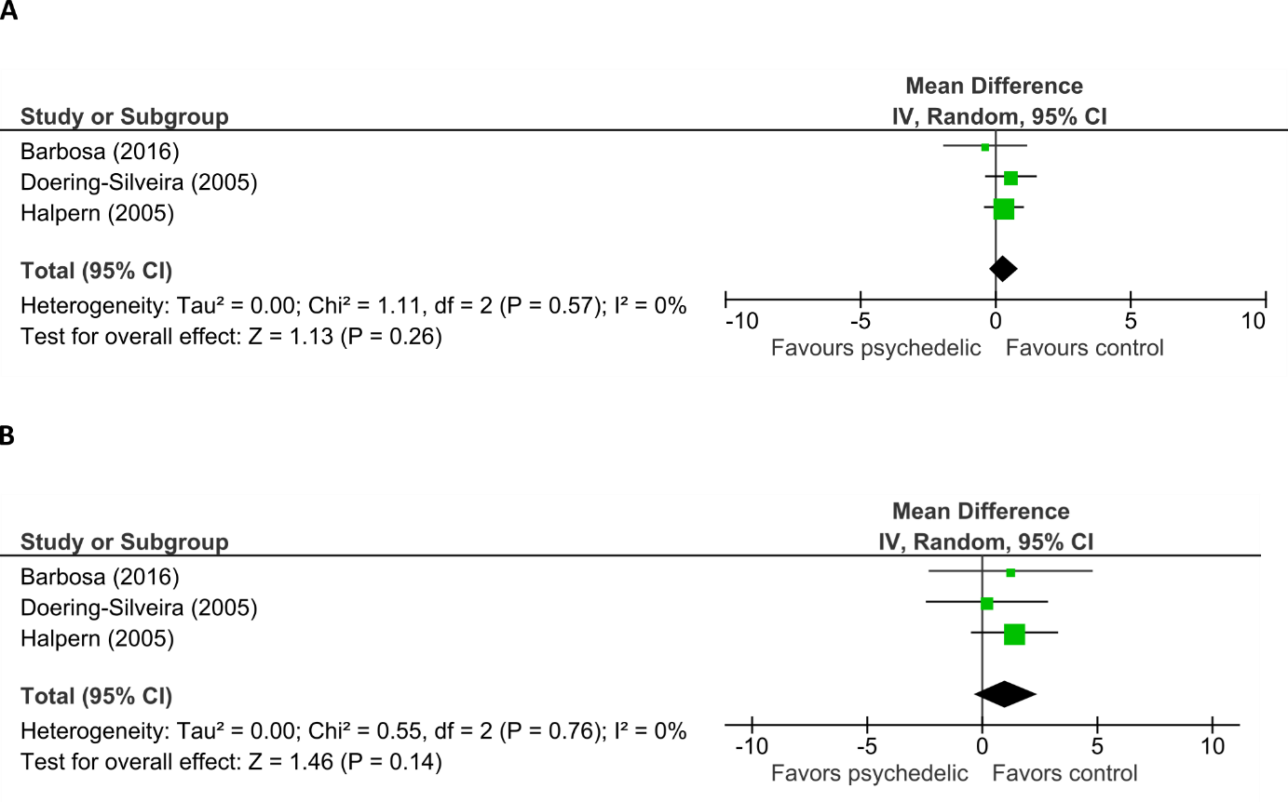

Supplementary Figure 2. Forest plots for the Trail Making Test. A) Trail A B) Trail B
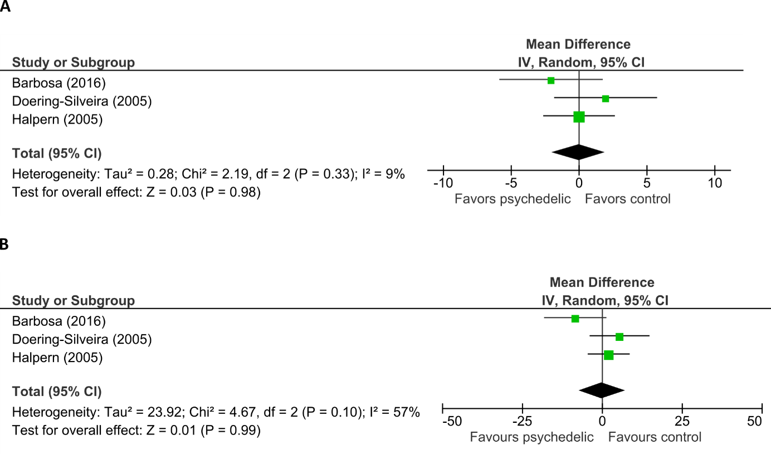
Supplementary Figure 3. Forest plots for the Stroop task. A) Word trials B) Color trials C) Incongruent trials
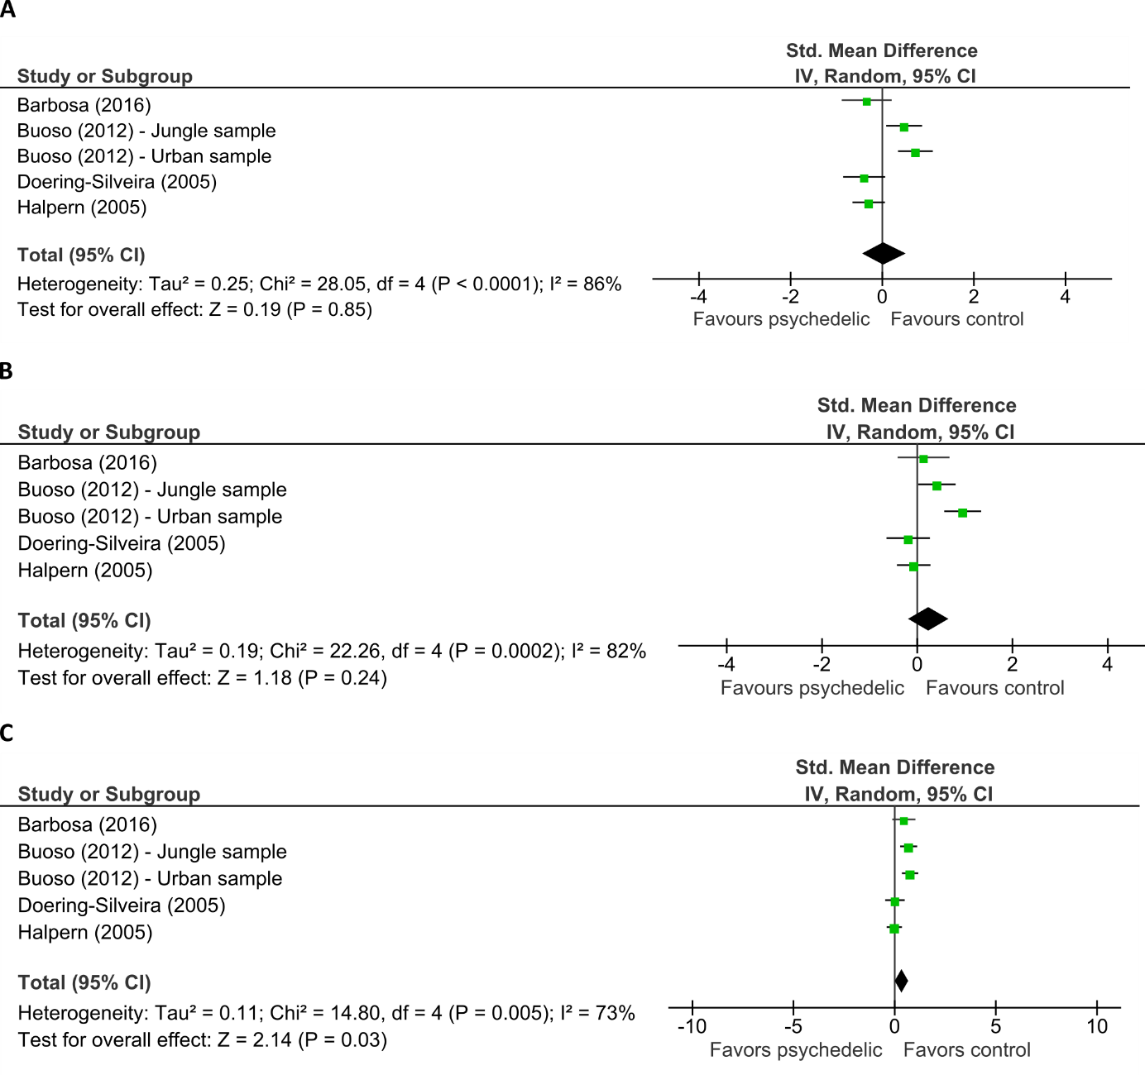

Supplementary Figure 4. Forest plots for the Verbal Learning tasks. A) Trial 5 B) Short Recall after Interference C) Recognition D) Long Delayed Recall


