Additional file 5. (Figures S1-21). Dumbbell plots of biomarkers, point-of-care tests and prediction rules for urinary tract infection

Figures S1- 21 Likelihood ratios and post-test disease probabilities (%) (dumbbell plots) of biomarkers, point-of-care tests and prediction rules for UTI
Figure S1 Nitrite (urine dipstick) for cystitis
Prevalence= number of children with uncomplicated UTI /sample size (n), LR+ = positive likelihood ratio, LR- = negative likelihood ratio, 95%CI = 95% confidence intervals, UTI= urinary tract infection, *Study data from Herreros et al (2018) was not added to the meta-analysis, + = positive, - = negative

Figure S2 Leukocyte esterase (urine dipstick) for cystitis
Prevalence= number of children with uncomplicated UTI /sample size (n), LR+ = positive likelihood ratio, LR- = negative likelihood ratio, 95%CI = 95% confidence intervals, UTI= urinary tract infection, + = positive, - = negative, NS= not specified, *Study data from Herreros et al (2018) was not added to the meta-analysis, **When no threshold was reported for LE (NS) we assumed ‘any discoloration’ as the positivity threshold (≥trace) for the meta-analysis

Figure S3 Protein, hemoglobin and glucose (urine dipstick) for cystitis
Prevalence= number of children with uncomplicated UTI /sample size (n), LR+ = positive likelihood ratio, LR- = negative likelihood ratio, 95%CI = 95% confidence intervals, UTI= urinary tract infection, + = positive, - = negative

Figure S4 Combination of Leukocyte Esterase or nitrite positive for cystitis
Prevalence= number of children with uncomplicated UTI /sample size (n), LR+ = positive likelihood ratio, LR- = negative likelihood ratio, 95%CI = 95% confidence intervals, UTI= urinary tract infection, *Study data from Herreros et al (2018) was not added to the meta-analysis, + = positive, - = negative

Figure S5 Combination of Leukocyte Esterase and nitrite positive for cystitis
Prevalence= number of children with uncomplicated UTI /sample size (n), LR+ = positive likelihood ratio, LR- = negative likelihood ratio, 95%CI = 95% confidence intervals, UTI= urinary tract infection, + = positive, - = negative

Figure S6 Combination of urine dipstick markers (Leukocyte Esterase, Nitrite, Hemoglobin and Protein) for cystitis
Prevalence= number of children with uncomplicated UTI /sample size (n), UTI= urinary tract infection, LE= Leucocyte Esterase > trace, N= Nitrite, Hb= Hemoglobin>trace, Prot= Protein>trace, n= sample size, LR+ = positive likelihood ratio, LR- = negative likelihood ratio, + = positive, - = negative

Figure S7 Urine white blood cells (manual microscopy) for cystitis
Prevalence= number of children with uncomplicated UTI /sample size (n), LR+ = positive likelihood ratio, LR- = negative likelihood ratio, 95%CI = 95% confidence intervals, UTI= urinary tract infection, *Study data from Pylkkanen et al. (1979) was not added to the meta-analysis, + = positive, - = negative, hpf= high power field

Figure S8 Urine white blood cells (automatic microscopy) for cystitis
Prevalence= number of children with uncomplicated UTI /sample size (n), LR+ = positive likelihood ratio, LR- = negative likelihood ratio, 95%CI = 95% confidence intervals, UTI= urinary tract infection, + = positive, - = negative, µl= microliter, *5 white blood cells per oil-immersion-fields (data from this study not added to the meta-analysis)
Figure S9 Urine unstained bacteria for cystitis
- Manual microscopy
- Automated microscopy
Prevalence= number of children with uncomplicated UTI /sample size (n), LR+ = positive likelihood ratio, LR- = negative likelihood ratio, 95%CI = 95% confidence intervals, UTI= urinary tract infection, *Study data from Pylkkanen et al. (1979) was not added to the meta-analysis, + = positive, - = negative, hpf = high power field, µl= microliter, ª= IRIS IQ200 analyzer, ^{b}= UF1000i analyzer, ^{c}=IQ200 analyzer

Figure S10 Urine gram stained bacteria (microscopy) for cystitis
Prevalence= number of children with uncomplicated UTI /sample size (n), LR+ = positive likelihood ratio, LR- = negative likelihood ratio, 95%CI = 95% confidence intervals, UTI= urinary tract infection, + = positive, - = negative, hpf = high power field

Figure S11 Urine red blood cells, NGAL, HD-5, HNP 1-3 for cystitis
Prevalence= number of children with uncomplicated UTI /sample size (n), LR+ = positive likelihood ratio, LR- = negative likelihood ratio, 95%CI = 95% confidence intervals, UTI= urinary tract infection, + = positive, - = negative, hpf= high power field, mg = milligram, ng= nanogram, pg= piccogram, ml= milliliter

Figure S12 Combination of urine bacteria and white blood cells (microscopy) for cystitis
Prevalence= number of children with uncomplicated UTI /sample size (n), LR+ = positive likelihood ratio, LR- = negative likelihood ratio, 95%CI = 95% confidence intervals, WBC= urine white blood cells, B= bacteria, B(g)= gram stained bacteria, hpf= high power field, mm³= cubic milliliter, UTI= urinary tract infection, + = positive, - = negative

Figure S13 Combination of urine dipstick test with urine white blood cells for cystitis
Prevalence= number of children with uncomplicated UTI /sample size (n), LR+ = positive likelihood ratio, LR- = negative likelihood ratio, 95%CI = 95% confidence intervals, UTI= urinary tract infection,+ = positive, - = negative, hpf= high power field

Figure S14 Combination of urine dipstick test, urine bacteria and urine white blood cells for cystitis
Prevalence= number of children with uncomplicated UTI /sample size (n), LR+ = positive likelihood ratio, LR- = negative likelihood ratio, 95%CI = 95% confidence intervals, UTI= urinary tract infection, + = positive, - = negative, hpf= high power field, oif= oil immersion fields, N= nitrite, LE= leucocyte esterase, B= bacteria unstained (urine), B (g)= gram stained bacteria (urine)

Figure S15 C-reactive protein (blood) for cystitis
Prevalence= number of children with uncomplicated UTI /sample size (n), LR+ = positive likelihood ratio, LR- = negative likelihood ratio, 95%CI = 95% confidence intervals, NS= not specified, UTI= urinary tract infection, *Study data from Yildirim et al. (2008) were not included in the meta-analysis because the threshold was not specified , + = positive, - = negative, mg= milligram, l= liter

Figure S16 Procalcitonin (blood) for cystitis
Prevalence= number of children with uncomplicated UTI /sample size (n), LR+ = positive likelihood ratio, LR- = negative likelihood ratio, 95%CI = 95% confidence intervals, UTI= urinary tract infection, + = positive, - = negative, ng= nanogram, ml= milliliter

Figure S17 White blood cell count and Absolute Neutrophil Count (blood) for pyelonephritis
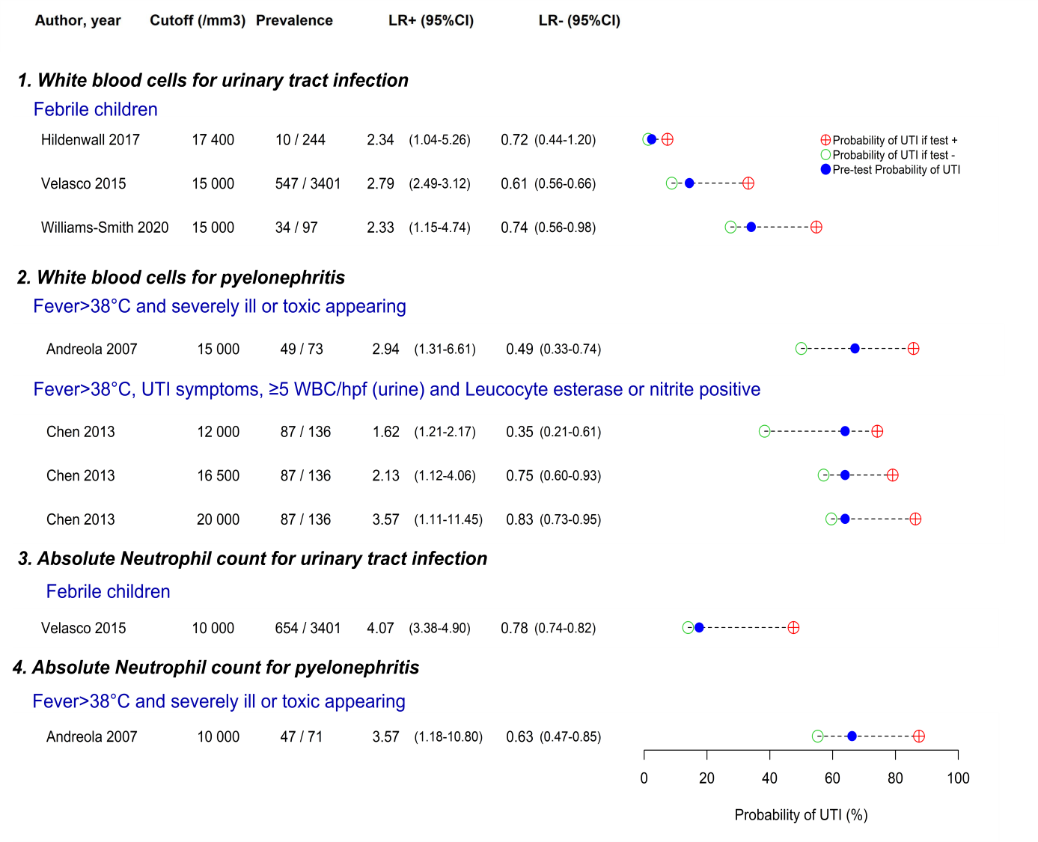
Prevalence= number of children with uncomplicated UTI /sample size (n), LR+ = positive likelihood ratio, LR- = negative likelihood ratio, 95%CI = 95% confidence intervals, UTI= urinary tract infection, + = positive, - = negative, mm³= cubic millimeter
Figure S18 Urine point-of-care tests for cystitis
POCT | VARIABLE | MECHANISM | THRESHOLD | TIME
Uriscreen | Bacteria, RBC, WBC | Catalase activity | >continuous ring of foam formation if any variable present | 2 minutes
Microstix dipslide | Bacteria, nitrite | One nitrite test area (Griess reaction); one gram negative and one gram positive test area (culture media) | >10⁵ cfu/ml on a culture pad  >any degree of pink on nitrite test area | Nitrite: 30 seconds  Bacteria: 18-24 hours
Uricult dipslide | Bacteria | Dipslide test with 3 culture media: E. Coli, CLED and MacConkey media | >10⁴ cfu/ml on CLED medium | 24-48 hours
Filtracheck | Bacteria, WBC | Colorimetric negatively charged filter | Color intensity >1+ (scale 0 to 4+) | 2 minutes
Diaper embedded test device | Leukocyte esterase and/or nitrite | Qualitative reagent strip | Any discoloration | Directly available after urination

POCT= point-of-care test, N= number of studies, RBC= urine red blood cells, WBC= urine white blood cells, E.Coli= Escherichia Coli, CLED= Cystine-lactose-electrolyte-deficient agar, cfu= colony forming units, ml= millilitre
Prevalence= number of children with uncomplicated UTI /sample size (n), LR+ = positive likelihood ratio, LR- = negative likelihood ratio, 95%CI = 95% confidence intervals, UTI= urinary tract infection, + = positive, - = negative

Figure S19 Clinical prediction rules for cystitis
RULE | VARIABLES
A | DUTY score (for nappy pad samples) with urine dipstick test (0 to 14 points (p) )
B | DUTY score (for clean catch samples) with urine dipstick test (0 to 13 points (p) )
C | ANC ≤4090/μl, PCT ≤1.71ng/ml, LE negative, N negative and <5WBC/hpf
D | NICE traffic light (amber or red colour) or dipstick (N positive)
E | NICE traffic light (amber or red colour) or dipstick (LE>trace)
F | NICE traffic light (amber or red colour) or dipstick (N positive or LE>trace)
G | NICE traffic light (amber or red colour) or dipstick (N positive and LE>trace)
H | UTIcalc with dipstick (LE>1+ or nitrite positive)
I | UTIcalc with dipstick (LE>1+ or nitrite positive) or gram stain (>any bacteria)
J | UTIcalc with dipstick (LE>1+ or nitrite positive) or urine white blood cell count (>10/µl)
K | UTIcalc with dipstick (LE>1+ or nitrite positive) or urine white blood cell count (>10/µl) or gram stain (>any bacteria)

Prevalence= number of children with uncomplicated UTI /sample size (n), LR+ = positive likelihood ratio, LR- = negative likelihood ratio, 95%CI = 95% confidence intervals, UTI= urinary tract infection, p= points, NCC= nested case control study, Prosp= prospective study, Retrosp= retrospective study, der= derivation study, val= validation study, y= year, NICE= National Institute for Health and Care Excellence, + = positive, - = negative, μl = microliter, ml= milliliter, ng= nano gram, LE= leucocyte esterase, N= nitrite, ANC= absolute neutrophil count, PCT= procalcitonin, WBC= white blood cell

Figure S20 Urine biomarkers for pyelonephritis (data from Shaikh et al. 2019b⁵⁰)
Prevalence= number of children with uncomplicated UTI /sample size (n), LR+ = positive likelihood ratio, LR- = negative likelihood ratio, 95%CI = 95% confidence intervals, UTI= urinary tract infection, NR= not reported, NGAL= Neutrophil Gelatinase Associated Lipocalin, IL= Interleukin, IFN=interferon, CXCL=chemokine, HGF= Hepatocyte growth factor, CCL= urinary Chemokine (C-C Motif) Ligand

Figure S21 Biomarkers for urinary tract infection with associated bacteraemia
Prevalence= number of children with uncomplicated UTI /sample size (n), LR+ = positive likelihood ratio, LR- = negative likelihood ratio, 95%CI = 95% confidence intervals, UTI= urinary tract infection, Model* = Not well appearing, <21d, C-reactive protein>20mg/l, PCT>0.5ng/ml (positive if one or more variables present), + = positive, - = negative, WBCu= urine white blood cells, hpf= high power field, LE = leucocyte esterase, PCT= procalcitonin

