Additional file 6. (Figures S22-23). Risk of bias and applicability assessment
Figure S22 Risk of bias and applicability concerns about each domain for each included study
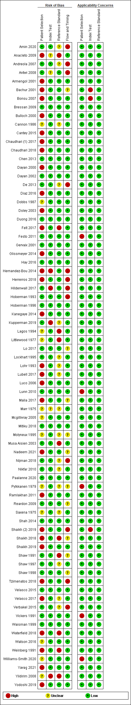
Risk of bias and applicability concerns summary: review authors' judgements about each domain for each included study; assessed by using the QUADAS-2 = Quality assessment of diagnostic accuracy studies

Figure S23 Risk of bias and applicability concerns as percentages across included studies
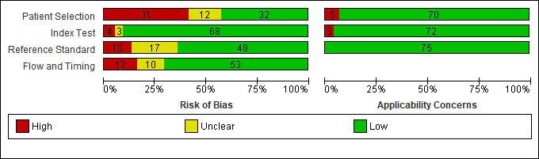
Risk of bias and applicability concerns graph: review authors' judgements about each domain presented as percentages across included studies; assessed by using the QUADAS-2 = Quality assessment of diagnostic accuracy studies

