Supplementary Material

Supplementary Figures

Supplementary Figure 1. The figure legends are required to have the same font as the main text, 12 point normal Times New Roman, single spaced. Please use a single paragraph for each legend and prepare the figures keeping in mind the PDF layout.
Supplementary Appendix – Electronic searches
- Medline and Embase
#1 "physical activity" [Title/Abstract]
#2 "physical therapy" [Title/Abstract]
#3 "resistance training" [Title/Abstract]
#4 “aerobic exercise” [Title/Abstract]
#5 "exercis*" [Title/Abstract]
#6 "train*"[Title/Abstract]
#7 #1 OR #2 OR #3 OR #4 OR #5 OR #6
#8 "sarcopenia" [Title/Abstract]
#9 "muscular atrophy" [Title/Abstract]
#10 "muscular weight" [Title/Abstract]
#11"grip strength" [Title/Abstract]
#12 "physical function" [Title/Abstract]
#13 #8 OR #9 OR #10 OR #11 OR #12
#14 "randomized controlled trials"[Title/Abstract]
#15 "clinical trial" [Title/Abstract]
#16 "random allocation" [Title/Abstract]
#17 #14 OR #16 OR #16
#18 "older adults" [Title/Abstract]
#19 "aged" [Title/Abstract]
#20 "elder*" [Title/Abstract]
#21 #18 OR #19 OR #20
#22 #7 AND #13 AND #21

- Cochrane library

#1 exercis*:ti,ab,kw, JOR “training”: ti,ab,kw, OR “physical activity”:ti,ab,kw, OR physical therapy: ti,ab,kw, OR walk*: ti,ab,kw OR aerobic program:ti,ab,kw, OR strength program: ti,ab,kw, OR resistance program: ti,ab,kw
#2 sarcopenia:ti,ab,kw, or “muscular mass”: ti,ab,kw, “muscle atrophy”:ti,ab,kw
#3 older adult*:ti,ab,kw OR aged:ti,ab,kw OR elder*:ti,ab,kw
#4 randomized controlled trial:ti,ab,kw OR random allocation :ti,ab,kw OR controlled trial:ti,ab,kw
#5 #1 AND #2 AND #3 AND #4

- SportDiscus and CLNAHL

#1 exercis*:ti,ab,kw, JOR “training”: ti,ab,kw, OR “physical activity”:ti,ab,kw, OR physical therapy: ti,ab,kw, OR walk*: ti,ab,kw OR aerobic program:ti,ab,kw, OR strength program: ti,ab,kw, OR resistance program: ti,ab,kw

#2 sarcopenia:ti,ab,kw, or “muscular mass”: ti,ab,kw, “muscle atrophy”:ti,ab,kw
#3 older adult*:ti,ab,kw OR aged:ti,ab,kw OR elder*:ti,ab,kw
#4 randomized controlled trial:ti,ab,kw OR random allocation :ti,ab,kw OR controlled trial:ti,ab,kw
#5 #1 AND #2 AND #3 AND #4

- SCOPUS
#1 TITLE-ABS-KEY ("physical activity" OR "physical therapy" OR "aerobic program" OR "strength program" OR "exercis*" OR "train*" OR "resistance training" OR "aerobic training")
#2 TITLE-ABS-KEY ("sarcopenia" OR "muscular atrophy" OR "muscular weight" OR "muscle mass")
#3 TITLE-ABS-KEY ("older adults" OR "aged" OR "elder*")
#4 TITLE-ABS-KEY ("randomized controlled trials" OR "clinical trial" OR "random allocation")
#5 #1 AND #2 AND #3 AND #4

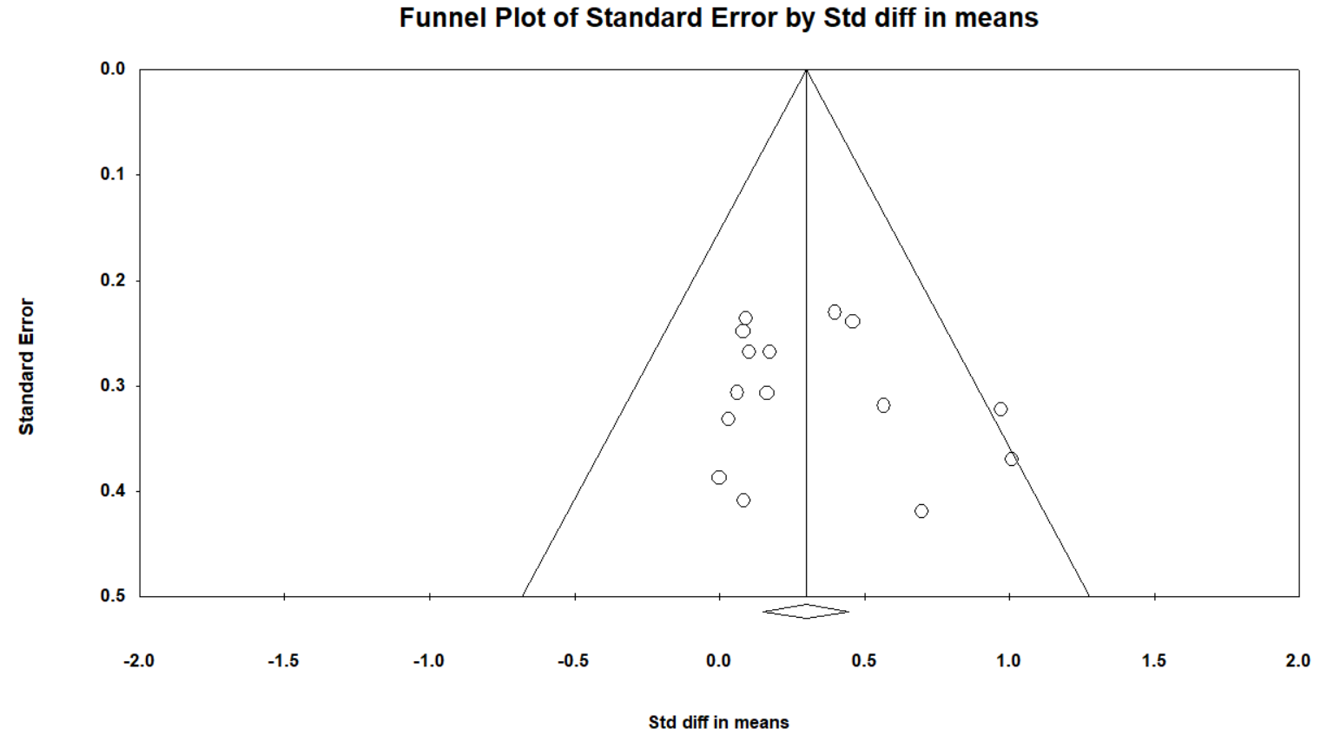

Supplementary Figure 1. Funnel plot estimating publication bias for Grip strength. Visual inspection indicates symmetrical distribution, and the Begg’s test was not statistically significant, suggesting an absence of publication bias (p=0.20).

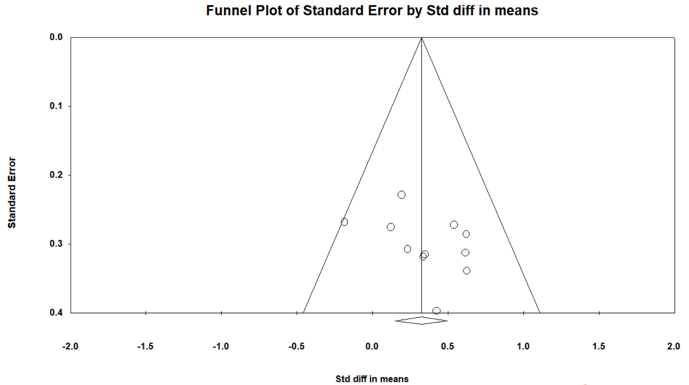
Supplementary Figure 2. Funnel plot estimating publication bias for Knee extension strength. Visual inspection indicates symmetrical distribution, and the Begg’s test was not statistically significant, suggesting an absence of publication bias (p=0.21).

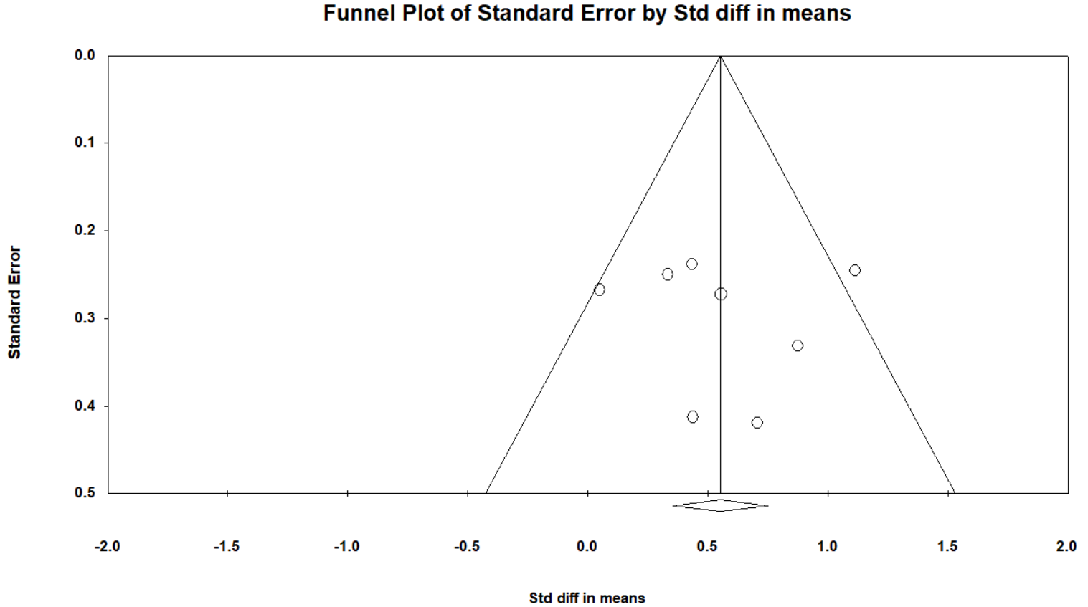
Supplementary Figure 3. Funnel plot estimating publication bias for Chair and stand test. Visual inspection indicates symmetrical distribution, and the Begg’s test was not statistically significant, suggesting an absence of publication bias (p=0.71).

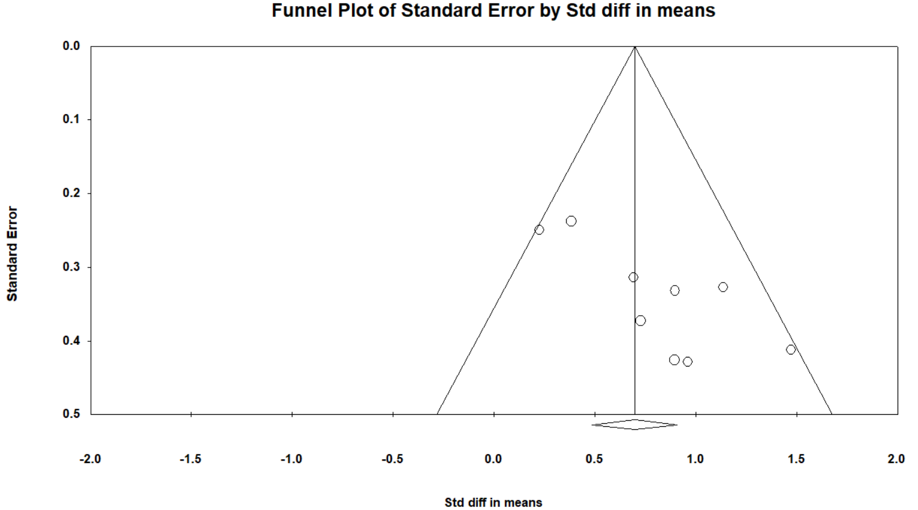
Supplementary Figure 4. Funnel plot estimating publication bias for Timed up and go. Visual inspection indicates symmetrical distribution, and the Begg’s test was not statistically significant, suggesting an absence of publication bias (p=0.12).

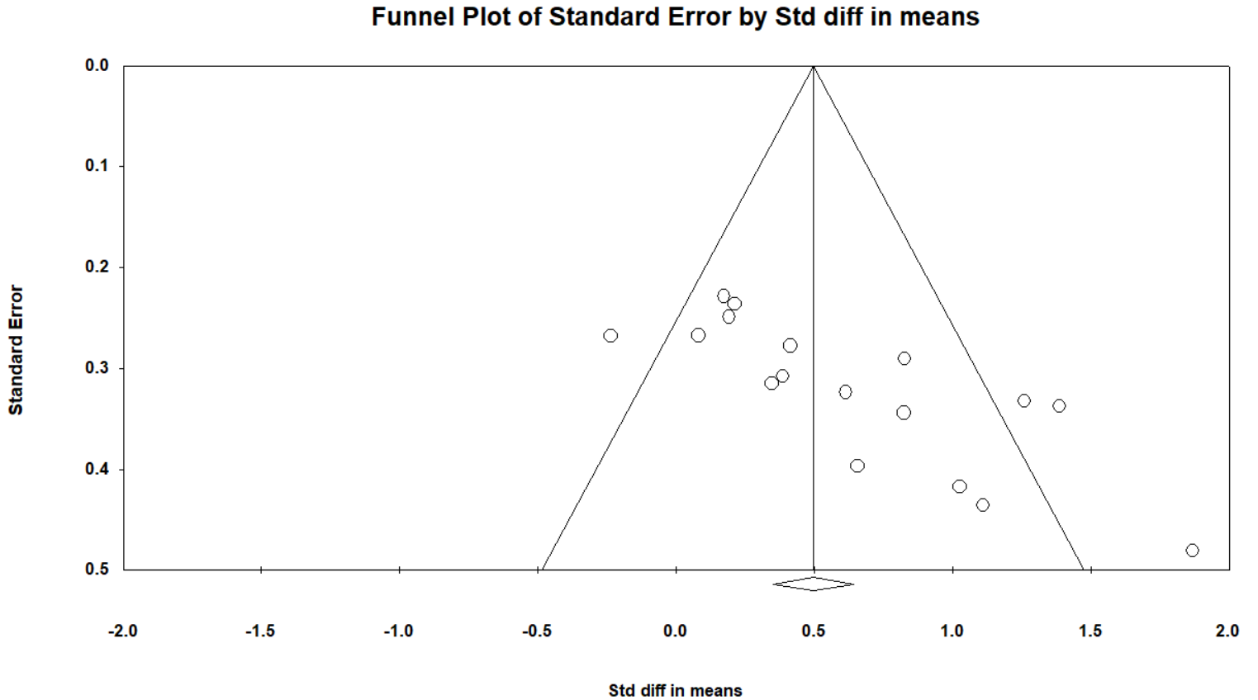
Supplementary Figure 5. Funnel plot estimating publication bias for Gait speed. Visual inspection indicates unsymmetrical distribution, and the Begg’s test was not statistically significant, suggesting a presence of publication bias (p<0.05).

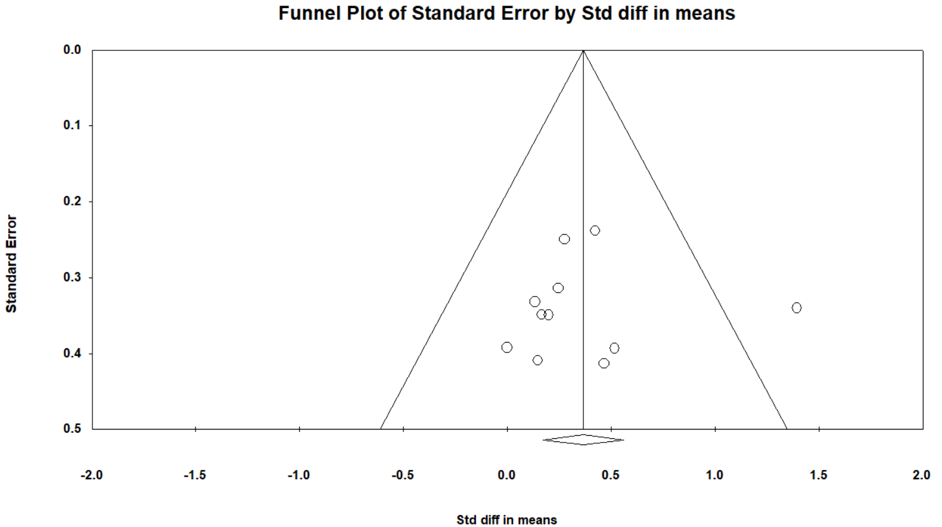

Supplementary Figure 6. Funnel plot estimating publication bias for Skeletal muscle index. Visual inspection indicates unsymmetrical distribution, and the Begg’s test was not statistically significant, suggesting an absence of publication bias (p=0.64).

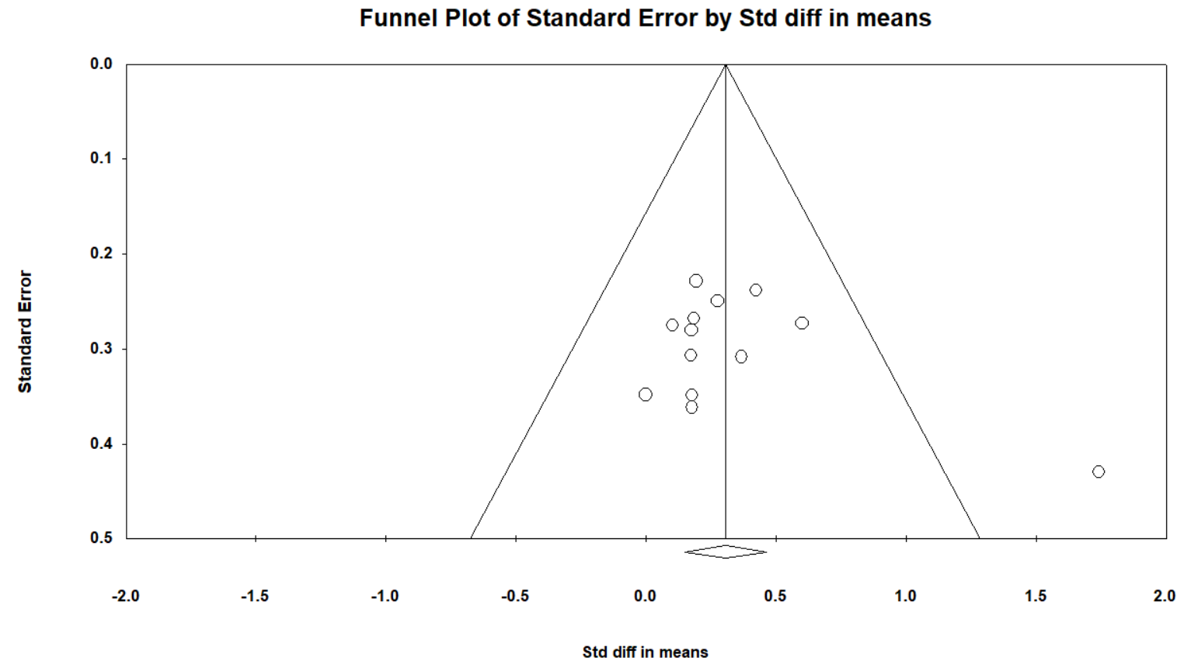
Supplementary Figure 7. Funnel plot estimating publication bias for appendicular muscle mass. Visual inspection indicates unsymmetrical distribution, and the Begg’s test was not statistically significant, suggesting an absence of publication bias (p=0.58).

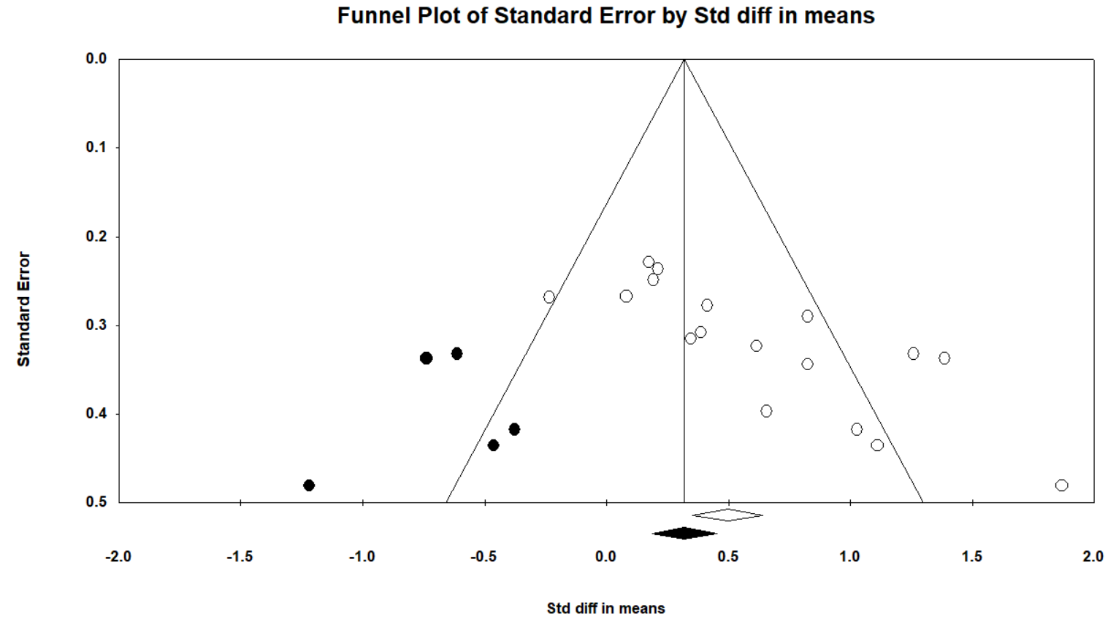
Supplementary Figure 8. Funnel plot for gait speed using trim and fill. The gait speed is SMD=0.35, 95%CI [0.08, 0.61].

