Supplementary Information
Title: Sulforaphane ameliorates lipid profile in rodents: An updated systematic review and meta-analysis
Author list: Kaili Du¹, Yuxin Fan¹ and Dan Li^{1, #}
¹Collaborative Innovation Center of Yangtze River Delta Region Green Pharmaceuticals, College of Pharmaceutical Sciences, Zhejiang University of Technology, Hangzhou, China.
# Correspondence: D. L. (Email: lidan@zjut.edu.cn)

Supplementary Table S1. Publication bias examined by Egger’s linear regression test.
 | BW | LW | TC | LDL-C | HDL-C | TG
Egger's test | 0.201 | 0.386 | 0.055 | 0.515 | 0.836 | 0.230

Supplementary Figure S1. A. Funnel plots for body weight analysis. B. Funnel plots for liver weight analysis. C. Funnel plots for serum total cholesterol analysis. D. Funnel plots for serum low-density lipoprotein cholesterol analysis. E. Funnel plots for serum high-density lipoprotein cholesterol analysis. F. Funnel plots for serum triglyceride analysis.

A
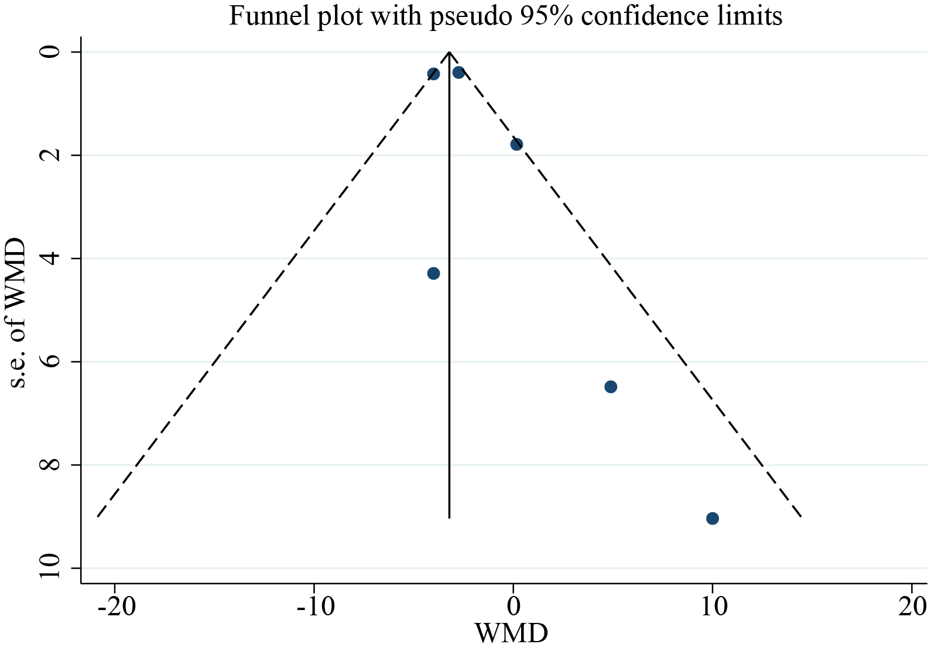
B
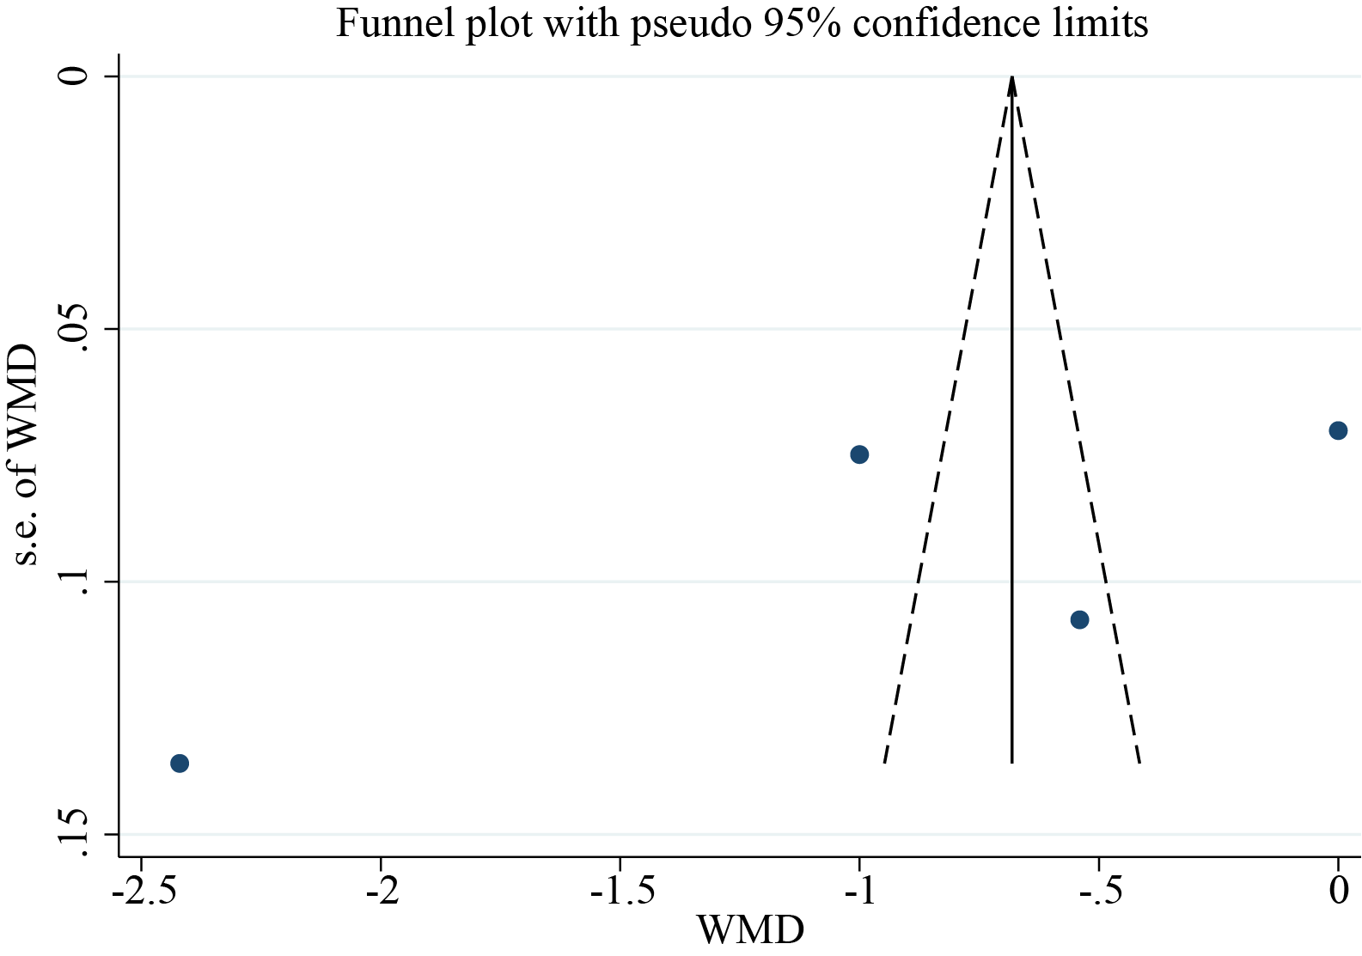
C
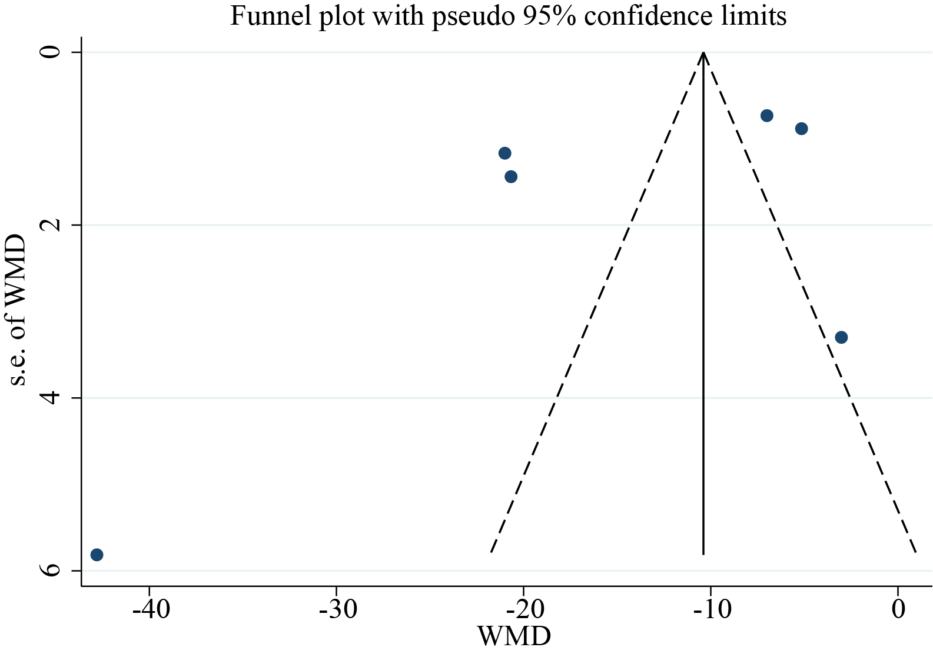
D
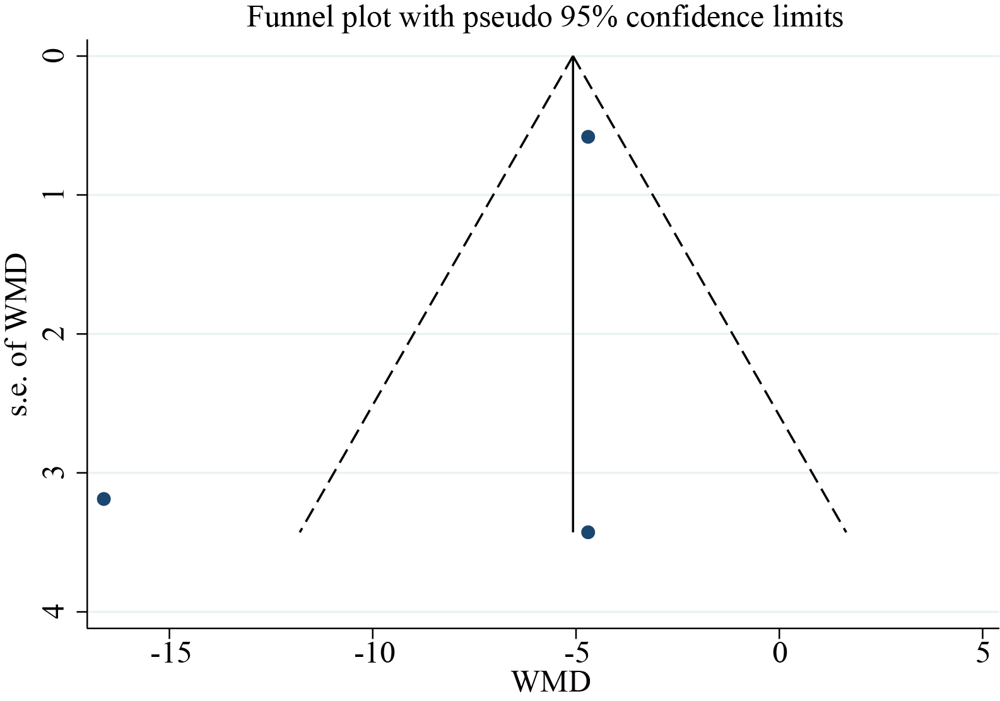
E
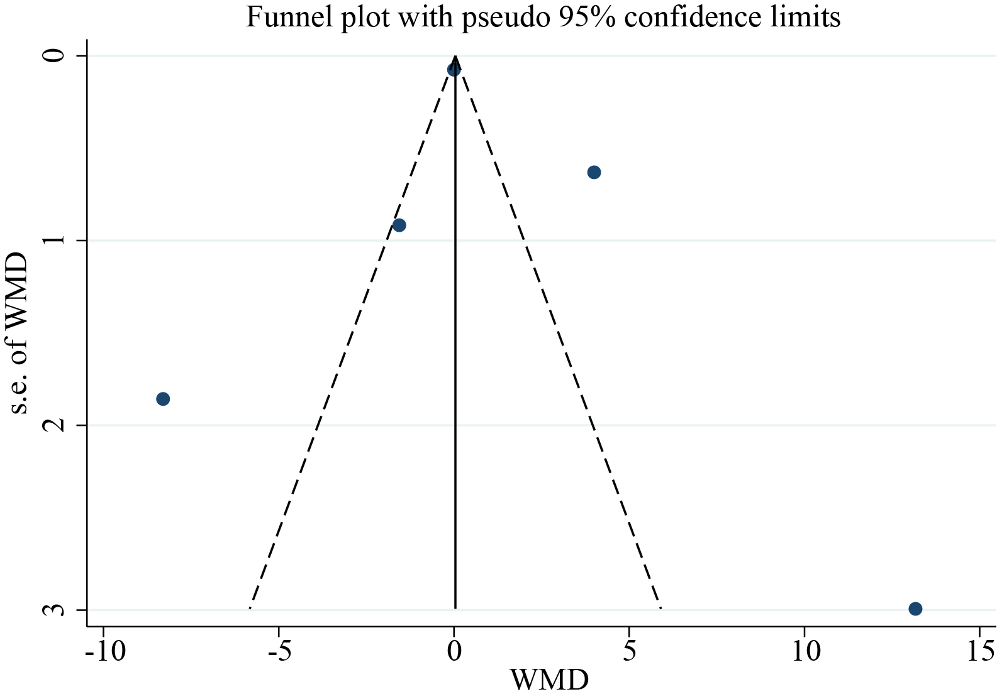
F
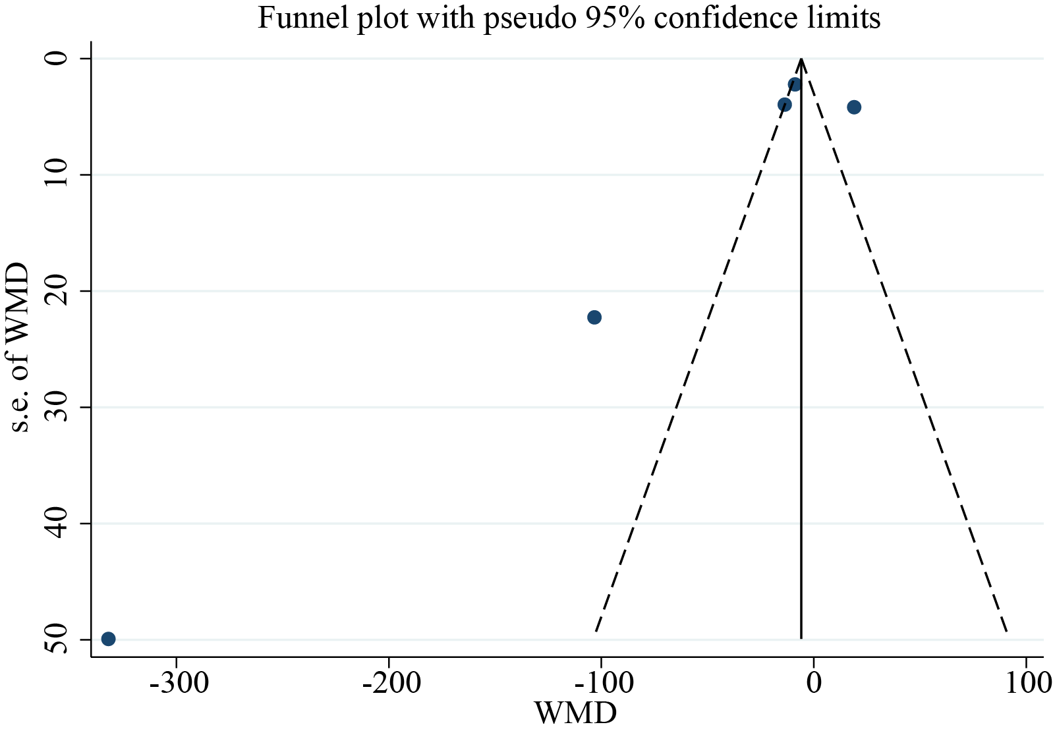

Supplementary Figure S2. A. Sensitivity analysis for the association between SFN supplement and body weight. B. Sensitivity analysis for the association between SFN supplement and liver weight. C. Sensitivity analysis for the association between SFN supplement and serum total cholesterol. D. Sensitivity analysis for the association between SFN supplement and serum low-density lipoprotein cholesterol levels. E. Sensitivity analysis for the association between SFN supplement and serum high-density lipoprotein cholesterol levels. F. Sensitivity analysis for the association between SFN supplement and serum triglyceride.

A
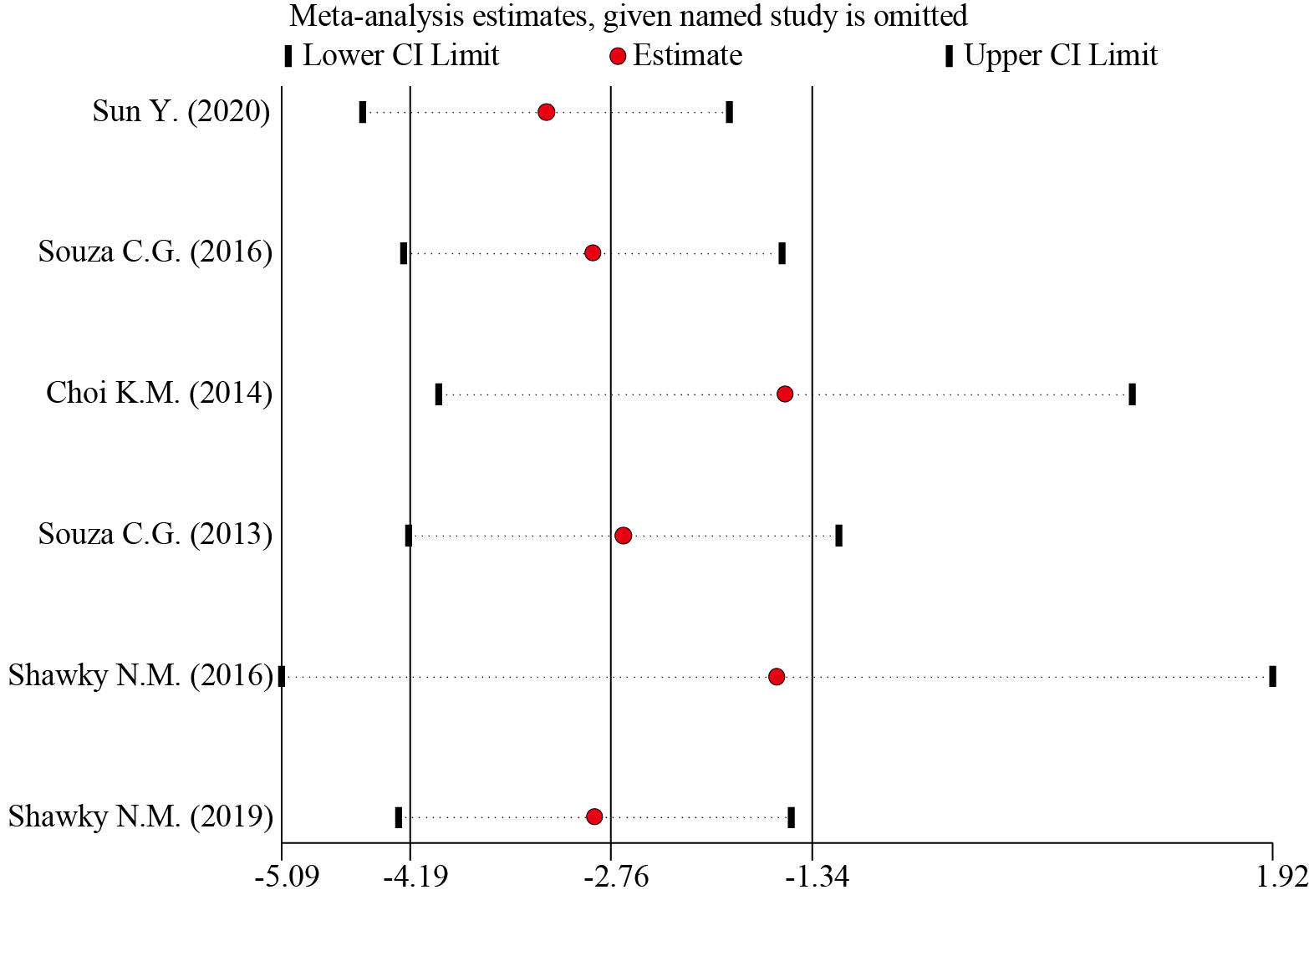
B
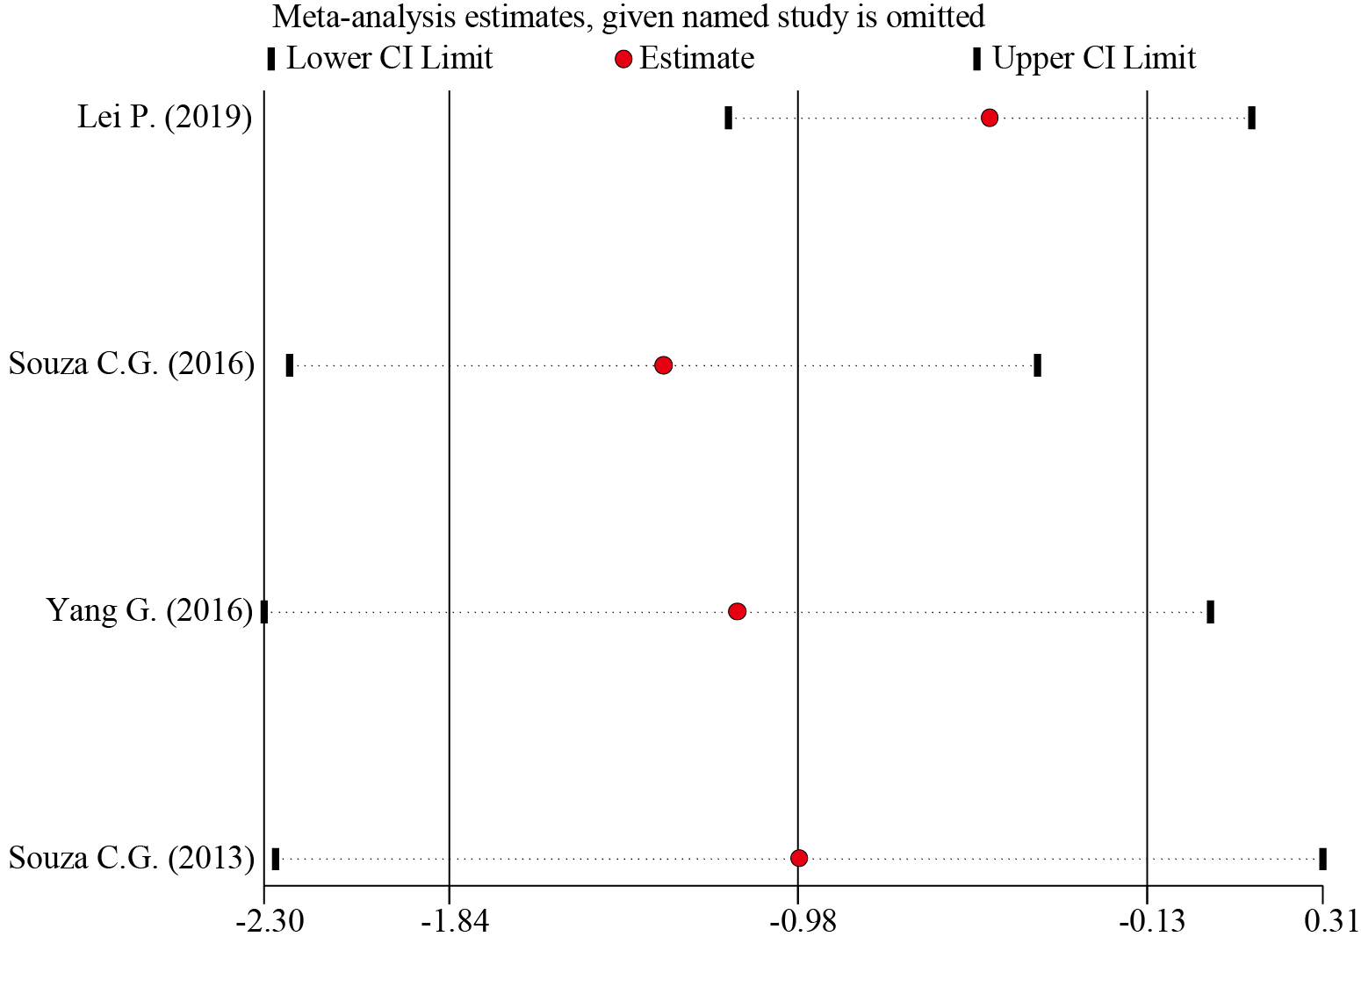
C
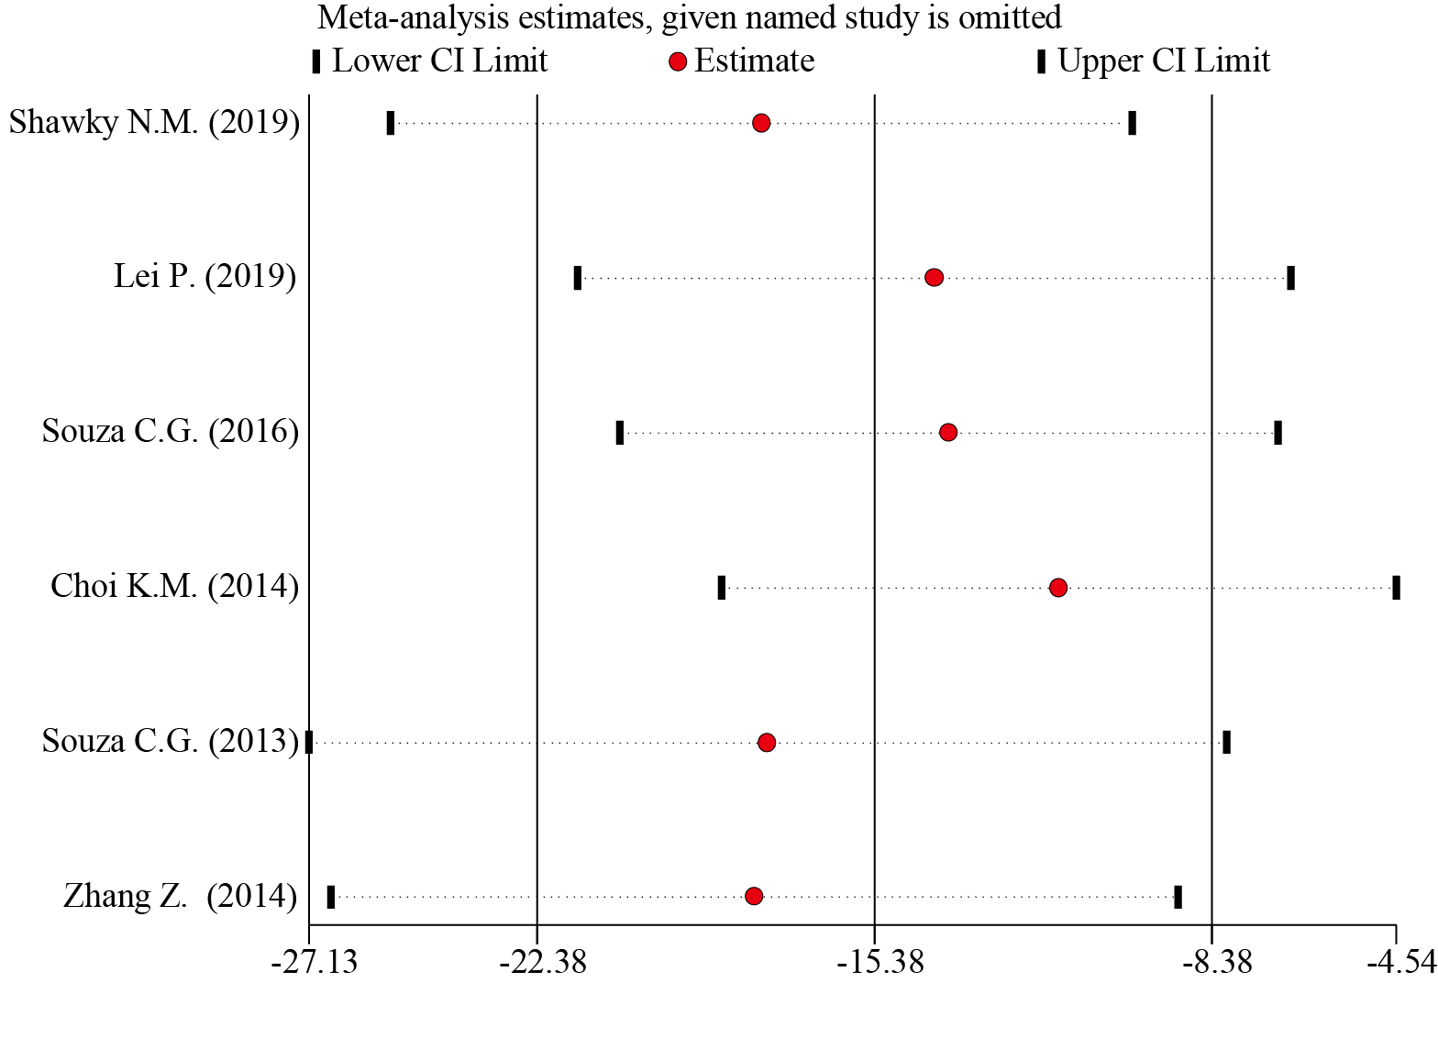
D
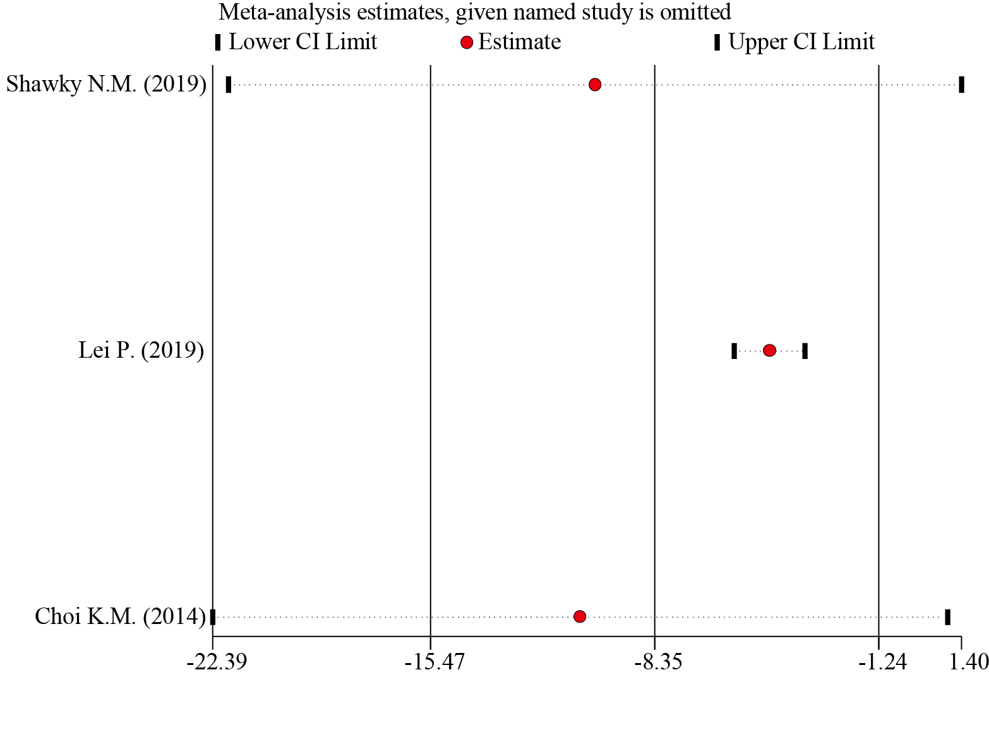
E
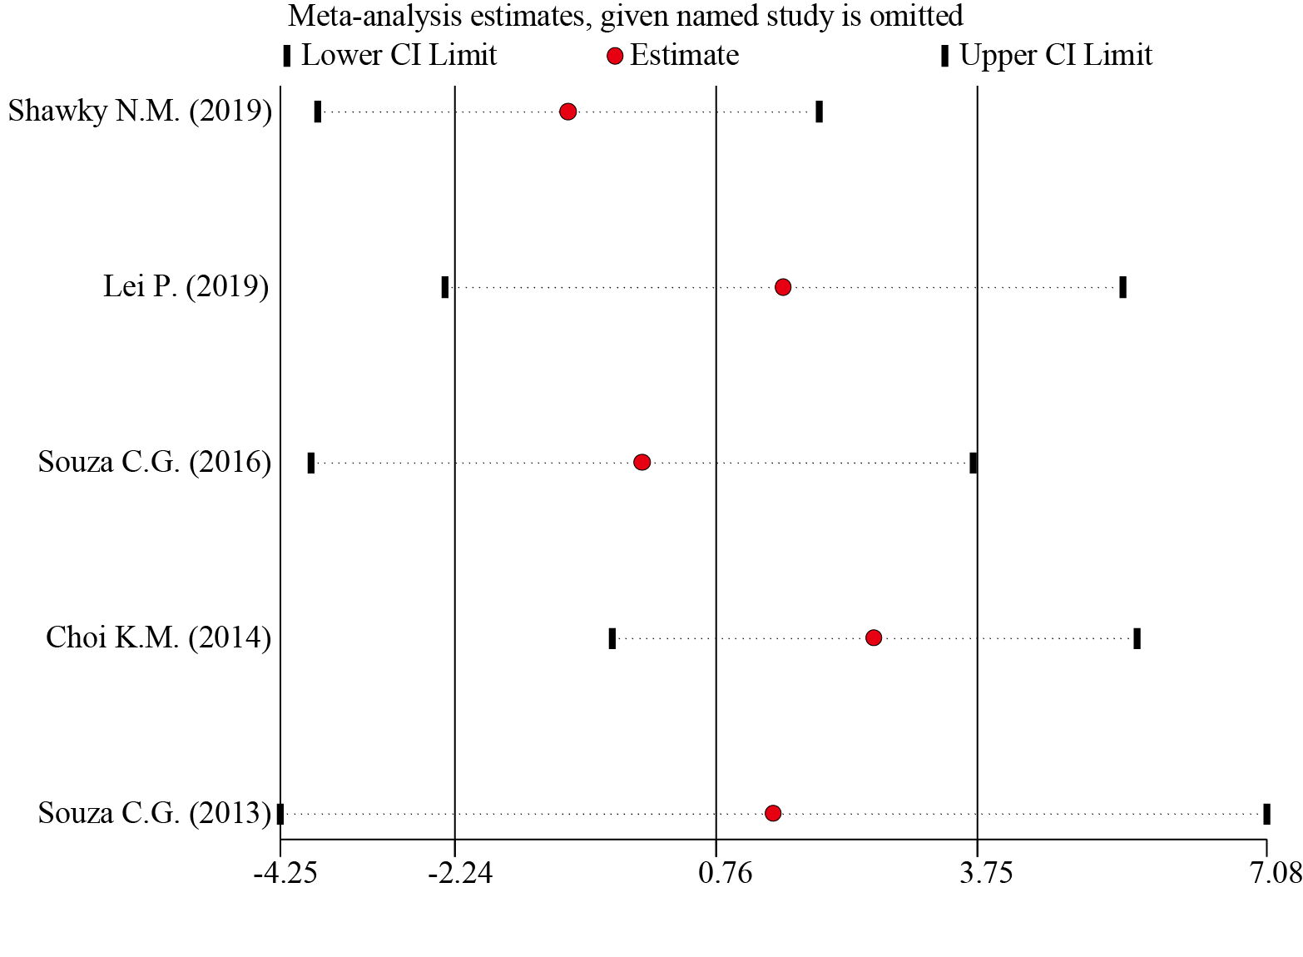
F


