a)
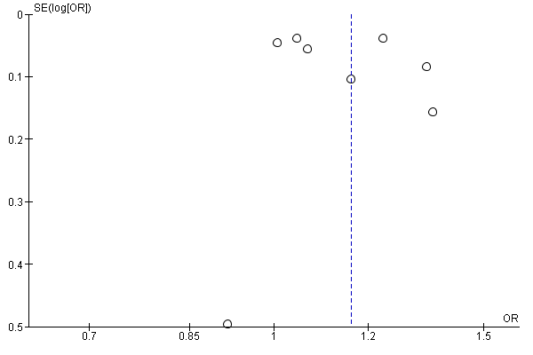
b)
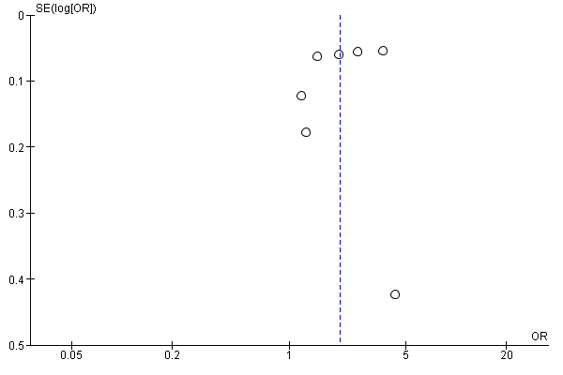

c)
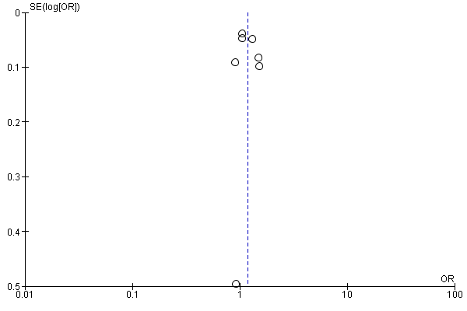
d)
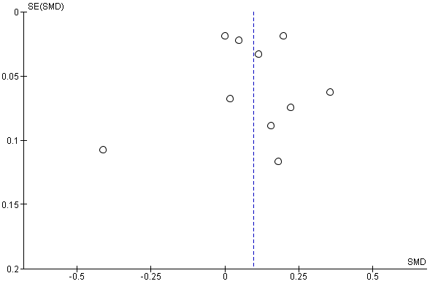
e)
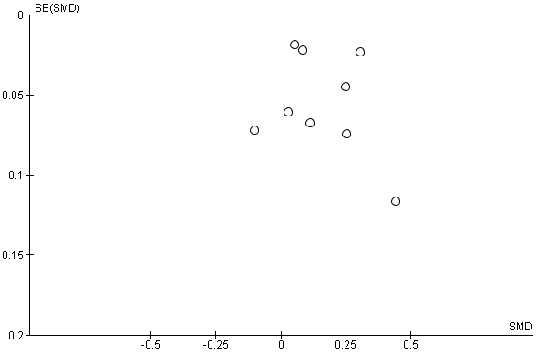
f)
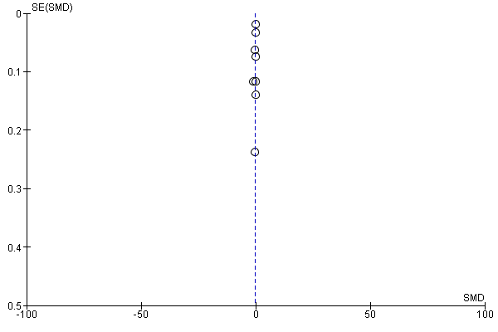
Supplementary file 4. Funnel lot for assessment of publication bias, famine exposure in early life and (a) overweight (b) general obesity (c) abdominal obesity (d) BMI (e) waist circumference (f) height in adults, 2021.

