eTable 1. Search strategy

Medline (via PubMed)
- "COVID-19"[Mesh]
- "SARS-CoV-2"[Mesh]
- "COVID-19"[Title/Abstract]
- "SARS-COV-2"[Title/Abstract]
- "SARS COV 2"[Title/Abstract]
- "Novel coronavirus"[Title/Abstract]
- "2019-novel coronavirus"[Title/Abstract]
- "2019-novel coronavirus"[Title/Abstract]
- "Coronavirus disease-19"[Title/Abstract]
- "Coronavirus disease 19"[Title/Abstract]
- "Coronavirus disease 2019"[Title/Abstract]
- "COVID 19"[Title/Abstract]
- "Novel CoV"[Title/Abstract]
- "2019-nCoV"[Title/Abstract]
- "2019 nCoV"[Title/Abstract]
- "2019-CoV"[Title/Abstract]
- OR/#1-#16
- "Anti-Inflammatory Agents, Non-Steroidal"[Mesh]
- "Aspirin"[Mesh]
- "Aspirin"[Title/Abstract]
- "NSAID*"[Title/Abstract]
- "Nonsteroidal Anti-Inflammatory"[Title/Abstract]
- "Nonsteroidal Anti Inflammatory"[Title/Abstract]
- "Nonsteroidal Antiinflammatory"[Title/Abstract]
- "Non-Steroidal Anti-Inflammatory"[Title/Abstract]
- "Non Steroidal Anti Inflammatory"[Title/Abstract]
- "Anti-Inflammatory Analgesics"[Title/Abstract]
- "Aspirin-Like Agents"[Title/Abstract]
- "Aspirin Like Agents"[Title/Abstract]
- "Aspirin-Like Agent"[Title/Abstract]
- "Aspirin Like Agent"[Title/Abstract]
- "Antipyretics"[Mesh]
- "Antipyretic"[Title/Abstract]
- "Antifebrile Agents"[Title/Abstract]
- "Antipyretic Agents"[Title/Abstract]
- "Antipyretic Effect"[Title/Abstract]
- "Antipyretic Effects"[Title/Abstract]
- "alpha-Methyl-4-(2-methylpropyl)benzeneacetic Acid"[Title/Abstract]
- "Ibuprofen"[Mesh]
- "Ibumetin"[Title/Abstract]
- "Ibuprofen*"[Title/Abstract]
- "Motrin"[Title/Abstract]
- "Nuprin"[Title/Abstract]
- "Rufen"[Title/Abstract]
- "Salprofen"[Title/Abstract]
- "Trauma-Dolgit Gel"[Title/Abstract]
- "Trauma Dolgit Gel"[Title/Abstract]
- "Brufen"[Title/Abstract]
- "Acetaminophen"[Mesh]
- "Acetaminophen"[Title/Abstract]
- "Acetominophen"[Title/Abstract]
- "Hydroxyacetanilide"[Title/Abstract]
- "APAP"[Title/Abstract]
- "p-Acetamidophenol"[Title/Abstract]
- "p-Hydroxyacetanilide"[Title/Abstract]
- "Paracetamol"[Title/Abstract]
- "N-(4-Hydroxyphenyl)acetanilide"[Title/Abstract]
- "Acetamidophenol"[Title/Abstract]
- "N-Acetyl-p-aminophenol"[Title/Abstract]
- "Acephen"[Title/Abstract]
- "Acetaco"[Title/Abstract]
- "Tylenol"[Title/Abstract]
- "Anacin-3"[Title/Abstract]
- "Anacin 3"[Title/Abstract]
- "Anacin3"[Title/Abstract]
- "Datril"[Title/Abstract]
- "Panadol"[Title/Abstract]
- "Acamol"[Title/Abstract]
- "Algotropyl"[Title/Abstract]
- OR/#18-#69
- #17 AND #70 Filters: Humans

The Cochrane Library
- MeSH descriptor[COVID-19]explode all trees
- MeSH descriptor[SARS-CoV-2]explode all trees
- "COVID-19":ab,ti
- "SARS-COV-2":ab,ti
- "SARS COV 2":ab,ti
- "Novel coronavirus":ab,ti
- "2019-novel coronavirus":ab,ti
- "2019-novel coronavirus":ab,ti
- "Coronavirus disease-19":ab,ti
- "Coronavirus disease 19":ab,ti
- "Coronavirus disease 2019":ab,ti
- "COVID 19":ab,ti
- "Novel CoV":ab,ti
- "2019-nCoV":ab,ti
- "2019 nCoV":ab,ti
- "2019-CoV":ab,ti
- OR/#1-#16
- MeSH descriptor[Anti-Inflammatory Agents, Non-Steroidal]explode all trees
- MeSH descriptor[Aspirin]explode all trees
- "Aspirin":ab,ti
- "NSAID*":ab,ti
- "Nonsteroidal Anti-Inflammatory":ab,ti
- "Nonsteroidal Anti Inflammatory":ab,ti
- "Nonsteroidal Antiinflammatory":ab,ti
- "Non-Steroidal Anti-Inflammatory":ab,ti
- "Non Steroidal Anti Inflammatory":ab,ti
- "Anti-Inflammatory Analgesics":ab,ti
- "Aspirin-Like Agents":ab,ti
- "Aspirin Like Agents":ab,ti
- Aspirin-Like Agent":ab,ti
- Aspirin Like Agent":ab,ti
- MeSH descriptor[Antipyretics]explode all trees
- "Antipyretic":ab,ti
- "Antifebrile Agents":ab,ti
- "Antipyretic Agents":ab,ti
- "Antipyretic Effect":ab,ti
- "Antipyretic Effects":ab,ti
- "alpha-Methyl-4-(2-methylpropyl) benzeneacetic Acid":ab,ti
- MeSH descriptor [Ibuprofen]explode all trees
- "Ibumetin":ab,ti
- "Ibuprofen*":ab,ti
- "Motrin":ab,ti
- "Nuprin":ab,ti
- "Rufen":ab,ti
- "Salprofen":ab,ti
- "Trauma-Dolgit Gel":ab,ti
- "Trauma Dolgit Gel":ab,ti
- "Brufen":ab,ti
- MeSH descriptor [Acetaminophen]explode all trees
- "Acetaminophen":ab,ti
- "Acetominophen":ab,ti
- "Hydroxyacetanilide":ab,ti
- "APAP":ab,ti
- "p-Acetamidophenol":ab,ti
- "p-Hydroxyacetanilide":ab,ti
- "Paracetamol":ab,ti
- "N-(4-Hydroxyphenyl) acetanilide":ab,ti
- "Acetamidophenol":ab,ti
- "N-Acetyl-p-aminophenol":ab,ti
- "Acephen":ab,ti
- "Acetaco":ab,ti
- "Tylenol":ab,ti
- "Anacin-3":ab,ti
- "Anacin 3":ab,ti
- "Anacin3":ab,ti
- "Datril":ab,ti
- "Panadol":ab,ti
- "Acamol":ab,ti
- "Algotropyl":ab,ti
- OR/#18-#69
- #17 AND #70

WHO COVID-19 Database
- "NSAID*"[Title/Abstract]
- "Nonsteroidal Anti-Inflammatory"[Title/Abstract]
- "Nonsteroidal Anti Inflammatory"[Title/Abstract]
- "Nonsteroidal Antiinflammatory"[Title/Abstract]
- "Non-Steroidal Anti-Inflammatory"[Title/Abstract]
- "Non Steroidal Anti Inflammatory"[Title/Abstract]
- "Anti-Inflammatory Analgesics"[Title/Abstract]
- "Aspirin-Like Agents"[Title/Abstract]
- "Aspirin Like Agents"[Title/Abstract]
- Aspirin-Like Agent"[Title/Abstract]
- Aspirin Like Agent"[Title/Abstract]
- "Antipyretic"[Title/Abstract]
- "Antifebrile Agents"[Title/Abstract]
- "Antipyretic Agents"[Title/Abstract]
- "Antipyretic Effect"[Title/Abstract]
- "Antipyretic Effects"[Title/Abstract]
- "alpha-Methyl-4-(2-methylpropyl) benzeneacetic Acid"[Title/Abstract]
- "Ibumetin"[Title/Abstract]
- "Ibuprofen*"[Title/Abstract]
- "Motrin"[Title/Abstract]
- "Nuprin"[Title/Abstract]
- "Rufen"[Title/Abstract]
- "Salprofen"[Title/Abstract]
- "Trauma-Dolgit Gel"[Title/Abstract]
- "Trauma Dolgit Gel"[Title/Abstract]
- "Brufen"[Title/Abstract]
- "Acetaminophen"[Title/Abstract]
- "Acetominophen"[Title/Abstract]
- "Hydroxyacetanilide"[Title/Abstract]
- "APAP"[Title/Abstract]
- "p-Acetamidophenol"[Title/Abstract]
- "p-Hydroxyacetanilide"[Title/Abstract]
- "Paracetamol"[Title/Abstract]
- "N-(4-Hydroxyphenyl) acetanilide"[Title/Abstract]
- "Acetamidophenol"[Title/Abstract]
- "N-Acetyl-p-aminophenol"[Title/Abstract]
- "Acephen"[Title/Abstract]
- "Acetaco"[Title/Abstract]
- "Tylenol"[Title/Abstract]
- "Anacin-3"[Title/Abstract]
- "Anacin 3"[Title/Abstract]
- "Anacin3"[Title/Abstract]
- "Datril"[Title/Abstract]
- "Panadol"[Title/Abstract]
- "Acamol"[Title/Abstract]
- "Algotropyl"[Title/Abstract]
- "Aspirin"[Title/Abstract]
- OR/#1-#47

Web of science (WOS)
- 主题: (COVID-19)
- 主题: ("SARS-COV-2")
- 主题: ("SARS COV 2")
- 主题: ("Novel coronavirus")
- 主题: ("2019-novel coronavirus")
- 主题: ("2019-novel coronavirus")
- 主题: ("Coronavirus disease-19")
- 主题: ("Coronavirus disease 19")
- 主题: ("Coronavirus disease 2019")
- 主题: ("COVID 19")
- 主题: ("Novel CoV")
- 主题: ("2019-nCoV")
- 主题: ("2019 nCoV")
- 主题: ("2019-CoV")
- OR/#1-#14
- 主题: (NSAID*)
- 主题: ("Nonsteroidal Anti-Inflammatory")
- 主题: ("Nonsteroidal Anti Inflammatory")
- 主题: ("Nonsteroidal Antiinflammatory")
- 主题: ("Non-Steroidal Anti-Inflammatory")
- 主题: ("Non Steroidal Anti Inflammatory")
- 主题: ("Aspirin")
- 主题: ("Anti-Inflammatory Analgesics")
- 主题: ("Aspirin-Like Agents")
- 主题: ("Aspirin Like Agents")
- 主题: ("Aspirin-Like Agent")
- 主题: ("Aspirin Like Agent")
- 主题: (Antipyretic)
- 主题: ("Antifebrile Agents")
- 主题: ("Antipyretic Agents")
- 主题: ("Antipyretic Effect")
- 主题: ("Antipyretic Effects")
- 主题: ("alpha-Methyl-4-(2-methylpropyl) benzeneacetic Acid")
- 主题: ("Ibumetin")
- 主题: ("Ibuprofen*")
- 主题: ("Motrin")
- 主题: (Nuprin)
- 主题: (Rufen)
- 主题: (Salprofen)
- 主题: ("Trauma-Dolgit Gel")
- 主题: ("Trauma Dolgit Gel")
- 主题: (Brufen)
- 主题: ("Acetaminophen")
- 主题: ("Acetominophen")
- 主题: ("Hydroxyacetanilide")
- 主题: ("APAP")
- 主题: ("p-Acetamidophenol")
- 主题: ("p-Hydroxyacetanilide")
- 主题: ("Paracetamol")
- 主题: ("N-(4-Hydroxyphenyl) acetanilide")
- 主题: ("N-Acetyl-p-aminophenol")
- 主题: ("N-Acetyl-p-aminophenol")
- 主题: (Acephen)
- 主题: (Acetaco)
- 主题: ("Tylenol")
- 主题: ("Anacin-3")
- 主题: ("Anacin 3")
- 主题: ("Anacin3")
- 主题: ("Datril")
- 主题: (Panadol)
- 主题: (Acamol)
- 主题: (Algotropyl)
- OR/#16-#60
- #15 AND #61

China Biology Medicine disc (CBM)
- "新冠肺炎"[常用字段:智能]
- "新型冠状病毒"[常用字段:智能]
- "COVID-19"[常用字段:智能]
- "COVID19"[常用字段:智能]
- "2019-nCoV"[常用字段:智能]
- "2019nCoV"[常用字段:智能]
- "2019-CoV"[常用字段:智能]
- "“2019 CoV"[常用字段:智能]
- "SARS-CoV-2"[常用字段:智能]
- “SARS COV 2"[常用字段:智能]
- OR/#1-#10
- “消炎药, 非甾类”[不加权:扩展]
- "布洛芬"[不加权:扩展]
- "醋氨酚"[不加权:扩展]
- "阿司匹林"[不加权:扩展]
- "阿司匹林"[常用字段:智能]
- "非甾体抗炎药"[常用字段:智能]
- "非甾体消炎镇痛药"[常用字段:智能]
- "解热镇痛药"[常用字段:智能]
- "退烧药"[常用字段:智能]
- "退热药"[常用字段:智能]
- "布洛芬"[常用字段:智能]
- "芬必得"[常用字段:智能]
- "美林"[常用字段:智能]
- "乙酰氨基酚"[常用字段:智能]
- "扑热息痛"[常用字段:智能]
- "泰诺林"[常用字段:智能]
- "必理通"[常用字段:智能]
- "百服宁"[常用字段:智能]
- OR/#12-#29
- #11 AND #30

China National Knowledge Infrastructure (CNKI)
- "新冠肺炎"(主题)
- "新型冠状病毒"(主题)
- "COVID-19"(主题)
- "COVID19"(主题)
- "2019-nCoV"(主题)
- "2019nCoV"(主题)
- "2019-CoV"(主题)
- "“2019 CoV"(主题)
- "SARS-CoV-2"(主题)
- "SARS COV 2"(主题)
- OR/#1-#10
- "消炎药, 非甾类"(主题)
- "醋氨酚"(主题)
- "阿司匹林"(主题)
- "非甾体抗炎药"(主题)
- "非甾体消炎镇痛药"(主题)
- "解热镇痛药"(主题)
- "退烧药"(主题)
- "退热药"(主题)
- "布洛芬"(主题)
- "芬必得"(主题)
- "美林"(主题)
- "乙酰氨基酚"(主题)
- "扑热息痛"(主题)
- "泰诺林"(主题)
- "必理通"(主题)
- "百服宁"(主题)
- OR/#12-#27
- #11 AND #28

Wanfang Database
- "新冠肺炎"[主题]
- "新型冠状病毒"[主题]
- "COVID-19"[主题]
- "COVID19"[主题]
- "2019-nCoV"[主题]
- "2019nCoV"[主题]
- "2019-CoV"[主题]
- "“2019 CoV"[主题]
- "SARS-CoV-2"[主题]
- "SARS COV 2"[主题]
- OR/#1-#10
- "消炎药, 非甾类"[主题]
- "醋氨酚"[主题]
- "非甾体抗炎药"[主题]
- "非甾体消炎镇痛药"[主题]
- "解热镇痛药"[主题]
- "退烧药"[主题]
- "退热药"[主题]
- "布洛芬"[主题]
- "芬必得"[主题]
- "美林"[主题]
- "乙酰氨基酚"[主题]
- "扑热息痛"[主题]
- "阿司匹林"[主题]
- "泰诺林"[主题]
- "必理通"[主题]
- "百服宁"[主题]
- OR/#12-#27
- #11 AND #28

eTable 2. Risk of bias in the included non-randomized studies (Newcastle-Ottawa Scale)
Study ID | Selection |  |  |  | Comparability | Outcome |  |  | Total scores
Study ID | Representativeness of the exposed cohort | Selection of the non-exposed cohort | Ascertainment of exposure | Demonstration that outcome of interest was not present at start of study | Comparability of cohorts on the basis of the design or analysis | Assessment of outcome | Was follow-up long enough for outcomes to occur | Adequacy of follow up of cohorts | Total scores
Abdelwahab et al, 2021 | 1 | 1 | 1 | 1 | 2 | 0 | 1 | 1 | 8
Abu Esba et al, 2020 | 1 | 1 | 1 | 1 | 2 | 0 | 1 | 1 | 8
Aghajani et al, 2021 | 1 | 1 | 1 | 1 | 2 | 0 | 1 | 1 | 8
Alamdari et al, 2020 | 1 | 1 | 1 | 1 | 2 | 0 | 1 | 1 | 8
Argenziano et al, 2020 | 1 | 1 | 1 | 1 | 0 | 1 | 1 | 1 | 7
Blanch-Rubió et al, 2020 | 1 | 1 | 0 | 1 | 2 | 0 | 1 | 1 | 7
Bruce et al, 2020 | 1 | 1 | 1 | 1 | 1 | 0 | 1 | 1 | 7
Chandan et al, 2021 | 1 | 1 | 1 | 1 | 2 | 0 | 1 | 1 | 8
Chow et al, 2021 | 1 | 1 | 1 | 1 | 2 | 0 | 1 | 1 | 8
Costantino et al, 2020 | 1 | 1 | 1 | 1 | 1 | 0 | 1 | 1 | 7
Drake et al, 2021 | 1 | 1 | 1 | 1 | 2 | 1 | 1 | 1 | 9
Gianfrancesco et al, 2020 | 1 | 1 | 1 | 1 | 2 | 1 | 1 | 1 | 9
Gupta et al, 2020 | 1 | 1 | 1 | 1 | 2 | 1 | 1 | 1 | 9
Hong et al, 2020 | 1 | 1 | 0 | 1 | 1 | 0 | 1 | 1 | 6
Huh et al, 2021 | 1 | 1 | 1 | 1 | 2 | 0 | 1 | 1 | 8
Hwang et al, 2020 | 1 | 1 | 1 | 1 | 1 | 0 | 1 | 1 | 7
Imam et al, 2020 | 1 | 1 | 1 | 1 | 1 | 0 | 1 | 1 | 7
Jehi et al, 2020 | 1 | 1 | 1 | 1 | 2 | 0 | 1 | 1 | 8
Jeong et al, 2020 | 1 | 1 | 1 | 1 | 2 | 0 | 1 | 1 | 8
Karruli et al, 2021 | 1 | 1 | 1 | 1 | 1 | 0 | 1 | 1 | 7
Kim et al, 2021 | 1 | 1 | 1 | 1 | 2 | 0 | 1 | 1 | 8
Kragholm et al, 2020 | 1 | 1 | 1 | 1 | 2 | 0 | 1 | 1 | 8
Liu et al, 2021 | 1 | 1 | 0 | 1 | 2 | 0 | 1 | 1 | 8
Lodigiani et al, 2021 | 1 | 1 | 1 | 1 | 0 | 0 | 1 | 1 | 6
Lund et al, 2020 | 1 | 1 | 1 | 1 | 2 | 0 | 1 | 1 | 8
Mancia et al, 2020 | 1 | 1 | 1 | 1 | 2 | 1 | 1 | 1 | 9
Martínez-Botía et al, 2021 | 1 | 1 | 0 | 1 | 2 | 0 | 1 | 1 | 7
Meizlish et al, 2021 | 1 | 1 | 1 | 1 | 2 | 1 | 1 | 1 | 9
Merzon et al, 2021 | 1 | 1 | 1 | 1 | 2 | 0 | 1 | 1 | 8
Ong et al, 2020 | 1 | 1 | 0 | 1 | 2 | 0 | 1 | 1 | 7
Osborne et al, 2021 | 1 | 1 | 1 | 1 | 2 | 0 | 1 | 1 | 8
Park et al, 2021 | 1 | 1 | 0 | 1 | 2 | 0 | 1 | 1 | 7
Reilev et al, 2020 | 1 | 1 | 1 | 1 | 2 | 0 | 1 | 1 | 8
Rinott et al, 2020 | 1 | 1 | 0 | 1 | 0 | 0 | 1 | 1 | 5
Sahai et al, 2021 | 1 | 1 | 1 | 1 | 2 | 0 | 1 | 1 | 8
Son et al, 2021 | 1 | 1 | 1 | 1 | 2 | 0 | 1 | 1 | 8
Vahedian-Azimi et al, 2021 | 1 | 1 | 1 | 1 | 1 | 0 | 1 | 1 | 7
Vila-Corcoles et al, 2020 | 1 | 1 | 1 | 1 | 2 | 0 | 1 | 1 | 8
Wong et al, 2021 | 1 | 1 | 1 | 1 | 2 | 1 | 1 | 1 | 9
Yuan et al, 2021 | 1 | 1 | 1 | 1 | 1 | 0 | 1 | 1 | 7
Note: “1” or “2” equals “low risk of bias”; “0” equals “high risk of bias”.

eTable 3. GRADE assessment (Summary of Findings table)
Certainty assessment |  |  |  |  |  |  | Summary of findings
Participants  (studies)  Follow-up | Risk of bias | Inconsistency | Indirectness | Imprecision | Publication bias | Overall certainty of evidence | Study event rates (%) |  | Relative effect  (95% CI) | Anticipated absolute effects
 |  |  |  |  |  |  | With non-NSAIDs | With NSAIDs | Relative effect  (95% CI) | Risk with non-NSAIDs | Risk difference with NSAIDs
Mortality
4241022  (29 OS) | not serious | seriousª | not serious | not serious | none | ⨁◯◯◯  Very low | 7957/3503894 (0.2%) | 2675/737128 (0.4%) | OR 0.93  (0.75 to 1.14) | 2 per 1,000 | 0 fewer per 1,000  (from 1 fewer to 0 fewer)
Mortality (adjusted)
NA (18 OS) | not serious | not serious | not serious | not serious | none | ⨁⨁◯◯  Low | NA | NA | OR 0.74  (0.61 to 0.90) | NA | NA
Risk of SARS-CoV-2 infection
581055  (10 OS) | not serious | seriousª | not serious | not serious | none | ⨁◯◯◯  Very low | 25988/506849 (5.1%) | 4026/74206 (5.4%) | OR 0.96  (0.86 to 1.07) | 51 per 1,000 | 2 fewer per 1,000  (from 7 fewer to 3 more)
ICU admission
27689  (12 OS) | not serious | seriousª | not serious | not serious | none | ⨁◯◯◯  Very low | 1481/20487 (7.2%) | 885/7202 (12.3%) | OR 1.28  (0.94 to 1.75) | 72 per 1,000 | 18 more per 1,000  (from 4 fewer to 48 more)
Mechanical ventilation
14717  (11 OS) | not serious | not serious | not serious | serious^{b} | none | ⨁⨁◯◯  Very low | 754/8788 (8.6%) | 491/5929 (8.3%) | OR 1.11  (0.79 to 1.54) | 86 per 1,000 | 9 more per 1,000  (from 17 fewer to 40 more)
Supplemental oxygen
9670  (5 OS) | not serious | not serious | not serious | serious^{b} | none | ⨁⨁◯◯  Very low | 2885/5125 (56.3%) | 2781/4545 (61.2%) | OR 0.80  (0.52 to 1.24) | 563 per 1,000 | 55 fewer per 1,000  (from 162 fewer to 52 more)
Composite adverse outcome
6288  (4 OS) | not serious | seriousª | not serious | not serious | none | ⨁◯◯◯  Very low | 806/5509 (14.6%) | 136/779 (17.5%) | OR 1.32  (0.75 to 2.33) | 146 per 1,000 | 38 more per 1,000  (from 32 fewer to 139 more)
Hospital admission
19384  (7 OS) | not serious | seriousª | not serious | not serious | none | ⨁◯◯◯  Very low | 3786/16565 (22.9%) | 979/2819 (34.7%) | OR 1.58  (1.06 to 2.36) | 229 per 1,000 | 90 more per 1,000  (from 10 more to 183 more)
CI: confidence interval; OR: odds ratio; OS: observational studies; NA: Not Applicable. Explanations: a. Downgraded one level due to serious inconsistency because of statistical heterogeneity; b. Downgraded one level due to wide confidence interval of results.

eFigure 1. Subgroup analysis of unadjusted and adjusted mortality
A) Types of NSAIDs (unadjusted)
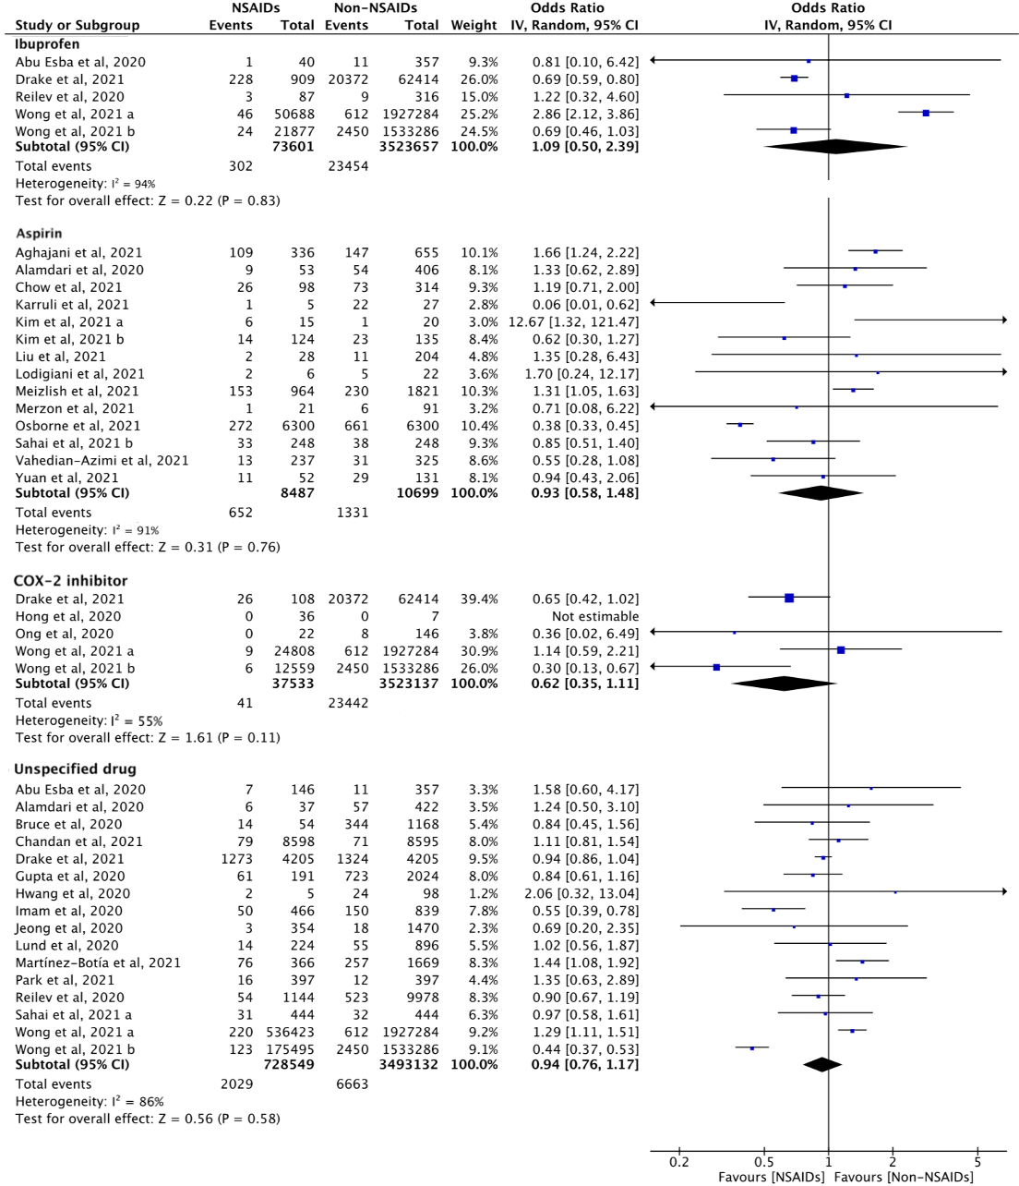

B) Types of NSAIDs (adjusted)
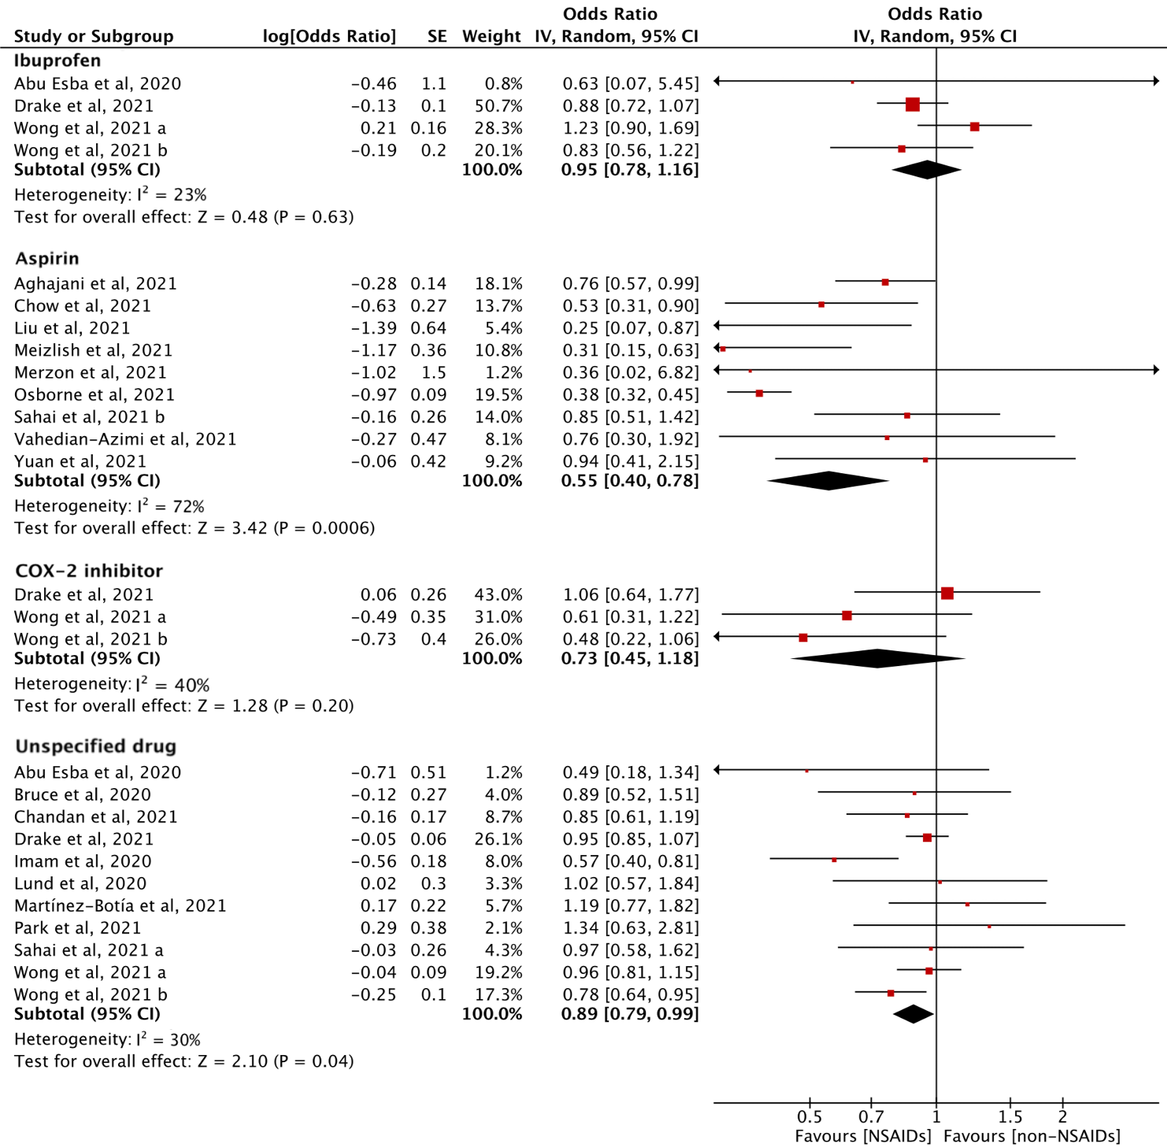

C) Population (unadjusted)
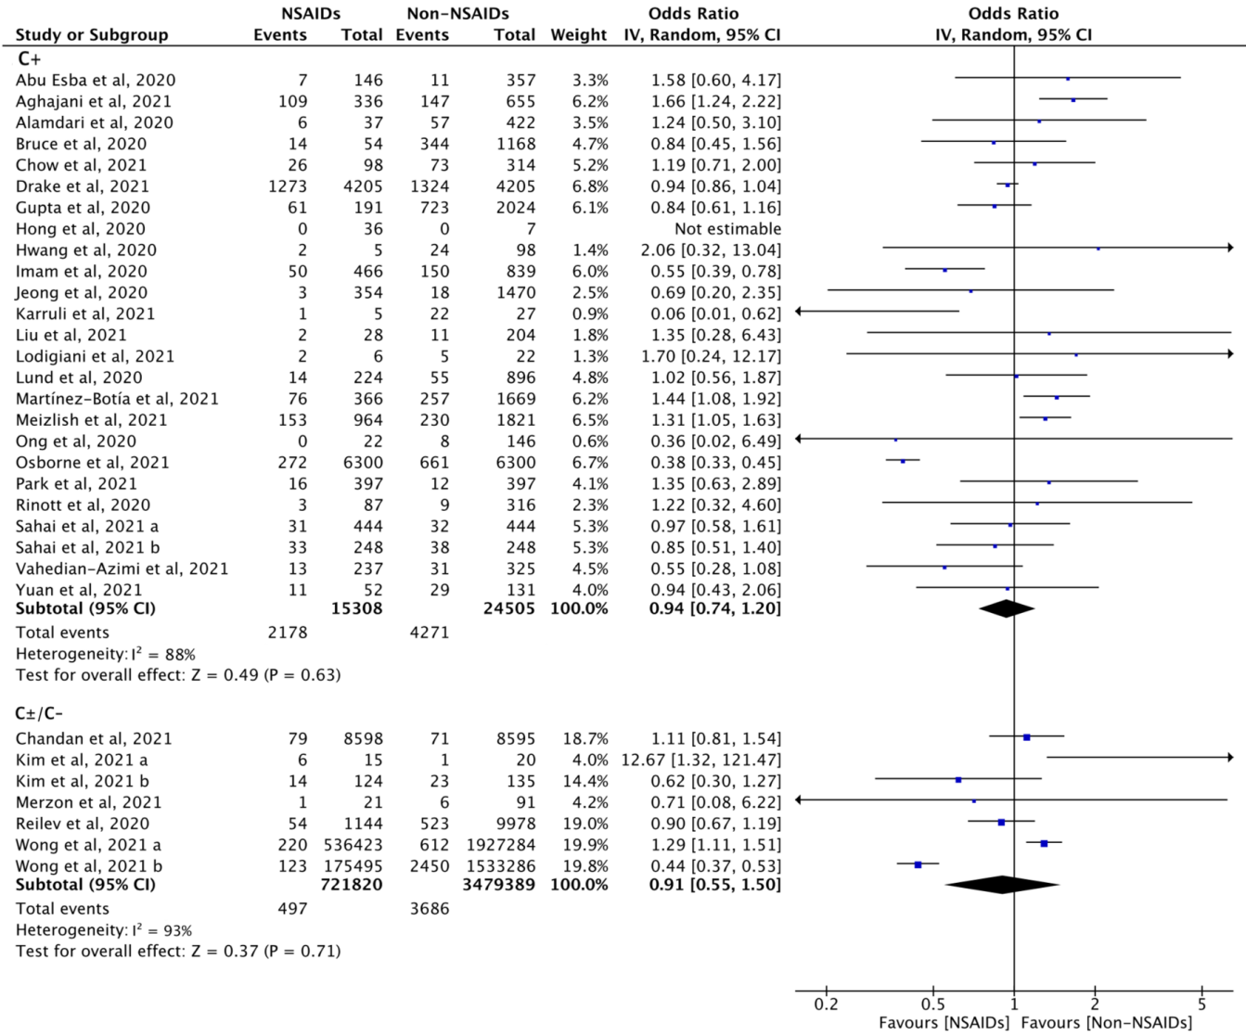

D) Population (adjusted)
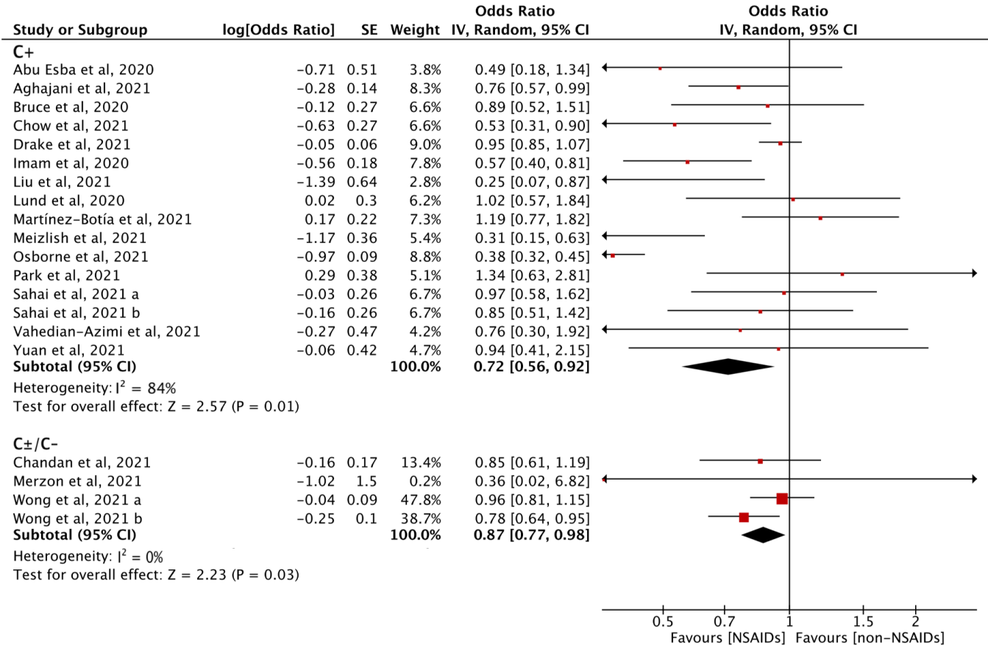

eFigure 2. Adjusted analysis
A) Adjusted OR of the association between NSAID and risk of SARS-CoV-2 infection
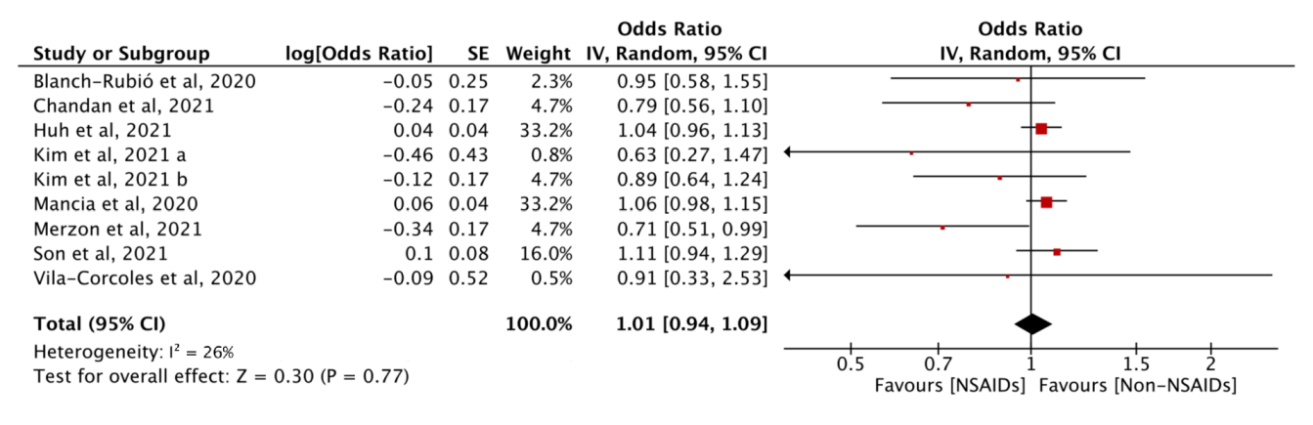

B) Adjusted OR of the association between NSAID and ICU admission
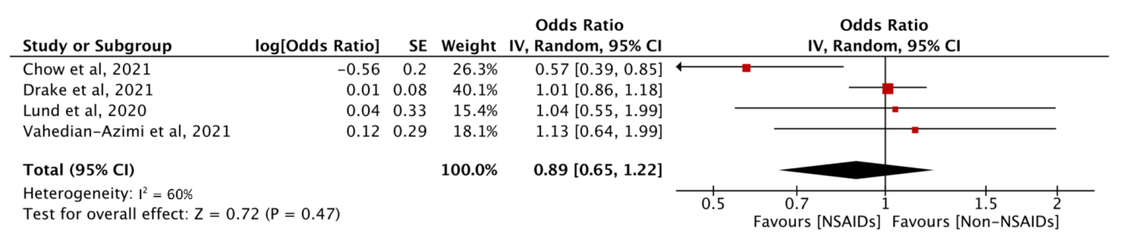

C) Adjusted OR of the association between NSAID and mechanical ventilation
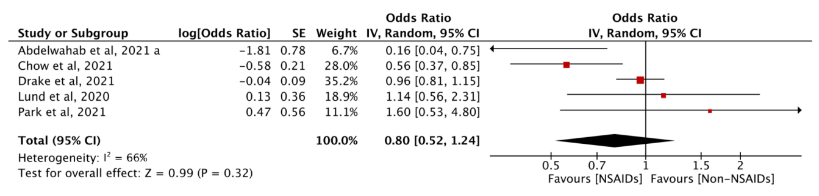

D) Adjusted OR of the association between NSAID and supplemental oxygen
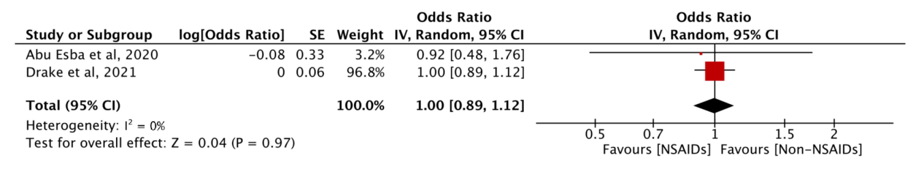

E) Adjusted OR of the association between NSAID and composite adverse outcome
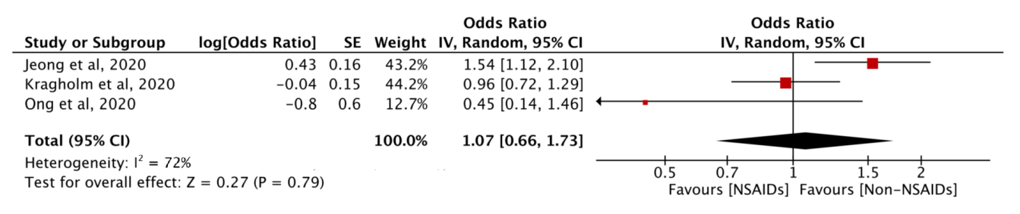

F) Adjusted OR of the association between NSAID and hospital admission
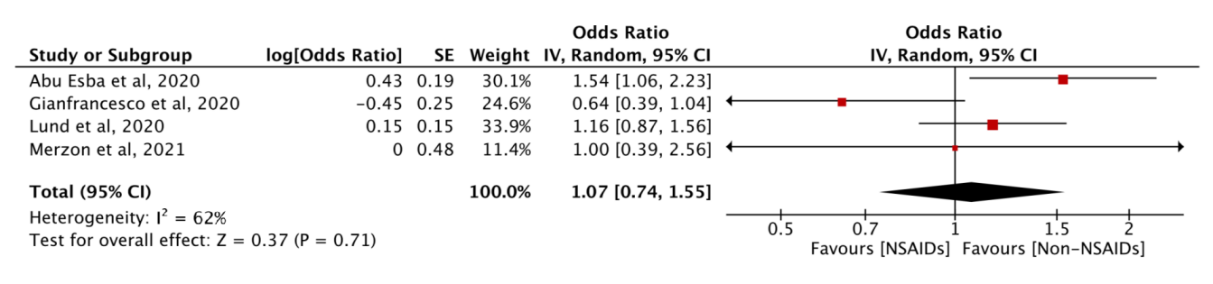

eFigure 3. Forest plots with summary effect sizes per publication type for A) Supplemental oxygen, B) Composite adverse outcome, and C) Hospital admission
A) Supplemental oxygen
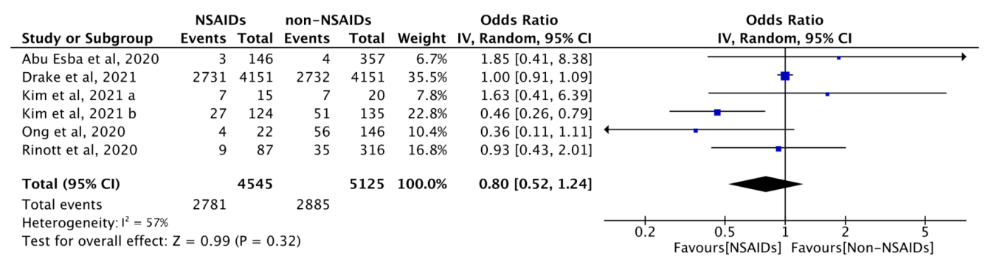
B) Composite adverse outcome
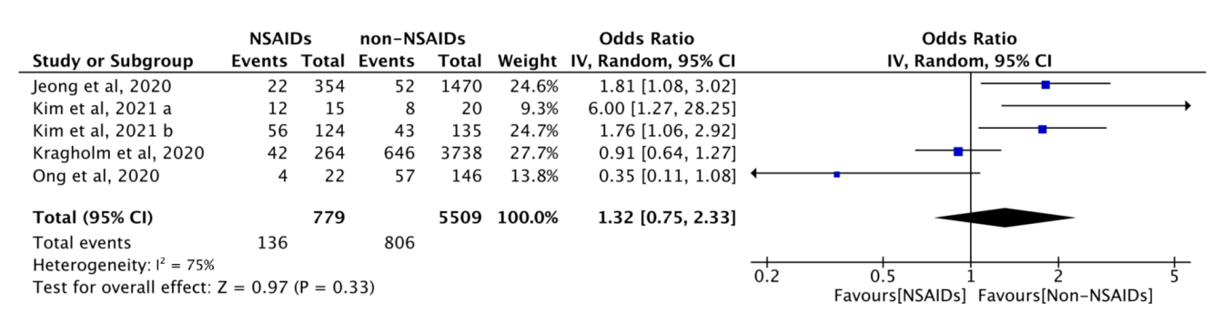
C) Hospital admission
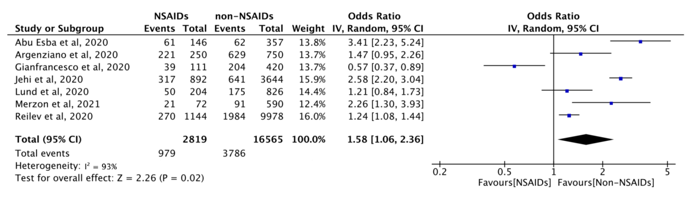

eFigure 4. Sensitivity analysis for studies of the association of exposure to NSAIDs and risk of death in users of NSAIDs with COVID-19.
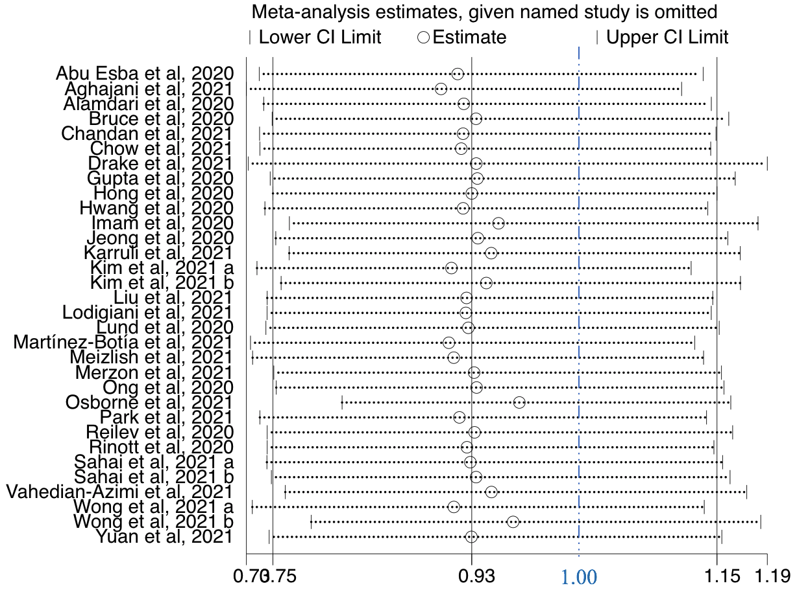
eFigure 5. Funnel plot for studies of the association of exposure to NSAIDs and risk of death in users of NSAIDs with COVID-19.


