ONLINE SUPPLEMENT

Complete search algorithm used in MEDLINE search.
Complete search algorithm used in SCOPUS search.
Supplementary Tables: S1-S3
Supplementary Figures: S1-S9
References used in the Supplement.

Complete search algorithm used in MEDLINE search.
("COVID-19 vaccines"[All Fields] OR "COVID-19 vaccine"[All Fields] OR "SARS-CoV-2 vaccine"[All Fields]) AND ("cerebral sinus thrombosis"[All Fields] OR "cerebral venous sinus thrombosis"[All Fields] OR "thrombotic events"[All Fields] OR "thromboses"[All Fields] OR "thrombocytopenia"[All Fields] OR "VITT"[All Fields] OR "VIPIT"[All Fields] OR "TTS"[All Fields])

Complete search algorithm used in SCOPUS search.
(TITLE-ABS-KEY({COVID-19 vaccines} OR {COVID-19 vaccine} OR {SARS-CoV-2 vaccine}) AND TITLE-ABS-KEY({cerebral sinus thrombosis}OR{cerebral venous sinus thrombosis}OR{thrombotic events}OR{thromboses}OR {thrombocytopenia} OR {VITT} OR {VIPIT} OR {TTS})) AND ( LIMIT-TO ( DOCTYPE , "ar" ) )

Supplementary Table-S1. Table of excluded studies with reasons for exclusion.
Study Name | Reason(s) for exclusion
Krzywicka et al. [1] | Pharmacovigilance registry with passive inclusion of cases
van de Munckhof et al. [2] | Pharmacovigilance registry with passive inclusion of cases
Smadja et al. [3] | Pharmacovigilance registry with passive inclusion of cases
Hippisley-Cox et al. [4] | Possible duplicate cases
Schulz et al. [5] | Possible duplicate cases
Pawlowski et al. [6] | No data regarding thrombocytopenia

Supplementary Table-S2. Quality assessment of included studies with the Newcastle–Ottawa Scale [7].
Study name | Selection† | Comparability‡ | Outcome§ | Overall score
Sánchez van Kammen et al. [8] | **** | ** | *** | 9
Perry et al. [9] | **** | ** | *** | 9
Overall Score | 8/8 | 4/4 | 6/6 | 18/18
† Selection: Both studies were deemed to have satisfied the representativeness, selection and exposure ascertainment criteria for both cases and controls.
‡ Comparability: Comparability between cases and controls in both studies was satisfied.
§ Outcome: Both studies assessed the outcomes of interest based on medical record linkage and reported an adequate follow-up of the included patients.

Supplementary Table-S3. Therapeutic management of TTS-CVST cases associated with COVID-19 vaccination.

Variable | Prevalence
Variable | Pooled estimates (95%CI) |  | I², p for Cochran Q
Anticoagulation
Heparin-Anticoagulants | 31% (17-47%) |  | 77%, 0.04
Direct Oral Anticoagulants | 16% (0-49%) |  | 95%, <0.01
Non-heparin Parenteral Anticoagulants | 57% (27-84%) |  | 93%, <0.01
Immunomodulation
Intravenous Immunoglobulin | 70% (51-86%) |  | 83%, 0.02
Plasmapheresis | 14% (0-32%) |  | 86%, 0.01
Corticosteroids | 53% (15-89%) |  | 96%, <0.01

Supplementary Figure-S1. Flow chart presenting the selection of eligible studies.
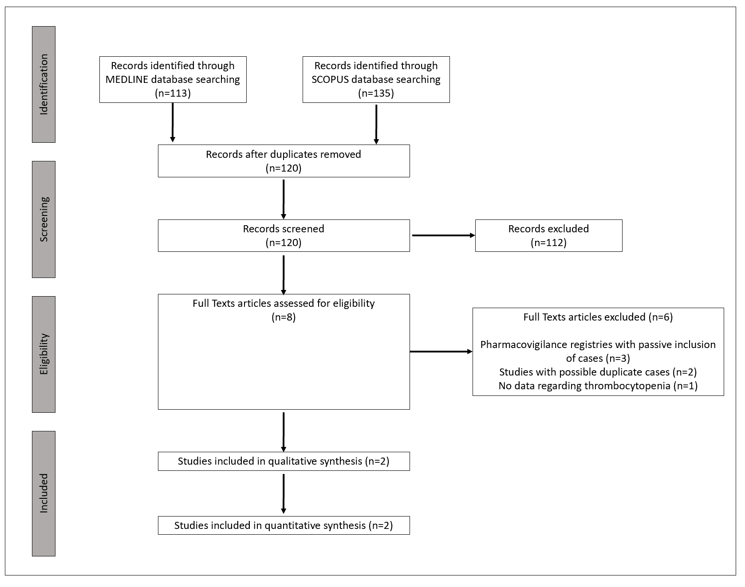

Supplementary Figure-S2. Forest plot presenting the pooled proportion of patients with TTS-associated CSVT among CVST cases following COVID-19 vaccination.
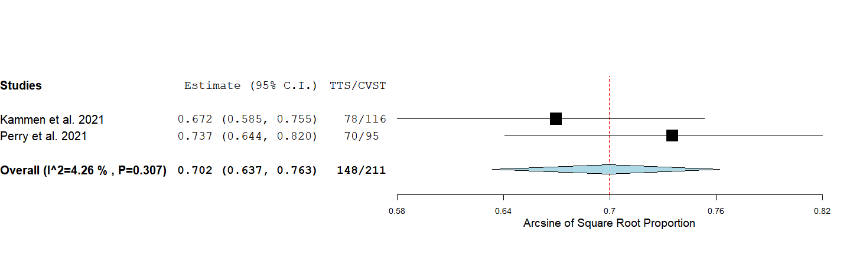
Supplementary Figure-S3. Forest plot presenting the mean difference of the interval between vaccination and symptom onset among TTS-associated CSVT compared to non-TTS-associated CVST cases.
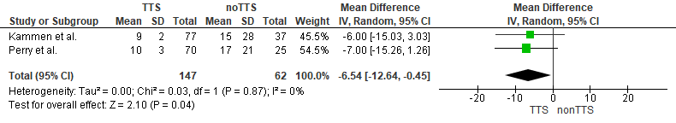

Supplementary Figure-S4. Forest plot presenting the mean difference of age among TTS-associated CSVT compared to non-TTS-associated CVST cases.
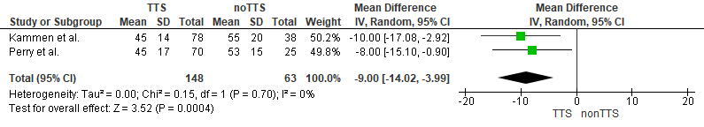
Supplementary Figure-S5. Forest plot presenting the odds ratio of patients without any risk factor for thrombosis among TTS-CVST compared to non-TTS-CVST cases.
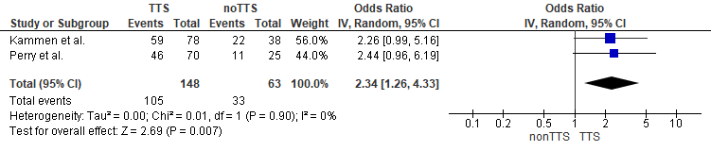
Supplementary Figure-S6. Forest plot presenting the odds ratio of intracerebral hemorrhage among TTS-CVST compared to non-TTS-CVST cases.
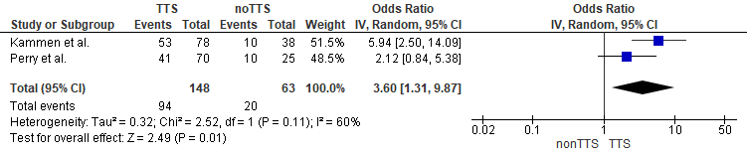
Supplementary Figure-S7. Forest plot presenting the odds ratio of concomitant thrombosis in other sites among TTS-CVST compared to non-TTS-CVST cases.
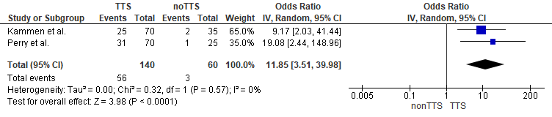

Supplementary Figure-S8. Forest plot presenting the odds ratio of women among TTS-CVST compared to non-TTS-CVST cases.
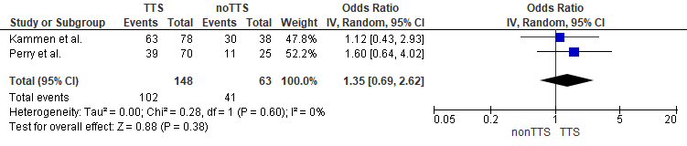

Supplementary Figure-S9. Forest plot presenting the pooled mortality rate among TTS-CVST cases treated with heparin anticoagulants.

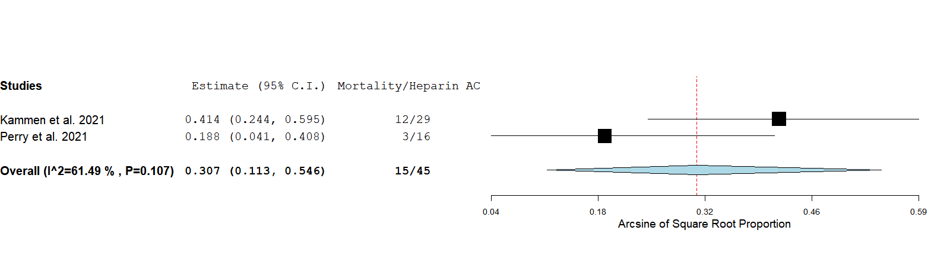

References used in the Supplement.
1. Krzywicka K, Heldner MR, Sánchez van Kammen M, et al. Post-Sars-Cov-2-Vaccination Cerebral Venous Sinus Thrombosis: An Analysis of Cases Notified to the European Medicines Agency. European journal of neurology. 2021;28(11):3656-3662.
2. van de Munckhof A, Krzywicka K, Aguiar de Sousa D, et al. Declining Mortality of Cerebral Venous Sinus Thrombosis with Thrombocytopenia after Sars-Cov-2 Vaccination. European journal of neurology. 2022;29(1):339-344.
3. Smadja DM, Yue QY, Chocron R, Sanchez O, Lillo-Le Louet A. Vaccination against Covid-19: Insight from Arterial and Venous Thrombosis Occurrence Using Data from Vigibase. The European respiratory journal. 2021;58(1).
4. Hippisley-Cox J, Patone M, Mei XW, et al. Risk of Thrombocytopenia and Thromboembolism after Covid-19 Vaccination and Sars-Cov-2 Positive Testing: Self-Controlled Case Series Study. BMJ (Clinical research ed). 2021;374:n1931.
5. Schulz JB, Berlit P, Diener HC, et al. Covid-19 Vaccine-Associated Cerebral Venous Thrombosis in Germany. Annals of neurology. 2021;90(4):627-639.
6. Pawlowski C, Rincón-Hekking J, Awasthi S, et al. Cerebral Venous Sinus Thrombosis Is Not Significantly Linked to Covid-19 Vaccines or Non-Covid Vaccines in a Large Multi-State Health System. Journal of stroke and cerebrovascular diseases : the official journal of National Stroke Association. 2021;30(10):105923.
7. Wells G, Shea B, O'connell D, Et Al. The Newcastle-Ottawa Scale (Nos) for Assessing the Quality of Nonrandomized Studies in Meta-Analyses. [Available From: Http://Www.Ohri.Ca/Programs/Clinical_Epidemiology/Oxford.Htm. On October 16, 2021.
8. Sánchez van Kammen M, Aguiar de Sousa D, Poli S, et al. Characteristics and Outcomes of Patients with Cerebral Venous Sinus Thrombosis in Sars-Cov-2 Vaccine-Induced Immune Thrombotic Thrombocytopenia. JAMA neurology. 2021;78(11):1314-1323.
9. Perry RJ, Tamborska A, Singh B, et al. Cerebral Venous Thrombosis after Vaccination against Covid-19 in the Uk: A Multicentre Cohort Study. Lancet. 2021;398(10306):1147-1156.

