Evidence Gaps in Economic Analyses of Hearing Healthcare: A Systematic Review
Supplementary Materials

Ethan D. Borre, B.A.
Mohamed M. Diab, M.D., M.Sc.
Austin Ayer, B.S.
Gloria Zhang, B.S.
Susan D. Emmett, M.D., M.P.H.
Debara L. Tucci, M.D., M.S., M.B.A.
Blake S. Wilson, Ph.D., D.Sc., D.Eng.
Kamaria Kaalund, B.A.
Osondu Ogbuoji, M.B.B.S., M.P.H., Sc.D.
Gillian D. Sanders, Ph.D.
Appendix 1: PRISMA 2009 Checklist
Section/topic | # | Checklist item | Reported on page #
TITLE
Title | 1 | Identify the report as a systematic review, meta-analysis, or both. | 1
ABSTRACT
Structured summary | 2 | Provide a structured summary including, as applicable: background; objectives; data sources; study eligibility criteria, participants, and interventions; study appraisal and synthesis methods; results; limitations; conclusions and implications of key findings; systematic review registration number. | 3-4
INTRODUCTION
Rationale | 3 | Describe the rationale for the review in the context of what is already known. | 4
Objectives | 4 | Provide an explicit statement of questions being addressed with reference to participants, interventions, comparisons, outcomes, and study design (PICOS). | 4-5
METHODS
Protocol and registration | 5 | Indicate if a review protocol exists, if and where it can be accessed (e.g., Web address), and, if available, provide registration information including registration number. | 4
Eligibility criteria | 6 | Specify study characteristics (e.g., PICOS, length of follow-up) and report characteristics (e.g., years considered, language, publication status) used as criteria for eligibility, giving rationale. | 6, Appendix 4
Information sources | 7 | Describe all information sources (e.g., databases with dates of coverage, contact with study authors to identify additional studies) in the search and date last searched. | 5-6, Appendix 3
Search | 8 | Present full electronic search strategy for at least one database, including any limits used, such that it could be repeated. | Appendix 3
Study selection | 9 | State the process for selecting studies (i.e., screening, eligibility, included in systematic review, and, if applicable, included in the meta-analysis). | 6
Data collection process | 10 | Describe method of data extraction from reports (e.g., piloted forms, independently, in duplicate) and any processes for obtaining and confirming data from investigators. | 7
Data items | 11 | List and define all variables for which data were sought (e.g., PICOS, funding sources) and any assumptions and simplifications made. | 7, Appendix 6
Risk of bias in individual studies | 12 | Describe methods used for assessing risk of bias of individual studies (including specification of whether this was done at the study or outcome level), and how this information is to be used in any data synthesis. | 7-8, Appendix 5, 7
Summary measures | 13 | State the principal summary measures (e.g., risk ratio, difference in means). | NA
Synthesis of results | 14 | Describe the methods of handling data and combining results of studies, if done, including measures of consistency (e.g., I²) for each meta-analysis. | NA

Section/topic | # | Checklist item | Reported on page #
Risk of bias across studies | 15 | Specify any assessment of risk of bias that may affect the cumulative evidence (e.g., publication bias, selective reporting within studies). | 7-8, Appendix 5, 7
Additional analyses | 16 | Describe methods of additional analyses (e.g., sensitivity or subgroup analyses, meta-regression), if done, indicating which were pre-specified. | NA
RESULTS
Study selection | 17 | Give numbers of studies screened, assessed for eligibility, and included in the review, with reasons for exclusions at each stage, ideally with a flow diagram. | Figure 1
Study characteristics | 18 | For each study, present characteristics for which data were extracted (e.g., study size, PICOS, follow-up period) and provide the citations. | Tables 2-4
Risk of bias within studies | 19 | Present data on risk of bias of each study and, if available, any outcome level assessment (see item 12). | Tables 2-4, Figure 2, Appendix 10, 11
Results of individual studies | 20 | For all outcomes considered (benefits or harms), present, for each study: (a) simple summary data for each intervention group (b) effect estimates and confidence intervals, ideally with a forest plot. | NA
Synthesis of results | 21 | Present results of each meta-analysis done, including confidence intervals and measures of consistency. | NA
Risk of bias across studies | 22 | Present results of any assessment of risk of bias across studies (see Item 15). | Figure 2, Appendix 10, 11
Additional analysis | 23 | Give results of additional analyses, if done (e.g., sensitivity or subgroup analyses, meta-regression [see Item 16]). | 13
DISCUSSION
Summary of evidence | 24 | Summarize the main findings including the strength of evidence for each main outcome; consider their relevance to key groups (e.g., healthcare providers, users, and policy makers). | 14-19
Limitations | 25 | Discuss limitations at study and outcome level (e.g., risk of bias), and at review-level (e.g., incomplete retrieval of identified research, reporting bias). | 18
Conclusions | 26 | Provide a general interpretation of the results in the context of other evidence, and implications for future research. | 14-19
FUNDING
Funding | 27 | Describe sources of funding for the systematic review and other support (e.g., supply of data); role of funders for the systematic review. | 8
From: Moher D, Liberati A, Tetzlaff J, Altman DG, The PRISMA Group (2009). Preferred Reporting Items for Systematic Reviews and Meta-Analyses: The PRISMA Statement. PLoS Med 6(7): e1000097. doi:10.1371/journal.pmed1000097 For more information, visit: www.prisma-statement.org.
Appendix 2: Lancet Commission on Hearing Loss Commissioner Roster List
Name | Title | Affiliation
Blake Wilson | Commission Chair | Duke University
Debara Tucci | Commission Co-Chair | National Institutes of Health
Bolajoko Olusanya | Commission Co-Chair | Centre for Healthy Start Initiative
Shelly Chadha | Commissioner Co-Chair | World Health Organization
Gillian Sanders Schmidler | Commissioner | Duke University
Howard Francis | Advisory Board Member | Duke University
Osondu Ogbuoji | Commissioner | Duke University
Gerry O’Donoghue | Commissioner | University of Nottingham
Anne Schilder | Commissioner | University College London
Catherine McMahon | Commissioner | Macquarie University
Enis Baris | Commissioner | The World Bank
Eric Finkelstein | Commissioner | Duke NUS Medical School
Fan-Gang Zeng | Commissioner | University of California, Irvine
Frank Lin | Commissioner | Johns Hopkins
George Tavartkiladze | Commissioner | National Research Centre for Audiology and Hearing Rehabilitation
Judy Dubno | Commissioner | Medical University of South Carolina
Ms. Katherine Bouton | Commissioner | Hearing Loss Association of America
Muhammad Pate | Commissioner | World Bank
Mark McClellan | Commissioner | Duke
Patricia Castellanos de Munoz | Commissioner | CEDAF Hearing Center
Ricardo Ferreira Bento | Commissioner | Medicine School University of Sao Paulo
Ronna Hertzano | Commissioner | University of Maryland
Susan Emmett | Commissioner | Duke
Zulfiqar Bhutta | Commissioner | University of Toronto  Aga Khan University
Isaac Macharia | Commissioner | University of Nairobi
Suneela Garg | Commissioner | Maulana Azad Medical College & Associated Hospitals New Delhi
Carolina Der | Commissioner | University of Chile
Charlotte Chiong | Commissioner | University of the Philippines
Mira Johri | Commissioner | University of Montreal
Janet Bettger | Commissioner | Duke University
Shiming Yang | Commissioner | Chinese PLA General Hospital

Appendix 3. Search Strategy
Database: MEDLINE (via PubMed)
Search date: 6/14/2020
Note: set sort order to Most Recent
# | Terms | Results
#1  Hearing loss | "Hearing Loss"[Mesh] OR “hearing”[tiab] | 128,921
#2  Cost effectiveness | "Costs and Cost Analysis"[Mesh] OR "Cost-Benefit Analysis"[Mesh] OR "cost-benefit"[tiab] OR "cost-effectiveness"[tiab] OR "cost utility"[tiab] OR “economic evaluation”[tiab] OR "economic evaluations"[tiab] OR “economic model”[tiab] OR "economic models"[tiab] | 271,991
#3  (combining) | #1 AND #2 | 919
#4  (narrowing) | #3 AND English[lang] | 856
#5  (narrowing) | #4 NOT (Editorial[ptyp] OR Letter[ptyp] OR Case Reports[ptyp] OR Comment[ptyp]) NOT (animals[mh] NOT humans[mh]) | 806

Database: EMBASE (via Elsevier)
Search date: 6/14/2020
Note: Search from the Results page
# | Terms | Results
#1  Hearing loss | 'hearing impairment'/exp OR hearing:ti,ab | 188,233
#2  Cost effectiveness | 'cost benefit analysis'/exp OR 'cost effectiveness analysis'/exp OR 'cost utility analysis'/exp OR 'economic evaluation'/de OR 'cost-benefit':ti,ab OR 'cost-effectiveness':ti,ab OR 'cost utility':ti,ab OR 'economic evaluation':ti,ab OR 'economic evaluations':ti,ab OR 'economic model':ti,ab OR 'economic models':ti,ab | 260,154
#3  (combining) | #1 AND #2 | 1,212
#4  (narrowing) | #3 AND [english]/lim AND [humans]/lim | 1,084
#5  (narrowing) | #4 NOT ('case report'/exp OR 'case study'/exp OR 'editorial'/exp OR [editorial]/lim OR 'letter'/exp OR [letter]/lim OR 'note'/exp OR [note]/lim OR [conference abstract]/lim OR 'conference abstract'/exp OR 'conference abstract'/it) | 882

Database: Cochrane Library (via Wiley)
Search date: 6/14/2020
Note: search from Advanced Search < Search Manager
# | Terms | Results
#1  Hearing loss | [mh "Hearing Loss"] OR hearing:ti,ab | 5611
#2  Cost effectiveness | [mh "Costs and Cost Analysis"] OR [mh "Cost-Benefit Analysis"] OR cost-benefit:ti,ab OR cost-effectiveness:ti,ab OR "cost utility":ti,ab OR "economic evaluation":ti,ab OR "economic evaluations":ti,ab OR "economic model":ti,ab OR "economic models":ti,ab | 25,215
#3  (combining) | #1 AND #2 | 97

Database: Global Index Medicus
Produced by the World Health Organization, this resource offers the ability to search the literature in regional medical indices, including AIM (AFRO), LILACS (AMRO/PAHO), IMEMR (EMRO), IMSEAR (SEARO), and WPRIM (WPRO).
Search date: 6/14/2020
Note: Search from Advanced Search
# | Terms | Results
#1 | tw:(hearing)) AND (tw:(cost OR costs OR cost-effectiveness OR cost-benefit OR cost-utility)) | 137
#2 | English Filter | 80

Appendix 4: Population, intervention, comparison, outcome, time, and study design table of the inclusion criteria.

 | Inclusion Criteria | Exclusion Criteria
Population or problem of interest | Persons with hearing loss  Conditions that affect hearing loss (i.e. bacterial meningitis, etc.) | Persons without hearing loss
Interventions / prognostic factors / diagnostic test / exposure of interest | Any diagnostic or therapeutic intervention related to hearing loss | Interventions unrelated to hearing loss
Comparison (if any) | Any comparison | -
Outcome | Study must consider costs and clinical benefits | Studies that do not consider costs and clinical benefits
Time | Any | -
Study Types | Original research articles  Cost-effectiveness analyses that utilize a decision model | Editorials, case reports, letters, comments  Trial-based cost-effectiveness analyses that do not use a decision model  Cost-benefit analyses that do not report clinical outcomes

Appendix 5: Consolidated Health Economic Reporting Standards – CHEERS Checklist
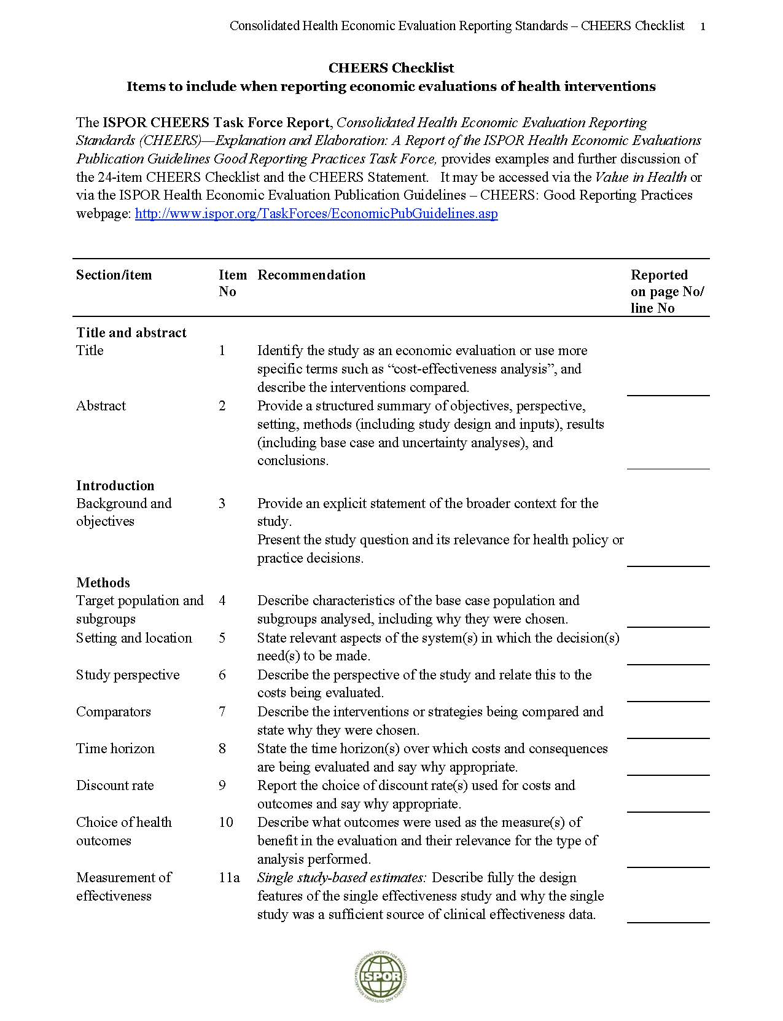

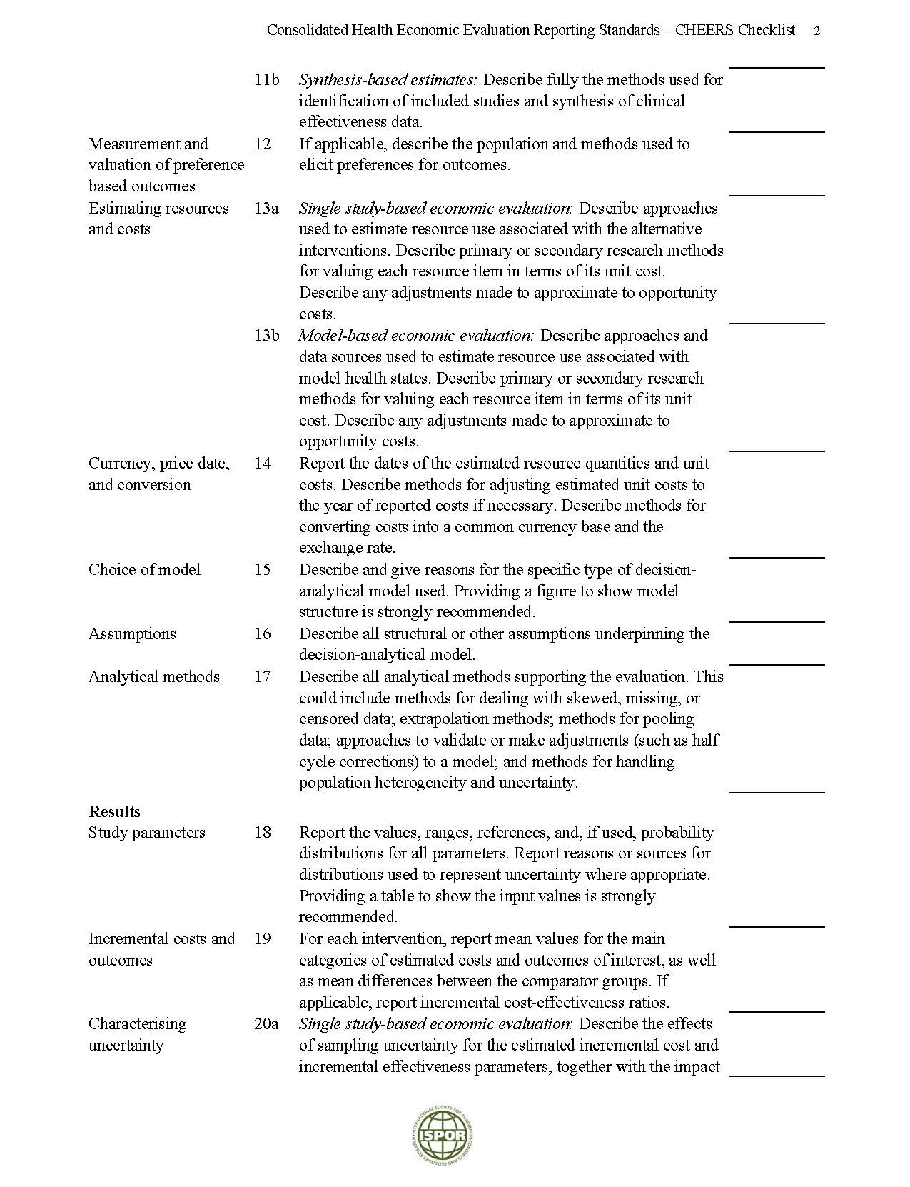

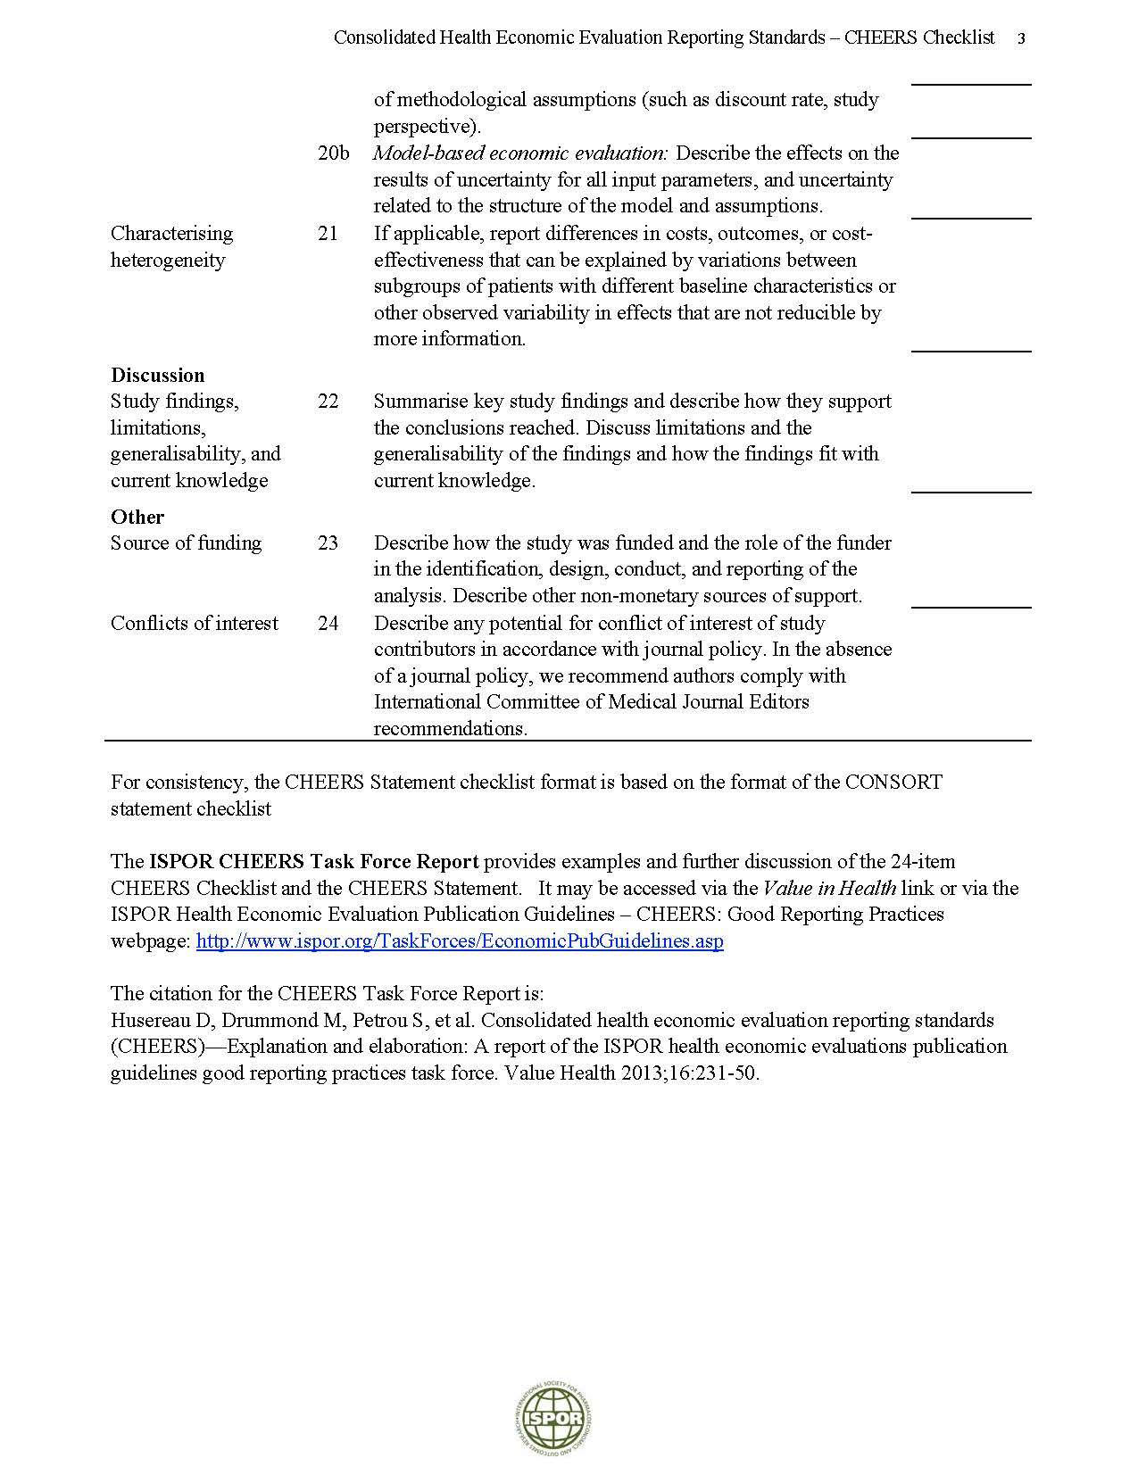

Appendix 6: Complete List of Data Points Extracted

Variable | Definition | Data Collection
Article Type | - | CEA with decision model  Systematic Review
Setting | What was the primary setting the study was performed? | Africa  Asia  Australia/NZ  Canada  Latin America  Middle East  South America  UK/Europe  United States  Other or unsure (list country here)
Intervention/Condition | What type of intervention or condition was analyzed? (select all that apply) | Cochlear Implants  Neonatal Screening  Child Screening  Occupational Exposure  Otitis Media with Effusion  Vaccine  Adult Screening  Hearing Aids  ASNHL MRI  Hearing loss general  Medulloblastoma  Drug Reactions  Neonatal CMV  Schwannoma  Otosclerosis  Implantable Hearing Aids  Other or Unsure (list here):
Model Type | What type of decision model was used? | Decision Tree  Markov  Diagram  Probabilistic  Net-Cost  Other/Unclear (list other model here)
Perspective | What was the perspective of the model? | Healthcare Payer  Healthcare System  Patient  Societal  Modified Societal  Not Clear  Other (list here):
Statement of Perspective | Was the perspective explicit or inferred? | Explicit  Inferred
Population | What was the population? | Pediatric (<18)  Adult (18+)  Subgroup (enter here):
Hearing Loss Type | What was the hearing loss type? | Unilateral sensorineural  Bilateral sensorineural  Sensorineural (not reported either unilateral or bilateral)  Conductive  Mixed  Unclear  Other (enter here):
Comparators | Enter each comparator in each field | Arm 1:  Arm 2:  Arm 3:  Etc.
Health Outcome Measurement | What was the health outcome measurement of the model? | QALY  DALY  Life-years  Other (enter here):
Definition of Hearing Loss | What was the definition of hearing loss in the model? | Enter here:
Time Horizon | What was the time horizon of the model? | Lifetime  Other: reported in years
Currency/Year | What was the currency/year of the model? | Year/Currency
Basecase ICER of Intervention | What are the “Abstract-worthy “cost-effectiveness results? | Enter here:
Model Validation | How was the model validated? | Enter here:
Method of Characterizing Uncertainty | What was the method of the model? | One-way deterministic  Multi-way deterministic  Probabilistic  Unclear  None  Other (list here):
Funding | What was the funding source? | No funding  Government  Non-Government/Non-Industry  Industry  Unclear  Other (enter here):
Disclosure Statement | Was there a disclosure statement? | Yes  No

Appendix 7. Summary of Quality Rating Measure
Criterion Short Name | Criterion Description | Weight
Study Objective | Was the study objective presented in a clear, specific, and measurable manner? | 7
Perspective | Were the perspective of the analysis (societal, third-party payer, etc.) and reasons for its selection stated? | 4
Source of variable estimates | Were variable estimates used in the analysis from the best available source (i.e. Randomized Control Trial-Best, Expert Opinion-Worst)? | 8
Subgroup | If estimates came from a subgroup analysis, were the groups prespecified at the beginning of the study? | 1
Uncertainty | Was uncertainty handled by: 1) statistical analysis to address random events; 2) sensitivity analysis to cover a range of assumptions? | 9
Incremental analysis | Was incremental analysis performed between alternatives for resources and costs? | 6
Data abstraction methodology | Was the methodology for data abstraction (including value health states and other benefits) stated? | 5
Time horizon | Did the analytic horizon allow time for all relevant and important outcomes? Were benefits and costs that went beyond 1 year discounted (3-5%) and justification given for the discount rate? | 7
Cost measurement | Was the measurement of costs appropriate and the methodology for the estimation of quantities and unit costs clearly described? | 8
Primary outcome measures | Were the primary outcomes measures/scales valid and reliable? If previously tested valid and reliable measures were not available, was justification given for the measures/scales used? | 6
Health outcomes measures | Were the health outcomes measures/scales valid and reliable? If previously tested valid and reliable measures were not available, was justification given for the measures/scales used? | 7
Display of economic model | Were the economic model (including structure), study methods and analysis, and the components of the numerator and denominator displayed in a clear transparent manner? | 8
Statement and justification of choices | Were the choice of economic mode, main assumptions and limitations of the study stated and justified? | 7
Direction and magnitude of potential biases | Did the author(s) explicitly discuss direction and magnitude of potential biases? | 6
Conclusions | Were the conclusions/recommendations of the study justified and based on the study results? | 8
Disclosure of funding | Was there a statement disclosing the source of funding for the study? | 3
Table Modified from Chiou et al. Med Care 2003, see main text for further details on quality abstraction.
Appendix 8. Intervention comparisons made among included studies.

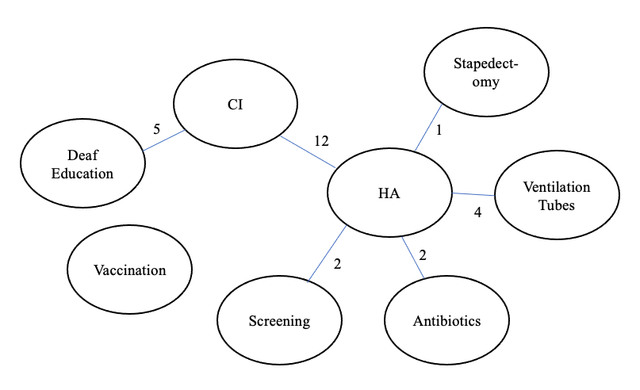

In this Figure, we compiled the number of studies that had comparisons across intervention categories. In this figure, we included studies that considered the four most common interventions: hearing screening, cochlear implants, hearing aids, and vaccination. CI: cochlear implantation, HA: hearing aid.

Appendix 9: Main cost-effectiveness findings from included studies.
Bibliography | Main Cost-Effectiveness Findings
Abrams, H., Chisolm, T. H., McArdle, R. A cost-utility analysis of adult group audiologic rehabilitation: are the benefits worth the cost? J Rehabil Res Dev. 2002. 39:549-58 | HA treatment cost $60.00/QALY gained compared to no treatment, while HA + audiologic rehabilitation cost only $31.91/QALY gained compared to no treatment.
Baltussen, R., Smith, A. Cost-effectiveness of selected interventions for hearing impairment in Africa and Asia: A mathematical modelling approach. International Journal of Audiology. 2009. 48:144-158 | Findings showed that in both regions, screening strategies for hearing impairment and delivery of hearing aids cost between I$1000/DALY and I$1600/DALY, with passive screening being the most efficient intervention. Active screening at schools and in the community were somewhat less cost-effective. In the treatment of chronic otitis media, aural toilet in combination with topical antibiotics costs was more efficient than aural toilet alone, and cost between I$11 and I$59/DALY in both regions. The treatment of meningitis with ceftriaxone cost between I$55 and I$217/DALY at low coverage levels, in both regions.
Baltussen, R. Smith, A. Cost effectiveness of strategies to combat vision and hearing loss in sub-Saharan Africa and South East Asia: mathematical modelling study. Bmj. 2012. 344:e615 | The cost per DALY averted was < I$285 for all hearing loss interventions.
Bamford, J. Fortnum, H., Bristow, K., Smith, J., Vamvakas, G., Davies, L., Taylor, R., Watkin, P., Fonseca, S., Davis, A., Hind, S. Current practice, accuracy, effectiveness and cost-effectiveness of the school entry hearing screen. Health Technol Assess. 2007. 11:1-168, iii-iv | Universal school entry screening based on pure-tone sweep tests was associated with higher costs and slightly higher QALYs compared with no screen and other screen alternatives; ICER = £2500/QALY gained. The range of expected costs, QALYs, and net benefits was broad.
Berman, S., Roark, R., Luckey., D. Theoretical cost effectiveness of management options for children with persisting middle ear effusions. Pediatrics. 1994. 93:353-63 | Most cost-effective intervention combination is corticosteroid plus an antibiotic at visit 1 followed by second antibiotic in non-responders at visit 2 and referral for ventilating tubes in non-responders at visit 3.
Beswick, R., David, M., Higashi, H., Thomas, D., Nourse, C., Koh, G., Koorts, P., Jardine, L. A., Clark, J. E. Integration of congenital cytomegalovirus screening within a newborn hearing screening programme. Journal of Paediatrics and Child Health. 2019. 55:1381-1388 | The cost comparison suggests the cost implementation of cCMV screening (and subsequent potential treatment benefits and management over time), compared to non-screening (and subsequent management), to be negligible.
Bichey, B. G., Hoversland, J. M., Wynne, M. K., Miyamoto, R. T. Changes in quality of life and the cost-utility associated with cochlear implantation in patients with large vestibular aqueduct syndrome. Otol Neurotol. 2002. 23:323-7 | Cochlear implantation vs hearing aid had an ICER of $12,774/QALY.
Bichey, B. G., Miyamoto, R. T. Outcomes in bilateral cochlear implantation. Otolaryngol Head Neck Surg. 2008. 138:655-61 | Results indicated a 0.48 mean gain in health utility after bilateral cochlear implantation and a discounted cost of $24,859/QALY in this cohort of patients.
Boas, G., Van Der Stel, H., Peters, H., Joore, M., Anteunis, L. Dynamic modeling in medical technology assessment: Fitting hearing aids in the Netherlands. International Journal of Technology Assessment in Health Care. 2001. 17:618-625 | In the age group of 60–64 years old, the costs per QALY ratios of the Fitting HA Program and the Post-purchase Counseling HA Program amounted to €21,154 and €18,046/QALY, respectively.
Bond, M., Mealing, S., Anderson, R., Elston, J., Weiner, G., Taylor, R. S., Hoyle, M., Liu, Z., Price, A., Stein, K. The effectiveness and cost-effectiveness of cochlear implants for severe to profound deafness in children and adults: a systematic review and economic model. Health Technol Assess. 2009. 13:1-330 | In prelingually deaf children, the ICER for u/l CI was £13,413/QALY, £40,410/QALY for simultaneous b/l CI, and 54,098/QALY for sequential b/l CI.  In post-lingually deaf adults, the ICER for u/l CI was £14,163, for simultaneous b/l CI was £49,559, and for sequential b/l CI was £60,301/QALY.
Bos, J. M., Rumke, H. C., Welte, R., Spanjaard, L., van Alphen, L., Postma, M. J. Combination vaccine against invasive meningococcal B and pneumococcal infections: potential epidemiological and economic impact in the Netherlands. Pharmacoeconomics. 2006. 24:141-53 | Base-case cost-effectiveness (vaccine price €40) was €17,700/QALY. The model was most sensitive to changes in incidence, vaccine price, and duration of protective efficacy.
Bos, Jasper M, Rümke, Hans, Welte, R, Postma, MJ. Epidemiologic impact and cost-effectiveness of universal infant vaccination with a 7-valent conjugated pneumococcal vaccine in the Netherlands. Clinical therapeutics. 2003. 25:2614-2630 | With a vaccine price of €40 per dose, the base-case cost-effectiveness ratio would be €71,250/QALY.
Boshuizen, H. C., van der Lem, G. J., Kauffman-de Boer, M. A., van Zanten, G. A., Oudesluys-Murphy, A. M., Verkerk, P. H. Costs of different strategies for neonatal hearing screening: a modelling approach. Arch Dis Child Fetal Neonatal Ed. 2001. 85:F177-81 | Costs of a three-stage screening process in child health clinics were €39.0 (95% confidence interval 20.0 to 57.0) per child detected with automated auditory brainstem response compared with €25.0  (14.4 to 35.6) per child detected with otoacoustic emissions.
Brown, J. Screening infants for hearing loss--an economic evaluation. J Epidemiol Community Health. 1992. 46:350-6 | Cost per unit output:  - £20.57 for the conventional screening  - £11.23 for Alternative policy 1  - £11.23 for Alternative policy 2  - £11.13 for Alternative policy 3  - £11.27 for No screening
Bruce, I., Harman, N., Williamson, P., Tierney, S., Callery, P., Mohiuddin, S., Payne, K., Fenwick, E., Kirkham, J., O'Brien, K. The management of Otitis Media with Effusion in children with cleft palate (mOMEnt): a feasibility study and economic evaluation. Health Technol Assess. 2015. 19:1-374 | VTs vs. do nothing had an ICER of £9,065 per QALY gained. Other strategies are dominated.
Burke, M. J., Shenton, R. C., Taylor, M. J. The economics of screening infants at risk of hearing impairment: an international analysis. Int J Pediatr Otorhinolaryngol. 2012. 76:212-8 | Universal screening vs. selective screening had an ICER per case detected of £36,181 ($58,497), and INR 157,084 ($9,863) for the UK and India, respectively. One-stage vs. two-stage universal screening had an ICER per case detected of £120,972 ($195,586), and INR 926,675 ($58,183) for the UK and India, respectively.
Butler, James RG, McIntyre, Peter, MacIntyre, C Raina, Gilmour, Robin, Howarth, Ann L, Sander, Beate. The cost-effectiveness of pneumococcal conjugate vaccination in Australia. Vaccine. 2004. 22:1138-1149 | The discounted cost per death avoided is $5.0 million, $230,130 per life-year saved, and $121,100 per DALY averted, giving a break-even vaccine price of $15.40 per dose.
Carter, R., Hailey, D. Economic evaluation of the cochlear implant. Int J Technol Assess Health Care. 1999. 15:520-30 | Costs in AUD per QALY (15-year assessment) ranged from $5,070–$11,100 for children, $11,790–$38,150 for profoundly deaf adults, and $14,410– $41,000 for partially deaf adults.
Chao, T. K., Chen, T. H. Cost-effectiveness of hearing aids in the hearing-impaired elderly: a probabilistic approach. Otol Neurotol. 2008. 29:776-83 | HA ICERs for women and men were US $13,615/QALY (Euro 10,826) and $9,702/QALY (Euro 7,715), respectively
Chen, J. M., Amoodi, H., Mittmann, N. Cost-utility analysis of bilateral cochlear implantation in adults: a health economic assessment from the perspective of a publicly funded program. Laryngoscope. 2014. 124:1452-8 | The ICER for bilateral CI compared to no intervention was $14,658/QALY. The ICUR was $55,020/QALY comparing unilateral to bilateral CI.
Cheng, A. K., Rubin, H. R., Powe, N. R., Mellon, N. K.,Francis, H. W., Niparko, J. K. Cost-utility analysis of the cochlear implant in children. Jama. 2000. 284:850-6 | The CI ICER was $9,029/QALY using the TTO, $7,500/QALY using the VAS, and $5,197/QALY using the HUI. CI was cost-saving when educational impact was included.
Cheng, L. J., Soon, S. S., Wu, D. B., Ju, H., Ng, K. Cost-effectiveness analysis of bilateral cochlear implants for children with severe-to-profound sensorineural hearing loss in both ears in Singapore. PLoS One. 2019. 14:e0220439 | Simultaneous bilateral cochlear implant compared to bimodal hearing had an ICER of $60,607/ QALY. Sequential bilateral cochlear implantation compared to bimodal had an ICER of $81,782/QALY.
Chiou, S. T., Lung, H. L., Chen, L. S., Yen, A. M., Fann, J. C., Chiu, S. Y., Chen, H. H. Economic evaluation of long-term impacts of universal newborn hearing screening. Int J Audiol. 2017. 56:46-52 | At willingness to pay of $20,000, aABR had a 90% probability of being cost-effective against TEOAE.
Claes, Christa, von der Schulenburg, Johann-Matthias Graf. Cost effectiveness of pneumococcal vaccination for infants and children with the conjugate vaccine PnC-7 in Germany. Pharmacoeconomics. 2003. 21:587-600 | Conjugate pneumococcal vaccine will result in and ICER of €72,866/life-year saved in Germany.
Clegg, A. J., Loveman, E., Gospodarevskaya, E., Harris, P., Bird, A., Bryant, J., Scott, D. A., Davidson, P., Little, P., Coppin, R. The safety and effectiveness of different methods of earwax removal: a systematic review and economic evaluation. Health Technol Assess. 2010. 14:1-192 | ICER of softeners followed by self-irrigation is £24,450/QALY.  ICER of softeners followed by irrigation at primary care is £32,136/QALY. ICERS are both compared to no treatment.
Colquitt, J. L., Jones, J., Harris, P., Loveman, E., Bird, A., Clegg, A. J., Baguley, D. M., Proops, D. W., Mitchell, T. E., Sheehan, P. Z., Welch, K. Bone-anchored hearing aids (BAHAs) for people who are bilaterally deaf: a systematic review and economic evaluation. Health Technol Assess. 2011. 15:1-200, iii-iv | Incremental cost per QALY gained was between £55,642 and £119,367 for children and between £46,628 and £100,029 for adults for BAHAs compared with BCHA.
Crowson, M. G., Rocke, D. J., Hoang, J. K., Weissman, J. L., Kaylie, D. M. Cost-effectiveness analysis of a non-contrast screening MRI protocol for vestibular schwannoma in patients with asymmetric sensorineural hearing loss. Neuroradiology. 2017. 59:727-736 | Screening MRI was dominant.
Daniels, R. L., Shelton, C., Harnsberger, H. R. Ultra-high resolution nonenhanced fast spin echo magnetic resonance imaging: cost-effective screening for acoustic neuroma in patients with sudden sensorineural hearing loss. Otolaryngol Head Neck Surg. 1998. 119:364-9 | The cost per tumor found was $26,087 for traditional protocol and $12,035 for FSE-MRI.
Dempsey, A. F., Pangborn, H. M., Prosser, L. A. Cost-effectiveness of routine vaccination of adolescent females against cytomegalovirus. Vaccine. 2012. 30:4060-6 | Base case: Vaccination is dominant  Does not report CEA findings.
Dorji, K., Phuntsho, S., Pempa, Kumluang, S., Khuntha, S., Kulpeng, W., Rajbhandari, S., Teerawattananon, Y. Towards the introduction of pneumococcal conjugate vaccines in Bhutan: A cost-utility analysis to determine the optimal policy option. Vaccine. 2018. 36:1757-1765 | In Bhutan, PCV13 produced an ICER of US $92 compared with PCV10.
Emmett, S. D., Tucci, D. L., Smith, M., Macharia, I. M., Ndegwa, S. N., Nakku, D., Mukara, K. B., Ibekwe, T. S., Mulwafu, W., Gong, W., Francis, H. W., Saunders, J. E. GDP Matters: Cost Effectiveness of Cochlear Implantation and Deaf Education in Sub-Saharan Africa. Otol Neurotol. 2015. 36:1357-65 | CI was CE in South Africa and Nigeria: CER/GDP was 1.03 and 2.05.  Deaf education was CE in South Africa, Nigeria, Kenya, Rwanda, Uganda, Malawi with CER/GDP ranging from 0.55-1.56.
Emmett, S. D., Tucci, D. L., Bento, R. F., Garcia, J. M., Juman, S., Chiossone-Kerdel, J. A., Liu, T. J., de Munoz, P. C., Ullauri, A., Letort, J. J., Mansilla, T., Urquijo, D. P., Aparicio, M. L., Gong, W., Francis, H. W., Saunders, J. E. Moving Beyond GDP: Cost Effectiveness of Cochlear Implantation and Deaf Education in Latin America. Otol Neurotol. 2016. 37:1040-8 | Deaf education was very cost effective in all countries (CER/GDP 0.07 – 0.93). CI was cost effective in all countries (CER/GDP 0.69 – 2.96).
Emmett, S. D., Sudoko, C. K., Tucci, D. L., Gong, W., Saunders, J. E., Akhtar, N., Bhutta, M. F., Touch, S., Pradhananga, R. B., Mukhtar, N., Martinez, N., Martinez, F. D., Ramos, H., Kameswaran, M., Kumar, R. N. S., Soekin, S., Prepageran, N. Expanding Access: Cost-effectiveness of Cochlear Implantation and Deaf Education in Asia. Otolaryngol Head Neck Surg. 2019. 161:672-682 | Deaf education was cost-effective in all countries except Nepal (CER/GDP, 3.59). CI was cost-effective in all countries except Nepal (CER/GDP, 6.38) and Pakistan (CER/GDP, 3.14).
Ess, Silvia M, Schaad, Urs B, Gervaix, Alain, Pinösch, Seline, Szucs, Thomas D. Cost-effectiveness of a pneumococcal conjugate immunisation program for infants in Switzerland. Vaccine. 2003. 21:3273-3281 | Pneumococcal vaccination has a cost-utility ratio of 35,700 CHF (approximately 26,300 USD) per QALY from the societal perspective and 39,300 CHF (28,900 USD) per QALY from the sickness funds’ perspective.
Fang, T. Y., Cheng, L. J., Wu, D. B., Wang, P. C. Cost-effective analysis of unilateral cochlear implantation under the Taiwan national healthcare insurance. Int J Audiol. 2019. 1-6 | The ICER for bimodal was $6,487/QALY.
Fortnum, H., O'Neill, C., Taylor, R., Lenthall, R., Nikolopoulos, T., Lightfoot, G., O'Donoghue, G., Mason, S., Baguley, D., Jones, H., Mulvaney, C. The role of magnetic resonance imaging in the identification of suspected acoustic neuroma: a systematic review of clinical and cost effectiveness and natural history. Health Technol Assess. 2009. 13:iii-iv, ix-xi, 1-154 | In the base-case, contrast-enhanced MR imaging cost an additional £71.79 per patient.
Fortnum, H., Leighton, P., Smith, M. D., Brown, L., Jones, M., Benton, C., Marder, E., Marshall, A., Sutton, K. Assessment of the feasibility and clinical value of further research to evaluate the management options for children with Down syndrome and otitis media with effusion: a feasibility study. Health Technol Assess. 2014. 18:1-147, v-vi | The most cost-effective strategy for a child with Down syndrome experiencing OME-induced hearing loss was watchful waiting, followed by symptom management using HAs.
Fortnum, H., Ukoumunne, O. C., Hyde, C., Taylor, R. S., Ozolins, M., Errington, S., Zhelev, Z., Pritchard, C., Benton, C., Moody, J., Cocking, L., Watson, J., Roberts, S. A programme of studies including assessment of diagnostic accuracy of school hearing screening tests and a cost-effectiveness model of school entry hearing screening programmes. Health Technol Assess. 2016. 20:1-178 | No screening was dominant over screening. Screening using pure-tone screening was dominant over screening using the HearCheck screener.
Foteff, C., Kennedy, S., Milton, A. H., Deger, M., Payk, F., Sanderson, G. Cost-Utility Analysis of Cochlear Implantation in Australian Adults. Otol Neurotol. 2016. 37:454-61 | Compared with bilateral hearing aids, the incremental cost-utility ratio for the CI treatment population was AUD 11,160/QALY.
Foteff, C., Kennedy, S., Milton, A. H., Deger, M., Payk, F., Sanderson, G. Economic Evaluation of Treatments for Pediatric Bilateral Severe to Profound Sensorineural Hearing Loss: An Australian Perspective. Otol Neurotol. 2016. 37:462-9 | The ICER for unilateral CI compared with HAs was AUD 21,947/QALY.  Weighted combined CI compared with HAs had an ICER of AUD 31,238/ QALY.
Francis, H. W., Chee, N., Yeagle, J., Cheng, A., Niparko, J. K. Impact of cochlear implants on the functional health status of older adults. Laryngoscope. 2002. 112:1482-8 | CI in older adults had a cost-utility of $9,530/QALY.
Gantt, S., Dionne, F., Kozak, F. K., Goshen, O., Goldfarb, D. M., Park, A. H., Boppana, S. B., Fowler, K. Cost-effectiveness of Universal and Targeted Newborn Screening for Congenital Cytomegalovirus Infection. JAMA Pediatr. 2016. 170:1173-1180 | The cost of identifying 1 case of hearing loss due to cCMV ranged from $27,460 - $90,038 for universal screening, and $975 - $3,916 for targeted screening.
Garcia, S. L., Smith, K. J., Palmer, C. Cost-Effectiveness Analysis of a Military Hearing Conservation Program. Mil Med. 2018. 183:e547-e553 | The ICER of a hearing conservation program was $10,657 per case of hearing loss prevented.
Gillard, D. M., Harris, J. P. Cost-effectiveness of Stapedectomy vs Hearing Aids in the Treatment of Otosclerosis. JAMA Otolaryngol Head Neck Surg. 2019. | In otosclerosis, stapedectomy had an ICER of $3,918.43/QALY compared to hearing aids.
Grill, E., Uus, K., Hessel, F., Davies, L., Taylor, R. S., Wasem, J., Bamford, J. Neonatal hearing screening: modelling cost and effectiveness of hospital- and community-based screening. BMC Health Serv Res. 2006. 6:14 | Both hospital and community programs yielded 794 quality weighted detected child months (QCM) at the age of 6 months with total costs of £3,690,000 per 100,000 screened children in the hospital and £3,340,000 in the community.
Grutters, J. P., Joore, M. A., Van Der Horst, F., Stokroos, R. J., Anteunis, L. J. Decision-analytic modeling to assist decision making in organizational innovation: the case of shared care in hearing aid provision. Health Serv Res. 2008. 43:1662-73 | Follow-up format resulted in €10,972 saved/QALY lost.
Heidari, S., Manesh, A. O., Rajabi, F., Moradi-Joo, M. Cost-effectiveness analysis of automated auditory brainstem response and otoacoustic emission in universal neonatal hearing screening. Iranian Journal of Pediatrics. 2017. 27 | Over 1 year, the AABR device cost $103,400 less than the OAE device, and detected 800 more cases than the OAE device.
Hessel, F., Grill, E., Schnell-Inderst, P., Siebert, U., Kunze, S., Nickisch, A., von Voss, H., Wasem, J. Economic evaluation of newborn hearing screening: modelling costs and outcomes. Ger Med Sci. 2003. 1:Doc09 | Cost per case detected:  Universal screening = €13,395  Risk screening = €6,715  No screening = €4,125
Hirano, E., Fuji, H., Onoe, T.,Kumar, V., Shirato, H., Kawabuchi, K. Cost-effectiveness analysis of cochlear dose reduction by proton beam therapy for medulloblastoma in childhood. J Radiat Res. 2014. 55:320-7 | The ICERs for proton therapy vs. x-ray therapy using EQ-5D, HUI3, and SF-6D QoL measures were $21,716/QALY, $11,773/QALY, and $20,150/QALY, respectively.
Hojjat, H., Svider, P. F., Davoodian, P., Hong, R. S., Folbe, A. J., Eloy, J. A., A. Shkoukani M. To image or not to image? A cost-effectiveness analysis of MRI for patients with asymmetric sensorineural hearing loss. Laryngoscope. 2017. 127:939-944 | ICERs of pursuing gadolinium T1-weighted magnetic resonance imaging (GdT1W) and T2 weighted magnetic resonance imaging (T2MR) were $27,660 and $15,943, respectively.
Huang, L. H., Zhang, L., Tobe, R. Y., Qi, F. H., Sun, L., Teng, Y., Ke, Q. L., Mai, F., Zhang, X. F., Zhang, M., Yang, R. L., Tu, L., Li, H. H., Gu, Y. Q., Xu, S. N., Yue, X. Y., Li, X. D., Qi, B. E., Cheng, X. H., Tang, W., Xu, L. Z., Han, D. M.. Cost-effectiveness analysis of neonatal hearing screening program in China: should universal screening be prioritized? BMC Health Serv Res. 2012. 12:97 | Targeted strategy tended to be cost-effective in Guangxi, Jiangxi, Henan, Guangdong, Zhejiang, Hebei, Shandong, and Beijing from the level of 9%, 9%, 8%, 4%, 3%, 7%, 5%, and 2%, respectively; while universal strategy trended to be cost-effective in those provinces from the level of 70%, 70%, 48%, 10%, 8%, 28%, 15%, 4%, respectively.
Hutton, J., Politi, C., Seeger, T. Cost-effectiveness of cochlear implantation of children. A preliminary model for the UK. Adv Otorhinolaryngol. 1995. 50:201-6 | CI in children had an ICER of £16,214/QALY.
Izquierdo, G., Torres, J. P., Santolaya, M. E., Valenzuela, M. T., Vega, J., Chomali, M. Cost-effectiveness analysis of a multicomponent meningococcal serogroup B vaccine in hypothetic epidemic situation in a middle-income country. Human Vaccines and Immunotherapeutics. 2015. 11:875-883 | In Chile, the 4CMenB mass vaccination strategy would avoid 215 cases, 61 sequelae, and 16 deaths per year. It would be CE at a dose cost <$18.
Joore, M. A., Van Der Stel, H., Peters, H. J., Boas, G. M., Anteunis, L. J. The cost-effectiveness of hearing-aid fitting in the Netherlands. Arch Otolaryngol Head Neck Surg. 2003. 129:297-304 | The ICER for hearing aid fitting was €15,807/QALY (US $17,072/QALY).
Kemper, A. R., Downs, S. M. A cost-effectiveness analysis of newborn hearing screening strategies. Arch Pediatr Adolesc Med. 2000. 154:484-8 | For every 100,000 newborns screened, universal screening detected 86 of 110 cases of congenital hearing loss, at a cost of $11,650 per case identified. Targeted screening identified 51 of 110 cases, at $3,120 per case identified.
Keren, R., Helfand, M., Homer, C., McPhillips, H., Lieu, T. A. Projected cost-effectiveness of statewide universal newborn hearing screening. Pediatrics. 2002. 110:855-64 | The ICER for selective screening vs. no screening was $16,400 per additional infant whose deafness was diagnosed by 6 months of age. The ICER for universal screening vs. selective screening was $44,000 per additional infant whose deafness was diagnosed by 6 months of age.
Kezirian, E. J., White, K. R., Yueh, B., Sullivan, S. D. Cost and cost-effectiveness of universal screening for hearing loss in newborns. Otolaryngol Head Neck Surg. 2001. 124:359-67 | Cost per infant with HL identified:  1- S-ABR/S-ABR = $8,112  2- S-ABR/None = $9,470  3- OAE/OAE= $5,113  4- OAE then S-ABR/None= $7,996.
Kitano, T., Onaka, M., Ishihara, M., Nishiyama, A., Hashimoto, N., Yoshida, S. Static model simulation for routine mumps vaccination in Japan: With a result of mumps-related complications in a Japanese community hospital. Clinical and Experimental Vaccine Research. 2017. 6:120-127 | Routine mumps vaccination in Japan is CE, with cost-benefit ratios ranging from 3.69-6.84.
Kosaner Kliess, M., Kluibenschaedl, M., Zoehrer, R., Schlick, B., Scandurra, F., Urban, M. Cost-Utility of Partially Implantable Active Middle Ear Implants for Sensorineural Hearing Loss: A Decision Analysis. Value Health. 2017. 20:1092-1099 | Active middle ear implants had an ICUR of AUD 9,913.72/QALY.
Kruyt, I. J., Bours, M. R. W., Rovers, M. M., Hol, M. K. S., Rongen, J. Economic Evaluation of Percutaneous Titanium Implants for Bone Conduction Hearing: A Cost-benefit Analysis. Otol Neurotol. 2020. 41:580-588 | Next generation implant is up to €506 more beneficial per patient over 10 years.
Kuznik, A., Iliyasu, G., Lamorde, M., Mahmud, M., Musa, B. M., Nashabaru, I., Obaro, S., Mohammed, I., Habib, A. G.. Cost-effectiveness of expanding childhood routine immunization against Neisseria meningitidis serogroups C, W and Y with a quadrivalent conjugate vaccine in the African meningitis belt. PLoS ONE. 2017. 12:#pages# | At an incidence rate of 50 per 100,000/year, routine conjugate vaccination is highly cost-effective in 14 out of 26 countries with a cost/DALY averted ranging from US$555-US$787.
Langer, A., Brockow, I., Nennstiel-Ratzel, U., Menn, P. The cost-effectiveness of tracking newborns with bilateral hearing impairment in Bavaria: a decision-analytic model. BMC Health Serv Res. 2012. 12:418 | The ICER of tracking vs. no tracking was €1,697 per additional case of bilateral hearing impairment detected.
Laske, R. D., Dreyfuss, M., Stulman, A., Veraguth, D., Huber, A. M., Roosli, C. Age Dependent Cost-Effectiveness of Cochlear Implantation in Adults. Is There an Age-Related Cut-off? Otol Neurotol. 2019. 40:892-899 | Unilateral CI was CE compared to HA in women up to age 91 and men 89. Sequential CI compared to HA was CE for up to 87 in women and 85 for men. Sequential CI was CE compared to unilateral CI up to age 80 in women and 78 in men.
Le, P., Rothberg, M. B. Cost-effectiveness of herpes zoster vaccine for persons aged 50 years. Annals of Internal Medicine. 2015. 163:489-497 | The ICER for herpes zoster vaccine versus no vaccine was $323,456 per QALY.
Lea, A. R., Hailey, D. M. The cochlear implant. A technology for the profoundly deaf. Med Prog Technol. 1995. 21:47-52 | CI had an ICER of $14,000/QALY in children and $22,000/QALY in adults.
Leeds, I. L., Namasivayam, V., Bamogo, A., Sankhla, P., Thayer, W. M. Cost Effectiveness of Meningococcal Serogroup B Vaccination in College-Aged Young Adults. American Journal of Preventive Medicine. 2019. 56:196-204 | Universal meningococcus vaccination was not CE in the US.
Lieu, T. A., Ray, G. T., Black, S. B., Butler, J. C., Klein, J. O., Brelman, R. F., Miller, M. A., Shinefield, H. R.. Projected cost-effectiveness of pneumococcal conjugate vaccination of healthy infants and young children. Journal of the American Medical Association. 2000. 283:1460-1468 | At the manufacturer’s list price of $58 per dose, infant vaccination would cost society $80,000 per life-year saved or $160 per otitis media episode prevented (other estimated costs would be $3,200 per pneumonia case prevented, $15,000 for bacteremia and $280,000 for meningitis).
Linssen, A. M., Anteunis, L. J., Joore, M. A. The Cost-Effectiveness of Different Hearing Screening Strategies for 50- to 70-Year-Old Adults: A Markov Model. Value Health. 2015. 18:560-9 | Incremental costs of the screening strategies compared with no screening ranged from €4 to €59. Incremental QALYs ranged from 0.0003 to 0.0104. The ICERs of all the screening strategies compared with the current practice were below €20,000/QALY gained.
Liu, C. F., Collins, M. P., Souza, P. E., Yueh, B. Long-term cost-effectiveness of screening strategies for hearing loss. J Rehabil Res Dev. 2011. 48:235-43 | The tone-emitting otoscope was the most cost-effective strategy, with a significant increase in hearing aid use 1 year after screening (2.8%) and an ICER of $1,439.00 per additional hearing aid user compared with the control group.
Lundkvist, J., Ekman, M., Ericsson, S. R., Jonsson, B., Glimelius, B. Cost-effectiveness of proton radiation in the treatment of childhood medulloblastoma. Cancer. 2005. 103:793-801 | Proton therapy was associated with €23,600 in cost savings and 0.68 additional quality-adjusted life-years per patient.
McIntosh, E David G, Conway, Peter, Willingham, Julie, Lloyd, Adam. The cost-burden of paediatric pneumococcal disease in the UK and the potential cost-effectiveness of prevention using 7-valent pneumococcal conjugate vaccine. Vaccine. 2003. 21:2564-2572 | NHS cost per life year gained was estimated at £31,512, close to the limit at which PCV would be considered cost-effective
Melegaro, Alessia, Edmunds, WJ. Cost-effectiveness analysis of pneumococcal conjugate vaccination in England and Wales. Vaccine. 2004. 22:4203-4214 | Under base-case assumptions (no herd immunity and no serotype replacement) the program is not expected to be cost-effective from the NHS perspective at the current price of the vaccine (assumed £30 per dose, three-dose program)
Merlin, T, Hedayati, H, Sullivan, T, Buckley, E, Newton, S, Hodgkinson, B, Bywood, P, Jenner, F, Moss, J, Hiller, JE. Universal neonatal hearing screening. MSAC reference 17 Assessment report. Canberra: MSAC. 2007. | In the short term, the decision analytic model presented in this report predicted that implementing a two-stage automated auditory brainstem response (AABR) universal neonatal hearing screening (UNHS) program for a cohort of 250,000 newborns would identify an extra 607 infants with unilateral or bilateral hearing impairment by the age of 6 months compared to no formal screening program, at an incremental cost of $6–$11 million. Where a targeted screening program is already in place, expanding to a universal screening program would identify 319 more infants, at an incremental cost of $4–$8 million.
Mohiuddin, S., Schilder, A., Bruce, I. Economic evaluation of surgical insertion of ventilation tubes for the management of persistent bilateral otitis media with effusion in children. BMC Health Serv Res. 2014. 14:253 | The ICER for VTs strategy compared with the HAs strategy was £5,086/QALY gained.
Mohiuddin, S., Payne, K., Fenwick, E., O'Brien, K., Bruce, I. A model-based cost-effectiveness analysis of a grommets-led care pathway for children with cleft palate affected by otitis media with effusion. Eur J Health Econ. 2015. 16:573-87 | The ICER of Grommets strategy vs. do-nothing was £9,065/QALY gained. Hearing-aids strategy was extendedly dominated by the grommets strategy.
Monksfield, P., Jowett, S., Reid, A., Proops, D. Cost-effectiveness analysis of the bone-anchored hearing device. Otol Neurotol. 2011. 32:1192-7 | BAHD had an ICER of £17,610 (US $26,415) per QALY gained.
Montes, F., Penaranda, A., Correa, S., Penaranda, D., Garcia, J. M., Aparicio, M. L., Varela, A. R., Castillo, M. Cochlear Implants Versus Hearing Aids in a Middle-Income Country: Costs, Productivity, and Quality of Life. Otol Neurotol. 2017. 38:e26-e33 | The ICER for CI was $15,169/QALY, and for HA was $15,430/QALY.
Moradi-Lakeh, M., Shakerian, S., Esteghamati, A. Immunization against Haemophilus Influenzae type B in Iran; cost-utility and cost-benefit analyses. International Journal of Preventive Medicine. 2012. 3:332-340 | Routine vaccination of the 2008 birth cohort would prevent 4,079 DALYs at a cost per DALY averted of US$4,535.
Morris, A. E., Lutman, M. E., Cook, A. J., Turner, D. An economic evaluation of screening 60- to 70-year-old adults for hearing loss. J Public Health (Oxf). 2013. 35:139-46 | The ICER of one-stage screening for 35 dB HL from 60 years vs. GP referrals was £1,461. Two-stage screening was eliminated by extended dominance.
Morris, A. An Economic Model of Adult Hearing Screening. Audiol Res. 2011. 1:e16 | The ICER of screening compared to general practitioner referral service ranged from £1,266 to £2,185.
Navas, Elisa, Salleras, L, Gisbert, Ramon, Dominguez, A, Timoner, E, Ibáñez, D, Prat, A. Cost-benefit and cost-effectiveness of the incorporation of the pneumococcal 7-valent conjugated vaccine in the routine vaccination schedule of Catalonia (Spain). Vaccine. 2005. 23:2342-2348 | The cost per DALY gained was €44,307 from the societal perspective and €80,291 from the provider’s perspective.
Newall, A. T., Reyes, J. F., McIntyre, P., Menzies, R., Beutels, P., Wood, J. G. Retrospective economic evaluation of childhood 7-valent pneumococcal conjugate vaccination in Australia: Uncertain herd impact on pneumonia critical. Vaccine. 2016. 34:320-327 | The incremental cost-effectiveness ratio was ∼ AUD $161,000 per QALY gained when including only IPD-related outcomes. The cost-effectiveness of PCV7 remained in the range A$88,000–$122,000 when changes in various non-invasive disease states were included.
Nguyen, K. H., Smith, A. C., Armfield, N. R., Bensink, M., Scuffham, P. A. Cost-Effectiveness Analysis of a Mobile Ear Screening and Surveillance Service versus an Outreach Screening, Surveillance and Surgical Service for Indigenous Children in Australia. PLoS One. 2015. 10:e0138369 | The ICER of MTESS (mobile telemedicine-enabled screening and surveillance) + Deadly Ears vs Deadly ears alone was AUD $656/QALY gained
Ning, G., Yin, Z., Li, Y., Wang, H., Yang, W. Cost-effectiveness of the Haemophilus influenzae type b vaccine for infants in mainland China. Hum Vaccin Immunother. 2018. 14:36-44 | The ICER was US $13,640, and US $59,122.9 per QALY gained using market prices and UNICEF prices, respectively.
Ontario Health Technology Assessment. Bilateral Cochlear Implantation: A Health Technology Assessment. Ontario Health Technology Assessment Series. 2018. 18:1-139 | Bilateral CI ICER:  Adult post-lingual: $48,978/QALY  Child prelingual: $27,427/QALY  Child post-lingual: $30,386/QALY
Ontario Health Technology Assessment. Implantable Devices for Single-Sided Deafness and Conductive or Mixed Hearing Loss: A Health Technology Assessment. Ontario Health Technology Assessment Series. 2020. 20:1-165 | Among people with single-sided deafness, cochlear implants may be cost-effective compared with no intervention, but bone-conduction implants are unlikely to be. Among people with conductive or mixed hearing loss, bone-conduction implants may be cost-effective compared with no intervention.
Perez-Martin, J., Artaso, M. A., Diez, F. J. Cost-effectiveness of pediatric bilateral cochlear implantation in Spain. Laryngoscope. 2017. 127:2866-2872 | The ICER for simultaneous bilateral CI for 1 year old was €10,323/QALY. The ICER for sequential bilateral CI for 1 year old is €11,733/QALY.
Prager, D. A., Stone, D. A., Rose, D. N. Hearing loss screening in the neonatal intensive care unit: auditory brain stem response versus Crib-O-Gram; a cost-effectiveness analysis. Ear Hear. 1987. 8:213-6 | Crib-O-Gram cost $14,310 per case detected.
Prusa, A. R., Kasper, D. C., Sawers, L., Walter, E., Hayde, M., Stillwaggon, E. Congenital toxoplasmosis in Austria: Prenatal screening for prevention is cost-saving. PLoS Negl Trop Dis. 2017. 11:e0005648 | The model calculated total lifetime costs of €103 per birth under prenatal screening as carried out in Austria, saving €323 per birth compared with No-Screening. Without screening and treatment, lifetime societal costs for all affected children would have been €35 million per year.
Pugh, S. J., Fletcher, M. A., Charos, A., Imekraz, L., Wasserman, M., Farkouh, R. Cost-Effectiveness of the Pneumococcal Conjugate Vaccine (10- or 13-Valent) Versus No Vaccination for a National Immunization Program in Tunisia or Algeria. Infectious Diseases and Therapy. 2019. 8:63-74 | PCV10 was cost-effective in both Algeria at $731/QALY and Tunisia at $1355/QALY.
Qiu, J., Yu, C., Ariyaratne, T. V., Foteff, C., Ke, Z., Sun, Y., Zhang, L., Qin, F., Sanderson, G. Cost-Effectiveness of Pediatric Cochlear Implantation in Rural China. Otol Neurotol. 2017. 38:e75-e84 | The ICER for the Payer + Patient perspective was 100,561 CNY/QALY ($15,084/QALY). The ICER for the Payer perspective was 40,929 CNY/QALY ($6,139/QALY). Both were below 3x Chinese GDP.
Rivera, Adovich S, Lam, Hilton Y, Chiong, Charlotte M, Reyes-Quintos, Maria Rina T, Ricalde, Rosario R. The cost-effectiveness and budget impact of a community-based universal newborn hearing screening program in the Philippines. Acta Medica Philippina. 2017. | Community-based universal newborn hearing screening was found to be cost saving.
Rob, B., Vinod, J. A., Monica, P., Balraj, A., Job, A., Norman, G., Joseph, A. Costs and health effects of screening and delivery of hearing aids in Tamil Nadu, India: an observational study. BMC Public Health. 2009. 9:135 | The cost per DALY averted was around Rs 42,200 (US$900) at secondary care level and Rs 33,900 (US$720) at tertiary care level.
Salo, Heini, Sintonen, Harri, Pekka Nuorti, J, Linna, Miika, Nohynek, Hanna, Verho, Jouko, Kilpi, Terhi. Economic evaluation of pneumococcal conjugate vaccination in Finland. Scandinavian journal of infectious diseases. 2005. 37:821-832 | In the base case, vaccination would cost society €134,986 per life year gained.
Saunders, J. E., Barrs, D. M., Gong, W., Wilson, B. S., Mojica, K., Tucci, D. L. Cost Effectiveness of Childhood Cochlear Implantation and Deaf Education in Nicaragua: A Disability Adjusted Life Year Model. Otol Neurotol. 2015. 36:1349-56 | Costs per DALY averted were $5,898 and $5,529 for CI and deaf education, respectively.
Schopflocher D, Corabian P, Eng K, Lier D. The use of the automated auditory brainstem response and otoacoustic emissions tests for newborn hearing screening. Institute for Health Economics: Alberta, Canada. 2007. | 1-stage AABR was more cost-effective than 1-stage AOAE. 2-stage (AOAE followed by AABR) cost $7,574.78 additional to correctly identify one additional infant.
Schnippel, K., Firnhaber, C., Page-Shipp, L., Sinanovic, E. Impact of adverse drug reactions on the incremental cost-effectiveness of bedaquiline for drug-resistant tuberculosis. Int J Tuberc Lung Dis. 2018. 22:918-925 | Including adverse drug reactions, bedaquiline vs. second-line injectable for multidrug-resistant and rifampicin-resistant tuberculosis is cost saving ($96 per patient) and more effective (0.96 DALY averted).
Semenov, Y. R., Yeh, S. T., Seshamani, M., Wang, N. Y., Tobey, E. A., Eisenberg, L. S., Quittner, A. L., Frick, K. D., Niparko, J. K. Age-dependent cost-utility of pediatric cochlear implantation. Ear Hear. 2013. 34:402-12 | CI led to net societal savings of $31,252, $10,217, and $6,680 for ages <18 months, 18-36 months, 36 months.
Sharma, A., Viets, R., Parsons, M. S., Reis, M., Chrisinger, J., Wippold, F. J., 2nd. A two-tiered approach to MRI for hearing loss: incremental cost of a comprehensive MRI over high-resolution T2-weighted imaging. AJR Am J Roentgenol. 2014. 202:136-44 | Conventional MRI had an ICER of $258,664 per unit increase in effectiveness.
Simon, M. S., Weiss, D., Geevarughese, A., Kratz, M. M., Cutler, B., Gulick, R. M., Zucker, J. R., Varma, J. K., Schackman, B. R. Cost-Effectiveness of Meningococcal Vaccination among Men Who Have Sex with Men in New York City. Journal of Acquired Immune Deficiency Syndromes. 2016. 71:146-154 | Compared with no vaccination, the targeted vaccination campaign averted an estimated 2.7 invasive meningococcal disease (IMD) cases, 1.0 IMD deaths, with an ICER of $66,000/QALY when herd immunity was assumed.
Summerfield, A.Q., Marshall, D.H., Davis, A.C. Cochlear implantation: demand, costs, and utility. Ann Otol Rhinol Laryngol Suppl. 1995. 166:245-8 | The cost of gaining 1 QALY through multichannel implantation in adulthood was between £8,624-25,871.
Summerfield, A. Q., Marshall, D. H., Archbold, S. Cost-effectiveness considerations in pediatric cochlear implantation. Am J Otol. 1997. 18:S166-8 | CI had an ICER of £15,600/QALY.
Summerfield, A. Q., Marshall, D. H., Barton, G. R., Bloor, K. E. A cost-utility scenario analysis of bilateral cochlear implantation. Arch Otolaryngol Head Neck Surg. 2002. 128:1255-62 | The ICERs were £16,774 for type 1: unilateral implantation vs no intervention, £27,401 for type 2: unilateral implantation vs management with hearing aids, £61,734 for simultaneous bilateral implantation vs unilateral implantation, and £68,916 for provision of an additional implant vs no additional intervention.
Summerfield, A. Q., Lovett, R. E., Bellenger, H., Batten, G. Estimates of the cost-effectiveness of pediatric bilateral cochlear implantation. Ear Hear. 2010. 31:611-24 | The net benefit was positive, provided that £21,768 could be spent to gain a QALY.
Theriou, C., Fielden, C. A., Kitterick, P. T. The Cost-Effectiveness of Bimodal Stimulation Compared to Unilateral and Bilateral Cochlear Implant Use in Adults with Bilateral Severe to Profound Deafness. Ear Hear. 2019. 40:1425-1436 | Bimodal had an ICER of £1,521/QALY in UK and $8,192 in US. The value of further research was £4.8M at 20,000/QALY in UK and $87.0M at $50,000/QALY in US.
Tobe, R. G., Mori, R., Huang, L., Xu, L., Han, D., Shibuya, K. Cost-effectiveness analysis of a national neonatal hearing screening program in China: conditions for the scale-up. PLoS One. 2013. 8:e51990 | OAE was the most cost-effective strategy at an average cost-effectiveness ratio of I$13,100 (95% CI: 8,400–17,200) per DALY averted.
Turner, R. G. Comparison of four hearing screening protocols. J Am Acad Audiol. 1992. 3:200-7 | NA
UK Cochlear Implant Group. Criteria of candidacy for unilateral cochlear implantation in post-lingually deafened adults II: cost-effectiveness analysis. Ear Hear. 2004. 25:336-60 | Unilateral CI in post lingually deafened adults had an ICER of €27,142/QALY.
Vallejo-Torres, L., Castilla, I., Couce, M. L., Pérez-Cerdá, C., Martín-Hernández, E., Pineda, M., Campistol, J., Arrospide, A., Morris, S., Serrano-Aguilar, P. Cost-effectiveness analysis of a national newborn screening program for biotinidase deficiency. Pediatrics. 2015. 136:e424-e432 | Newborn biotinidase deficiency screening was CE at $24,677/QALY in Spain.
Veenstra, D. L., Harris, J., Gibson, R. L., Rosenfeld, M., Burke, W., Watts, C. Pharmacogenomic testing to prevent aminoglycoside-induced hearing loss in cystic fibrosis patients: potential impact on clinical, patient, and economic outcomes. Genet Med. 2007. 9:695-704 | Genetic testing had an ICER of $79,300/QALY.
Williams, E. J., Gray, J., Luck, S., Atkinson, C., Embleton, N. D., Kadambari, S., Davis, A., Griffiths, P., Sharland, M., Berrington, J. E., Clark, J. E. First estimates of the potential cost and cost saving of protecting childhood hearing from damage caused by congenital CMV infection. Arch Dis Child Fetal Neonatal Ed. 2015. 100:F501-6 | The cost per case of cCMV-related SNHL identified was £668. The cost per case of cCMV-related SNHL improved was £14,202.
Williamson, I., Benge, S., Barton, S., Petrou, S., Letley, L., Fasey, N., Abangma, G., Dakin, H., Little, P. A double-blind randomised placebo-controlled trial of topical intranasal corticosteroids in 4- to 11-year-old children with persistent bilateral otitis media with effusion in primary care. Health Technol Assess. 2009. 13:1-144 | Placebo dominated intranasal steroids.
Wong, B. Y., Hui, Y., Au, D., Wei, W. Economic evaluation of cochlear implantation. Adv Otorhinolaryngol. 2000. 57:377-81 | The ICER for unilateral cochlear implantation was HK$133,087/QALY in adults and HK$183,100/QALY in children.
Wong, L. Y., Espinoza, F., Alvarez, K. M., Molter, D., Saunders, J. E. Otoacoustic Emissions in Rural Nicaragua: Cost Analysis and Implications for Newborn Hearing Screening. Otolaryngol Head Neck Surg. 2017. 156:877-885 | OAE screening was cost-effective without treatment (CER/GDP=0.06-2.00) and with treatment (CER/GDP-0.58-2.52).
Wyatt, JR., Niparko, JK. Evaluating the cost-effectiveness of hearing rehabilitation. 1995. (Number 1) | The ICER for CI was $9,325/QALY, with a range of $7,988-$11,201/QALY.
Wyatt, J. R., Niparko, J. K., Rothman, M. L., deLissovoy, G. Cost effectiveness of the multichannel cochlear implant. Am J Otol. 1995. 16:52-62 (Number 2) | The ICER for cochlear implantation was $15,600/QALY.
Wyatt, J. R., Niparko, J. K., Rothman, M., deLissovoy, G. Cost utility of the multichannel cochlear implants in 258 profoundly deaf individuals. Laryngoscope. 1996. 106:816-21 | The ICER for CI was $15,928/QALY.

Currencies: AUD – Australian Dollar, HK – Hong Kong Dollar, CHF – Swiss Franc, INR/Rs – Indian Rupee, USD – United States Dollar, GDP – Global Domestic Product, £ – Pound, € – Euro, I$ – International Dollars
Other Abbreviations: HL – hearing loss, SNHL – sensorineural hearing loss, BAHA – bone anchored hearing aid, BAHD – bone anchored hearing device, HA – hearing aid, HA – hearing aid, CI – cochlear implant, VTs – ventilation tubes, DN – do nothing, QALY – quality-adjusted life year, DALY – disability-adjusted life years, QoL – quality of life, (U)NHS – (universal) newborn hearing screening, OME – otitis media with effusion, cCMV – congenital cytomegalovirus, CE – cost-effectiveness, (I)CER – (incremental) cost-effectiveness ratio, ICUR – incremental cost-utility ratio, OEA – otoacoustic emission, TEOAE – Transient Evoked Otoacoustic Emissions, S-ABR – simulated auditory brain response, AABR – automated auditory brain response, HUI – health utilities index, TTO – Time Trade Off, SF-6D – Short Form Dimension Six

Appendix 10: Funding sources for included studies.

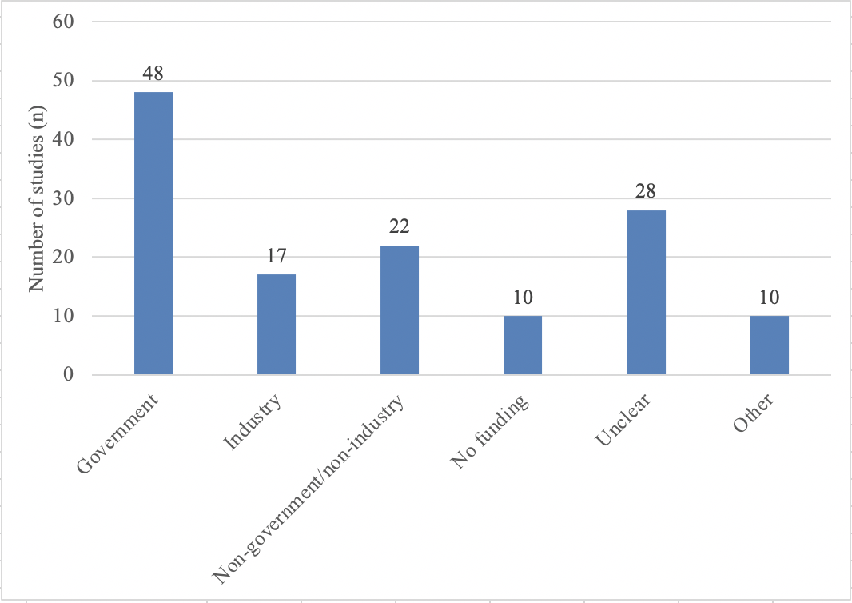
Legend: Appendix Figure 10 indicates the number of studies that reported each type of funding. Note some studies had more than 1 funding source.

Appendix 11: Median quality scores by intervention category.

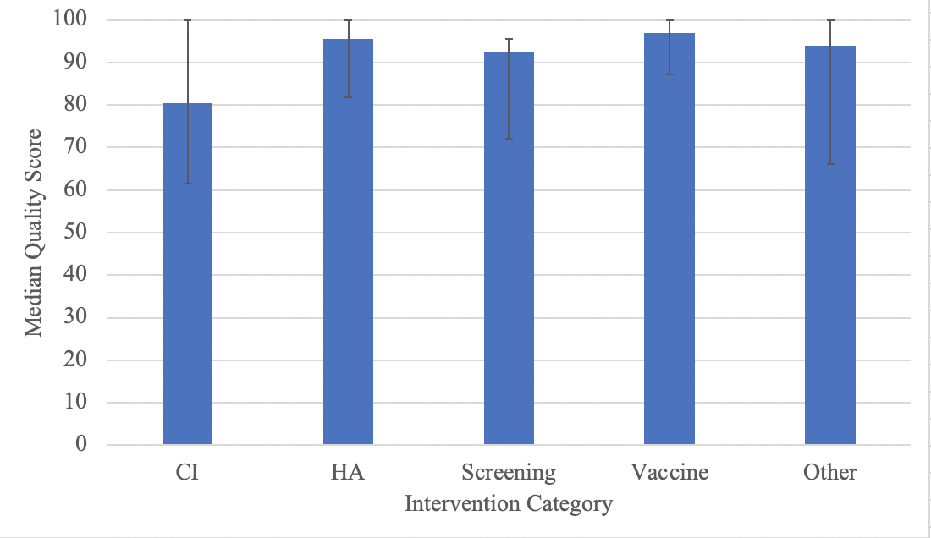
Legend: Appendix Figure 11 indicates the median quality score for studies in each intervention category. Error bars indicate the interquartile range.

Table: The distribution of quality scores by intervention category.
 | Intervention Category
Quality Score Range | CI | HA | Screening | Vaccine | Other
>90 | 41.2% | 64.3% | 54.3% | 72.7% | 55.2%
80-90 | 11.8% | 17.9% | 14.3% | 13.6% | 10.3%
70-80 | 11.8% | 0.0% | 8.6% | 9.1% | 3.4%
<70 | 35.3% | 17.9% | 22.9% | 4.5% | 31.0%
CI: cochlear implantation, HA: Hearing Aid.

