Assessment of clinical data on urocortins and their therapeutic potential in cardiovascular diaseses: a systematic review and meta-analysis

Dóra K. Kovács¹, Nelli Farkas², Alexandra Soós¹, Péter Hegyi^{1, 3, 4}, Leonardo Kelava¹, Szimonetta Eitmann¹, Anna Schekk¹, Zsolt Molnár¹, Bálint Erőss¹, Márta Balaskó¹

Table of contents:
Table S1 Risk of bias assessment of the analyzed studies
Table S2 Certainty of evidence
Figure S1 Association between blood urocortin 1 (Ucn1) level and left ventricular ejection fraction (LVEF)
Figure S2 Association between blood urocortin 2 (Ucn2) level and left ventricular ejection fraction (LVEF)
Reference list

Table S1 Risk of bias assessment of the analyzed studies (References of the assessed studies are found in the Reference list of this Supplemetary appendix – from page 6 – in the order of appearance.)
Panel A
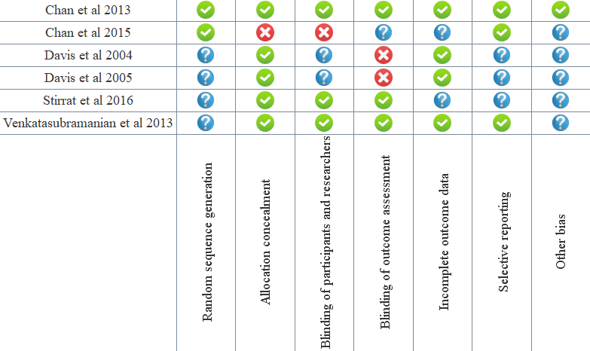

Panel B
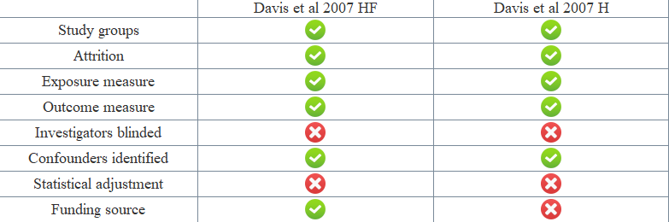

Panel C
Domain | Selection | Comparability | Exposure | Sum
Alarslan et al 2019 | *** | ** | *** | 8
Argan et al. 2015 | ** | * | *** | 6
Aslan et al. 2020 | ** | ** | *** | 7
Emeto et al 2014 | ** | ** | *** | 7
Gruson et al. 2011 | * | 0 | *** | 4
Gruson et al. 2010 | * | ** | *** | 6
Kavalakatt et al.2019 | ** | 0 | *** | 5
Liew et al. 2016 | **** | * | *** | 8
Ng et al. 2004 | ** | * | *** | 6
Phrommintikul et al. 2010 | *** | * | *** | 7
Pintalho et al 2018 | ** | 0 | *** | 5
Takahashi et al 2004 | * | 0 | *** | 4
Tang et al. 2010 | * | 0 | *** | 4
Topal et al. 2012 | ** | 0 | *** | 5
Tsuda et al 2017 | *** | * | *** | 7
Yildirim et al. 2014 | ** | 0 | *** | 5
Yildirim et al. 2017 | ** | * | *** | 6
Walczewska et al 2019 | *** | * | *** | 7
Wright et al.2009 | * | * | *** | 5

Panel A shows the risk of bias assessment of the randomized studies based on the Cochrane risk of bias tool 1
Panel B shows the risk of bias assessment of the non-randomized interventional studies based on the modified Newcastle-Ottawa Scale
H- healthy participants; HF- participants with heart failure
Panel C shows the risk of bias assessment of the non-randomized observational studies based on the Newcastle-Ottawa Scale

Table S2 Certainty of evidence
Certainty assessment |  |  |  |  |  |  | № of patients | Effect  MD (95% CI) | Certainty | Importance
№ of studies | Study design | Risk of bias | Inconsistency | Indirectness | Imprecision | Other considerations
Mean arterial pressure (assessed with: mmHg)
3 | Randomized and non-randomized interventional studies | serious | serious | not serious | serious | none | 21 | MD 9.161 lower  (12.661 lower to 5.66 lower)  [mmHg] | ⨁◯◯◯  VERY LOW | Not important
Heart rate (assessed with: beats/min)
3 | Randomized and non-randomized interventional studies | serious | serious | not serious | serious | none | 21 | MD 5.629 higher  (1.612 higher to 9.646 higher)  [beats/minutes] | ⨁◯◯◯  VERY LOW | Not important
Association between urocortin 1 level and left ventricular ejection fraction
9 | observational studies | not serious | serious | serious | serious | none | 1344 | No association | ⨁◯◯◯  VERY LOW | Not important
Association between urocortin 2 level and left ventricular ejection fraction
6 | observational studies | not serious | serious | serious | serious | none | 709 | No association | ⨁◯◯◯  VERY LOW | Not important
CI: Confidence interval; MD: Mean difference

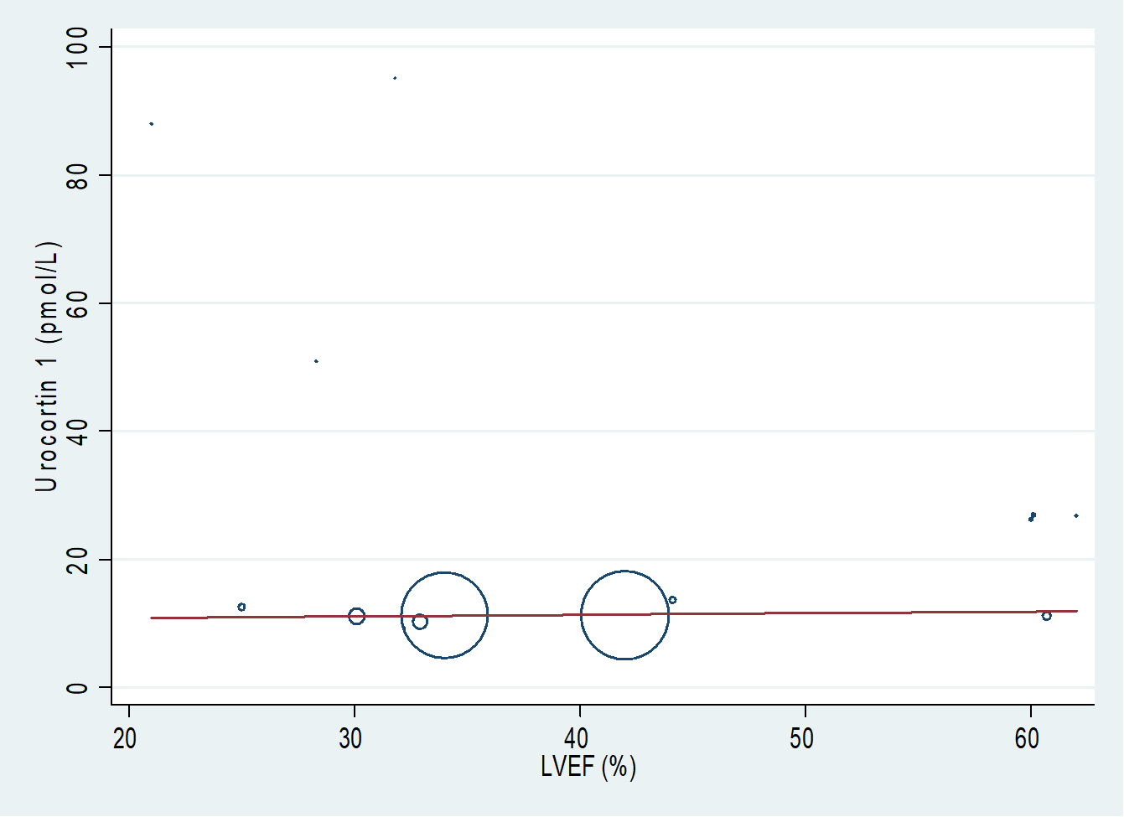
Figure S1 Association between blood urocortin 1 (Ucn1) level and left ventricular ejection fraction (LVEF)
Meta-regression of blood urocortin 1 (Ucn1) levels versus left ventricular ejection fraction (LVEF) using data from our analyzed studies [26-29, 31-35]. Some data points from the included 14 were assigned so little weight by the Stata 15.1. program that they are not visible on the figure.

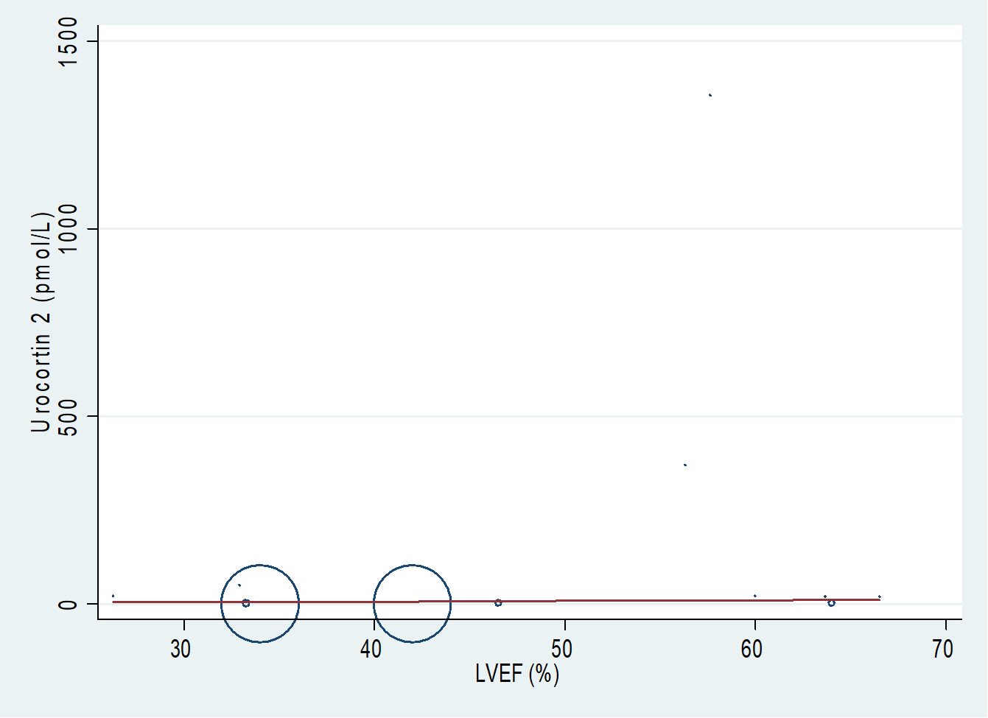
Figure S2 Association between blood urocortin 2 (Ucn2) level and left ventricular ejection fraction (LVEF)
Meta-regression of blood urocortin 2 (Ucn2) levels versus left ventricular ejection fraction (LVEF) using data from our analyzed studies [26, 28, 37-38, 40, 42]. Some data points from the included 12 were assigned so little weight by the Stata 15.1. program that they are not visible on the figure.

Reference list:
- Chan WY, Frampton CM, Crozier IG et al. Urocortin-2 infusion in acute decompensated heart failure: findings from the UNICORN study (urocortin-2 in the treatment of acute heart failure as an adjunct over conventional therapy). JACC Heart Fail. 2013;(5):433-41. doi: 10.1016/j.jchf.2013.07.003
- Chan WYW, Charles CJ, Frampton CM et al. Human muscle sympathetic nerve responses to urocortin-2 in health and stable heart failure. Clin Exp Pharmacol Physiol. 2015;42(9):888-895. doi: 10.1111/1440-1681.12449.
- Davis ME, Pemberton CJ, Yandle TG et al. Urocortin-1 infusion in normal humans. J Clin Endocrinol Metab. 2004;89(3):1402-9. doi: 10.1210/jc.2003-031231
- Davis ME, Pemberton CJ, Yandle TG et al. Effect of urocortin 1 infusion in humans with stable congestive cardiac failure. Clin Sci (Lond). 2005;109(4):381-8. doi:10.1042/CS20050079
- Stirrat CG, Venkatasubramanian S, Pawade T et al. Cardiovascular effects of urocortin 2 and urocortin 3 in patients with chronic heart failure. Br J Clin Pharmacol. 2016;82(4):974-82. doi: 10.1111/bcp.13033.
- Venkatasubramanian S, Griffiths ME, McLean SG et al. Vascular effects of urocortins 2 and 3 in healthy volunteers. J Am Heart Assoc. 2013;2(1):e004267. doi: 10.1161/JAHA.112.004267.
- Davis ME, Pemberton CJ, Yandle TG et al. Urocortin 2 infusion in human heart failure. Eur Heart J. 2007;(21):2589-97. doi: 10.1093/eurheartj/ehm340
- Davis ME, Pemberton CJ, Yandle TG et al. Urocortin 2 infusion in healthy humans: hemodynamic, neurohormonal, and renal responses. J Am Coll Cardiol. 2007;49(4):461-71. doi: 10.1016/j.jacc.2006.09.035
- Alarslan P, Unal Kocabas G, Demir I et al. Increased urocortin 3 levels are associated with the risk of having type 2 diabetes mellitus. J Diabetes. 2020;12(6):474-482. doi: 10.1111/1753-0407.13020.
- Argan O, Kozdaʇ G, Ural D et al. The relationship between the urocortin-1 level, mortality and atrial fibrillation in patients with chronic systolic heart failure. Anadolu Kardiyoloji Dergisi 2015;15 SUPPL. 1 (25)
- Aslan G, Aytekin S. Evaluation of Serum Urocortin 2 Levels in Patients with Hypertension. High Blood Press Cardiovasc Prev. F 2020;27(1):35-42 doi: 10.1007/s40292-019-00357-x.
- Emeto TI, Moxon JV, Biros E et al. Urocortin 2 is associated with abdominal aortic aneurysm and mediates anti-proliferative effects on vascular smooth muscle cells via corticotrophin releasing factor receptor 2. Clin Sci (Lond. 2014;126(7):517-27. doi: 10.1042/CS20130425.
- Gruson D, Lepoutre T, Verschuren F et al. Evaluation of urocortin and copeptin, two stress related peptides, in patients admitted to emergency department, Clinical Chemistry and Laboratory Medicine 2011 49 SUPPL. 1 (S302) doi: 10.1515/CCLM.2011.508
- Gruson D, Ahn SA, Ketelslegers JM et al. Circulating levels of stress associated peptide Urocortin in heart failure patients. Peptides. 2010;(2):354-6 doi: 10.1016/j.peptides.2009.11.023.
- Kavalakatt S, Khadir A, Madhu D et al. Urocortin 3 Levels Are Impaired in Overweight Humans With and Without Type 2 Diabetes and Modulated by Exercise. Front Endocrinol (Lausanne) 2019;10:762. doi: 10.3389/fendo.2019.00762. eCollection 2019.
- Liew OW, Yandle TG, Chong JP et al. High-Sensitivity Sandwich ELISA for Plasma NT-proUcn2: Plasma Concentrations and Relationship to Mortality in Heart Failure. Clin Chem. 2016;62(6):856-65. doi: 10.1373/clinchem.2015.252932.
- Ng LL, Loke IW, O'Brien RJ et al. Plasma urocortin in human systolic heart failure. Clin Sci (Lond). 2004;106(4):383-8. doi: 10.1042/CS20030311
- Phrommintikul A, Sivasinprasasn S, Lailerd N et al. Plasma urocortin in acute myocardial infarction patients. Eur J Clin Invest. 2010;40(10):874-82. doi: 10.1111/j.1365-2362.2010.02343.x.
- Pintalhao M, Maia-Rocha C, Martins R et al. Serum urocortin-2 is associated with volume overload and pulmonary hypertension in acute heart failure, Circulation 2018;138 Supplement 1
- Takahashi K, Totsune K, Murakami O et al. Expression of urocortin III/stresscopin in human heart and kidney. J Clin Endocrinol Metab. 2004;89(4):1897-903. doi: 10.1210/jc.2003-031663
- Tang WH, Shrestha K, Martin MG et al. Clinical significance of endogenous vasoactive neurohormones in chronic systolic heart failure. J Card Fail 2010;(8):635-40. doi: 10.1016/j.cardfail.2010.03.011.
- Topal E, Yağmur J, Otlu B et al. Relationship of urocortin-2 with systolic and diastolic functions and coronary artery disease: an observational study. Anadolu Kardiyol Derg. 2012;(2):115-20. doi: 10.5152/akd.2012.036.
- Tsuda T, Takefuji M, Wettschureck N et al. Corticotropin releasing hormone receptor 2 exacerbates chronic cardiac dysfunction. J Exp Med. 2017;214(7):1877-1888. doi: 10.1084/jem.20161924
- Yildirim E, Keles I, Cakmak HA et al. Evaluation of the clinical utility of urocortin 1 in systolic heart failure. Kardiol Pol. 2014;72(5):452-8. doi: 10.5603/KP.a2013.0353.
- Yıldırım E, Cengiz M, Yıldırım N et al. The evaluation of the clinical utility of urocortin 1 and adrenomedullin versus proBNP in systolic heart failure. Anatol J Cardiol. 2017;17(3):184-190 doi: 10.5152/akd.2014.5793
- Walczewska J, Siga O, Dzieza-Grudnik A et al. Urocortin 2 in patients with hypertension treated with angiotensin converting enzyme inhibitors or angiotensin receptor blockers. J Physiol Pharmacol. 2019;70(2). doi: 10.26402/jpp.2019.2.15.
- Wright SP, Doughty RN, Frampton CM et al. Plasma urocortin 1 in human heart failure. Circ Heart Fail. 2009;(5):465-71. doi: 10.1161/CIRCHEARTFAILURE.108.840207.

