Supplementary Figure:
S1: forest plots of unadjusted OR of DM patients baseline characteristics for SAF
A: SAF and Age
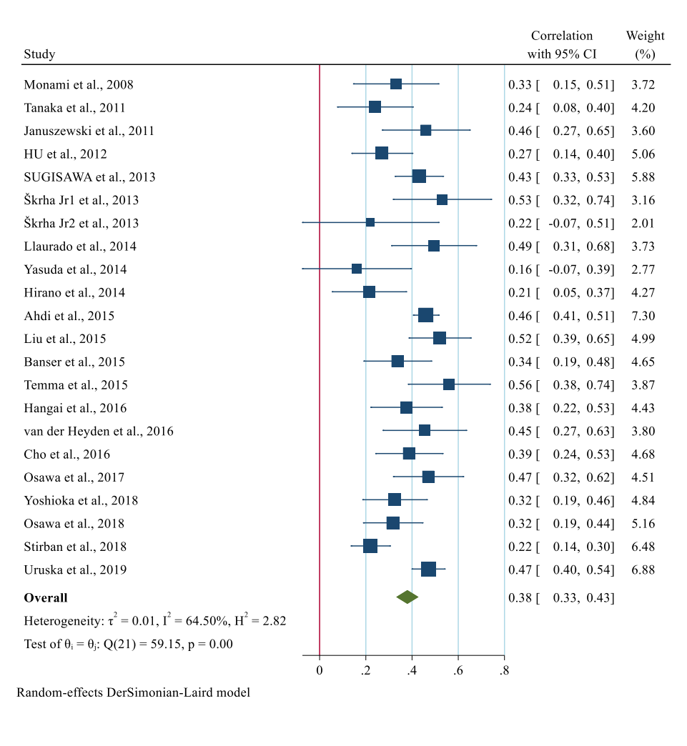
Favors higher ages

B: SAF and BMI
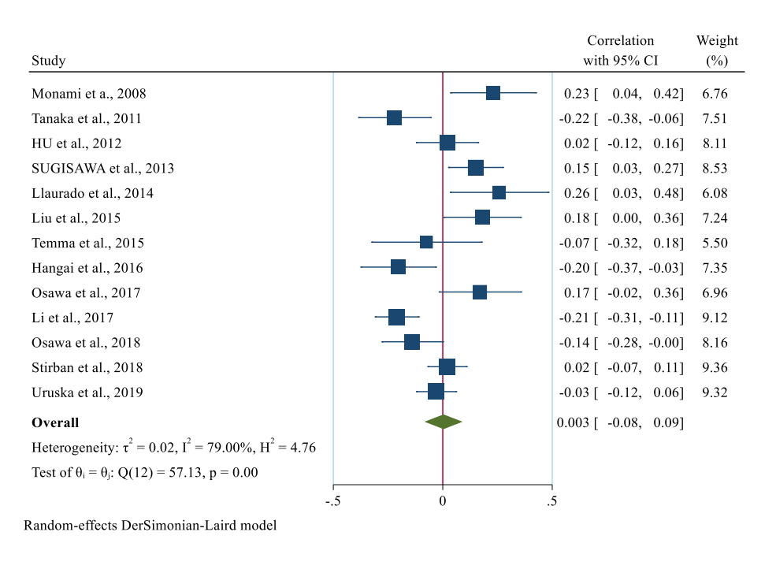
Favors Lower BMI Favors higher BMI

C: SAF and diabetic duration
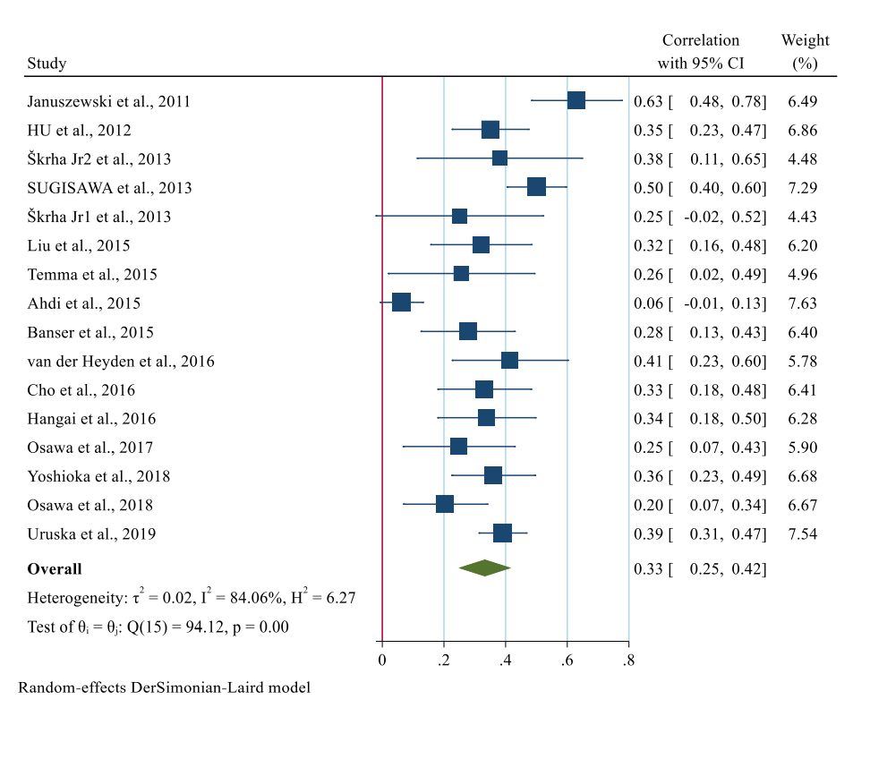
Favors DM patients for several years

D: SAF and HbA1c
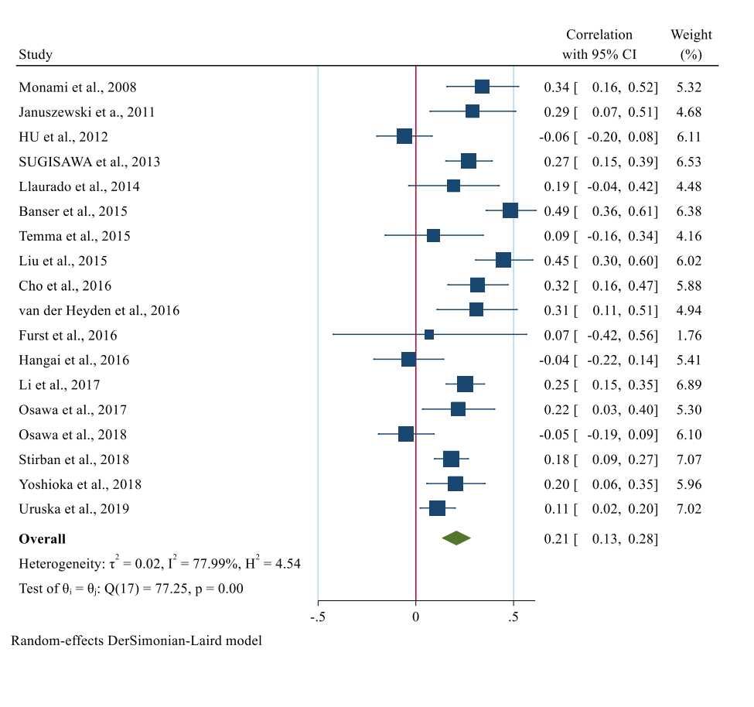
Favors DM patients with lower HbA1c Favors DM patients with higher HbA1c

E: SAF and max-IMT
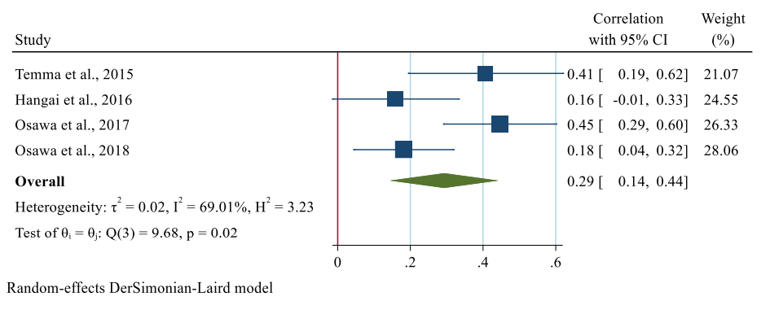
Favors DM patients with higher max-IMT
Supplementary Figure S1: Forest plot of pooled unadjusted OR of age range for SAF level (A). Pooled unadjusted OR of BMI (Body Mass Index) measurement for SAF(B). Pooled unadjusted OR of diabetic duration for SAF (C). Pooled unadjusted OR of HbA1c for SAF (D). Pooled unadjusted OR of max-IMT (max carotid Intima Media Thickness) for SAF level. 95% CI, 95% confidence interval. I² represents the quantity of heterogeneity (between 0 and 100%). T² is the inter-study variance. H: Heterogeneity. p is the p-value of the heterogeneity test.
.

Supplementary figure S2: funnel plots for publication bias in studies evaluating the clinical significance of SAF regarding diabetic vascular complications
A: SAF and DR B: SAF and DPN
C: SAF and DNP D: SAF and D-MVE
E: SAF and DFU F: SAF and diabetic any microvascular complication

Supplementary figure S2: A. Funnel plot for publication bias among studies evaluating the validation of SAF for DR. (Egger’s test: p=0.0008). B. Funnel plot for publication bias among studies evaluating the validation of SAF for DPN. (Egger’s test: p=0.0001). C. Funnel plot for publication bias among studies evaluating the validation of SAF for DNP. (Egger’s test: p=0.0020). D. Funnel plot for publication bias among studies evaluating the validation of SAF for D-MVE. (Egger’s test: p=0.0035). E. Funnel plot for publication bias among studies evaluating the validation of SAF for DFU. (Egger’s test: p=0.7185). F. Funnel plot for publication bias among studies evaluating the validation of SAF for diabetic any microvascular complication. (Egger’s test: p=0.1928). The white line represents pseudo 95% of confidence interval (CI), while the red line shows estimated theta test. The effect size is on the X-axis while the variance on the Y-axis, in case of no publication bias the studies would be around the mean effect size.

Supplementary figure 3: funnel plots for publication bias in studies assessing the clinical significance of SAF regarding DM patients baseline characteristics
A : SAF and age B: SAF and BMI
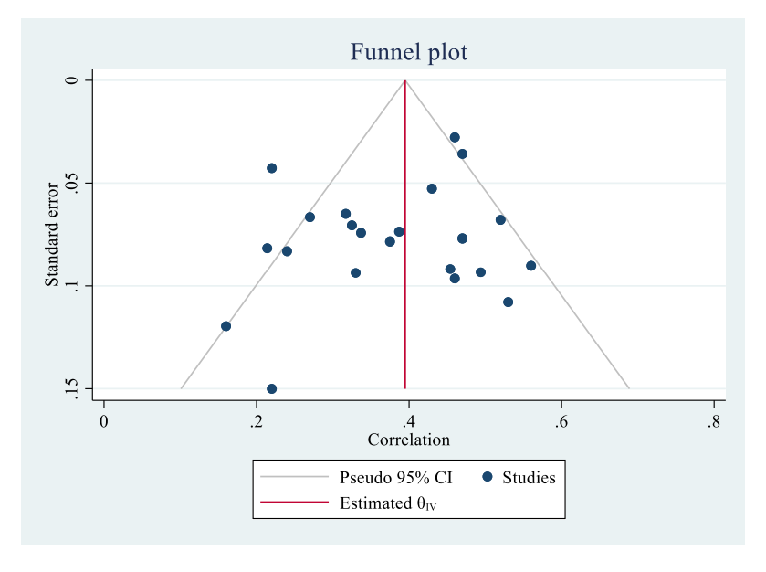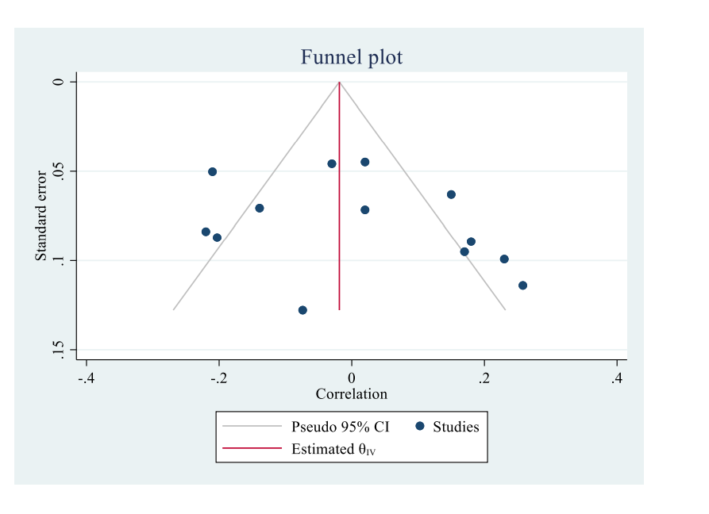
C : SAF and diabetic duration D: SAF and max-IMT
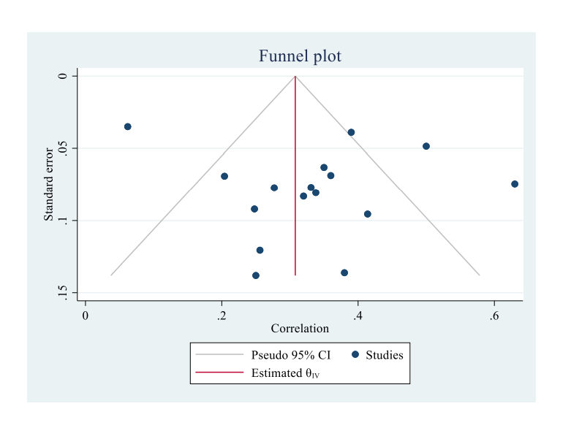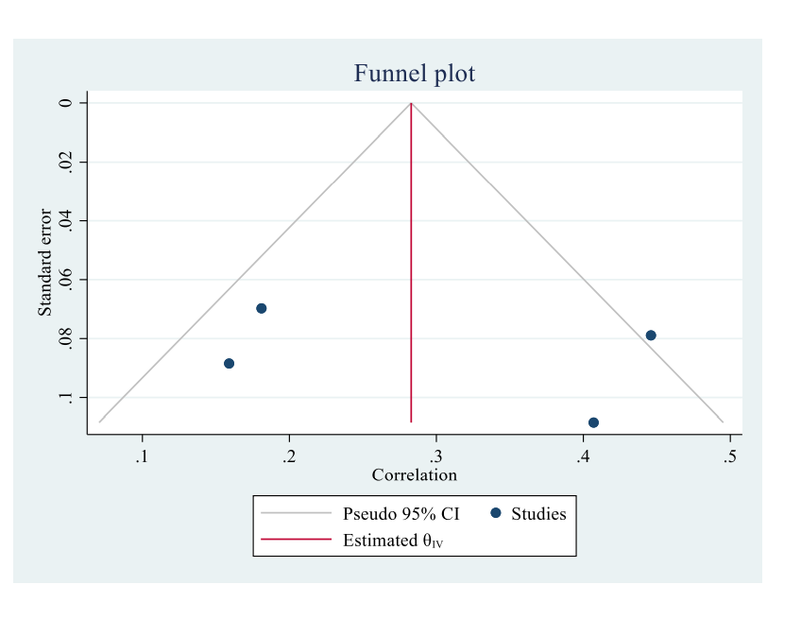
E: SAF and HbA1c
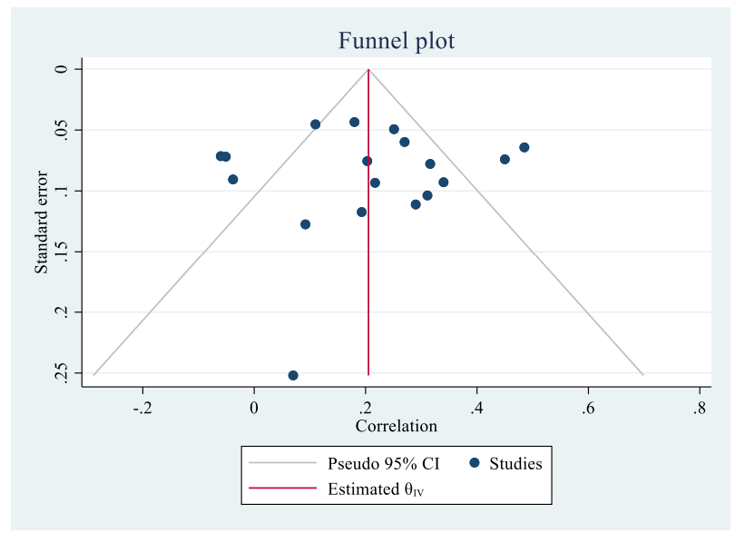

Supplementary figure 3: A. Funnel plot for publication bias among studies evaluating the relation between SAF and age. (Egger’s test: p=0.5271). B. Funnel plot for publication bias among studies evaluating the relation between SAF and BMI. (Egger’s test: p=0.2326). C. Funnel plot for publication bias among studies evaluating the relation between SAF and diabetic duration. (Egger’s test: p=0.9464). D. Funnel plot for publication bias among studies evaluating the relation between SAF and max-IMT. (Egger’s test: p=0.5634). E. Funnel plot for publication bias among studies evaluating the relation between SAF and HbA1c. (Egger’s test: p=0.7186) The white line represents pseudo 95% of confidence interval (CI), while the red line shows estimated theta test. The effect size is on the X-axis while the variance on the Y-axis, in case of no publication bias the studies would be around the mean effect size.

