Supplement Additional Figures
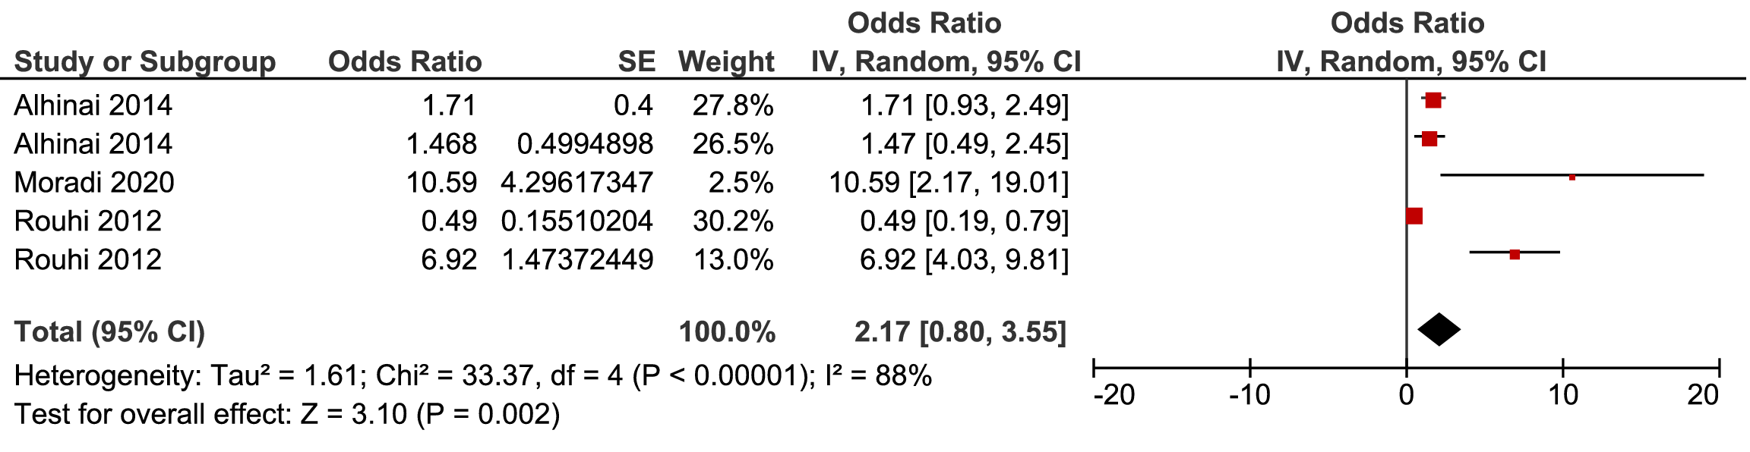
Additional figure 8: Forest plot for pooled association between lack of relationship with family (Ref. Relationship with family) and postpartum depression in the Middle East.
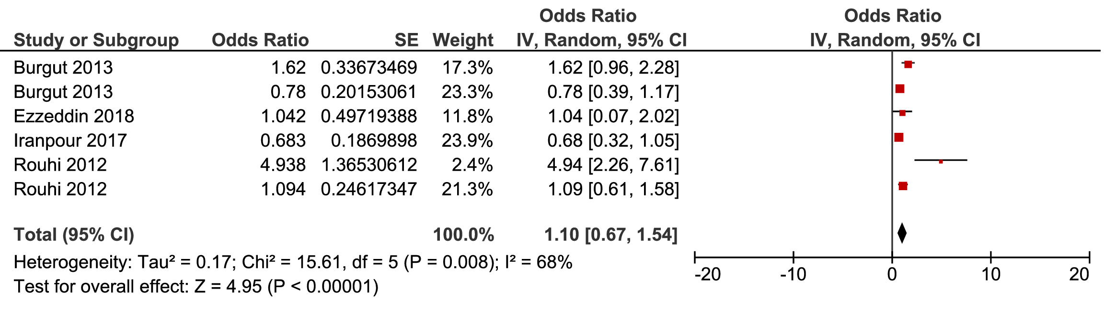
Additional figure 9: Forest plot for pooled association between low education (Ref. Mother’s education) and postpartum depression in the Middle East.
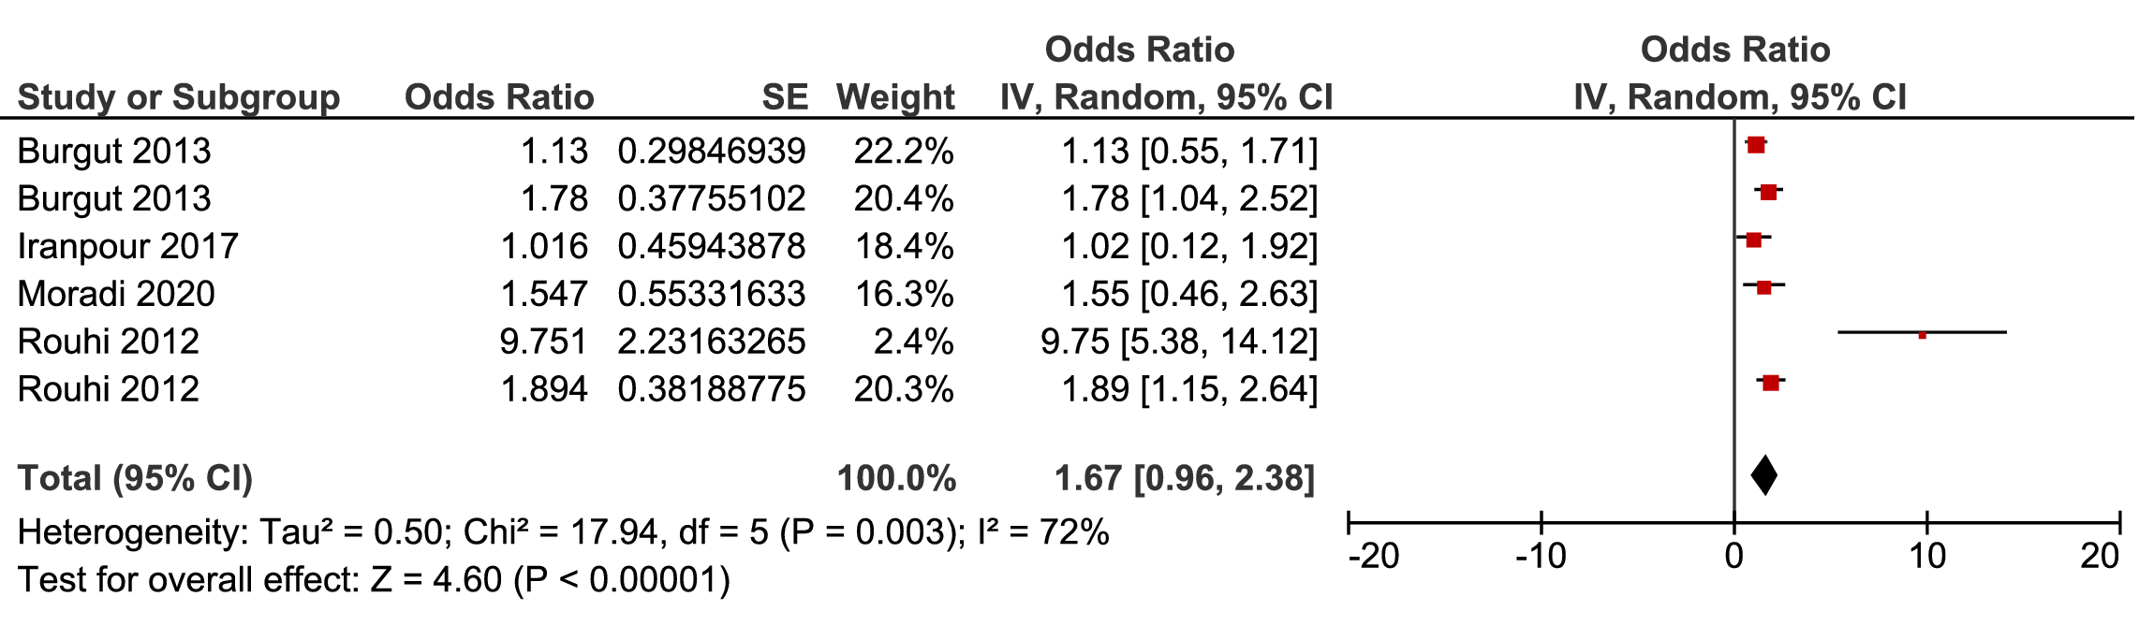
Additional figure 10: Forest plot for pooled association between housewife (Ref. Mother’s occupation) and postpartum depression in the Middle East.
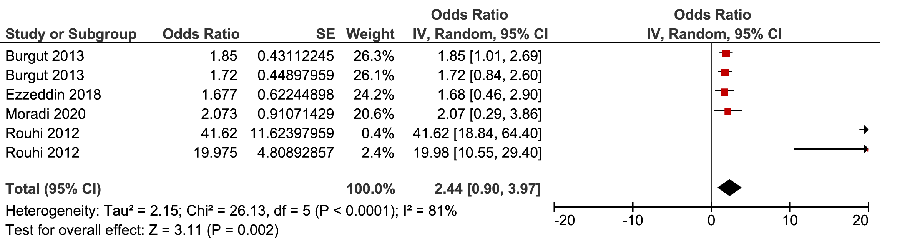
Additional figure 11: Forest plot for pooled association between unplanned pregnancy (Ref.Planned pregnancy) and postpartum depression in the Middle East.
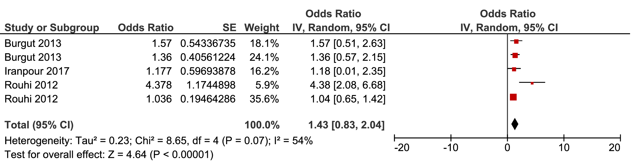
Additional figure 12: Forest plot for pooled association between young age (Ref. Age) and postpartum depression in the Middle East.
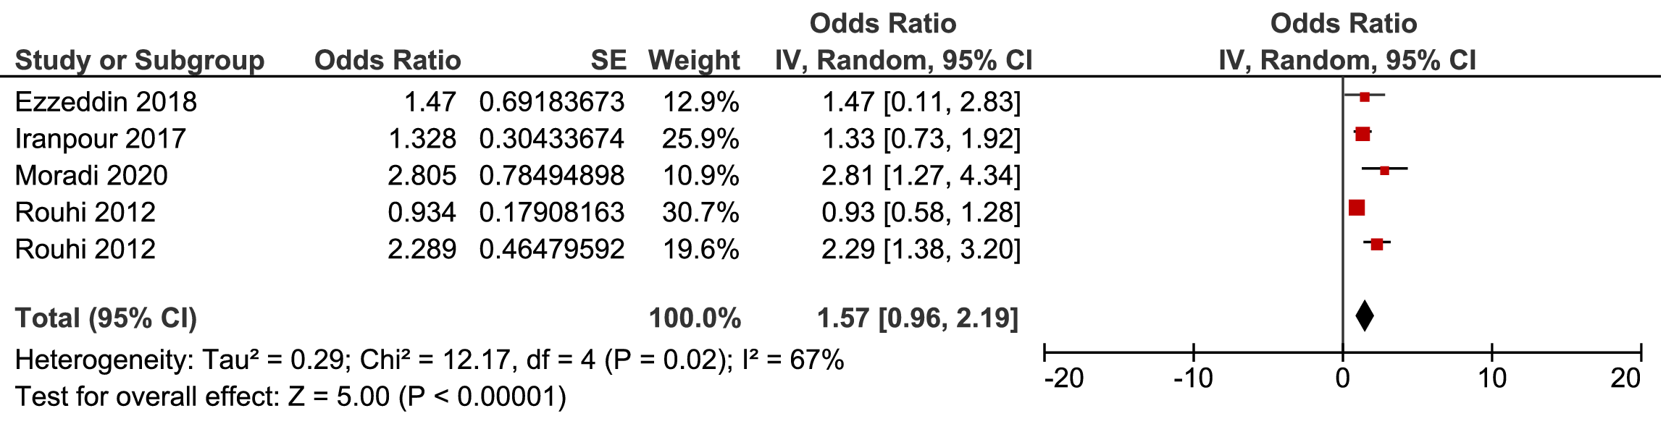
Additional figure 13: Forest plot for pooled association between unwanted baby gender (Ref.Baby’s gender) and postpartum depression in the Middle East.
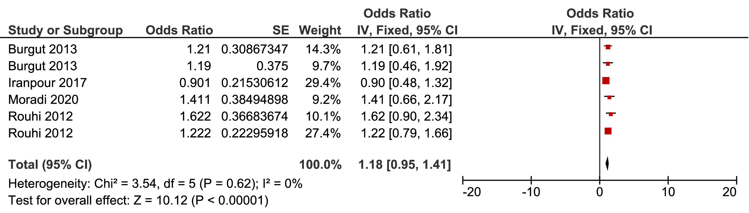
Additional figure 14: Forest plot for pooled association between mode of delivery and postpartum depression in the Middle East.
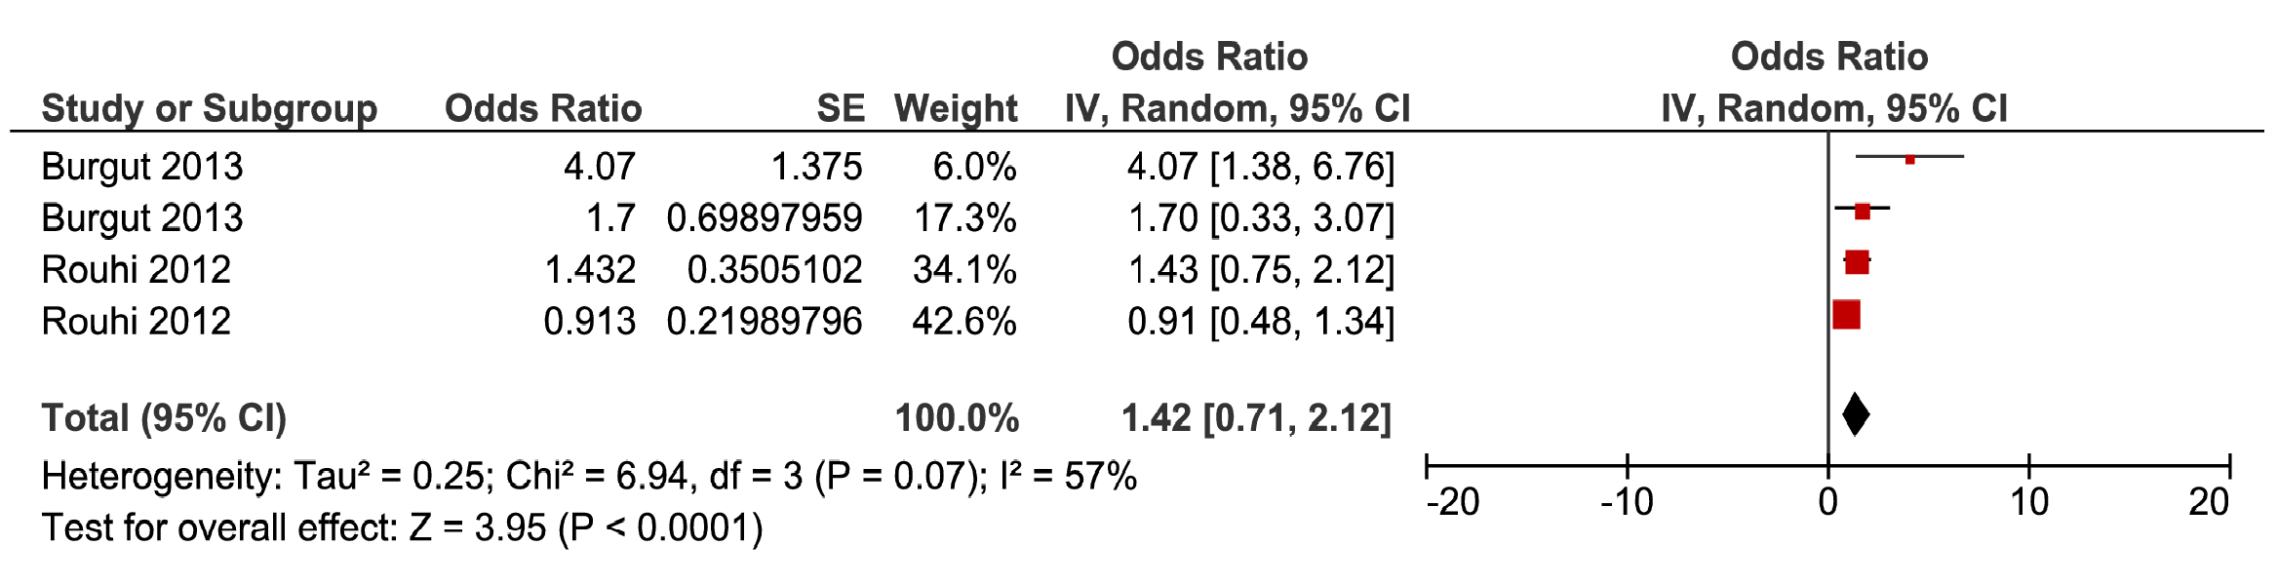
Additional figure 15: Forest plot for pooled association between feeding by formula (Ref. Type of feeding) and postpartum depression in the Middle East.

